- display all customer details who have made more than 5 payments.
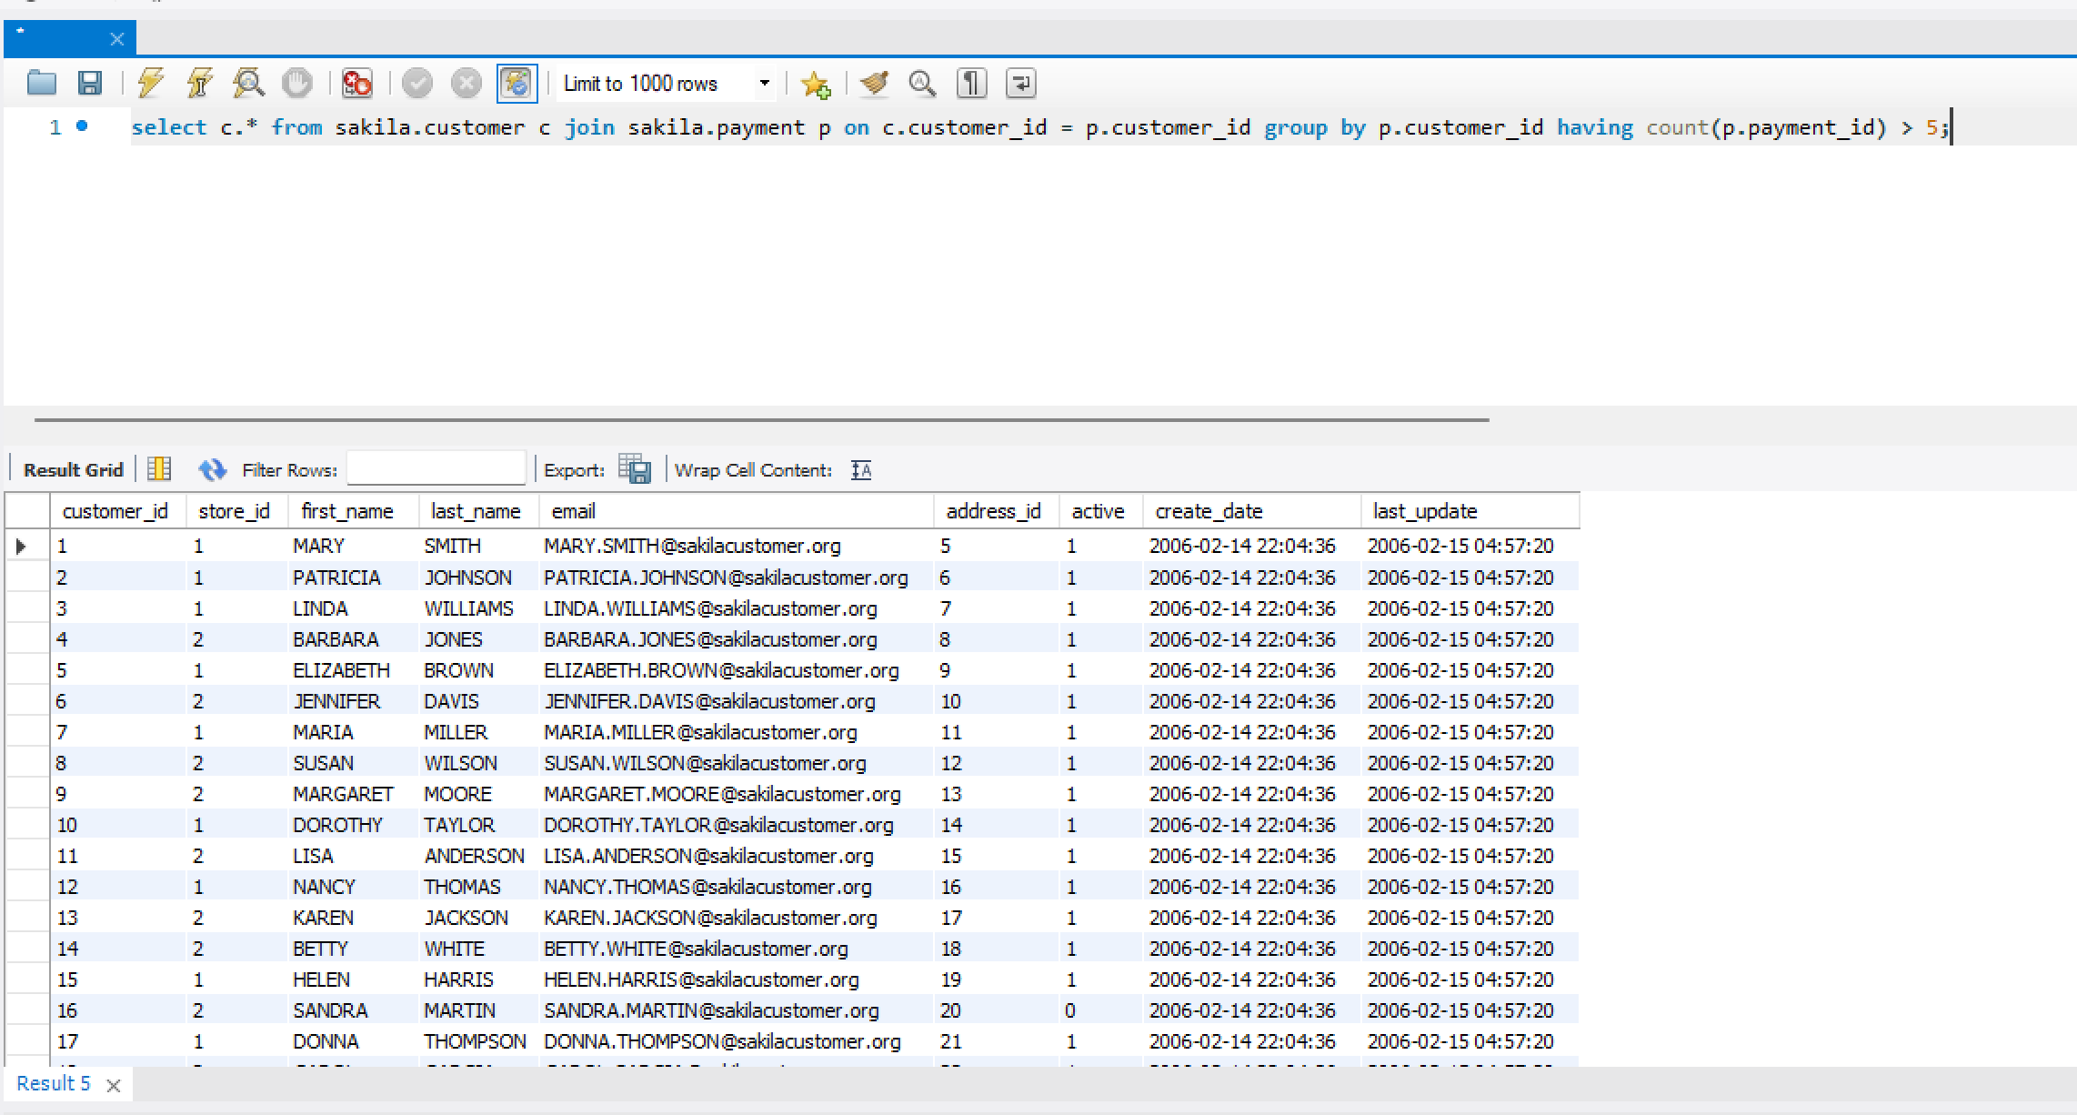
- Find the names of actors who have acted in more than 10 films.
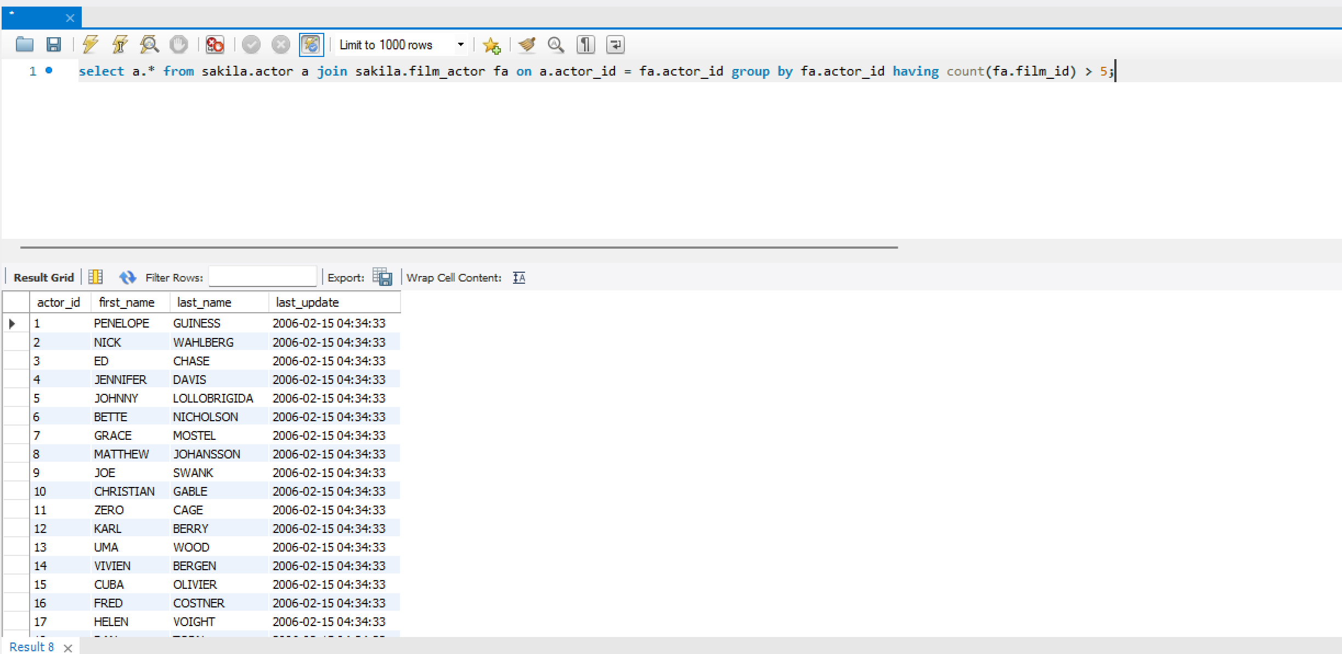
- Find the names of customers who never made a payment.
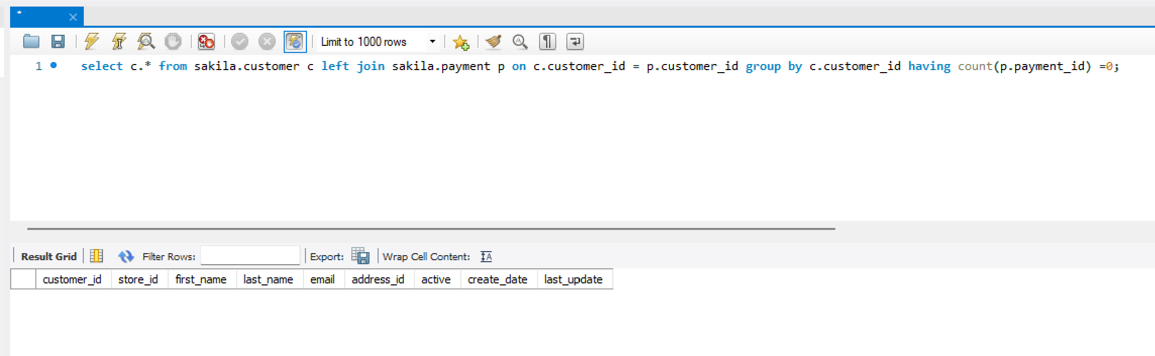
- List all films whose rental rate is higher than the average rental rate of all films.
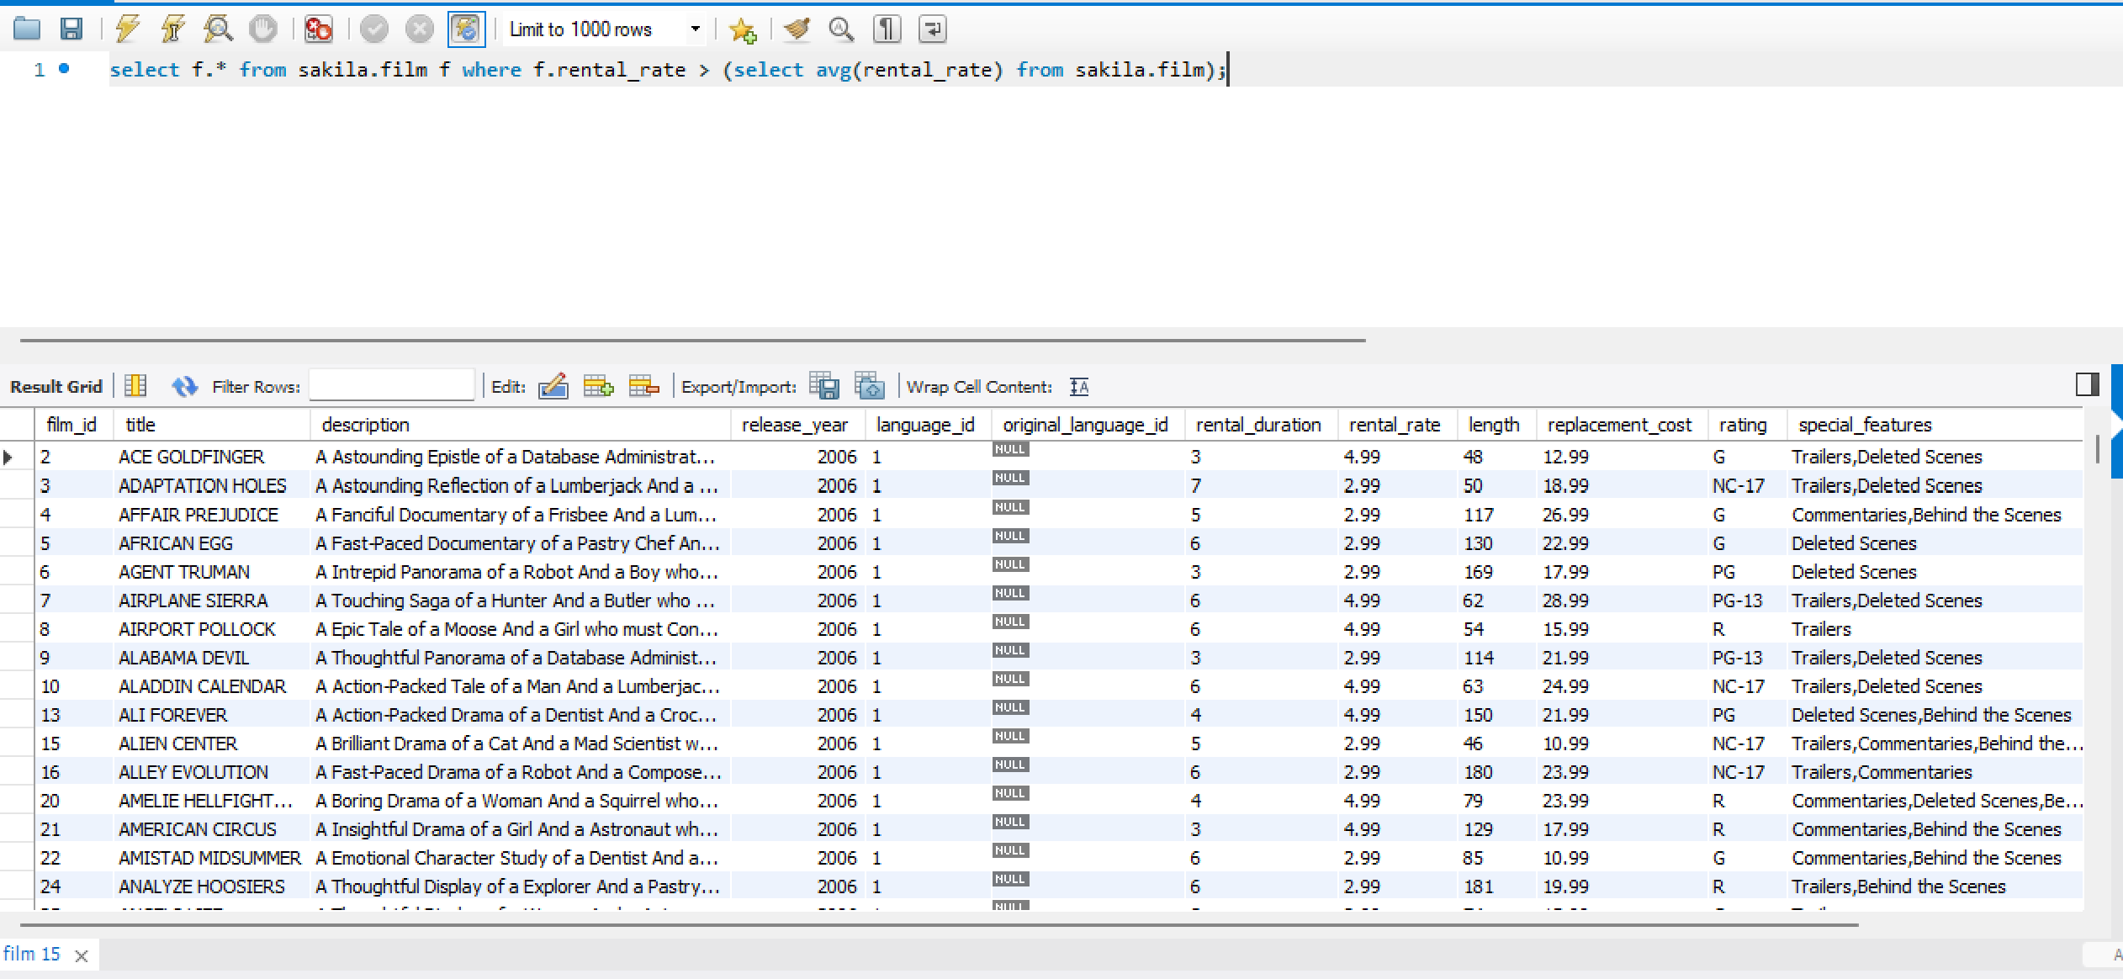
- List the titles of films that were never rented.
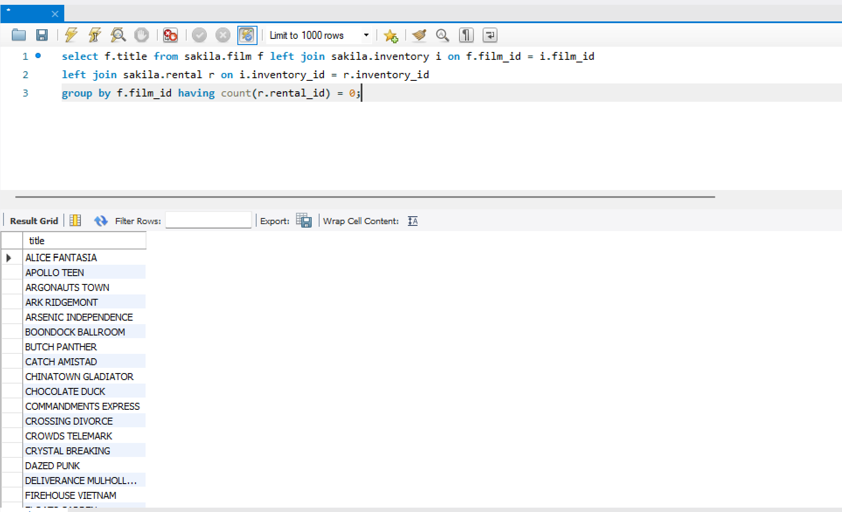
- Display the customers who rented films in the same month as customer with ID 5.
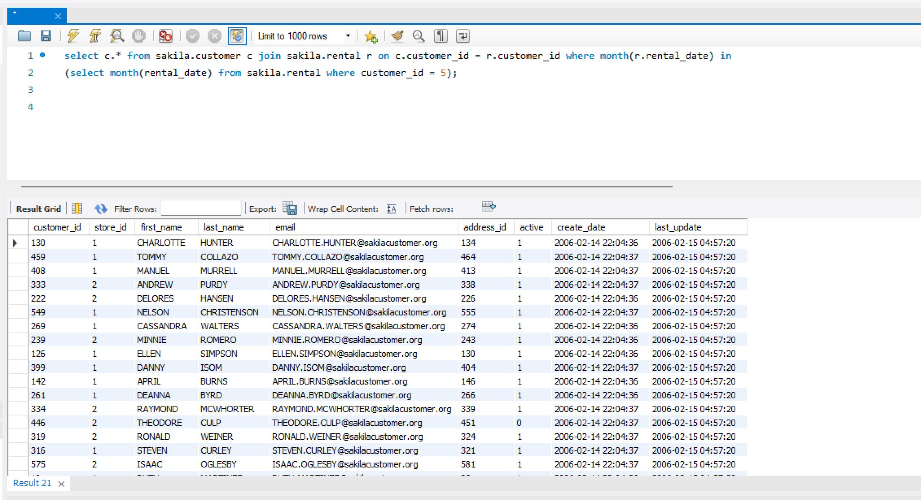
- Find all staff members who handled a payment greater than the average payment amount.
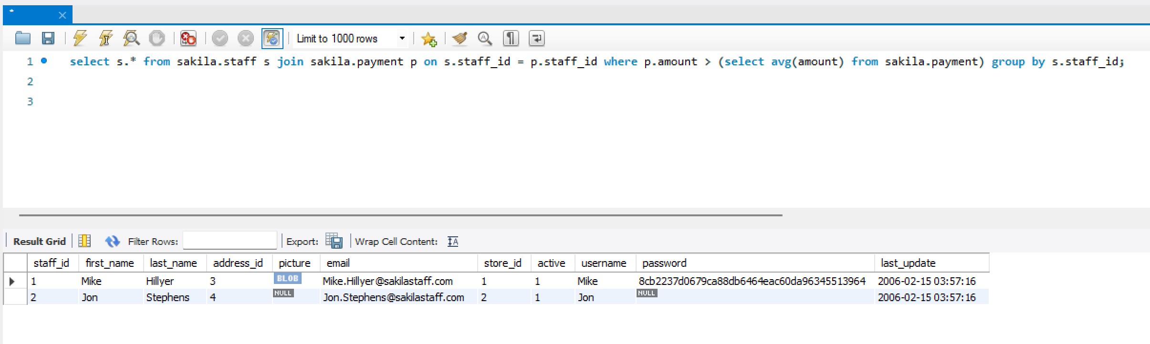

- Show the title and rental duration of films whose rental duration is greater than the average.

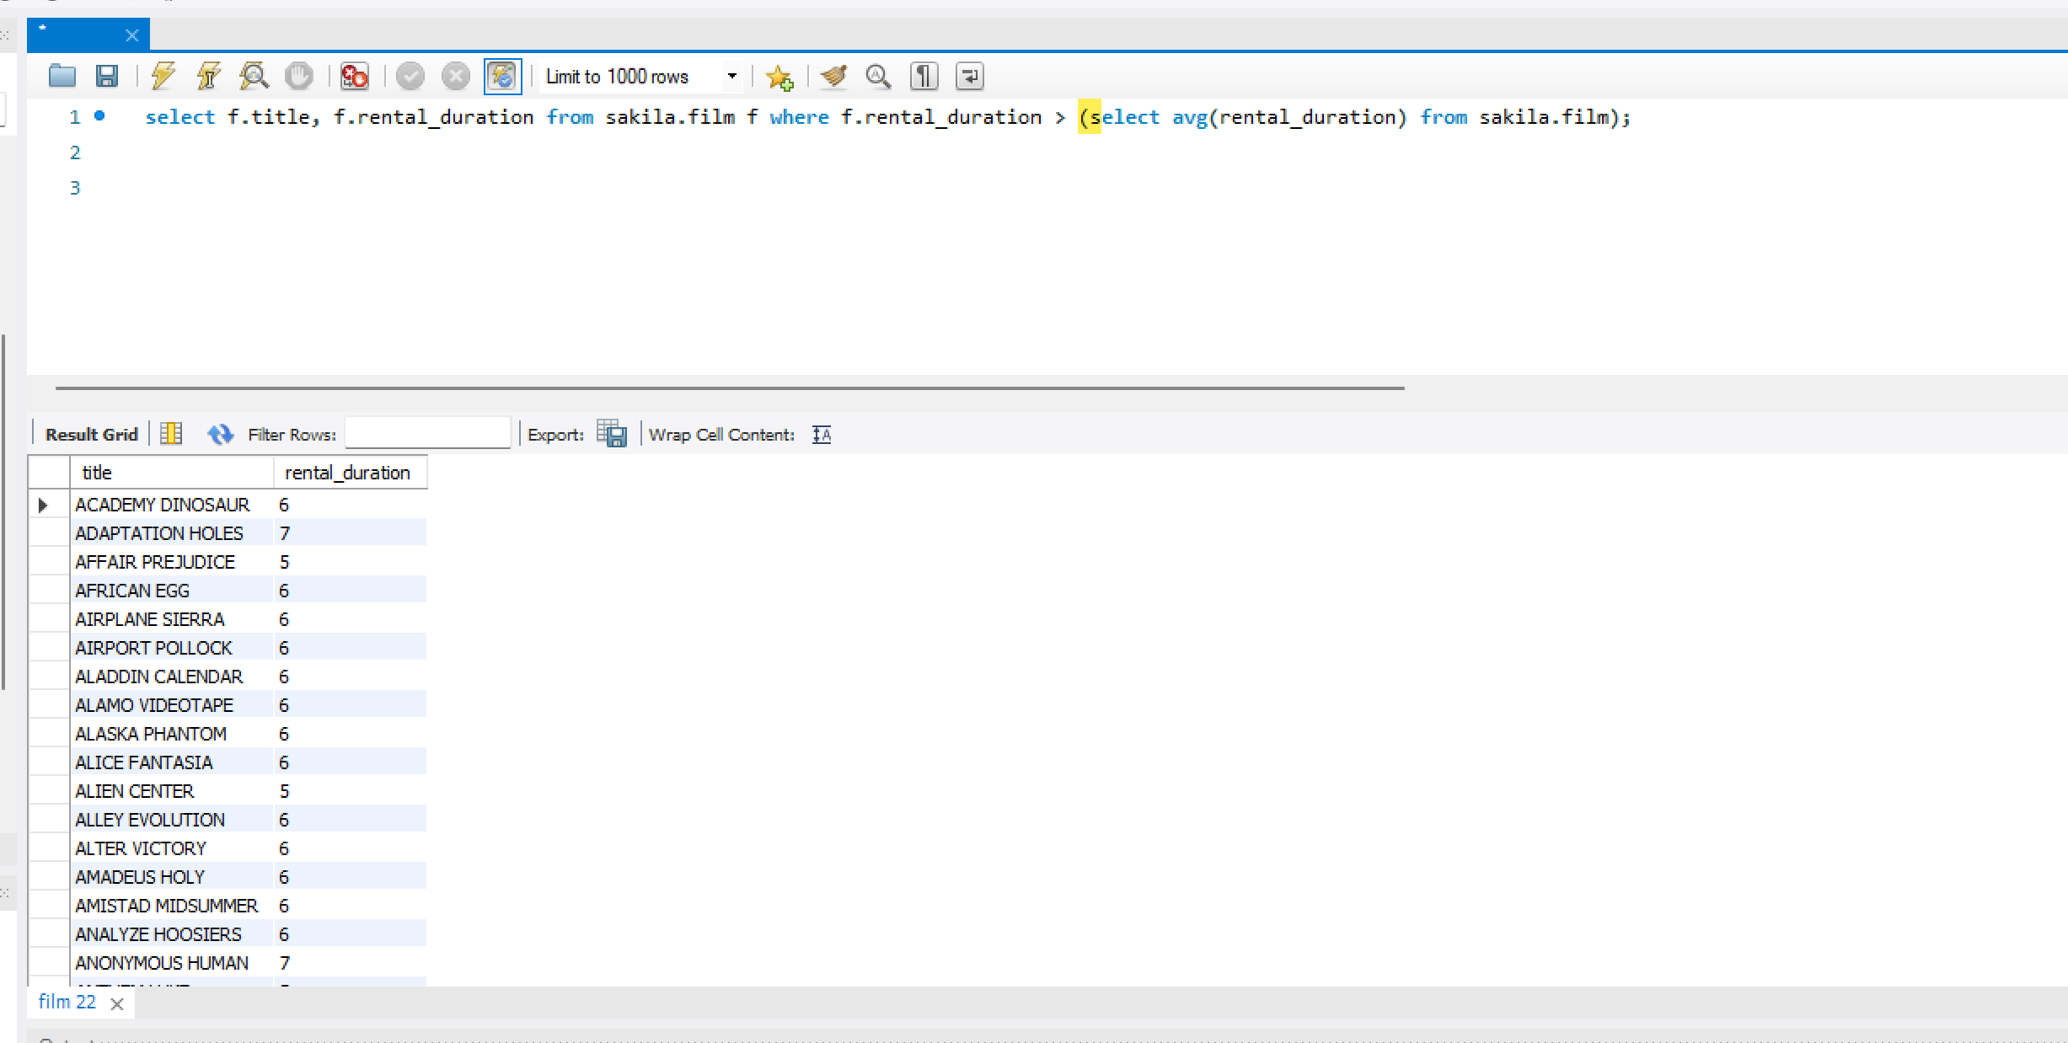
9. Find all customers who have the same address as customer with ID 1.
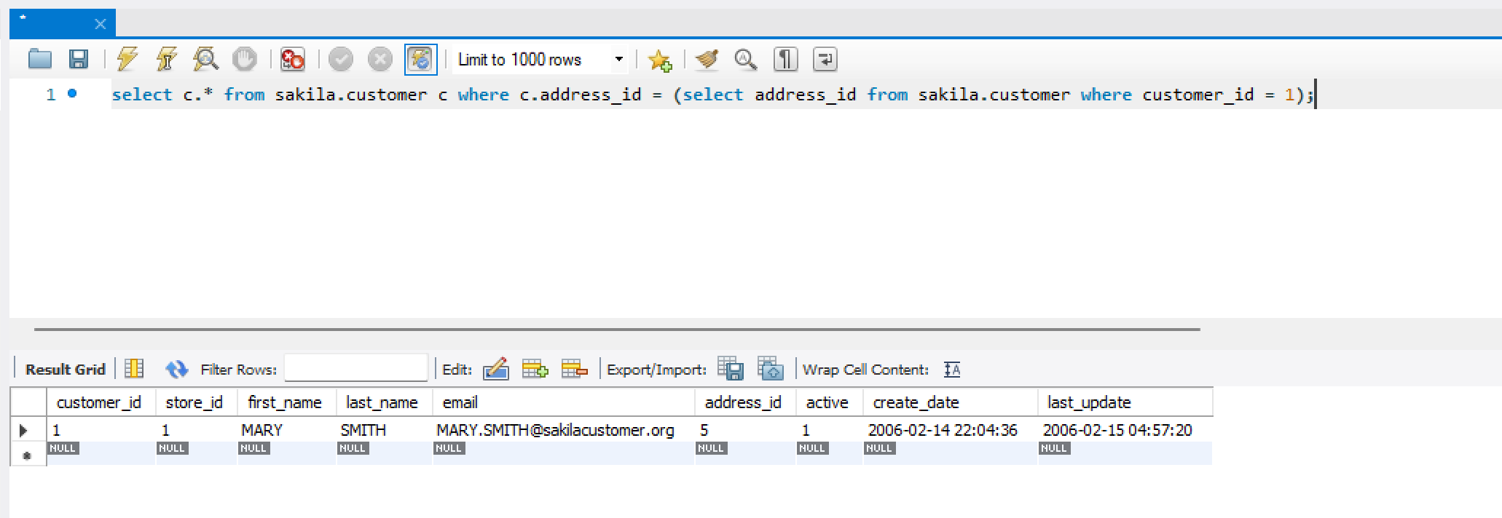
10. List all payments that are greater than the average of all payments.
