INDUSTRIAL TRAINING REPORT

SUBMITTED BY
APPANA NAGA CHAITANYA

In Partial Fulfilment of the Requirements for the Award of Diploma in Computer Engineering
UNDER THE ESTEEMED GUIDANCE OF
SRI S.M.M.M.KALYAN KUMAR SIR[DIO]
SRI J.SRINIVAS SIR[ADIO]
DEPARTMENT OF COMPUTER ENGINEERING
ANDHRA POLYTECHNIC, KAKINADA – 533002
ACADEMIC YEAR: 2026–2027 (Batch: 2024–2027)
ANDHRA POLYTECHNIC

DEPARTMENT OF COMPUTER ENGINEERING

CERTIFICATE
This is to certify that the industrial training report entitled “A GENERIC AND MODULAR STUDENT ADMISSIONS WORKFLOW AND REPORTS FRAMEWORK” is the bonafide record of work carried out by APPANA NAGA CHAITANYA (24010-CM-001), a student of the Diploma in Computer Engineering programme, during the training period from 15/05/2026 to 20/11/2026 for the academic year 2026–2027.

Guide Head of Department
(Sri J.Srinivas,Sri S.M.M.M.Kalyan kumar) (Sri.V.Vizia kumar, Principal(FAC))

External Examiner
Date: __________ Place: Kakinada

Certificate from Intern organization

This is to certify that APPANA NAGA CHAITANYA,
Register Number: 24010-CM-001, from Andhra Polytechnic, Kakinada,
has undergone industrial training at National Informatics Centre (NIC), Kakinada
from 15/05/2026 to 20/11/2026.

The overall performance of the intern during the training period is found to be
SATISFACTORY.

Authorized signature with date and Seal

ACKNOWLEDGEMENT

I express my sincere gratitude to the officers and staff who guided me during the industrial training and helped me understand the development and maintenance of the ITI Admissions Portal.
I am thankful to my project guide, Sri S. M. M. M. Kalyan Kumar, for his guidance, cooperation and valuable suggestions throughout the training.
I also thank the lecturers and faculty members of the Computer Engineering Department for their encouragement and academic support.
I express my gratitude to the Head of the Department and the Principal (FAC) of Andhra Polytechnic, Kakinada, for their support.
Finally, I thank everyone who contributed directly or indirectly to the successful completion of this training report.
INDEX
1. INTRODUCTION
1.1 Profile
2. TOOLS &amp; TECHNOLOGIES
2.1 Hardware
2.2 Software
2.3 Versions
3. PROJECT PROFILE
3.1 Objective
4. SYSTEM ANALYSIS
4.1 Introduction…………………………………………………………………………………
4.2 Existing System (Before Rebuilding)……………………………………………………
4.3 Rebuilt System………………………………………………………………………………
4.4 System Objectives……………………………………………………………………………
4.5 Functional Overview of Reports Module
4.5.1 Authentication & Reporting Access
4.5.2 ITI Institutional Reports………………………………………………………………
4.5.3 District Level Reports &amp; Monitoring………………………………………………
4.5.4 Nodal Center Reports &amp; Seat Abstracts…………………………………………
4.5.5 State Administration &amp; Directorate Reports………………………………………
4.5.6 Verification &amp; Compliance Reports………………………………………………
4.6 Non-Functional Requirements……………………………………………………………
4.7 Benefits of the Rebuild System……………………………………………………………
4.8 Conclusion……………………………………………………………………………………
5. WEB DEVELOPMENT TOOLS
5. Web Development Tools
5.2 BACKEND (5.2.1 Spring Boot, 5.2.2 Java, 5.2.3 RESTful API Architecture)……
5.3 DATABASE (5.3.1 PostgreSQL)……………………………………………………………
5.4 BUILD TOOLS (5.4.1 Apache Maven)……………………………………………………
6. REPORTS MODULE
6.1 Authentication & Reporting Dashboard Access
6.1.1 Login Module……………………………………………………………………………
6.1.2 Home / Reports Dashboard……………………………………………………………
6.2 ITI Level Reports……………………………………………………………………………
6.2.1 Applicant Report………………………………………………………………………
6.2.2 ITI-Wise Admission Status Report……………………………………………………
6.2.3 ITI Admission Report…………………………………………………………………
6.2.4 ITI DSC List Report……………………………………………………………………
6.2.5 ITI API Dashboard Report……………………………………………………………
6.3 District Level Reports………………………………………………………………………
6.3.1 Verified Application Count Report……………………………………………………
6.3.2 ITI Wise District Year Report…………………………………………………………
6.3.3 Applicant Address With Mobile Report………………………………………………
6.3.4 District API Dashboard Report………………………………………………………
6.3.5 Caste Wise Admissions Abstract Report………………………………………………
6.3.6 District Shift Unit Report &amp; Shift Unit Verify……………………………………
6.3.7 District DSC List Report………………………………………………………………
6.4 Nodal Level Reports…………………………………………………………………………
6.4.1 Total Applicant’s Count Report………………………………………………………
6.4.2 24 Months Trade Seats Abstract Report……………………………………………
6.4.3 Nodal API Dashboard (State) Report…………………………………………………
6.4.4 Phase Wise Admissions Details Report………………………………………………
6.4.5 Today Schedule ITIs Report…………………………………………………………
6.4.6 Trade Wise Report……………………………………………………………………
6.4.7 District Wise Applicant Report………………………………………………………
6.4.8 DIST/ITI/Trade Wise Seats Abstract Report…………………………………………
6.4.9 Duration Wise Trade Seats Abstract Report…………………………………………
6.4.10 Govt or Pvt Dist Wise Seats Abstract Report………………………………………
6.4.11 Student Registration Details Report………………………………………………
6.4.12 Students Not Admitted Report………………………………………………………
6.5 State &amp; Directorate Administrative Reports……………………………………………
6.5.1 District Counselling Schedule Report………………………………………………
6.5.2 Admitted Seats Abstract Report………………………………………………………
6.5.3 Distwise Admitted Seats Abstract Report……………………………………………
6.5.4 Trade / District Wise Admission Report……………………………………………
6.5.5 Tradewise Vacant Position Report……………………………………………………
6.5.6 All Resource Role Report……………………………………………………………
6.6 Public &amp; Regulatory Compliance Reports………………………………………………
6.6.1 Verification Report……………………………………………………………………
6.6.2 DGT Permitted Shift Unit Report……………………………………………………
6.6.3 ITI Profile Report……………………………………………………………………
6.6.4 ITI List Report…………………………………………………………………………
6.6.5 STRIVE Project Report &amp; Disclosure Management…………………………………
6.6.6 Central Reports Dashboard &amp; API Documentation……………………………………
7. UML DIAGRAMS
7.1 Class Diagrams………………………………………………………………………………
7.2 Use Case Diagram……………………………………………………………………………
7.3 Sequence Diagrams…………………………………………………………………………
7.4 Module Diagram (7.4.1 Dashboard Module, 7.4.2 Login Module)……………………
7.5 Flowchart………………………………………………………………………………………
7.6 ER Diagram……………………………………………………………………………………
7.7 Activity Diagram………………………………………………………………………………
8. THE OUTLINE OF WORK CARRIED OUT
8.1 Screenshots of ITI Admissions Portal
8.2 System Architecture…………………………………………………………………………
8.3 Code Screens
8.4 Conclusion
1. INTRODUCTION:

  - PROFILE :
The Andhra Pradesh ITI Admissions Portal supports the admission process for Industrial Training Institutes (ITIs). It brings together candidate applications, institute information, verification activities, admission schedules, seat information and administrative reports in one web-based system. The portal serves users at different administrative levels, including ITIs, district offices, nodal offices and state-level administrators.
This training work focuses on understanding and documenting the Reports Module of the portal. The module presents admission and institute data in structured reports so that authorised users can review application progress, verification counts, admission status, seat availability and other operational information. The documentation is based on the current source code and the report screens included in this document.
The application is organised as two cooperating web applications. The frontend application renders JSP-based pages and handles browser navigation, while the backend application exposes REST endpoints and performs report-service and database operations. The separation allows the user interface and data-processing responsibilities to be maintained independently.
The Reports Module groups report pages according to their intended administrative use. The repository contains report pages for ITI, district, nodal and state-level users, as well as public information pages such as the ITI directory, ITI profile, STRIVE information and disclosure management.
The purpose of this report is to describe the project context, technologies, system structure and the Reports Module workflows. It also records the work carried out during training and explains the main source-code components that support the reporting features.
2. Tools & Technologies
2.1. Hardware:
The hardware values below describe the development workstation used for the project. The client application can be accessed from a computer with a supported modern web browser.
Parameter | Value
CPU | AMD Ryzen 5 7520U with Radeon 610M
RAM | 16 GB
Storage | 512 GB NVMe SSD
Display | 1920 × 1080
System Type | 64-bit x64
2.2. Software:
The software environment consists of the Java runtime, Spring Boot applications, PostgreSQL database, Maven build system and a browser-based JSP interface. The two applications are maintained as separate Maven projects.
Parameter | Value
Database | PostgreSQL
Browser | Microsoft Edge, Google Chrome
Web/Application Server | Spring Boot applications on a Tomcat-compatible servlet container
Development IDE | Visual Studio Code / Eclipse IDE
Build Tool | Apache Maven Wrapper
Operating System | Windows 11 (development workstation)
JavaScript Test Runner | Node.js built-in test runner (node:test)
2.3. Versions:
The versions listed below are taken from the current repository configuration and the development environment. The backend and frontend POM files currently specify different Spring Boot parent versions.
Technology/Tool | Version | Website Links
PostgreSQL | 13.23 (development database) | https://www.postgresql.org/
Java JDK | 22 | https://www.oracle.com/java/
Spring Boot – Backend | 4.0.8 | https://spring.io/projects/spring-boot
Spring Boot – Frontend | 4.1.1 | https://spring.io/projects/spring-boot
Apache Maven Wrapper | 3.9.16 | https://maven.apache.org/
springdoc OpenAPI – Backend | 3.0.3 | https://springdoc.org/
springdoc OpenAPI – Frontend | 3.1.1 | https://springdoc.org/
3. Project Profile
3.1. Objective :
The objective of this project is to maintain and document a modular reporting component for the Andhra Pradesh ITI Admissions Portal. The module retrieves admissions-related information from the PostgreSQL database through backend services and exposes the results to the JSP-based frontend through REST APIs.
The application is divided into a frontend project and a backend project. The frontend presents report pages and calls backend endpoints; the backend validates request parameters, invokes service methods, executes database queries and returns structured response objects.
Source repository reviewed for this report: https://github.com/nagachaitanyaappana/itiadmissions
The application aims to:
- Provide report views for different administrative levels, including ITI, district, nodal and state users.
- Allow report data to be filtered using available parameters such as admission year, district, ITI, phase, institute type and category.
- Return structured report data in JSON format through REST endpoints.
- Support pagination and total-record counts for report endpoints that return large result sets.
- Keep the presentation layer separate from report-query and database responsibilities.

Key Features

• Spring Boot Framework
Spring Boot is used to configure and run the Java web applications. The backend uses Spring MVC REST controllers and service classes; the frontend uses Spring MVC controllers to resolve JSP views.

• RESTful API Architecture
The frontend communicates with backend services through HTTP REST endpoints. The report API controller groups these endpoints under the /api/reports path.

• Maven Build Tool
Maven manages dependencies and build lifecycles. Both Backend and Frontend contain their own Maven project configuration and Maven Wrapper files.

• Database Integration
The backend connects to PostgreSQL using the PostgreSQL JDBC driver and uses Spring data-access components, including JdbcTemplate and Spring Data JPA dependencies, for database operations.

• Modular Architecture
The codebase separates frontend page routing, backend API handling and report-service logic into different packages and projects.

• Security and Validation
The report-page controller checks for an HTTP session containing the sessionUser attribute and compares the available role identifier with the allowed role values for selected pages. The implementation should be described as session-based access checking; the current code does not establish JWT-based authentication for these report pages.
4. SYSTEM ANALYSIS

4.1. Introduction
The portal supports candidate admissions and related administrative workflows. The Reports Module provides a consolidated way to inspect data generated by these workflows. This chapter describes the current implementation visible in the repository; details of the earlier portal are included only as project background from the supplied draft.
The current repository is organised as a two-application solution: a frontend web application and a backend REST application. Each application has its own pom.xml and Maven Wrapper configuration.

4.2. Existing System (Before Rebuilding)
The supplied draft identifies the earlier portal as the starting point for the rebuild. The previous implementation is not included in the inspected repository, so its internal architecture and performance cannot be independently verified from the current source.
- Admission registration and verification
- The current project keeps browser-facing pages, REST endpoints and database-oriented service logic in separate application layers.
- The frontend routes users to JSP report pages and sends requests to the backend API.
- The backend exposes report endpoints and returns structured response objects, including paged responses for selected reports.
The backend service layer contains report-query methods and uses PostgreSQL data access.

Technical Problems
- The current repository separates the frontend and backend into independent Maven projects.
- The frontend contains Spring MVC controllers and JSP views under the web application directory.
- The frontend uses JSP, HTML, CSS and browser-side JavaScript for report presentation and interaction.
- The backend uses Spring Boot REST controllers and service classes to process report requests.
- The database connection is configured through application properties and environment-based values; credentials are not hard-coded in the tracked application properties.
Functional Limitations
- The frontend report controller checks the HTTP session and, for selected routes, checks role identifiers stored in the session. This is not JWT authentication.

- The backend report endpoints accept request parameters for filtering where applicable. The service layer constructs and executes the corresponding database queries.
- Several endpoints support page and size parameters and return a PagedResponse containing the data and total count.
- Report pages are rendered as JSP views by the frontend application; browser-side scripts can request data from the backend without requiring every report to be implemented as a separate backend page.
- The report catalogue includes dashboards, applicant lists, admission summaries, seat abstracts, schedule information and public institute information.
4.3. Rebuilt System (Proposed/Current System)
The current system is a web application split into two Spring Boot applications. The frontend is responsible for JSP page rendering and browser interaction. The backend provides REST APIs, service methods and PostgreSQL access. The frontend's backend base URL and each application's server port are configurable through application properties and environment variables.

Technologies Used

Frontend: Spring MVC, JSP, HTML, CSS and JavaScript. JSP files are stored under Frontend/src/main/webapp/WEB-INF and are resolved through the configured view prefix and suffix.

Backend: Java 22 and Spring Boot. The backend project uses Spring MVC REST controllers, service classes and database-access components.

Database: PostgreSQL, accessed through the PostgreSQL JDBC driver. The checked-in source configures the JDBC connection through environment-based properties.

Security and sessions: The report page controller uses the Servlet HttpSession and session attributes. The inspected report controller does not use JWT for its page checks; do not describe these routes as JWT-authenticated.

• Build Tools: Apache Maven – for enterprise dependency management and automated build lifecycle management.

The implementation separates browser page routes from REST API routes, uses typed response DTOs, supports filtering and pagination in selected reports, and provides OpenAPI/Swagger documentation configuration for the backend APIs.
The backend uses typed response DTOs, service methods and PostgreSQL queries; selected endpoints support filtering and pagination.
Report pages are rendered through JSP views and retrieve report data through backend REST APIs.
The frontend and backend are separate Spring Boot applications with independent Maven configurations.
The current implementation has the following identifiable characteristics:

Area | Current implementation observed in the repository | Main source location
Architecture | Two separate Spring Boot applications: frontend and backend | Frontend/ and Backend/
User interface | Spring MVC controllers render JSP views; HTML, CSS and JavaScript provide page structure and behaviour | Frontend/src/main/webapp/WEB-INF/
Report APIs | REST endpoints are grouped under /api/reports | ReportRestController.java
Page access | HTTP session checks use sessionUser and, where present, roleId or role_id | ReportsController.java
Data access | Report services retrieve and aggregate PostgreSQL records | ReportServiceImpl.java
Pagination | Selected endpoints accept page and size and return data with a total count | PagedResponse and ReportRestController
API documentation | springdoc OpenAPI and Swagger UI are configured in the backend | Backend application.properties

4.4. System Objectives
- Separate browser-facing pages from backend data services.
- Organise report functions by administrative level and purpose.
- Provide consistent report parameters and structured API responses.

- Use session information and configured role checks when routing users to selected report pages.
- Support report filtering and pagination where implemented by the corresponding endpoint.
- Keep database connection settings configurable outside tracked source files.
4.5. Functional Overview of Reports Module
The Reports Module is implemented through frontend JSP pages, a frontend page controller, backend REST controllers and report-service classes. The frontend routes are grouped under /reports, while the main report API controller uses the /api/reports base path. The module covers applicant information, admission summaries, verification counts, institute status, schedules, seat abstracts and public institute information.
4.5.1. Authentication & Role-Based Reporting Access
The frontend uses an HTTP session to identify an authenticated user. The ReportsController checks for a session containing sessionUser. For routes with an allowed-role list, it reads roleId or role_id and compares the value with the permitted role identifiers. If the role attribute is absent, the current helper allows the existing session; therefore, the implementation should not be represented as strict role enforcement or JWT authentication.
ITI pages include the applicant report, ITI-wise status dashboard, ITI admission details, DSC list and ITI API dashboard.
District pages include verified-application counts, applicant contact information, district dashboards, caste-wise admission summaries and shift/unit reports.
Nodal pages provide state-level dashboards, phase-wise summaries, daily schedules, trade reports, applicant reports and seat abstracts.
State and administrative pages include district schedules, admitted-seat summaries, trade-wise vacancy information and resource-role listings.
4.5.2. ITI Institutional Reports
These pages are intended for institute-level users. The frontend routes include /reports/applicant-report, /reports/admission-report, /reports/dsc-list and /reports/api-dashboard-iti.
Applicant Report: Lists applicant details for the selected admission phase, including SSC registration number, mobile number, registration ID, candidate name and parent names.
ITI-Wise Admission Status: Provides institute status counts for the selected year and location filters. The current response DTO includes total, successful, pending SID, verified and follow-up status counts.
Admission Details Report: Returns paginated admission records with candidate identity, contact, shift/unit and selected category fields.
DSC Candidate List: Retrieves the DSC report using district, ITI, trade, phase, year and admission-mode parameters.
4.5.3. District Level Reports & Monitoring
District pages support monitoring across ITIs within a district and include application verification, applicant contact, dashboard and admission-category reports.
Verified Application Count: Provides a year- and district-filtered verification summary through the /api/reports/verified-application-count endpoint.
ITI-Wise District/Year Status: Uses the ITI-wise status endpoint with year, district and optional ITI filters to review institute-level application status.
Caste-Wise Admissions Abstract: Summarises admission records by category and accepts year, district, government/private type, phase and gender filters.
Shift Unit Report: Displays permitted shift/unit information for selected district and ITI filters. The separate verification workflow is described in Chapter 6.3.6.
4.5.4. Nodal Center Reports & Seat Abstracts
Nodal pages provide state-level or multi-district views of applicant activity, admission phases, schedules, trade summaries and seat availability.
Applicant Count Report: The backend includes district-wise application-count and state-wise applicant-report operations. These provide broader applicant totals and candidate lists according to their respective response types.
24-Month Trade Seats Abstract: The trade-duration endpoint accepts a duration in months. Selecting 24 months produces the two-year duration view; it is not a separate backend endpoint.
Phase-Wise Admissions Details: Returns summary rows for the admission year through /api/reports/phase-wise.
Government/Private Seats Abstract: The /api/reports/govt-pvt-seats endpoint accepts year and institute management type and returns district-wise seat summary rows.
4.5.5. State Administration & Directorate Reports
State and Directorate pages provide wider administrative summaries, schedule information, admitted-seat reports, trade/district admission aggregates and vacancy information.
Trade-Wise Vacant Position: Returns vacancy summary rows for a selected year and district through /api/reports/trade-vacant-positions.
District Schedule: Returns schedule records for a selected district and year. The endpoint supports pagination and a separate total-count query.
Statewide Admitted Seats Abstract: The /api/reports/iti-admissions endpoint supports year, district, management type, caste, gender and NCVT/SCVT filters and returns paginated admission-summary rows.
4.5.6. Verification & Regulatory Compliance Reports
This group includes verification-related views and public institute information pages. The repository contains dedicated routes and APIs for the items listed below.
Verification Report: The backend provides verification summary and district-wise application-count endpoints. The exact values shown are defined by the response DTOs and the corresponding JSP view.
DGT Permitted Shift Unit: The /api/reports/permitted-shift-unit endpoint returns permitted shift/unit information for selected district and ITI filters.
Public ITI Profiles and Directories: The frontend provides public pages for ITI profiles and ITI lists, with supporting trade-display endpoints for institute and trade information.
STRIVE Project Disclosures: The frontend contains public JSP routes for STRIVE information and disclosure management. Detailed funding-utilisation or trainer-performance metrics are not established by the report API source inspected.
Duration-Wise Trade Seats Abstract: This report uses /api/reports/trade-duration-seats and accepts year, durationMonths and itiType filters.
The following quality attributes are relevant to the current implementation. They describe design characteristics visible in the code and intended qualities; they are not measured performance or security test results.
- Session Handling and Access Checks:
  - Selected report pages require an HTTP session containing the sessionUser attribute. Where a role identifier is available, the frontend controller compares it with the allowed role values for that route.
  - The report-page helper permits access when a session exists but the role attribute is absent. This fallback should be documented accurately and reviewed before the application is described as enforcing strict role-based authorisation.
  - The checked-in report controller does not use JWT token validation for these page checks. CAPTCHA validation is not established by the inspected report controller.

- Performance:
  - Selected report APIs accept page and size parameters and use count methods to support paginated results.
  - Database connection pooling is configured in the backend application properties. The repository does not include benchmark results, so response-time claims are not made.
  - The frontend uses JSP pages and browser-side JavaScript to present report information.
Trade-Wise Vacant Position: The endpoint /api/reports/trade-vacant-positions accepts year and district code and returns trade-wise vacancy rows.
- Scalability:
  - The frontend and backend are separate Maven projects and can be built and maintained independently.
  - Report functions are grouped into controllers and service classes, making it possible to locate and extend individual report operations.

- Reliability:
  - The backend uses typed response DTOs to define the data returned by report endpoints.
  - The shift/unit verification endpoint returns different HTTP outcomes for successful updates, missing admission numbers and invalid requests.

- Usability:
  - The frontend provides separate pages for report groups and uses request parameters for available filters.
  - The report pages are organised around the responsibilities of ITI, district, nodal and state-level users.

- Maintainability:
- Frontend page routing, backend REST handling and report-service logic are separated into different classes and projects.
- The Maven Wrapper and project-specific POM files provide repeatable build configuration for the two applications.
4.7. Benefits of the Current Structure
- Separate frontend and backend projects make responsibilities easier to identify.
- Dedicated REST endpoints provide a consistent interface for report data.
- Filter parameters allow reports to be narrowed to relevant years, districts, institutes, phases or categories where supported.
- Paginated endpoints help handle reports that return larger record sets.

- Environment-based database configuration avoids storing the database password directly in the tracked properties file.
- OpenAPI/Swagger configuration makes the backend API definitions available for inspection.
- The report catalogue groups information by administrative purpose and level.

4.8. Conclusion
The current ITI Admissions Portal uses a layered structure in which JSP pages present the reports, frontend controllers handle page navigation, backend REST controllers receive data requests, and report services query PostgreSQL. The source code reviewed for this report confirms a broad set of reporting operations, including applicant details, admission summaries, verification counts, schedules and seat abstracts. This structure provides a clear basis for maintaining and documenting the Reports Module.
5. Web Development Tools
5.1. FRONTEND:
5.1.1. JSP (JavaServer Pages):
JavaServer Pages (JSP) is used by the frontend application to render server-side web views. The frontend Spring MVC controller returns logical view names such as reports/applicant-report, and the configured JSP view resolver maps those names to JSP files under WEB-INF.
5.1.2. HTML (HyperText Markup Language):
HTML provides the structure for report pages, including headings, filter controls, forms and tabular data. It is used together with JSP to generate the pages delivered by the frontend application.
5.1.3. JavaScript:
JavaScript provides browser-side behaviour for report pages, including handling user interactions and making asynchronous requests where implemented. The repository's frontend package.json defines a Node.js built-in test-runner command for JavaScript unit tests; it does not define a frontend bundling step.
5.1.4. CSS (Cascading Style Sheets):
CSS is used to style the JSP-rendered pages, arrange report controls and tables, and maintain a consistent visual presentation. The exact responsive behaviour depends on the stylesheets included with each page.
5.2. BACKEND:
5.2.1. Spring Boot:
Spring Boot is used in both applications. The backend uses Spring MVC REST controllers and service classes to expose report data. The frontend uses Spring MVC controllers to select JSP views and configure the frontend web application.
5.2.2. Java (JDK 22):
Java 22 is specified by both Maven projects. The backend and frontend are separate applications and currently declare different Spring Boot parent versions in their respective POM files.

5.2.3. RESTful API Architecture:
The backend exposes report endpoints under /api/reports. The controller maps HTTP GET requests to report-service methods and returns JSON response objects. Some operations use paged responses containing the current page, page size, total count and data.
5.3. DATABASE:
5.3.1. PostgreSQL:
PostgreSQL is the relational database configured for the backend. The connection URL, username and password are supplied through environment-based properties. The repository includes the PostgreSQL JDBC driver and uses database access through service classes.
5.4. BUILD TOOLS:
5.4.1. Apache Maven:
Apache Maven is used to compile, test and package the two applications. Each project includes a Maven Wrapper configured to use Maven 3.9.16, allowing the build tool version to be consistent across development environments.
Key Features of Maven in the Project:
Both projects define their dependencies and build settings in separate pom.xml files.
The Maven Wrapper downloads or uses the Maven distribution configured by the wrapper properties.
The README recommends using the wrapper and JDK 22 for building the repository.
The frontend also defines an npm test command that runs JavaScript tests using Node's built-in test runner; package.json states that no bundler is used.
The Reports Module is the part of the ITI Admissions Portal that organises admission-related information into report pages and API responses. The frontend renders the report screens, while the backend supplies data through REST endpoints and service classes. The following sections describe the report groups and the corresponding implementation visible in the repository.
The Reports Module is the central analytical system of the Student Admissions Workflow. Powered by Spring Boot REST APIs and optimized PostgreSQL views, it aggregates data from student registrations, certificate verifications, merit rankings, and admission transactions into highly structured, role-specific reports. Below is the detailed documentation of each report across all institutional tiers, illustrating both existing legacy screens and modern redesigned interfaces.

The Reports Module is accessed through the ITI Admissions Portal. The frontend exposes report pages under /reports. Selected pages check for an existing HTTP session and use session attributes to determine whether the user may open the page. The exact route and role checks are implemented in ReportsController.java.
6.1.1. Login Module:
The login flow used by the report pages is session-based. The frontend report controller looks for the sessionUser attribute in HttpSession and reads roleId or role_id when a route has an allowed-role list. The inspected report controller does not implement JWT token validation for these report pages. CAPTCHA behaviour is not asserted here because it is not established by the inspected report controller.
Existing Login: Redesigned Login:
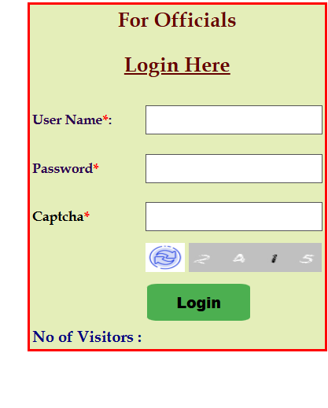 | 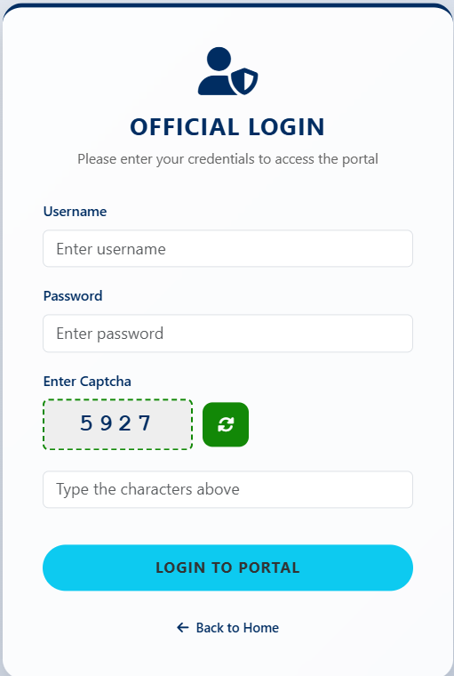
6.1.2. Home / Reports Dashboard:
The Reports landing page is mapped to /reports and returns the reports/reports JSP view. It acts as the navigation point for report pages grouped by ITI, district, nodal, state/administrative and public-information functions.
Existing Page:
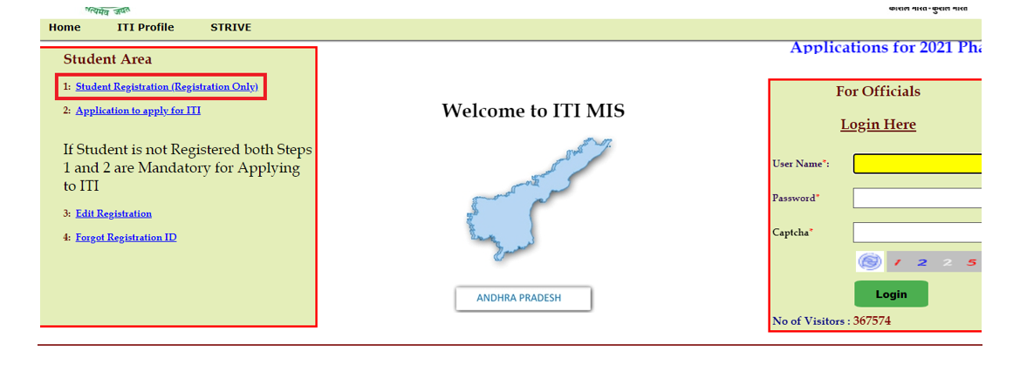
Redesigned Page:
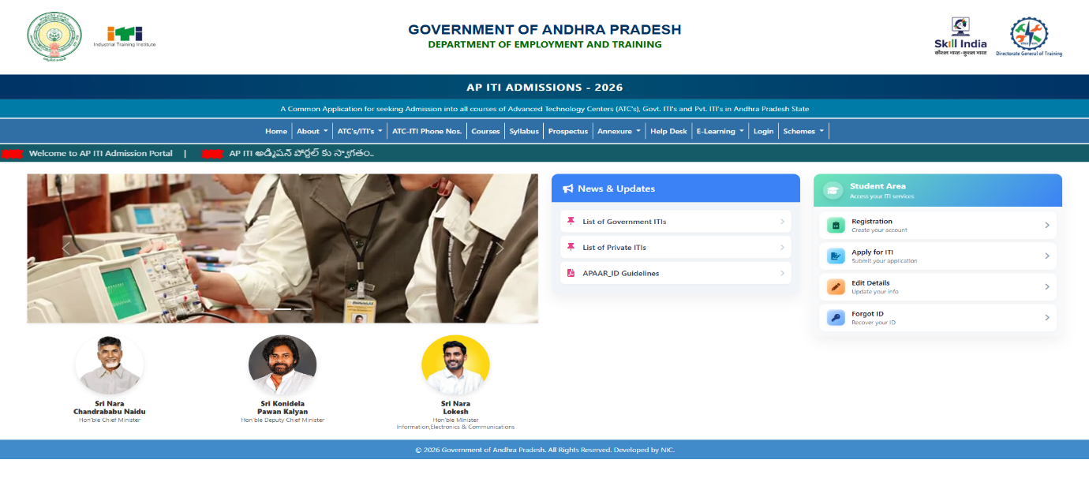

6.2. ITI Level Reports:
6.2.1. Applicant Report:
The report retrieves candidate application details for a selected admission phase. The API accepts phase as a required parameter and can also filter by year, ITI code and district code. The response includes SSC registration number, mobile number, registration ID, candidate name, father name and mother name. The endpoint supports pagination and returns the total record count.
Existing page:
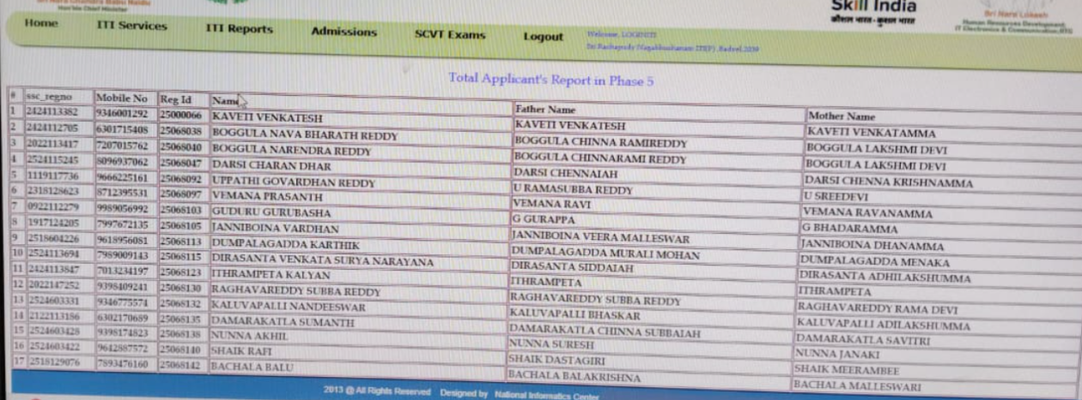
Redesigned Page:
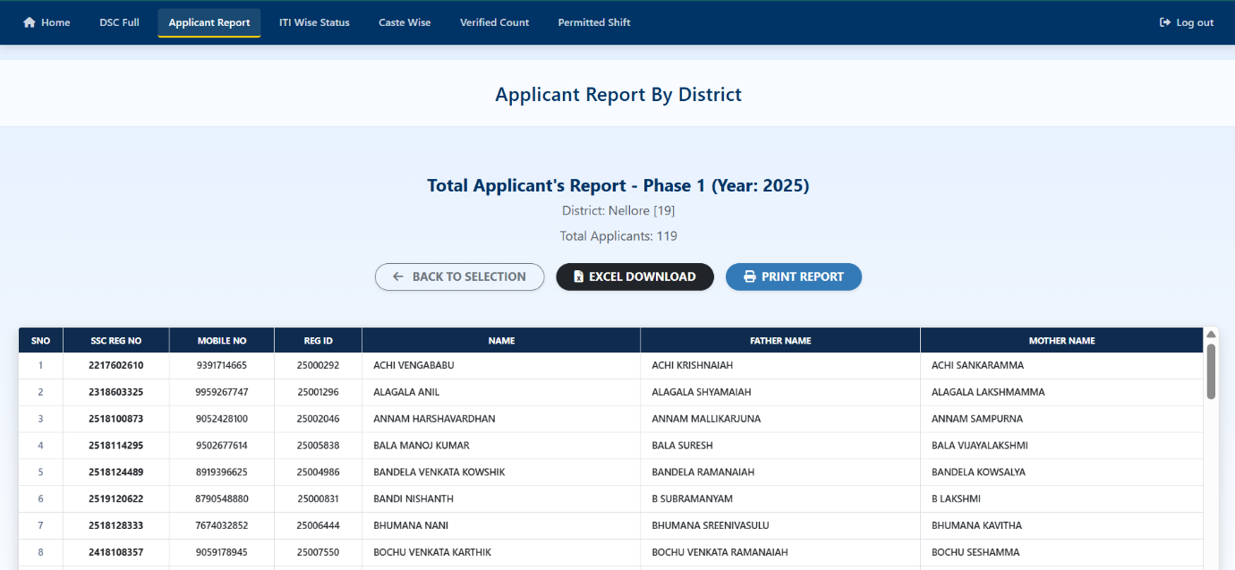
6.2.2. ITI-Wise Admission Status Report:
The ITI-wise status report accepts year, district code and ITI code filters. It returns institute status rows with counts such as total, successful, pending SID, verified and records requiring follow-up, based on the response DTO. The endpoint supports pagination and a separate count query.
Existing Page:
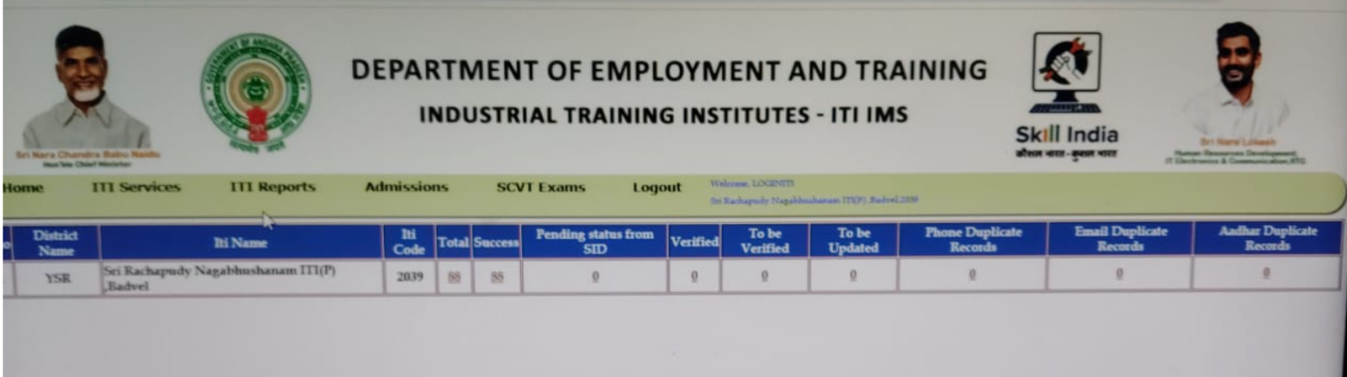
Redesigned Page:
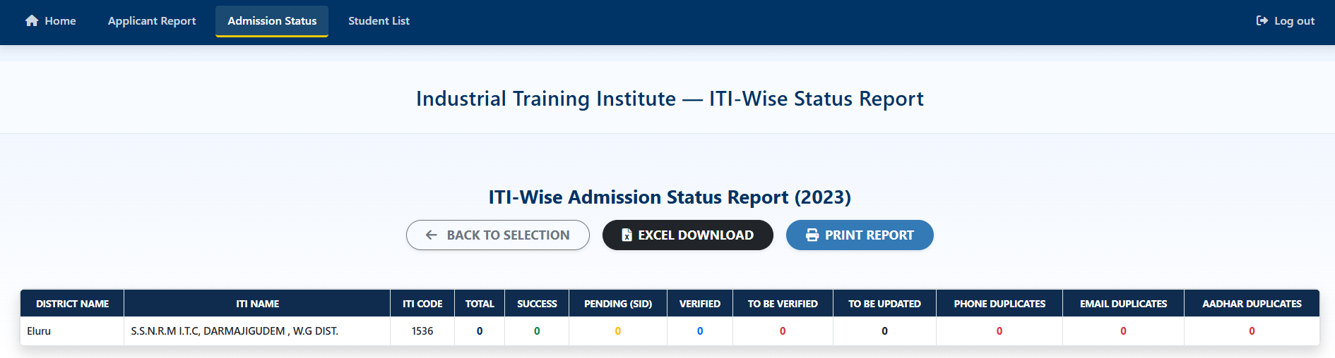
6.2.3. Admission Report:
The ITI admission report provides paginated admission details. The backend query selects admission number, SSC registration number, candidate and parent names, date of birth, phone, email, shift, unit and selected candidate-category indicators. The page can use these fields to review admission records; additional filters should only be described if present in the page implementation.
Redesigned Page:
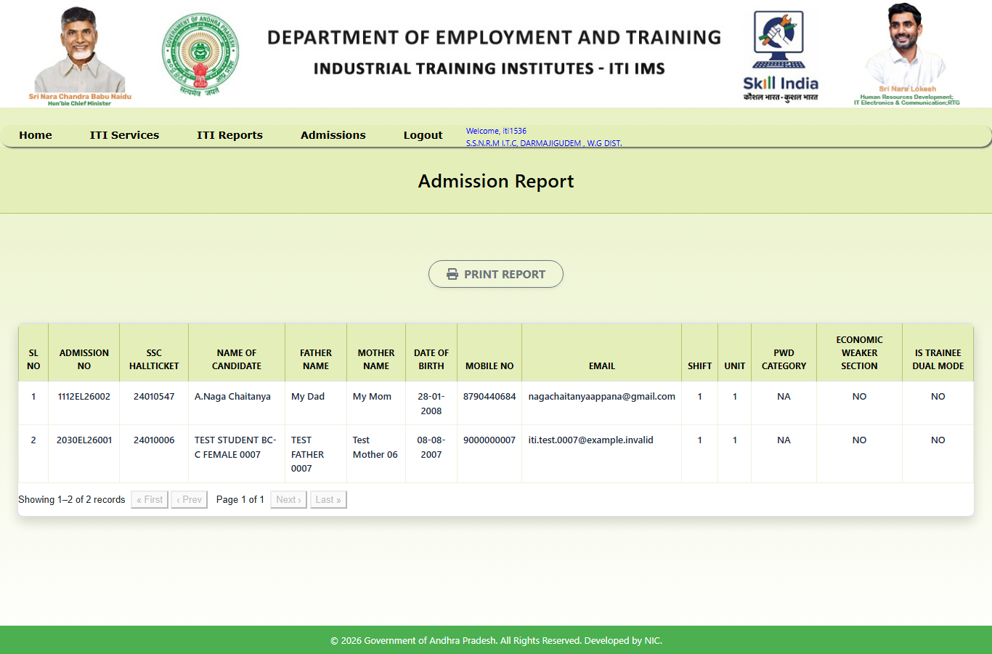
6.2.4. DSC List Report:
The DSC list is generated using the district, ITI, trade, phase, year and admission-mode parameters. The backend provides a full-report endpoint and a separate options endpoint for the district/ITI selection controls.
Redesigned Page:
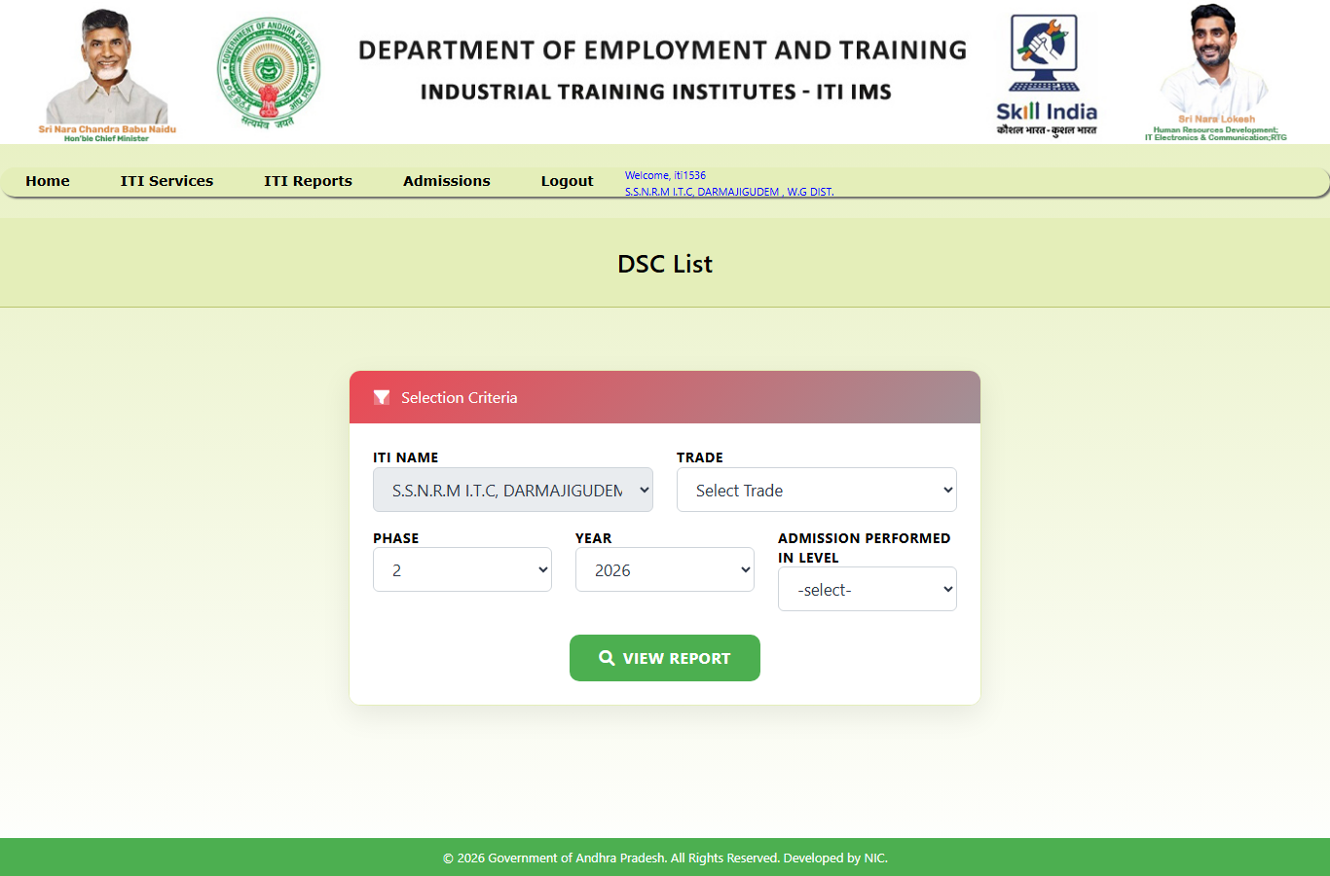
6.2.5. ITI API Dashboard:
The ITI dashboard page is served through the frontend route /reports/api-dashboard-iti. The backend report API includes institute status data that can be filtered by year, district and ITI. The dashboard's exact counters and labels are defined by its JSP and response DTO rather than by a generic claim of live transaction monitoring.
Redesigned Page:
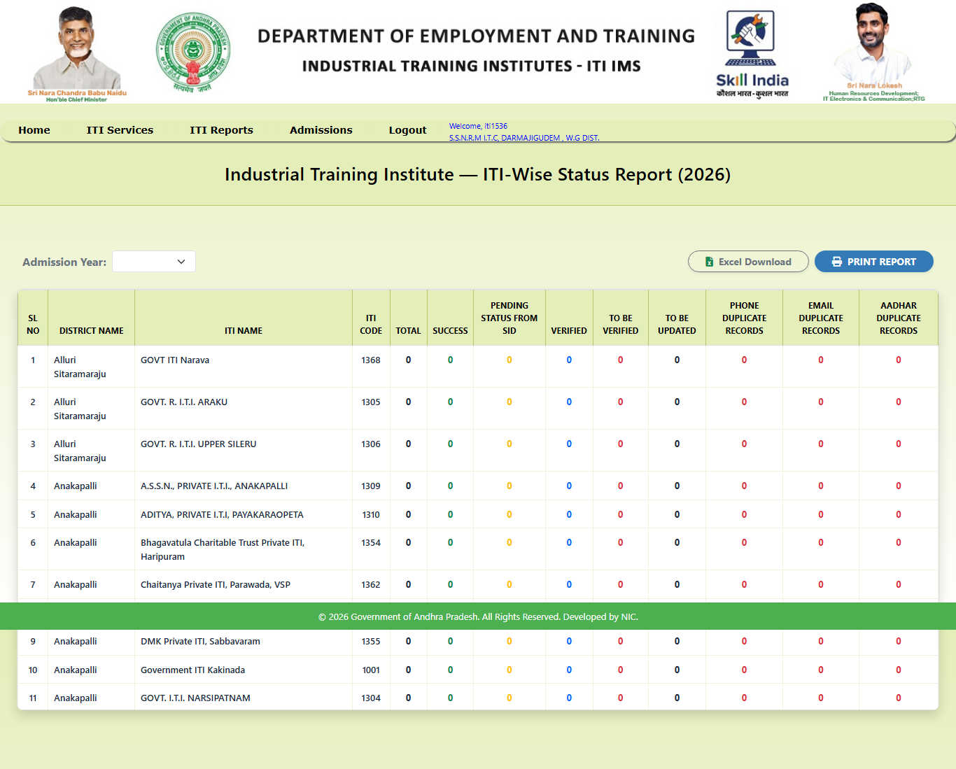
6.3. District Level Reports:
6.3.1. Verified Application Count Report:
This report provides an overview of application verification for a selected year and district. The backend endpoint /api/reports/verified-application-count returns a summary response. The exact status labels and totals are defined by VerifiedApplicationCountReportResponse.
Existing Page:
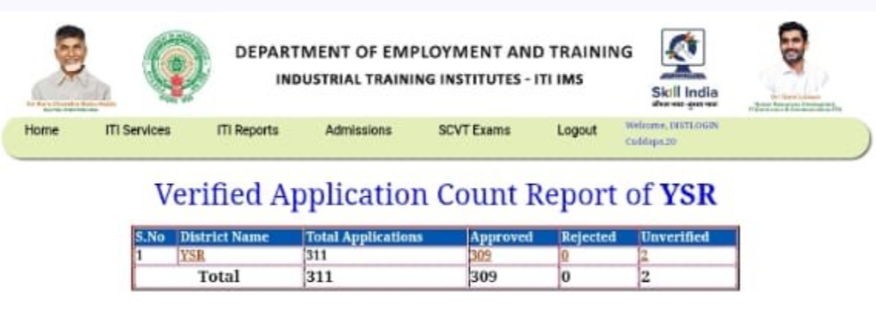
Redesigned Page:
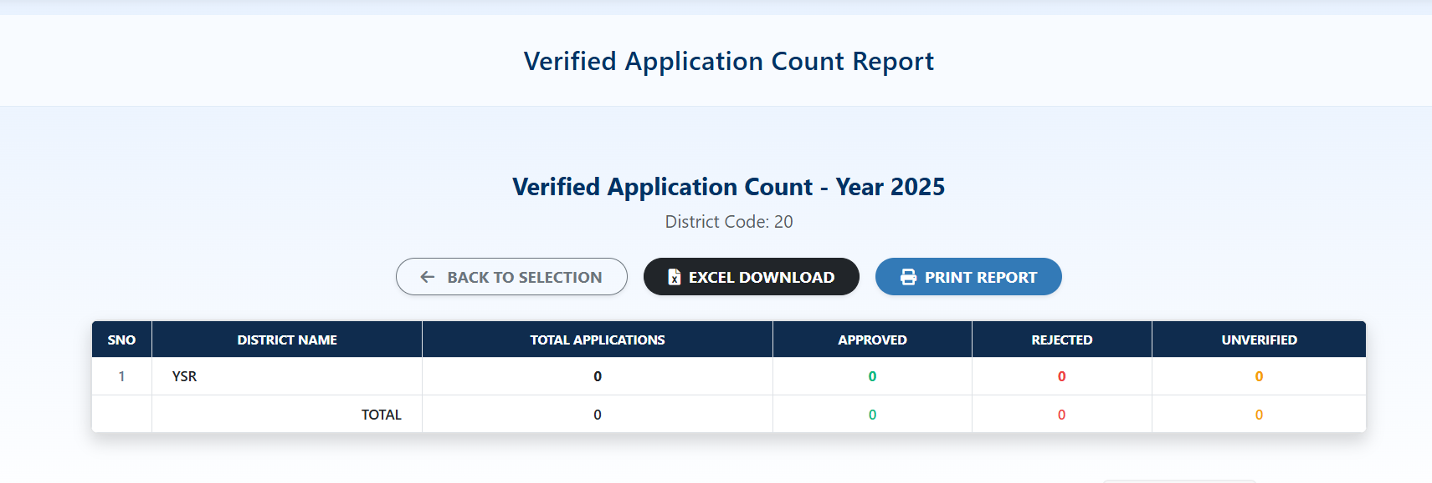
6.3.2. ITI Wise District Year Report:
The ITI-wise status endpoint can be filtered by admission year and district and, optionally, by ITI. It provides a paginated view of institute status information for the selected district.
Existing Page:
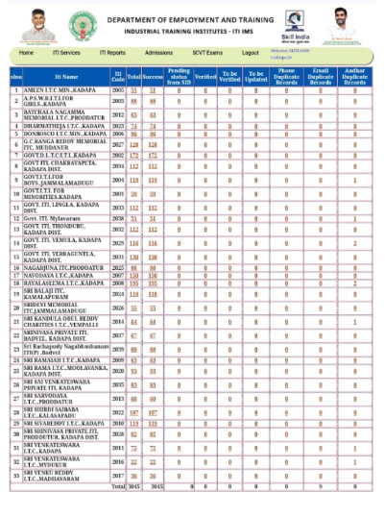
Redesigned Page:
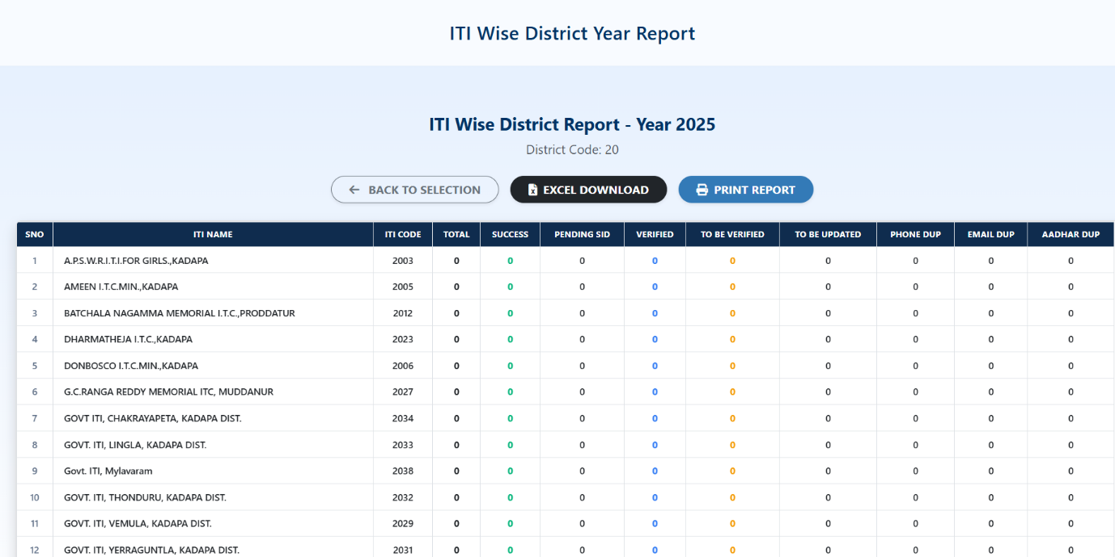
6.3.3. Applicant Address with Mobile Report:
This report returns candidate contact and address information for a selected year and district. The API endpoint /api/reports/applicant-mobile-address supports pagination and a total-count query.
Redesigned Page:
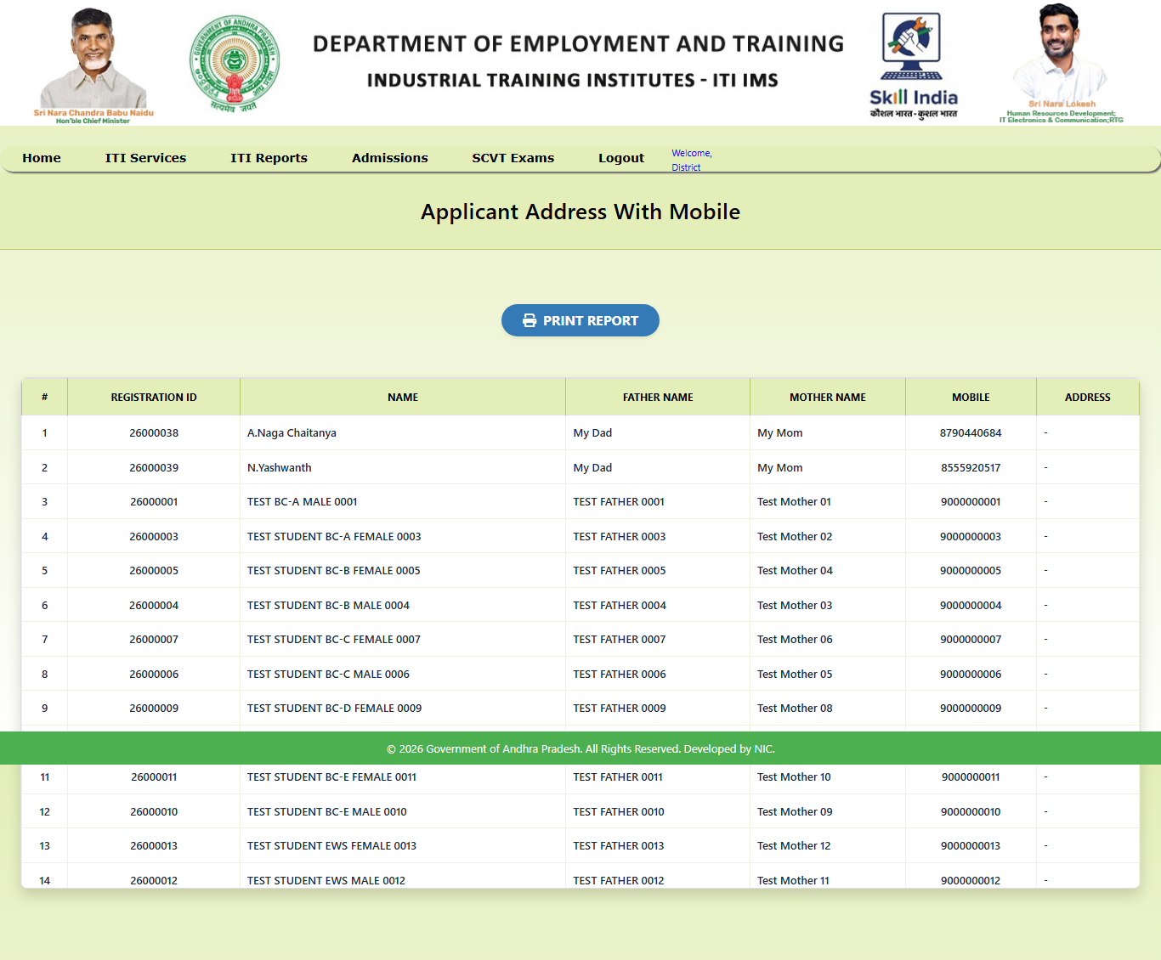
6.3.4. District API Dashboard:
The district dashboard page is mapped to /reports/api-dashboard-district. Its data is provided through the /api/reports/api-dashboard endpoint, which accepts year and district code.
Redesigned Page:
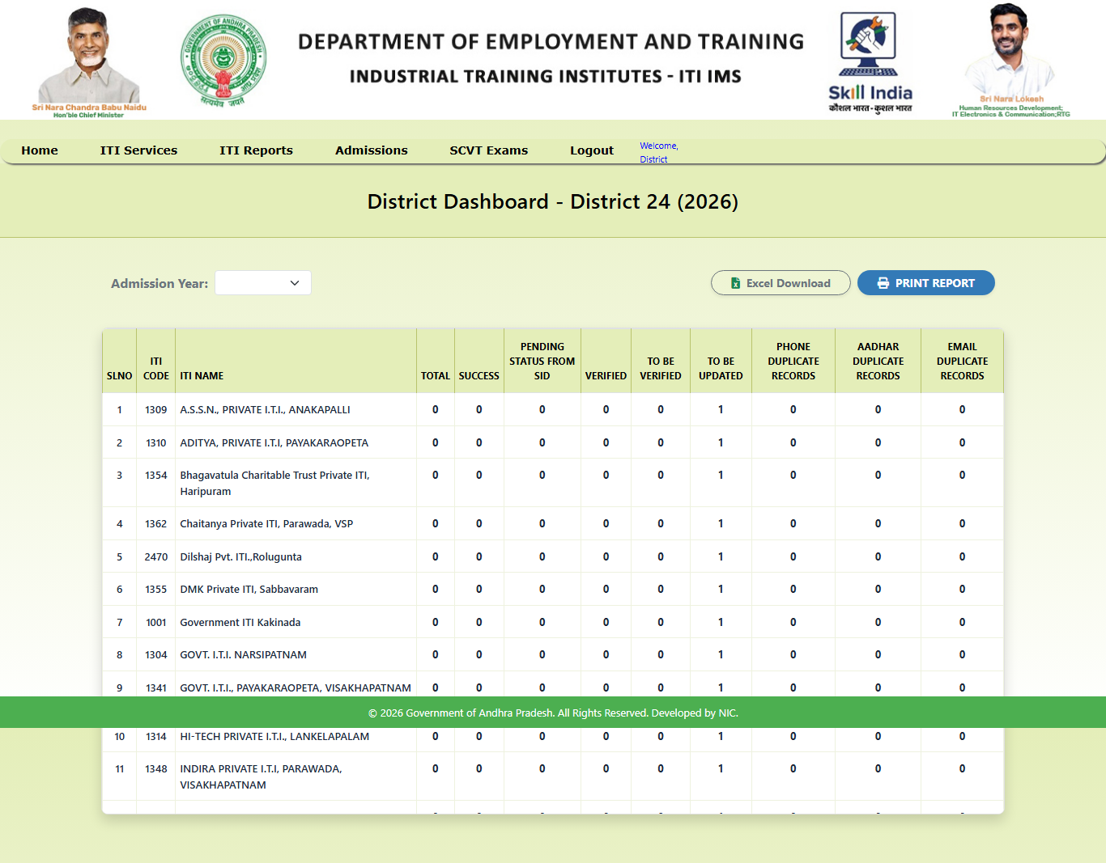
6.3.5. Caste Wise Admissions Abstract Report:
The caste-wise admissions abstract accepts year, district, government/private type, phase and gender filters. It returns aggregated admission information by category through the /api/reports/caste-wise-admissions endpoint.
Redesigned Page:
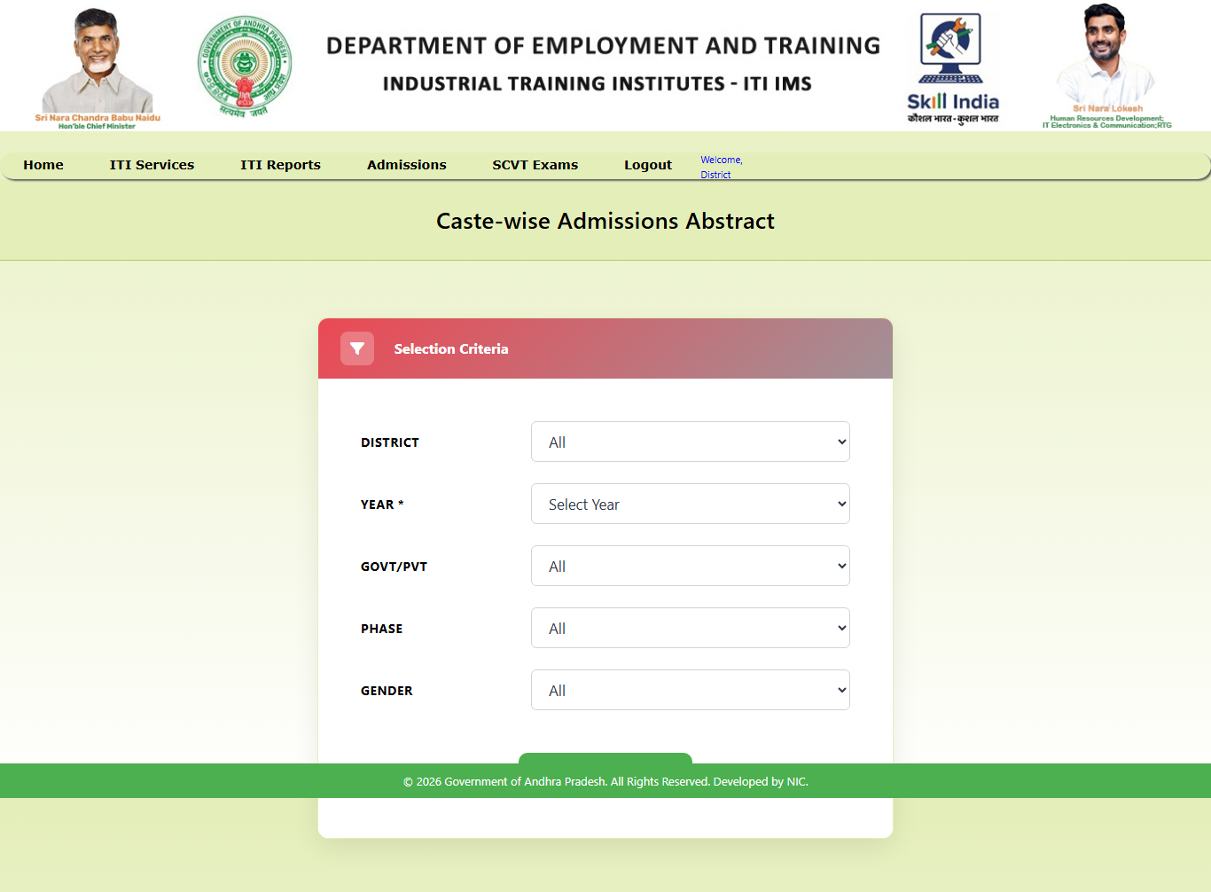
6.3.6. District Shift Unit Report & Shift Unit Verify:
The permitted shift/unit report provides institute-level information for selected district and ITI filters. The separate shift-unit verification workflow lists admissions with rec_status='E'; after an authorised verification action, the service updates shift and unit and changes rec_status to 'D'.
Redesigned Page:
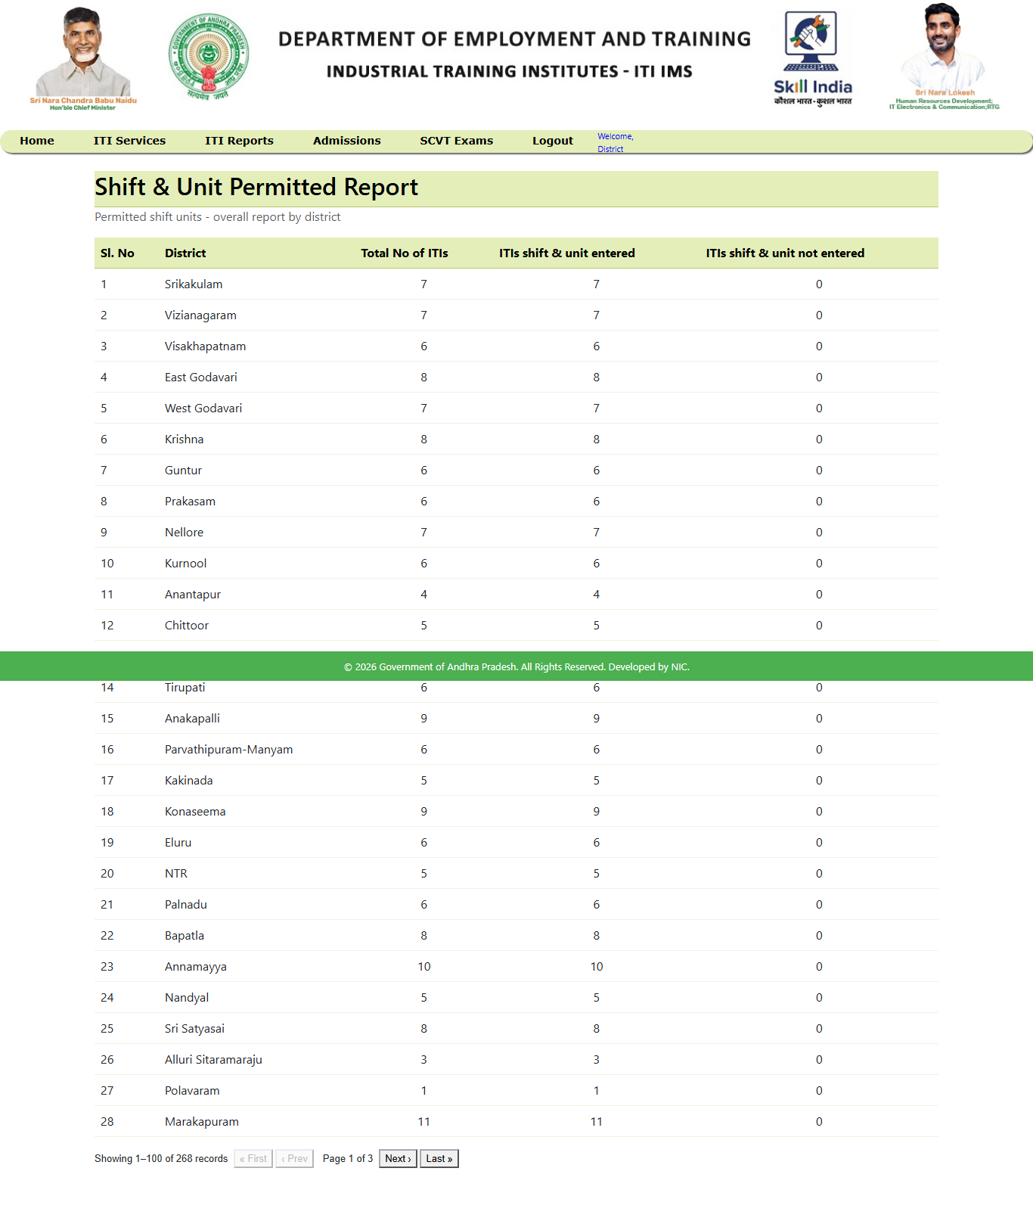
6.3.7. District DSC List Report:
The DSC full-report API accepts district, ITI, trade, phase, year and admission mode. The endpoint returns the report data for the selected combination. The actual fields are defined by DscFullReportResponse.
Redesigned Page:
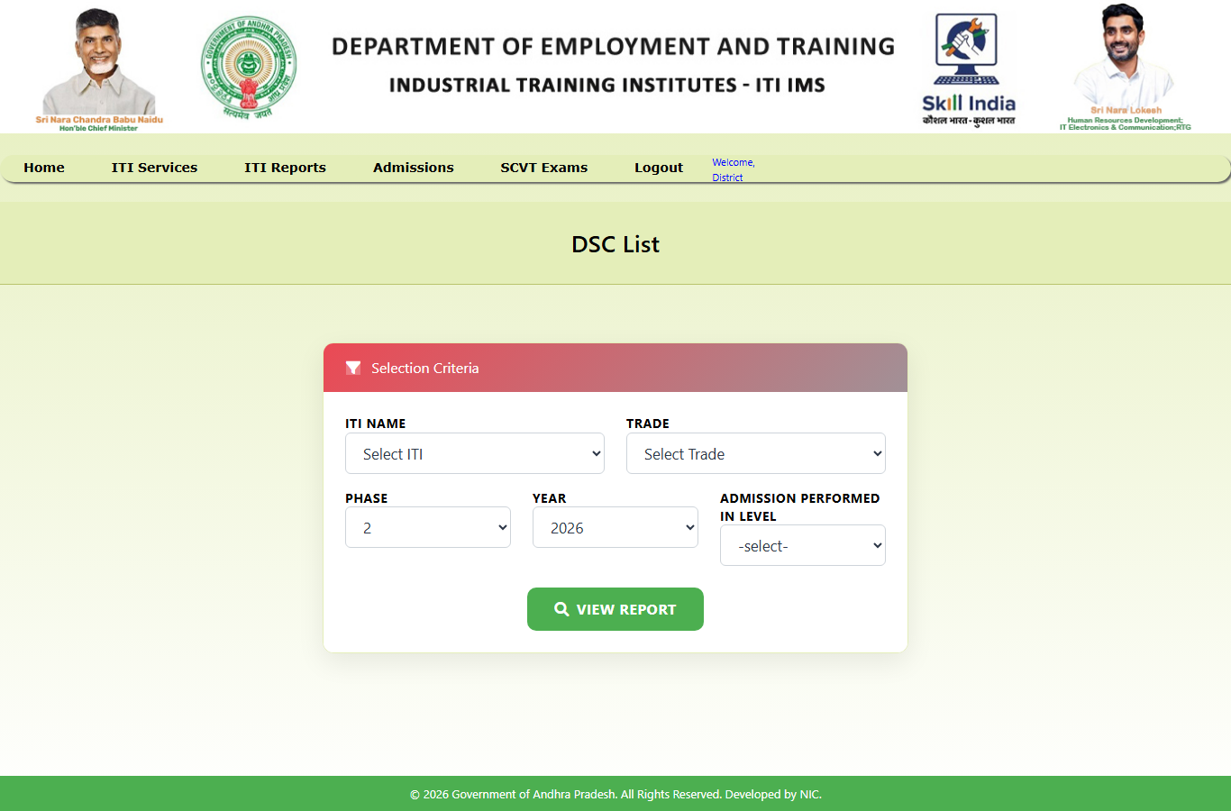

6.4. Nodal Level Reports :
6.4.1. Total Applicant’s Count Report:
The Total Applicant Count report provides an aggregated view of application counts across districts. The backend includes a district-wise application-count endpoint and a state-wise applicant-report endpoint; the exact breakdown depends on the response DTO and filters used by the page.
Existing Page:
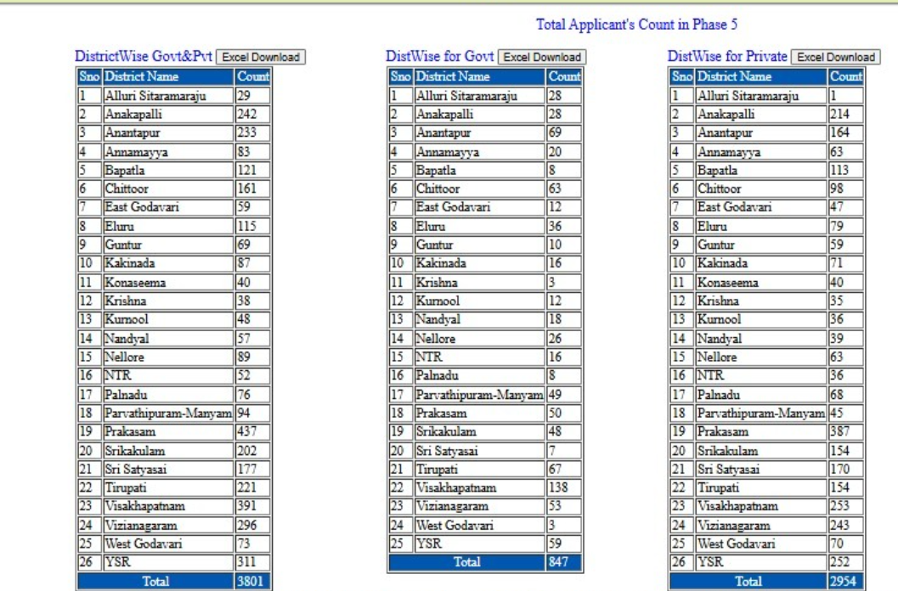
Redesigned Page:
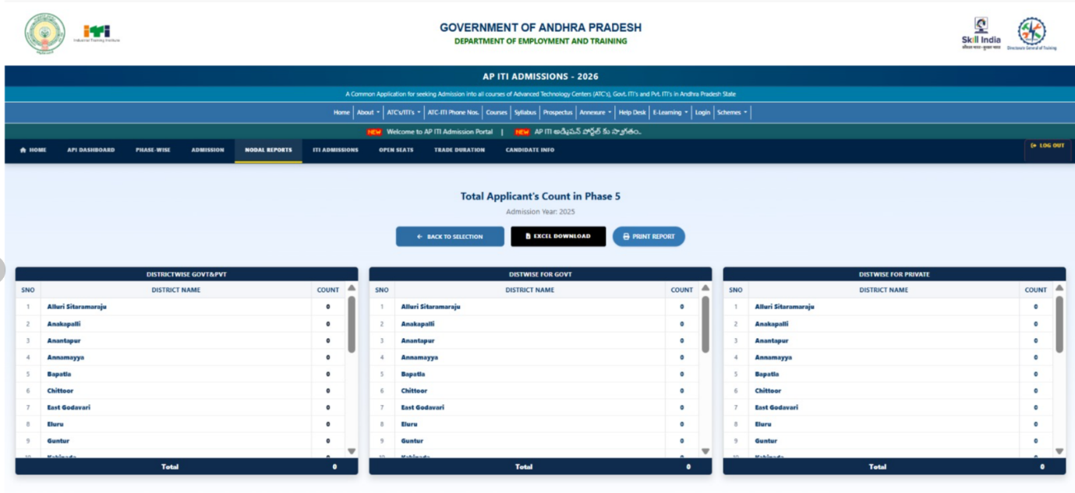
6.4.2. 24 Months Trade Seats Abstract Report :
This report can be produced for a selected course duration using the /api/reports/trade-duration-seats endpoint. The API accepts year, durationMonths and ITI type; a 24-month report is the two-year duration selection.
Existing Page:
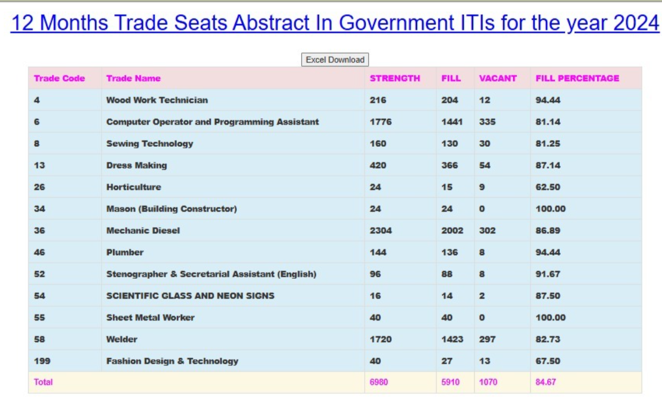
Redesigned Page:
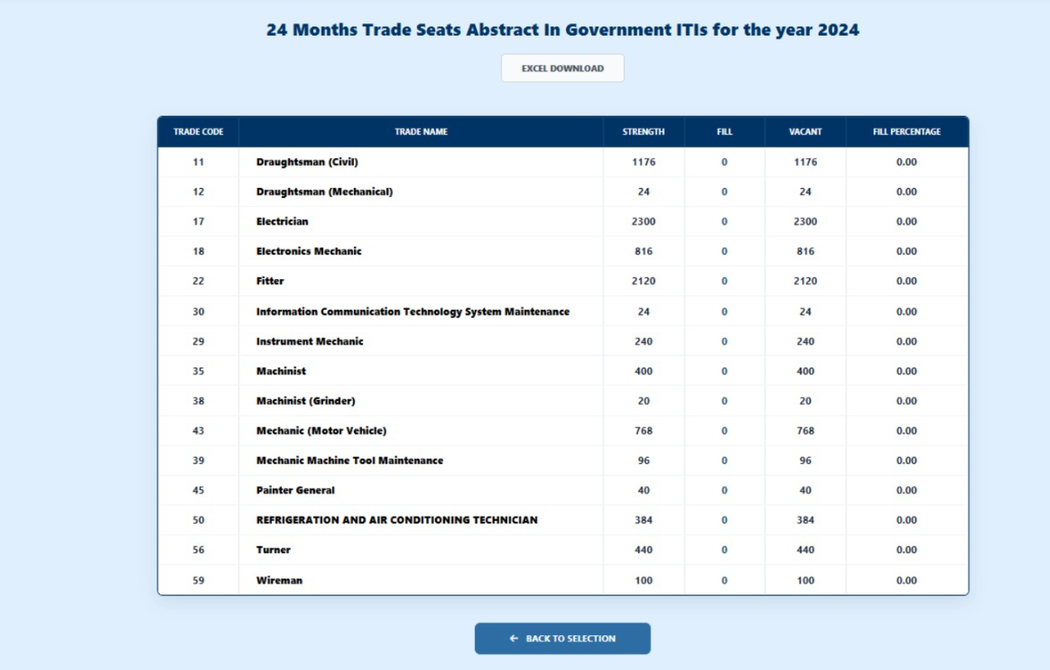
6.4.3. State & Nodal API Dashboard :
The nodal dashboard page is /reports/api-dashboard-state. It uses the state dashboard endpoint, which accepts year and government/private type. The actual dashboard fields are defined by StateDashboardResponse.
Redesigned Page:
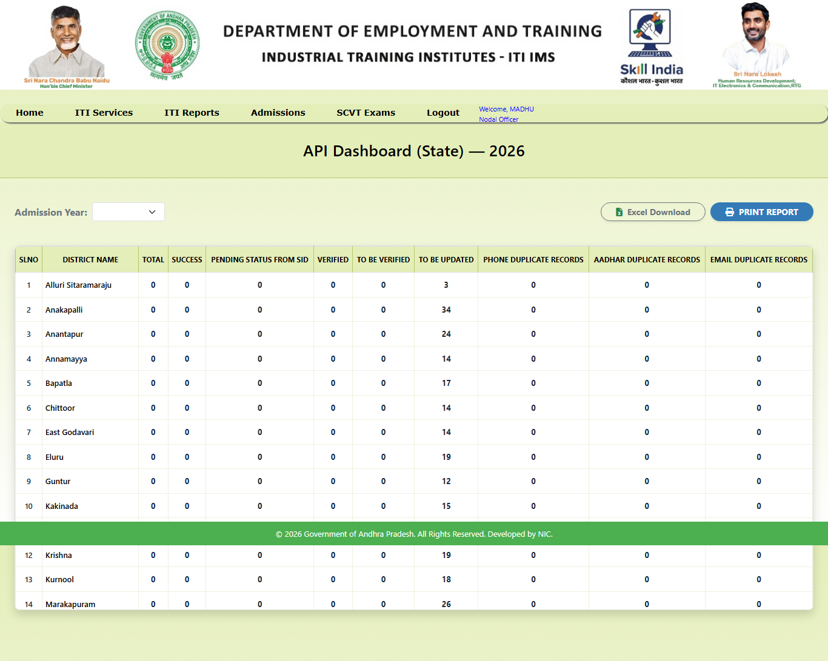
6.4.4. Phase Wise Admissions Details Report :
The phase-wise report uses /api/reports/phase-wise and accepts the admission year. It returns summary rows for the admission phases represented in the source data.
Redesigned Page:
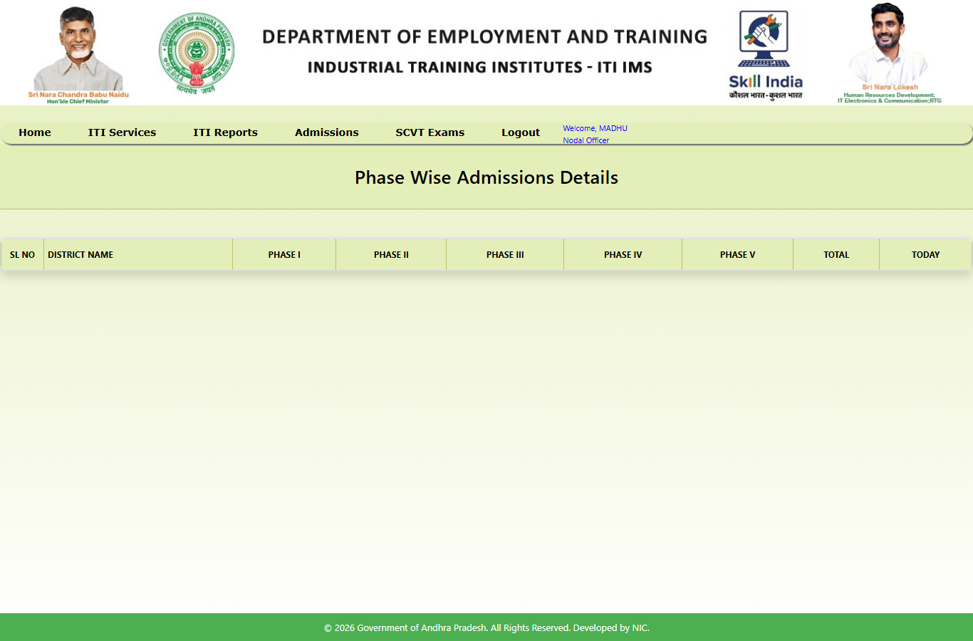
6.4.5. Today Schedule ITIs Report :
The daily schedule report is backed by /api/reports/today-schedule. It returns the ITI schedule rows used by the page. The repository endpoint does not take a date parameter.
Redesigned Page:
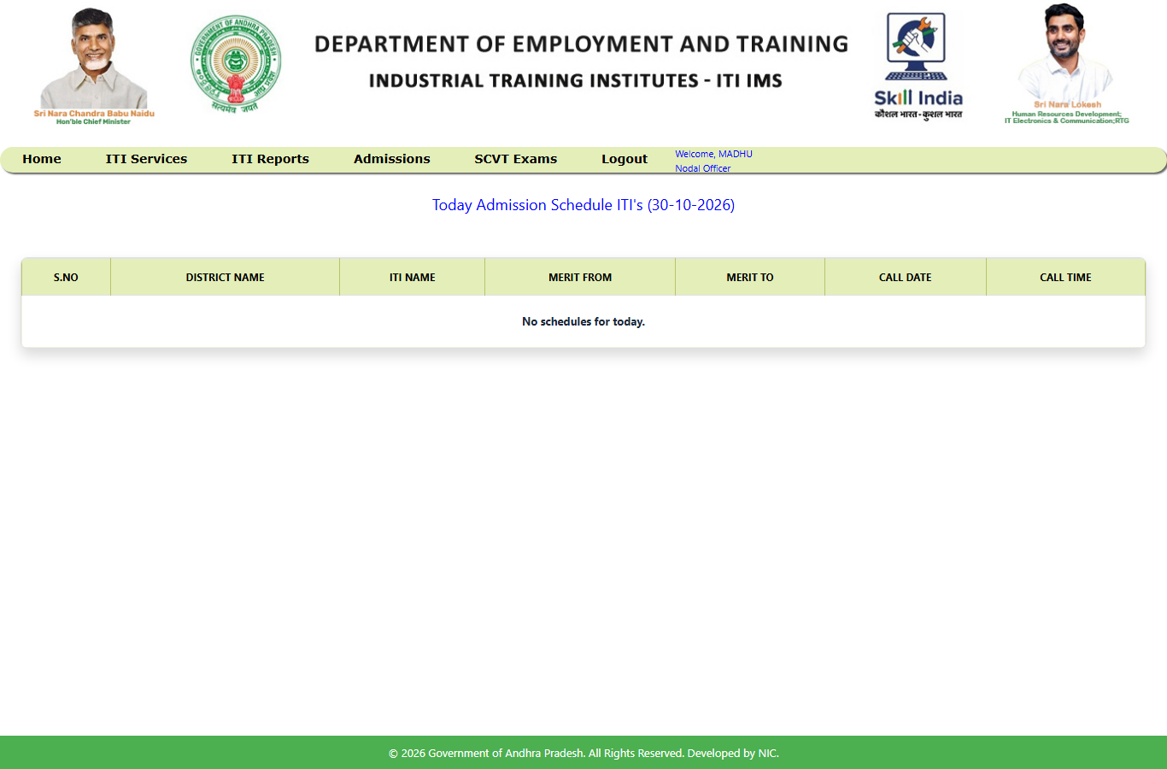
6.4.6. Trade Wise Report :
The trade-wise report endpoint accepts year, district code and ITI type. It returns trade-wise summary rows based on the filters selected by the user.
Redesigned Page:
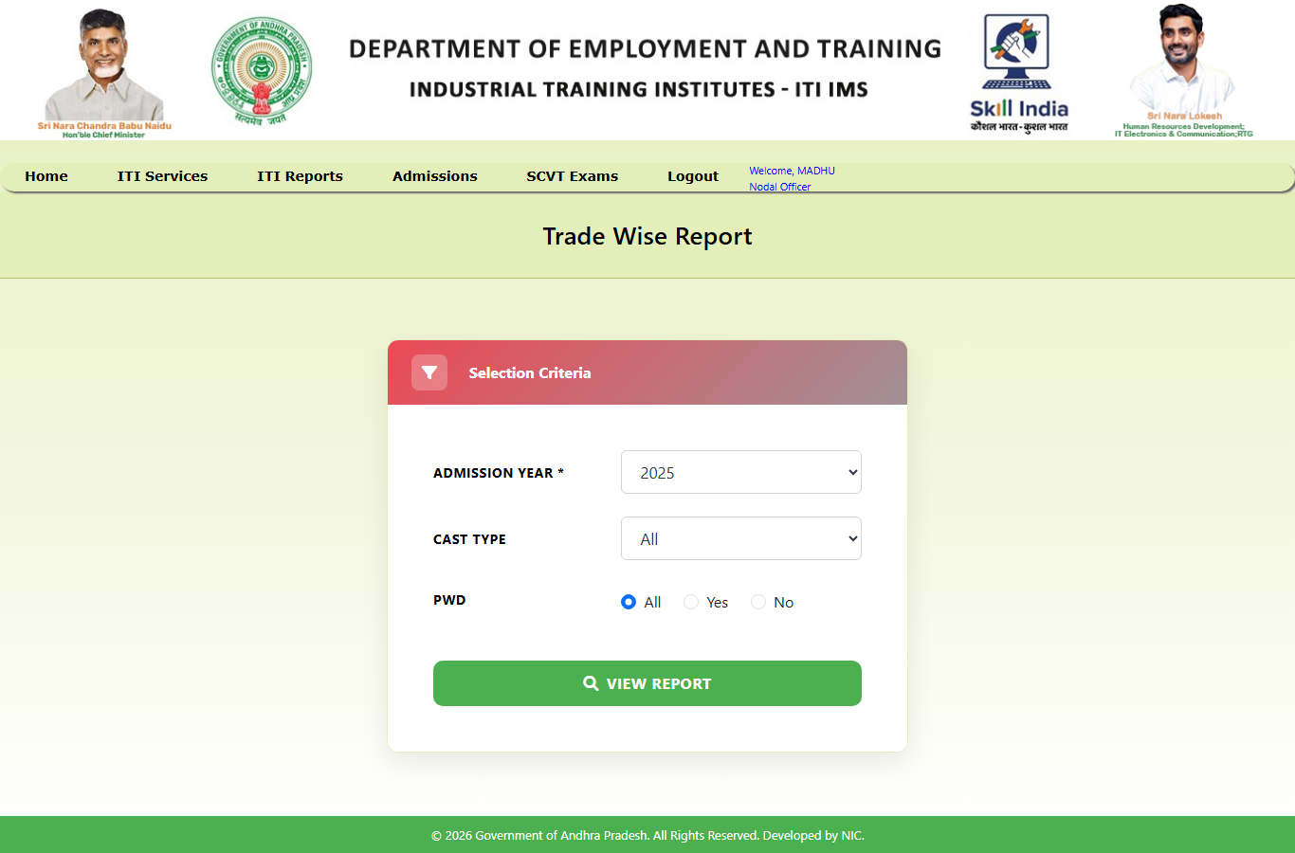
6.4.7. District Wise Applicant Report :
The state-wise applicant report uses the applicant-report service and supports phase, year, ITI and district filters. Candidate details are returned as a paginated response.
Redesigned Page:
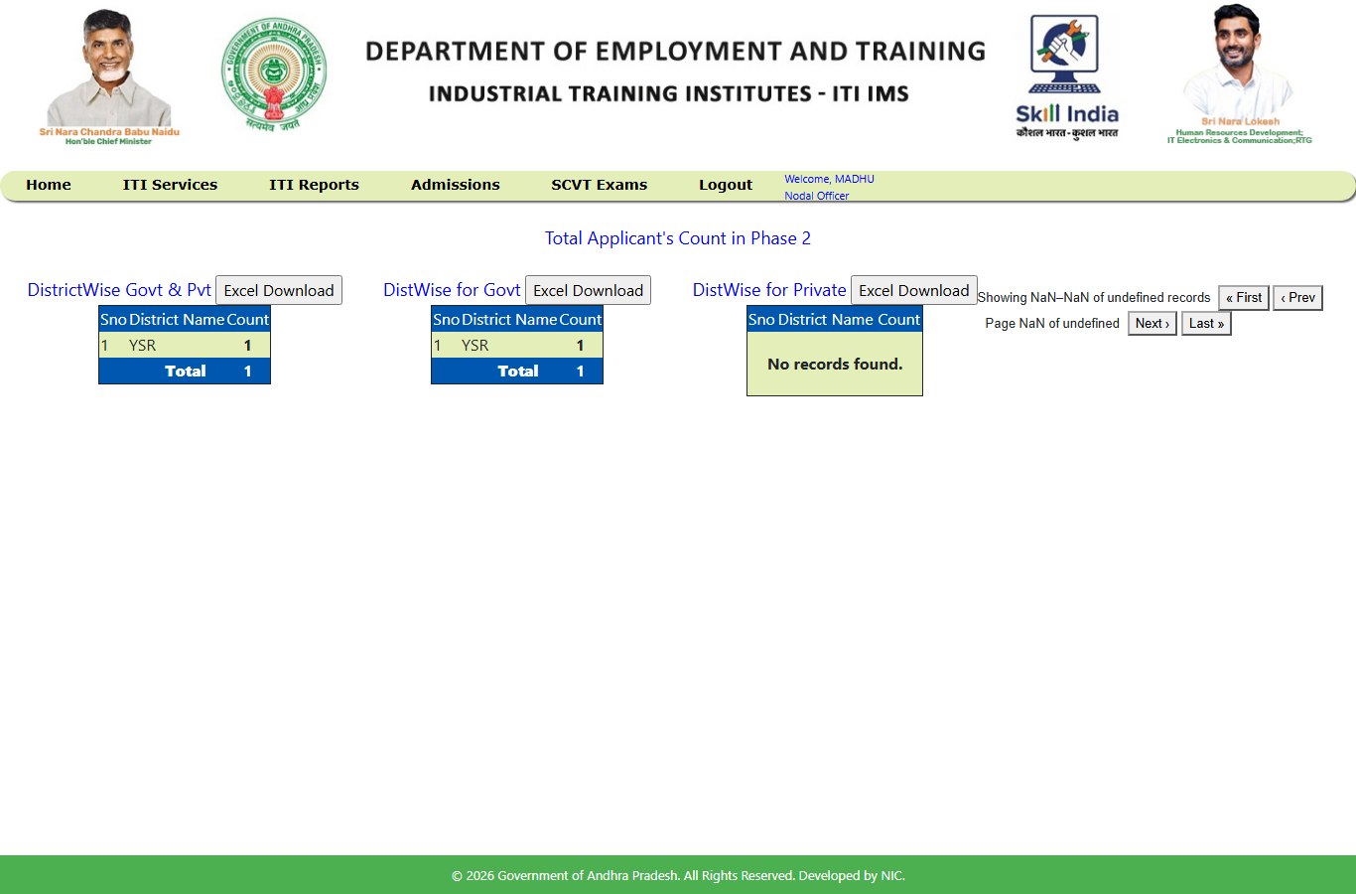
6.4.8. DIST / ITI / Trade Wise Seats Abstract Report :
The open-seats abstract endpoint returns seat-availability rows for the selected admission year. The response structure is defined by OpenSeatsAbstractResponse.
Redesigned Page:
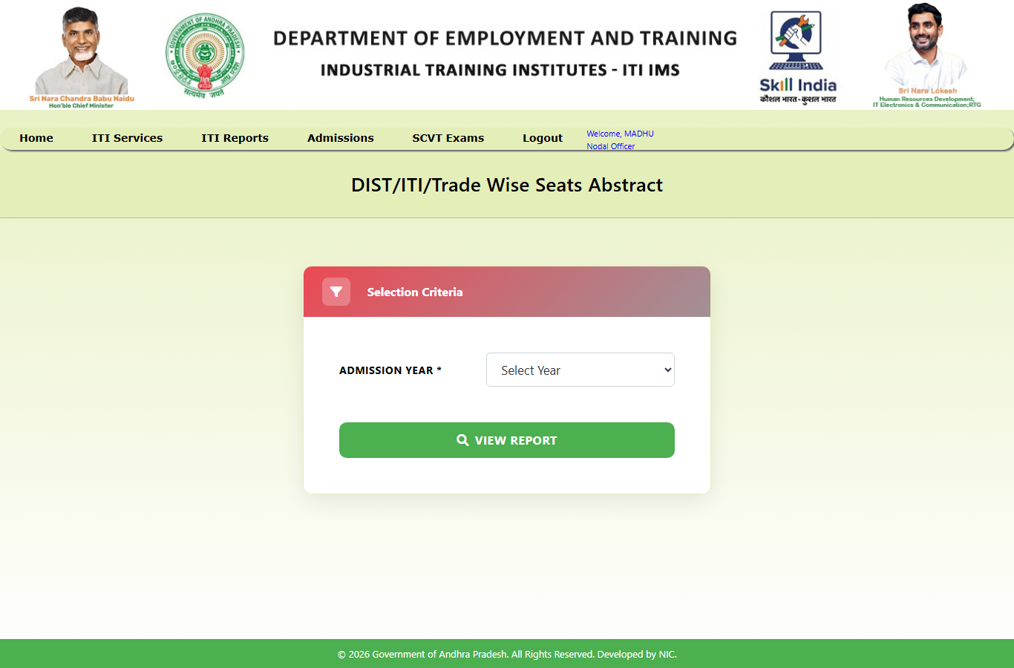
6.4.9. Duration Wise Trade Seats Abstract Report :
The duration-wise seat abstract endpoint accepts admission year, course duration in months and ITI type. It returns trade-duration seat-summary rows.
Redesigned Page:
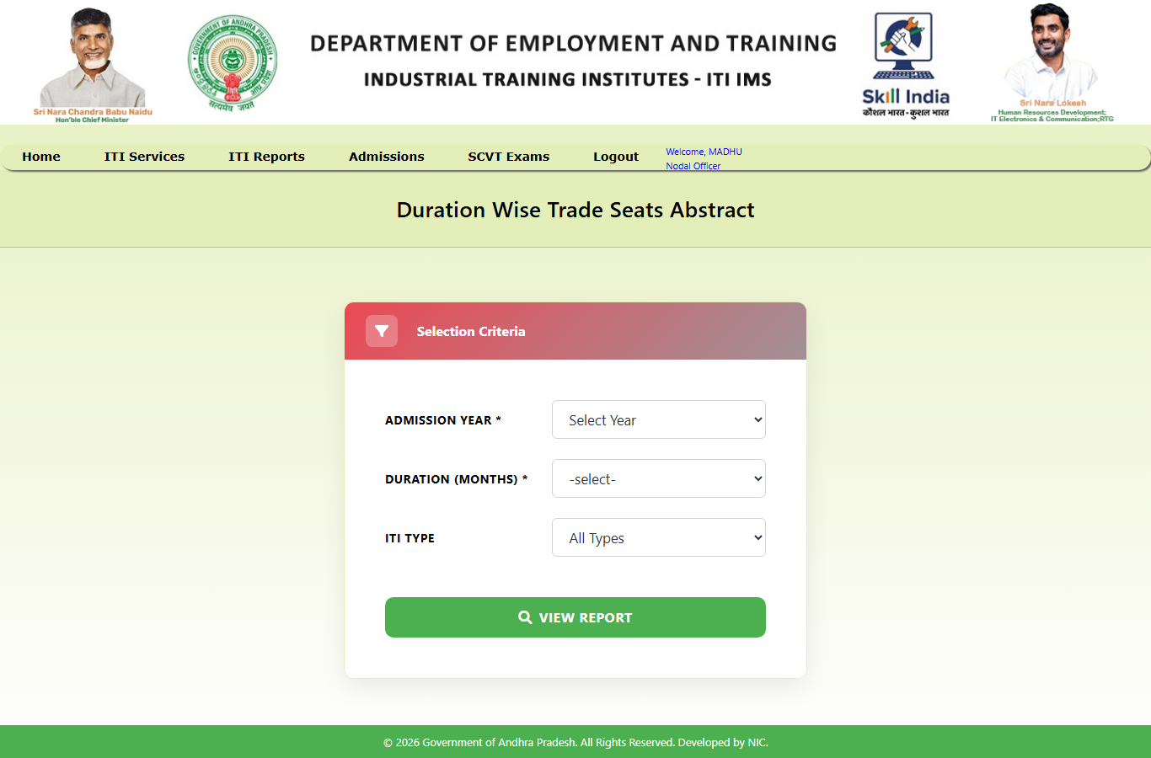
6.4.10. Government vs Private District Wise Seats Abstract :
The government/private district-wise seats abstract accepts year and institute management type and returns district-wise summary rows.
Redesigned Page:
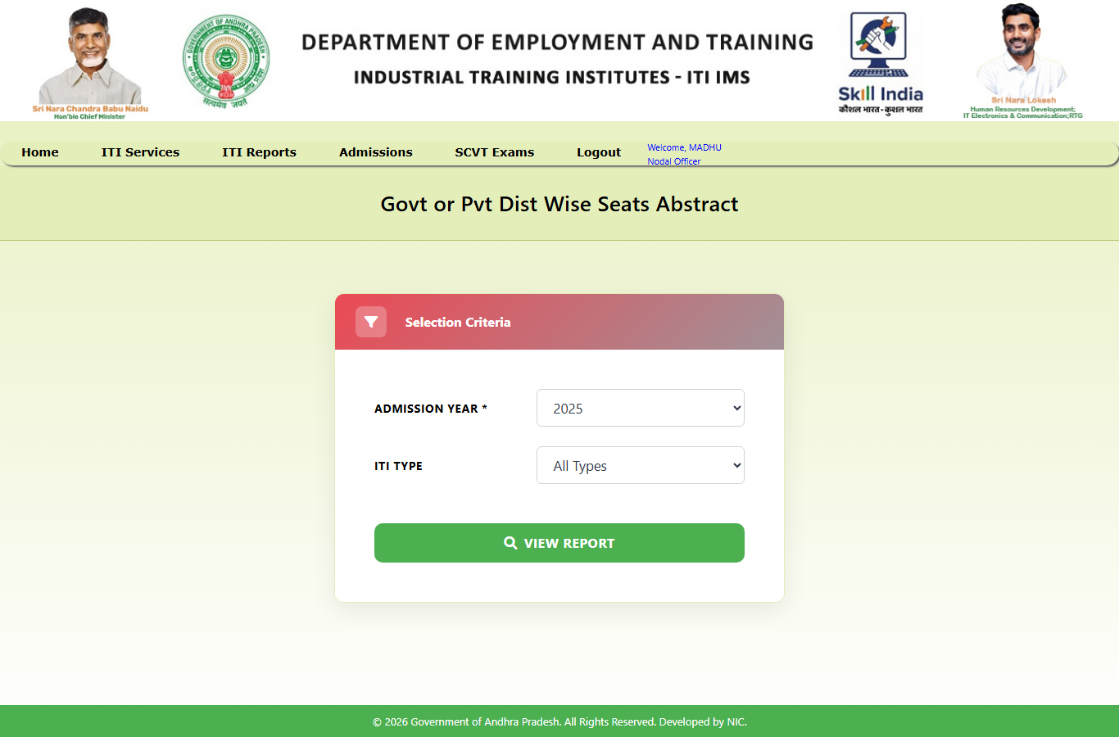
6.4.11. Student Registration Details Report :
The student registration details endpoint accepts a registration ID and/or admission number and returns the complete student-details response defined by StudentCompleteDetailsResponse.
Redesigned Page:
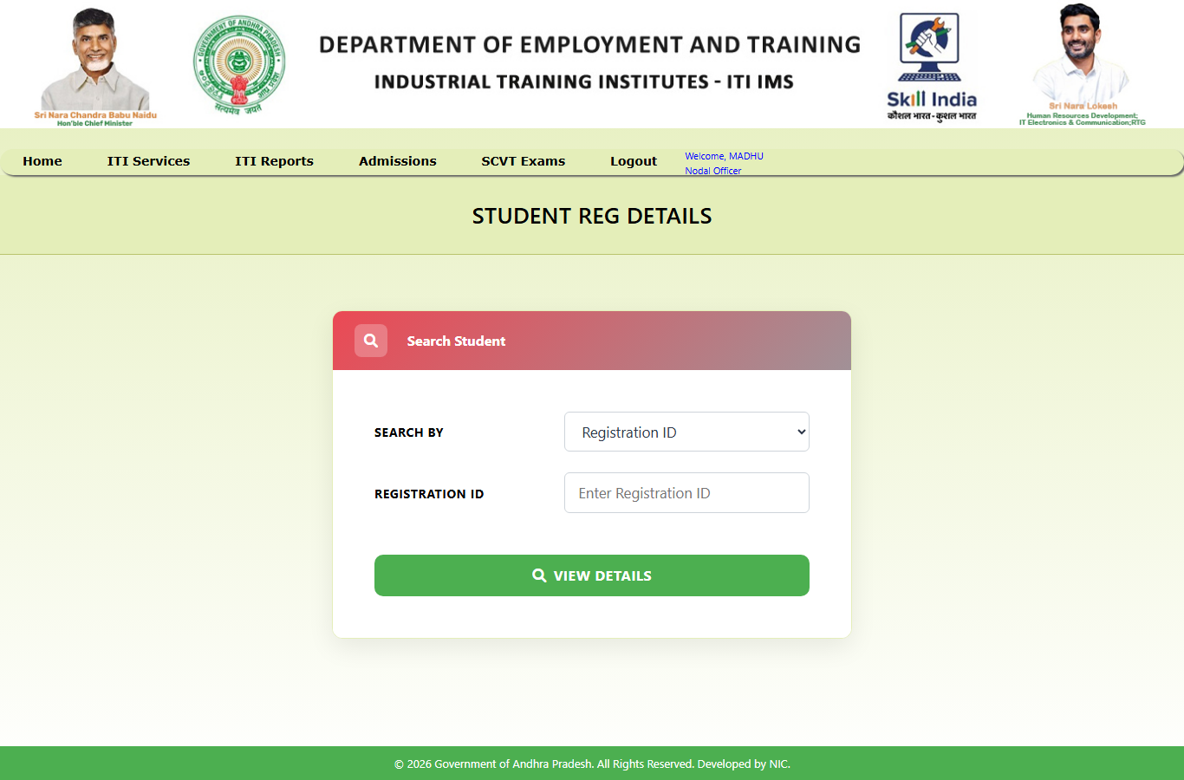
6.4.12. Students Not Admitted Report :
This report identifies registered students who do not have a corresponding admission record, according to the service description. The API provides a year list and a paginated report endpoint with optional phase filtering.
Redesigned Page:
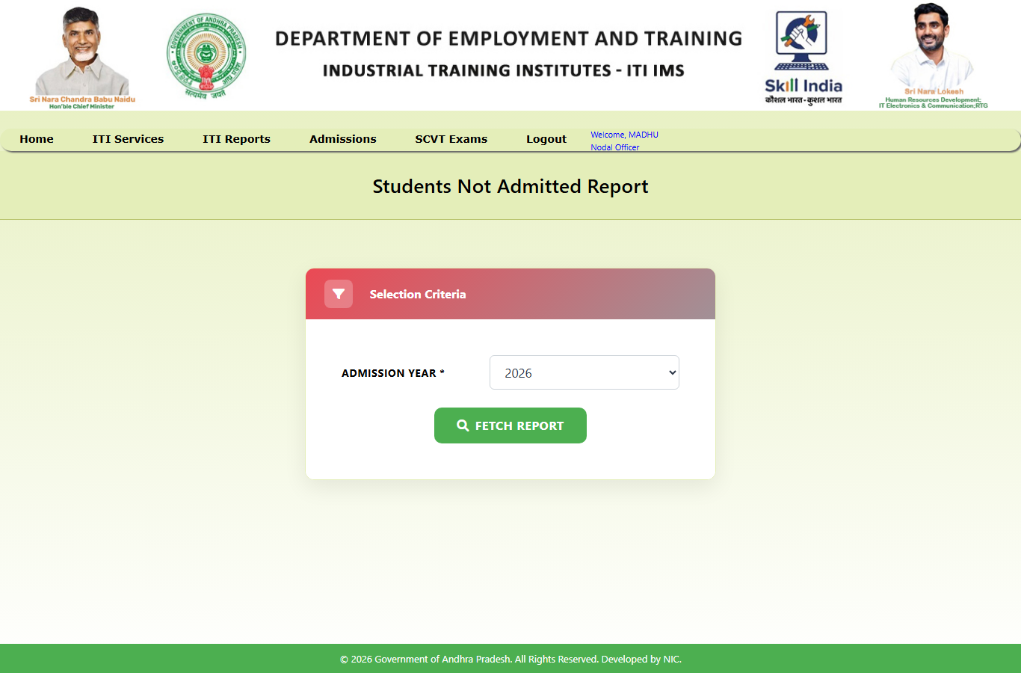

6.5. State & Directorate Administrative Reports:
6.5.1. District Counselling Schedule Report:
The district schedule endpoint accepts district code and year and returns schedule records. It supports pagination and a separate total-count query.
Redesigned Page:
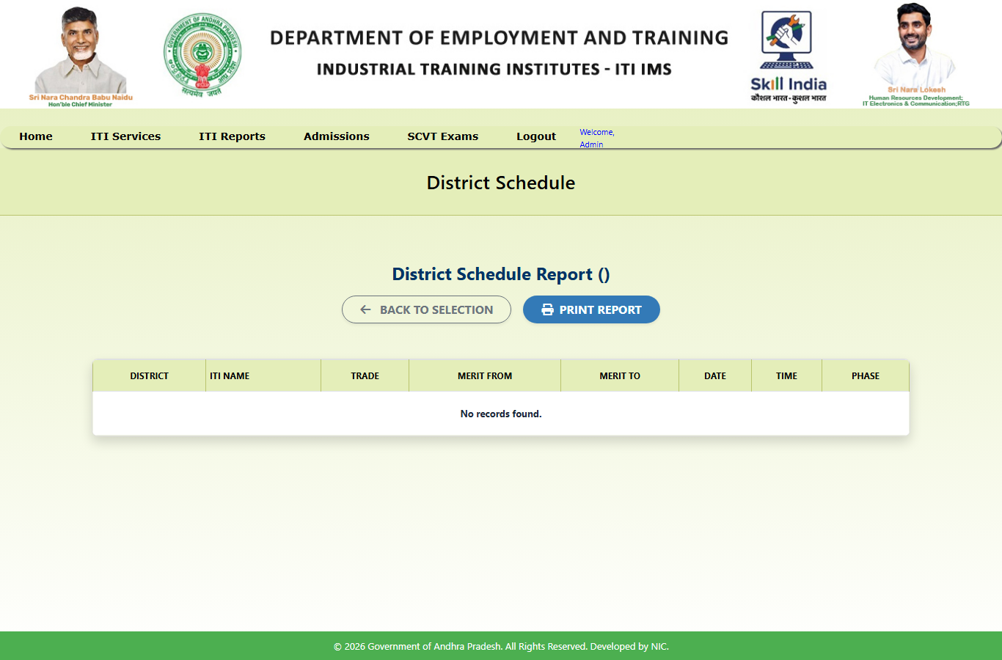
6.5.2. State Level Admitted Seats Abstract:
The admitted-seat report accepts year, district, government/private type, caste, gender and NCVT/SCVT filters. The backend returns paginated admission-summary rows.
Redesigned Page:
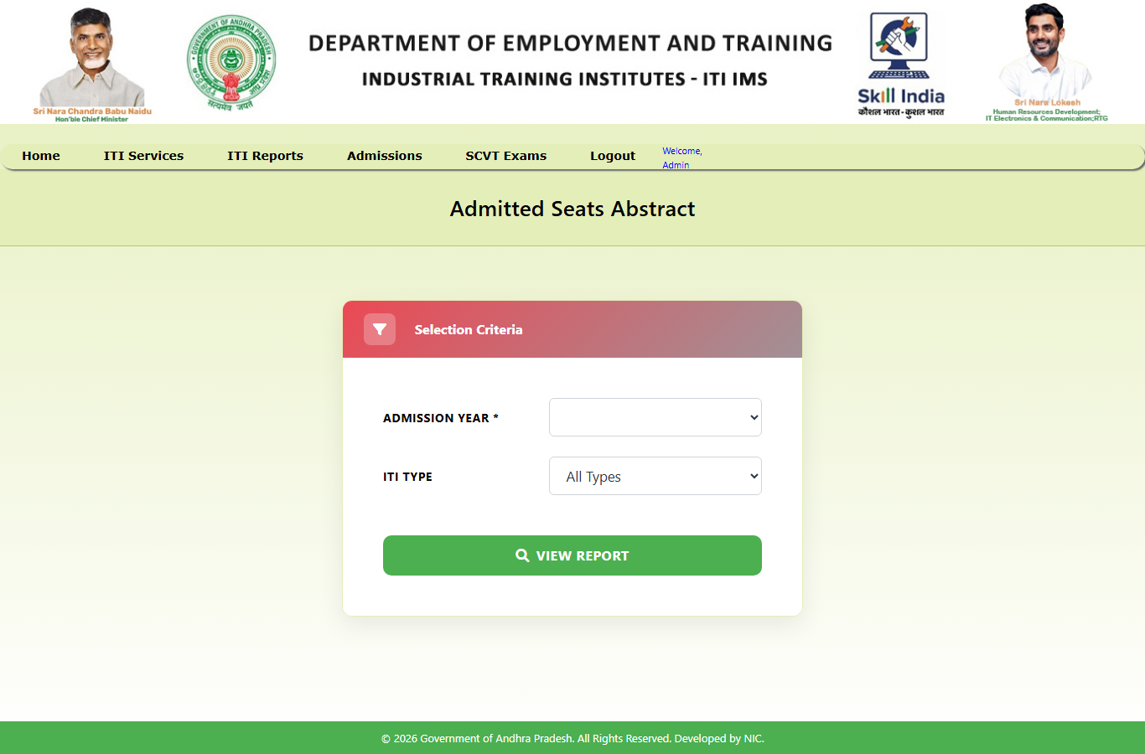
6.5.3. Distwise Admitted Seats Abstract Report:
The strength-filled-seats endpoint accepts year and district code and returns a summary of sanctioned/available strength and filled-seat values as defined by StrengthFilledSeatsResponse.
Redesigned Page:
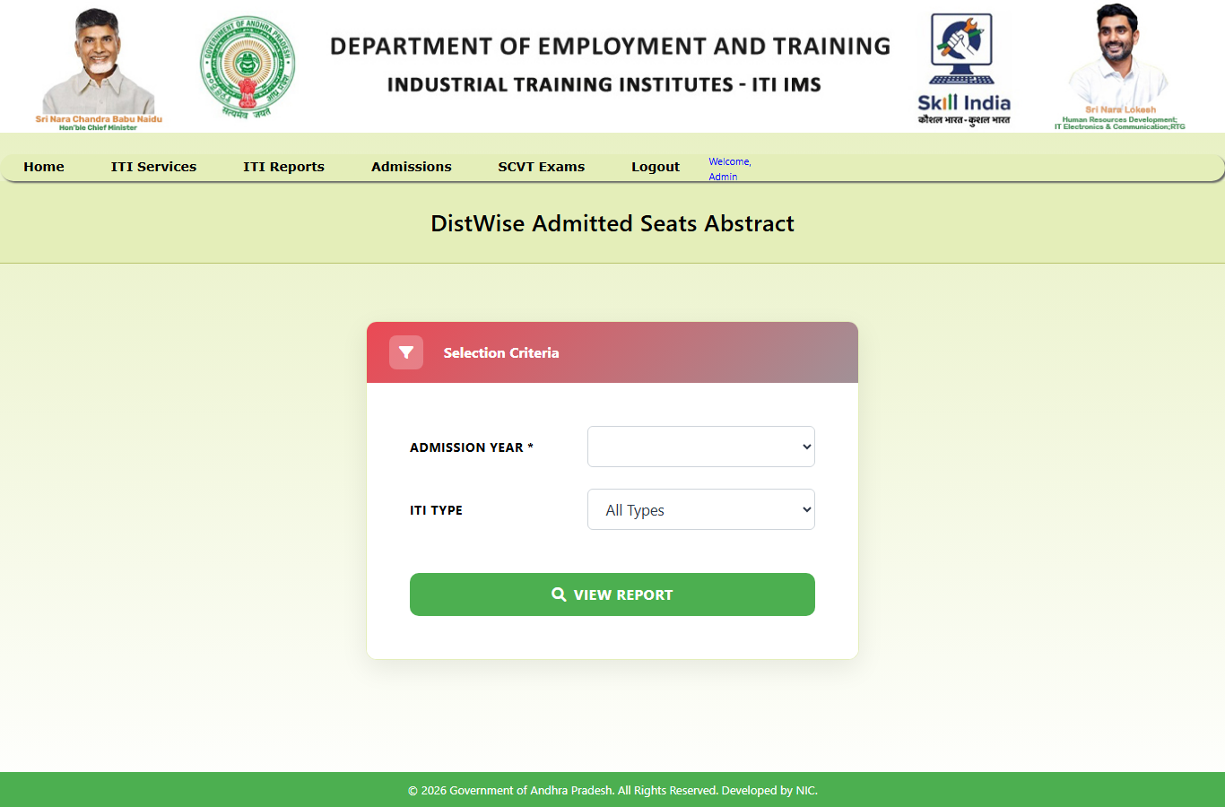
6.5.4. Trade / District Wise Admission Report:
The trade/district admission report is backed by the trade-wise admission aggregation endpoint. It can be filtered by year, caste and PWD category and returns boys, girls and total counts grouped by trade.
Redesigned Page:
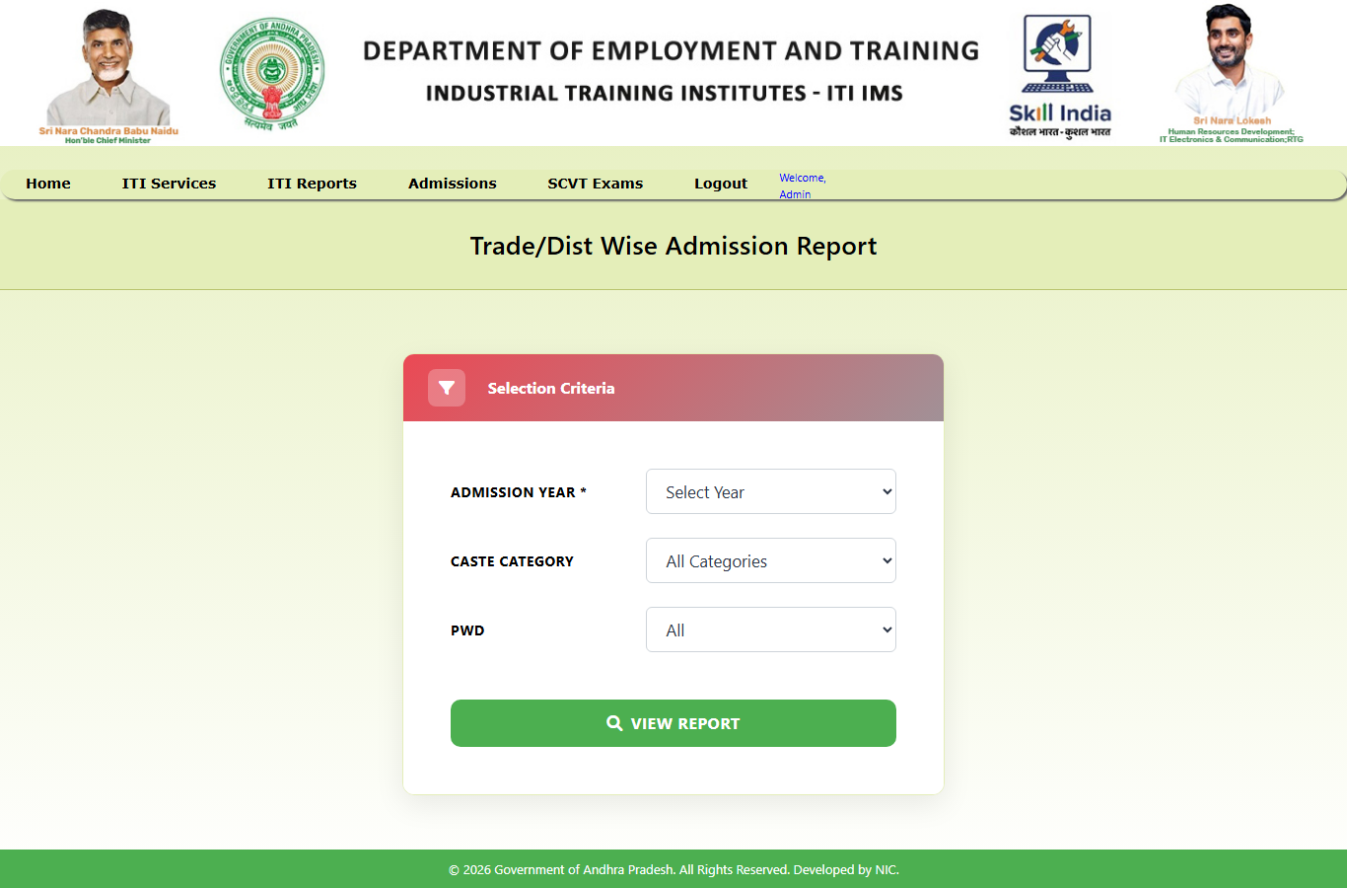
6.5.5. Tradewise Vacant Position Report:
The trade-wise vacancy endpoint accepts year and district code and returns vacancy summary rows by trade.
Redesigned Page:
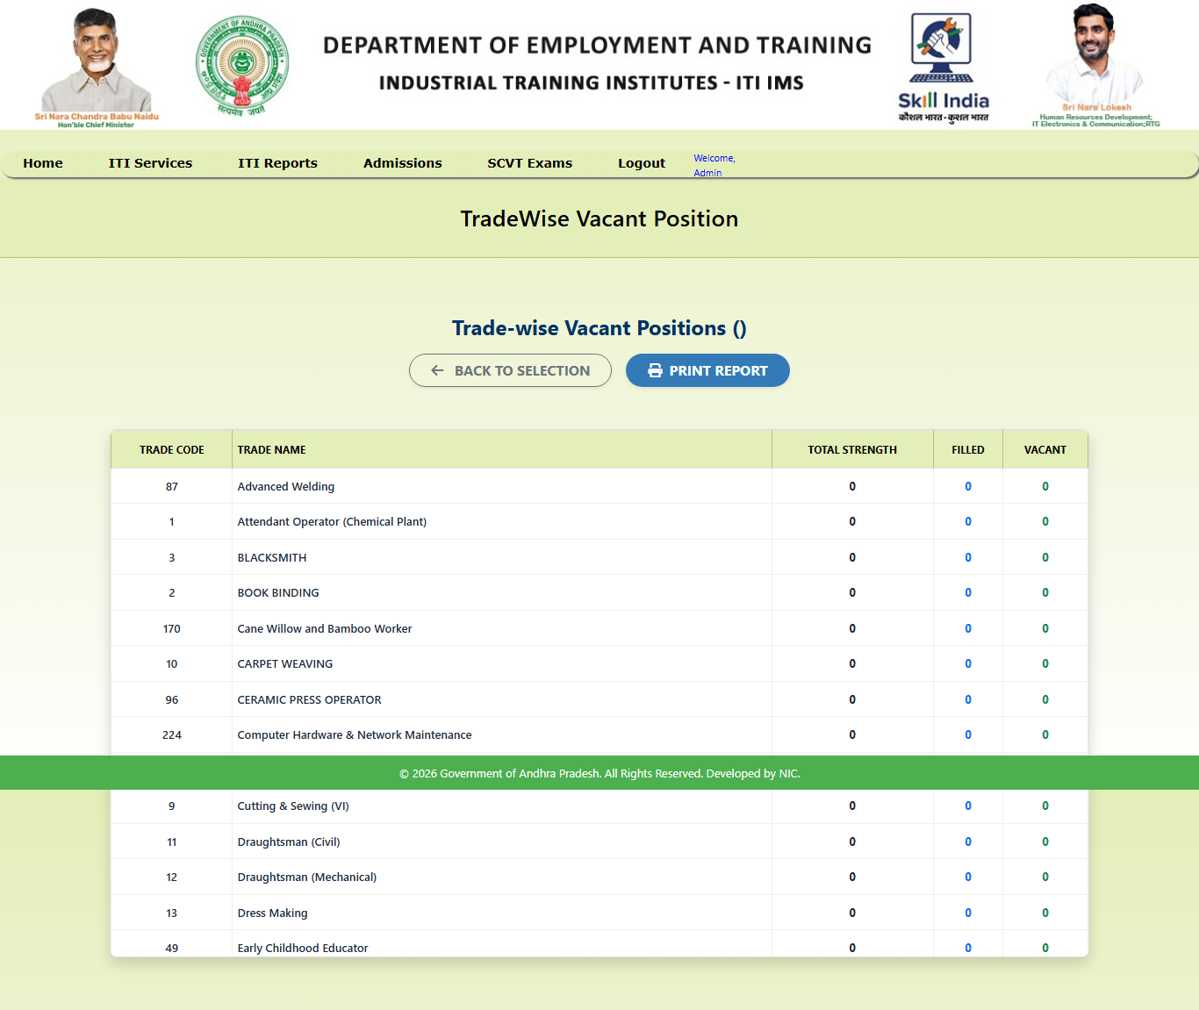
6.5.6. All Resource Role Report:
The resource-role report returns resource-role records and supports page and size parameters together with a total-record count.
Redesigned Page:
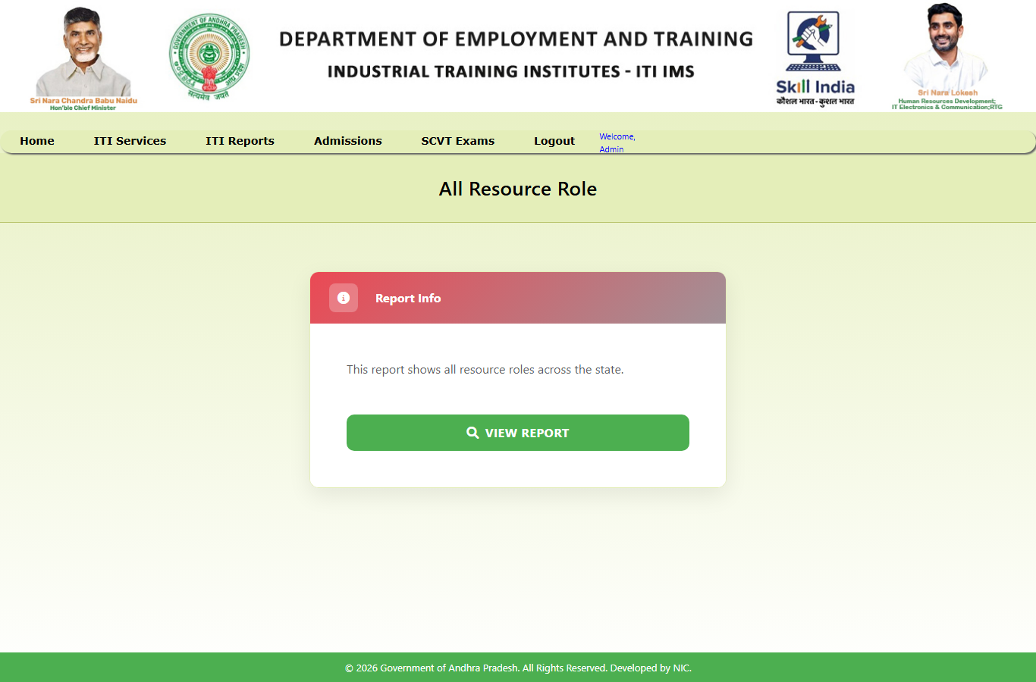

6.6. Public & Regulatory Compliance Reports:
6.6.1. Verification Report:
The verification report pages use the verification and district application-count APIs. The backend returns summary data through dedicated response DTOs; the precise fields should be read from the corresponding DTO and JSP.
Existing Page:
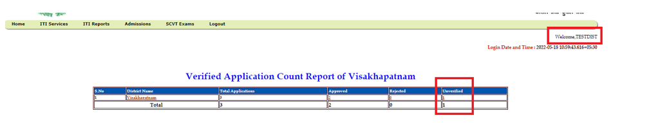
Redesigned Page:
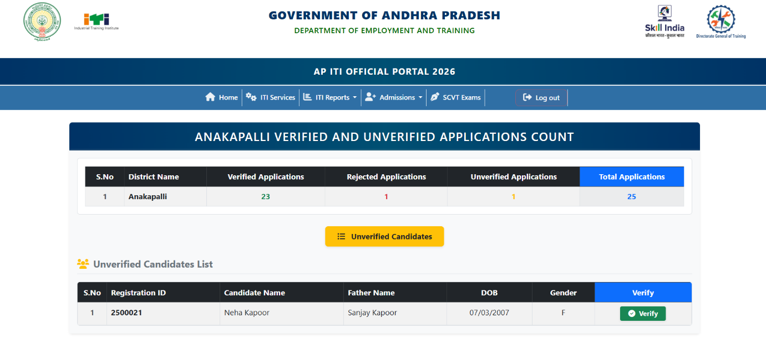
6.6.2. DGT Permitted Shift Unit Report:
The permitted shift/unit report returns records filtered by district and ITI. The API supports pagination and a total-count query.
Existing Page:
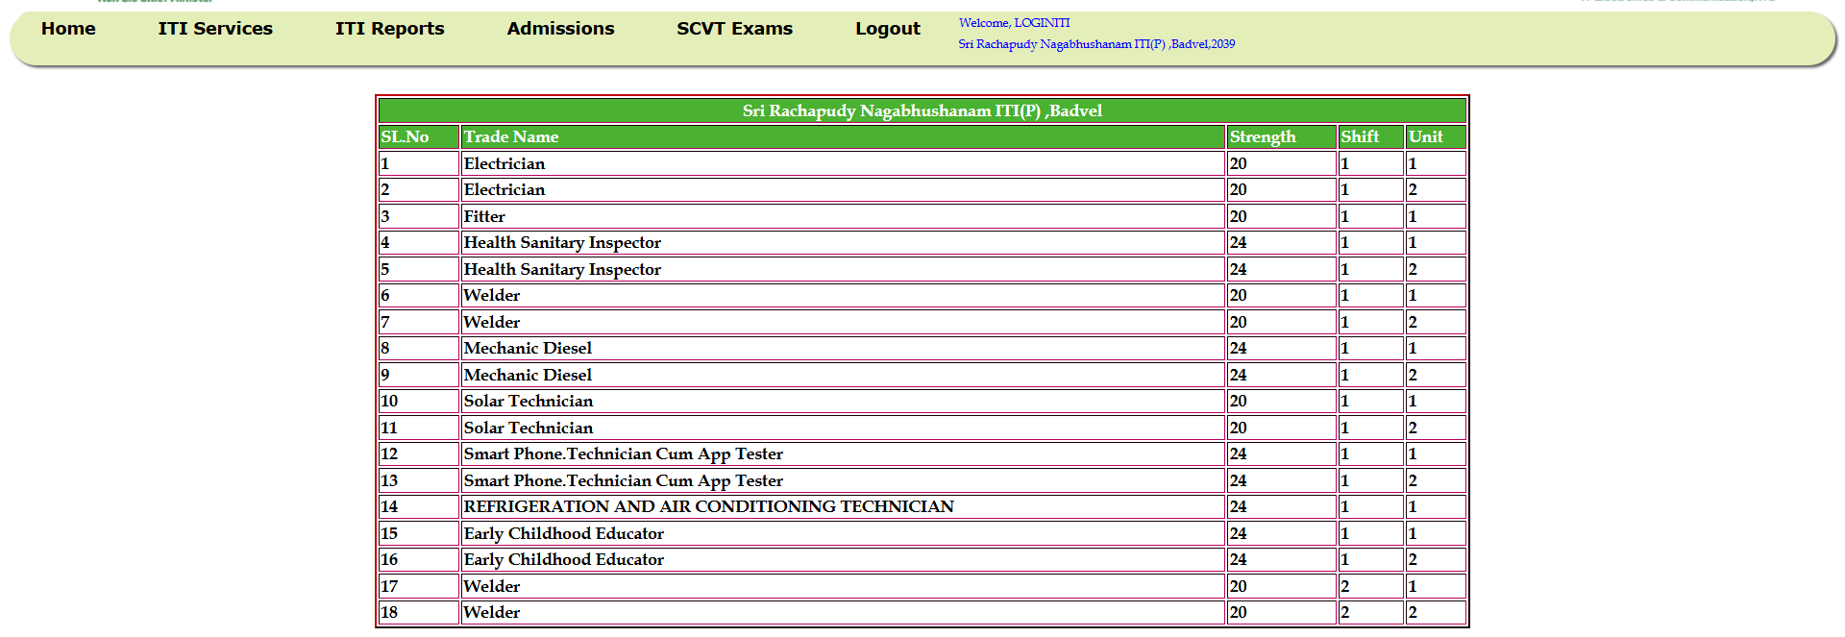
Redesigned Page:
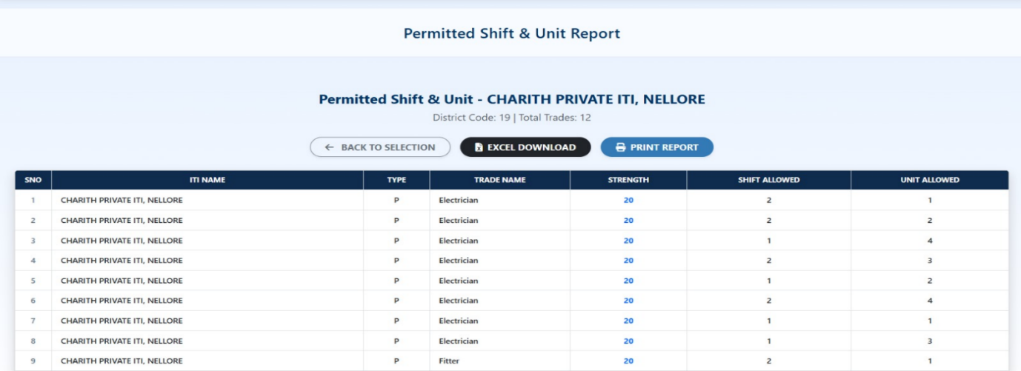
6.6.3. ITI Profile Report:
The public ITI profile page is mapped to /reports/iti-profile. Related trade-display endpoints provide district options and institute/trade information used by the public-facing pages.
Redesigned Page:
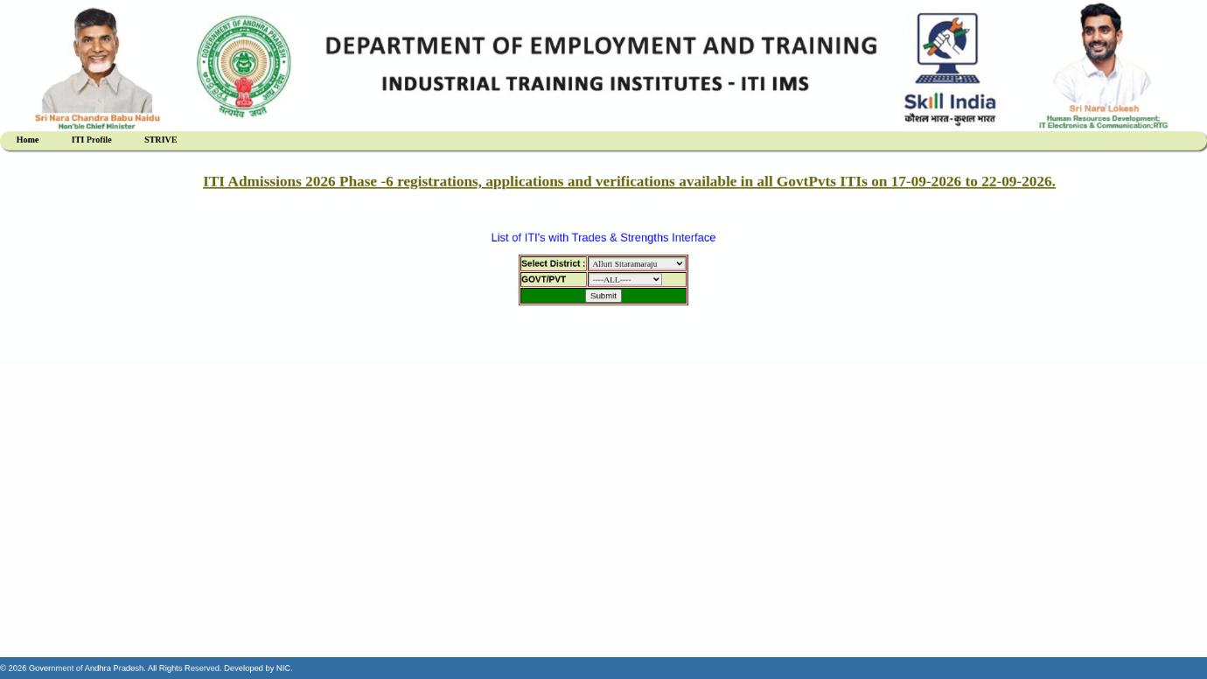
6.6.4. ITI Directory & Institute List Report:
The ITI list page is mapped to /reports/iti-list. The related /api/reports/trade-display/iti-list endpoint returns ITI list data and accepts an institute-type filter.
Redesigned Page:
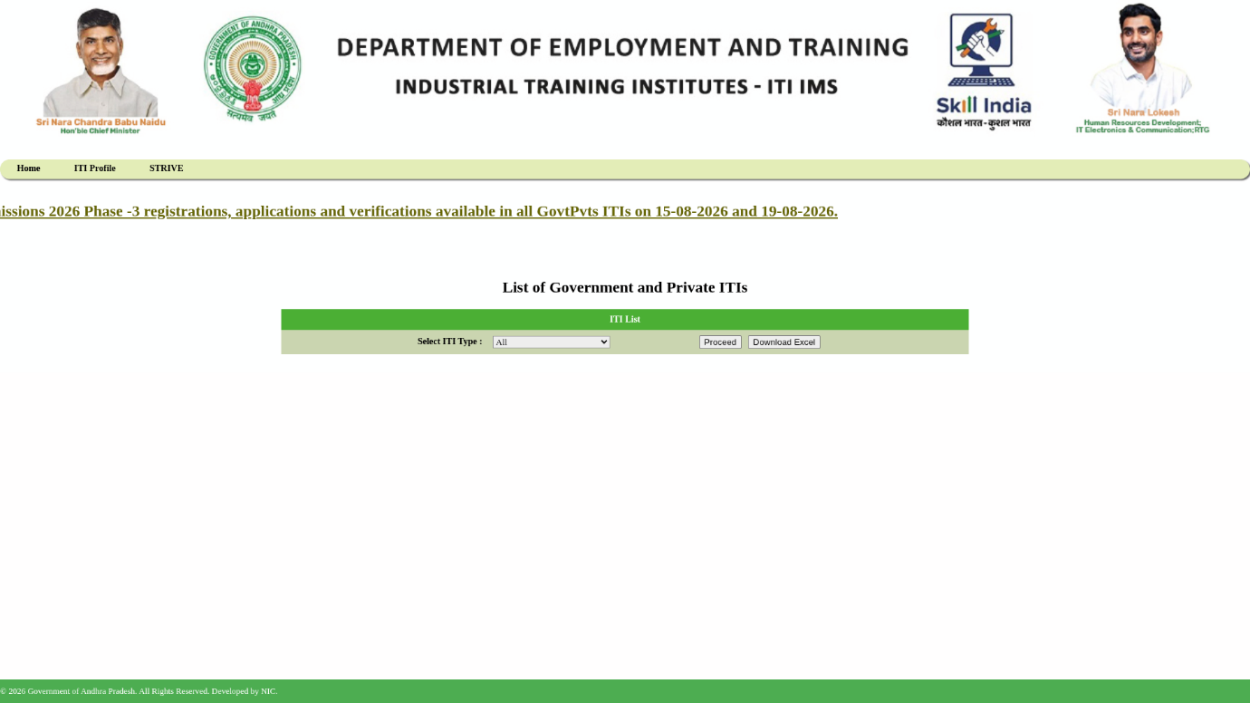
6.6.5. STRIVE Project Report & Disclosure Management:
The frontend includes public pages for STRIVE information and disclosure management. Their routes are /reports/about-strive and /reports/disclosure-management. The current report API source does not establish the detailed funding-utilisation or trainer-performance claims in the earlier draft.
Redesigned Page:
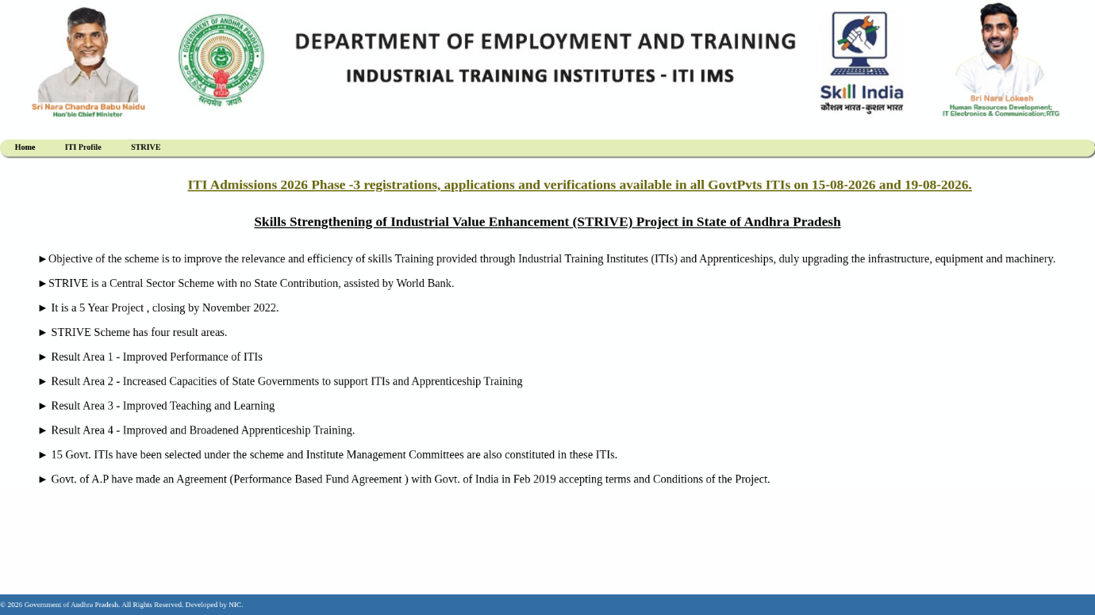
6.6.6. Reports Dashboard & Central Analytics:
The reports landing page is available at /reports. The frontend also provides /reports/api-documentation. The backend configures springdoc OpenAPI and a Swagger UI path for API exploration.
Redesigned Page:
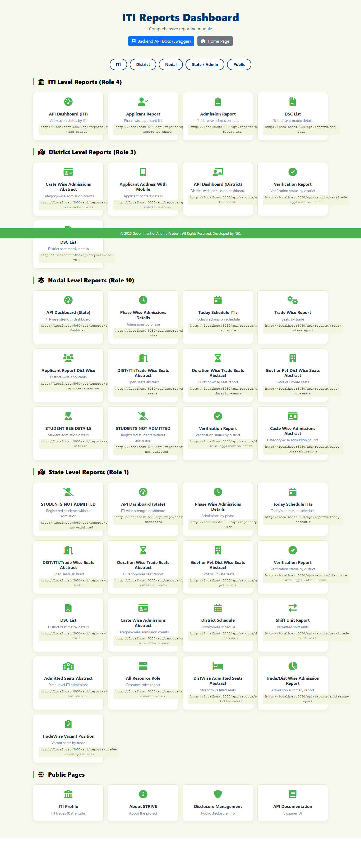
7.UML (Unified Modelling Language) Diagram:
Unified Modelling Language (UML) diagrams are used to represent the structure and behaviour of a software system. This chapter retains the diagrams included in the draft and explains their purpose in the context of the ITI Admissions Portal. The diagrams are high-level documentation views and should be updated if the implementation changes.
7.1 Class Diagram
- The class diagram represents selected classes and their relationships. For the reporting component, important implementation classes include ReportRestController, ReportService, ReportServiceImpl, response DTO classes and the frontend ReportsController.
- It helps explain the separation between request handling, report processing and the data returned to the frontend.
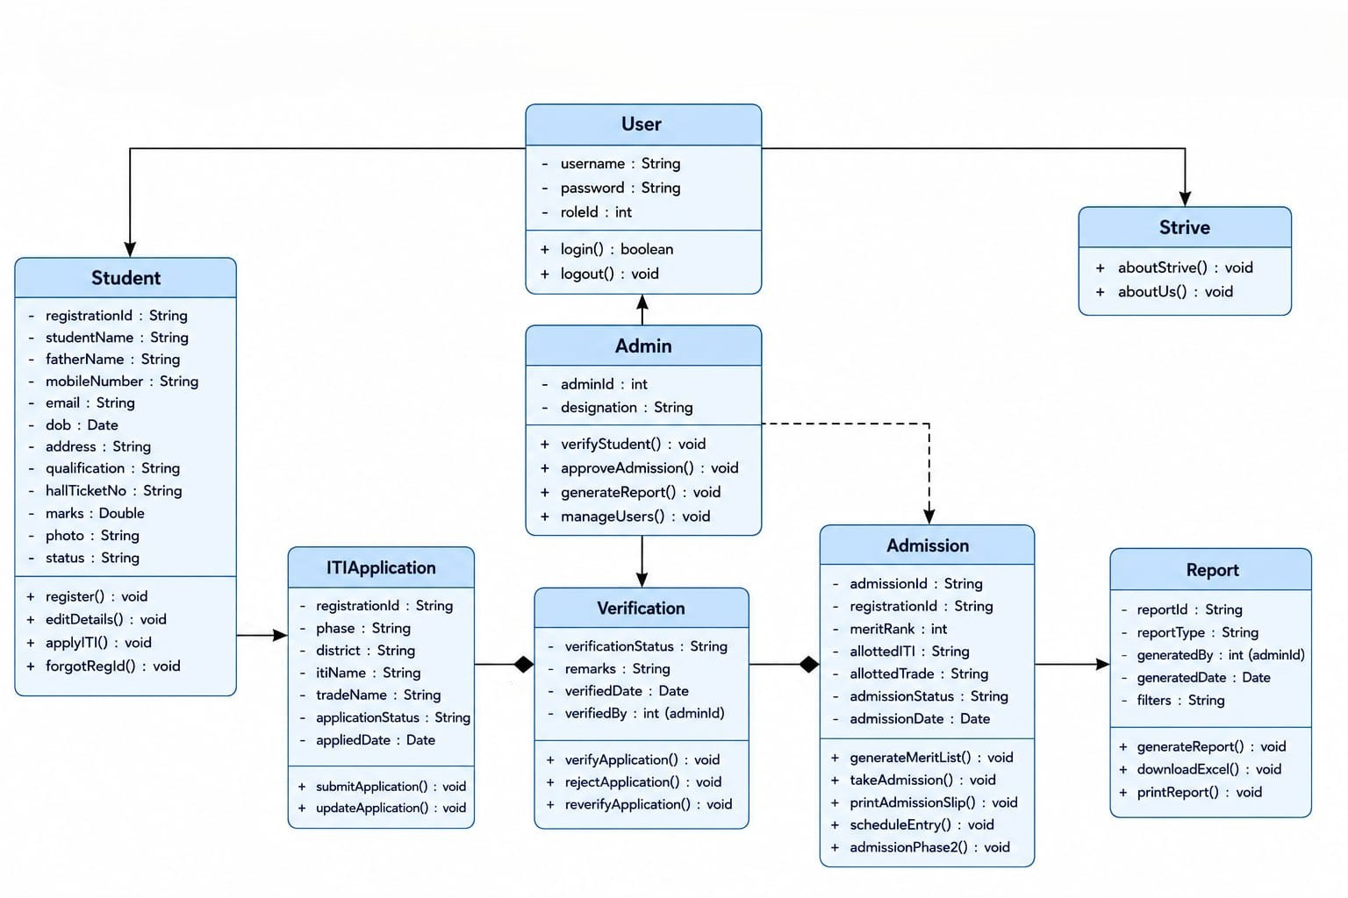

7.2 Use Case Diagram
- The use-case diagram identifies the main user groups and the reporting functions available to them. The current frontend routes group report pages for ITI, district, nodal and state/administrative users, together with public information pages.
- Actors and access permissions should be interpreted alongside the session and role checks implemented in ReportsController.java.

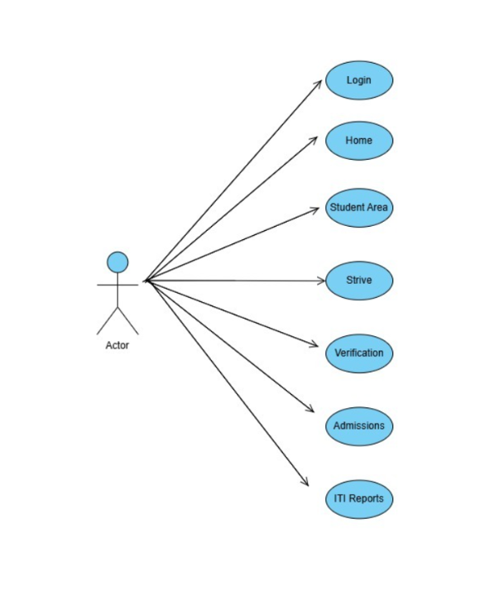
7.3 Sequence Diagram
- The sequence diagram illustrates the request flow: a browser requests a JSP page from the frontend; the page sends a request to a backend REST endpoint; the REST controller invokes a report-service method; the service obtains data from PostgreSQL and returns a response DTO; the frontend displays the result.
- This sequence separates page rendering, API handling and database operations. The exact sequence differs by report and by whether the endpoint returns a paginated or non-paginated response.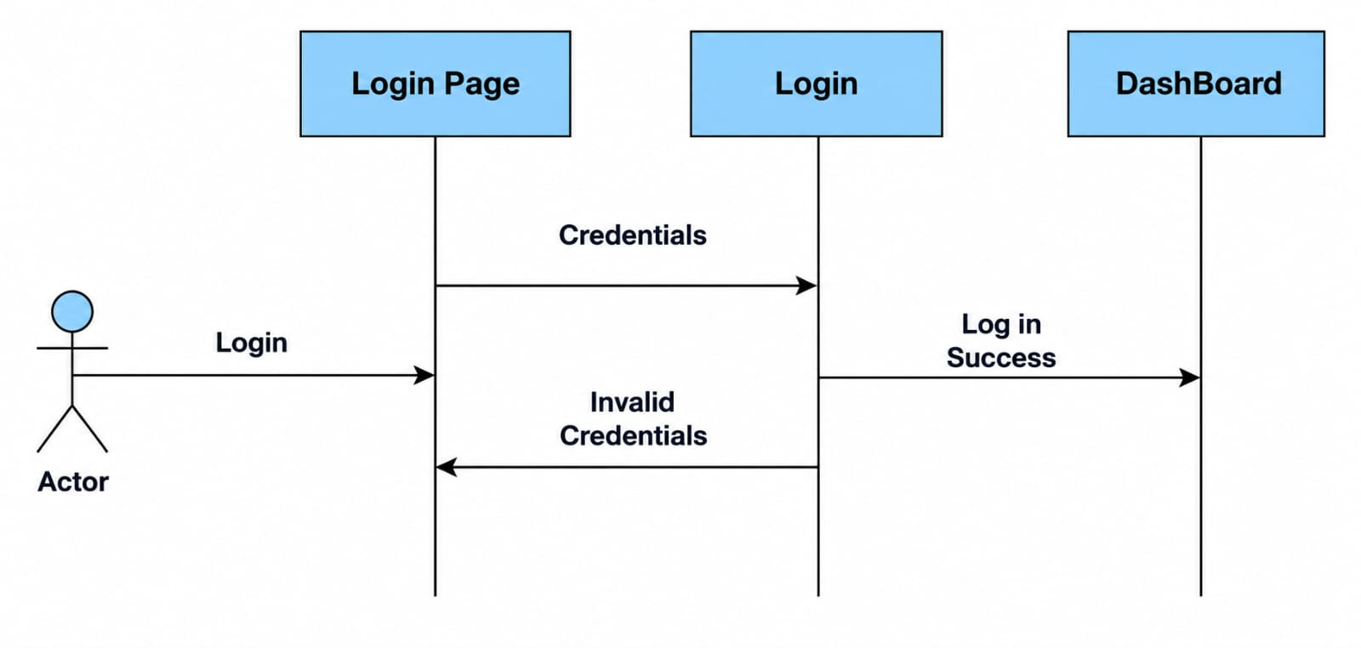
7.4 Module Diagram
- The module diagram shows the major application components and their relationships: JSP-based frontend, frontend MVC controller, backend REST controller, report service, response DTOs and PostgreSQL database.
- It provides a high-level view of the separation between user-interface, service and persistence responsibilities.
7.4.1 Dashboard Module:
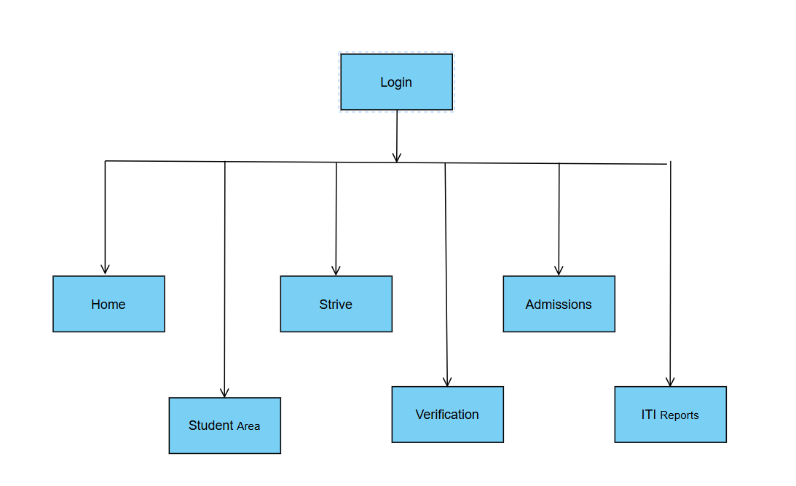
7.4.2 Login Module:

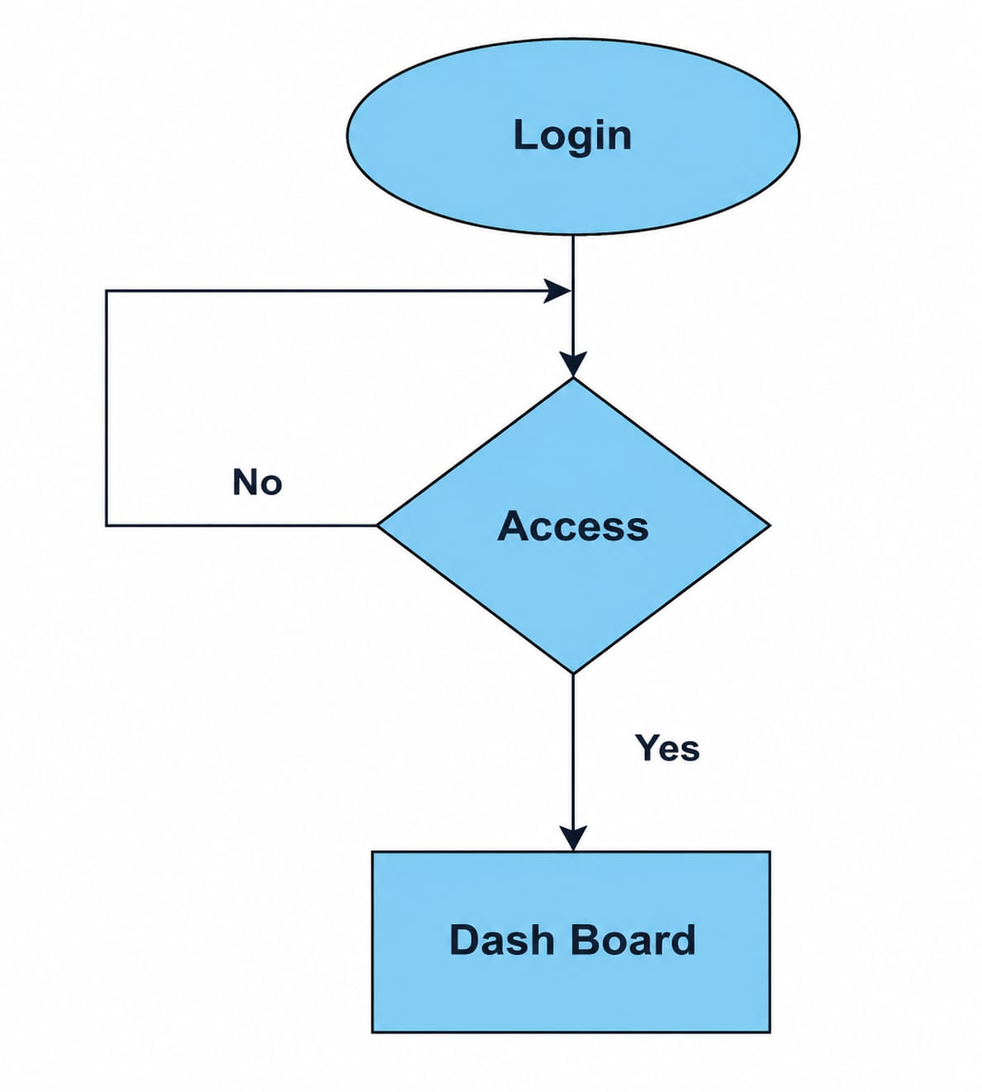
7.5 Flowchart

- The flowchart represents the general report request process: open the report page, select available filters, submit the request, receive the response, and display the returned records or an appropriate message.
- For the shift/unit verification workflow, the process additionally includes loading pending records, submitting corrected shift and unit values, and updating the verification status.

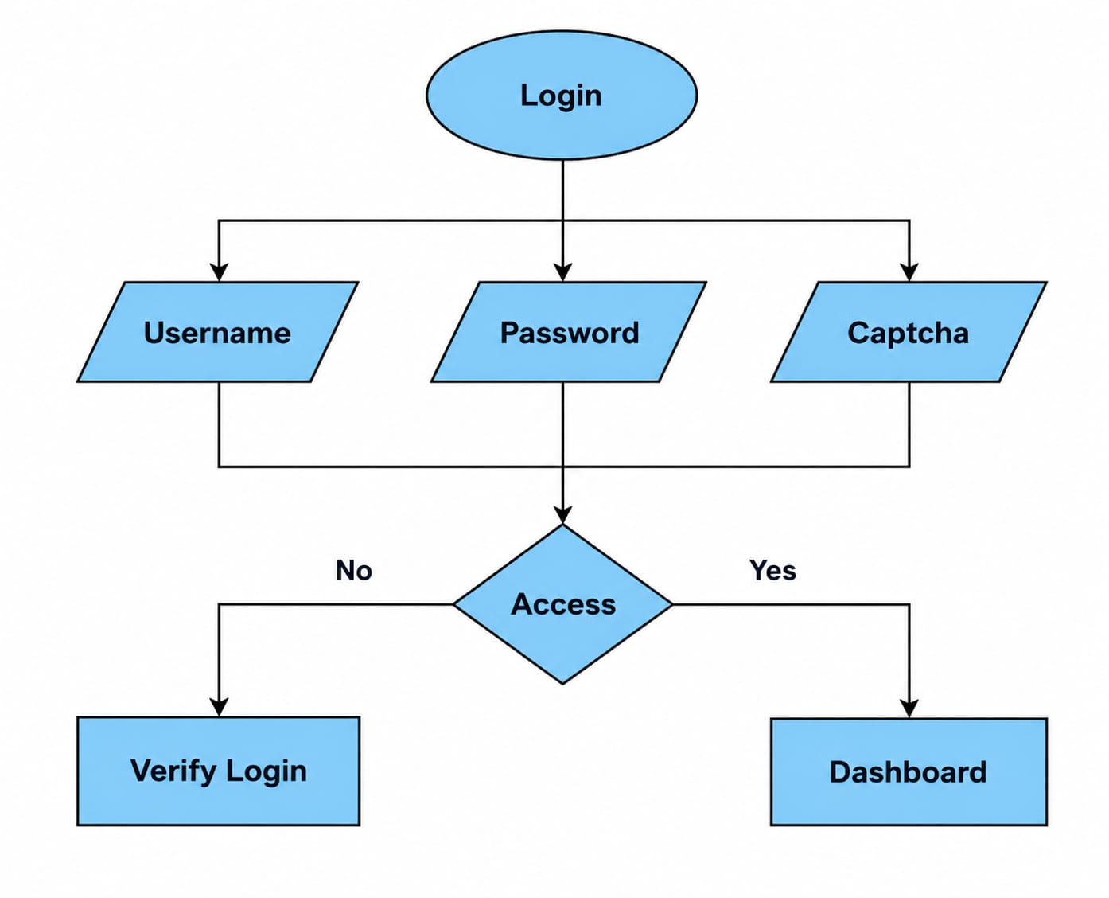

7.6 ER Diagram
- The ER diagram illustrates the database entities and relationships relevant to admissions and institute reporting. The report queries in the backend refer to tables such as student_application, iti, ititrade_master and admissions.iti_admissions. The exact schema and foreign-key relationships must be taken from the deployed database definition; they are not fully defined by the application repository alone.
- This helps in planning the organization of data within a system.
- The ER diagram is therefore a conceptual view of the data used by the reports, not a complete database-schema export.
- ER (Entity Relationship) Diagram represents the logical structure of a database.
- Relationships in the diagram should be checked against the database schema before being treated as authoritative.
- Relationships show how entities are related to each other.

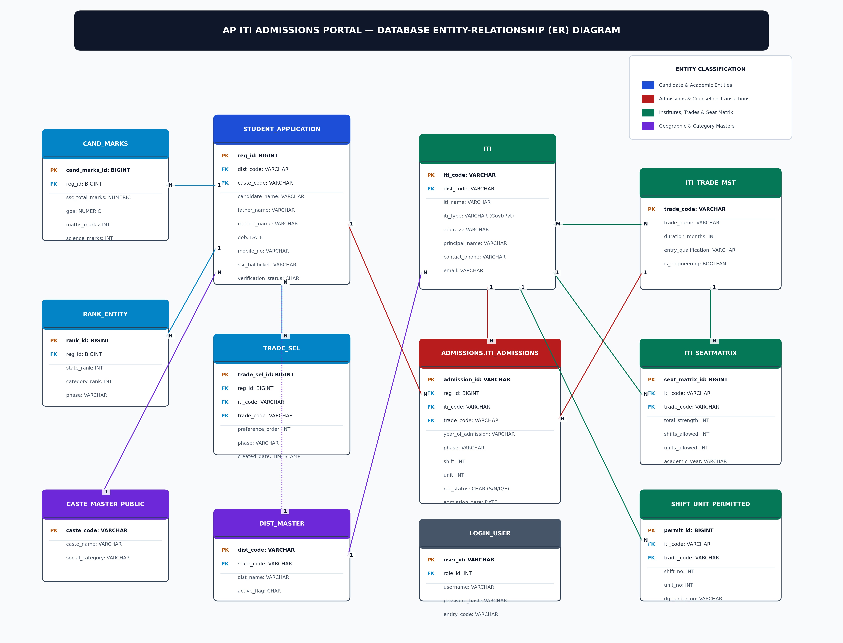

7.7 Activity Diagram
Activity (Dashboard Diagram):
- The activity diagram represents the sequence of activities performed by a user and the application while accessing a report. It includes session checking, page navigation, filter selection, API request, data retrieval and report display.
- It is a behavioural overview of the reporting workflow and does not replace the detailed controller and service implementation.

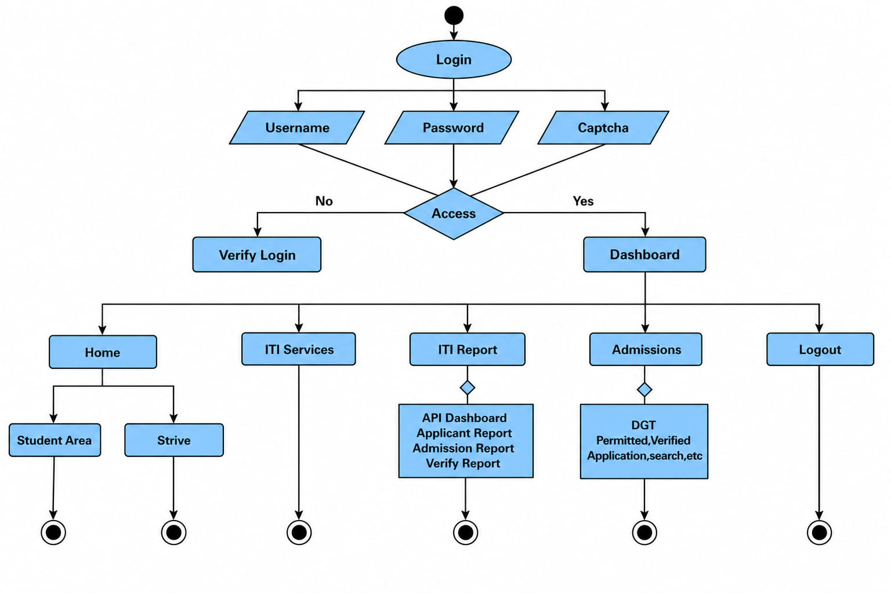
8. THE OUTLINE OF WORK CARRIED OUT
This chapter records the training work represented in the supplied screenshots and source-code excerpts. The screenshots are retained from the original draft and should be checked against the final running application before submission.
8.1.1 Login Screen:
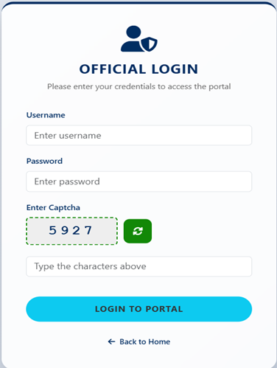
8.1.2 Home Page, Reports Navigation and Logout:
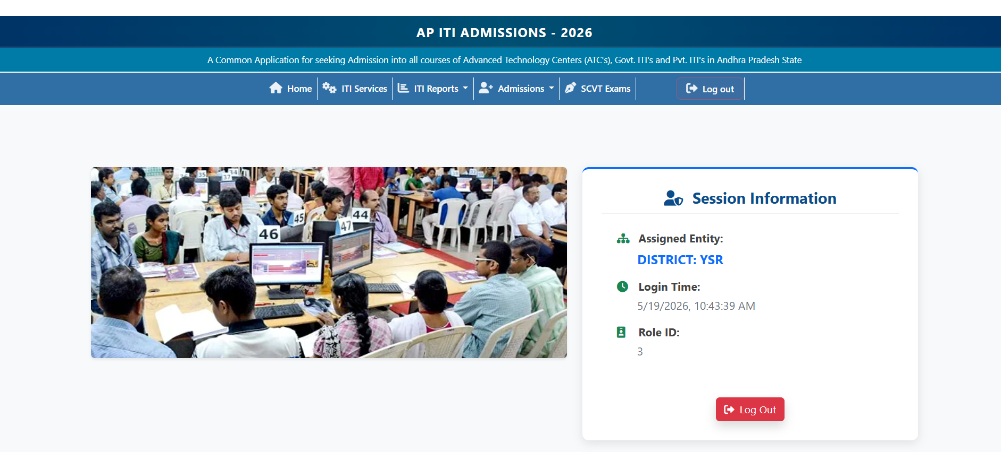

8.2 System Architecture:
The system architecture consists of two Spring Boot applications. The frontend application serves JSP views and browser resources. It sends HTTP requests to the backend application, whose REST controllers invoke report services. The report services query PostgreSQL and return JSON data to the frontend. Each application has its own Maven project and configuration; the frontend backend URL and server ports can be changed through configuration properties and environment variables.

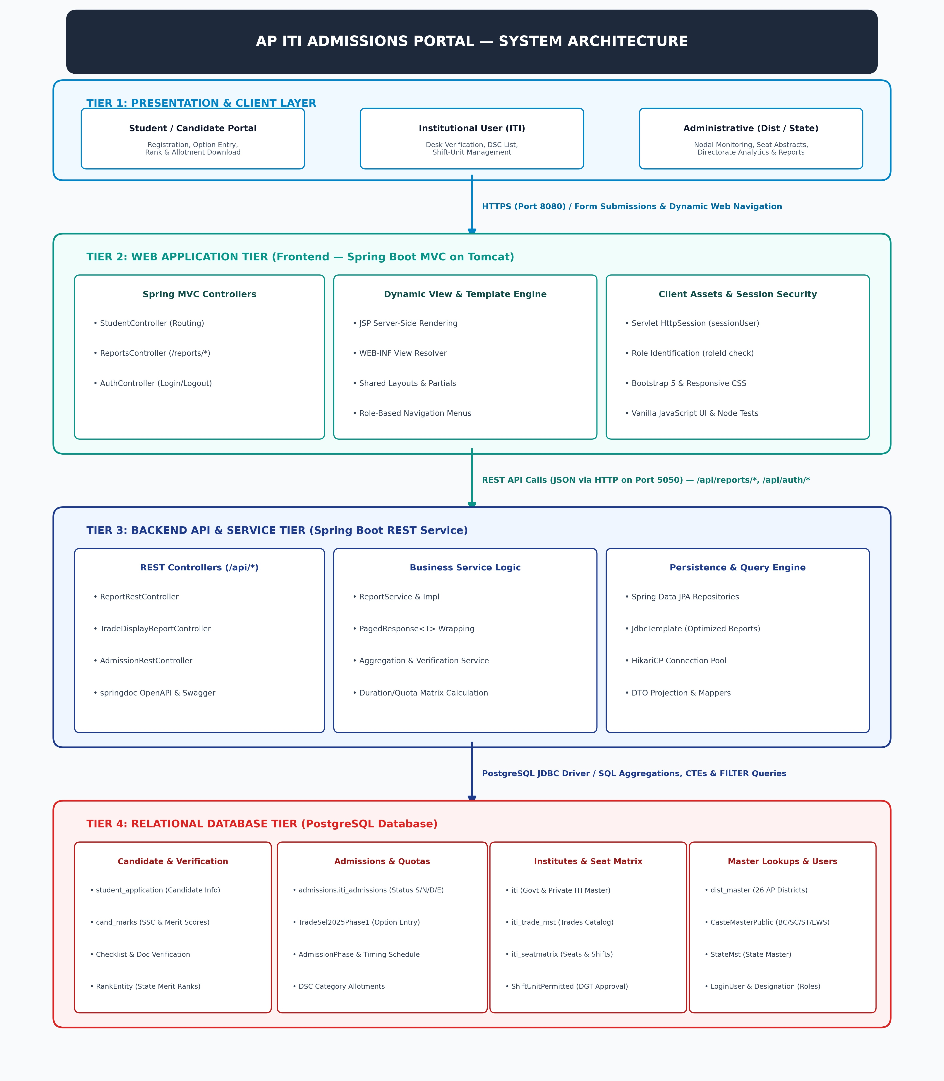

8.3. Selected Source-Code Screenshots
8.3.1 Frontend Source Code:
The frontend code includes the Spring Boot application entry point, MVC controllers and JSP views. The ReportsController maps /reports URLs to report JSP pages and applies the session checks described in Chapter 6.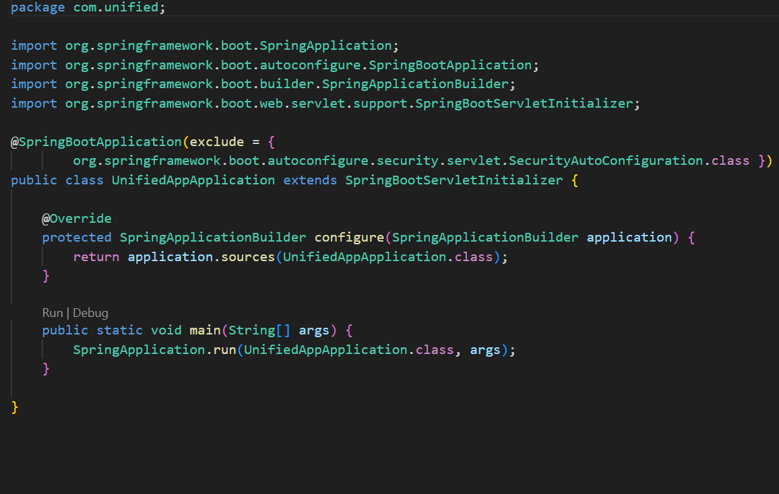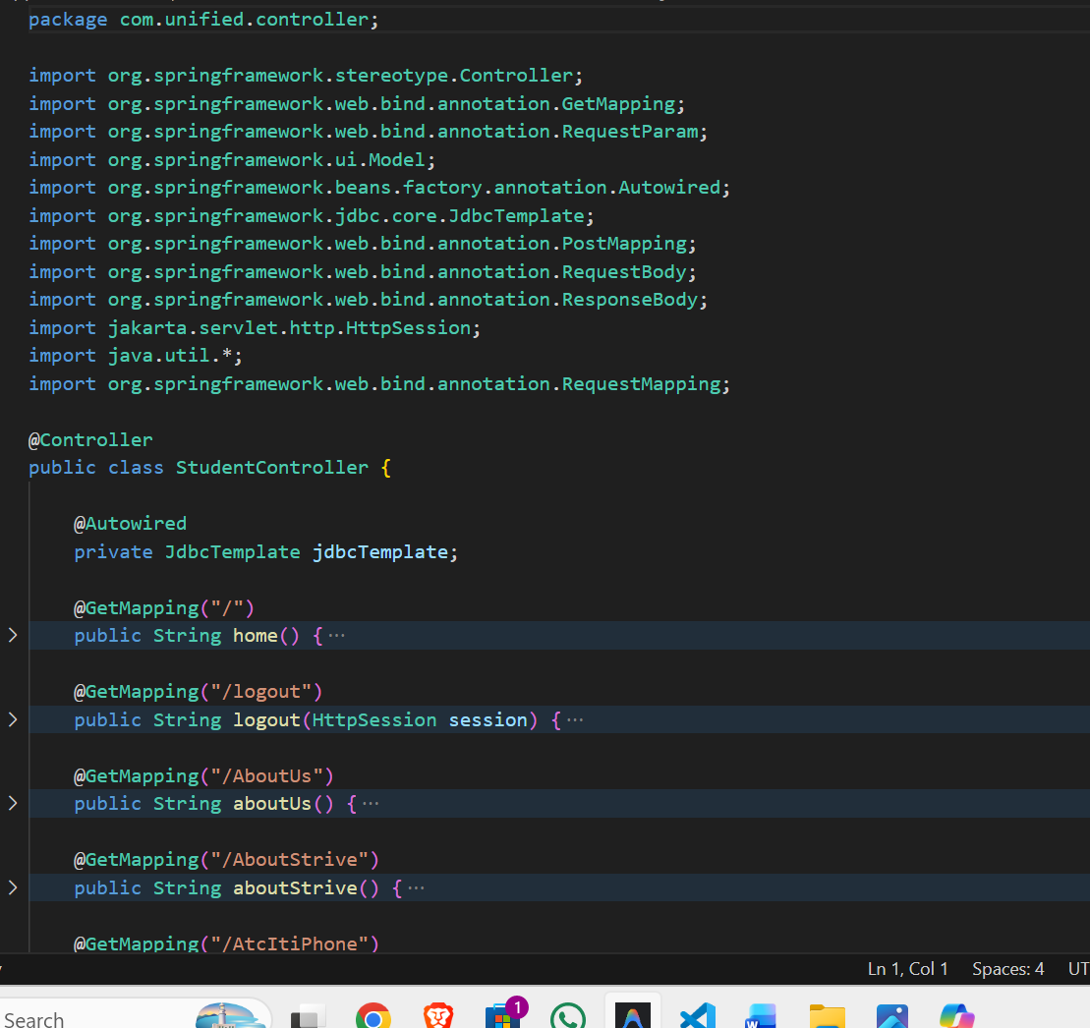 The embedded code screenshots are retained from the draft; compare them with the current repository before treating them as the latest source version.
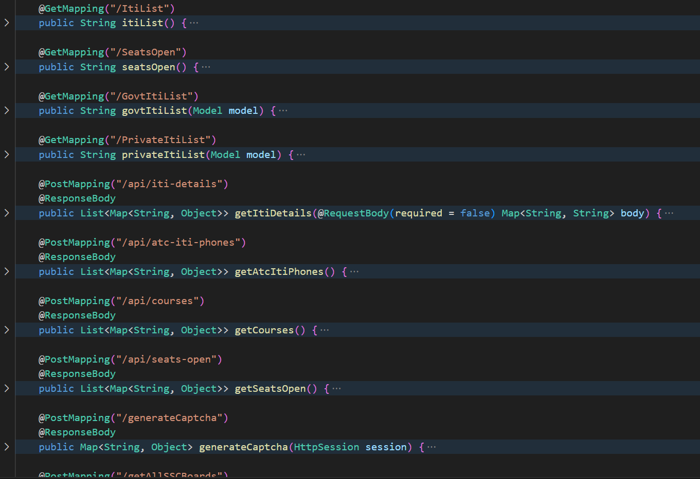
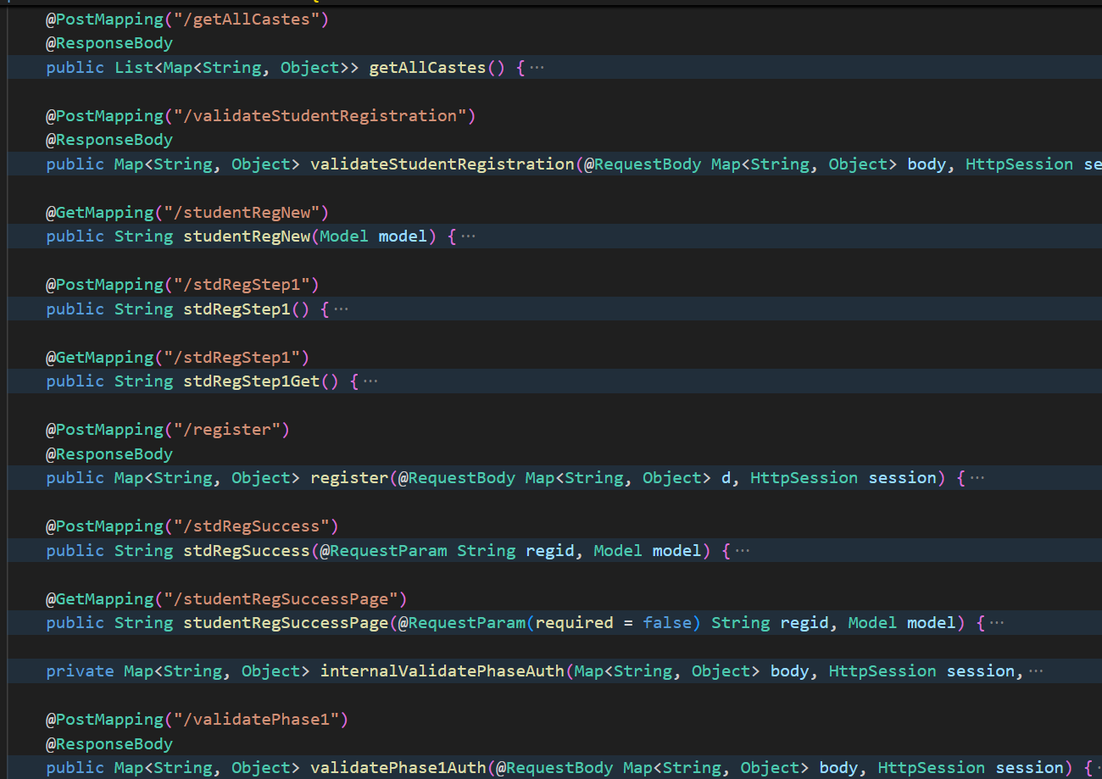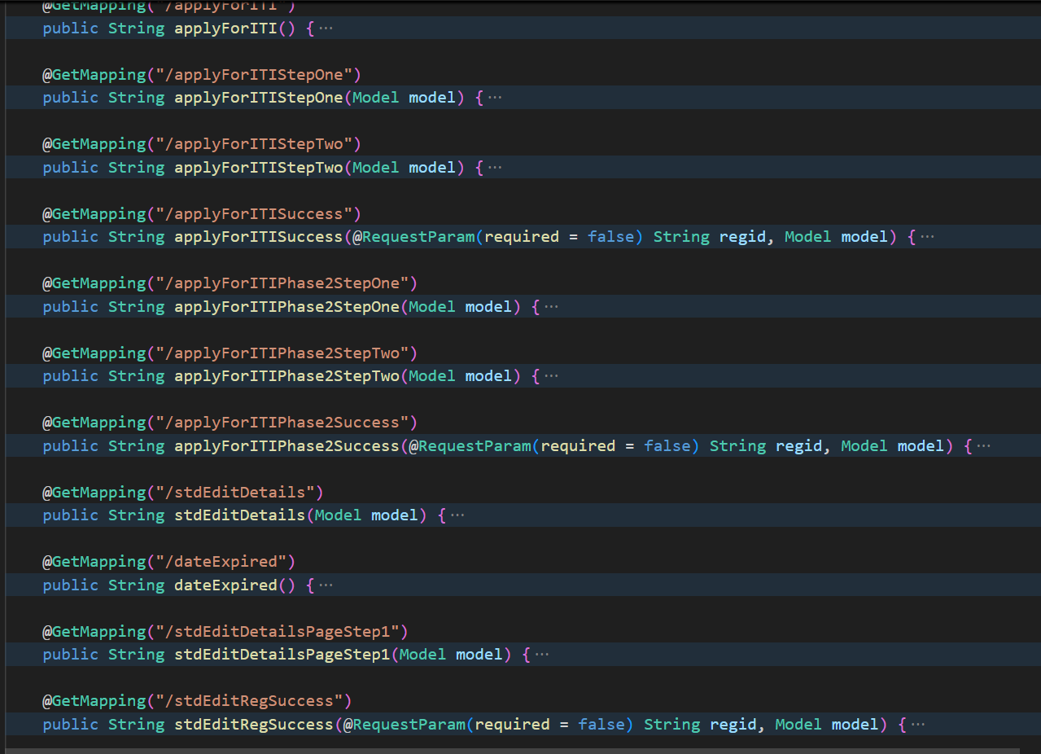
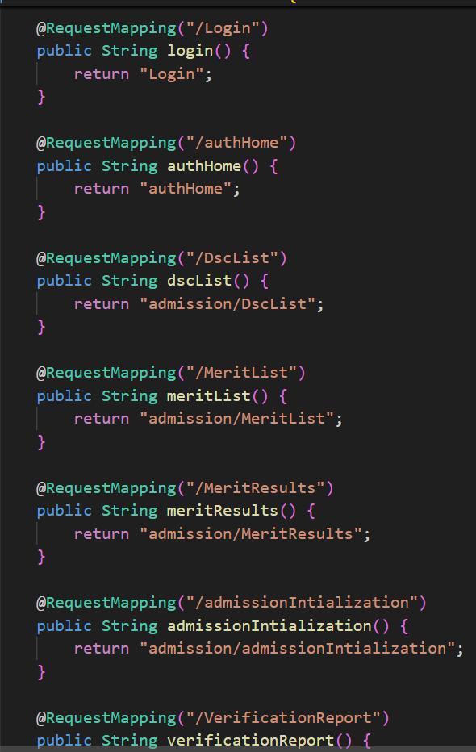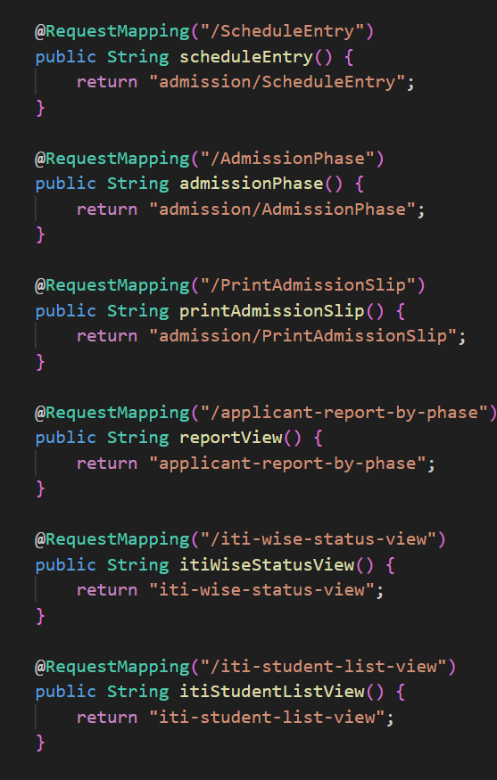
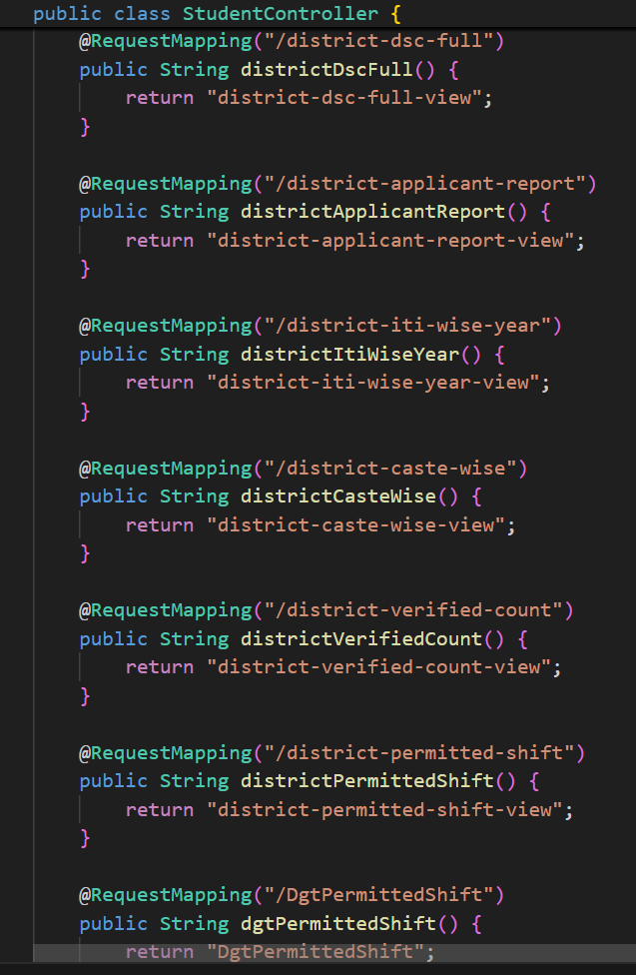
JSP Views and Shared Navigation:
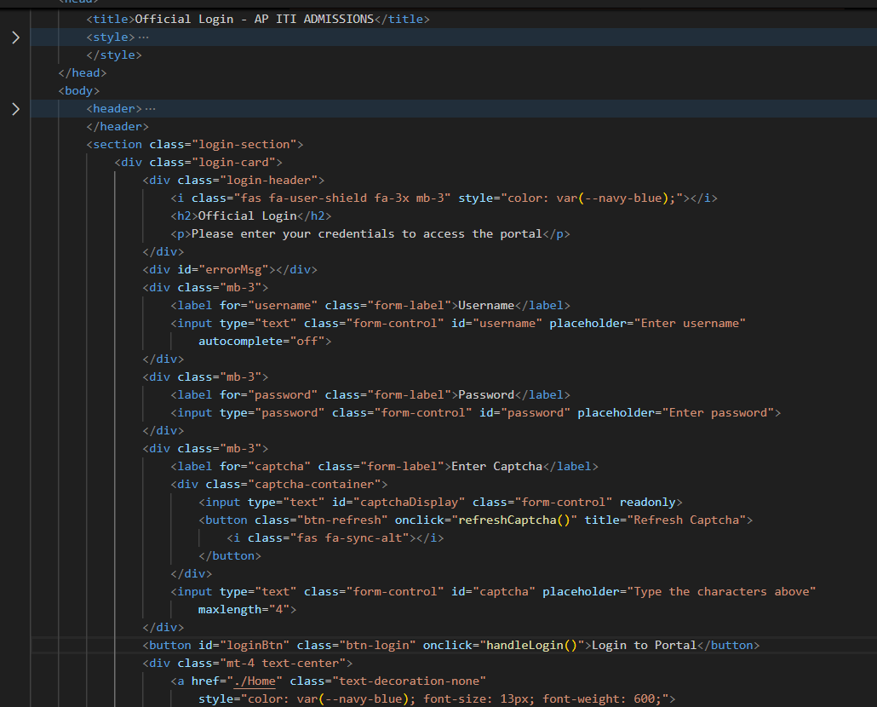
The JSP pages form the presentation layer. They provide the report layout and browser controls, while JavaScript communicates with the backend endpoints where required.
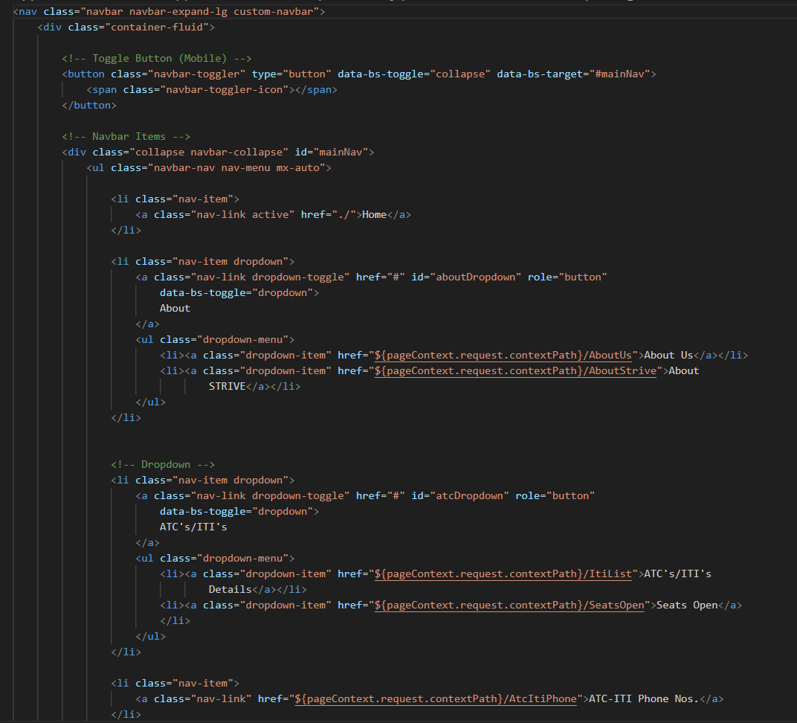
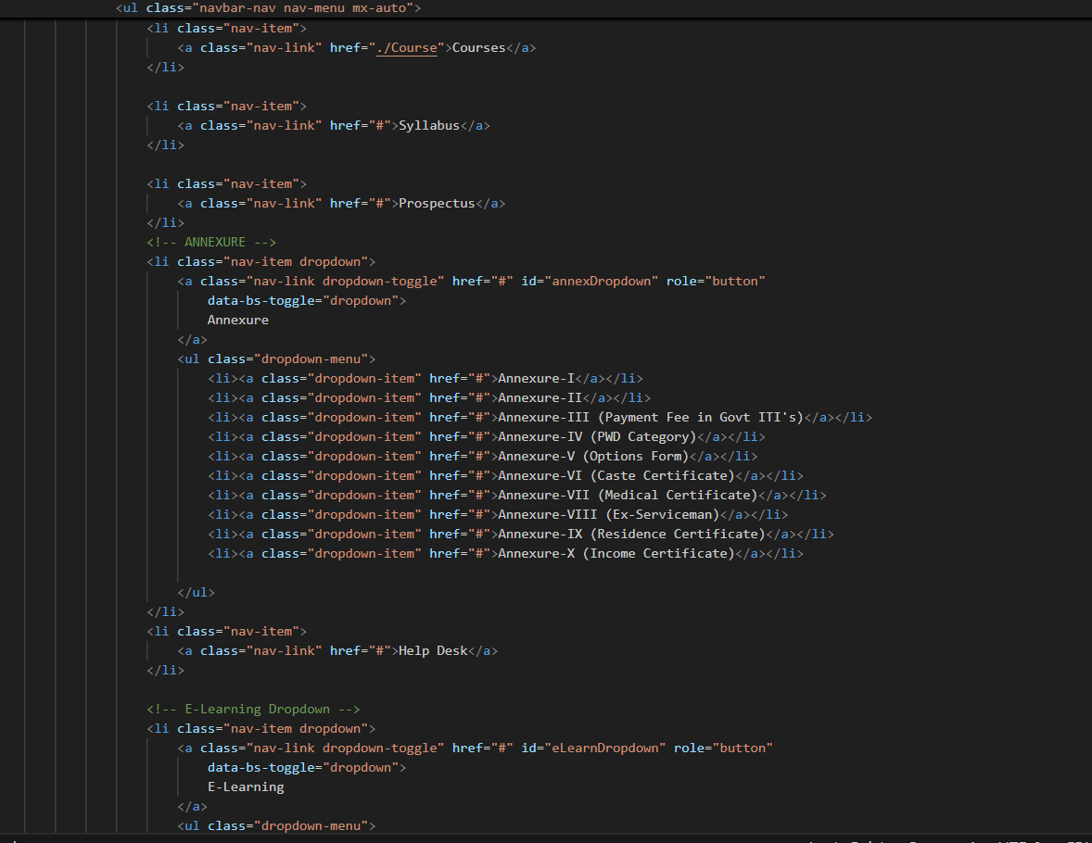
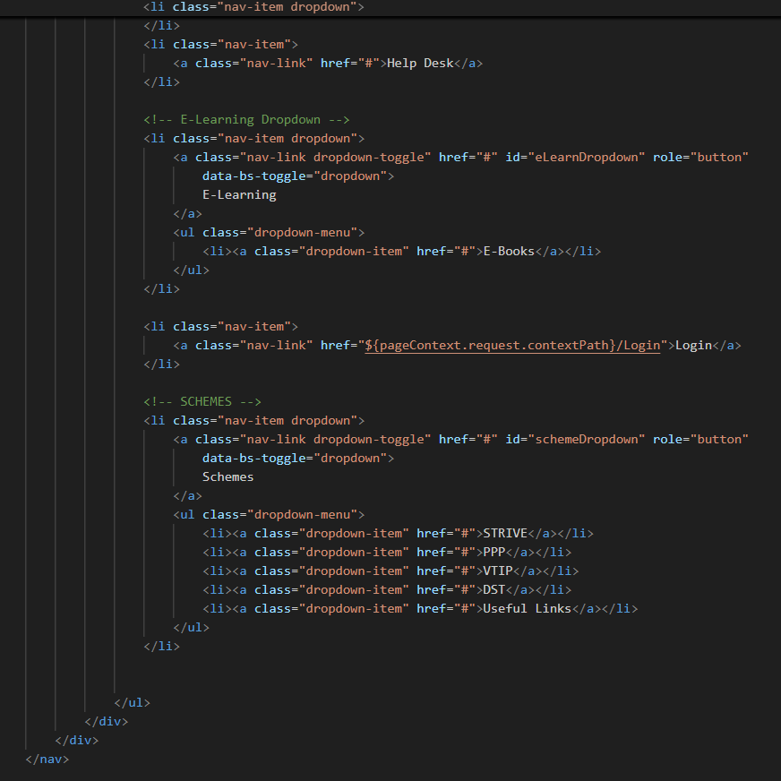

8.3.2 Backend Source Code (Spring Boot REST APIs and Services):
REST Controller (ReportRestController.java): This class maps report-related HTTP requests under /api/reports and delegates processing to service classes.
package com.server.backend.controller.Reports;

@Tag(name = "Reports")
@RestController
@RequestMapping("/api/reports")
public class ReportRestController {

private final TradeDisplayReportService tradeDisplayReportService;
private final ReportService reportService;

public ReportRestController(TradeDisplayReportService tradeDisplayReportService,
ReportService reportService) {
this.tradeDisplayReportService = tradeDisplayReportService;
this.reportService = reportService;
}

// ========== 1 - API Dashboard (ITI) ==========
@Operation(summary = "1 - API Dashboard (ITI)")
@GetMapping("/iti-wise-status")
public ResponseEntity<PagedResponse<ItiWiseStatusResponse>> getItiWiseStatus(
@RequestParam(required = false) String year,
@RequestParam(required = false, defaultValue = "All") String distCode,
@RequestParam(required = false, defaultValue = "All") String itiCode,
@RequestParam(required = false, defaultValue = "0") int page,
@RequestParam(defaultValue = "100") int size) {
List<ItiWiseStatusResponse> data = reportService.getItiWiseStatus(year, distCode, itiCode, page, size);
long count = reportService.countItiWiseStatus(year, distCode, itiCode);
return ResponseEntity.ok(new PagedResponse<>(data, page, size, count));
}

// ========== 2 - Applicant Report ==========
@Operation(summary = "2 - Applicant Report")
@GetMapping("/applicant-report-by-phase")
public ResponseEntity<PagedResponse<ApplicantReportResponse>> getApplicantReportByPhase(
@RequestParam String phase,
@RequestParam(required = false) String year,
@RequestParam(required = false, defaultValue = "All") String itiCode,
@RequestParam(required = false, defaultValue = "All") String distCode,
@RequestParam(required = false, defaultValue = "0") int page,
@RequestParam(defaultValue = "100") int size) {
List<ApplicantReportResponse> data = reportService.getApplicantReportByPhase(phase, year, itiCode, distCode, page, size);
long count = reportService.countApplicantReportByPhase(phase, year, itiCode, distCode);
return ResponseEntity.ok(new PagedResponse<>(data, page, size, count));
}

// ========== 3 - Admission Report (ITI) ==========
@Operation(summary = "3 - Admission Report (ITI)")
@GetMapping("/admission-report-iti")
public ResponseEntity<PagedResponse<AdmissionReportDetailResponse>> getAdmissionReportIti(
@RequestParam(required = false, defaultValue = "0") int page,
@RequestParam(defaultValue = "200") int size) {
List<AdmissionReportDetailResponse> data = reportService.getAdmissionReportDetails(page, size);
long count = reportService.countAdmissionReportDetails();
return ResponseEntity.ok(new PagedResponse<>(data, page, size, count));
}
}
Service Interface (ReportService.java): This interface defines the report operations used by the REST controller, including applicant, admission, schedule, seat and verification-related queries.
package com.server.backend.service.Reports;
import java.util.List;
public interface ReportService {
List<ItiWiseStatusResponse> getItiWiseStatus(
String year, String distCode, String itiCode, int page, int size);
long countItiWiseStatus(String year, String distCode, String itiCode);
List<ApplicantReportResponse> getApplicantReportByPhase(
String phase, String year, String itiCode, String distCode, int page, int size);
long countApplicantReportByPhase(
String phase, String year, String itiCode, String distCode);
List<AdmissionReportResponse> getAdmissionReport(
String year, String caste, String pwd);
List<AdmissionReportDetailResponse> getAdmissionReportDetails(
int page, int size);
long countAdmissionReportDetails();
DscFullReportResponse getDscFullReport(
String distCode, String itiCode, String tradeCode,
String phase, String year, String modeAdm);
DscOptionsResponse getDscOptions(String distCode, String itiCode);
List<CasteWiseAdmissionsResponse> getCasteWiseAdmissions(
String year, String distCode, String govt, String phase, String gender);
// The interface also declares district, schedule, seat, student,
// resource-role, vacancy and students-not-admitted report operations.
}
Service Implementation (ReportServiceImpl.java): This class implements the report-service operations and contains the database access logic used to retrieve and aggregate report data.
// Selected excerpt from ReportServiceImpl.java
@Override
public List<ItiWiseStatusResponse> getItiWiseStatus(
String year, String distCode, String itiCode, int page, int size) {
String effectiveYear = resolveAdmissionYear(year);
StringBuilder sql = new StringBuilder("""
WITH iti_data AS (
SELECT a.iti_code,
COUNT(*) AS total,
COUNT(*) FILTER (WHERE a.rec_status = 'S') AS success,
COUNT(*) FILTER (WHERE a.rec_status = 'N') AS pending_sid,
COUNT(*) FILTER (WHERE a.rec_status = 'D') AS verified,
COUNT(*) FILTER (WHERE a.rec_status = 'E') AS to_be_verified
-- Further status and duplicate counters are included
-- in the complete query in the repository.
FROM admissions.iti_admissions a
WHERE a.year_of_admission = ? OR '2026' = ?
GROUP BY a.iti_code
)
SELECT d.dist_name, i.iti_name, i.iti_code,
COALESCE(id.total, 0) AS total,
COALESCE(id.success, 0) AS success,
COALESCE(id.pending_sid, 0) AS pending_sid,
COALESCE(id.verified, 0) AS verified
FROM (SELECT DISTINCT dist_code, dist_name FROM public.dist_mst) d
JOIN public.iti i ON d.dist_code = i.dist_code
LEFT JOIN iti_data id ON i.iti_code = id.iti_code
WHERE 1=1
""");
List<Object> params = new ArrayList<>();
params.add(effectiveYear);
params.add(effectiveYear);
// Optional district and ITI filters are appended here.
// The complete implementation then adds LIMIT and OFFSET.
return jdbcTemplate.query(sql.toString(),
(rs, rowNum) -> new ItiWiseStatusResponse(
rs.getString("dist_name"),
rs.getString("iti_name"),
rs.getString("iti_code"),
rs.getInt("total"),
rs.getInt("success"),
rs.getInt("pending_sid"),
rs.getInt("verified")),
params.toArray());
}

8.4. Conclusion
The training work provided practical exposure to a multi-layer web application used for ITI admissions administration. The Reports Module demonstrates how JSP-based pages, REST APIs, Java service classes and PostgreSQL queries cooperate to present operational information. Reviewing the source code and documenting the report workflows strengthened understanding of application architecture, API design, data retrieval and maintainable software organisation.

