**Activity Diagrams.**

**Draw an activity Diagram for online voting System**

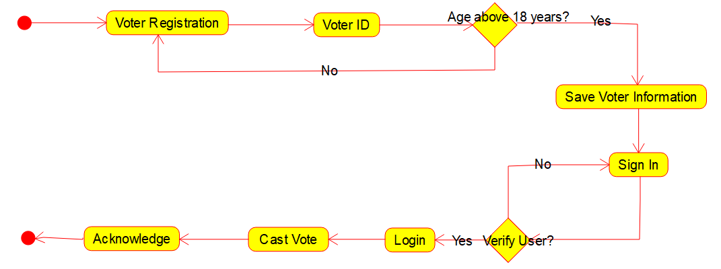

**Draw an activity Diagram for Library Management System**

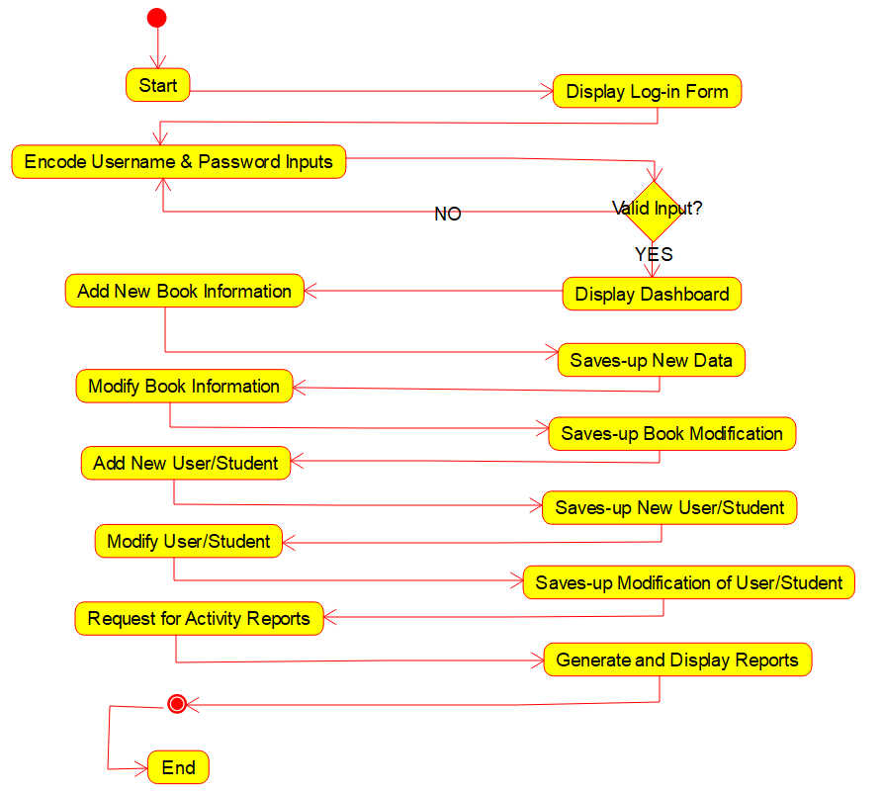

**Draw an activity diagram for online shopping System**

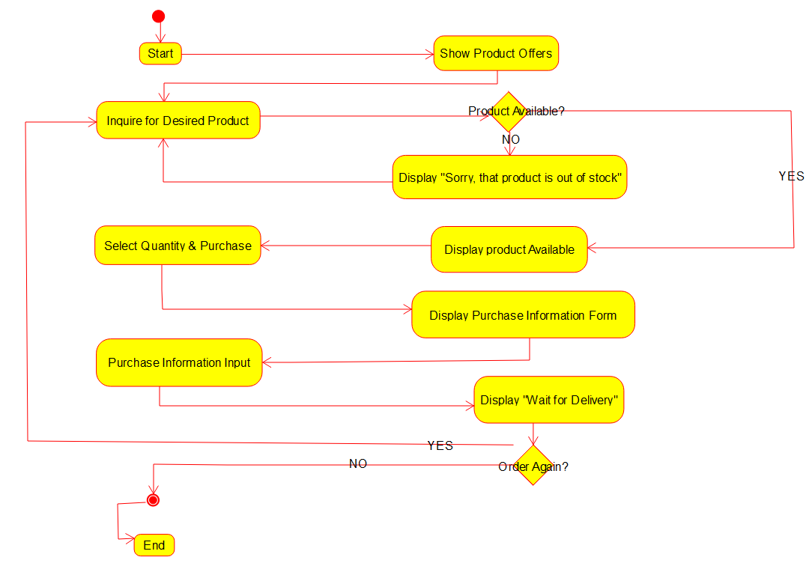

**Draw an activity diagram for Railway Reservation System**

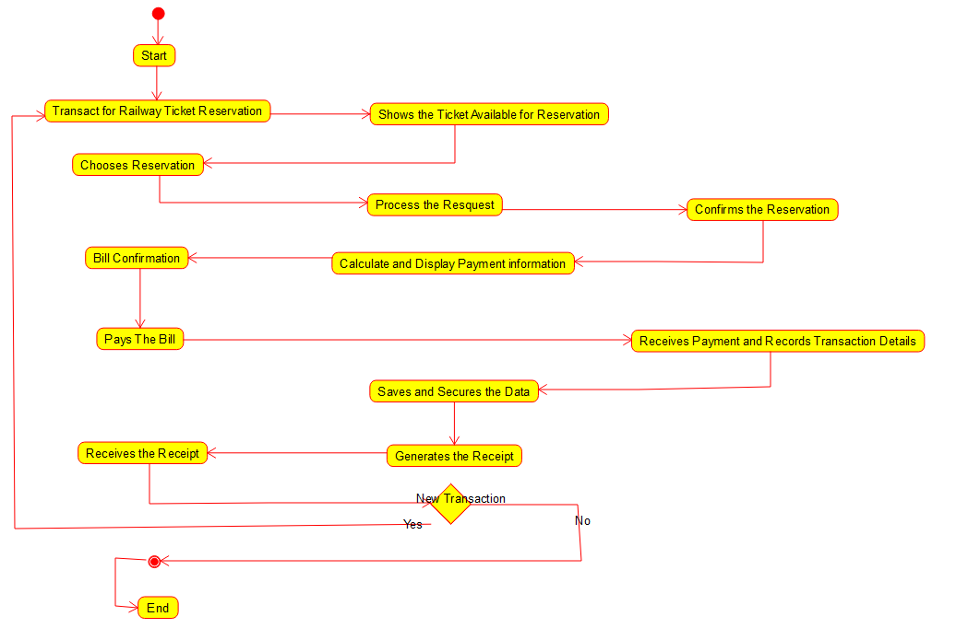

**Draw an activity Diagram for Online Banking System**

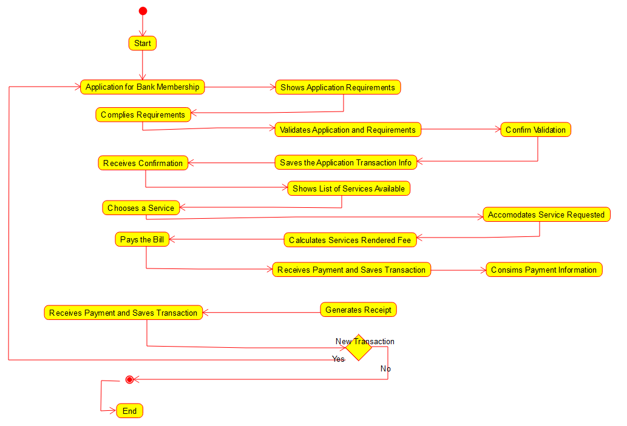

**Draw an Activity Diagram for E-Library**

