**Class Diagram For Online Voting System**

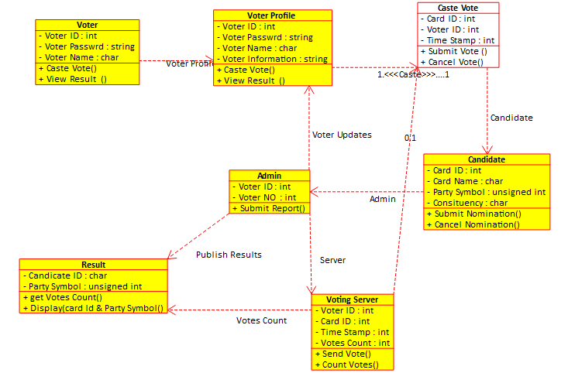

**Class Diagram For Library Management System**

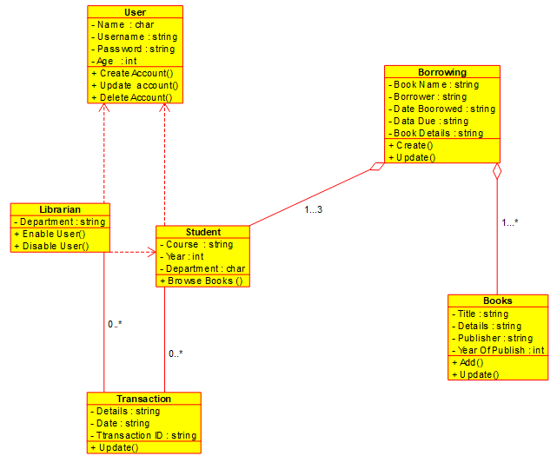

**Class Diagram For an E- Library online Public Access Catalogue**

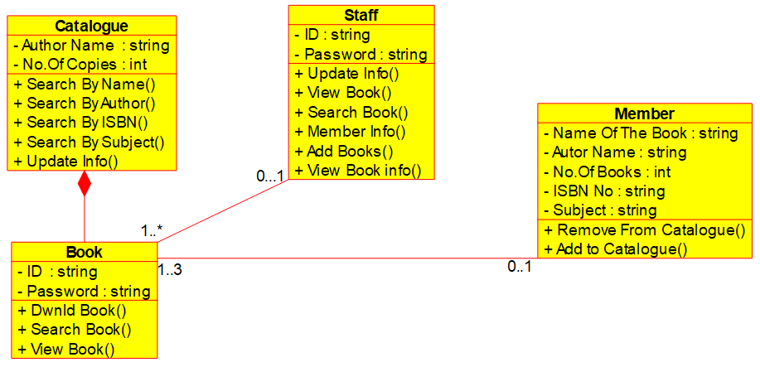

**Class Diagram For a Restaurant**

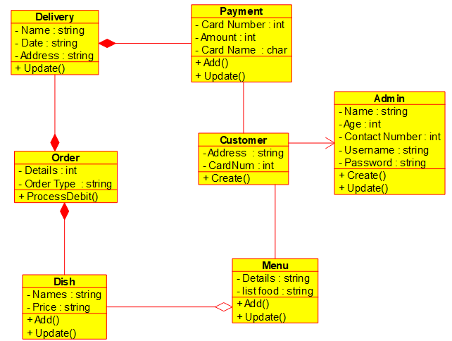

**Class Diagram For a Quiz**

