**Problem-1**

Create a Navigation bar using HTML (With out CSS and Bootstarp), it should contain

-> Home

-> Signup

-> Login

-> Search Bar.

Note: once you create web page upload the page to Github account with public access

Code: navbar.html

<!DOCTYPE html>

<html lang="en">

<head>

    <meta charset="UTF-8">

    <meta name="viewport" content="width=device-width, initial-scale=1.0">

    <title>Document</title>

</head>

<body>

    <h2>Navbar</h2>

    <nav>

        <a href="#">Home</a> |

        <a href="#">Signup</a> |

        <a href="#">Login</a> |

        <input type="text" placeholder="Search...">

        <button>Search</button>

    </nav>

</body>

</html>

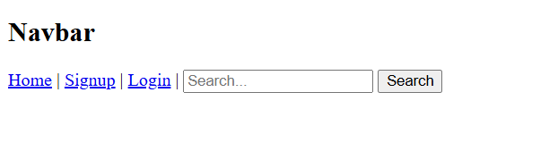

 github link here :  https://github.com/nagadhanush23/fewdlab/blob/main/exp1/navbar.html

**Problem-2**

Create a Portfolio page using HTML , it should contain

-> Self introduction

-> skills

-> projects/work experiences (Git links)

-> Feedback /achivements

-> Education profile

-> Contact information.(Social media /phone /email)

Note: once you create the poftfolio upload the page with neccesary document to Github account with public access

Code:portfolio.html

<!DOCTYPE html>

<html lang="en">

<head>

    <meta charset="UTF-8">

    <meta name="viewport" content="width=device-width, initial-scale=1.0">

    <title>Portfolio</title>

</head>

<body>

    <header>

        <h1>My Portfolio</h1>

    </header>

    <section id="introduction">

        <h2>Self Introduction</h2>

        <p>

            Hello! My name is Nagadhanush. I am a Student with a passion for Computer science.

            I am currently learning web development and looking for opportunities to work on exciting projects.

        </p>

    </section>

    <section id="skills">

        <h2>Skills</h2>

        <ul>

            <li>HTML</li>

            <li>CSS</li>

            <li>MONGO DB</li>

            <li>SQL</li>

        </ul>

    </section>

    <section id="projects">

        <h2>Projects/Work Experiences</h2>

        <ul>

            <li><a href="https://github.com/yourusername/project1">Project 1</a></li>

            <li><a href="https://github.com/yourusername/project2">Project 2</a></li>

            <li><a href="https://github.com/yourusername/project3">Project 3</a></li>

        </ul>

    </section>

    <section id="feedback">

        <h2>Feedback/Achievements</h2>

        <p>Project School</p>

        <p>Kulturehire Internship</p>

        <p>IFS Trainee</p>

    </section>

    <section id="education">

        <h2>Education Profile</h2>

        <p>Intermediate from Sri Chaitanya junior collage, 2022</p>

        <p>B Tech from Keshav Meomerial Junior Collage, 2026</p>

    </section>

    <section id="contact">

        <h2>Contact Information</h2>

        <p>Email: <a href="mailto:your.email@example.com">your.email@example.com</a></p>

        <p>Phone: XXXXX XXXXX</p>

        <p>Social Media: <a href="https://twitter.com/yourusername">Twitter</a>, <a href="https://linkedin.com/in/yourusername">LinkedIn</a></p>

    </section>

</body>

</html>

Output:

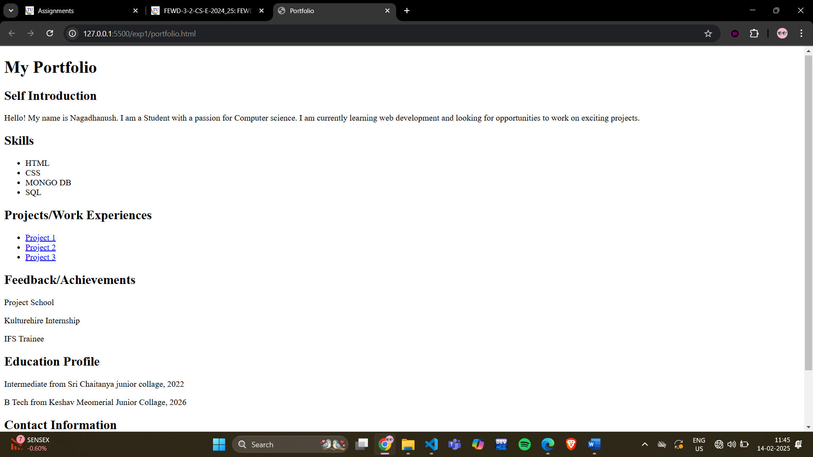

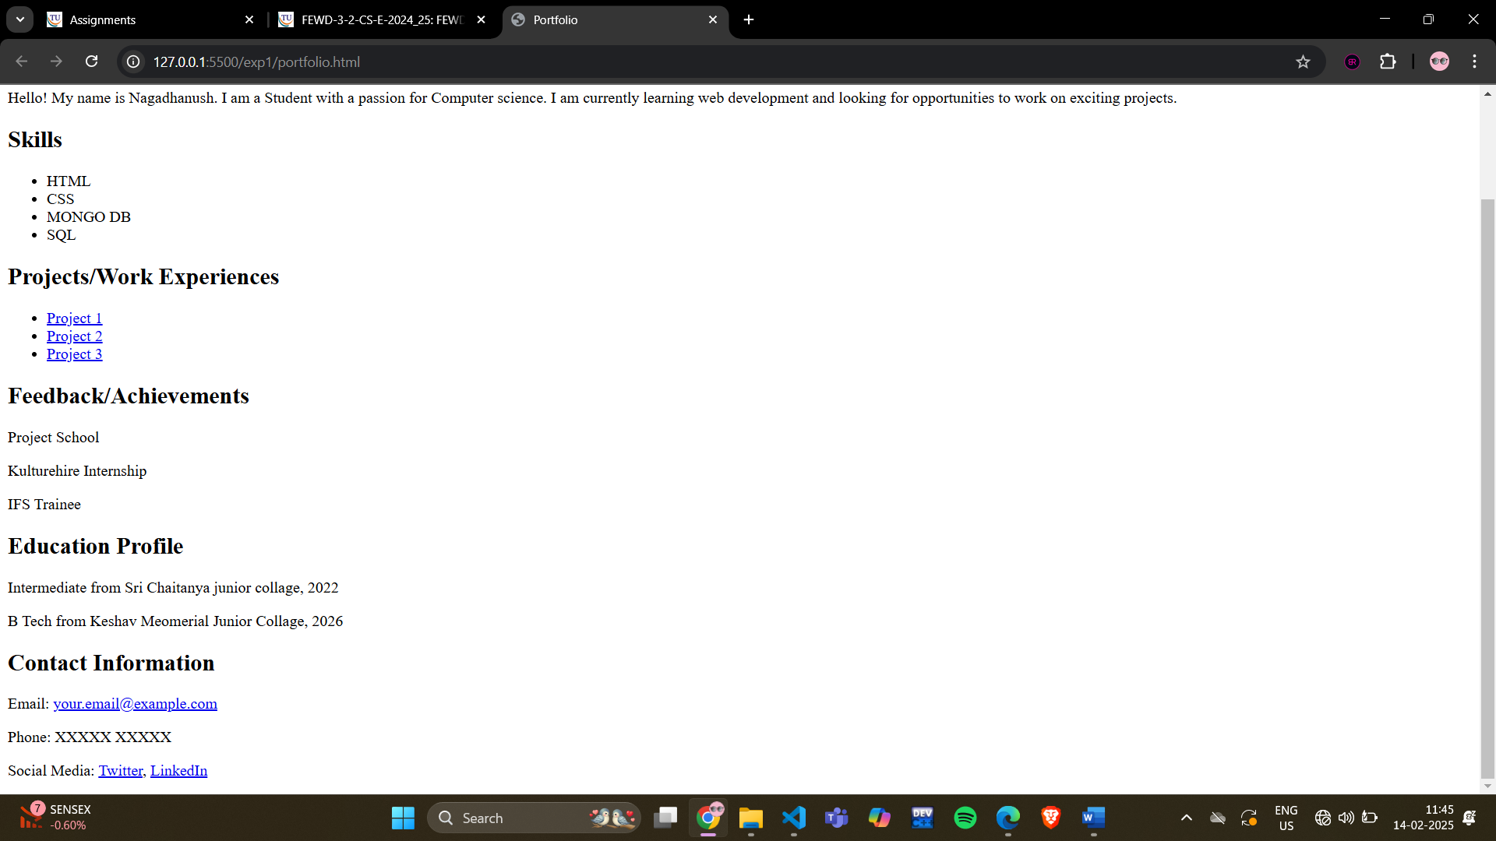

 github link here : https://github.com/nagadhanush23/fewdlab/blob/main/exp1/portfolio.html