**problem-1**

Create a Feedback form using HTML (With Internal CSS), it should contain

-> Name (optional)

-> Email(Optional)

-> phone (optional)

-> Rating

-> Any Questions regarding product or service.

-> Additional comments (optional)

-> Submit button

Note: once you create web page upload the page to Github account with public access

Code:navarbar.html

<!DOCTYPE html>

<html lang="en">

<head>

    <meta charset="UTF-8">

    <meta name="viewport" content="width=device-width, initial-scale=1.0">

    <title>Feedback Form</title>

    <style>

        body {

            font-family: Arial, sans-serif;

            margin: 10;

            padding: 0;

            height: 100vh;

            display: flex;

            justify-content: center;

            align-items: center;

            background-color: #f4f4f4;

        }

        .feedback-form {

            background: #fff;

            padding: 40px;

            border-radius: 10px;

            box-shadow: 0 0 10px rgba(0, 0, 0, 0.1);

            width: 350px;

            text-align: center;

        }

        .feedback-form h2 {

            margin-bottom: 20px;

        }

        .feedback-form label {

            display: block;

            margin-bottom: 5px;

        }

        .feedback-form input, .feedback-form textarea, .feedback-form select {

            width: 100%;

            padding: 10px;

            margin-bottom: 10px;

            border: 1px solid #ccc;

            border-radius: 3px;

        }

        .feedback-form button {

            background: #28a745;

            color: #fff;

            border: none;

            padding: 10px 15px;

            border-radius: 3px;

            cursor: pointer;

        }

        .feedback-form button:hover {

            background: #218838;

        }

    </style>

</head>

<body>

    <div class="feedback-form">

        <h2>Feedback Form</h2>

        <form action="#" method="post">

            <label for="name">Name (optional)</label>

            <input type="text" id="name" name="name">

            <label for="email">Email (optional)</label>

            <input type="email" id="email" name="email">

            <label for="phone">Phone (optional)</label>

            <input type="tel" id="phone" name="phone">

            <label for="rating">Rating</label>

            <select id="rating" name="rating" required>

                <option value="1">1 - Very Poor</option>

                <option value="2">2 - Poor</option>

                <option value="3">3 - Average</option>

                <option value="4">4 - Good</option>

                <option value="5">5 - Excellent</option>

            </select>

            <label for="questions">Any Questions regarding product or service</label>

            <textarea id="questions" name="questions" rows="4" required></textarea>

            <label for="comments">Additional comments (optional)</label>

            <textarea id="comments" name="comments" rows="4"></textarea>

            <button type="submit">Submit</button>

        </form>

    </div>

</body>

</html>

Output:

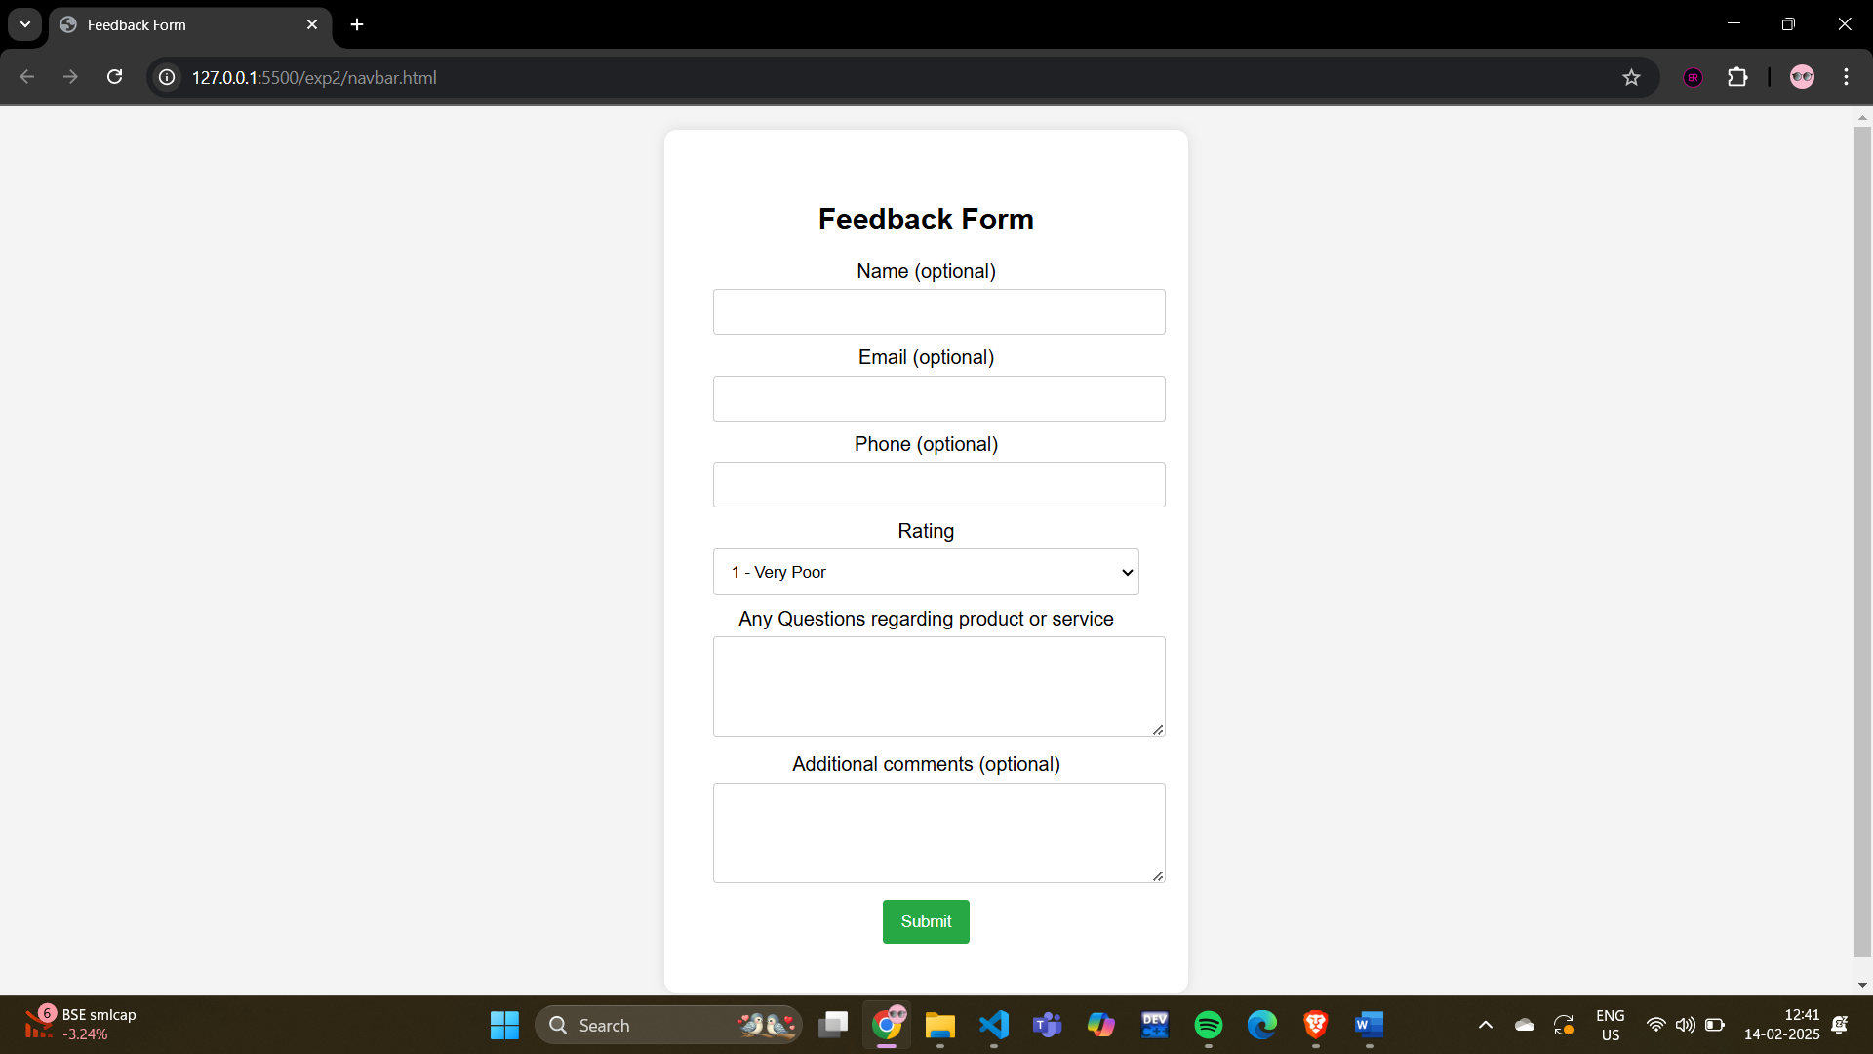

 and submit that github link here :

**Problem-2**

update a Portfolio page using internal CSS , it should contain

-> Self introduction

-> skills

-> projects/work experiences (Git links)

-> Feedback /achivements

-> Education profile

-> Contact information.(Social media /phone /email)

Note: add Internal CSS

Note: once you update the poftfolio page upload the page with neccesary documents to Github account with public access

Code:portfolio.html

<!DOCTYPE html>

<html lang="en">

<head>

    <meta charset="UTF-8">

    <meta name="viewport" content="width=device-width, initial-scale=1.0">

    <title>Portfolio</title>

    <style>

        body {

            font-family: Arial, sans-serif;

            margin: 0;

            padding: 0;

            background-color: #f4f4f4;

        }

        .container {

            width: 80%;

            margin: auto;

            overflow: hidden;

        }

        header {

            background: #806fbd;

            color: #fff;

            padding-top: 30px;

            min-height: 70px;

            border-bottom: #141414 3px solid;

        }

        header a {

            color: #fff;

            text-decoration: none;

            text-transform: uppercase;

            font-size: 16px;

        }

        header ul {

            padding: 0;

            list-style: none;

        }

        header li {

            float: left;

            display: inline;

            padding: 0 20px 0 20px;

        }

        header #branding {

            float: left;

        }

        header #branding h1 {

            margin: 0;

        }

        header nav {

            float: right;

            margin-top: 10px;

        }

        section {

            padding: 20px;

            margin: 20px 0;

            background: #fff;

        }

        h2 {

            color: #333;

        }

        .skills, .projects, .feedback, .education, .contact {

            margin-bottom: 20px;

        }

    </style>

</head>

<body>

    <header>

        <div class="container">

            <div id="branding">

                <h1>My Portfolio</h1>

            </div>

            <nav>

                <ul>

                    <li><a href="#introduction">Introduction</a></li>

                    <li><a href="#skills">Skills</a></li>

                    <li><a href="#projects">Projects</a></li>

                    <li><a href="#feedback">Feedback</a></li>

                    <li><a href="#education">Education</a></li>

                    <li><a href="#contact">Contact</a></li>

                </ul>

            </nav>

        </div>

    </header>

    <div class="container">

        <section id="introduction">

            <h2>Self Introduction</h2>

            <p>Hello! I am Nagadhanush, a passionate software developer with expertise in web development and a keen interest in learning new technologies.</p>

        </section>

        <section id="skills" class="skills">

            <h2>Skills</h2>

            <ul>

                <li>HTML, CSS, JavaScript</li>

                <li>React, Angular</li>

                <li>Node.js, Express</li>

                <li>Python, Django</li>

                <li>Git, GitHub</li>

            </ul>

        </section>

        <section id="projects" class="projects">

            <h2>Projects/Work Experiences</h2>

            <ul>

                <li><a href="https://github.com/yourusername/project1">Project 1</a></li>

                <li><a href="https://github.com/yourusername/project2">Project 2</a></li>

                <li><a href="https://github.com/yourusername/project3">Project 3</a></li>

            </ul>

        </section>

        <section id="feedback" class="feedback">

            <h2>Feedback/Achievements</h2>

            <p>Received positive feedback from clients for delivering high-quality projects on time.</p>

            <p>Awarded 'Best Developer' in XYZ Company for outstanding performance.</p>

        </section>

        <section id="education" class="education">

            <h2>Education Profile</h2>

            <p>Bachelor of Science in Computer Science, ABC University</p>

        </section>

        <section id="contact" class="contact">

            <h2>Contact Information</h2>

            <p>Email: yourname@example.com</p>

            <p>Phone: XXXXX XXXXX</p>

            <p>LinkedIn: <a href="https://linkedin.com/in/yourprofile">linkedin.com/in/yourprofile</a></p>

            <p>GitHub: <a href="https://github.com/yourusername">github.com/yourusername</a></p>

        </section>

    </div>

</body>

</html></html>

Output: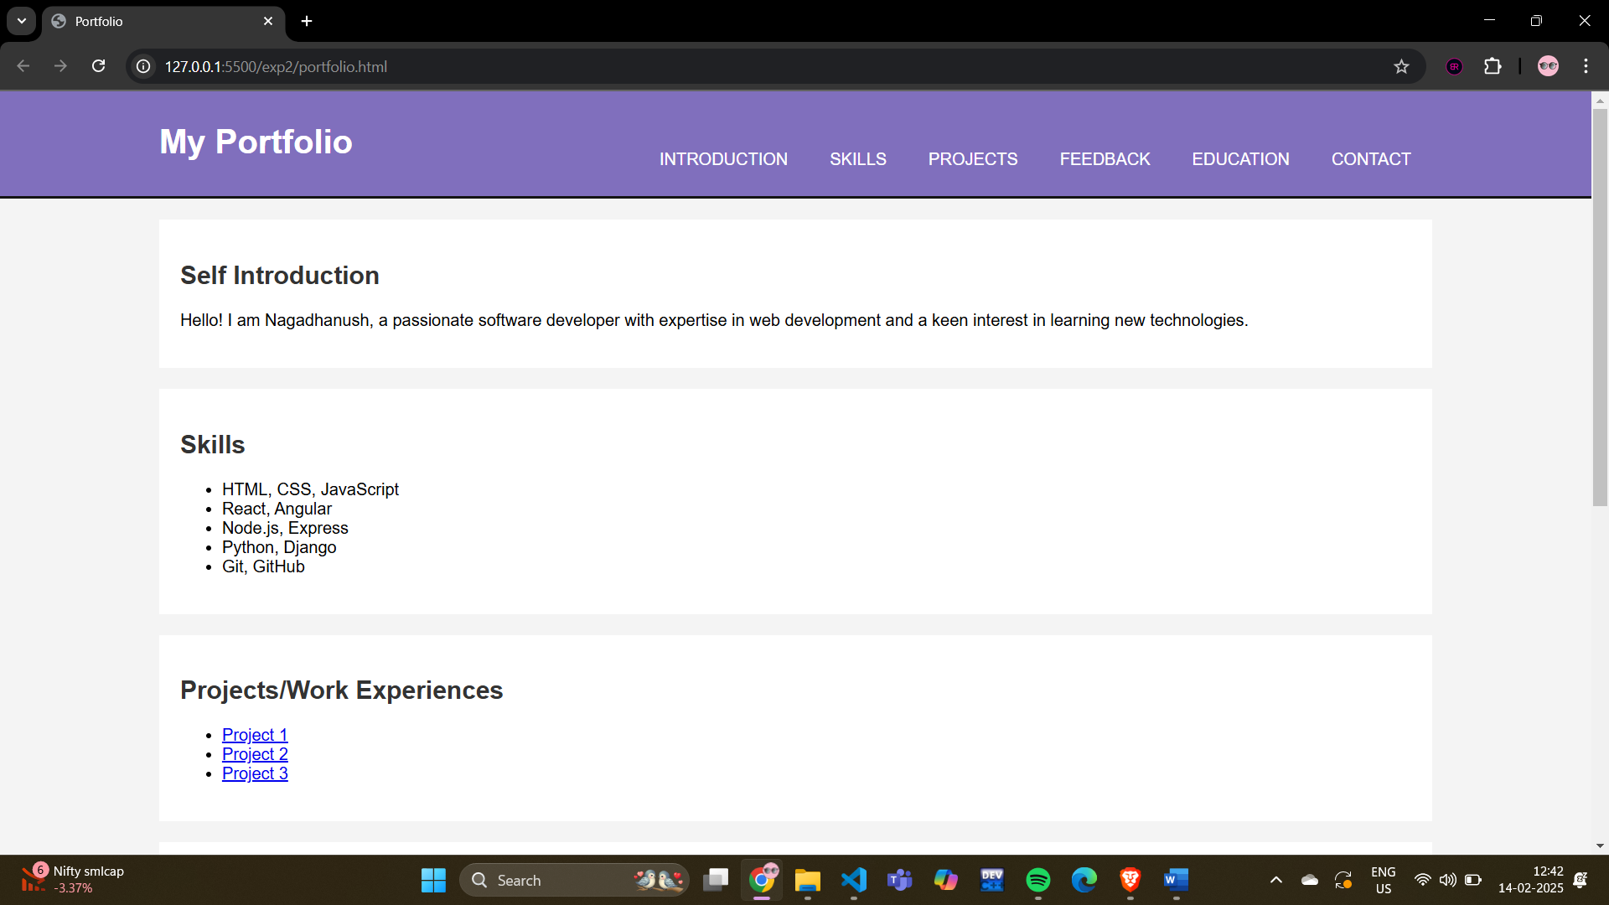

and submit that github link here :

**problem-3**

Update the both (feedback and portfolio) pages with external css.

Note: once you update the poftfolio and Feedback pages  upload the page with neccesary document to Github account with public access

Navbar using external css:

File name: navbarex.html

<!DOCTYPE html>

<html lang="en">

<head>

    <meta charset="UTF-8">

    <meta name="viewport" content="width=device-width, initial-scale=1.0">

    <title>Feedback Form</title>

    <link rel="stylesheet" href="style1.css">

</head>

<body>

    <div class="feedback-form">

        <h2>Feedback Form</h2>

        <form action="#" method="post">

            <label for="name">Name (optional)</label>

            <input type="text" id="name" name="name">

            <label for="email">Email (optional)</label>

            <input type="email" id="email" name="email">

            <label for="phone">Phone (optional)</label>

            <input type="tel" id="phone" name="phone">

            <label for="rating">Rating</label>

            <select id="rating" name="rating" required>

                <option value="1">1 - Very Poor</option>

                <option value="2">2 - Poor</option>

                <option value="3">3 - Average</option>

                <option value="4">4 - Good</option>

                <option value="5">5 - Excellent</option>

            </select>

            <label for="questions">Any Questions regarding product or service</label>

            <textarea id="questions" name="questions" rows="4" required></textarea>

            <label for="comments">Additional comments (optional)</label>

            <textarea id="comments" name="comments" rows="4"></textarea>

            <button type="submit">Submit</button>

        </form>

    </div>

</body>

</html>

Filename: style1.css

body {

    font-family: Arial, sans-serif;

    margin: 0;

    padding: 0;

    height: 100vh;

    display: flex;

    justify-content: center;

    align-items: center;

    background-color: #f4f4f4;

}

.feedback-form {

    background: #fff;

    padding: 40px;

    border-radius: 10px;

    box-shadow: 0 0 10px rgba(0, 0, 0, 0.1);

    width: 350px;

    text-align: center;

}

.feedback-form h2 {

    margin-bottom: 20px;

}

.feedback-form label {

    display: block;

    margin-bottom: 5px;

}

.feedback-form input,

.feedback-form textarea,

.feedback-form select {

    width: 100%;

    padding: 10px;

    margin-bottom: 10px;

    border: 1px solid #ccc;

    border-radius: 3px;

}

.feedback-form button {

    background: #28a745;

    color: #fff;

    border: none;

    padding: 10px 15px;

    border-radius: 3px;

    cursor: pointer;

}

.feedback-form button:hover {

    background: #218838;

}

Output:

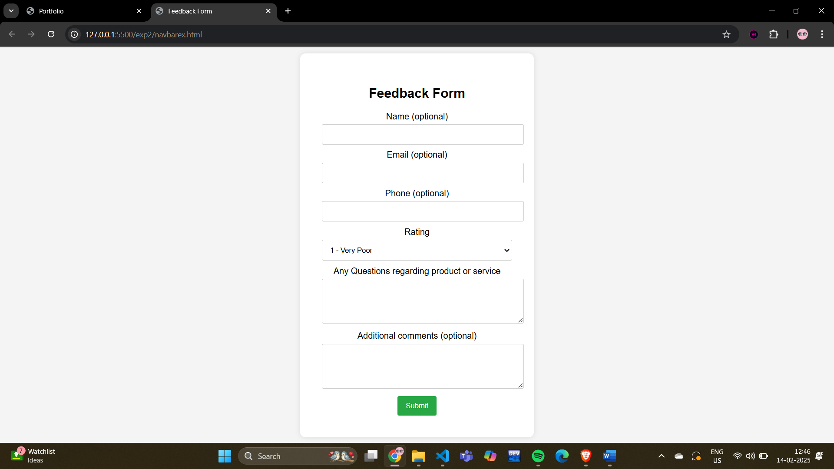

Portfolio using external.css

Filename: portfolioex.html

<!DOCTYPE html>

<html lang="en">

<head>

    <meta charset="UTF-8">

    <meta name="viewport" content="width=device-width, initial-scale=1.0">

    <title>Portfolio</title>

    <link rel="stylesheet" href="style2.css">

</head>

<body>

    <header>

        <div class="container">

            <div id="branding">

                <h1>My Portfolio</h1>

            </div>

            <nav>

                <ul>

                    <li><a href="#introduction">Introduction</a></li>

                    <li><a href="#skills">Skills</a></li>

                    <li><a href="#projects">Projects</a></li>

                    <li><a href="#feedback">Feedback</a></li>

                    <li><a href="#education">Education</a></li>

                    <li><a href="#contact">Contact</a></li>

                </ul>

            </nav>

        </div>

    </header>

    <div class="container">

        <section id="introduction">

            <h2>Self Introduction</h2>

            <p>Hello! I am Nagadhanush, a passionate software developer with expertise in web development and a keen interest in learning new technologies.</p>

        </section>

        <section id="skills" class="skills">

            <h2>Skills</h2>

            <ul>

                <li>HTML, CSS, JavaScript</li>

                <li>React, Angular</li>

                <li>Node.js, Express</li>

                <li>Python, Django</li>

                <li>Git, GitHub</li>

            </ul>

        </section>

        <section id="projects" class="projects">

            <h2>Projects/Work Experiences</h2>

            <ul>

                <li><a href="https://github.com/yourusername/project1">Project 1</a></li>

                <li><a href="https://github.com/yourusername/project2">Project 2</a></li>

                <li><a href="https://github.com/yourusername/project3">Project 3</a></li>

            </ul>

        </section>

        <section id="feedback" class="feedback">

            <h2>Feedback/Achievements</h2>

            <p>Received positive feedback from clients for delivering high-quality projects on time.</p>

            <p>Awarded 'Best Developer' in XYZ Company for outstanding performance.</p>

        </section>

        <section id="education" class="education">

            <h2>Education Profile</h2>

            <p>Bachelor of Science in Computer Science, ABC University</p>

        </section>

        <section id="contact" class="contact">

            <h2>Contact Information</h2>

            <p>Email: yourname@example.com</p>

            <p>Phone: XXXXX XXXXX</p>

            <p>LinkedIn: <a href="https://linkedin.com/in/yourprofile">linkedin.com/in/yourprofile</a></p>

            <p>GitHub: <a href="https://github.com/yourusername">github.com/yourusername</a></p>

        </section>

    </div>

</body>

</html>

Filename: style2.css

body {

    font-family: Arial, sans-serif;

    margin: 0;

    padding: 0;

    background-color: #f4f4f4;

}

.container {

    width: 80%;

    margin: auto;

    overflow: hidden;

}

header {

    background: #806fbd;

    color: #fff;

    padding-top: 30px;

    min-height: 70px;

    border-bottom: #141414 3px solid;

}

header a {

    color: #fff;

    text-decoration: none;

    text-transform: uppercase;

    font-size: 16px;

}

header ul {

    padding: 0;

    list-style: none;

}

header li {

    float: left;

    display: inline;

    padding: 0 20px;

}

header #branding {

    float: left;

}

header #branding h1 {

    margin: 0;

}

header nav {

    float: right;

    margin-top: 10px;

}

section {

    padding: 20px;

    margin: 20px 0;

    background: #fff;

}

h2 {

    color: #333;

}

.skills, .projects, .feedback, .education, .contact {

    margin-bottom: 20px;

}

Output:

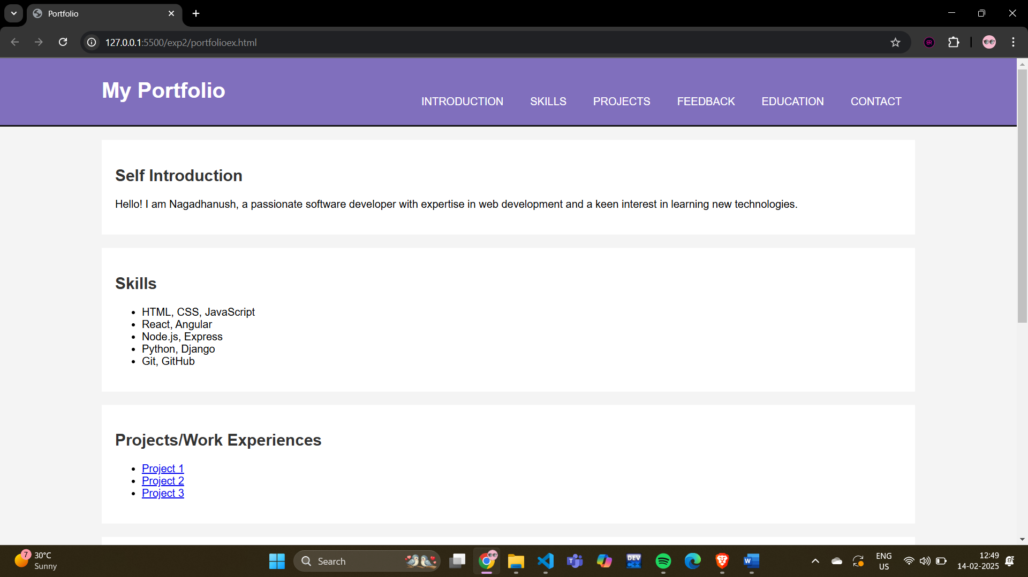

Git hub link: