**HTML FILE:** **analysis_report.HTML**

**OUTPUT: HTML FILE**

**Data Analysis Report**

**1. Columns with Missing Values**

* STATE
* TENURE_IN_MONTHS
* CLOSESTSTOREDISTANCE
* AGE
* INCOME
* LENGTH OF RESIDENCE
* NUMBER OF PERSONS IN LIVING UNIT
* NUMBER OF ADULTS IN LIVING UNIT
* MOSAIC
* CAPE: AGE: POP: MEDIAN AGE
* CAPE: AGE: POP: % 0-17
* CAPE: AGE: POP: % 18-99+
* CAPE: AGE: POP: % 65-99+
* CAPE: ETHNIC: POP: % WHITE ONLY
* CAPE: ETHNIC: POP: % BLACK ONLY
* CAPE: ETHNIC: POP: % ASIAN ONLY
* CAPE: ETHNIC: POP: % HISPANIC
* CAPE: DENSITY: PERSONS PER HH FOR POP IN HH
* CAPE: HHSIZE: HH: AVERAGE HOUSEHOLD SIZE
* CAPE: TYP: HH: % MARRIED COUPLE FAMILY
* CAPE: CHILD: HH: % WITH PERSONS LT18
* CAPE: CHILD: HH: % MARR COUPLE FAMW- PERSONS LT18
* CAPE: CHILD: HH: % MARR COUPLE FAMW-O PERSONS LT18
* CAPE: LANG: HH: % SPANISH SPEAKING
* CAPE: EDUC: POP25+: MEDIAN EDUCATION ATTAINED
* CAPE: HOMVAL: OOHU: MEDIAN HOME VALUE
* CAPE: BUILT: HU: MEDIAN HOUSING UNIT AGE
* CAPE: TENANCY: OCCHU: % OWNER OCCUPIED
* CAPE: TENANCY: OCCHU: % RENTER OCCUPIED
* CAPE: EDUC: ISPSA
* CAPE: EDUC: ISPSA DECILE
* CAPE: INC: FAMILY INC STATE DECILE
* CAPE: INC: HH: MEDIAN FAMILY HOUSEHOLD INCOME

**2. Numeric Columns**

* CUSTOMERID
* LCPCOUNT
* TENURE_IN_MONTHS
* CLOSESTSTOREDISTANCE
* FEMALE
* AGE
* HS_DIPLOMA
* SOME_COLLEGE
* BACH_GRAD_DEG
* LT_HS_DIPLOMA
* MARRIED
* MNGMNT_OFFICEADMIN
* TECH_PROF
* SALES_JOB
* BLUE_COLLAR
* FARMER
* RETIRED
* SFDU
* MFDU
* HOMEOWNER
* INCOME
* MAIL_RESP_MULTI
* MAIL_RESP_SINGLE
* LENGTH OF RESIDENCE
* NUMBER OF PERSONS IN LIVING UNIT
* NUMBER OF ADULTS IN LIVING UNIT
* METRO
* URBAN
* MOR BANK: UPSCALE MERCHANDISE BUYER
* MOR BANK: MALE MERCHANDISE BUYER
* MOR BANK: FEMALE MERCHANDISE BUYER
* MOR BANK: CRAFTS-HOBBY MERCHANDISE BUYER
* MOR BANK: GARDENING-FARMING BUYER
* MOR BANK: BOOK BUYER
* MOR BANK: COLLECT-SPECIAL FOODS BUYER
* MOR BANK: GIFTS AND GADGETS BUYER
* MOR BANK: GENERAL MERCHANDISE BUYER
* MOR BANK: FAMILY AND GENERAL MAGAZINE
* MOR BANK: FEMALE ORIENTED MAGAZINE
* MOR BANK: MALE SPORTS MAGAZINE
* MOR BANK: RELIGIOUS MAGAZINE
* MOR BANK: GARDENING-FARMING MAGAZINE
* MOR BANK: CULINARY INTERESTS MAGAZINE
* MOR BANK: HEALTH AND FITNESS MAGAZINE
* MOR BANK: DO-IT-YOURSELFERS
* MOR BANK: NEWS AND FINANCIAL
* MOR BANK: PHOTOGRAPHY
* MOR BANK: OPPORTUNITY SEEKERS AND CE
* MOR BANK: RELIGIOUS CONTRIBUTOR
* MOR BANK: POLITICAL CONTRIBUTOR
* MOR BANK: HEALTH AND INSTITUTION CONTRIBUTOR
* MOR BANK: GENERAL CONTRIBUTOR
* MOR BANK: MISCELLANEOUS
* MOR BANK: ODDS AND ENDS
* MOR BANK: DEDUPED CATEGORY HIT COUNT
* MOR BANK: NON-DEDUPED CATEGORY HIT COUNT
* MORTGAGE-HOME PURCHASE: HOME PURCHASE PRICE
* CHILDREN
* CAPE: AGE: POP: MEDIAN AGE
* CAPE: AGE: POP: % 0-17
* CAPE: AGE: POP: % 18-99+
* CAPE: AGE: POP: % 65-99+
* CAPE: ETHNIC: POP: % WHITE ONLY
* CAPE: ETHNIC: POP: % BLACK ONLY
* CAPE: ETHNIC: POP: % ASIAN ONLY
* CAPE: ETHNIC: POP: % HISPANIC
* CAPE: DENSITY: PERSONS PER HH FOR POP IN HH
* CAPE: HHSIZE: HH: AVERAGE HOUSEHOLD SIZE
* CAPE: TYP: HH: % MARRIED COUPLE FAMILY
* CAPE: CHILD: HH: % WITH PERSONS LT18
* CAPE: CHILD: HH: % MARR COUPLE FAMW- PERSONS LT18
* CAPE: CHILD: HH: % MARR COUPLE FAMW-O PERSONS LT18
* CAPE: LANG: HH: % SPANISH SPEAKING
* CAPE: EDUC: POP25+: MEDIAN EDUCATION ATTAINED
* CAPE: HOMVAL: OOHU: MEDIAN HOME VALUE
* CAPE: BUILT: HU: MEDIAN HOUSING UNIT AGE
* CAPE: TENANCY: OCCHU: % OWNER OCCUPIED
* CAPE: TENANCY: OCCHU: % RENTER OCCUPIED
* CAPE: EDUC: ISPSA
* CAPE: EDUC: ISPSA DECILE
* CAPE: INC: FAMILY INC STATE DECILE
* CAPE: INC: HH: MEDIAN FAMILY HOUSEHOLD INCOME
* FREQUENCY
* QUANTITY
* TOTALSALES
* FREQUENCY_2Y
* QUANTITY_2Y
* TOTALSALES_2Y
* 1-Engagement Spend
* 2-Wedding Bands Spend
* 3-Fashion Diamonds Spend
* 4-Fashion Jewelry Spend
* 5-Close Out Spend
* 6-Promotional Items Spend
* 7-Cost Only Spend
* 8-Marketing Premium SKUs Spend
* 9-Repairs & Appraisals Spend
* 10-Pre Owned Spend
* 11-Watches Spend
* 12-Misc Merchandise Spend
* 15-Store Events Spend
* 16-Single Stone Jewelry Spend
* MDAYREV_L1Y
* MDAYREV_L2Y
* MDAYREV_L3Y
* MDAYREV_L4Y
* MDAYQTY_L1Y
* MDAYQTY_L2Y
* MDAYQTY_L3Y
* MDAYQTY_L4Y
* MDAYSHOPPER_L1Y
* MDAYSHOPPER_L2Y
* MDAYSHOPPER_L3Y
* MDAYSHOPPER_L4Y

**3. Categorical Columns**

* STATE
* PRIVATELABELTENDERFLAG
* MOSAIC

**4. Duplicate Columns**

['CHILDREN', 'CAPE: HHSIZE: HH: AVERAGE HOUSEHOLD SIZE', '7-Cost Only Spend']

**5. Constant Columns**

['MARRIED', 'CHILDREN', '7-Cost Only Spend']

**6. Boxplots**

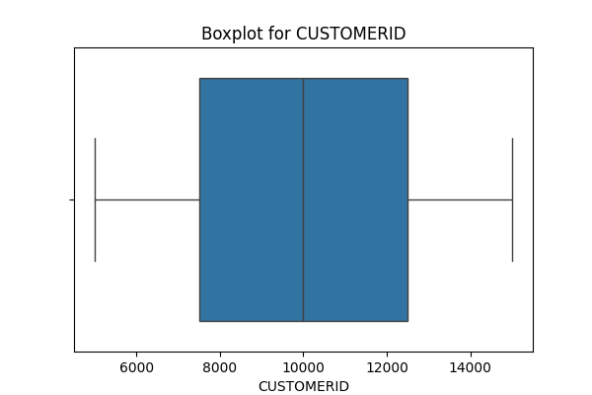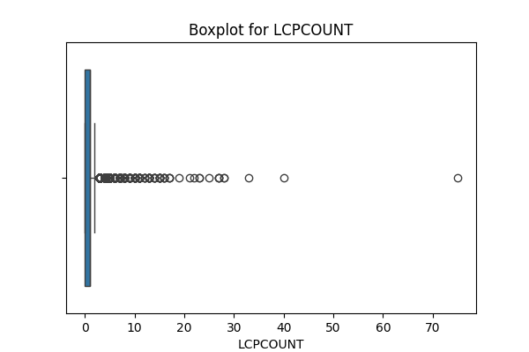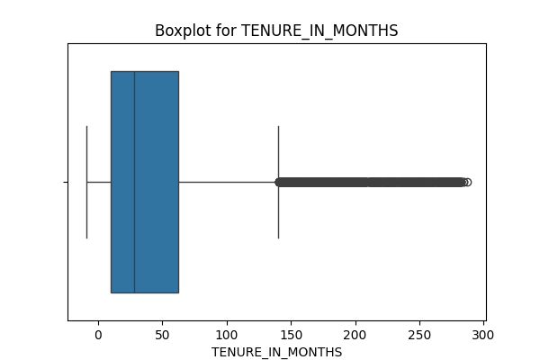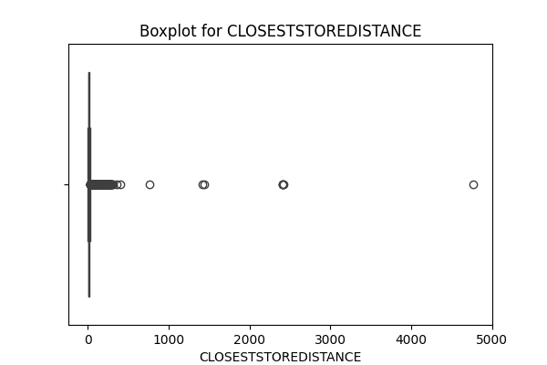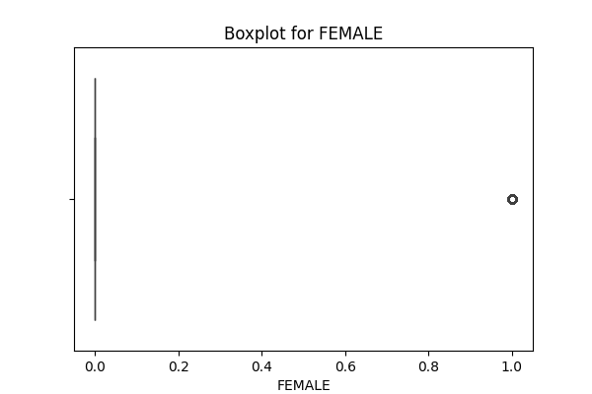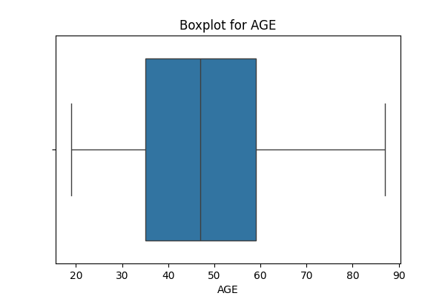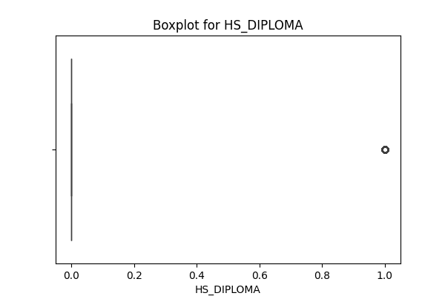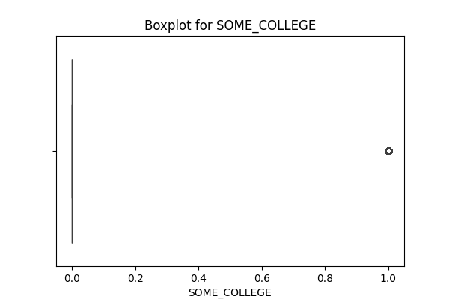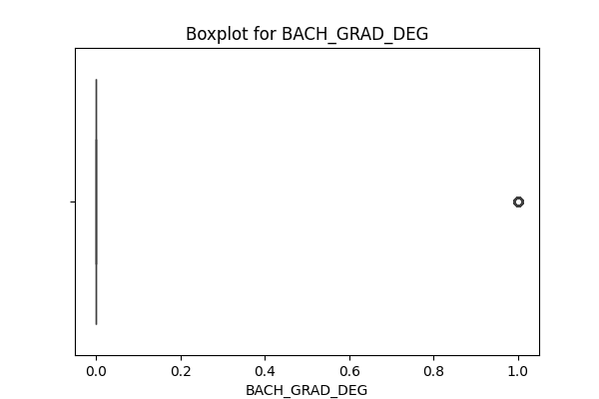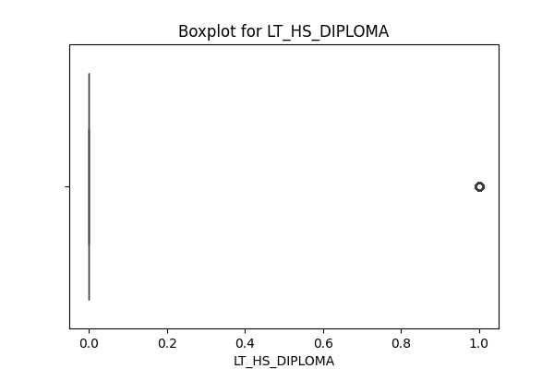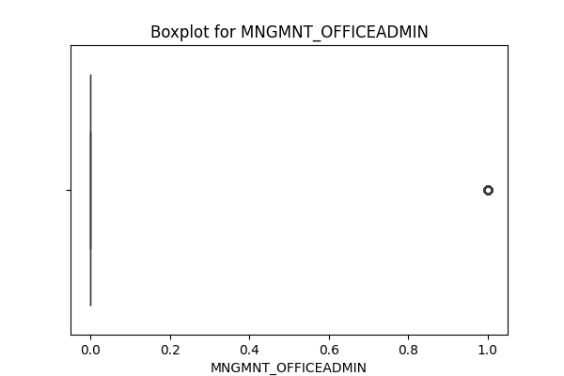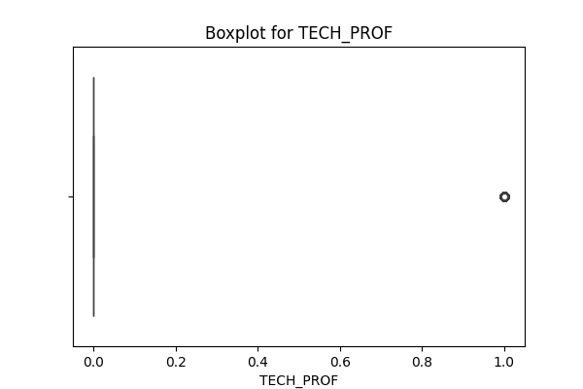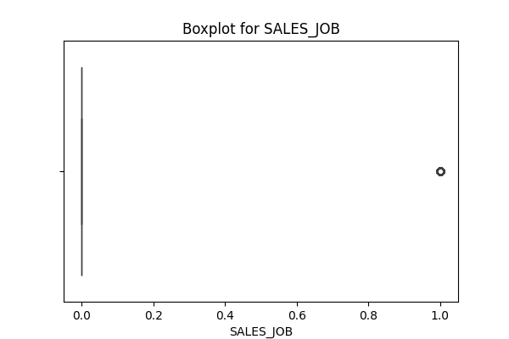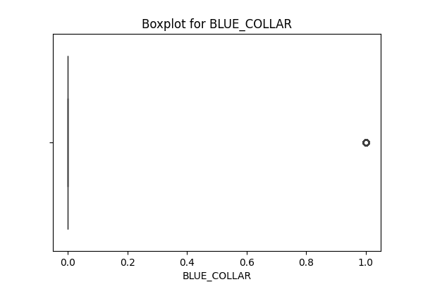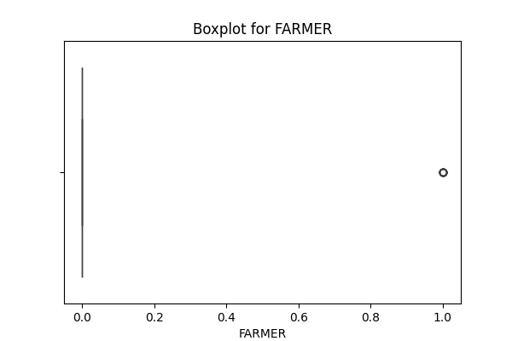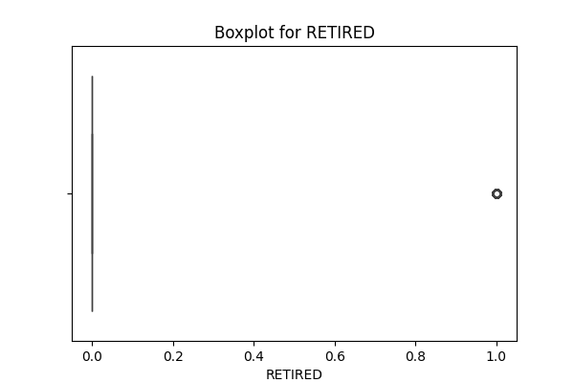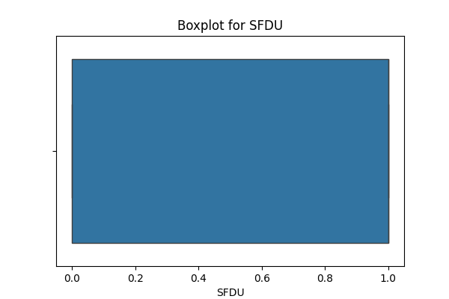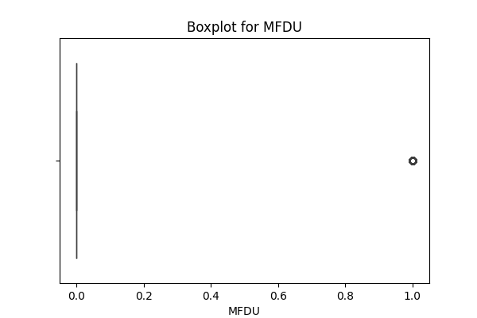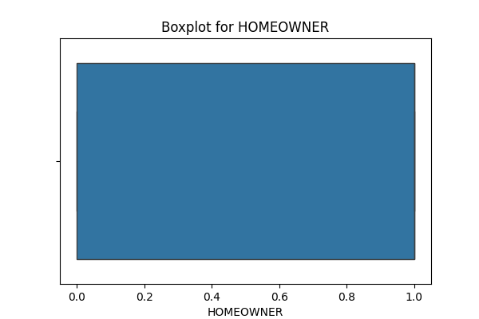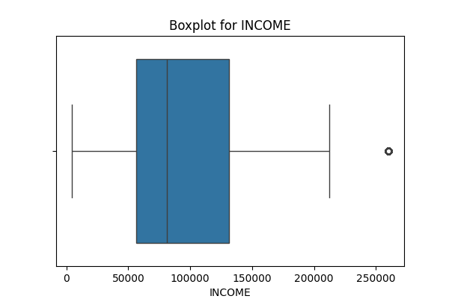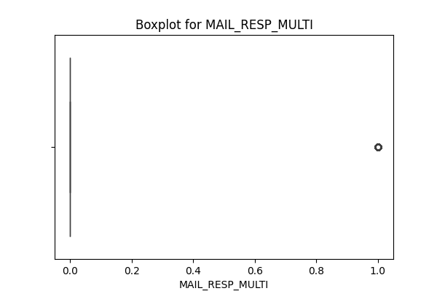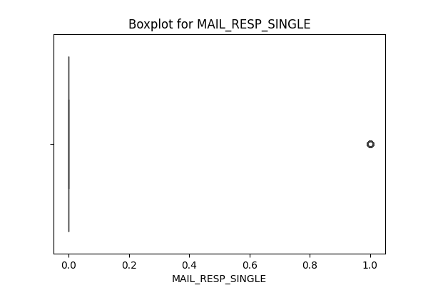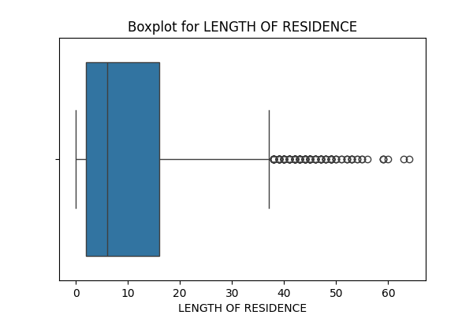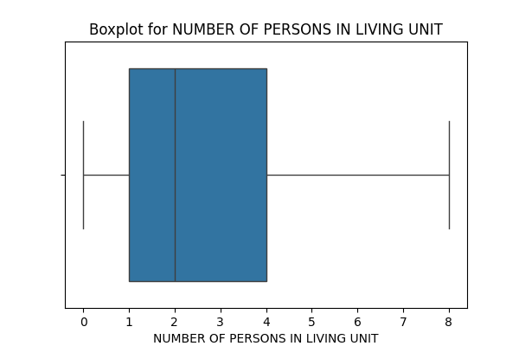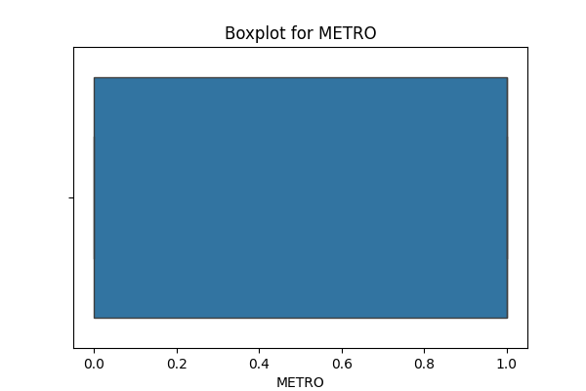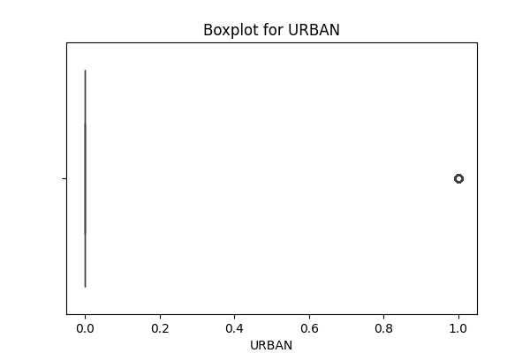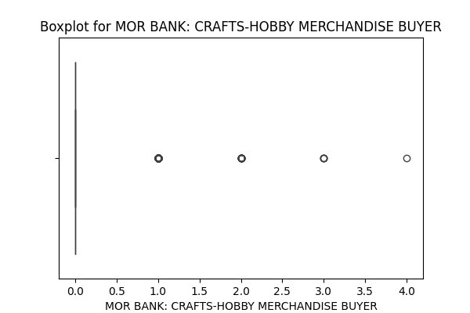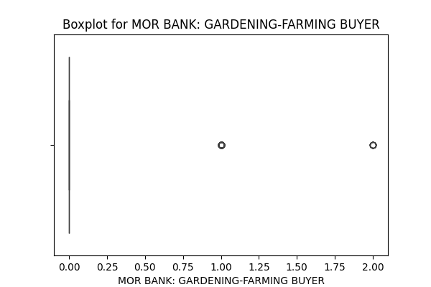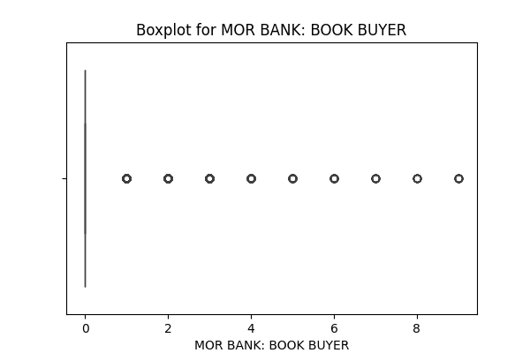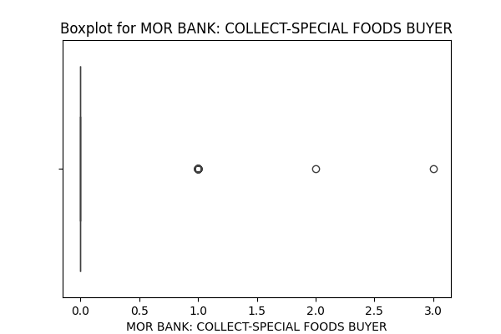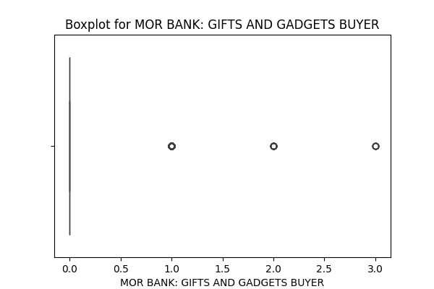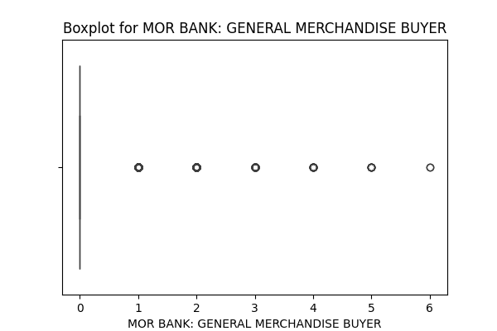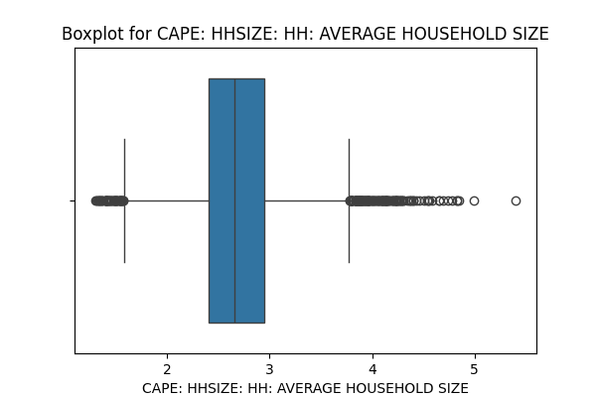

**7. Distributions**

