**DBMS Project Report Guidelines**

**NUMBER OF COPIES:**

* **Prepare 1 copy for department (per group) and submit it to your respected Lab in-charge.**
* **Submit soft copy of your project to your guide (including report and project) for necessary evaluation.**
* **Other copies are to be prepared as per the need of student.**
* **Student have to submit report copy in plastic/paper strip file or spiral bound.**

A

Project Report

on

**Project Title**

Developed by

**All Names**

**(Name, branch & Institute**

**For example)**

**XYZ – Department of IT, DD University**

**XYZ1- Department of IT, DD University**

**Guided By**

**Internal Guide:**

**Name**

**Department of Information Technology**

**Faculty of Technology**

**DD University**



**Department of Information Technology**

**Faculty of Technology, Dharmsinh Desai University**

**College Road, Nadiad-387001**

**October - 2018**

## **DHARMSINH DESAI UNIVERSITY**

## **NADIAD-387001, GUJARAT**



## **CERTIFICATE**

### This is to certify that the project entitled “ ________________________________

__________________________________” is a bonafied report of the work carried out by Mr./Miss/ _________________, Student ID No: _______ of Department of Information Technology, semester V, under the guidance and supervision for the subject Database Management System. He/She was involved in Project during academic year 2018-2019.

Prof. Roshni M. Raval / Prof. Sunil K. Vithlani

(Project Guide)

Department of Information Technology,

Faculty of Technology,

Dharmsinh Desai University, Nadiad

Date:

Prof. Vipul Dabhi

Head , Department of Information Technology,

Faculty of Technology,

Dharmsinh Desai University, Nadiad

## Date:

## **DHARMSINH DESAI UNIVERSITY**

## **NADIAD-387001, GUJARAT**



## **CERTIFICATE**

### This is to certify that the project entitled “ ________________________________

__________________________________” is a bonafied report of the work carried out by

1) Mr./Miss/ _________________, Student ID No: _______

2) Mr./Miss/ _________________, Student ID No: _______

of Department of Information Technology, semester V, under the guidance and supervision for the subject Database Management System. They were involved in Project training during academic year 2018-2019..

Prof. Roshni M. Raval / Prof. Sunil K. Vithlani

(Project Guide)

Department of Information Technology,

Faculty of Technology,

Dharmsinh Desai University, Nadiad

Date:

Prof. Vipul Dabhi

Head , Department of Information Technology,

Faculty of Technology,

Dharmsinh Desai University, Nadiad

## Date:

**ACKNOWLEDGEMENT**

1. **TABLE OF CONTENTS**

**I. Certificate I**

**II. Acknowledgement II**

**1. SYSTEM OVERVIEW 1**

1.1 Current system 2

1.2 Objectives of the Proposed System 3

1.3 Advantages of the Proposed system (over current) 4

**2. E-R DIAGRAM 5**

2.1 Entities…………………………………………………………………………..5

2.2 Relationships……………………………………………………………………6

2.3 Mapping Constraints……………………………………………………………6

**3. DATA DICTIONARY 7**

**4. SCHEMA DIAGRAM 8**

**5. DATABASE IMPLEMENTION 9**

5.1 Create Schema 9

5.2 Insert Data values 9

5.3 Queries (Based on functions, group by, having, joins, sub query etc.) 10

5.4 PL/SQL Blocks (Procedures and Functions) 10

5.5 Views 11

5.6 Triggers 12

5.7 Cursors. 13

**6. FUTURE ENHANCEMENTS OF THE SYSTEM 14**

**7. BIBLIOGRAPHY 15**

**PAPER: Use A4 SIZE Paper.**

**MARGINS: Margins for pages including the regular text should be as below:**

**Left: 1.5 Inches**

**Right: 1.0 Inch**

**Top: 1.0 Inch**

**Bottom: 1.0 Inch**

**FOLLOWING MUST BE STRICTLY FOLLOWED**

TOP-RIGHT CORNER : Contains the chapter heading

TOP-LEFT CORNER : Contains the Project Name

BOTTOM-LEFT CORNER : Contains “ DDU (Faculty of Tech., Dept. of IT)”.

BOTTOM- RIGHT CORNER : Contains the page number

**NUMBERING**

All pages in the report except the cover pages and dedication page must be numbered. All the page numbers should be located at the BOTTOM RIGHT of the page.

The page numbering starting from certificate up to the beginning of the chapters should be numbered in small roman letters, i.e. i, ii, …

The page numbering starting from the beginning of Chapter 1 up to the end of the report, should be numbered in Arabic numerals, i.e. 1,2, 3,….

**PREPARATION OF CHAPTERS**

**Color:**  All the text including Tables should be Black prints. However, Graphs and Figures can have color prints.

**Font :**

**Chapter Headings** : Times New Roman 16pts, bold print all capitals

**Section Headings :** Times New Roman 14 pts, bold print all capitals

**Subsection Headings :** Times New Roman 12 pts, bold print leading capitals (only first letter in each word should be capital

**Regular Text :** Times New Roman 12 pts, normal prints

**Special Text :** Times New Roman Italics 12 pts (for foot notes, symbols, quotes, Mathematical notations….)

**SPACING/ALIGNMENT**

Use Single spacing between lines of regular text

Use double spacing between :

1. Paragraphs
2. Chapter title and section Heading
3. Section heading and paragraphs

Use double spacing between :

1. Table Title and Table
2. Figure Title and Figure

Use single spacing between text corresponding to bullets, listing and quotes in the main body of text.

All paragraphs in the report are to be fully justified from the first line to the last line and should start from left without any hyphenation/indent. Text corresponding to bullets, listings and quotes in the main body of text should be indented.

**SECTION/SUBSECTION NUMBERING**

Section numbering should be left justified using bold print with Arabic numerals and decimals.

Section numbering: <Chapter.Section number> <3 blanks> Section heading

Example : 1.1, 2.1

Subsection numbering: <Chapter.Subsectionnumber>

Example : 1.2.1

**EQUATIONS/FORMULAS**

Numbering for equation if necessary, should be done in the following format:

(Chapter number. Section number. Equation serial number)

Example:

Y= mx + b (3.1.1)

**FIGURES:**

Figures should follow immediately after/on immediate next page after they are referred to for the first time in the text. Figure headings should be given at the bottom of the figure. All the figures in landscape format must be placed in such a way that their top portions are to the left side of the page. However, numbering should be at the bottom of the report for landscape page (similar to the next page). All figures are to be central aligned on the page.

Format for Figure Heading:

Fig. <blank> Chapter number. Serial number <3 blanks> Figure title (center aligned, leading caps)

Example: 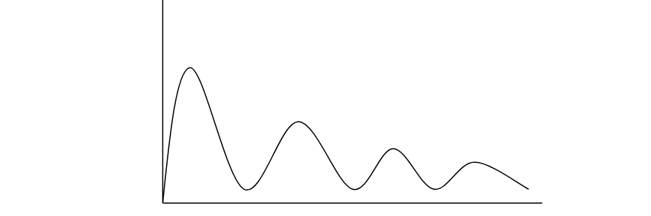

Fig 6.13 Typical Component Event

**DIAGRAMS:**

Diagrams larger than A4 size are not encouraged. If larger sizes are absolutely necessary, they should be folded to A4 size. Each drawing is to be numbered and referred to as Figures only. Diagram title should be similar to figure titles.

**TABLES:**

Tables should follow immediately after/on immediate next page after they are referred to for the first time in the text. Table heading should be given at the top of the table. All the tables in landscape format must be placed in such a way that their top portions are to the left side of the page. However, numbering should be at the bottom of the report for landscape page. All tables are to be central aligned on the page.

Format for Table heading:

Table <blank> Chapter number. Serial number <3 blanks> Table Title (Left aligned, leading caps)

Example:

Table 6.13 Comparison of methods

|  |  |  |
| --- | --- | --- |
|  |  |  |
|  |  |  |