Vulnerability Analysis and Penetration Testing Report
Assessment Date: 5th August 2026 | Assessor: Nagaditya
Target Host: 192.168.29.214(SUNSET O.S)

Table of Contents
1. Executive Summary
2. Background
3. Objectives
4. Scope of Assessment
5. Out of Scope
6. Tools Used
7. Summary of Findings
8. Testing Methodology & Technical Findings
8.1 Information Gathering & Port Scanning
8.2 Unauthenticated Anonymous FTP Access
8.3 Exposure of Sensitive Backup File & Password Hashes
8.4 Weak Password Hashing & Credential Cracking
9. Risk Assessment & Recommendations

1. Executive Summary
The purpose of this Web & System Security Assessment was to identify exploitable vulnerabilities and insufficiently configured security controls to determine the likelihood that users with considerable, little, or no prior knowledge of the applications (e.g., informed and uninformed insiders or outsiders) could exploit weaknesses cataloged in standards such as the OWASP Top 10, OWASP ASVS, SANS, NIST, and the Penetration Testing Execution Standard (PTES).
The assessment included a review of security controls and operational configurations. The testing leveraged automated discovery tools alongside in-depth manual analysis. The results contained in this document reflect the security posture at a specific point in time.
2. Background
This exercise aimed to perform Penetration Testing of the applications and network services in scope to determine if they were vulnerable to unauthorized access and exploitation. The test consisted of active enumeration, service analysis, and manual exploitation verification.
The assessment was conducted on 4th August 2026 to propose remediation steps for identified security vulnerabilities.
3. Objectives
The primary objectives of this assessment were to:
- Identify possible vulnerabilities and security gaps within the host services.
- Assess identified gaps to determine overall operational and security risk.
- Provide technical proof-of-concept evidence and actionable remediation steps.
4. Scope of Assessment
The scope for this assessment included the following activities:
- Network Reconnaissance & Port Scanning
- Service Identification & Vulnerability Analysis
- Authentication & Access Control Assessment
- Target Host: 192.168.29.214

5. Out of Scope
The following activities were explicitly excluded from this engagement:
- Denial of Service (DoS / DDoS) testing
- Intrusive destructive testing or modification of production data
- Social engineering or physical security testing
6. Tools Used
- Nmap (Network Mapper & Service Enumeration)
- Kali Linux (Penetration Testing Operating System)
- pyftpdlib / FTP Client (Service Interaction)
- John the Ripper (Offline Credential Recovery & Hash Analysis)
7. Summary of Findings
 | Finding Name | Severity | Risk Score | Status
01 | Weak Password Storage & Vulnerable Credentials | Critical | 9.1 | Confirmed
02 | Sensitive Information Exposure | High | 8.0 | Confirmed
03 | Anonymous FTP Access Allowed | High | 7.5 | Confirmed

8. Testing Methodology & Technical Findings
8.1 Information Gathering & Port Scanning
Scan was executed using Nmap against target host 192.168.29.214 to identify open ports, running services.
- Port 21/tcp: Running pyftpdlib 1.5.5 (FTP) with Anonymous FTP login allowed .
- Port 22/tcp: Running OpenSSH 7.9p1 Debian 10.
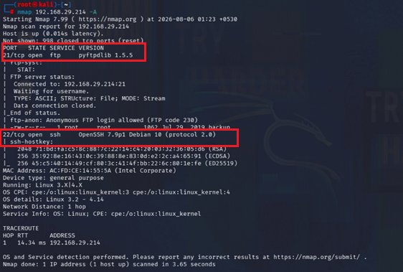
8.2 Unauthenticated Anonymous FTP Access
Enumeration of port 21 confirmed that the FTP server allows unauthenticated connections using the anonymous username.
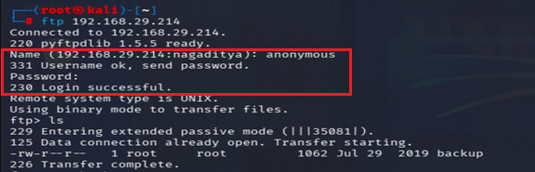
8.3 Exposure of Sensitive Backup File & Password Hashes
Using the anonymous FTP connection, the file backup was downloaded.
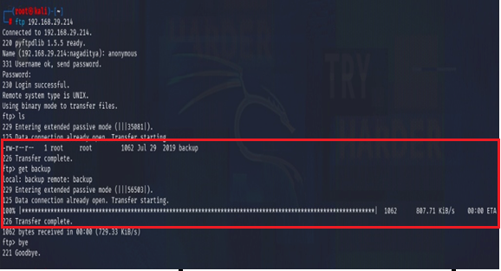
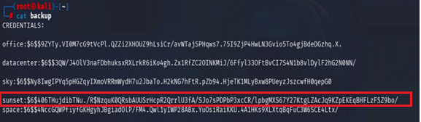

8.4 Weak Password Hashing & Credential Cracking
The extracted password hashes were passed to John the Ripper (john pass.txt) for offline dictionary analysis.
Result: The hash for one of the target user accounts was successfully cracked in 5 minutes, revealing a weak password (cheer14).
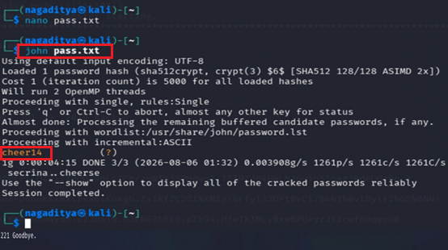

9. Risk Assessment & Recommendations
- Disable Anonymous FTP Access
- Secure Sensitive Files and Storage

- Enforce Strong Password Policies

