**Comprehending brand position for MatterOne Electric bike in India**

Marketing country where the buying decision mainly depends on the cost and the value for money. Even though the electric motorcycle can reduce pollution and offer other host of features, the cost can offset of all of them. Unlike electric cars, the cost has been kept low by the companies for motorcycle market. So, the low cost entices the customer towards electric segment of two wheelers. When comparing with oil fuelled vehicles, other key driver is pickup and top speed. People consider that these vehicles have relatively low pickup and speed compared to traditional petrol run engines. The cost of maintenance is another key driver in the purchase. With low cost of maintenance, electric motorcycles stand a better chance of consideration. Sustainable and environment consciousness also plays a critical role with global warming and alarming rise of pollution levels. With the Government of India offering tax exemption for purchasing electric vehicles, the consumer perception has changed towards these vehicles. The electric vehicle market is still in nascent stage in India as manufacturers have not come up with a plethora of products yet. They have to work on developing technology, pickup, speed, range and efficiency.

Establishing and promoting a brand personality is important to get consumers excited. Consumers relate the brand to their personality and life style if they find similar traits in the product. The actual brand identity and perceived brand image are not usually synchronized and this creates a gap for the brand. For the brand to be successful, it is essential to identify and measure the gap between the brand identity and the perceived image. Let us construct and measure the gaps for the electric bike, MatterOne using the widely used brand prism tool. Once the gaps are identified, we can propose measures to bridge those gaps and then construct a brand and value position.

First step in creating a brand is to define the physique. It is external face of the brand and communicates the brand to the world. Look and feel of the brand, specific traits and features which defines the brand are the most common ones to identify the physique. For MatterOne electric bike, we define physique as muscular and youthful. The perceived image by the consumer is not really synchronized with its identity as electric bikes are considered as not so powerful bikes. So, it is imperative for the company to bridge this gap by communicating that this bike is powerful, youthful and muscular**.** The second element of brand prism is brand personality. While communicating the brand, it acquires a unique character which is consistent among all communication. This is defined as the brand personality. Consumers tend to choose a brand that reflects their own personality. Brand personality can be gauged in terms of the human traits which it exhibits. For MatterOne**,** we define brand personality as dynamic, confident and smart**.** Consumers are not aware of the fact of 4G connectivity part and there is an opportunity to showcase the smart feature of the bike. Brand culture can be attributed to the artifacts, values and assumption. Artifacts are perceptible elements of branding like logo, design, punch line and other graphical elements of how it is represented in the communication. Values are observed through the actions and approaches taken at different circumstances. Culture is the essential principle which governs the brand to the outside world. The brand is socially responsible as electric bikes are eco-friendly and promotes environment friendly living in the society. This has to be the focal point in the promotions and brand awareness campaigns. The future of the motorcycle market is electrical and this has to be communicated very clear**.** For MatterOne, the brand culture can be defined as passion for sustainable living, being honest, and promise of growth. Brands are identified as relationships as they provide an intangible exchange between consumer and the producer. Consumers form relationships with the brand like the way they form with each other socially. Maximizing customer satisfaction and customer relationship management plays a key role in shaping the brand and defines the relationship with the consumers. The brand relationship of MatterOne can be defined as exclusive, loyal and friendly. The exclusivity of owning an electric bike has to be communicated well as it provides social and emotional satisfaction to the consumers.

**In t e r n a l i z a t i o n**

Self Image eco conscious strong willed independent

Reflection Youthful confident exclusivity seeker

Culture

Being Honest Passion for Sustainable living Promise of Growth

MATTERONE

Relationship Exclusive Loyal Friendly

Physique Youthful Powerful Muscular

**Ex t e r n a l i z a t i o n**

**Brand Identity Prism of MatterOne**

Personality

Dynamic Confident Smart

Conry

Brand reflection refers to the targeted purchasers. By defining the persona of the target segment, the company can play their campaigns to reflect who the target consumers are and appeal to them in all their communication. For MatterOne, it is evident that their consumers will be keen to be identified as youthful, exclusive seeker, and confident. Self-image is the facet of brand identity prism that complements brand reflection. Consumers acquire the perceived traits, attitude of the brand on usage of the brand. For example, consumers feel that they are rich by wearing a brand like Rolex watch even though they are not rich. The patrons of the MatterOne brand will opine themselves as eco conscious, strong willed and independent. Electric vehicles are still considered as a new entrant into the market although they have been around for quite some time. The urge to try something new and seek exclusivity fits an independent thinker. By using brand prism, we have identified the brand identity that the organization is willing to communicate to the prospective buyers. The target buyers have some perceived image already about the brand. Most of the elements in the brand prism that the organization identified are not in sync with the perceived image of the consumers. Clearly, the main gap is that the electric vehicle’s capability measured via top speed, pick up and power/torque. The perceived image is that the electrical vehicles are inferior to petrol run vehicles in term of the above said metrics. So, the brand position should be to showcase this vehicle as powerful vehicle and at the same time environment friendly and very low cost of maintenance compared to the other competitors. Having been identified the brand gaps; let us leverage this to create a compelling brand positioning statement for this product. Let us review the below four points which will help us to create a positioning statement,

1. Target Customer: “Young male bike buyers” is the persona we are appealing the product to.

2. Market Definition: Electric two wheelers market

3. Brand Promise: Powerful, eco-friendly electric bikes.

4. Reason to Believe: With zero pollution and very low costs of maintenance.

**Brand positioning statement:**

“For young people who purchase motorcycles, MatterOne is a leading electric two wheeler manufacturer that produces the best in class eco-friendly bikes. Unlike traditional motorcycle companies, MatterOne produces bikes that are environment friendly, powerful and provide low costs of maintenance.”

**Tagline**:

“Save the Mother Earth by being an eco-friendly rider”.

The positioning aims by communicating to target audience that the bike is as powerful as traditional bike in addition to low costs of maintenance and sustainable living. This would create demand among the target buyers to check out the offering. After all, marketing is all about enabling the consumer to buy the product. Let us now try to create a story board for MatterOne so that the campaign will create demand for the product.

**Story board:**

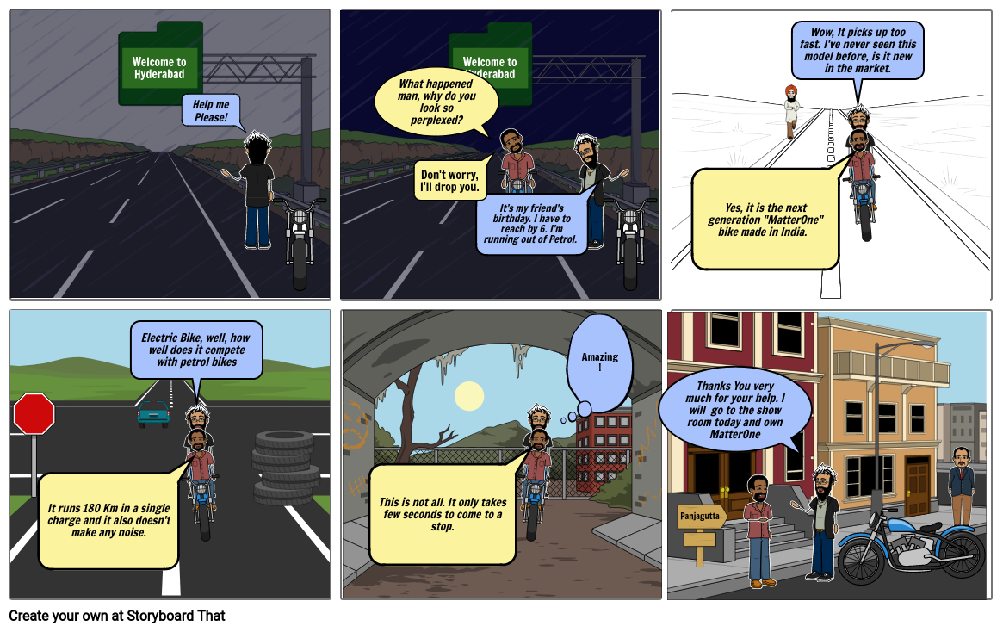

**Courtesy**: Created using <https://www.storyboardthat.com/> website picture.