First.html

<html>

<head>

</head>

<body>

<a href="second.html">second.html</a>

</body>

</html>

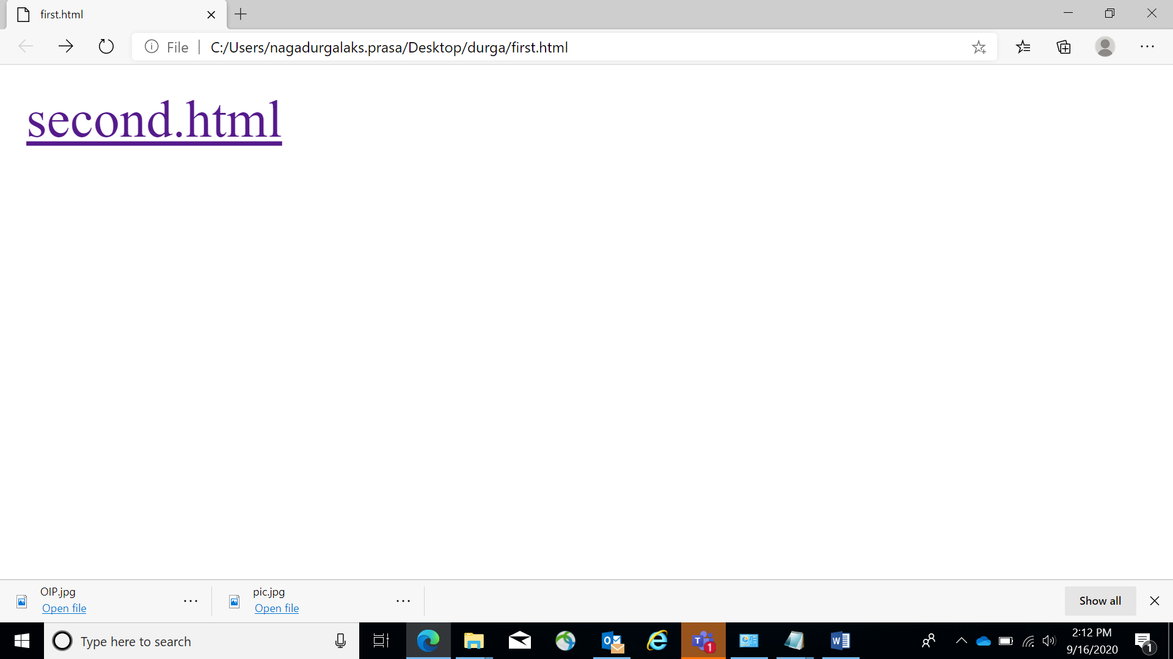

SECOND.HTML

<html>

<head>

</head>

<body>

<pre>

durga

kadapa

9988776655

</pre>

<ul type="bullet">

<li><a href="My Hobbies">My Hobbies</a></li><li>

<a href="My fav subjects">My Fav Subjects</a></li>

<li><a href="fav sport">fav sports</a></li>

<li><a href="fav food">fav food</a></li></ul>

<a href="https://www.google.com/">www.google.com</a><br>

<br>

<a href="https://www.msn.com/en-in/">www.msn.com</a><br>

<br>

<hr style="">

<style>

<!--

body

{background-image:url('pic.jpg');

background-repeat:no-repeat}

-->

</style>

</body>

</html>

