PYTHON ACTIVITY-BASED LEARNING
10 Complete Case Studies
Problem statements • Objectives • Assumptions • Algorithms • Flowcharts • Pseudocode • Python • Testing
Prepared according to the mandatory deliverables and syllabus listed in the uploaded “Python Activity-Based Learning”

Advanced Numeric Pattern Generator

1. Problem statement
Produce a hollow diamond or symmetric numerical pattern using a user-specified size. Reject invalid dimensions and align the output carefully.

2. Objectives
- Generate a hollow diamond and a symmetric numeric pattern.
- Validate dimensions before generating output.
- Use nested loops and spacing to keep the pattern aligned.

3. Assumptions
- The size is a positive odd integer from 3 through 19.
- The selected pattern is either H (hollow diamond) or N (numeric diamond).
- Rows are centered using spaces; numeric values cycle from 1 to 9.

4. Algorithm
1. Read pattern choice and size.
2. Validate the choice and require an odd size in the stated range.
3. For each row, calculate its distance from the middle and the required indentation.
4. Print boundary stars for a hollow diamond, or symmetric numbers for a numeric diamond.

5. Flowchart
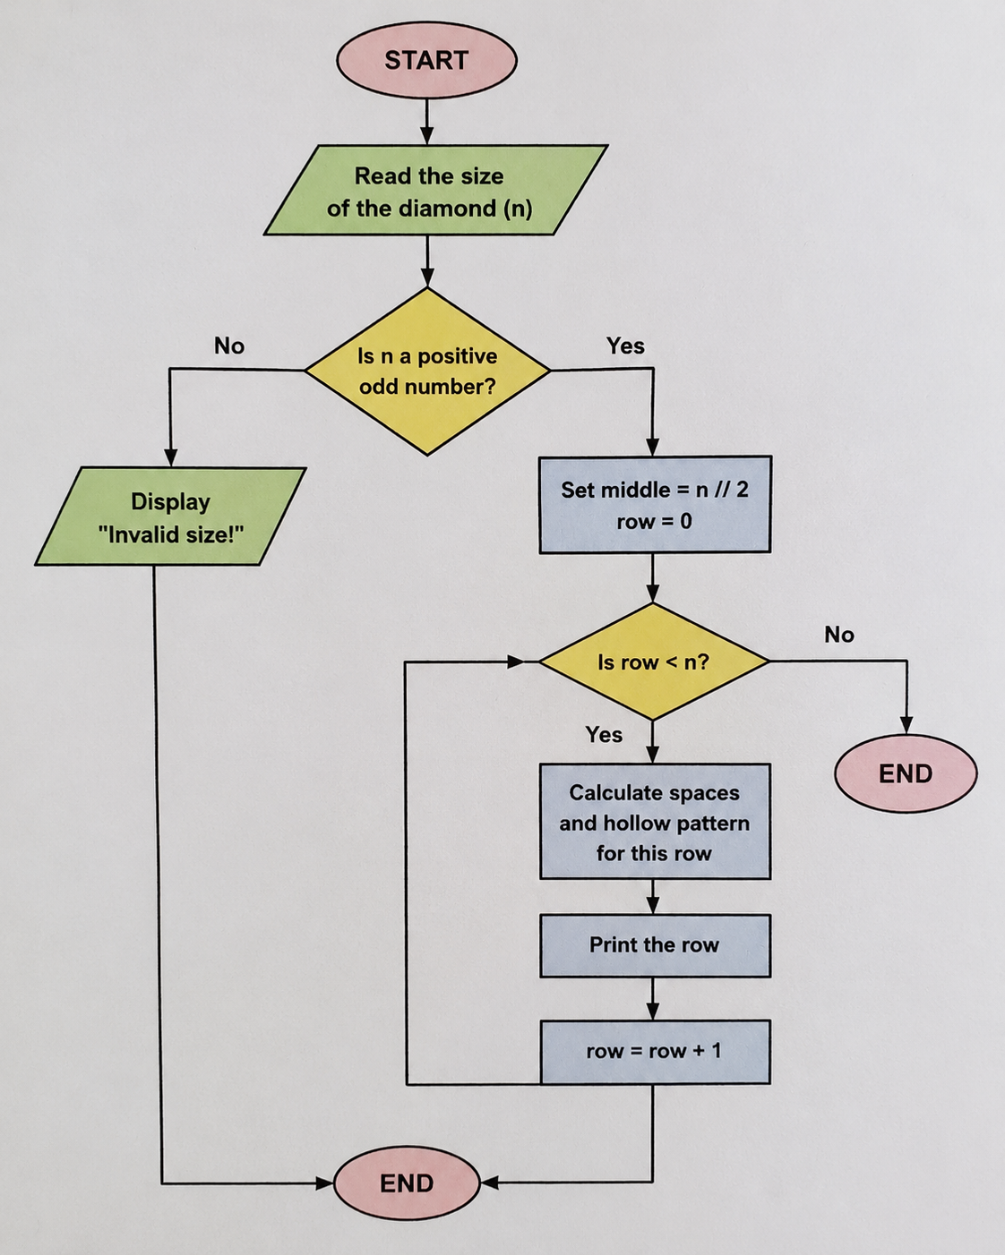
Flowchart represented as a linear decision/process diagram for clear rendering in Word.

6. Pseudo code
INPUT choice, size\nIF size is invalid OR choice not in {H, N}: PRINT error\nELSE:\n FOR each row r from 0 to size-1:\n compute indent and width\n IF choice = H: print hollow row with boundary stars\n ELSE: print symmetric numeric row

7. Python source code
# Hollow Diamond Pattern

size = int(input("Enter the size of the diamond (positive odd number): "))

if size <= 0 or size % 2 == 0:
print("Invalid size! Please enter a positive odd number.")
else:
middle = size // 2

for row in range(size):
if row <= middle:
spaces = middle - row
else:
spaces = row - middle

print(" " * spaces, end="")

for col in range(size - 2 * spaces):
if col == 0 or col == size - 2 * spaces - 1:
print("*", end="")
else:
print(" ", end="")

print()

8. Test cases and output screenshots
Test input | Expected output
H, 5 | *\n * *\n* *\n * *\n *
N, 5 | 1\n 1 2 1\n1 2 3 2 1\n 1 2 1\n 1
H, 4 | Invalid input: choose H/N and an odd size from 3 to 19.
Sample console output screenshot:
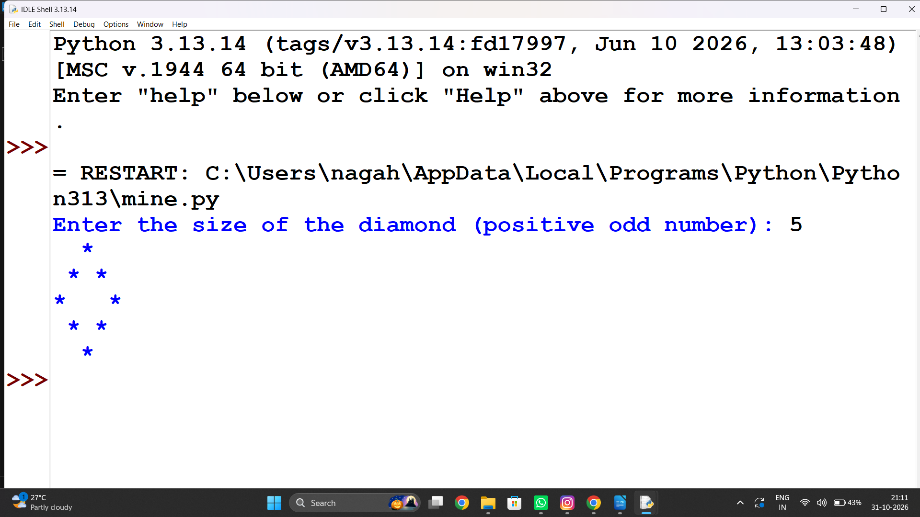

9. Conclusion
The generator produces centered hollow and numeric diamonds and prevents invalid dimensions from reaching the pattern logic.

Warehouse Inventory Reconciliation

1. Problem statement
Compare opening stock, received quantities, dispatched quantities, and recorded closing stock for products; report discrepancies and replenishment needs.

2. Objectives
- Calculate expected closing stock.
- Detect mismatches with recorded stock.
- Estimate replenishment needed to meet a target.

3. Assumptions
- Quantities are non-negative integers.
- Target stock is supplied for each product.
- Expected closing = opening + received − dispatched.

4. Algorithm
1. Read each product's values.
2. Calculate expected closing stock.
3. Compare expected and recorded values.
4. Compute target shortage and print a report.

5. Flowchart
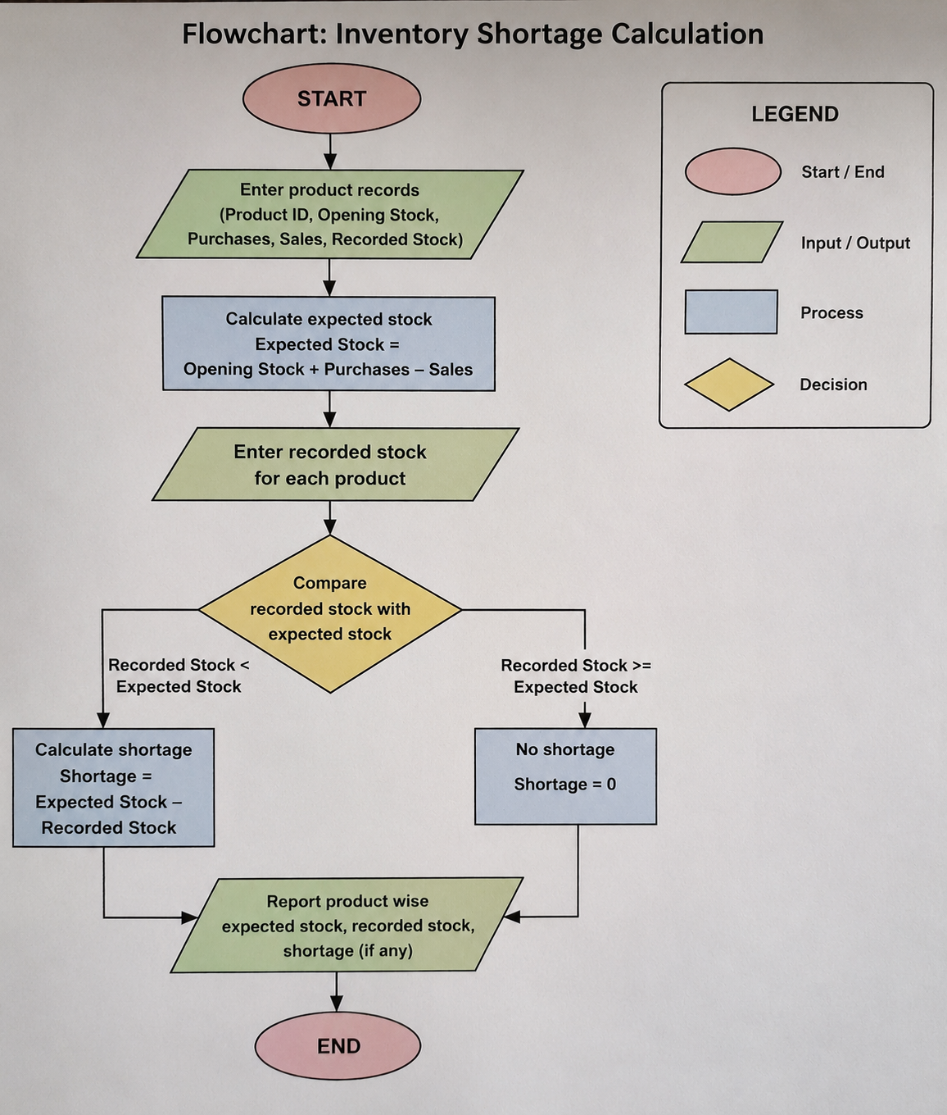

Flowchart represented as a linear decision/process diagram for clear rendering in Word.

6. Pseudo code
FOR each product tuple (name, opening, received, dispatched, recorded, target):\n expected = opening + received - dispatched\n discrepancy = recorded - expected\n shortage = max(0, target - recorded)\n PRINT values

7. Python source code
# Inventory Reconciliation

opening = int(input("Enter opening stock: "))
received = int(input("Enter received quantity: "))
dispatched = int(input("Enter dispatched quantity: "))
recorded = int(input("Enter recorded closing stock: "))

expected = opening + received - dispatched

print("Expected closing stock:", expected)

if expected != recorded:
print("Stock discrepancy found")

if expected > recorded:
print("Shortage:", expected - recorded)
else:
print("Extra stock:", recorded - expected)
else:
print("No discrepancy")

if recorded <= 5:
print("Replenishment needed")
else:
print("Stock is sufficient")

8. Test cases and output screenshots
Test input | Expected output
Pens | expected 70; recorded 70; difference 0; replenish 20; OK
Books | expected 55; recorded 60; difference 5; replenish 20; CHECK
Files | expected 20; recorded 18; difference -2; replenish 7; CHECK
Sample console output screenshot:
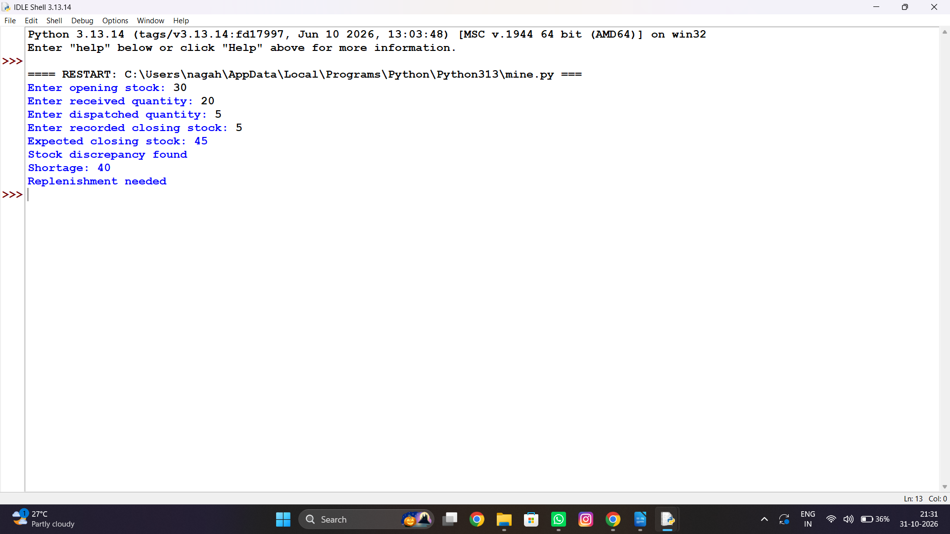

9. Conclusion
The reconciliation report highlights stock-record errors and quantifies replenishment for each item.

Examination Result and Grace-Mark Validation

1. Problem statement
Evaluate marks against subject pass requirements, apply a limited grace policy, and classify the final result without exceeding maximum marks.

2. Objectives
- Check each subject's pass mark.
- Apply grace marks under a defined rule.
- Produce a pass/fail result and classification.

3. Assumptions
- Each subject is out of 100 and has a pass mark of 35.
- At most 3 grace marks may be added to one subject.
- Final marks cannot exceed 100.

4. Algorithm
1. Read subject marks.
2. For each subject below 35 by no more than 3, add the required grace marks.
3. Check all subjects for passing.
4. Classify the average if all subjects pass.

5. Flowchart
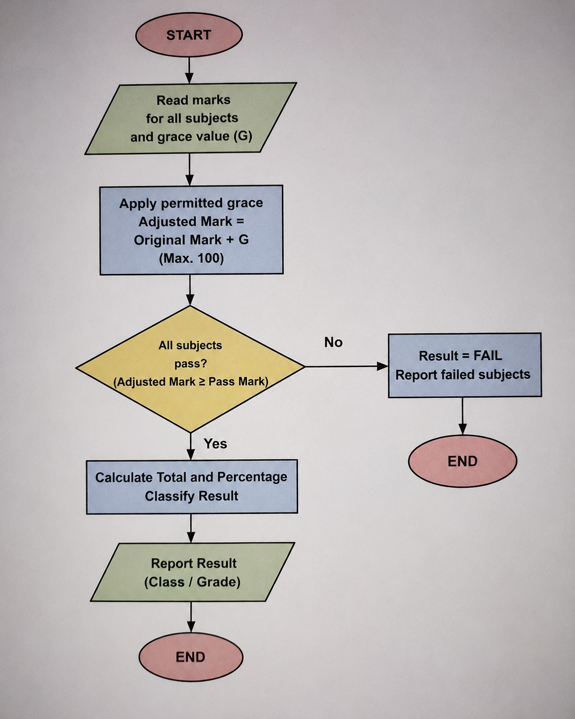

Flowchart represented as a linear decision/process diagram for clear rendering in Word.

6. Pseudo code
FOR each mark:\n IF mark < 35 AND 35-mark <= 3: mark = min(100, 35)\nIF every mark >= 35: compute average and classification\nELSE: result = FAIL

7. Python source code
# Marks Evaluation with Grace Marks

mark1 = int(input("Enter marks for subject 1: "))
mark2 = int(input("Enter marks for subject 2: "))
mark3 = int(input("Enter marks for subject 3: "))

pass_mark = 35
grace = 5

# Apply grace marks
if mark1 < pass_mark:
mark1 = mark1 + grace

if mark2 < pass_mark:
mark2 = mark2 + grace

if mark3 < pass_mark:
mark3 = mark3 + grace

# Do not allow marks above 100
if mark1 > 100:
mark1 = 100

if mark2 > 100:
mark2 = 100

if mark3 > 100:
mark3 = 100

print("Final marks:", mark1, mark2, mark3)

# Check result
if mark1 >= pass_mark and mark2 >= pass_mark and mark3 >= pass_mark:
total = mark1 + mark2 + mark3
percentage = total / 3

print("Total marks:", total)
print("Percentage:", percentage)

if percentage >= 75:
print("Result: Distinction")
elif percentage >= 60:
print("Result: First Class")
elif percentage >= 50:
print("Result: Second Class")
else:
print("Result: Pass")
else:
print("Result: Fail")

8. Test cases and output screenshots
Test input | Expected output
34,67,81,35 | Final marks: [35, 67, 81, 35] Average: 54.5 Result: Pass
20,67,81,35 | Final marks: [20, 67, 81, 35] Result: FAIL
Sample console output screenshot:
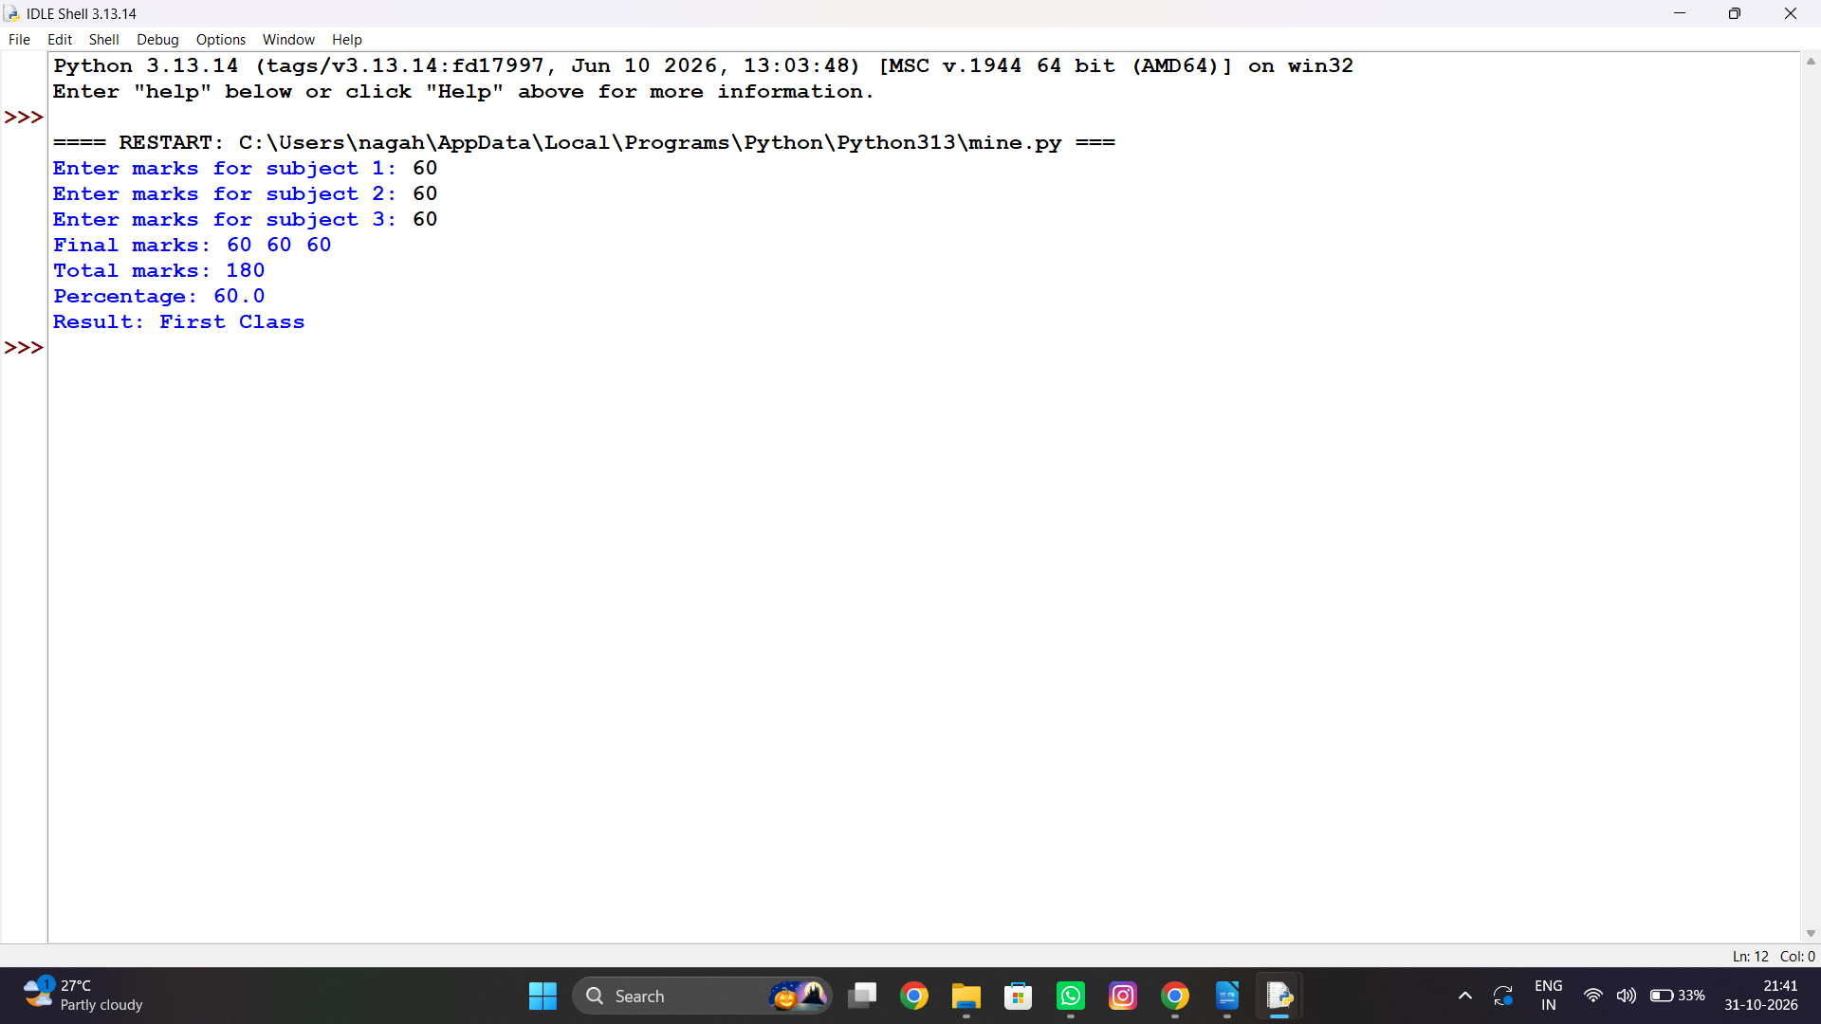

9. Conclusion
Grace marks are applied only within the stated limit, and the result is computed consistently from the final marks.

Nested Loop Examination Seating Generator

1. Problem statement
Generate a classroom seating layout with row and column identifiers while preserving designated reserved seats.

2. Objectives
- Create a grid using nested loops.
- Label seats consistently.
- Mark reserved positions separately.

3. Assumptions
- Rows and columns are positive integers.
- Reserved seats are provided as zero-based coordinate pairs.
- A reserved seat is shown as R; other seats show their row-column label.

4. Algorithm
1. Read dimensions and reserved coordinates.
2. Loop through every row and column.
3. Print R for reserved locations; otherwise print the seat identifier.
4. Display the completed grid.

5. Flowchart
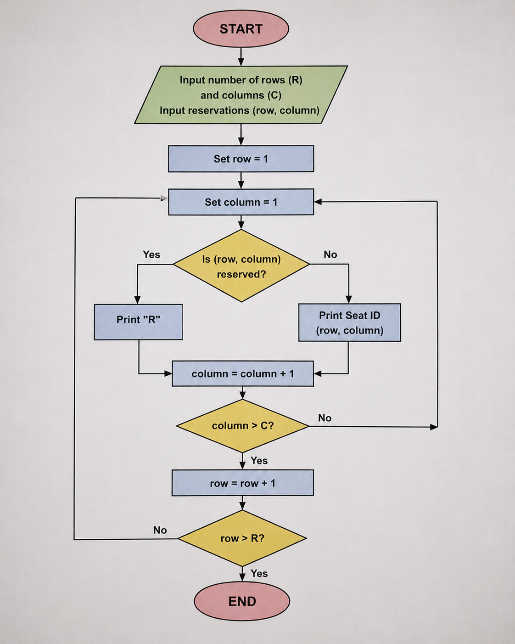

Flowchart represented as a linear decision/process diagram for clear rendering in Word.

6. Pseudo code
FOR row in range(rows):\n FOR col in range(cols):\n IF (row,col) reserved: print R\n ELSE: print seat label\n print newline

7. Python source code
# Classroom Seating Layout

rows = int(input("Enter number of rows: "))
columns = int(input("Enter number of columns: "))

reserved_row = int(input("Enter reserved seat row: "))
reserved_column = int(input("Enter reserved seat column: "))

for i in range(1, rows + 1):
for j in range(1, columns + 1):

if i == reserved_row and j == reserved_column:
print("R", end=" ")
else:
print(str(i) + "-" + str(j), end=" ")

print()

8. Test cases and output screenshots
Test input | Expected output
3 rows × 4 columns | 1-1 | R | 1-3 | 1-4\n2-1 | 2-2 | 2-3 | 2-4\n3-1 | 3-2 | 3-3 | R
Sample console output screenshot:
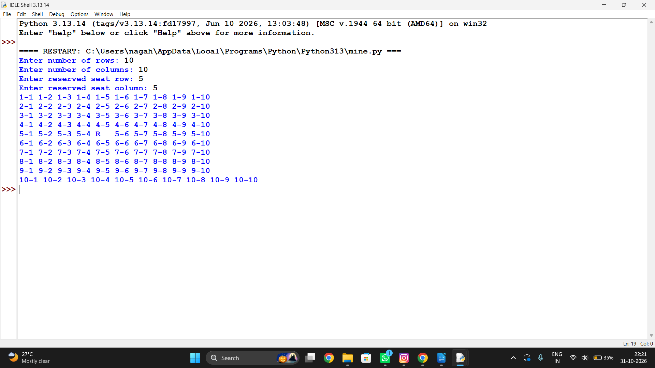

9. Conclusion
Nested loops provide a simple way to build and display a seating matrix while keeping reserved locations identifiable.

Text Compression Using Character Runs

1. Problem statement
Encode consecutive repeated characters as a character followed by its run count, and compare encoded and original lengths.

2. Objectives
- Identify consecutive character runs.
- Create a run-length encoded string.
- Report whether encoding reduces length.

3. Assumptions
- Input is a string; case and spaces are preserved.
- Each run is represented as character + decimal count.
- Empty input produces an empty encoding.

4. Algorithm
1. Read text.
2. Track the current character and run length.
3. When a character changes, append the prior run.
4. Append the final run and compare lengths.

5. Flowchart
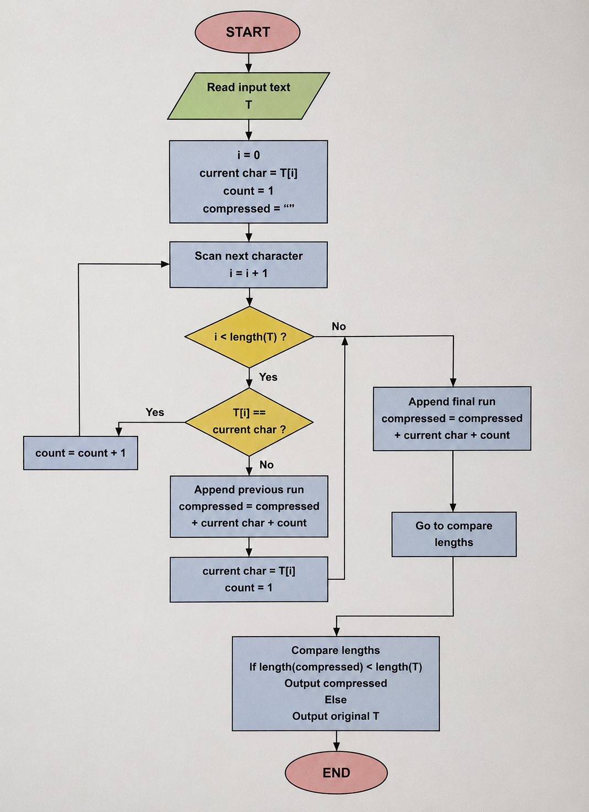

Flowchart represented as a linear decision/process diagram for clear rendering in Word.

6. Pseudo code
IF text empty: encoded = empty\nELSE initialize current and count\nFOR each next character: update count or append current+count\nappend final run\nPRINT encoding and length comparison

7. Python source code
# Simple Text Encoding

text = input("Enter a text: ")

encoded = ""
count = 1

for i in range(1, len(text)):
if text[i] == text[i - 1]:
count = count + 1
else:
encoded = encoded + text[i - 1] + str(count)
count = 1

# Add the last character and its count
if len(text) > 0:
encoded = encoded + text[-1] + str(count)

print("Encoded text:", encoded)

if len(encoded) < len(text):
print("Encoded text is shorter")
else:
print("Original text is shorter or equal")

8. Test cases and output screenshots
Test input | Expected output
aaabbc | Encoded: a3b2c1; Original length: 6; Encoded length: 6; Beneficial: False
aaaaaaaa | Encoded: a8; Original length: 8; Encoded length: 2; Beneficial: True
Sample console output screenshot:
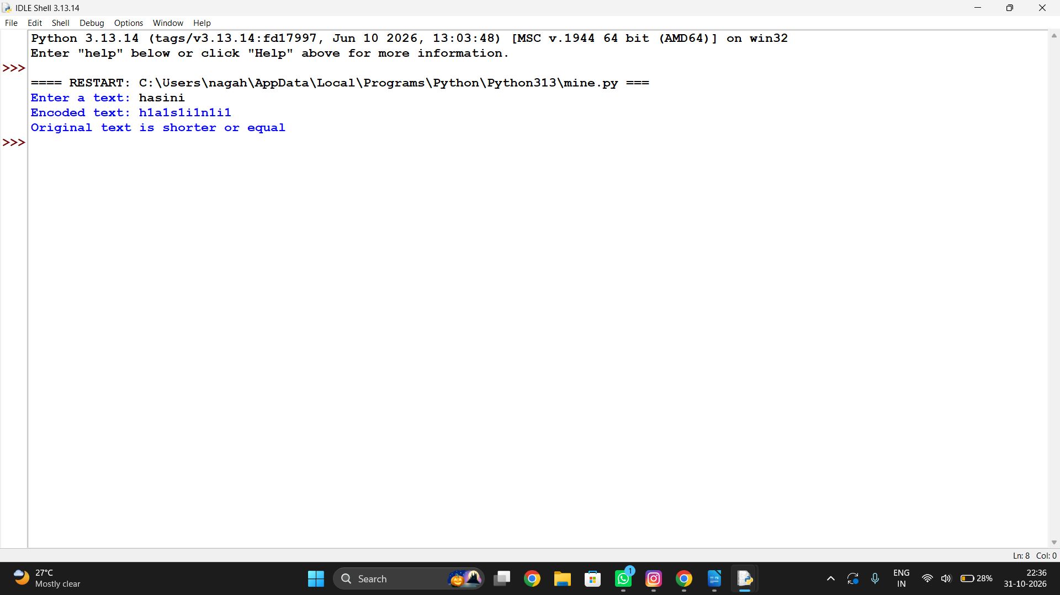

9. Conclusion
Run-length encoding is implemented using a single scan; the length comparison identifies when the encoding is useful.

Student Marks Matrix Analysis

1. Problem statement
Analyze a matrix of marks to calculate student totals and averages, subject averages, and identify the highest-scoring student.

2. Objectives
- Use nested lists to store marks.
- Calculate row and column statistics.
- Find the top performer.

3. Assumptions
- Rows represent students and columns represent subjects.
- All marks are numeric and use the same scale.
- The first maximum is reported if totals tie.

4. Algorithm
1. Store the marks matrix.
2. Compute each row's total and average.
3. Compute each subject's average by column.
4. Find the index of the maximum student total.

5. Flowchart
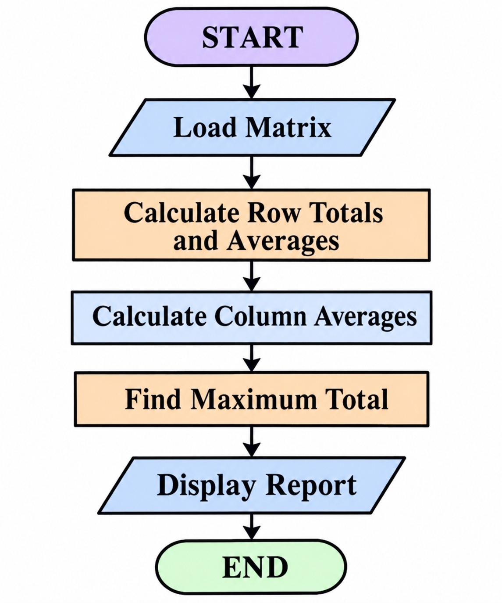

Flowchart represented as a linear decision/process diagram for clear rendering in Word.

6. Pseudo code
FOR each student row: total=sum(row), average=total/subjects\nFOR each subject column: average=sum(column)/students\nfind maximum row total\nPRINT statistics

7. Python source code

marks = [
[80, 75, 90],
[70, 85, 80],
[90, 95, 85]
]

students = ["A", "B", "C"]
subjects = 3

# Student totals and averages
for i in range(3):
total = sum(marks[i])
avg = total / subjects
print(students[i], "Total:", total, "Average:", avg)

# Subject averages
for j in range(subjects):
total = 0
for i in range(3):
total += marks[i][j]
print("Subject", j+1, "Average:", total/3)

# Highest scoring student
totals = [sum(row) for row in marks]
highest = totals.index(max(totals))

print("Highest Scoring Student:", students[highest])
print("Highest Total:", totals[highest])

8. Test cases and output screenshots
Test input | Expected output
Matrix shown in code | Totals 251, 242, 244; subject averages Python 78.33, Maths 82.00, English 85.33; top Student 1
Sample console output screenshot:
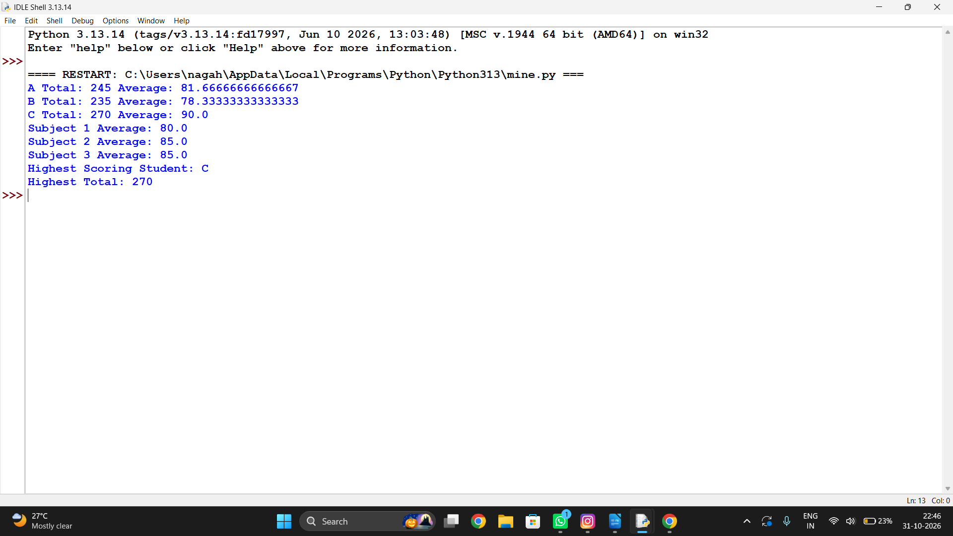

9. Conclusion
The matrix approach efficiently summarizes performance both student-wise and subject-wise.

Fuel Consumption and Route Comparison

1. Problem statement
Compare vehicles for a journey using distance, mileage, fuel price, and a reserve requirement; identify the lowest-cost feasible vehicle.

2. Objectives
- Calculate required fuel and estimated cost.
- Check reserve feasibility.
- Select the cheapest feasible option.

3. Assumptions
- Distance and mileage are positive.
- Fuel price is the same for all vehicles.
- Required fuel includes the specified reserve percentage.

4. Algorithm
1. Read trip distance, fuel price, and reserve percentage.
2. For each vehicle, calculate base fuel and reserve-adjusted fuel.
3. Calculate cost and mark feasible options.
4. Choose the minimum-cost feasible vehicle.

5. Flowchart
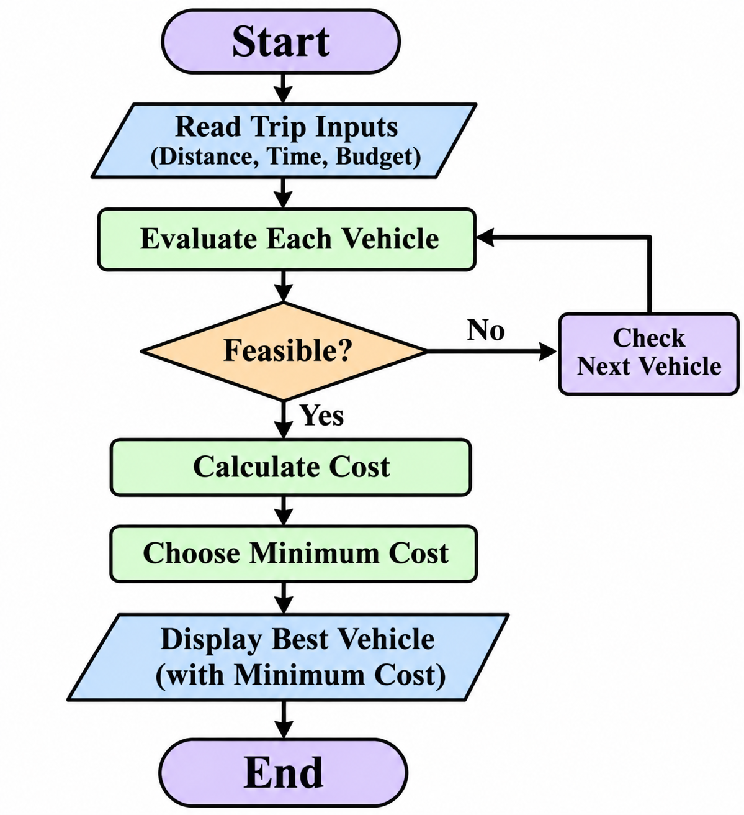

Flowchart represented as a linear decision/process diagram for clear rendering in Word.

6. Pseudo code
FOR each vehicle (name, mileage):\n fuel = distance/mileage * (1+reserve/100)\n cost = fuel*price\n store result\nchoose minimum cost among feasible vehicles

7. Python source code

distance = float(input("Enter journey distance: "))
reserve = float(input("Enter reserve fuel: "))

vehicles = [
["Car", 15, 5],
["Bike", 40, 3],
["Bus", 10, 8]
]

min_cost = 999999
best_vehicle = ""

for v in vehicles:
name = v[0]
mileage = v[1]
fuel_price = v[2]

fuel = distance / mileage

if fuel >= reserve:
cost = fuel * fuel_price

print(name, "Cost:", cost)

if cost < min_cost:
min_cost = cost
best_vehicle = name

if best_vehicle != "":
print("Best Vehicle:", best_vehicle)
print("Minimum Cost:", min_cost)
else:
print("No feasible vehicle found")

8. Test cases and output screenshots
Test input | Expected output
240 km, $1.80/L, 10% reserve | Car A: 17.60 L, $31.68; Car B: 13.20 L, $23.76; Car C: 22.00 L, $39.60; lowest: Car B
Sample console output screenshot:
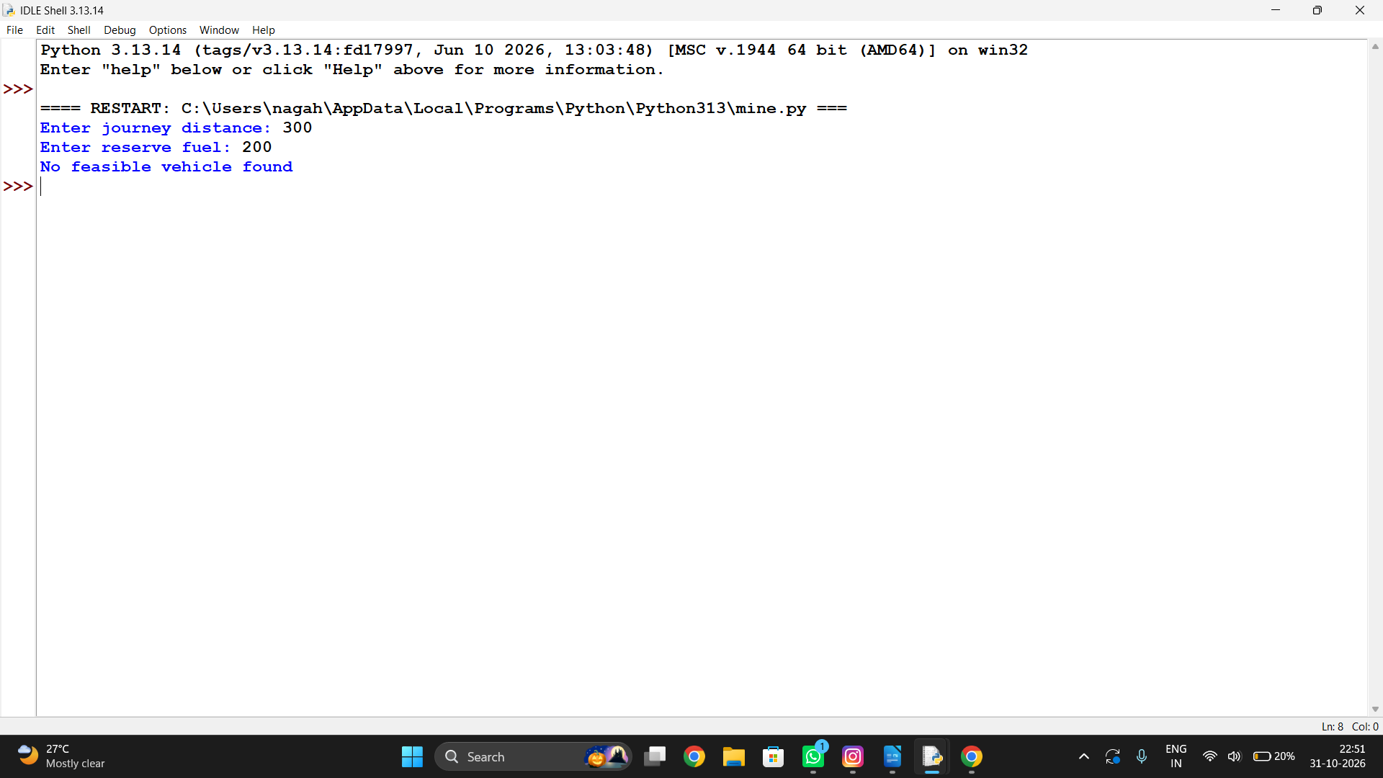

9. Conclusion
The calculation compares vehicles on a consistent basis and selects the lowest estimated cost.

String-Based Examination Answer Evaluation

1. Problem statement
Compare student answer strings with an answer key, count correct, incorrect, and unanswered items, and calculate a score with negative marking.

2. Objectives
- Compare answers position by position.
- Count response categories.
- Apply the supplied scoring rule.

3. Assumptions
- Answer key and response have equal length.
- Correct answer earns 2 marks; incorrect answer loses 0.5; blank earns 0.
- Comparison ignores letter case and surrounding whitespace.

4. Algorithm
1. Read the key and student answers.
2. Normalize each response.
3. Compare corresponding answers.
4. Update category counts and score; print the result.

5. Flowchart
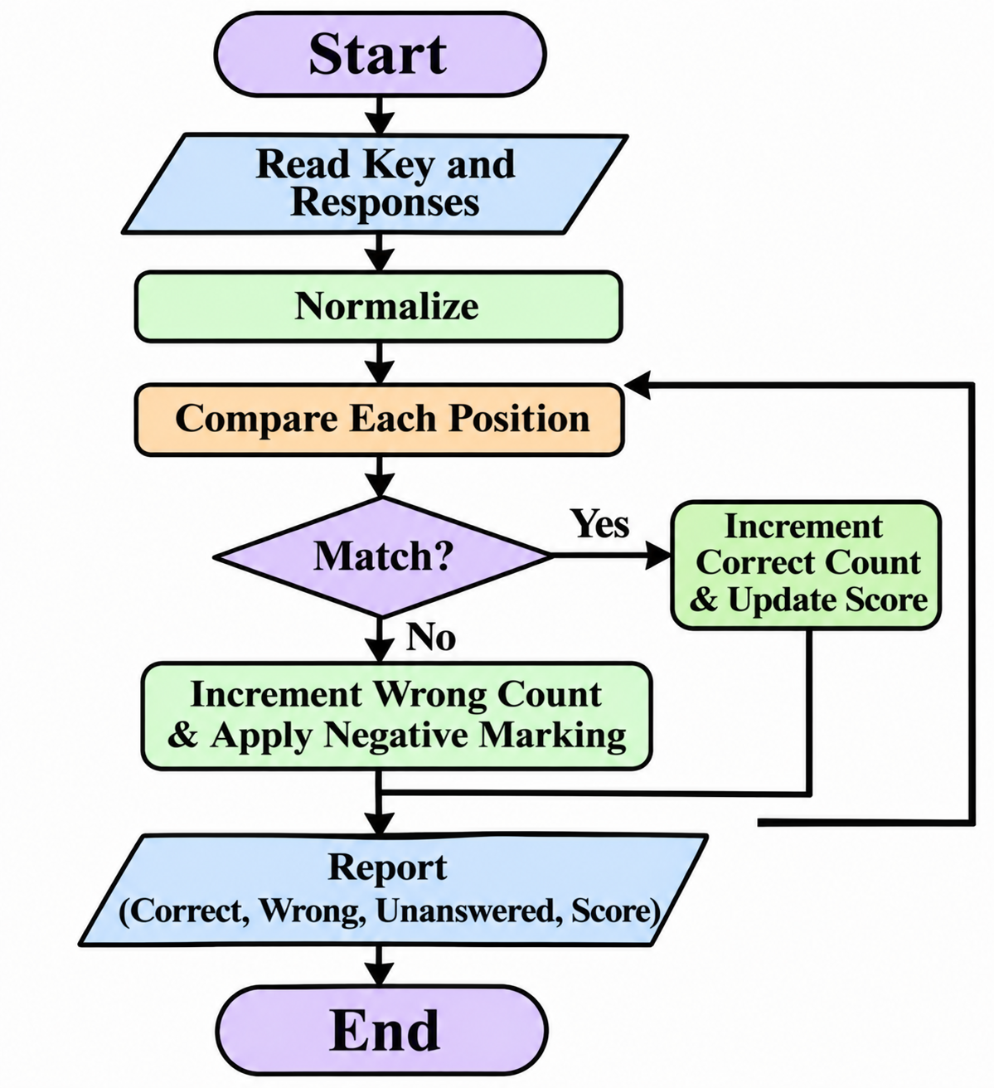

Flowchart represented as a linear decision/process diagram for clear rendering in Word.

6. Pseudo code
FOR each paired key and answer:\n IF answer blank: unanswered++\n ELSE IF normalized answer equals key: correct++, score+=2\n ELSE: incorrect++, score-=0.5\nPRINT counts and score

7. Python source code

key = ["A", "B", "C", "D", "A"]
answers = ["A", "B", "D", "", "A"]

correct = 0
wrong = 0
unanswered = 0

for i in range(len(key)):
if answers[i] == "":
unanswered += 1
elif answers[i] == key[i]:
correct += 1
else:
wrong += 1

score = (correct * 2) - (wrong * 0.5)

print("Correct Answers:", correct)
print("Wrong Answers:", wrong)
print("Unanswered:", unanswered)
print("Final Score:", score)

8. Test cases and output screenshots
Test input | Expected output
A,C,B,D,A vs a,B,blank,D,A | Correct: 3 Incorrect: 1 Unanswered: 1; Score: 5.5
Sample console output screenshot:
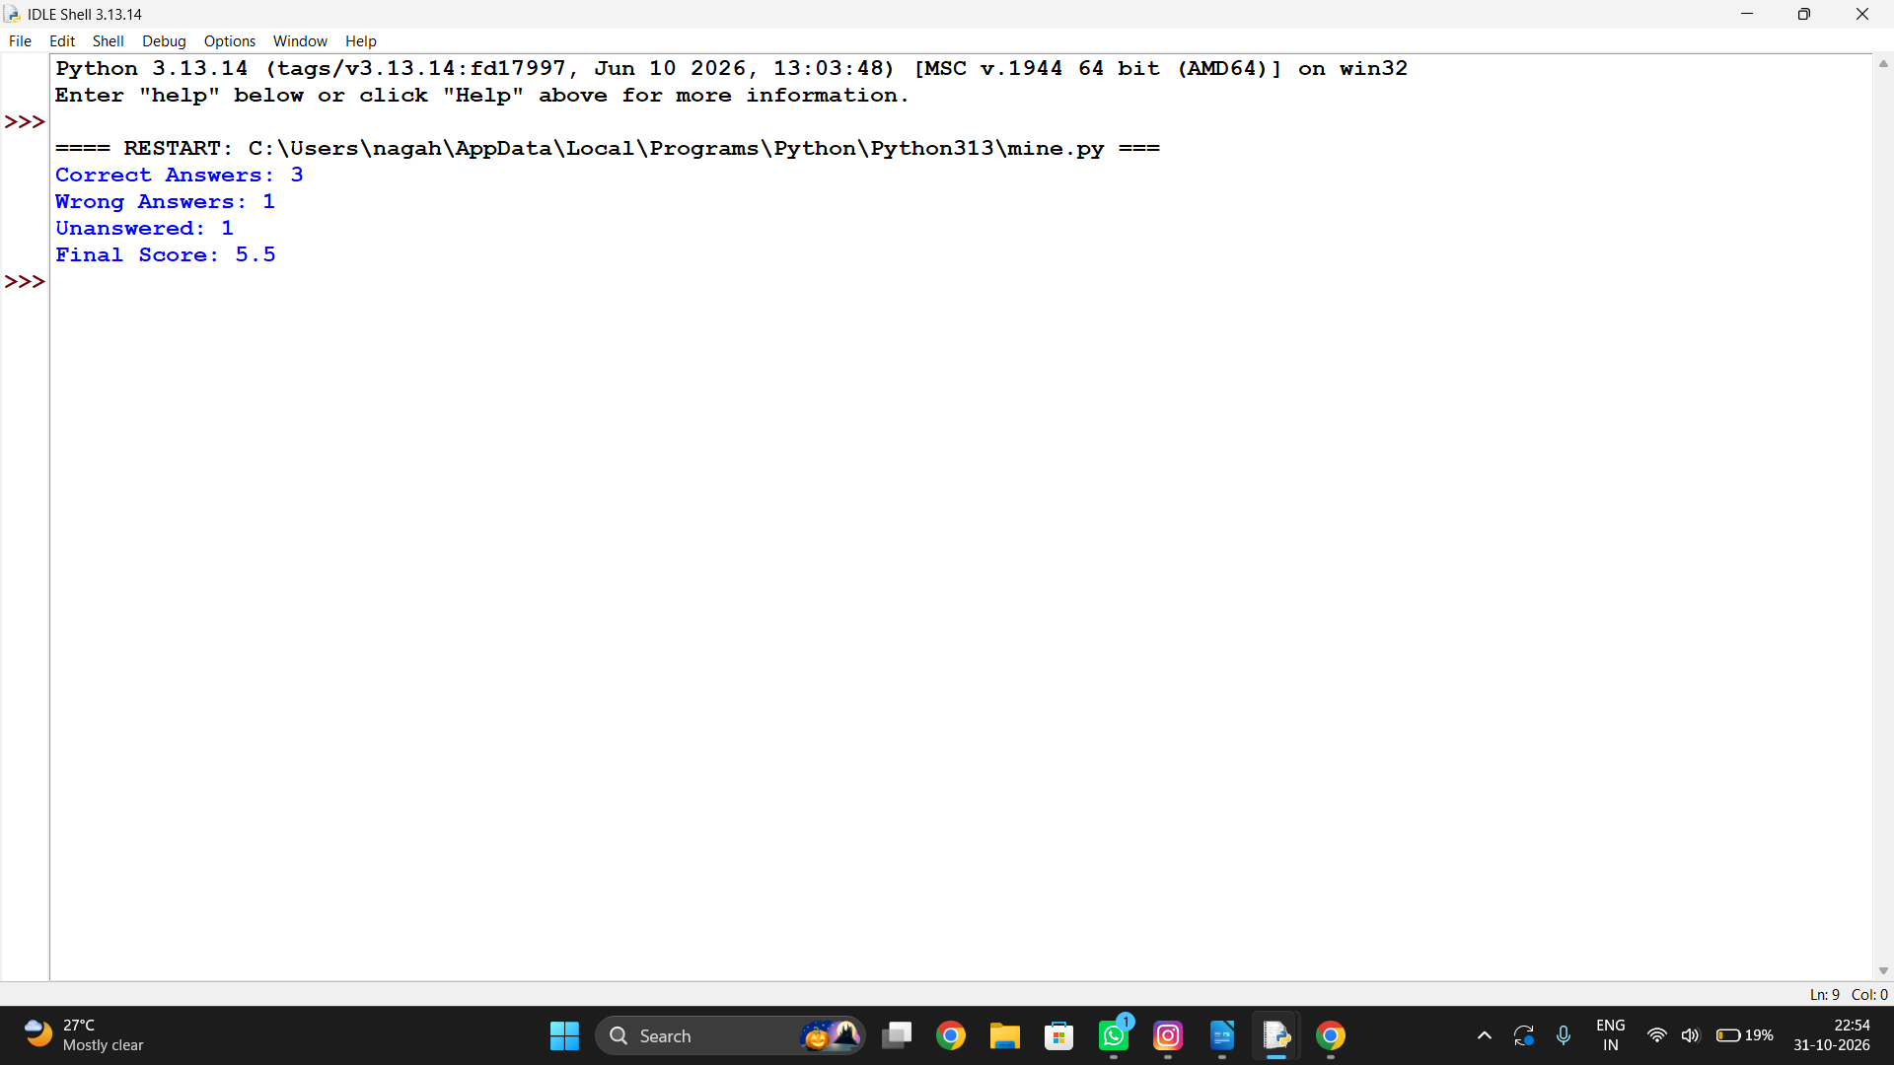

9. Conclusion
String normalization makes evaluation case-insensitive, while the loop applies the scoring policy to every item.

Campus Transport Allocation

1. Problem statement
Determine how many buses are needed for each route based on passenger demand and bus capacity, and report unserved passengers if capacity is insufficient.

2. Objectives
- Calculate required buses using integer arithmetic.
- Compare demand with available buses.
- Report any unmet passenger demand.

3. Assumptions
- Passenger demand and bus capacity are non-negative integers; capacity is positive.
- Each route has a fixed number of available buses.
- Buses can be filled up to capacity.

4. Algorithm
1. Read each route's demand, capacity, and available buses.
2. Calculate buses required using ceiling division.
3. Calculate total available capacity.
4. Find unserved demand and print route summary.

5. Flowchart
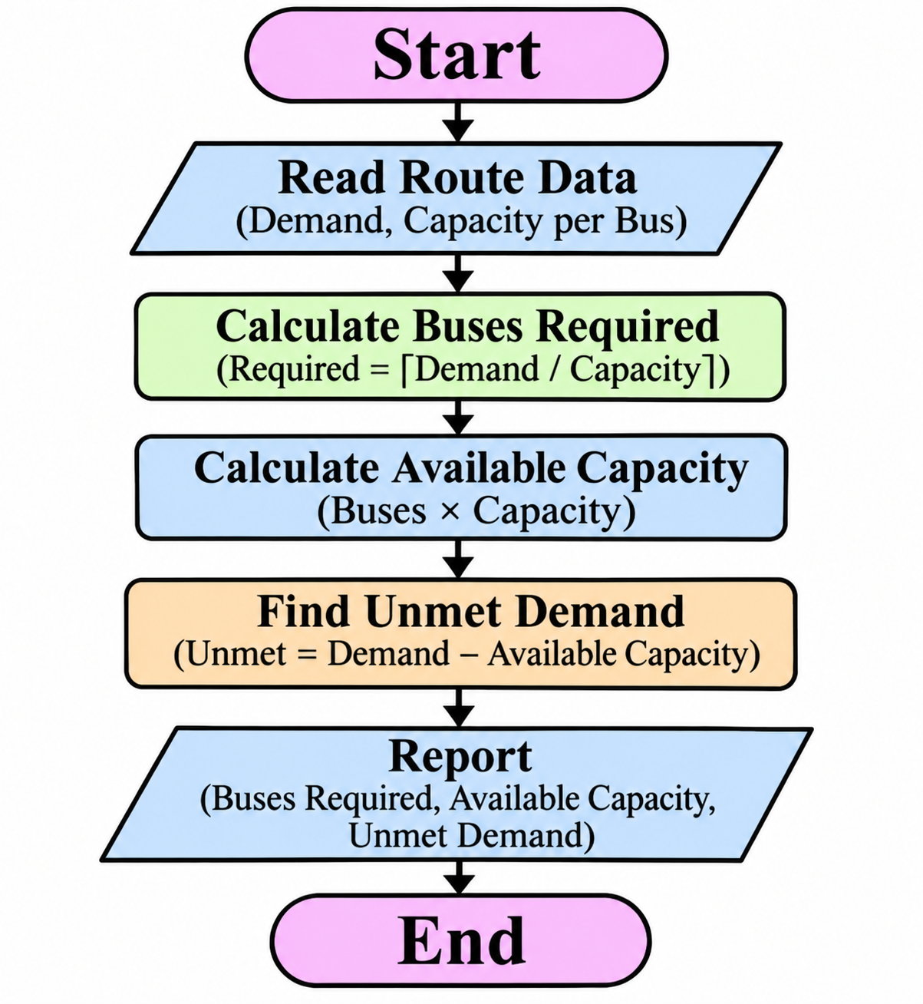

Flowchart represented as a linear decision/process diagram for clear rendering in Word.

6. Pseudo code
FOR each route:\n needed = (demand + capacity - 1) // capacity\n available_capacity = available_buses * capacity\n unserved = max(0, demand - available_capacity)\n PRINT needed and unserved

7. Python source code

routes = ["Route A", "Route B", "Route C"]

demand = [100, 150, 80]
capacity = 50

for i in range(3):
buses = (demand[i] + capacity - 1) // capacity
available = buses * capacity
unserved = max(0, demand[i] - available)

print(routes[i])
print("Buses Required:", buses)
print("Available Capacity:", available)
print("Unserved Passengers:", unserved)

8. Test cases and output screenshots
Test input | Expected output
North 145/50/3 | 3 buses needed; available 3; unserved 0
South 92/40/2 | 3 buses needed; available 2; unserved 12
East 60/30/3 | 2 buses needed; available 3; unserved 0
Sample console output screenshot:
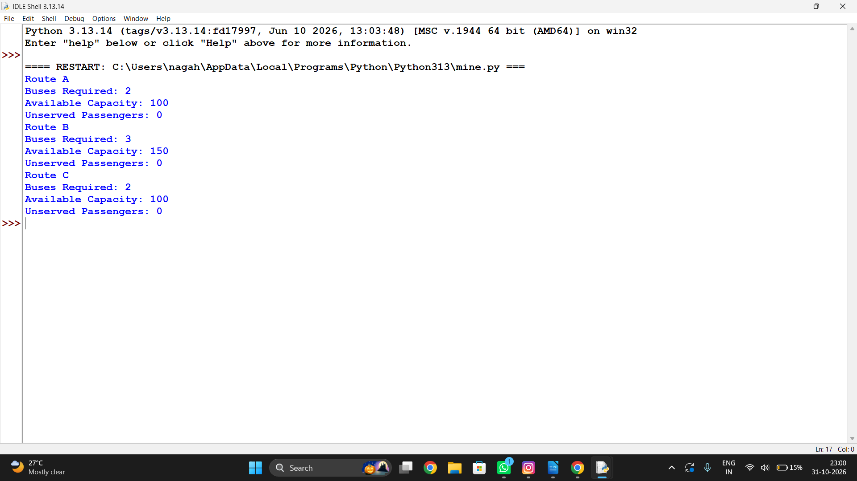

9. Conclusion
The program estimates bus requirements and flags routes where the current fleet cannot accommodate all passengers.

Progressive Electricity Billing

1. Problem statement
Calculate an electricity bill using progressive consumption slabs, a fixed charge, and a rebate, then display the final amount.

2. Objectives
- Apply slab rates incrementally.
- Include fixed charges.
- Apply a rebate under a defined threshold.

3. Assumptions
- Units are non-negative.
- Rates: first 100 units at 1.5, next 100 at 2.5, remaining at 4.0.
- Fixed charge is 30; a 5% rebate applies when energy charge is below 200.

4. Algorithm
1. Read units.
2. Calculate each slab's charge.
3. Add fixed charge.
4. Apply the rebate if eligible and display bill.

5. Flowchart
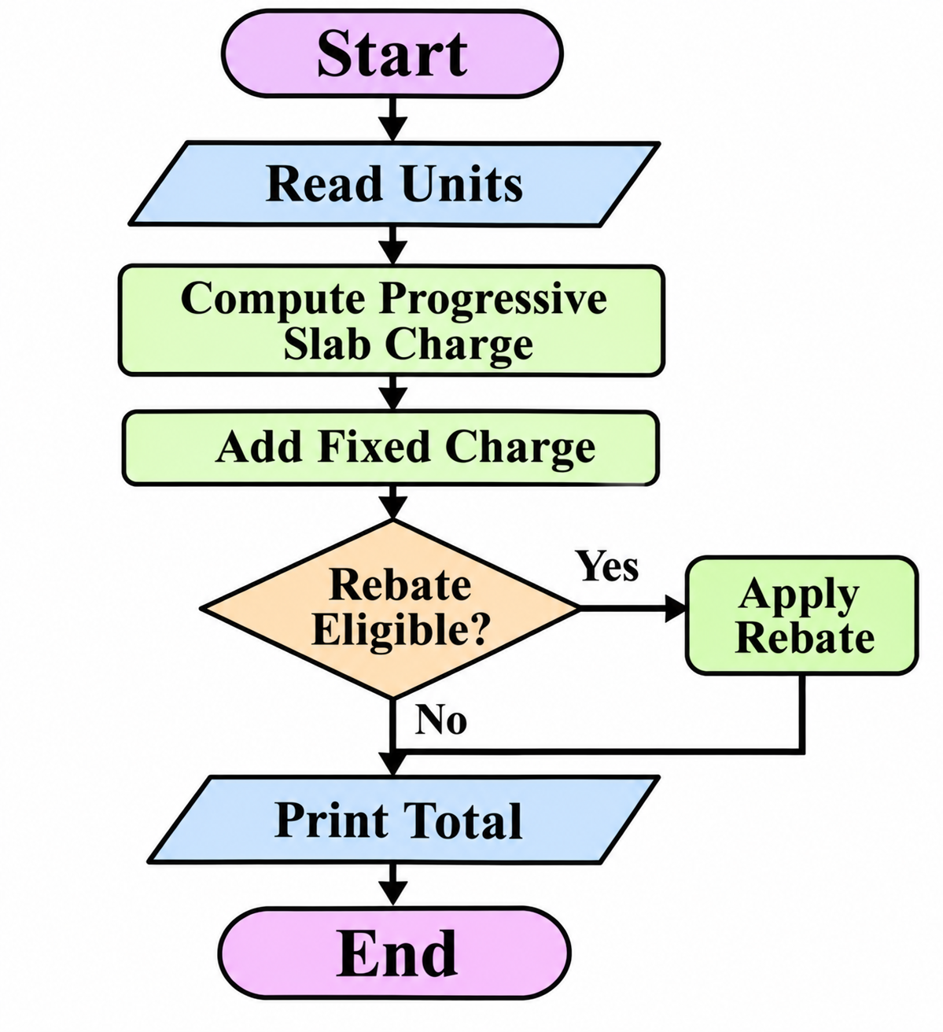

Flowchart represented as a linear decision/process diagram for clear rendering in Word.

6. Pseudo code
energy = 0\ncharge first min(units,100) at 1.5\ncharge next min(max(units-100,0),100) at 2.5\ncharge remaining at 4.0\ntotal = energy + fixed\nIF energy < 200: total = total * 0.95\nPRINT total

7. Python source code

units = int(input("Enter electricity units: "))

if units <= 100:
bill = units * 2
elif units <= 200:
bill = 100 * 2 + (units - 100) * 3
else:
bill = 100 * 2 + 100 * 3 + (units - 200) * 5

fixed_charge = 50
rebate = 20

total = bill + fixed_charge - rebate

print("Energy Charge:", bill)
print("Fixed Charge:", fixed_charge)
print("Rebate:", rebate)
print("Final Electricity Bill:", total)

8. Test cases and output screenshots
Test input | Expected output
80 units | Energy charge: 120.00; Final bill: 142.50
250 units | Energy charge: 450.00; Final bill: 480.00
-4 units | Invalid units: enter a non-negative value.
Sample console output screenshot:

9. Conclusion
Progressive billing is calculated slab by slab, with fixed fees and rebate logic handled transparently.


