**CS443 – Lab 2**

**Question 1:**

Consider the following information:

Supplier: SupplierId, SupplierName, SupplierAddress (The address consists of StreetName, AptNo, PostalCode)

Shipment: ShipmentId, ShipmentDate, ShipmentTime

Item: ItemNo, ItemDescription, QuantityOnHand

One supplier can send many shipments; however, a particular shipment is only sent by one supplier. One item can be in many shipments and a shipment can include many items. A supplier can supply many items and a particular item can also be supplied by many suppliers.

1. **Create your ERD.**

1. **Create associated tables**

**Supplier(**SupplierID, SupplierName, SupplierAddress, StreetName, AptNo, PostalCode**)**

**Shipment(**ShipmentID, ShipmentDate, ShipmentTime, SupplierID\***)**

**Item(**ItemNo, ItemDescription, QuantityOnHand**)**

**CanBe(**ShipmentID*, ItemNo\***)**

**Supply**(SupplierID*, ItemNo\***)**

**Question 2:**

Provide the tables for the following ERD

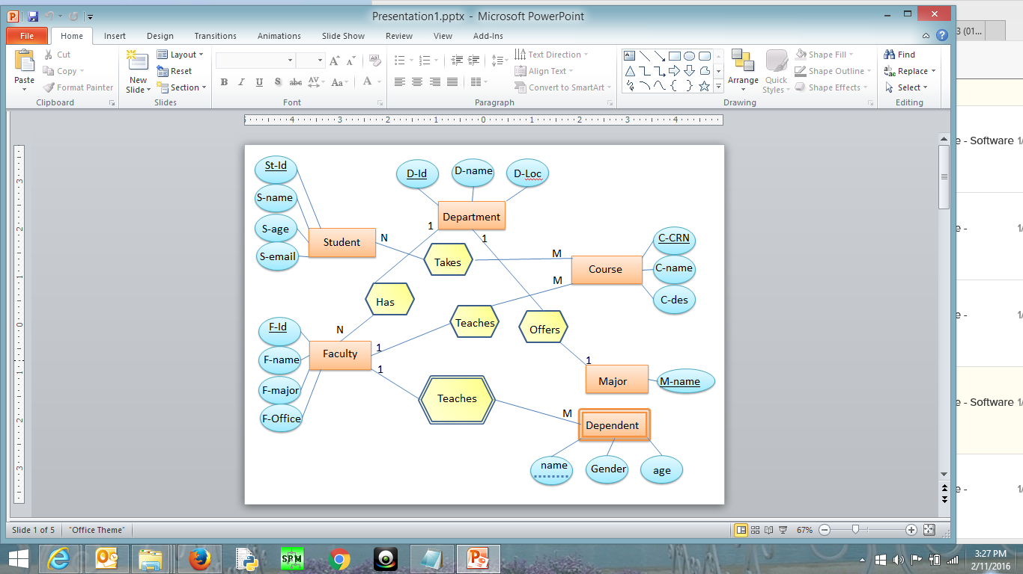

**Student**(St-Id, S-name, S-age, S-email)

**Faculty**(F-Id, F-name, F-major, F-Office, D-Id*)

**Department**(D-Id, D-name, D-Loc)

**Course**(C-CRN, C-name, C-des, F-Id*)

**Major**(M-name, D-Id*)

**Dependent**(F-Id*, name, gender, age)

**Takes**(St-Id*, C-CRN*)

**Question 3:**

Provide the tables for the following ERD

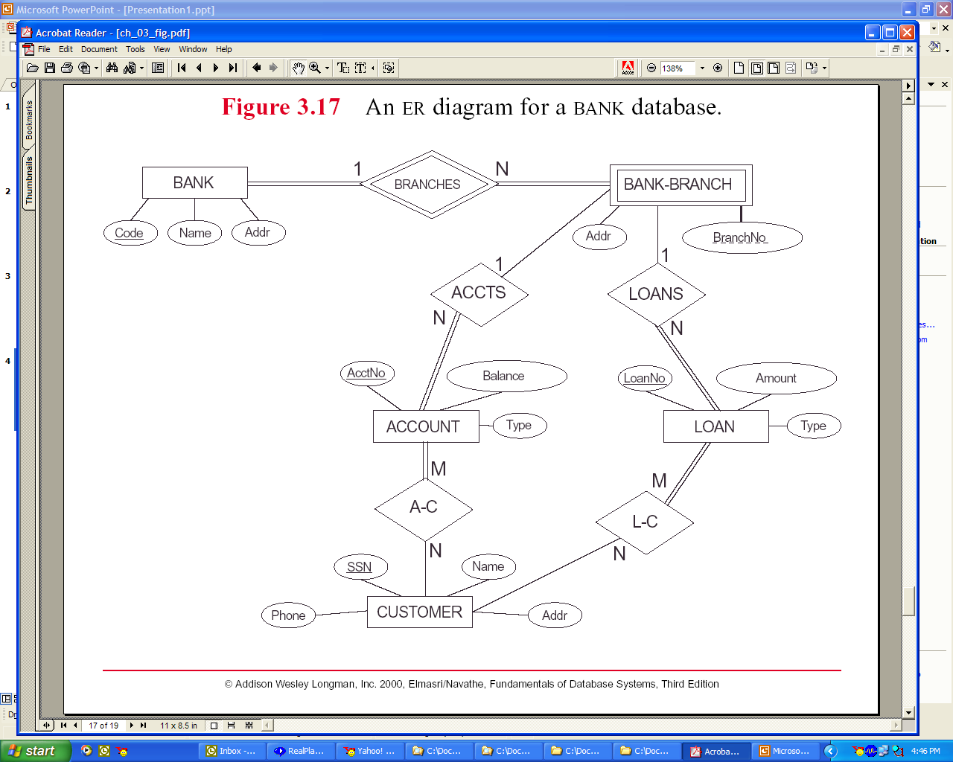

**Bank**(Code, BankName, BankAddr)

**Bank-Branch**(BranchNo, Code*, BBAddr)

**Account**(AcctNo, Balance, AccountType, BranchNo*, Code*)

**Loan**(LoanNo, Amount, LoanType, BranchNo*, Code*)

**Customer**(SSN, Phone, CustomerName, CustomerAddr)

**A-C**(SSN*, AcctNo*)

**L-C**(SSN*, LoanNo*)