**CS443 – Lab 5**

**Question 1:**

Use extended hashing technique to insert the employees in which their corresponding binary Empl_IDs are shown below. Assume you can have two employees per block. Show the depth of both global and local directories. The bits should be considered from left to right as shown in the lecture..

**00001, 10000, 10100, 00111, 11011, 11101, 10010, 01111, 10101**

**STEP 1: STEP 2:**

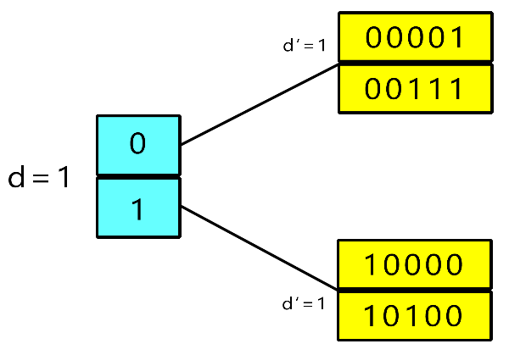 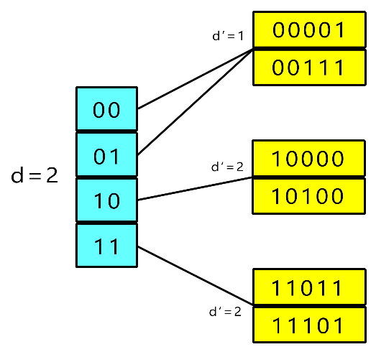

**STEP 3: STEP 4:**

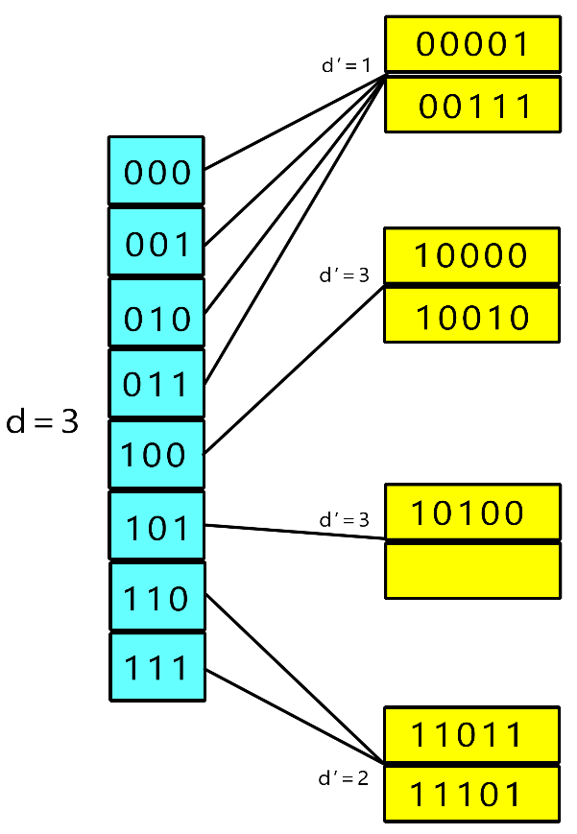 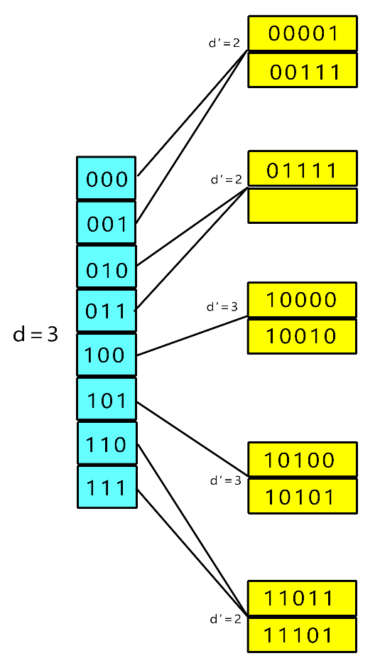

**Question 2:**

Consider the following records of question 1: (Again Digits should be considered from left to right)

**00001, 10000, 10100, 00111, 11011, 11101, 10010, 01111, 10101**

Load the records into files using Dynamic Hashing Scheme. You can put two records per block. Show the directory at each step, and the global and local depths.

**STEP 1: STEP 2:**

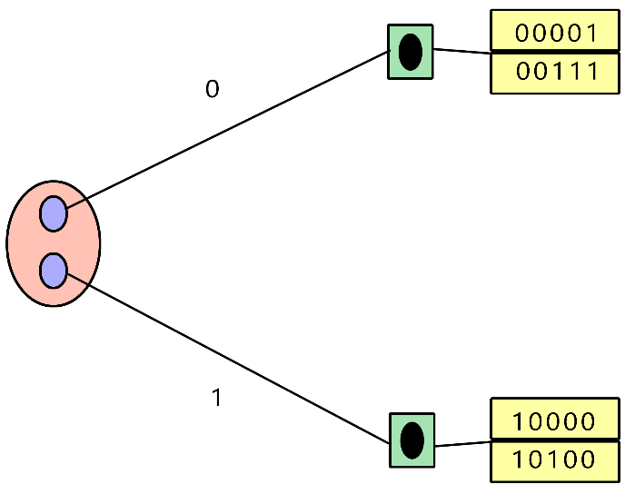 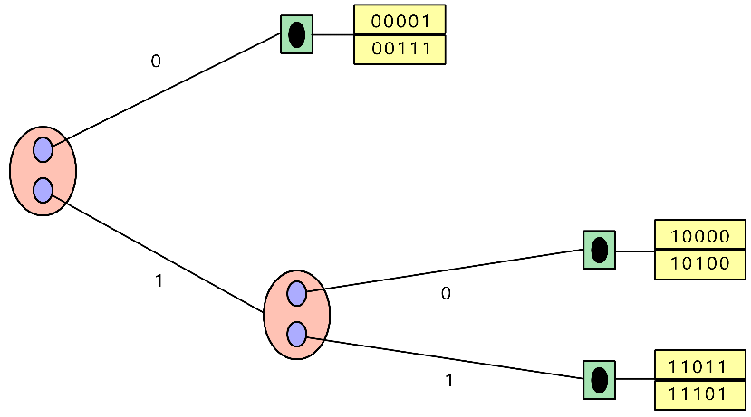

**STEP 3:**

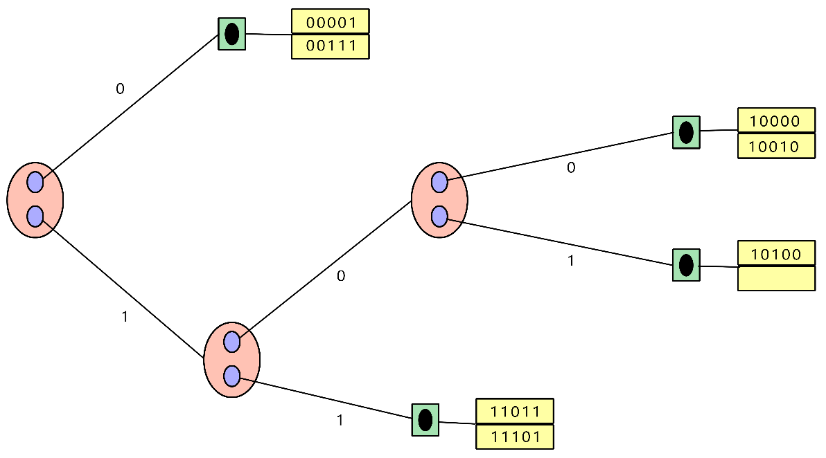

**STEP 4:**

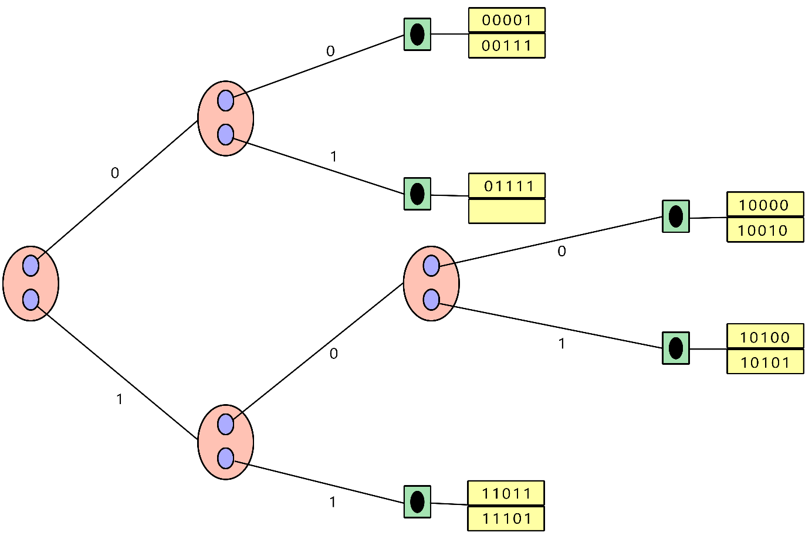

**Question 3:**

Insert the following into B+ tree of order **3**. Show your work step by step with proper illustration of pointers as shown in pages 47-54 in multi-way trees lecture

**90, 22, 27, 24, 28, 20, 51, 63, 8, 80, 15, 71, 35, 55**

**Insert 90: Insert 22: Insert 27:**

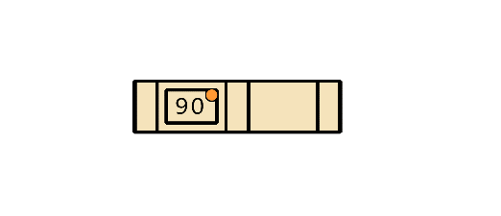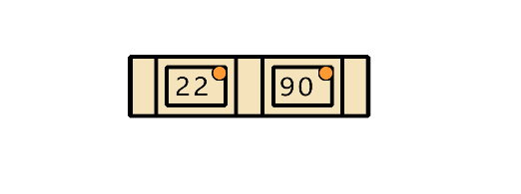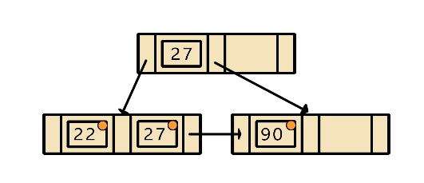

**Insert 24: Insert 28:**

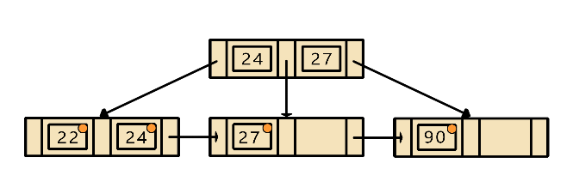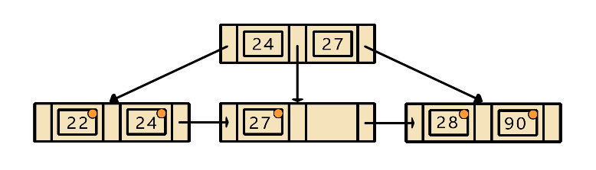**Insert 20: Insert 51:**

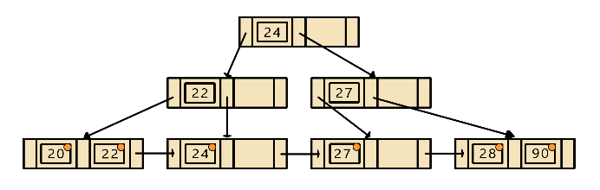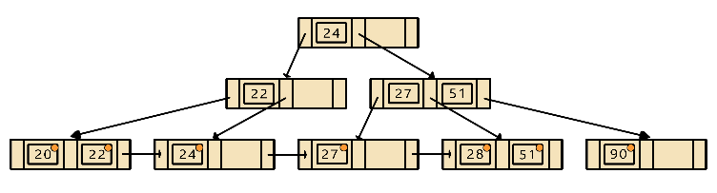

**Insert 63:**

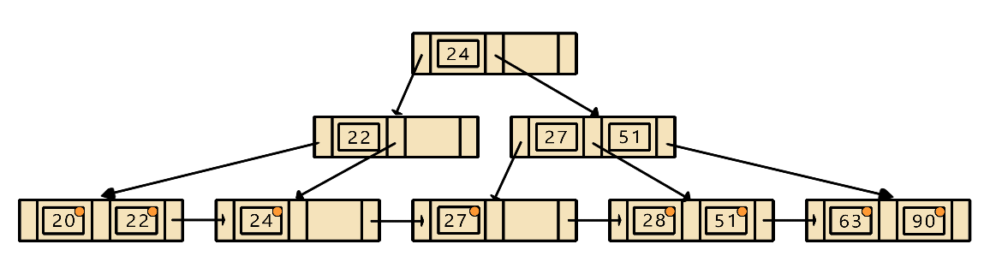

**Insert 8:**

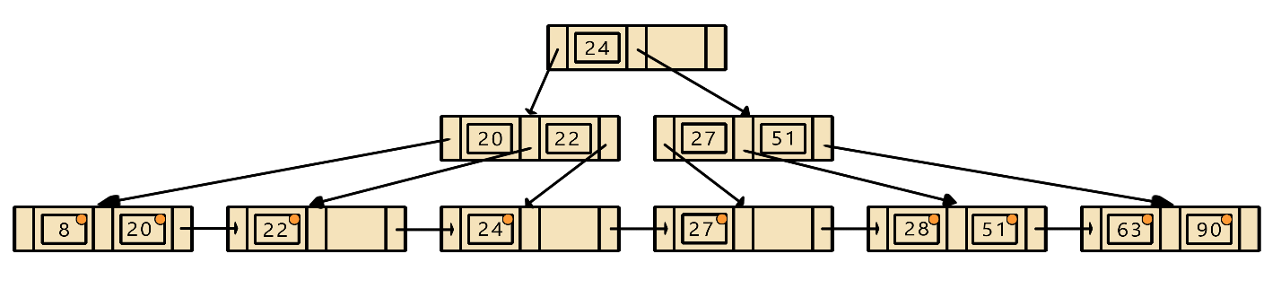

**Insert 80:**

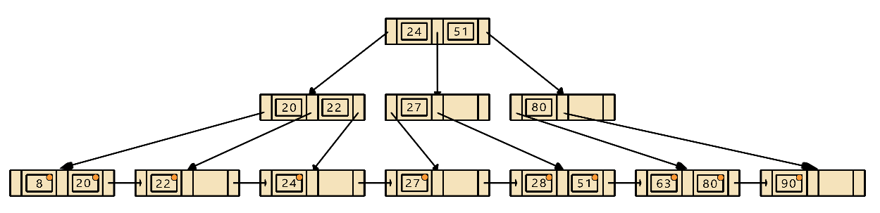

**Insert 15:**

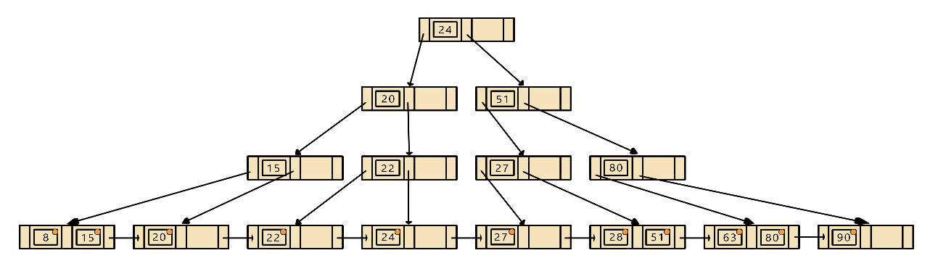

**Insert 71:**

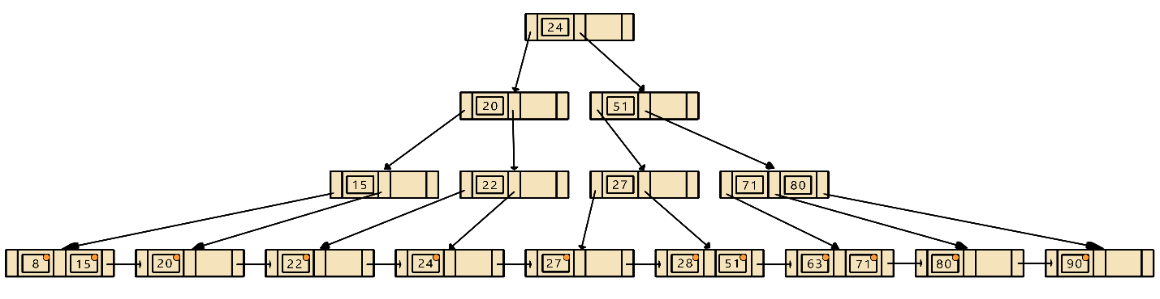

**Insert 35:**

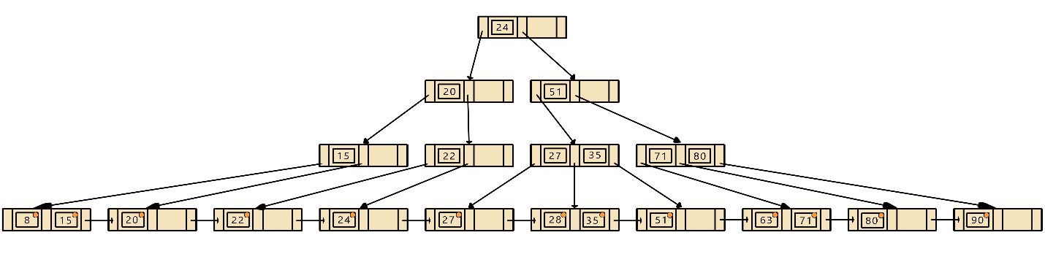

**Insert 55:**

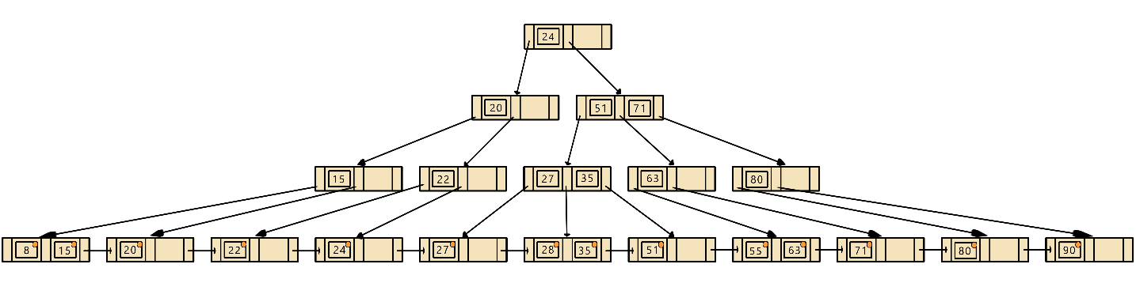

**Question 4:**

Insert the following into B_tree of order **3**. Show your work step by step with proper illustration of pointers as shown in pages 47-54 in multi-way trees lecture

**2, 99, 9, 71, 16, 11, 15, 13, 91, 92, 94**

**Insert 2: Insert 99: Insert 9:**

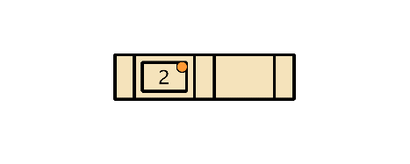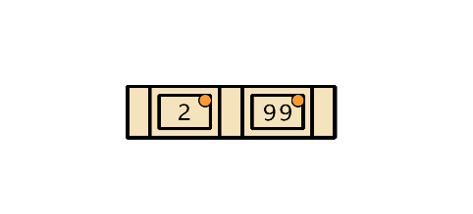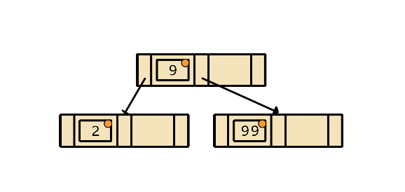

**Insert 71: Insert 16:**

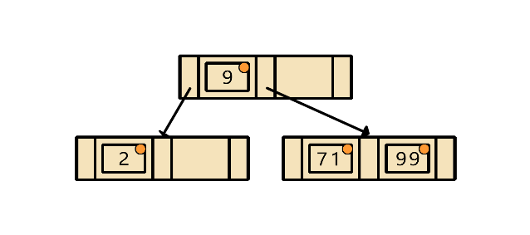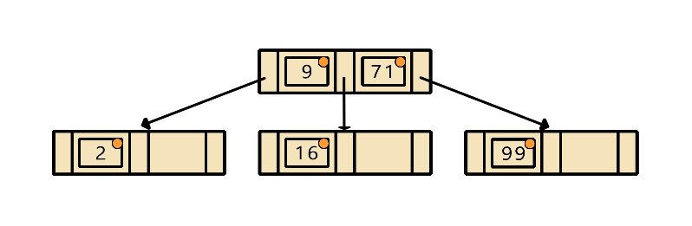

**Insert 11: Insert 15:**

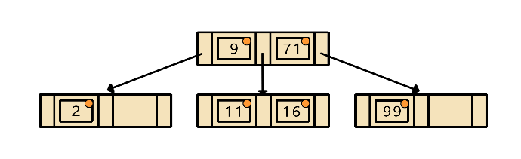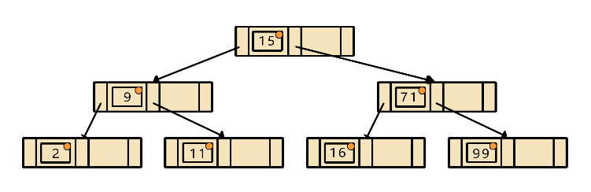

**Insert 13: Insert 91:**

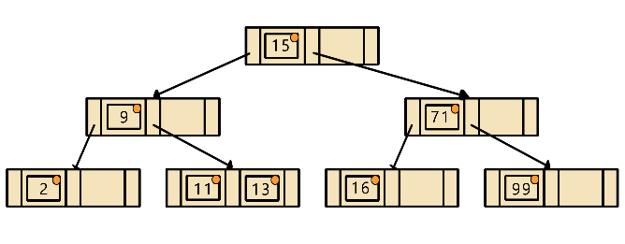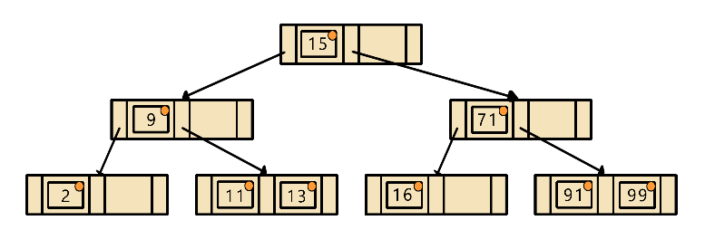

**Insert 92:**

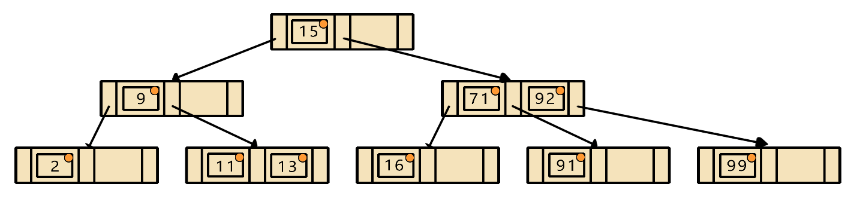

**Insert 94:**

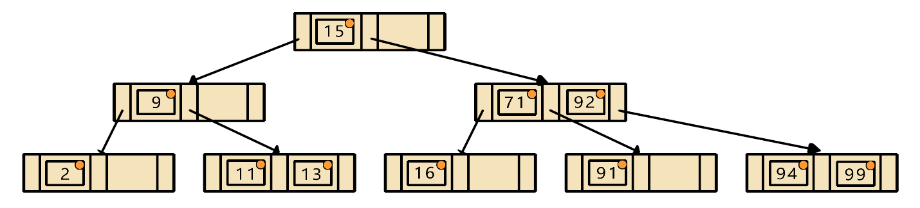

**Question 5:**

Consider the following B-tree.

a) Redraw the tree after deleting 14.

b) Again, redraw the tree after deleting 15.

c) Again, redraw the tree after deleting 25.

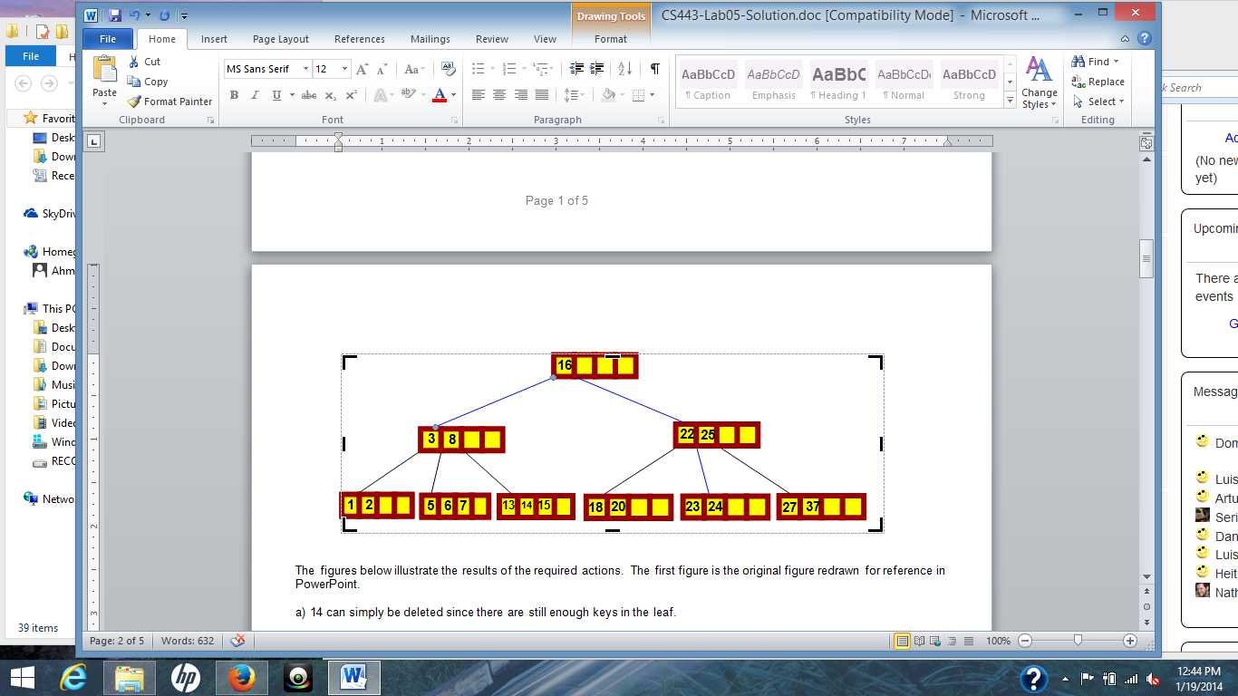

**Question 4:**

Insert the following into B_tree of order **3**. Show your work step by step with proper illustration of pointers as shown in pages 47-54 in multi-way trees lecture

**2, 99, 9, 71, 16, 11, 15, 13, 91, 92, 94**

**Question 5:**

Consider the following B-tree.

1. Redraw the tree after deleting 14.

1. Again, redraw the tree after deleting 15.

1. Again, redraw the tree after deleting 25.

**Question 6:**

Consider the following B+ tree:

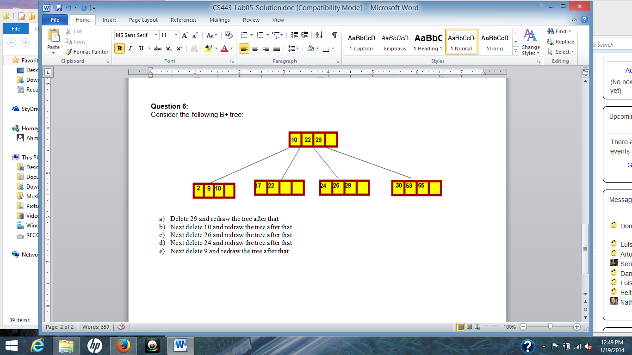

1. Delete 29 and redraw the tree after that
2. Next delete 10 and redraw the tree after that
3. Next delete 26 and redraw the tree after that
4. Next delete 24 and redraw the tree after that
5. Next delete 9 and redraw the tree after that
6. Delete 29 and redraw the tree after that

1. Next delete 10 and redraw the tree after that

1. Next delete 26 and redraw the tree after that

1. Next delete 24 and redraw the tree after that

1. Next delete 9 and redraw the tree after that

