**Overview of the Program:**

I've developed a predictive model that forecasts the potential career outcomes of NBA players based on their performance during the first four years of their professional careers. My model considers important player statistics like minutes played, field goals made and attempted, and three-point field goals made and attempted. I used a machine learning technique called logistic regression to make these predictions. My model doesn't just give a single career outcome prediction for each player; it also estimates the probability of the player falling into different outcome categories: "Elite," "All-Star," "Starter," "Rotation," "Roster," and "Out of the League."

**Strengths and Weaknesses of the Model:**

**Strengths:**

* Utilizes a combination of player statistics and awards data to inform predictions.
* Provides probabilities for different career outcomes, allowing for a nuanced understanding.
* Simple and interpretable model suitable for decision makers without extensive statistical background.

**Weaknesses:**

* The model's predictions are based solely on the available data and features. It may not capture all factors influencing player career trajectories.
* Assumes that the selected features and criteria are comprehensive enough to determine career outcomes accurately.
* Ignores external factors like injuries, team dynamics, and player development programs that can significantly impact a player's trajectory.

**Addressing Weaknesses with More Time/Data:**

* **Feature Engineering:** Collect additional features such as advanced statistics, player roles, and team performance to capture a more complete picture of a player's impact.
* **Advanced Techniques:** Experiment with more complex machine learning algorithms, like ensemble methods or neural networks, to capture intricate patterns.
* **Handling Class Imbalance:** Address potential class imbalance by using techniques like oversampling, undersampling, or synthetic data generation.
* **Cross-Validation:** Implement cross-validation and hyperparameter tuning to ensure the model's robustness and generalization.

**Visualization: Bar Plot of Predicted Career Outcomes**

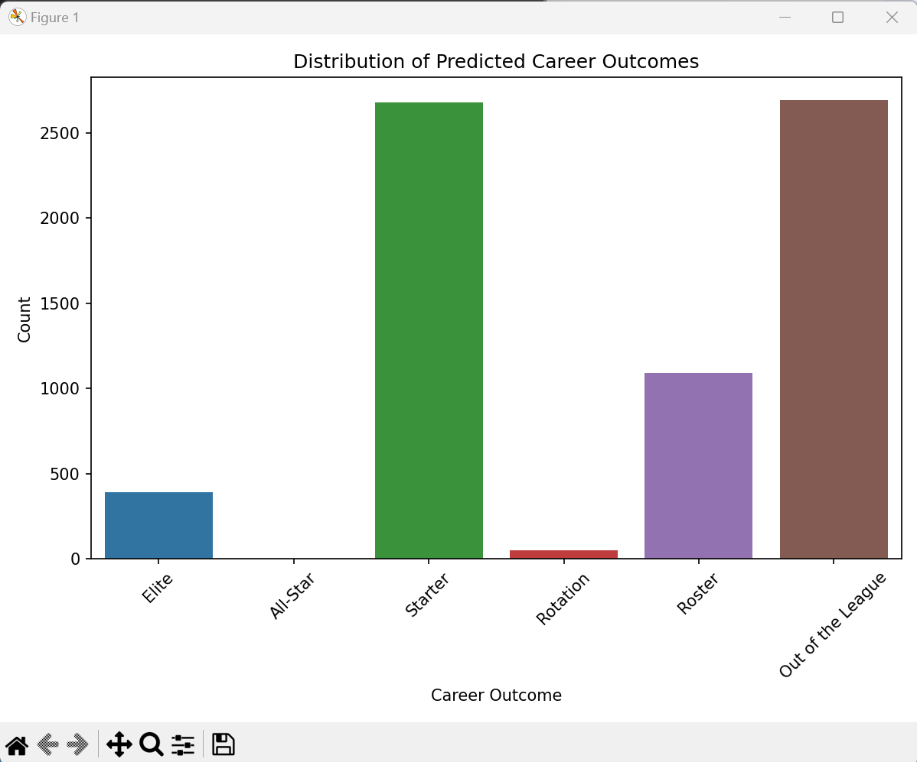

**Predictions for Selected Players:**

* **Shai Gilgeous-Alexander:** Predicted Outcome - Roster, Probabilities - [Elite: 0.28%, All-Star: 0.46%, Starter: 0.45%, Rotation: 2.39%, Roster: 92.42%, Out of the League: 3.00%]
* **Zion Williamson:** Predicted Outcome - Elite, Probabilities - [Elite: 89.18%, All-Star: 1.85%, Starter: 1.68%, Rotation: 2.39%, Roster: 1.49%, Out of the League: 3.42%]
* **James Wiseman:** Predicted Outcome - Rotation, Probabilities - [Elite: 0.49%, All-Star: 1.37%, Starter: 4.46%, Rotation: 56.22%, Roster: 34.80%, Out of the League: 2.66%]
* **Josh Giddey:** Predicted Outcome - Starter, Probabilities - [Elite: 0.11%, All-Star: 0.29%, Starter: 43.45%, Rotation: 21.75%, Roster: 27.08%, Out of the League: 7.32%]

**HTML Table (Bonus):**

I've generated an HTML table containing all predictions for the players drafted in 2019-2021. You can find the tablein the folder attached.