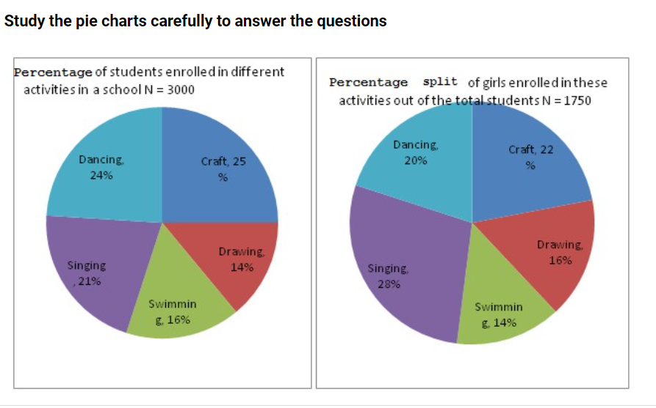

**What is the ratio of the number of girls enrolled in swimming to the number of boys enrolled in Swimming**

47 : 49



29 : 23



23 : 29



49 : 47



CORRECT

**2..Study the following table which shows the number of students appeared and passed in different streams in a university and answer the questions**

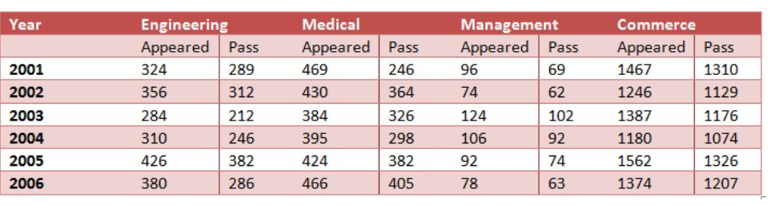

**The number of students appearing in all streams was minimum in the year**

2003



2006



2002



2004



CORRECT

**3..Sales of books ( in thousands ) from six branches (B1, B2 , B3 , B4 , B5 , B6) of a publishing company are given below**

**Study the graph and answer the questions**

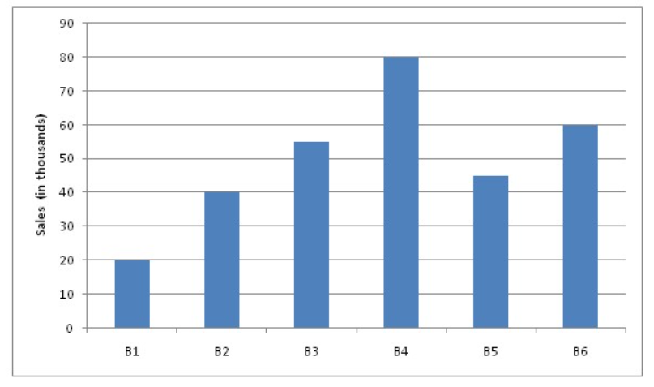

**The number of branches in which sales of books are below the average level is**

3



CORRECT

1



2



4



4...



**What is the total number of girls enrolled in swimming and Drawing together**

495



525



CORRECT

480



505



**5..Study the following graph carefully to answer the question Number of computers**

**Manufactured and sold by various Companies in a year( number in Lakhs)**

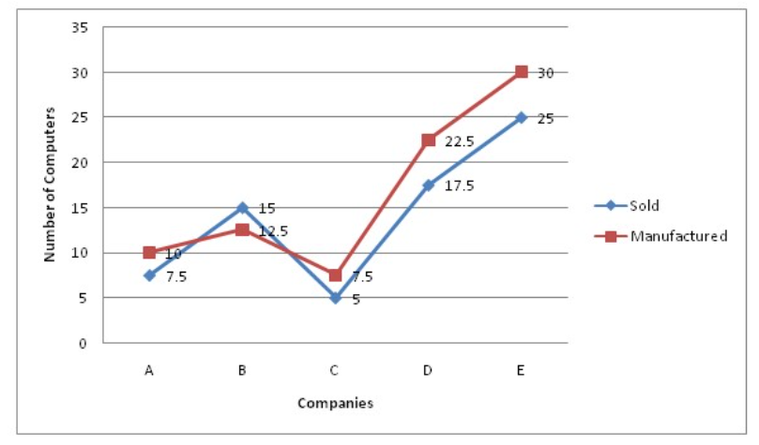

**What is the difference between the average number of computers manufactured by all the companies together and the average number of computers sold by all the companies together**

25000



250



2500



250000



CORRECT

6..**Study the pie charts carefully to answer the questions**



**The number of girls enrolled in Dancing forms what per cent of the total number of students in the school (rounded off to two digits after decimal)**

14.12



12.35



11.67



CORRECT

10.08



**7..Study the following table which shows the number of students appeared and passed in different streams in a university and answer the questions**



**Find the total number students passed in all years in the stream of Engineering**

1750



1800



1650



1727



CORRECT

**8..Study the following table which shows the number of students appeared and passed in different streams in a university and answer the questions**



**Approximately what percent of students appearing in medical, passed in 2003**

85%



CORRECT

75%



88%



78%



**9..Study the following graph and answer the questions**

**Number of students from various Departments studying in various colleges( number in thousands)**

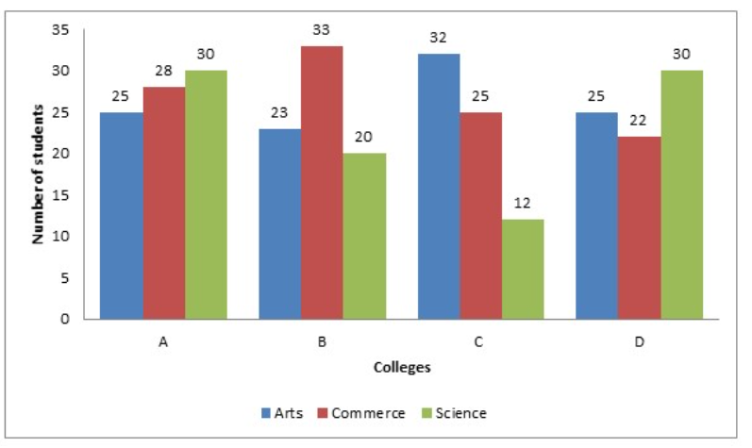

**The students from the Department of commerce studying in college B are approximately what percent of the total number of students in the same college**

43



CORRECT

30



48



35



10..**Study the following bar graph and answer the questions**

**Gross profit and Net profit of a company ( in lakhs of rupees ) for the years 1994 - 1997**

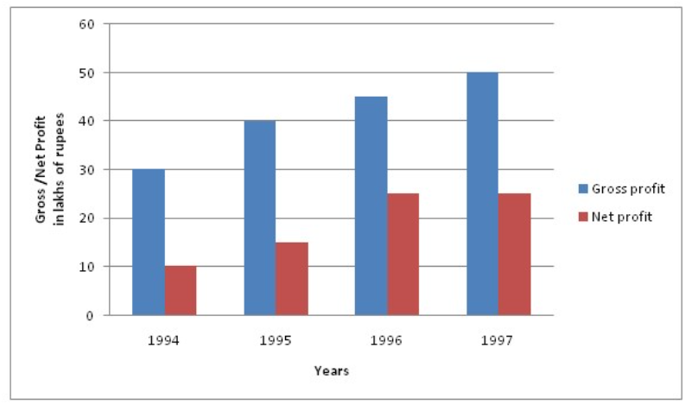

**The ratio of gross profit to net profit in a year was greatest in the year**

1997



1994



CORRECT

1995



1996



**11..Study the following bar graph and answer the questions**

**Gross profit and Net profit of a company ( in lakhs of rupees ) for the years 1994 - 1997**



**The difference of average gross profit and average net profit calculated for four years is**

Rs. 18.75 lakhs



Rs. 22.5 lakhs



CORRECT

Rs. 19.75 lakhs



Rs. 20.5 lakhs



12..**Study the following pie chart carefully to answer the questions**

**Percentage split of employees of Company X Across different cities( Total no of employees of company X = 1800)**

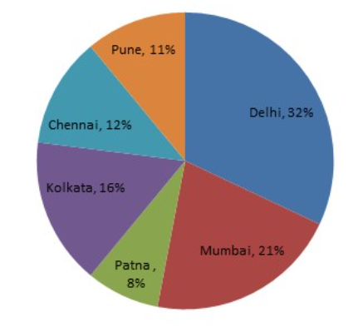

**If 2/9 th of the total number of employees working in Chennai were transferred to Patna, how many employees would there be in Patna**

198



202



192



CORRECT

168



13..**The bar graph shows the total number of children in five different schools and the line graph shows the percentage of girls in them**

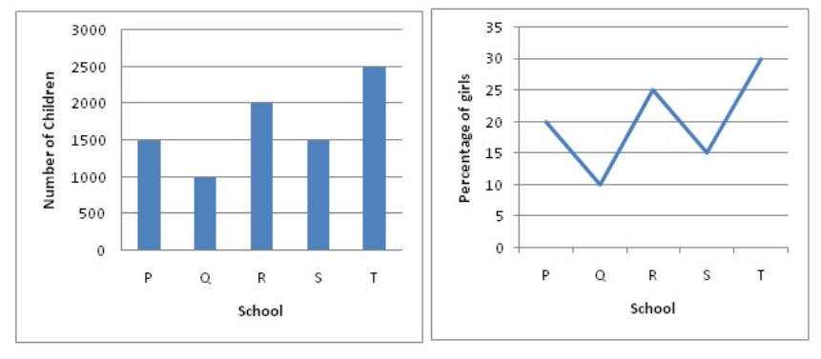

**What is the average number of boys in School R and School T together**

1644



1675



1625



CORRECT

1602



14..**The Pie chart given below represents the modes of transport for 1400 officers of the Staff Selection Commission, Kolkata. Study the chart and answer the following questions**



**The ratio of two wheelers and cars being used as modes of transport is**

7 : 5



3 : 5



5 : 7



CORRECT

4 : 7



15..**Study the following graph and answer the questions**

**Number of students from various Departments studying in various colleges( number in thousands)**