Syntax Checking Of C Language Expressions

In this project we are building an online application which will check syntax errors from C/CPP programs. All existing system requires users to install C/CPP software in order to compile or check syntax of their program and it require users to be well experienced with commands to compile program.

In propose system users are not required to install any software’s in their machine and not required to learn any commands to compile them. They can directly upload their program to this application and then application will check all syntax and give detail report to user. This application will also display number of different variables used in the program.

This system consists of two users

Admin User: This user login to system by using username as ‘admin’ and password as ‘admin’ and then defines all possible erroneous syntax. Admin can view all register users and can view all syntax also.

User Module: Using this module user will register with the application and then login to application. After login user can upload any C/CPP program to check syntax of their application.

To implement above project we user below softwares

Java, Mysql, tomcat web server.

To run this project install Mysql and create database by copying content from ‘db.txt’ file and this file you can find inside WEB-INF folder.

Now install tomcat web server and put ‘SyntaxCheck’ folder inside tomcat WEBAPP directory.

Now start tomcat server and open your browser and enter URL as ‘http://localhost:8888.SyntaxCheck to get below screen

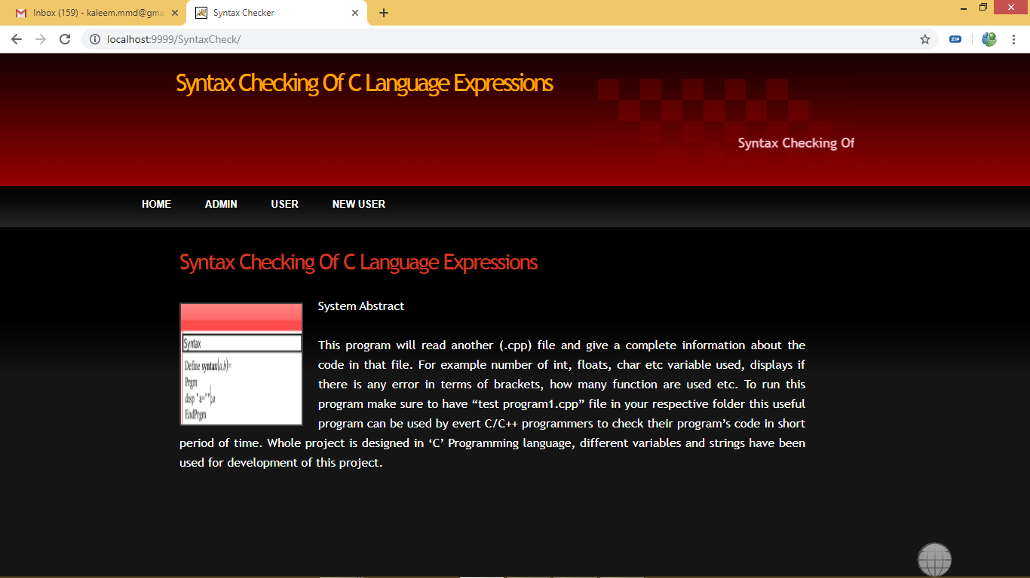

Now click on ‘New User’ link to register new user

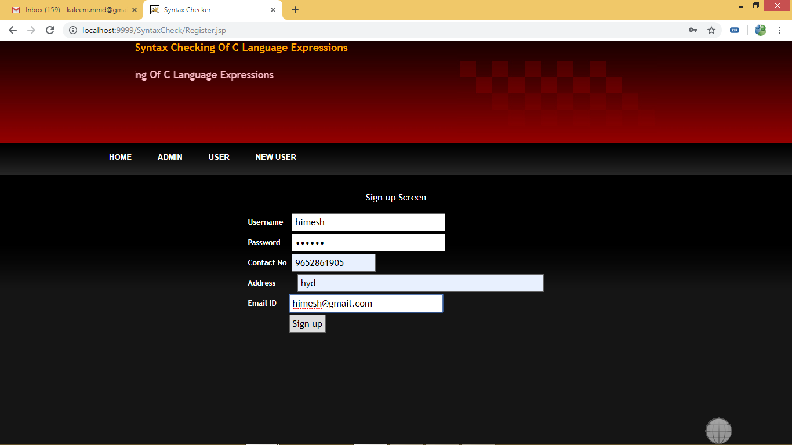

After registration will get below screen

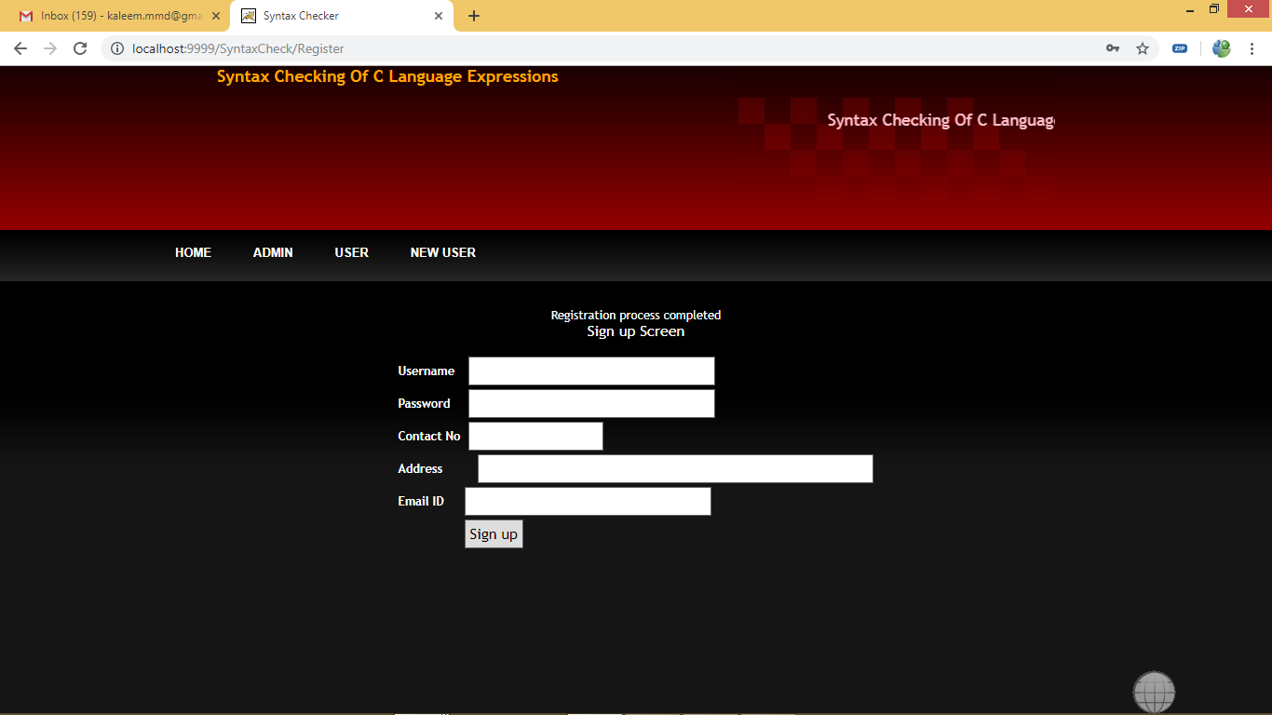

Now login as user to get below screen

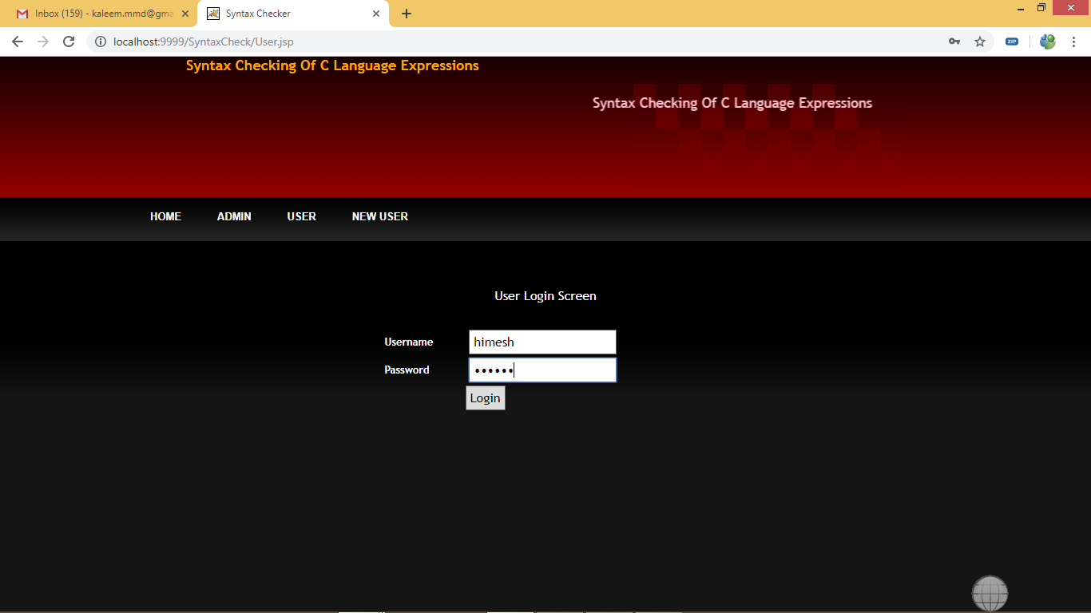

After login will get below screen

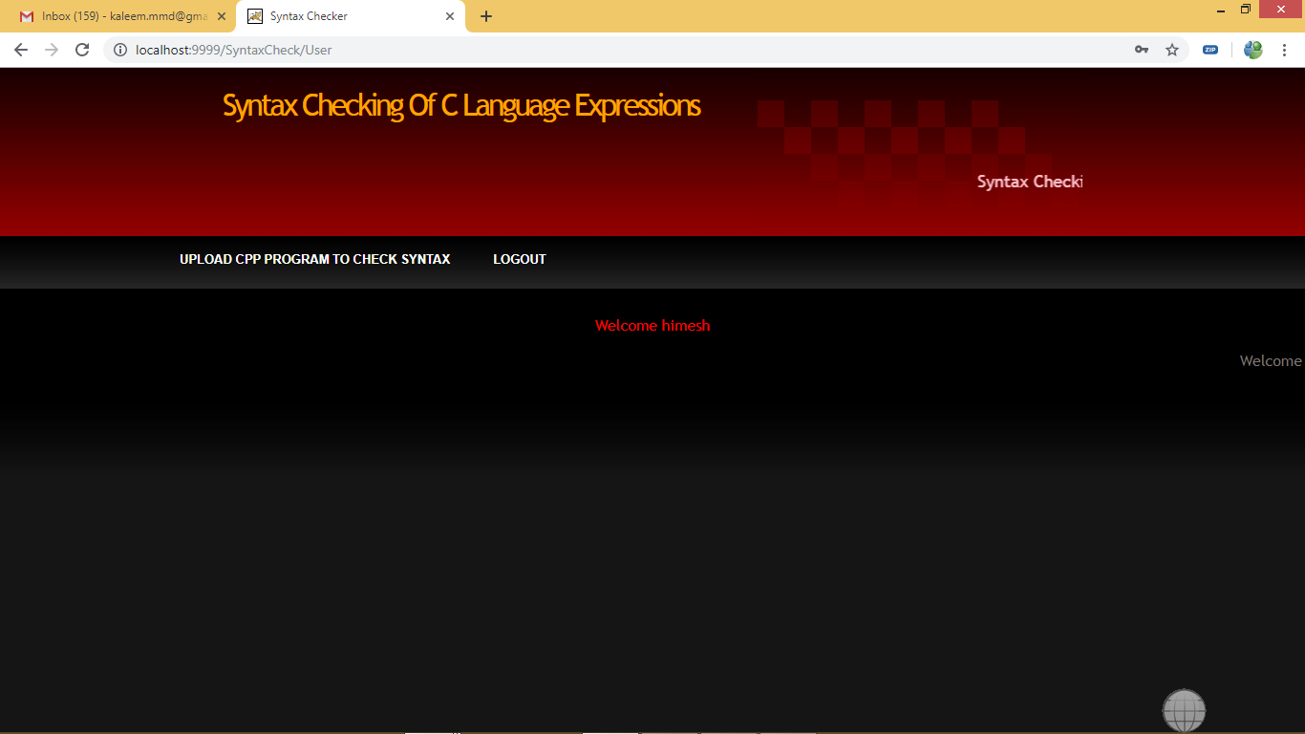

Now in above screen click on ‘Upload CPP Program To Check Syntax’ link to get below program upload screen

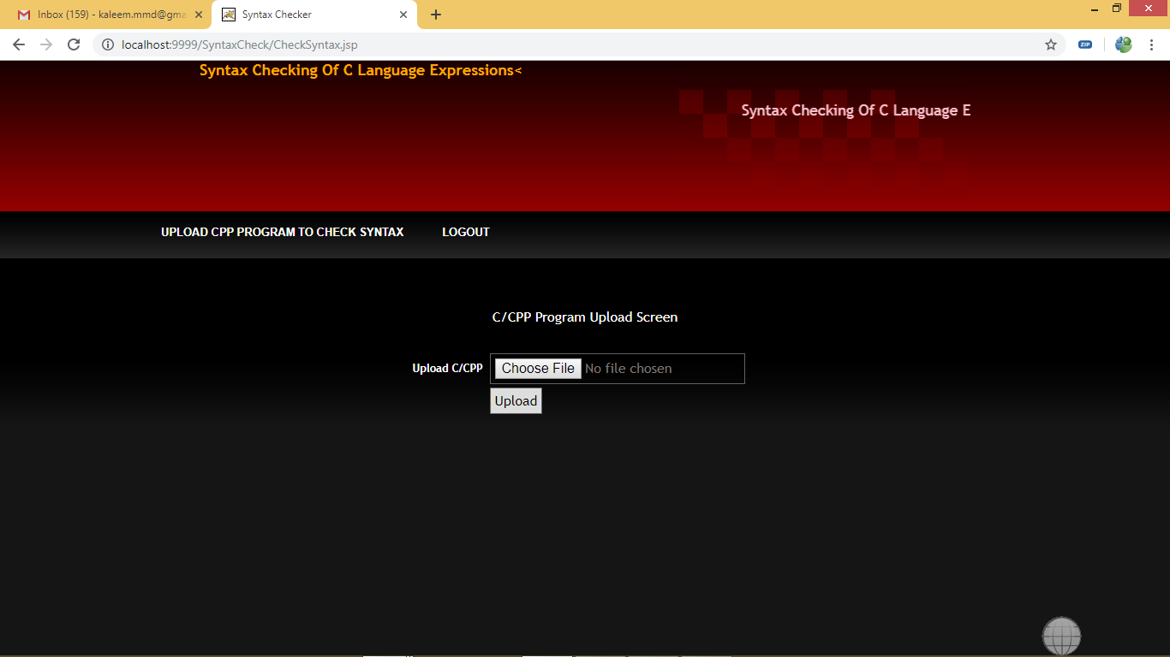

In above screen click on ‘Choose File’ button and upload CPP program and for testing purpose i am saving one CPP file inside WEB-INF folder

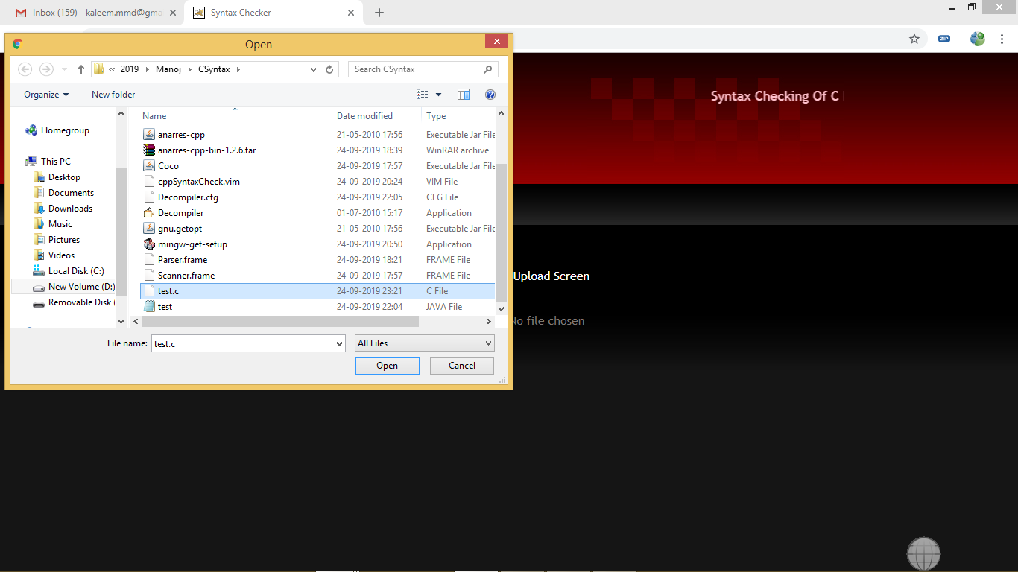

In above screen i uploaded ‘test.c’ file and then click upload button to get below screen

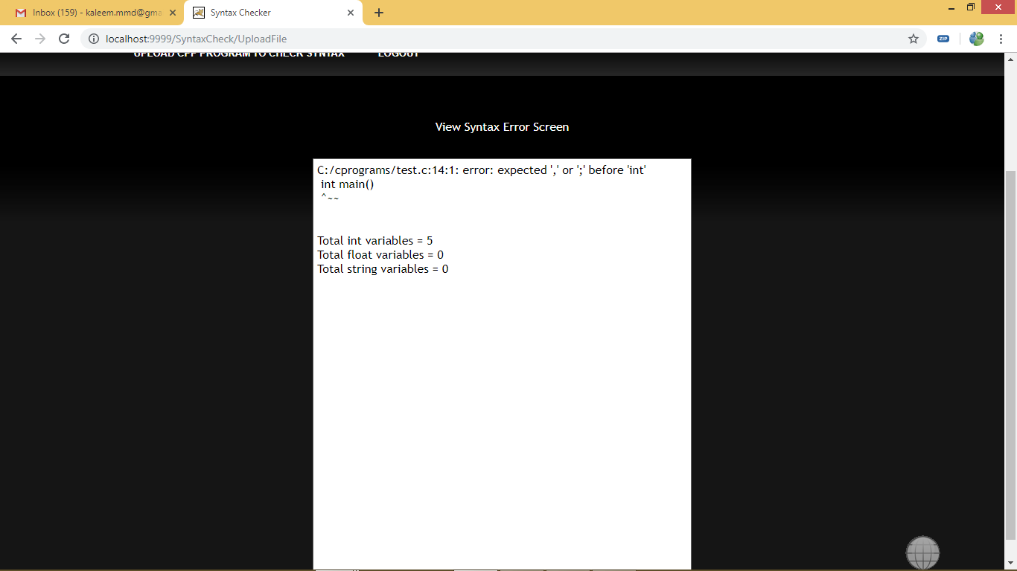

In above screen we can see about error details and total number of variables found in application

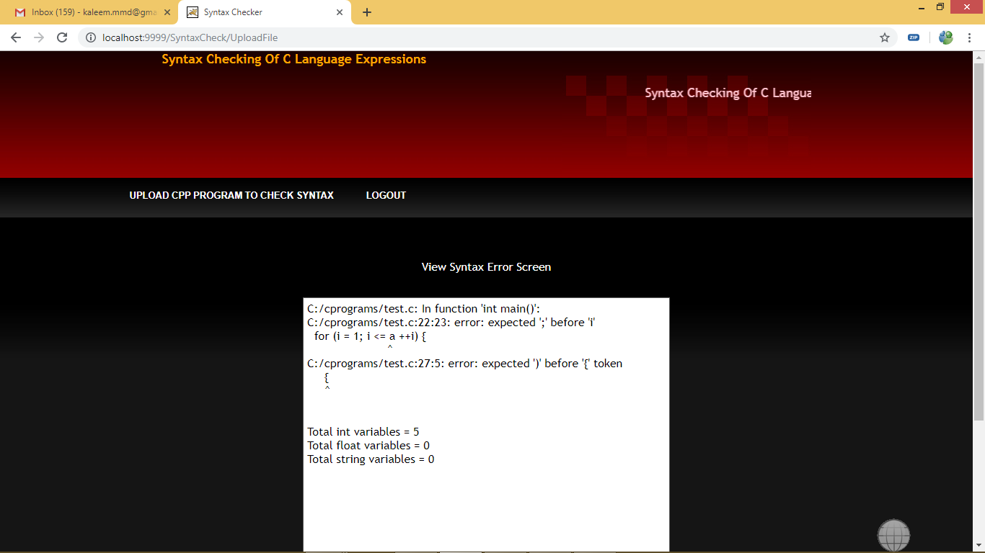

Now logout and login as admin to get below screen

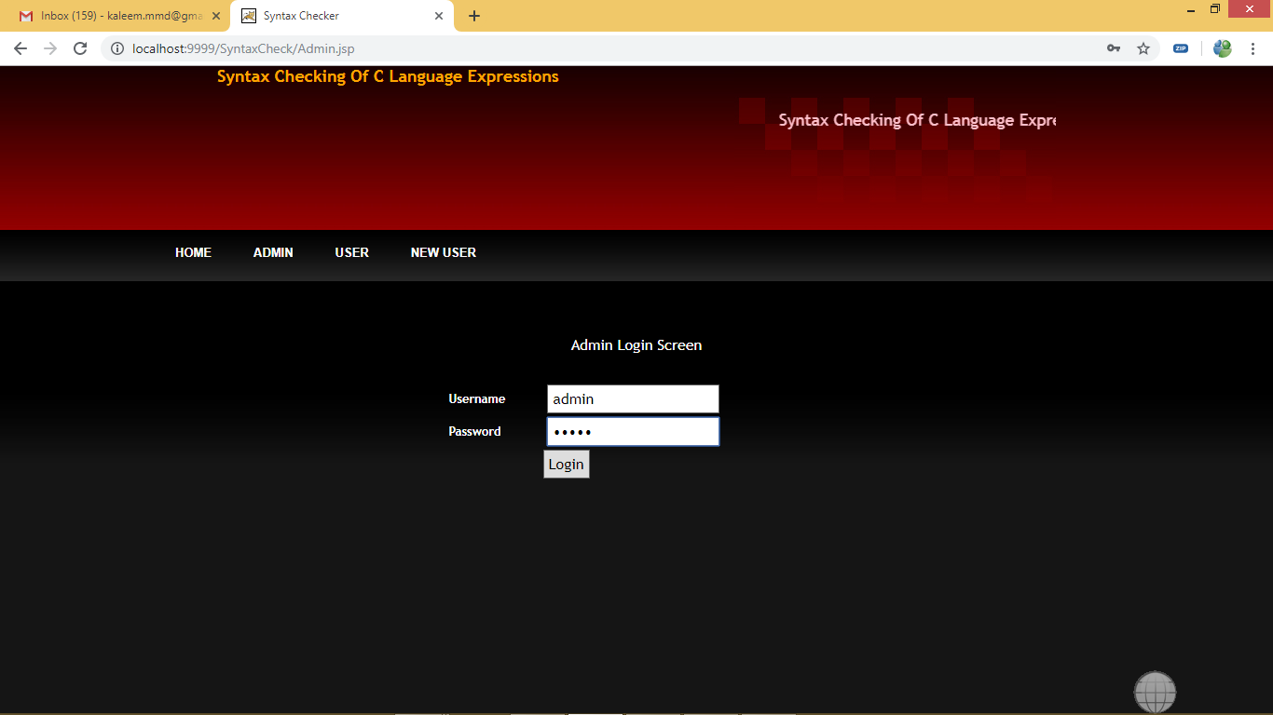

After login will get below screen

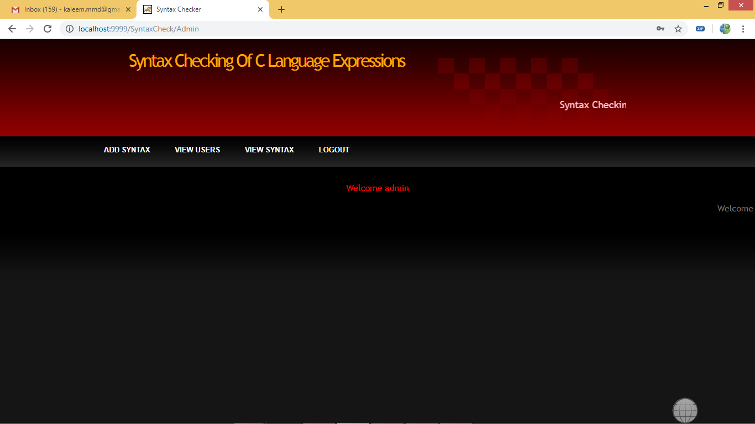

Click on ‘Add Syntax’ link to add new syntax

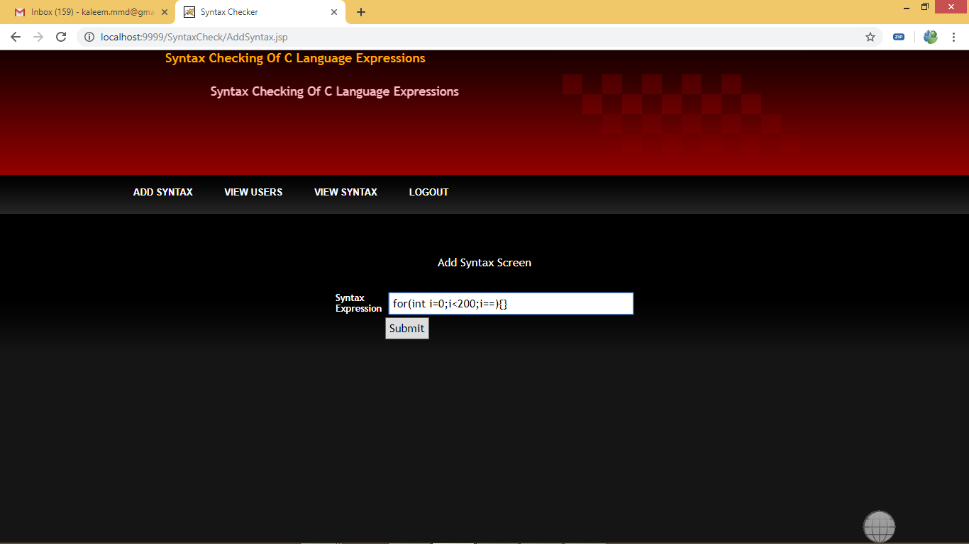

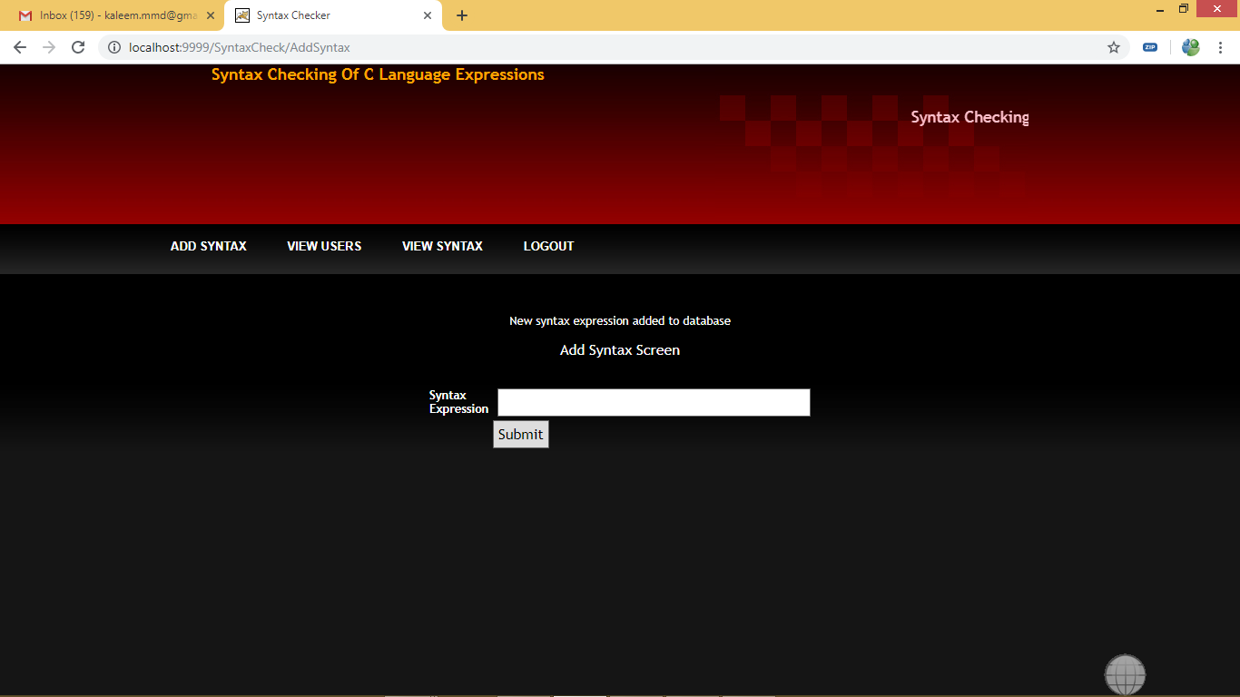

Click on ‘View Users’ link to view all user details

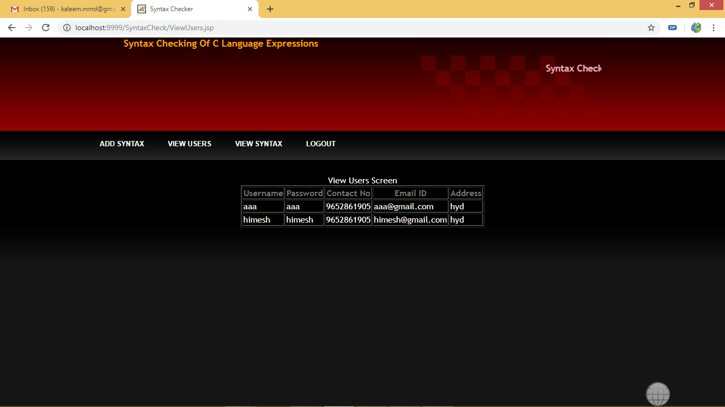

Click on ‘View Syntax’ link to get all syntax details

