Open git bash cmd

And open the requested folder to push

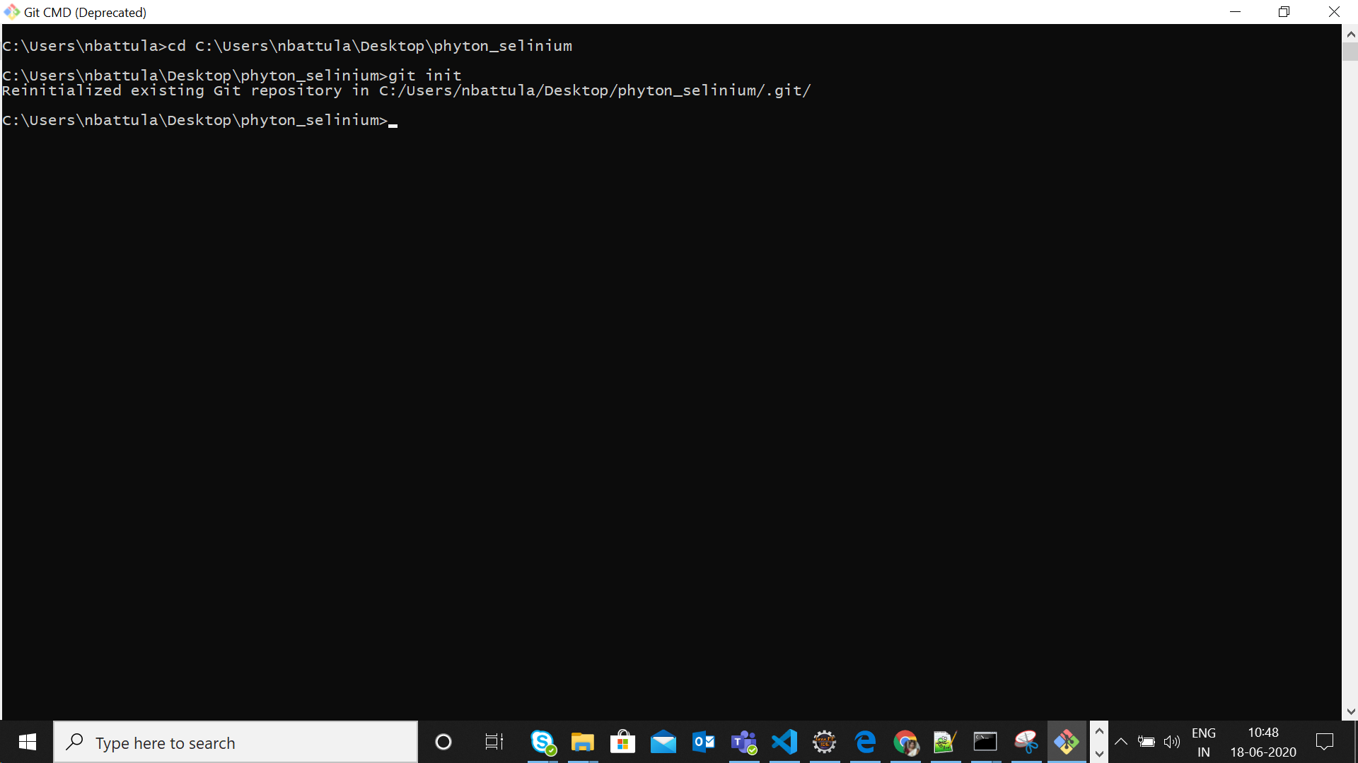

Git init

git add -A

once everything is add

git commit -m "First commit"

<https://github.com/nagamani-git/Appd_Python_selenium-scripts.git>

$ git remote add origin remote repository URL

# Sets the new remote

$ git remote -v

# Verifies the new remote URL

$ git push origin master

If some errors with push

Apply the below

git push origin master --force