Set up for python-selenium scripts to run in local.

Softwares

Python 2.7.16

Selenium 3

Visual studio

Any web browser dirver

Step1: Install Python

Python to install

Here we are preferring the python 2.7.18,click on the below link for python downloads

<https://www.python.org/downloads/release/python-2718/>

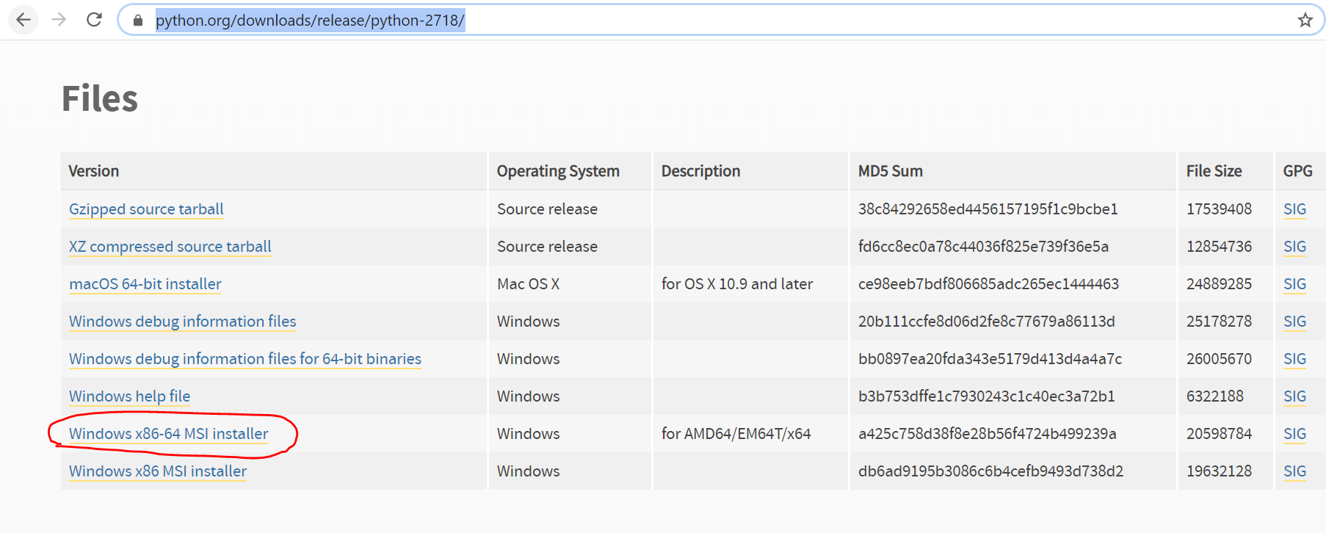

Download the respective according your operating system ,Here We are using Windows so I have downloaded Window x86-64 MSI installer.

Once properly installed the Folder structure like below

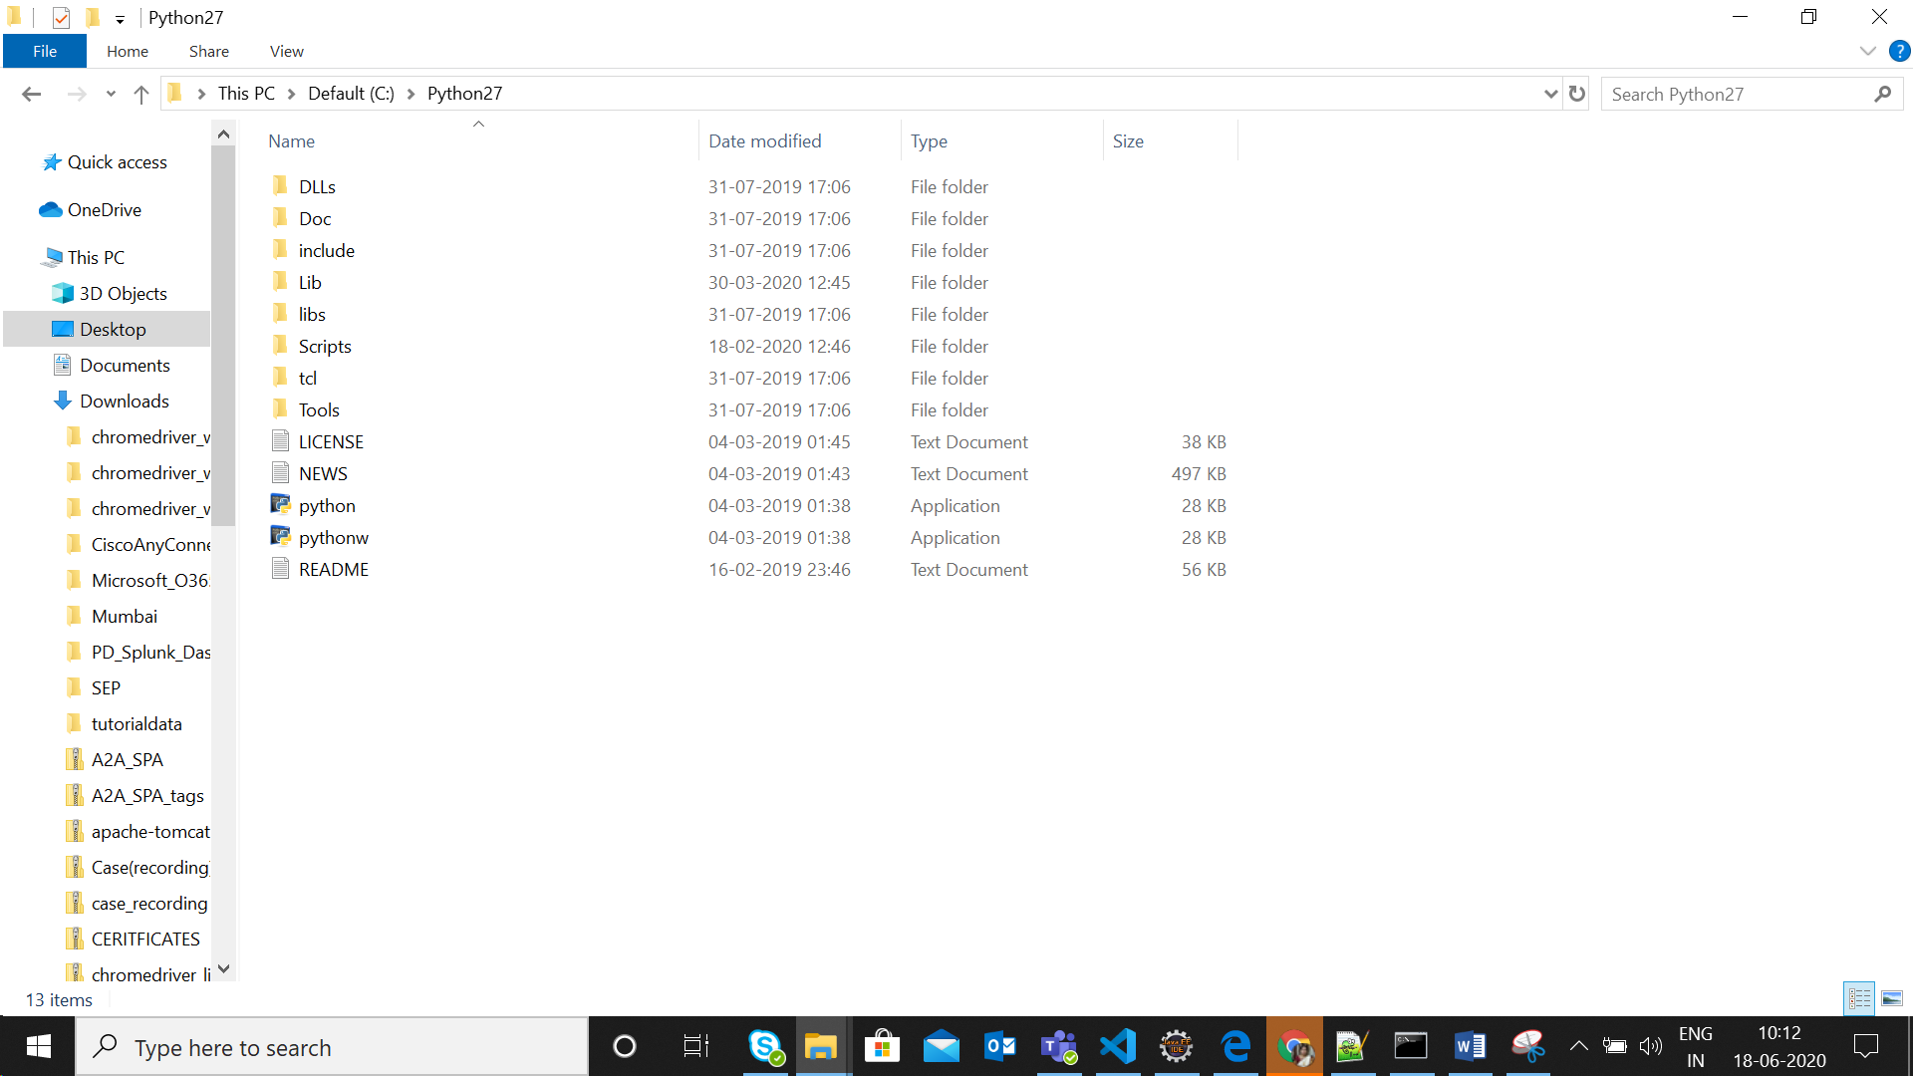

Step2: Install selenium

open the python27 folder in your local - > Go to scripts

Check whether you have Pip is there.

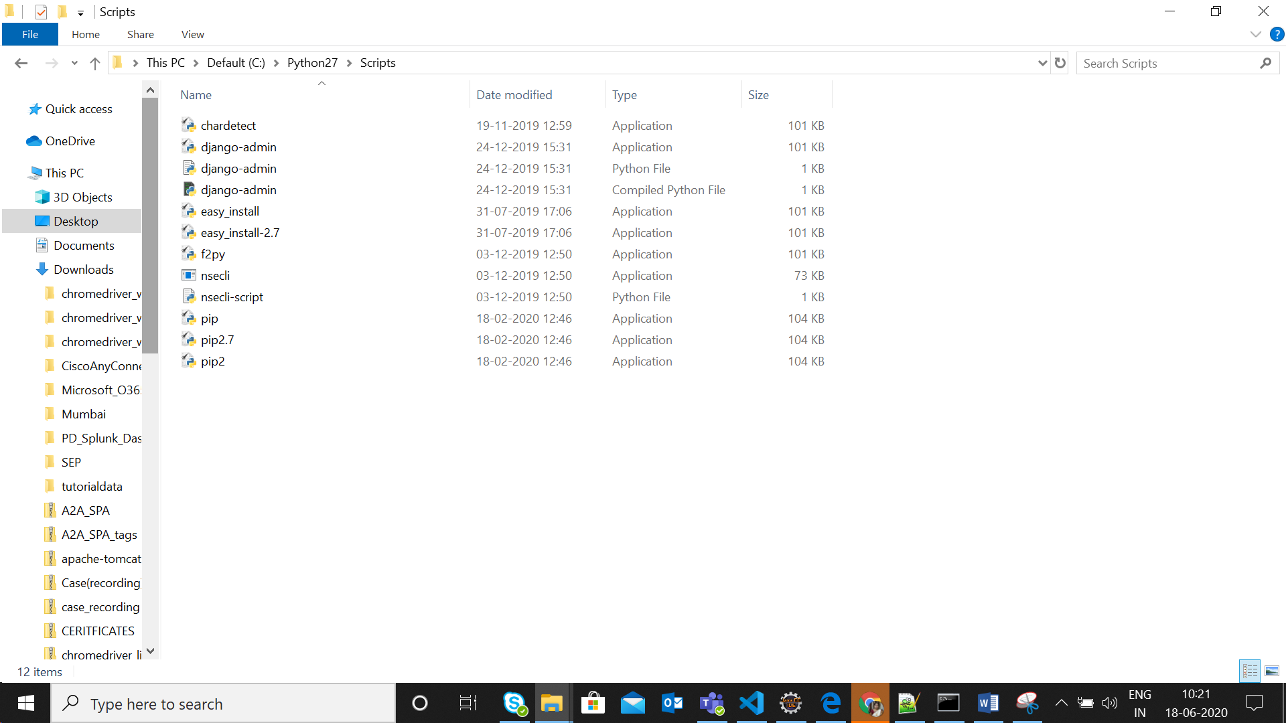

Once it is available set the path In CMD

Using command pip install selenium

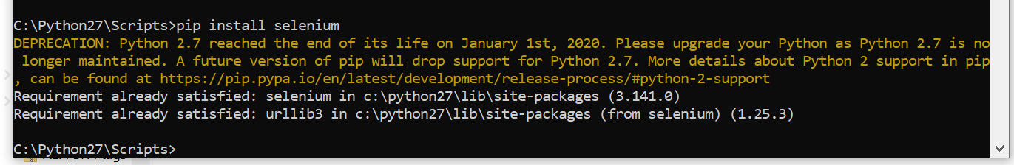

Step3:

Similarly download the VS.

<https://visualstudio.microsoft.com/downloads/>

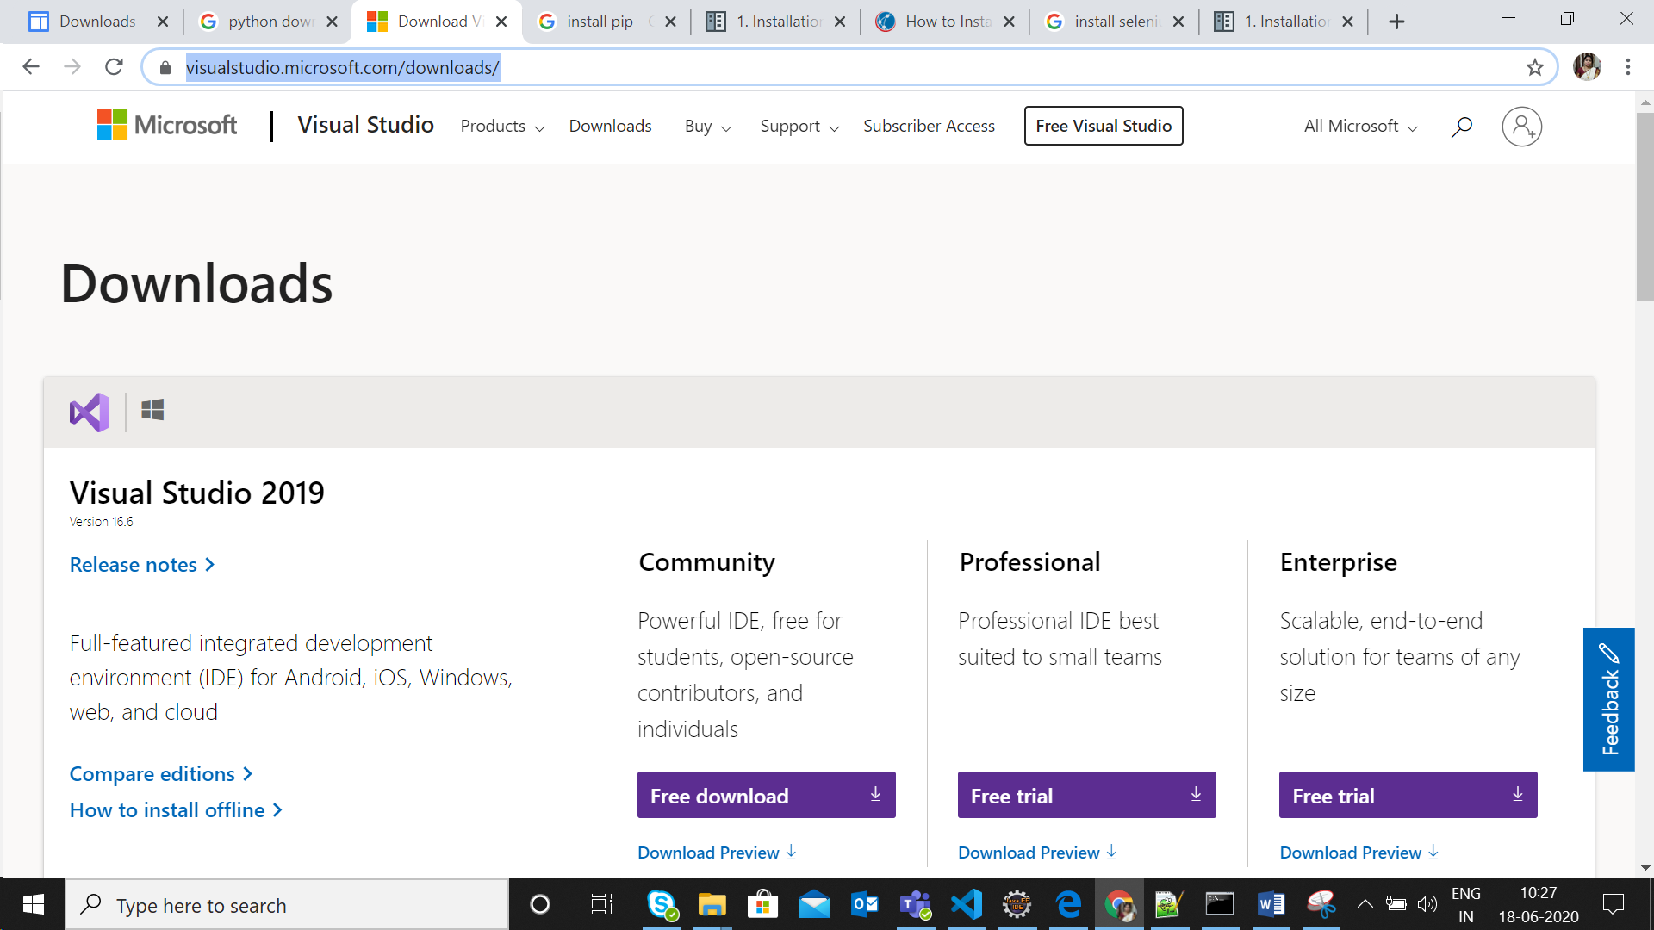

Open the VS and set the python path

VSCODE ->SETTINGS -> In setting search for python.pythonPath

Now set python27 folder path and assign in setting section.

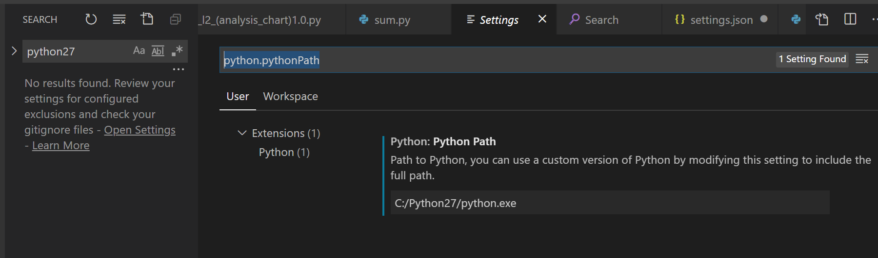

Step4: Install chrome driver.

<https://chromedriver.chromium.org/downloads>

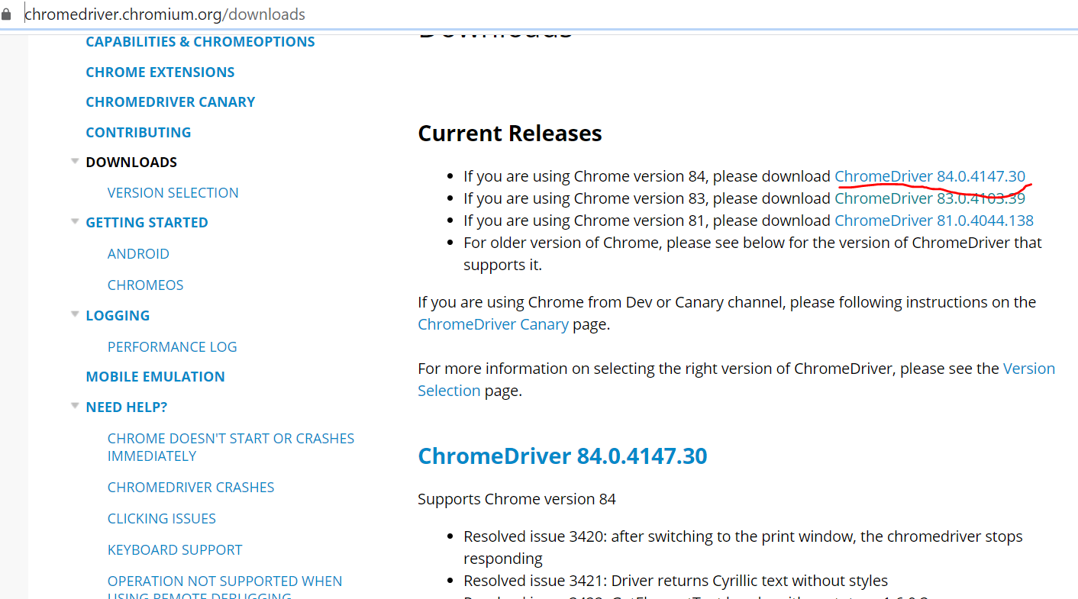

We need to need the path of chromedriver.exe file to set in our script

driver = webdriver.Chrome("C://Softwares//chrome_83//chromedriver.exe")