REACT:
Step 1: Start With a Problem (Relatable Introduction)
You can say:
“Till now, we learned HTML, CSS, and JavaScript.
But when websites become large like Instagram, Netflix, or Amazon…
managing everything using only JavaScript becomes difficult.
So developers needed something smarter and faster.
That’s where React comes.”

🔹 Step 2: What is React?


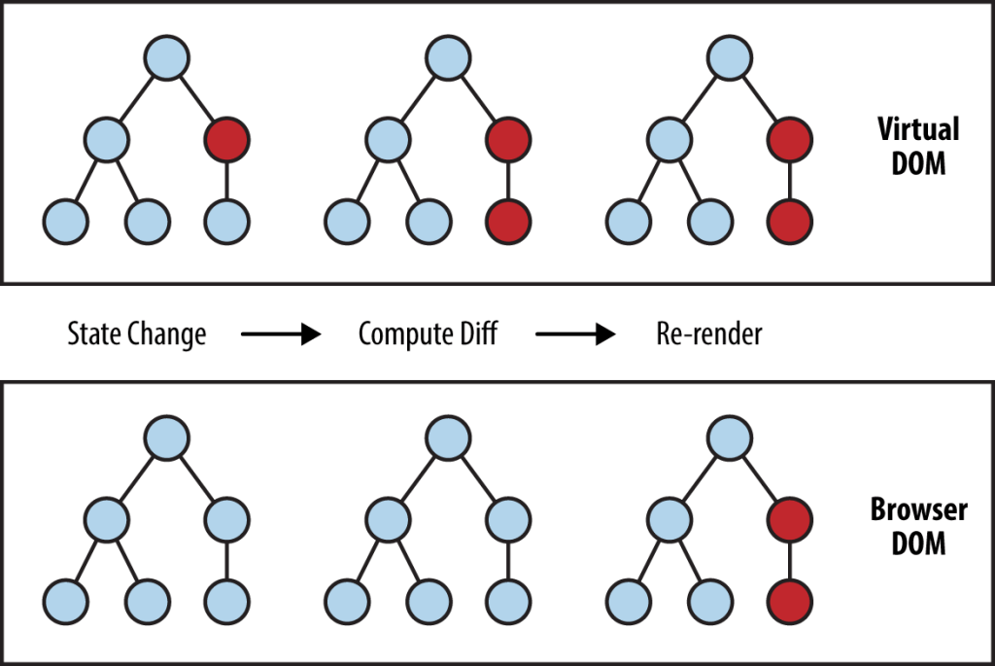
4
Now say:
“React is a JavaScript library used to build user interfaces (UI).
It was created by Facebook in 2013.
React helps us build fast, interactive, and dynamic web applications.”
You can also mention:
- Developed by → Facebook (now Meta)
- React is mainly used for → Single Page Applications (SPA)

🔹 Step 3: Why Do We Need React?
Ask students:
👉 “When we update one small part in a website… should the whole page reload?”
Then explain:
- In normal JS → Page reloads
- In React → Only required part updates (using Virtual DOM)
Simple line to say:
“React updates only what is needed, not the entire page.”

🔹 Step 4: Core Idea of React (Very Important)
Say this clearly:
“React is completely based on Components.”
Explain:
- Everything in React is a component
- Header → component
- Navbar → component
- Card → component
- Footer → component
You can say:
“React allows us to break big UI into small reusable pieces.”

🔹 Step 5: One Powerful Definition
Tell them to remember this:
“React is a JavaScript library for building fast and reusable UI components.”
You are absolutely correct ✅
JavaScript DOM manipulation does NOT reload the entire page.
So that line:
“In normal JS → Page reloads”
❌ is not technically correct.
Let me explain clearly so you can teach it correctly.

🔹 First Clear the Confusion
There are two different things:
- 🔁 Page Reload
- 🔄 DOM Update
They are NOT the same.

🔹 In Vanilla JavaScript (DOM)
When you do this:
document.getElementById("demo").innerHTML = "Hello";
👉 The page does NOT reload.
👉 Only that element updates.
So yes — JS can update part of the page without reload.
You are right 👍

🔹 Then What Is Special About React?
The difference is NOT about reload.
The difference is about:
How efficiently and automatically updates are managed.

🔹 Problem With Large Applications in Vanilla JS
Let’s imagine:
You have:
- Navbar
- Sidebar
- Product list
- Cart
- User profile
- Notifications
If state changes (example: cart item added),
In Vanilla JS:
- You must manually decide:
  - Which elements to update
  - Where to update
  - When to update
- You write a lot of DOM manipulation code
- It becomes messy in large apps

🔹 How React Solves This
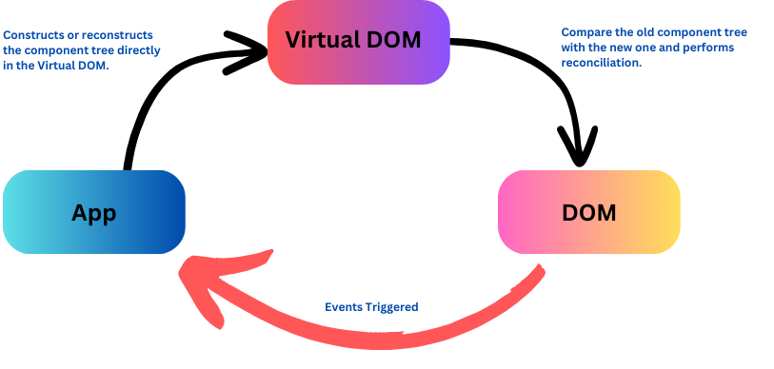

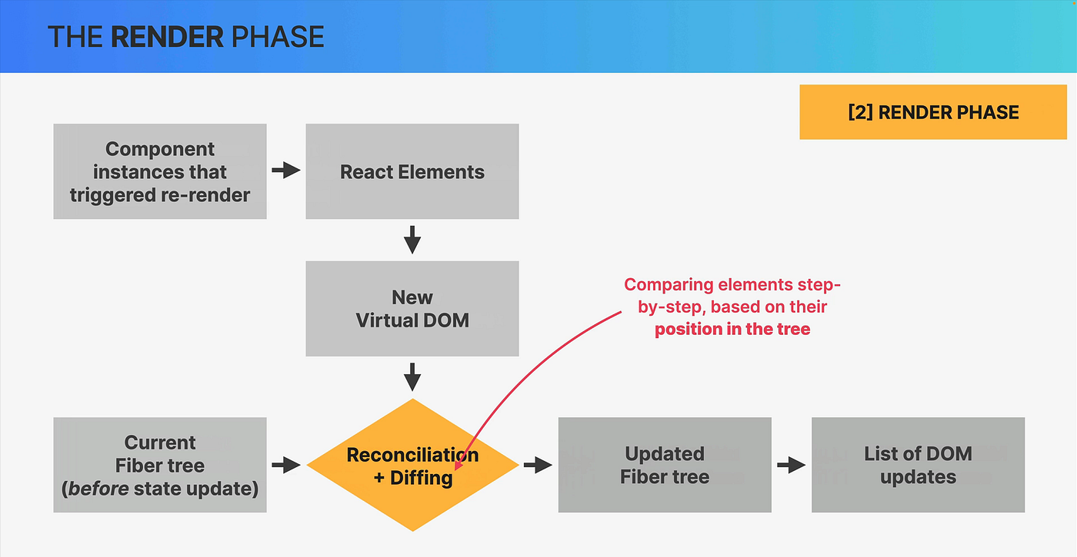
4
React uses something called:
👉 Virtual DOM
Instead of directly touching the real DOM:
- React creates a virtual copy of the DOM
- When state changes:
  - It creates a new virtual DOM
  - Compares with old one (Diffing)
  - Updates ONLY the changed part in real DOM
You don’t manually select elements.
You just change state.
React handles the rest.

🔹 Real Difference (Correct Explanation You Can Teach)
Instead of saying:
❌ “Normal JS reloads the page”
Say this:
✅ “In Vanilla JS, we manually update the DOM.
In React, UI automatically updates when state changes.”

🔹 Simple Classroom Explanation
You can say:
“JavaScript can update the DOM without reloading.
But in large applications, managing updates manually becomes complex.
React simplifies this by using a Virtual DOM and automatic re-rendering.”
That is technically correct ✅

🔹 One More Important Difference
In Vanilla JS:
You think:
- “Which element should I update?”
In React:
You think:
- “What should the UI look like for this state?”
This is called:
👉 Declarative programming (React)
vs
👉 Imperative programming (Vanilla JS)

🔹 Single Page Application (SPA)

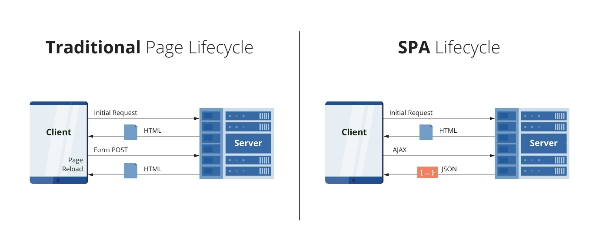
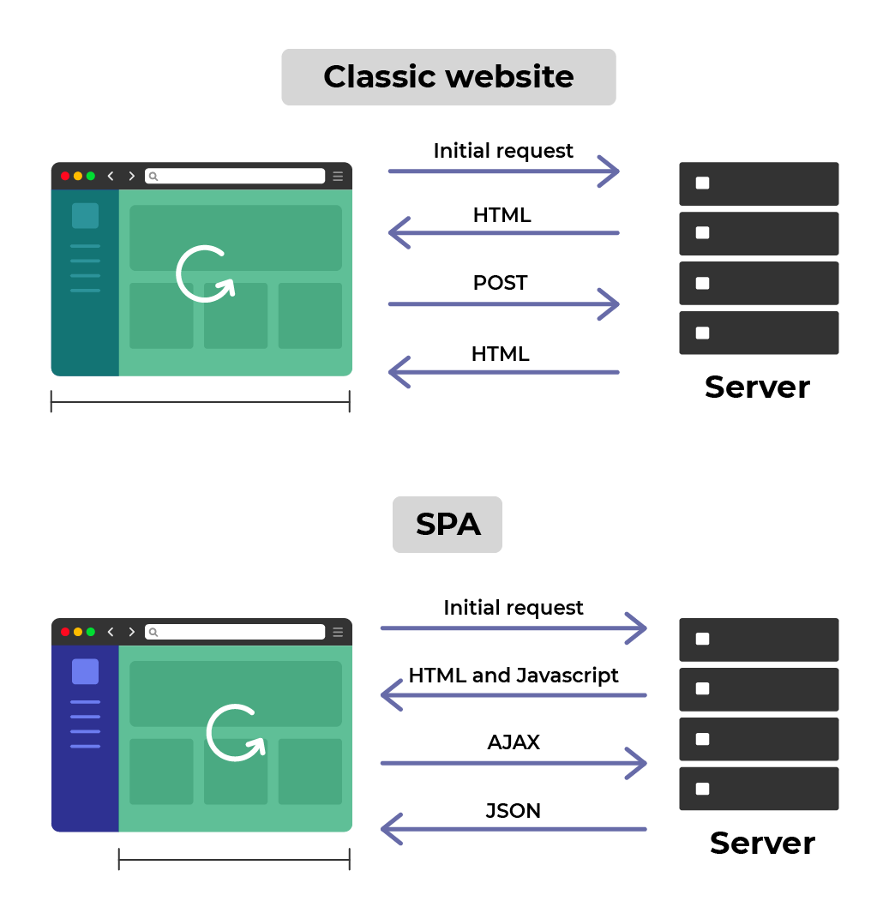
4
✅ What is a Single Page Application?
A Single Page Application (SPA) is a web application that:
Loads one HTML page only once,
and then dynamically updates content
without reloading the entire page.

🔹 Traditional Website vs SPA
🧱 Traditional Website (Multi-Page Application)
When you:
- Click Home
- Click About
- Click Contact
👉 Each click sends a request to the server
👉 The browser loads a new HTML page every time
👉 Full page refresh happens

⚡ Single Page Application
In an SPA:
- The page loads only once
- When you click different sections:
  - Only content changes
  - No full page reload
  - JavaScript handles routing

🔹 Example of SPA
Popular SPA frameworks:
- React
- Angular
- Vue.js
Apps that behave like SPA:
- Instagram
- Facebook
- Netflix
When you scroll or click inside these apps —
notice 👀
The page doesn’t refresh.

🔹 Why SPAs Are Fast?
Because:
- No repeated HTML loading
- No full browser refresh
- Only required data is fetched (via APIs)
- UI updates dynamically

🔹 How React Helps in SPA?
React:
- Uses components
- Uses Virtual DOM
- Works with client-side routing (like React Router)
- Updates only required parts of UI

🔹 Simple Definition You Can Say in Class
“A Single Page Application loads one HTML page once and updates content dynamically without reloading the browser.”

🔹 One Line for Students to Remember
“SPA = One Page + Dynamic Updates + No Full Reload.”
🔹 JSX (JavaScript XML)
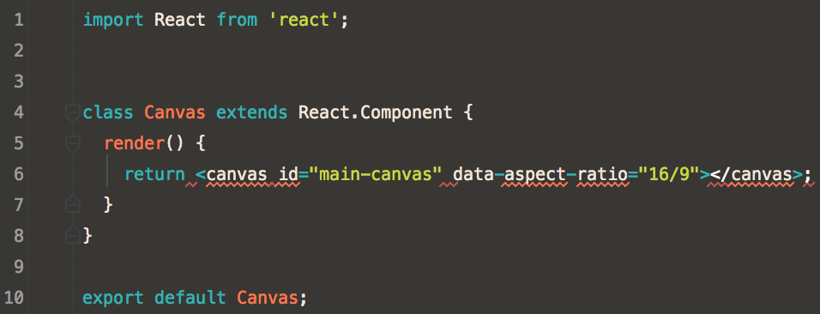
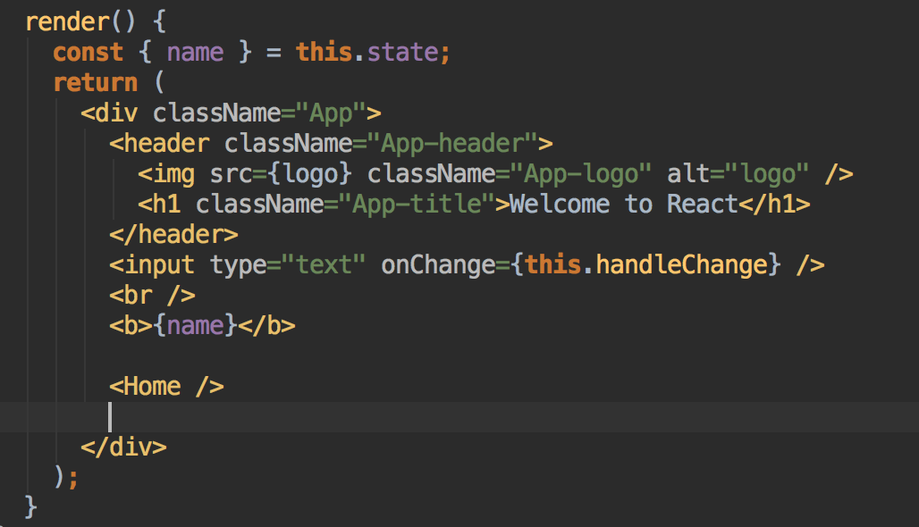
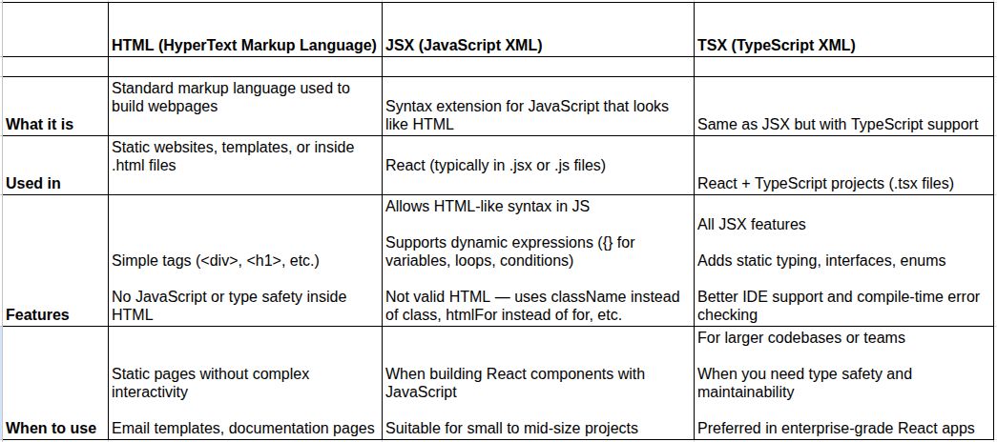
4

✅ What is JSX?
JSX (JavaScript XML) is a syntax used in React that allows us to write HTML-like code inside JavaScript.
👉 It looks like HTML
👉 But it is actually JavaScript

🔹 Why Do We Need JSX?
Before JSX, React used something like this:
React.createElement("h1", null, "Hello World")
But this looks complicated 😵
So JSX was introduced to make code:
- ✅ More readable
- ✅ Easier to write
- ✅ HTML-like
Now we can write:
<h1>Hello World</h1>
Much cleaner 👍

🔹 Important: Is JSX HTML?
❌ No.
JSX is not HTML.
Browsers do not understand JSX directly.
JSX is converted into normal JavaScript using tools like:
- Babel
So internally:
<h1>Hello</h1>
Becomes:
React.createElement("h1", null, "Hello")

🔹 Basic JSX Example
function App() {
return (
<div>
<h1>Welcome</h1>
<p>This is JSX</p>
</div>
);
}
Notice:
- Looks like HTML
- But written inside JavaScript
- Must return only one parent element

🔹 JSX Rules (Very Important for Students)
1️⃣ Must return one parent element
❌ Wrong:
<h1>Hello</h1>
<p>Hi</p>
✅ Correct:
<div>
<h1>Hello</h1>
<p>Hi</p>
</div>

2️⃣ Use className instead of class
❌
<div class="box"></div>
✅
<div className="box"></div>
Because class is a reserved keyword in JavaScript.

3️⃣ JavaScript inside JSX → Use {}
let name = "Reshma";

<h1>Hello {name}</h1>
Curly braces allow us to write:
- Variables
- Expressions
- Functions

🔹 How to Explain in Class (Simple Script)
You can say:
“JSX allows us to write HTML inside JavaScript.
It makes React code easy to read and write.
JSX is not HTML — it is converted into JavaScript behind the scenes.”

🔹 One Line Definition for Students
“JSX is a syntax extension in React that lets us write HTML-like code inside JavaScript.”

Components in React

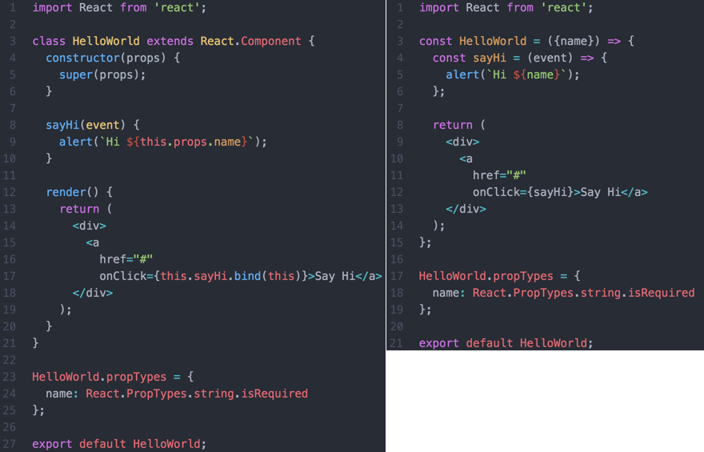
4
In React, everything is built using components.

✅ What is a Component?
A component is a small, reusable piece of UI.
For example:
- Navbar → Component
- Footer → Component
- Product Card → Component
- Button → Component
👉 Big UI = Combination of small components

🔹 Types of Components
React mainly has two types:
- Class Components
- Functional Components

1️⃣ Class Components
These were used more in older versions of React.
They use:
- class keyword
- extends React.Component
- render() method
- this keyword
📌 Example:
import React from "react";

class Welcome extends React.Component {
render() {
return <h1>Hello Students</h1>;
}
}

export default Welcome;
🔹 Features:
- Can use state
- Can use lifecycle methods
- Uses this.state
- More complex syntax

2️⃣ Functional Components
These are modern and most commonly used today.
They are just JavaScript functions.
📌 Example:
function Welcome() {
return <h1>Hello Students</h1>;
}

export default Welcome;
Or using arrow function:
const Welcome = () => {
return <h1>Hello Students</h1>;
};

🔹 Can Functional Components Use State?
Yes ✅
Earlier → Only class components could use state.
Now → With Hooks (like useState), functional components can also use state.
Example:
import { useState } from "react";

function Counter() {
const [count, setCount] = useState(0);

return (
<div>
<h1>{count}</h1>
<button onClick={() => setCount(count + 1)}>
Increase
</button>
</div>
);
}

🔹 Class vs Functional (Clear Comparison)
Class Component | Functional Component
Uses class keyword | Just a function
Uses render() method | Direct return
Uses this keyword | No this
Complex | Simple
Old approach | Modern approach
Lifecycle methods | Hooks

🔹 Which One Should We Teach First?
👉 In 2026, Functional Components are recommended.
Class components are mostly for:
- Understanding old code
- Interview knowledge

🔹 Simple Way to Explain in Class
You can say:
“Components are reusable building blocks of React.
Earlier we used Class components.
Now we mostly use Functional components because they are simple and powerful.”

🔹 One-Line Definitions
✅ Component → “Reusable piece of UI.”
✅ Class Component → “Component written using class syntax.”
✅ Functional Component → “Component written as a JavaScript function.”

Here’s how to uninstall Node.js depending on your system 👇

🪟 Windows
🔹 Method 1: Using Control Panel (Recommended)
- Press Windows + R
- Type appwiz.cpl → Press Enter
- Find Node.js
- Right click → Uninstall
- Restart your computer

🔹 After Uninstall (Important Cleanup)
Sometimes some files remain. Check and delete manually:
- C:\Program Files\nodejs
- C:\Users\YourName\AppData\Roaming\npm
- C:\Users\YourName\AppData\Roaming\npm-cache
(Only delete if they exist)

🔹 Verify Removal
Open Command Prompt and type:
node -v
If it says:
'node' is not recognized...
✅ Node is successfully removed.

🍎 macOS
🔹 If Installed Using Installer (.pkg)
Open Terminal:
sudo rm -rf /usr/local/bin/node
sudo rm -rf /usr/local/lib/node_modules
sudo rm -rf /usr/local/include/node

🔹 If Installed Using Homebrew
brew uninstall node

🐧 Linux (Ubuntu/Debian)
sudo apt remove nodejs
sudo apt purge nodejs
sudo apt autoremove

⚠️ If You Installed Using NVM
If you used Node Version Manager:
nvm uninstall <version>
Example:
nvm uninstall 18.17.0

First Question
👉 Is React dependent on Node?
Answer:
❌ React does NOT run on Node in the browser.
✅ But we NEED Node to build and manage a React project.
Now let me explain properly.

🔹 What is React?
React is a frontend JavaScript library.
It runs inside the browser.
So technically:
Browser → Runs React
Not Node.

🔹 Then Why Do We Install Node?
Because React projects need tools.
And those tools run using Node.js

🔹 What Node Provides
When you install Node, you get:
1️⃣ npm (Node Package Manager)
npm helps to:
- Install React
- Install libraries
- Install dependencies
- Manage project packages
Example:
npm create vite@latest
Without npm → You cannot install React easily.

2️⃣ Development Server
When you run:
npm run dev
Node runs a local development server like:
http://localhost:5173
That server:
- Compiles your JSX
- Bundles files
- Refreshes browser automatically

3️⃣ JSX Compilation
Remember:
JSX is NOT understood by browser.
It must be converted into normal JavaScript.
That conversion is done by tools like:
- Babel
- Vite
- Webpack
All these tools run using Node.

🔹 Simple Real-Life Analogy
You can say this in class:
“React is like ingredients.
Node is like the kitchen.
npm is like the grocery shop.”
Without kitchen → You cannot cook.

🔹 Very Clear Technical Flow
- We install Node
- Node gives npm
- npm installs React
- Node runs development server
- Browser runs the final React app

🔹 Important Line for Students
“React runs in the browser, but Node helps us build and manage React projects.”

🔹 One More Important Thing
After building the project (production build):
We don't need Node to run it.
Only HTML, CSS, JS files are served.
Node is mainly needed during development.

How To Say To Students (You Can Literally Speak This)
“Earlier React apps were created using create-react-app.
But now industry uses Vite because it is faster and lightweight.
So we will follow the modern way.”

🔹 Step-by-Step You Should Teach
Step 1 — Create project
npm create vite@latest myapp
Then choose:
Framework → React
Variant → JavaScript

Step 2 — Move into folder
cd myapp

Step 3 — Install dependencies
npm install

Step 4 — Run project
npm run dev
Now open:
http://localhost:5173
React app running 🎉

🔹 What to Explain While Teaching
While running commands, explain meaning:
Command | What it does
npm create vite | Creates project
npm install | Downloads packages
npm run dev | Starts development server

🔹 One Important Line To Tell Students
“We don’t install React globally.
We create a React project using tools.”

🔹 Short Version You Can Write On Board
Install Node
↓
npm create vite@latest myapp
↓
cd myapp
↓
npm install
↓
npm run dev

If you want, next I can help you explain:
- Folder structure of React project
- package.json meaning
- node_modules explanation (students always ask this 😄)
Tell me 😊
what is vite here
Perfect question 👌 — students always ask this after running
npm create vite@latest

🔹 What is Vite?
Vite is a tool that helps us create and run modern frontend projects faster.
Vite is the tool that prepares React so the browser can understand and run it.

🔹 Why React Needs Vite?
Browser cannot understand JSX directly.
Example:
<h1>Hello</h1>
Browser only understands:
React.createElement("h1", null, "Hello")
So something must convert and manage files.
👉 That “something” is Vite.

🔹 What Vite Does Internally
When you run:
npm run dev
Vite:
- Converts JSX → JavaScript
- Starts local server (localhost)
- Reloads browser automatically
- Optimizes project speed
- Bundles files for production

🔹 Why We Use Vite Instead of create-react-app
create-react-app | Vite
Slow start | Instant start ⚡
Heavy | Lightweight
Old method | Modern industry method
Takes minutes | Takes seconds

🔹 Simple Analogy (Tell Students)
“React is the car.
Vite is the engine starter.”
or
“React is code.
Vite prepares it so browser can run it.”

🔹 One Line Definition (Students Note)
“Vite is a build tool that creates and runs React applications quickly.”

🔹 Important Clarification
Vite is NOT React
- React → Library to build UI
- Vite → Tool to run React project

