include<stdio.h>

#include<string.h>

int length(char *s){

int k=0;

for(int i=0;s[i]!='\0';i++){

k++;

}

return k;

}

int freq(char *s){

int n=length(s);

for(int i=0;i<n;i++){

int count=1;

if(s[i]){

for(int j=i+1;j<n;j++){

if(s[i]==s[j]){

count++;

s[j]='\0';

}

}

}

if(s[i]!='\0'){

printf("the frequency of '%c' is %d\n",s[i],count);

}

}

}

int main(){

char str[100];

printf("enter the string \n");

gets(str);

int n=length(str);

printf("the length of the string is %d\n",n);

freq(str);

}

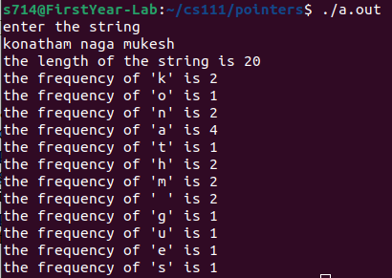

include<stdio.h>

int swap(int *a,int *b);

int main(){

int a,b;

printf("enter the two numbers to be swapped \n");

scanf("%d %d",&a,&b);

printf("the numbers before swapping are %d and %d\n",a,b);

int *x=&a;

int *y=&b;

swap(x,y);

printf("the numbers after swapping are %d and %d\n",*x,*y);

}

int swap(int *a,int *b){

int temp;

temp=*a;

*a=*b;

*b=temp;

}

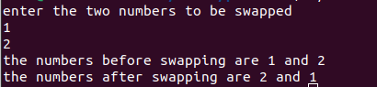

include<stdio.h>

#define PI 3.1416

float area_circle(int *r){

float area;

area=PI*(*r)*(*r);

return area;

}

float peri(int *r){

float perimeter;

perimeter=2*PI*(*r);

return perimeter;

}

int main(){

int radius;

printf("enter the radius \n");

scanf("%d",&radius);

int *r;

r=&radius;

printf("the perimeter of the circle is %f \n",peri(r));

printf("the area of the circle is %f\n",area_circle(r));

}

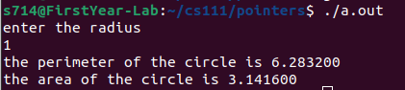

include<stdio.h>

#include<string.h>

int length(char *s){

int count=0;

for(int i=0;s[i]!='\0';i++){

count++;

}

return count;

}

void compare(char *a,char *b){

int n=strcmp(a,b);

if(n>0){

printf("the string %s is greater than %s\n",a,b);

}

else if(n<0){

printf("the string %s is greater than %s\n",b,a);

}

else{

printf("both the strings are equal\n");

}

}

void append(char *a,char *b){

a=strcat(a,b);

printf("the appended string is %s\n",a);

}

void copy(char *a,char *b){

b=strcpy(a,b);

printf("the copied string is %s\n",b);

}

void reverse(char *s){

int n=length(s);

char str[n];

for(int i=0;i<n;i++){

str[i]=s[n-i-1];

}

str[n]='\0';

printf("the reversed string is %s\n",str);

}

int main(){

char a[100],b[100];

printf("enter the two strings \n");

scanf("%s",a);

scanf("%s",b);

printf("the length of the string a is %d and string b is %d\n",length(a),length(b));

compare(a,b);

reverse(a);

reverse(b);

append(a,b);

copy(a,b);

}

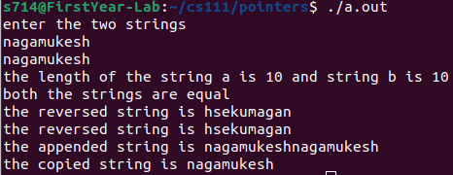

#include <stdio.h>

#include <stdlib.h>

int main() {

int n, i;

int *numbers;

int max;

printf("Enter the number of elements: ");

scanf("%d", &n);

numbers = (int *) malloc(n * sizeof(int));

if (numbers == NULL) {

printf("Memory allocation failed.");

exit(1);

}

printf("Enter the elements: ");

for (i = 0; i < n; i++) {

scanf("%d", &numbers[i]);

}

max = numbers[0];

for (i = 1; i < n; i++) {

if (numbers[i] > max) {

max = numbers[i];

}

}

printf("The largest number is: %d\n", max);

free(numbers);

return 0;

}

