1)to find length of a string

#include<stdio.h>

int main(){

char str[100];

printf("enter the string \n");

gets(str);

int l=0;

for(int i=0;str[i]!='\0';i++){

l++;

}

printf("the length of the string is %d \n",l);

}

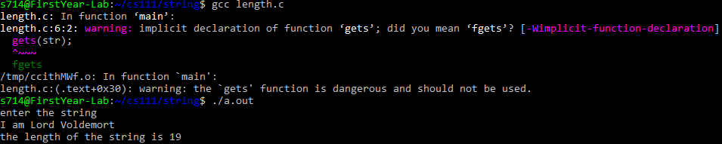

2)to reverse a string and check it is a palindrome or not

#include<stdio.h>

#include<string.h>

int main(){

char str[100],rev[100];

printf("enter the string \n");

gets(str);

int len=strlen(str);

int i;

for(i=0;i<len;i++){

rev[len-1-i]=str[i];

}

rev[i]='\0';

puts(rev);

int count=0;

if(strcmp(rev,str)==0){

printf("%s is a palindrome \n",str);

}

else{

printf("%s is not a palindrome \n",str);

}

}

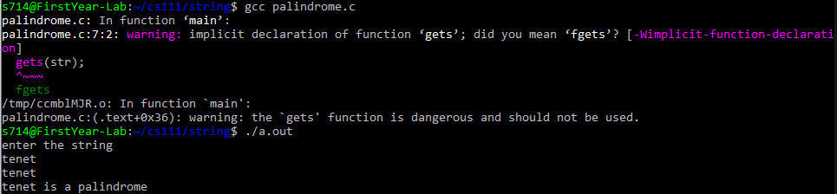

3)delete extra blank spaces

#include<stdio.h>

#include<string.h>

int main(){

char str[100];

printf("enter the string \n");

gets(str);

int n=strlen(str);

for(int i=0;str[i]!='\0';i++){

while(str[i]==' ' && str[i+1]==' '){

for(int j=i;str[j]!='\0';j++){

str[j]=str[j+1];

}

}

}

printf("the modified string is %s\n",str);

}

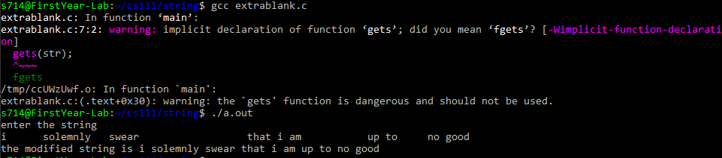

4)to change lowercase to uppercase and viceversa

#include<stdio.h>

#include<string.h>

int main(){

char str[100];

printf("enter the string \n");

gets(str);

int n=strlen(str);

for(int i=0;i<n;i++){

if('A'<=str[i] && str[i]<='Z'){

str[i]+=32;

}

else if('a'<=str[i] && str[i]<='z'){

str[i]-=32;

}

}

printf("the modified string is %s \n",str);

}

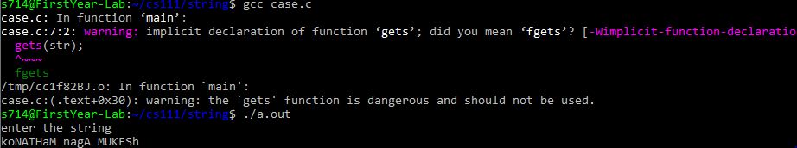

5)to delete all occurences of a substring in the given string

include<stdio.h>

#include<string.h>

int main(){

char str[100],sub[100];

printf("enter the string \n");

gets(str);

printf("enter the substring \n");

gets(sub);

int len=strlen(str);

int sublen=strlen(sub);

int i,j;

for(i=0;str[i]!='\0';i++){

int f=1;

for(j=0;sub[j]!='\0';j++){

if(str[i+j]!=sub[j]){

f=0;

break;

}

}

if(f==1){

for(int k=i;str[k]!='\0';k++){

str[k]=str[k+j];

}

i--;

}

}

printf("the modified string is %s \n",str);

}

