#include<stdio.h>

struct book {

char title[100];

char author[100];

int isbn;

int price;

};

void print(struct book b1){

printf("the name of the book is %s \n",b1.title);

printf("the author of the book is %s \n",b1.author);

printf("isbn no:%d \n",b1.isbn);

printf("price of the book is %d \n",b1.price);

}

int main(){

printf("enter 1 to continue and 0 to exit \n");

int n;

scanf("%d",&n);

while(n){

struct book b1;

printf("enter the name of the book \n");

scanf("%s",b1.title);

printf("enter the author of the book \n");

scanf("%s",b1.author);

printf("enter the isbn number of the book \n");

scanf("%d",&b1.isbn);

printf("enter the price of the book \n");

scanf("%d",&b1.price);

print(b1);

printf("enter 1 to continue and 0 to exit \n");

scanf("%d",&n);

}

}

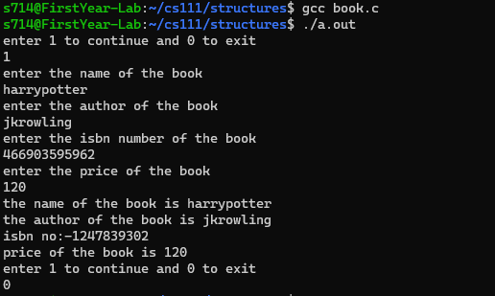

#include<stdio.h>

struct market{

char itemname[100];

int price;

int stock;

};

int main(){

int n;

printf("enter n \n");

scanf("%d",&n);

struct market supermarket[n];

for(int i=0;i<n;i++){

printf("enter the name of item \n");

scanf("%s",supermarket[i].itemname);

printf("enter the price and stock of this item \n");

scanf("%d %d",&supermarket[i].price,&supermarket[i].stock);

}

for(int i=0;i<n;i++){

if(supermarket[i].price>129){

printf("%s has price greater than Rs 129 \n",supermarket[i].itemname);

}

if(supermarket[i].stock<5){

printf("%s has stock less than 5 \n",supermarket[i].itemname);

}

}

}

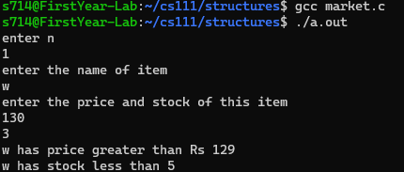

#include<stdio.h>

struct distance{

int d;

};

struct complex{

int r,c;

};

struct time{

int t;

};

int main(){

printf("add two distances :\n");

struct distance d1,d2;

printf("enter the distances \n");

scanf("%d %d",&d1.d,&d2.d);

struct distance result;

result.d=d1.d+d2.d;

printf("the resulting distance is %d \n",result.d);

printf("add two complex numbers: \n");

struct complex c1,c2,res;

printf("enter the real and complex components of first number \n");

scanf("%d %d",&c1.r,&c1.c);

printf("enter the real and the complex components of second number \n");

scanf("%d %d",&c2.r,&c2.c);

res.r=c1.r+c2.r;

res.c=c1.c+c2.c;

printf("the added complex number is %d+%di \n",res.r,res.c);

printf("difference between two time periods \n");

struct time t1,t2,t3;

printf("enter the time periods\n");

scanf("%d %d",&t1.t,&t2.t);

t3.t=t2.t-t1.t;

printf("the difference of the time periods is %d \n",t3.t);

}

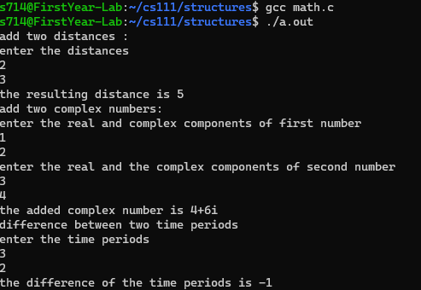

#include<stdio.h>

struct alpha{

int a;

char b;

float d;

int e[4];

};

union beta{

int p;

char q;

float s;

int t[4];

};

int main(){

struct alpha one;

union beta two;

one.a=1;

one.b='r';

two.p=2;

two.q='t';

int size1=sizeof(one);

int size2=sizeof(two);

printf("the size of structure is %d and size of union is %d \n",size1,size2);

}



#include<stdio.h>

#include<string.h>

struct person{

int number;

char name[100];

char address[100];

};

int name(struct person people[],char key[]){

int k=0;

for(int i=0;i<5;i++){

if(strcmp(people[i].name,key)==0){

printf("the person with the name %s was there among the people \n",key);

k++;

break;

}

}

if(k==0){

printf("the person with the name %s was not among the people \n",key);

}

}

void number(struct person people[],int key){

int k=0;

for(int i=0;i<5;i++){

if(people[i].number==key){

printf("the person with number %d is found \n",key);

printf("the person with number %d is found \n",key);

k++;

break;

}

}

if(k==0){

printf("the person with number %d is not found \n",key);

}

}

int main(){

struct person people[5];

for(int i=0;i<5;i++){

printf("enter the name of %d person \n",i+1);

scanf("%s",people[i].name);

printf("enter the telephone number \n");

scanf("%d",&people[i].number);

printf("enter the address \n");

scanf("%s",people[i].address);

}

printf("enter 1 to search by name and 2 to search by telephone number \n");

int l;

scanf("%d",&l);

switch(l){

case 1:

printf("enter the name \n");

char key[100];

scanf("%s",key);

scanf("%s",key);

name(people,key);

break;

case 2:

printf("enter the number \n");

int telno;

scanf("%d",&telno);

number(people,telno);

break;

}

