Testme.exe

**Spec:**

Testme is a command-line application that takes as input a number and outputs a consistent, unique, scrambled version.

e.g.

**> testme 10**

input: 10

output: 2983557137299388795107192986413907782003447359461

**> testme 10**

input: 10

output: 2983557137299388795107192986413907782003447359461

**> testme 1**

input: 1

output: 3243625888179112696126389

**> testme 15**

input: 15

output: 40545706088984994368247988223015076920717228050

**Running testme:**

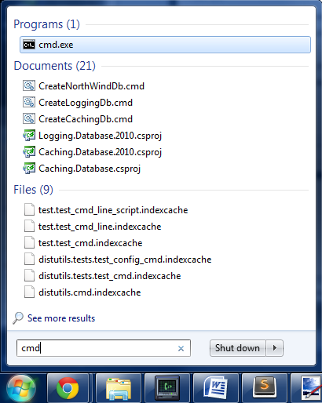

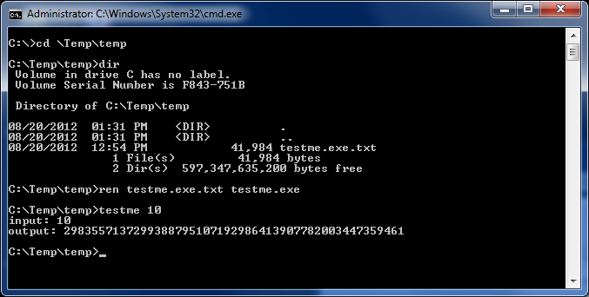

**Tasks:**

1. Write a test plan for testme.exe (deliverable: doc)
2. Test the program and write bug reports for anything you find wrong (deliverable: doc)
3. Automate what you can of your test plan (deliverables: **A.** doc explaining your automated tester and **B.** code for it. *Any programming language will do e.g. Python*)