Assignment 3: Understanding Algorithm Efficiency and Scalability

Naga Naveena Chennupati
Student ID: 005063666
MSCS 532 – Algorithms and Data Structures
University of the Cumberlands
September 27, 2026

Understanding Algorithm Efficiency and Scalability
Introduction
Divide-and-conquer algorithms can have very different practical behavior even when their expected asymptotic performance is similar. In this assignment, I examined that difference using Randomized Quicksort and a deterministic version of Quicksort that always selects the first element as the pivot. I also implemented a hash table using separate chaining to study how collision handling and load factor affect the expected cost of basic dictionary operations.
For the Quicksort experiment, I used Python implementations with the same Hoare partitioning approach so that pivot selection remained the main difference between the two algorithms. The randomized version selected a pivot uniformly from the current subarray, while the deterministic version always used the first element. I tested both algorithms on random, sorted, reverse-sorted, and repeated-element data using input sizes from 100 to 5,000 elements. Each timing experiment was repeated five times, and I recorded both the average execution time and the standard deviation.
For the hashing portion, I implemented separate chaining with an affine universal-style hash function for integer keys. The table supports insertion, search, and deletion and automatically resizes when the projected load factor exceeds 0.75. In addition to theoretical analysis, I used automated tests to verify correctness, collision handling, resizing, edge cases, and larger operation sequences.

Randomized Quicksort Analysis
Randomized Quicksort follows the divide-and-conquer strategy by selecting a pivot, partitioning the current subarray around that pivot, and recursively sorting the resulting partitions. In my implementation, the pivot position is selected uniformly at random from the indices between the current low and high bounds. The selected pivot is then moved to the first position so that the same Hoare partitioning method can be used for both the randomized and deterministic versions. This design keeps the comparison focused mainly on the pivot-selection strategy.
For the standard rank-based analysis of Randomized Quicksort, if the selected pivot has rank k + 1, then there are k elements smaller than the pivot and n − k − 1 elements larger than it. The recurrence can therefore be written as:
T(n) = T(k) + T(n-k-1) + Θ(n)
The Θ(n) term represents the partitioning work. Because Randomized Quicksort chooses each pivot position with equal probability, every possible value of $k$ from 0 through $n-1$ is equally likely. Therefore, the expected running time satisfies:
E[T(n)] = (1/n) Σ[k=0 to n-1] (E[T(k)] + E[T(n-k-1)]) + Θ(n)
which can be simplified to:
E[T(n)] = (2/n) Σ[k=0 to n-1] E[T(k)] + Θ(n)
Solving this recurrence gives an expected running time of Θ(n log n). The reason is that random pivot selection makes it unlikely that highly unbalanced partitions will occur repeatedly across many recursive levels. The expected amount of partitioning work at each effective level remains linear, while the expected number of levels grows logarithmically with the input size.
Another way to view the analysis is through indicator random variables. In the standard analysis with distinct keys, let Xᵢⱼ indicate whether two ordered elements zᵢ and zⱼ are compared during the algorithm. The probability that they are compared depends on whether one of them becomes the first pivot selected from the elements between them. This probability is:
P(Xᵢⱼ = 1) = 2 / (j - i + 1)
If Cₙ represents the total number of comparisons, then by linearity of expectation:
E[Cₙ] = Σ₁≤ᵢ<ⱼ≤ₙ E[Xᵢⱼ] = Σ₁≤ᵢ<ⱼ≤ₙ 2 / (j - i + 1) = Θ(n log n)
Therefore, the expected running time is O(n log n); more precisely, the expected running time is Θ(n log n) (Cormen et al., 2022).
Randomization does not eliminate the theoretical worst case. If extremely unbalanced partitions occur repeatedly, the running time can still reach Θ(n²). The important difference is that the input order no longer directly determines the pivot sequence. This makes Randomized Quicksort much less sensitive to already sorted or reverse-sorted inputs than a fixed first-pivot strategy. My implementation also recurses on the smaller partition first and continues processing the larger partition in a loop, which helps control Python recursion depth without changing the sorting result.

Deterministic Quicksort and Empirical Comparison
The deterministic implementation uses the first element of each current subarray as the pivot. It uses the same Hoare partitioning approach as the randomized version, which makes pivot selection the main difference between the two algorithms. With a reasonably balanced pivot, the recurrence is approximately
T(n) = 2T(n/2) + Θ(n),
which gives Θ(n log n) behavior. However, when the first element is repeatedly one of the smallest or largest values, the partitions become highly unbalanced. For sorted or reverse-sorted input, the recurrence can approach
T(n) = T(n − 1) + Θ(n),
which expands to Θ(n²). This makes first-pivot Quicksort especially sensitive to the original ordering of the input.
To compare the practical behavior of the two implementations, I tested input sizes of 100, 500, 1,000, 2,000, and 5,000 elements. Four distributions were used: random, sorted, reverse-sorted, and repeated-element data. Each timing test was repeated five times using time.perf_counter() (Python Software Foundation, n.d.), and I calculated both the average execution time and standard deviation. The input list was copied before timing began so that setup time was not included in the sorting measurement. Fixed seeds were used for dataset generation and randomized pivot selection to make the experiment reproducible. Every timed result was also checked against Python’s sorted() result before being recorded.
The largest differences appeared on sorted and reverse-sorted data. At n = 5,000, Randomized Quicksort completed the sorted dataset in 7.6334 ms, while Deterministic Quicksort required 495.0036 ms. On reverse-sorted data, the randomized version required 8.0949 ms, compared with 530.1679 ms for the deterministic version. These results are consistent with the theoretical analysis because repeatedly selecting the first element from ordered data produces very uneven partitions, while randomized pivot selection reduces the dependence on input order.
The behavior was different for random and repeated-element data. At n = 5,000, Deterministic Quicksort completed the random dataset in 6.4698 ms, compared with 8.7365 ms for Randomized Quicksort. On repeated-element data, the deterministic version required 6.6118 ms, while the randomized version required 8.7254 ms. Random input did not consistently favor the same implementation at every tested size; for example, at n = 2,000, Randomized Quicksort was slightly faster at 2.5297 ms compared with 2.7612 ms for Deterministic Quicksort. This shows why the empirical comparison is useful: randomization improves resistance to consistently poor pivot choices, but it does not guarantee the lowest execution time for every individual dataset. The randomized implementation also performs extra work to select and reposition a random pivot.
The standard deviations also showed that execution time was not identical across repeated trials. This variation was more noticeable in some larger cases, particularly the deterministic reverse-sorted test at n = 5,000, where the standard deviation was 69.7501 ms. Because the measured times were short and the randomized implementation can follow different pivot sequences, some run-to-run variation is expected. I therefore used averaged measurements rather than drawing conclusions from a single execution.
Table 1
Quicksort Performance at n = 5,000
Dataset | Randomized Quicksort (ms) | Deterministic Quicksort (ms)
Random | 8.7365 | 6.4698
Sorted | 7.6334 | 495.0036
Reverse Sorted | 8.0949 | 530.1679
Repeated Elements | 8.7254 | 6.6118

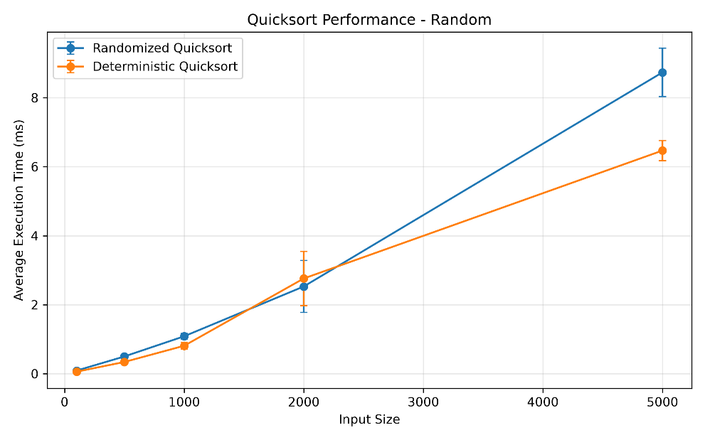
Figure 1. Random-input Quicksort performance comparison.
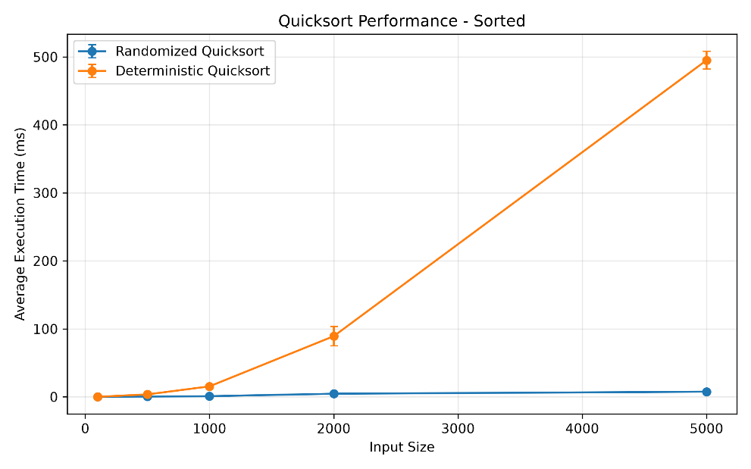
Figure 2. Sorted-input Quicksort performance comparison.

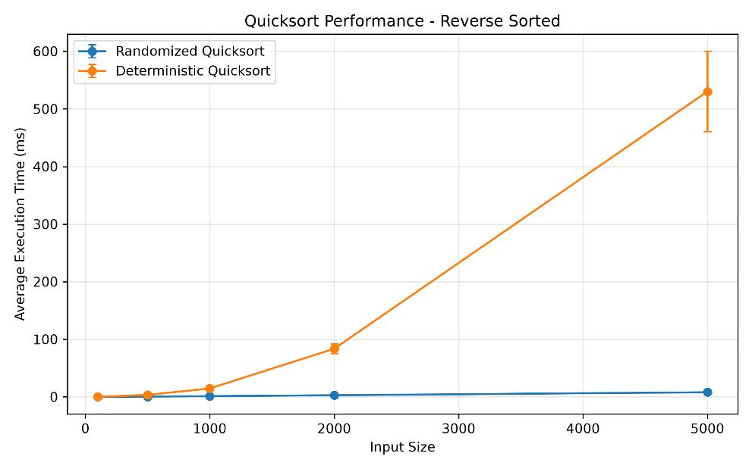
Figure 3. Reverse-sorted-input Quicksort performance comparison.
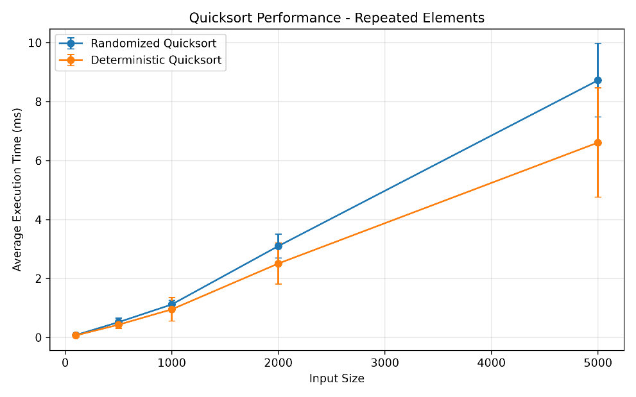
Figure 4. Repeated-element Quicksort performance comparison.

Hash Table with Chaining
The hash table implementation uses separate chaining to resolve collisions. Each bucket stores one or more key-value pairs, so when different keys map to the same bucket, the existing value is not overwritten. The table supports insertion, search, and deletion, and it also updates the stored value when an existing key is inserted again.
For integer keys, the implementation uses an affine universal-style hash function:
h(k) = ((ak + b) mod p) mod m
where k is the key, p is a large prime, m is the number of buckets, and a and b are parameters selected when the table is created. In my implementation, p = 2⁶¹ − 1. This form helps distribute keys across the available buckets and reduces the effect of simple patterns in the key values.
The efficiency of separate chaining depends on the load factor:
α = n / m
where n is the number of stored key-value pairs and m is the number of buckets. Under simple uniform hashing, search and delete require expected Θ(1 + α) time because the number of entries examined in a bucket depends on the average chain length. My insertion method first checks whether the key already exists, so insertion also requires expected Θ(1 + α) time when resizing is not necessary (Cormen et al., 2022).
The implementation uses a maximum load-factor threshold of 0.75. Before a new key is inserted, the projected load factor is checked. If the next insertion would exceed the threshold, the table doubles its capacity and rehashes all existing entries into the new bucket array. Rehashing requires Θ(n) time because every stored entry must be processed again. However, doubling the capacity makes resizing less frequent, so the resizing cost is distributed across later insertions and insertion has expected constant-time amortized performance while the load factor remains bounded.
Collision handling was also tested directly. Two different keys that mapped to the same bucket were inserted and then searched independently to verify that both values remained accessible. Additional tests confirmed that updating an existing key changed its value without increasing the table size, deleting an existing key removed the correct entry, and deleting a missing key returned False. I also tested zero and negative integer keys, invalid constructor values, invalid key types, and larger insertion and deletion sequences to verify that the table remained consistent as it grew.

Testing and Validation
The implementations were tested with automated test cases before the performance comparison was completed. For Quicksort, I tested empty lists, single-element inputs, sorted and reverse-sorted arrays, repeated values, all-equal values, negative values, mixed inputs, and larger datasets. The randomized implementation was also tested with multiple random seeds to confirm that different pivot choices still produced the correct sorted result.
Both Quicksort implementations were checked against Python’s built-in sorted() function. This provided a simple reference result for each test case and helped confirm that the algorithms were producing the correct ordering before any timing measurements were recorded. Larger tests were also included to verify that both implementations continued to work correctly as the input size increased.
The hash table was tested across all required operations. The tests covered insertion, search, updating an existing key, deletion, missing keys, collision handling, load-factor calculation, and dynamic resizing. I also tested zero and negative integer keys, invalid constructor values, and invalid key types. One resizing test inserted 100 key-value pairs and then verified that every value was still accessible after the table expanded.
A larger hash-table test inserted 500 entries, deleted every even-numbered key, and then verified the remaining values. After the deletions, the table contained 250 entries, and each remaining odd-numbered key still returned the expected value. This helped confirm that resizing, deletion, and chaining did not corrupt previously stored data.
The final automated test suite contained 15 tests, and all of them passed successfully. I also used py_compile to check the main Python files for syntax errors. These checks were completed before using the benchmark results in the analysis so that the performance comparison was based on implementations that had already been verified for correctness.

Conclusion
The comparison between Randomized Quicksort and first-pivot Deterministic Quicksort showed that input order can have a major effect on practical performance. Both implementations produced correct results, but the deterministic version became much slower on sorted and reverse-sorted data as the input size increased. The randomized version remained much less sensitive to those input patterns because the pivot was not tied to the original ordering. On random and repeated-element inputs, however, the deterministic version was still competitive and was faster in several of the measured cases. This confirms that randomization mainly reduces the risk of consistently poor pivot choices rather than guaranteeing the lowest execution time for every dataset.
The hash-table implementation showed how separate chaining and load-factor control support efficient dictionary operations as the table grows. Colliding keys remained accessible within the same bucket, while dynamic resizing helped keep the average chain length under control. The tests also confirmed that insertion, search, deletion, updating existing keys, collision handling, and resizing continued to work correctly across larger sequences of operations.
Overall, the assignment showed the value of using both theoretical analysis and empirical testing when evaluating algorithms. Complexity analysis explains how an algorithm is expected to scale, while measured results show the effects of implementation choices, input characteristics, and runtime variation. Looking at both made the differences between the Quicksort strategies and the behavior of the chained hash table much clearer.

GitHub Repository
The complete Python implementations, automated tests, benchmark results, performance graphs, README documentation, and report are available in the following GitHub repository:
https://github.com/naganaveenachennupati/MSCS532_Assignment3

References
Cormen, T. H., Leiserson, C. E., Rivest, R. L., & Stein, C. (2022). Introduction to algorithms (4th ed.). The MIT Press.
Python Software Foundation. (n.d.). time — Time access and conversions. Python 3.14 documentation. https://docs.python.org/3/library/time.html

