Assignment 4: Heap Data Structures: Implementation, Analysis, and Applications

Naga Naveena Chennupati

Student ID: 005063666

MSCS 532 – Algorithms and Data Structures

University of the Cumberlands

October 4, 2026

Assignment 4: Heap Data Structures: Implementation, Analysis, and Applications
Introduction
Heap data structures provide an efficient way to maintain ordering relationships without requiring an entire collection to remain globally sorted. Their array-based representation makes them useful for both sorting algorithms and applications in which the highest- or lowest-priority element must be retrieved efficiently. In this assignment, I implemented and evaluated two major applications of binary heaps: Heapsort and a max-heap priority queue used in a non-preemptive task-scheduling simulation.
The first part of the project implements Heapsort using bottom-up max-heap construction and an iterative heapify procedure. I analyzed its time and space complexity and then evaluated its practical performance against Randomized Quicksort and Merge Sort. The empirical study used input sizes of 100, 500, 1,000, 2,000, and 5,000 elements. Four input distributions were evaluated: random, sorted, reverse sorted, and repeated values. Every algorithm-size-distribution combination was executed five times, resulting in 300 timed sorting executions. The benchmark recorded individual timings, mean runtime, and sample standard deviation. Each timed result was also verified against Python’s built-in sorted() result before being accepted.
The second part of the project applies a binary max heap to task scheduling. I designed a Task representation containing a task ID, priority, arrival time, execution time, and deadline. The priority queue supports insertion, extraction of the maximum-priority task, increasing and decreasing task priorities, viewing the current maximum task, and checking whether the queue is empty. A task-to-index position map was also incorporated to make priority changes more efficient. The priority queue was then used in a non-preemptive scheduling simulation that calculates task execution order, waiting time, turnaround time, tardiness, deadline completion, and processor idle time.
The complete implementation was validated using 43 automated tests. These tests covered sorting correctness, max-heap construction, edge cases, priority queue operations, invalid input handling, scheduling behavior, deadline handling, and larger input sets. All 43 tests completed successfully.

Heapsort Design and Implementation
The Heapsort implementation uses a binary max heap stored directly in a Python list. An array-based representation is appropriate because the parent-child relationships in a complete binary tree can be calculated directly from indices. For an element located at index i, the left child is stored at 2i + 1, the right child at 2i + 2, and the parent at (i - 1) / 2 rounded down. This representation eliminates the need for separately allocated tree nodes or explicit references between nodes.
The implementation contains two main heap operations: build_max_heap and max_heapify. During heap construction, the algorithm begins with the final internal node and processes nodes toward the root. Leaf nodes do not require heapification because they already satisfy the heap property by themselves. For each internal node, max_heapify compares the current value with its children. If one of the children is larger, the larger child is exchanged with the current element and the procedure continues downward until the max-heap property has been restored.
I implemented max_heapify iteratively instead of recursively. The iterative design still follows a single path through the heap but avoids adding recursive stack frames. This implementation decision becomes relevant when considering the auxiliary-space complexity of the sorting algorithm.
Once the max heap has been constructed, the maximum value is located at index 0. Heapsort exchanges that root value with the final element of the active heap. The active heap size is then reduced by one because the exchanged maximum value is already in its correct final position. max_heapify is applied again to the root of the reduced heap. Repeating this process produces the complete list in ascending order.
The implementation was tested on empty input, one-element input, two-element input, already sorted input, reverse-sorted input, repeated values, all-equal values, negative values, mixed positive and negative values, and a larger random dataset. Additional tests explicitly verified that build_max_heap produced a valid max heap and that Heapsort modified the original list in place.

Theoretical Analysis of Heapsort
Complexity of Max-Heapify
A binary heap containing n elements has height O(log n). When the max-heap property is violated at a node, max_heapify may move the value downward through the heap. At each level, only one of the two child paths is followed. Therefore, in the worst case, the procedure travels from near the root to a leaf (Cormen et al., 2022).
T_heapify(n) = O(log n)
Complexity of Building the Max Heap
A straightforward but loose upper bound might suggest that heap construction costs O(n log n), because there are O(n) nodes and an individual heapify call can cost O(log n). However, this is not a tight bound for bottom-up heap construction. Most nodes in a binary heap are located close to the leaves. Approximately half of the nodes are leaves and require no heapify work. Approximately one quarter have height one, one eighth have height two, and the number of nodes continues to decrease geometrically as height increases (Cormen et al., 2022).
The total work can be represented as:
Sum from h = 0 to floor(log n) of [n / 2^(h + 1)] x O(h)
Factoring out n gives:
O(n) x Sum from h = 0 to infinity of [h / 2^h]
The infinite series converges to a constant. Therefore, the total asymptotic cost of bottom-up heap construction is:
T_build-heap(n) = O(n)
This is an important property of Heapsort because it means that creating the initial max heap is linear rather than O(n log n).
Complexity of the Sorting Phase
After the max heap has been constructed, the algorithm performs up to n - 1 extraction-style iterations. In every iteration, the maximum element is moved from the root to the end of the active heap. Restoring the max-heap property after this exchange may require a heapify operation. Since each heapify operation requires at most O(log n) time, the complete extraction phase requires:
T_extraction(n) = (n - 1) x O(log n) = O(n log n)
Combining heap construction with the extraction phase produces:
T(n) = O(n) + O(n log n) = O(n log n)
Best, Average, and Worst Cases
Heapsort retains the same asymptotic time complexity regardless of the original ordering of the input. The major heap construction and extraction operations still occur whether the list begins in random, sorted, reverse-sorted, or repeated-value order (Cormen et al., 2022).
Best case: O(n log n)
Average case: O(n log n)
Worst case: O(n log n)
Unlike some implementations of Quicksort, Heapsort does not become quadratic simply because the data is initially sorted or reverse sorted. Its extraction phase still maintains the same logarithmic-height heap operations.
Space Complexity
The implementation rearranges the input list rather than allocating another list proportional to the input size. Because max_heapify is iterative rather than recursive, the implementation also avoids a recursion stack whose depth increases with heap height. Only a constant amount of additional local storage is required for indices and temporary values.
Auxiliary space = O(1)
This is one practical advantage over the Merge Sort implementation used in the comparison, which requires an auxiliary list proportional to the input size.
Empirical Comparison Methodology
To examine practical performance rather than relying only on asymptotic analysis, Heapsort was empirically compared with Randomized Quicksort and Merge Sort. Randomized Quicksort selects a pivot randomly from the active subarray and uses Hoare partitioning. Randomized pivot selection was chosen because it reduces dependence on the original ordering of the input. The implementation also recursively processes the smaller partition and handles the larger partition iteratively to reduce unnecessary recursion depth.
Merge Sort recursively divides an input range into smaller portions and merges the sorted portions with the assistance of an auxiliary list. Its theoretical running time is O(n log n) in the best, average, and worst cases, although it requires additional memory for merging (Cormen et al., 2022).
The experiment evaluated five input sizes: 100, 500, 1,000, 2,000, and 5,000 elements. Four data distributions were tested: random, sorted, reverse sorted, and repeated values. Every combination was executed five times.
5 input sizes x 4 distributions x 3 algorithms x 5 trials = 300 timed sorting executions
The random, sorted, and reverse-sorted cases were based on the same underlying distinct values for a given input size and trial, so the primary difference among those datasets was the initial ordering. The repeated-value input was generated separately from a much smaller numerical range to intentionally create duplicate values.
Timing was performed with Python's time.perf_counter_ns() function, which provides a high-resolution performance counter as an integer number of nanoseconds (Python Software Foundation, n.d.). The source list was copied before the timed interval began, and the expected sorted result was also generated before timing. As a result, list-copying and correctness-check preparation were not included in the reported sorting times. After every timed execution, the resulting list was compared with Python's sorted() output. An incorrect sorting result would raise an error rather than being stored in the benchmark file.
For every algorithm, input size, and distribution, all five individual runtimes were recorded. The program then calculated the arithmetic mean and sample standard deviation. The complete results were stored in results/sorting_results.csv.
Sorting Results
Table 1 summarizes the final measured mean runtimes at the largest tested input size, n = 5000.
Table 1. Mean Runtime at n = 5000
Input Distribution | Heapsort | Randomized Quicksort | Merge Sort
Random | 7.2376 ms | 4.9627 ms | 5.6812 ms
Sorted | 7.6021 ms | 3.9975 ms | 4.8285 ms
Reverse Sorted | 6.7596 ms | 4.0168 ms | 4.6984 ms
Repeated | 7.1007 ms | 4.4317 ms | 5.4142 ms

Random Input
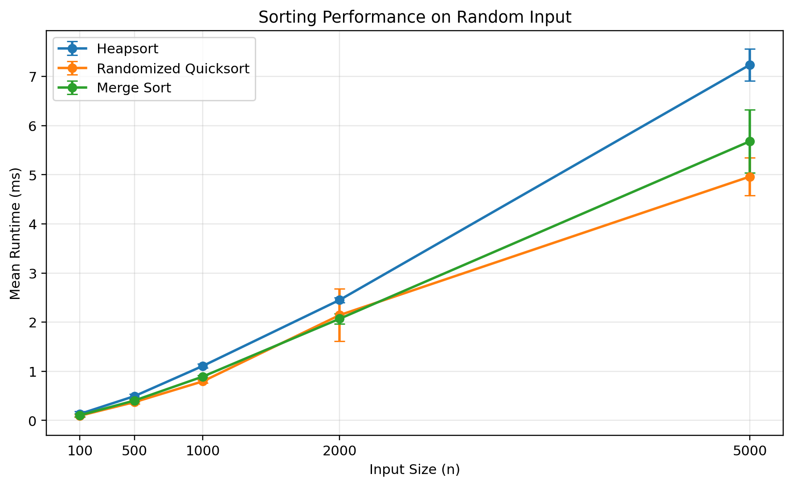
Figure 1. Sorting performance on random input.
For random data, all three algorithms exhibited increasing runtime as input size increased. At n = 5000, Randomized Quicksort had the lowest mean runtime at 4.9627 ms, followed by Merge Sort at 5.6812 ms and Heapsort at 7.2376 ms. The relative performance does not conflict with their asymptotic behavior. Big-O notation describes the rate of growth rather than implementation constants, so differences in comparisons, assignments, partition operations, memory access patterns, and Python-level overhead can make one O(n log n) implementation faster than another for the tested sizes.

Sorted Input
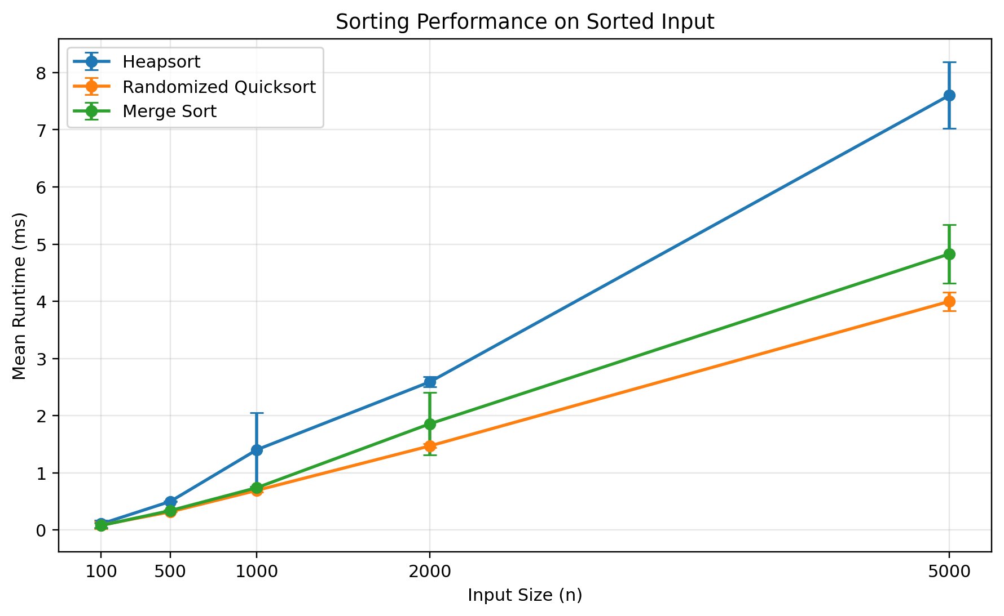
Figure 2. Sorting performance on sorted input.
For already sorted input at n = 5000, Heapsort required 7.6021 ms, Randomized Quicksort required 3.9975 ms, and Merge Sort required 4.8285 ms. The sorted dataset did not cause Randomized Quicksort to degrade toward quadratic behavior because the pivot was selected randomly from each active subarray rather than being fixed at the first or last position. Heapsort also retained its expected behavior because its asymptotic work is largely independent of whether the original list is sorted.

Reverse-Sorted Input
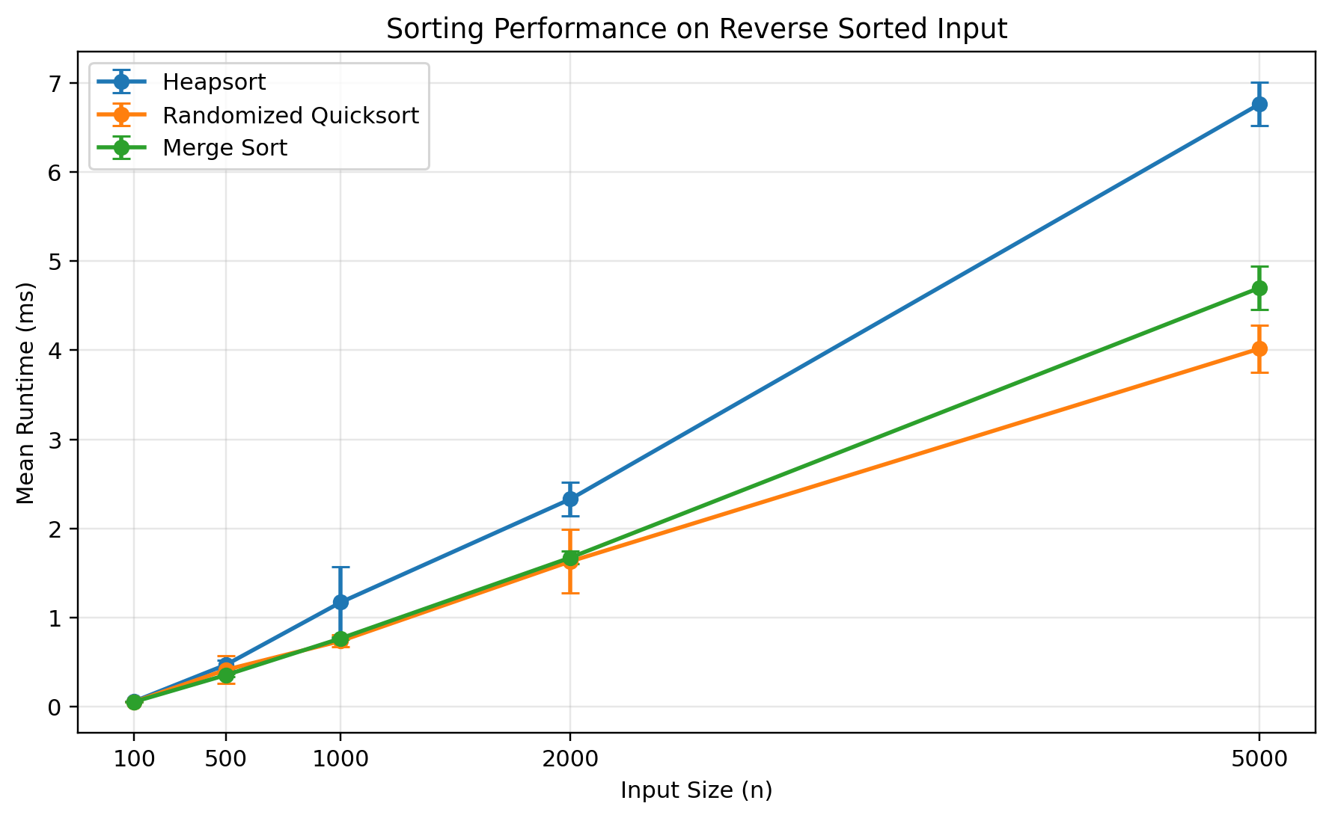
Figure 3. Sorting performance on reverse-sorted input.
For reverse-sorted input at n = 5000, Heapsort recorded a mean of 6.7596 ms, Randomized Quicksort recorded 4.0168 ms, and Merge Sort recorded 4.6984 ms. The reverse ordering did not produce the severe degradation that can occur when a deterministic Quicksort implementation repeatedly chooses a poor pivot. Heapsort produced its lowest n = 5000 mean among the four tested distributions on reverse-sorted data, although this difference should not be interpreted as a change in its asymptotic complexity.

Repeated-Value Input
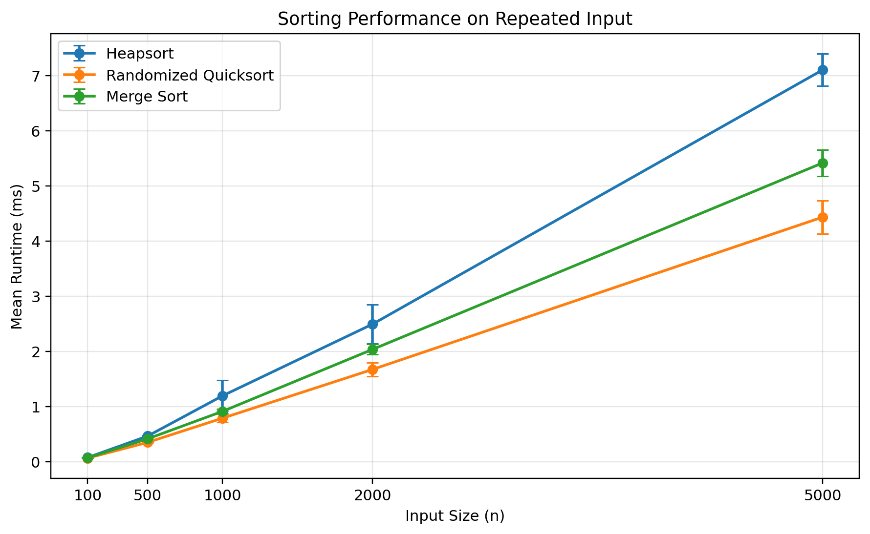
Figure 4. Sorting performance on repeated-value input.
The repeated-value dataset intentionally contained many duplicate values. At n = 5000, Heapsort required 7.1007 ms, Randomized Quicksort required 4.4317 ms, and Merge Sort required 5.4142 ms. All three implementations correctly handled duplicate values. Across all four distributions at n = 5000, Heapsort ranged from approximately 6.76 ms to 7.60 ms, which is consistent with its input-order-independent O(n log n) bound.

Discussion of Empirical Results
At n = 5000, Randomized Quicksort produced the lowest measured mean runtime for every tested input distribution. Merge Sort generally produced the second-lowest runtime, and Heapsort was slower in this particular Python implementation. This does not imply that Heapsort is theoretically inferior. The experiment demonstrates an important distinction between asymptotic complexity and practical runtime. Multiple algorithms can belong to the same asymptotic complexity class while still exhibiting measurable differences because Big-O analysis omits constant factors, language overhead, memory allocation details, and processor-level effects.
Heapsort's major theoretical advantage is predictability. Its best-, average-, and worst-case time complexity remains O(n log n), while also using O(1) auxiliary sorting space in this implementation. Merge Sort also provides guaranteed O(n log n) running time but requires an auxiliary array. Randomized Quicksort performed best in these experiments, but its O(n log n) running time is expected rather than guaranteed for every possible pivot sequence.
Some configurations also showed higher sample standard deviation than others. Benchmark runs measuring only fractions of a millisecond are particularly sensitive to normal system activity. Reporting five trials along with mean and standard deviation provides more context than reporting a single measurement and helps avoid drawing conclusions from one unusually fast or slow run.

Priority Queue Design
The second major component of the assignment is a binary-heap priority queue designed for task scheduling. I selected a Python list to represent the binary heap because a complete binary tree maps naturally to an array representation. Parent and child positions can be calculated directly without allocating separate node objects.
Parent(i) = (i - 1) / 2, rounded down
Left(i) = 2i + 1
Right(i) = 2i + 2
A max heap was selected because the scheduling policy defines larger numerical priority values as more important. Therefore, the task with the greatest current scheduling priority is maintained at the root of the heap and can be accessed efficiently.
Task Representation
Each task is represented by a Python dataclass containing a task ID, priority, arrival time, execution time, and deadline. These fields provide enough information for both heap ordering and scheduling analysis. The Task class validates its attributes when a task is created. Task IDs must be non-empty strings, priority values must be integers, arrival times cannot be negative, execution times must be positive, and a deadline cannot occur before the task's arrival time. Validating the values at object creation prevents malformed task data from reaching the heap or scheduling simulation.

Priority Ordering and Tie Handling
The primary ordering rule is numerical priority. A larger priority value means the task should appear closer to the root of the max heap. If two tasks have equal priority, the task with the earlier arrival time is considered higher in the ordering. If both priority and arrival time are equal, task ID is used as a final deterministic tie-break. The use of deterministic tie handling is important for testing and reproducibility because the same set of tasks always produces the same ordering.

Task Position Map
In addition to the heap list, the priority queue maintains a dictionary mapping each task ID to its current heap index. This design choice is especially useful for increase_key and decrease_key. If only the heap list were available, locating a specific task by ID could require an O(n) linear scan before its priority could be modified. With the task-position dictionary, the task can be located in expected O(1) dictionary-lookup time. Whenever two tasks are exchanged in the heap, the position map is updated so that it remains synchronized with the actual heap structure.
The map requires O(n) additional storage, but it improves task-priority modification from a potential O(n) search plus heap adjustment to an expected constant-time lookup followed by at most O(log n) heap restoration.

Priority Queue Operation Analysis
Insert
A new task is appended to the end of the heap and moved upward until the max-heap property is restored. Because the heap height is O(log n), the task can move through at most O(log n) levels.
T_insert(n) = O(log n)
Extract Maximum
The task at the root is removed. The final task is moved to the root and then moved downward until the max-heap property is restored. The downward path is bounded by the heap height.
T_extract-max(n) = O(log n)
Increase Key
The task-position dictionary locates the target task in expected O(1) time. After the priority increases, the task may move upward through at most the height of the heap.
T_increase-key(n) = O(log n)
Decrease Key
The task-position dictionary again locates the target task directly. After the priority decreases, the task may move downward through at most the height of the heap.
T_decrease-key(n) = O(log n)
Peek Maximum
The maximum-priority task is stored at the root, so reading it requires no traversal.
T_peek-max(n) = O(1)
Is Empty
Checking whether the internal heap list contains any tasks is a constant-time operation.
T_is-empty(n) = O(1)
Table 2. Priority Queue Operation Complexity
Operation | Time Complexity
Insert | O(log n)
Extract Maximum | O(log n)
Increase Priority | O(log n)
Decrease Priority | O(log n)
Peek Maximum | O(1)
Is Empty | O(1)

The heap stores n tasks and therefore requires O(n) storage. The position map also requires O(n) storage. Combining them still results in an overall asymptotic storage requirement of O(n).

Priority Scheduling Application
The priority queue was applied to a non-preemptive task scheduler. In this scheduling model, only tasks whose arrival time is less than or equal to the current simulation time are inserted into the ready queue. The highest-priority available task is then extracted and executed. Once a task begins executing, it runs until completion even if another task with higher priority arrives during that interval. The newly arrived task becomes eligible for consideration only after the currently running task has completed.
If the ready queue becomes empty while tasks are still scheduled to arrive later, the simulation advances the current time to the next arrival. This makes processor idle periods explicit rather than incorrectly treating a future task as immediately available. For each completed task, the scheduler records arrival time, execution time, priority, deadline, start time, completion time, waiting time, turnaround time, tardiness, and whether the deadline was met.
Waiting Time = Start Time - Arrival Time
Turnaround Time = Completion Time - Arrival Time
Tardiness = max(0, Completion Time - Deadline)
Deadline met when Completion Time <= Deadline

Scheduler Results
The sample scheduling workload produced the following execution order:
T1 -> T2 -> T5 -> T4 -> T3 -> T6
Table 3. Priority Scheduling Simulation Results
Task | Pri | Arr | Exec | Start | End | Wait | Turn | Deadline | Met
T1 | 3 | 0 | 4 | 0 | 4 | 0 | 4 | 8 | Yes
T2 | 5 | 1 | 3 | 4 | 7 | 3 | 6 | 9 | Yes
T5 | 5 | 6 | 2 | 7 | 9 | 1 | 3 | 13 | Yes
T4 | 4 | 3 | 5 | 9 | 14 | 6 | 11 | 16 | Yes
T3 | 2 | 2 | 2 | 14 | 16 | 12 | 14 | 14 | No
T6 | 4 | 20 | 3 | 20 | 23 | 0 | 3 | 25 | Yes

The simulation scheduled six tasks. The average waiting time was 3.67 time units, while the average turnaround time was 6.83 time units. Five of the six tasks completed by their deadlines, producing a deadline success rate of 83.33%. The processor experienced four time units of idle time.
T1 executes first even though T2 has a larger numerical priority. At time 0, T1 is the only task that has arrived. It therefore begins execution immediately. T2 arrives at time 1, but because the scheduling algorithm is non-preemptive, T2 cannot interrupt T1. Once T1 completes at time 4, the scheduler selects the highest-priority task then available.
T5 executes before T4 because T5 has priority 5 while T4 has priority 4 and both are available when the scheduler makes the next relevant choice. T3 has a comparatively low priority of 2 and remains in the ready queue while several higher-priority tasks execute. As a result, T3 waits 12 time units and completes at time 16, two time units after its deadline of 14.
After T3 completes at time 16, no task is ready to run. T6 does not arrive until time 20. The processor therefore remains idle for four time units before T6 enters the queue and is executed. The result demonstrates an important characteristic of priority scheduling: higher-priority tasks receive favorable service when multiple tasks are waiting, but low-priority tasks may experience significantly longer waiting times. In larger systems, this effect can lead to starvation unless the scheduling policy includes a technique such as aging. Aging was not implemented here because it was outside the required operations, but T3's waiting time illustrates why such mechanisms can matter.

Testing and Validation
Testing was treated as a separate part of the implementation rather than relying only on demonstration outputs. The project includes automated tests for the sorting algorithms, priority queue, and scheduling simulation. The sorting tests cover empty input, single-element input, two-element input, already sorted values, reverse-sorted values, repeated values, all-equal values, negative values, mixed values, large randomized input, in-place sorting, and explicit max-heap-property validation. Randomized Quicksort and Merge Sort were also tested on multiple edge cases and larger randomized datasets.
The priority queue tests verify empty-queue behavior, insertion, extraction order, increasing priorities, decreasing priorities, equal-priority ordering, duplicate task IDs, invalid priority-change direction, invalid task attributes, negative priorities, missing task IDs, and a larger queue containing 500 tasks. The scheduler tests cover empty schedules, highest-priority selection, arrival-time restrictions, non-preemptive execution, processor idle periods, equal-priority handling, deterministic task-ID tie breaking, waiting-time and turnaround-time calculations, missed deadlines and tardiness, duplicate task IDs, and the expected execution order of the complete sample workload.
The final complete test command was python -m unittest -v. The verified result was 43 tests run and 43 tests passed, with no failures or errors. Source files were also checked using Python's compilation validation command during development. Benchmark outputs were verified after every timed sort, and the scheduler CSV output was compared with the expected execution order and calculated metrics.

Practical Applications
Heap structures are useful when an application repeatedly needs access to an extreme-priority element without fully sorting the entire dataset after each update. Operating-system schedulers, event-processing systems, network traffic management, job queues, simulation engines, and resource-allocation systems are examples in which priority queues can be useful.
The scheduling application in this assignment demonstrates this behavior directly. A newly arriving task can be inserted in O(log n) time, and the next highest-priority task can be removed in O(log n) time. These costs are more scalable than repeatedly sorting the entire collection of waiting tasks after every insertion or priority change. Heapsort represents a different use of the same structural property. Instead of maintaining an ongoing queue, it repeatedly moves the largest remaining value into its final sorted position. This demonstrates how one underlying binary-heap concept can support both sorting and dynamic priority management.

Conclusion
This assignment demonstrated both theoretical and practical uses of binary heaps through Heapsort and a priority-based scheduling application. The Heapsort implementation uses bottom-up max-heap construction and iterative heap restoration. Bottom-up heap construction requires O(n) time, while the subsequent extraction phase requires O(n log n), giving Heapsort O(n log n) time complexity in its best, average, and worst cases. Because the implementation works in place and uses iterative heapify, its auxiliary-space requirement is O(1).
The empirical experiment compared Heapsort with Randomized Quicksort and Merge Sort using five input sizes and four different input distributions. A total of 300 timed sorting executions were collected. At n = 5000, Randomized Quicksort produced the lowest mean runtime for all four distributions, while Merge Sort generally ranked second and Heapsort third. Nevertheless, Heapsort remained comparatively consistent across random, sorted, reverse-sorted, and repeated-value inputs, which is consistent with its predictable O(n log n) asymptotic behavior.
The second part of the project demonstrated how a binary max heap can efficiently support a task-priority system. The implementation supports insertion, extraction, priority increases, priority decreases, maximum lookup, and empty-queue checks. A dictionary mapping task IDs to heap positions avoids a linear search during priority modification.
The non-preemptive scheduler demonstrated how priority, arrival time, execution duration, and deadlines affect actual task execution. Five of six sample tasks met their deadlines, the average waiting time was 3.67 time units, the average turnaround time was 6.83 time units, and the processor experienced four idle time units. The lower-priority T3 task experienced the longest wait and missed its deadline, illustrating an important tradeoff in priority scheduling.
Finally, the project was validated with 43 automated tests, all of which passed. Taken together, the theoretical analysis, empirical measurements, testing, and scheduling application demonstrate why heaps remain an important data structure for both efficient sorting and priority-oriented computing problems.

GitHub Repository
The complete Python implementation, automated tests, benchmark results, generated figures, scheduling results, README documentation, and final report are available in the Assignment 4 GitHub repository:
https://github.com/naganaveenachennupati/MSCS532_Assignment4
References
Cormen, T. H., Leiserson, C. E., Rivest, R. L., & Stein, C. (2022). Introduction to algorithms (4th ed.). The MIT Press.
Python Software Foundation. (n.d.). time — Time access and conversions. Python 3.14 documentation. https://docs.python.org/3/library/time.html

