Assignment 5: Quicksort Algorithm:
Implementation, Analysis, and Randomization

Naga Naveena Chennupati

Student ID: 005063666

MSCS 532 – Algorithms and Data Structures

University of the Cumberlands

October 18, 2026

Introduction
Quicksort is widely used because it combines an efficient average running time with an in-place partitioning strategy, but its performance depends heavily on how pivots are selected. For this assignment, I implemented two versions of Quicksort in Python to examine that behavior directly. The deterministic version selects the last element of the current subarray as the pivot, while the randomized version selects a pivot uniformly from the active range before applying the same Lomuto partitioning procedure. Keeping the partitioning logic consistent between the two implementations makes it possible to focus the comparison primarily on the effect of pivot selection.
In addition to implementing the algorithms, I analyzed their best-case, average-case, and worst-case behavior and connected the theoretical analysis to measured performance. Both implementations sort the input list in place. I also used a smaller-partition-first recursion strategy, where the smaller side is processed recursively and the larger side is handled iteratively. This does not change Quicksort’s underlying time complexity, but it limits unnecessary growth of the Python call stack during highly unbalanced partitions.
The empirical portion of the assignment compares deterministic and randomized Quicksort across input sizes of 100, 500, 1,000, 2,000, and 5,000 elements. Four input distributions were evaluated: random, sorted, reverse-sorted, and repeated values. Each algorithm-distribution-size combination was executed for five trials, producing 200 timed sorting runs in total. The implementations were also validated through 22 automated tests covering normal inputs, edge cases, duplicate values, ordering patterns, in-place behavior, and partition correctness. The results show a clear difference between the two pivot strategies on sorted and reverse-sorted inputs, while also illustrating that randomization adds some overhead and does not eliminate all forms of unfavorable partitioning.

Deterministic Quicksort Implementation
My deterministic implementation uses Lomuto partitioning and always selects the last element of the current subarray as the pivot. During partitioning, a boundary index tracks the position where the next value less than or equal to the pivot should be placed. The algorithm scans from the low index through the element immediately before the pivot. Whenever a value is less than or equal to the pivot, it is exchanged into the left portion of the subarray. After the scan is complete, the pivot is moved into its final partition position. At that point, values on the left are less than or equal to the pivot and values on the right are greater than the pivot.
The public quicksort() function sorts the supplied mutable sequence in place and returns the same sequence after sorting. Empty lists and single-element lists require no partitioning, so they are handled naturally without unnecessary recursive work. I kept the partition operation separate from the main sorting logic because it made the implementation easier to test independently. This was useful in the automated test suite, where I verified not only complete sorting results but also the partition property itself.
One implementation detail I added was to recurse only on the smaller partition after each pivot is placed. The larger partition is then processed iteratively within the same function. A straightforward recursive Quicksort can create a very deep call stack when partitions are repeatedly unbalanced. Processing the smaller side recursively limits the depth of active recursive calls without changing the sequence of partitioning work that determines Quicksort’s running time. Therefore, this design improves stack behavior, but it does not remove the algorithm’s quadratic worst-case running time.
Choosing the last element as a fixed pivot also provides a useful deterministic baseline for the experiment. On inputs where that pivot tends to divide the data reasonably well, the implementation performs efficiently. On already sorted or reverse-sorted inputs containing distinct values, however, the endpoint pivot repeatedly produces highly uneven partitions. This behavior is important because it gives a direct way to compare the deterministic version with randomized pivot selection later in the experiment.

Theoretical Performance Analysis
Best Case
The best case occurs when each pivot divides the current subarray into two nearly equal parts. Partitioning still examines the elements in the active subarray, so each level of the algorithm performs Θ(n) work. When the partitions remain balanced, the recurrence can be written as:
T(n) = 2T(n/2) + Θ(n)
By the Master Theorem, this recurrence evaluates to Θ(n log n) (Cormen et al., 2022). The reason is that the recursion has approximately log n levels, while the total partitioning work across each level remains proportional to n.
Average Case
In the average case, the pivot does not have to divide the array exactly in half. What matters is that the sequence of partitions is sufficiently balanced overall. For a typical permutation of the input, the partitions vary in size, but the expected recursion depth remains proportional to log n. Since partitioning across a level still accounts for linear work, the resulting average running time is Θ(n log n).
The deterministic implementation does not guarantee balanced partitions because its pivot is always taken from the end of the active subarray. Its average-case behavior therefore depends on the arrangement of the input. This distinction became important in the empirical results, where random input behaved efficiently while sorted and reverse-sorted inputs exposed the weakness of the fixed endpoint pivot.
Worst Case
The worst case occurs when the selected pivot repeatedly becomes either the smallest or the largest value in the current subarray. In that situation, one partition contains n - 1 elements while the other contains no elements. The recurrence becomes:
T(n) = T(n - 1) + Θ(n)
Expanding this recurrence gives a sequence of partitioning costs proportional to n + (n - 1) + (n - 2) + ... + 1, which sums to Θ(n²). With the deterministic last-element pivot, already sorted and reverse-sorted arrays of distinct values produce this type of highly unbalanced behavior. The benchmark results later in this report show this effect clearly.

Space Complexity and Implementation Overhead
Lomuto partitioning operates directly on the input list, so the partition procedure itself uses O(1) auxiliary space aside from the call stack. A conventional recursive implementation of Quicksort can require O(n) stack space in the worst case when partitions are repeatedly unbalanced. In this implementation, however, only the smaller partition is processed recursively while the larger partition is handled iteratively. Because the recursively processed side can contain at most about half of the current elements, the active recursion depth is bounded by O(log n).
This stack optimization changes the amount of recursion-related memory used by the implementation, but it does not change the number of comparisons and partition operations performed. Therefore, the deterministic implementation can still require Θ(n²) time in the worst case even though its call-stack growth is controlled.
Randomized Quicksort Implementation
The randomized implementation keeps the same overall Quicksort structure and Lomuto partitioning procedure used by the deterministic version, but changes how the pivot is selected. Instead of always using the final element of the active subarray, the algorithm selects a random index between the current low and high bounds. The selected value is then swapped with the element at the high index so that the existing Lomuto partition function can be reused without duplicating partition logic.
Reusing the same partition procedure was an intentional design choice. It keeps the deterministic and randomized implementations comparable because the main difference between them is the pivot-selection strategy. This makes the empirical results easier to interpret: when performance changes significantly, the change can be connected more directly to how the pivot is selected rather than to a different partitioning algorithm.
The randomized version also sorts the input sequence in place and follows the same smaller-partition-first recursion strategy used by the deterministic implementation. The smaller side is processed recursively, while the larger side continues iteratively. This preserves the same controlled call-stack behavior while allowing the pivot position to vary independently of the original ordering of the input.
For reproducible testing and benchmarking, the randomized implementation accepts an optional Python random-number generator. In the experiment, fixed seeds were used so that the sequence of pivot selections could be repeated when necessary. Reproducibility was important because it allowed the randomized version to be tested consistently while still preserving random pivot selection within each run.

Effect of Randomization on Performance
Randomization changes the relationship between the input arrangement and the pivot sequence. With the deterministic endpoint strategy, a sorted or reverse-sorted array can consistently force the pivot into an extreme position. Random pivot selection makes that behavior much less likely because the pivot is selected independently from the fixed ordering of the input.
The expected running time of randomized Quicksort is Θ(n log n) because, over many possible pivot selections, the partitions are expected to remain sufficiently balanced (Cormen et al., 2022).
Randomization does not make the worst case impossible. A sequence of consistently poor random pivots can still produce the recurrence T(n) = T(n - 1) + Θ(n) and therefore Θ(n²) running time. The important benefit is that the probability of repeatedly making those poor choices is greatly reduced compared with a deterministic pivot strategy that is vulnerable to particular input arrangements.
Randomization also introduces a small amount of additional work. A random pivot index has to be generated and the chosen pivot is exchanged with the final element before partitioning. On inputs that already behave well with the deterministic implementation, such as the random datasets used in this experiment, that extra work can make the randomized version slightly slower. The benchmark results reflect this tradeoff: randomization improves robustness against unfavorable ordering, but it is not automatically faster for every dataset.
Empirical Methodology
To compare the two implementations under different conditions, I created a benchmark that evaluates deterministic and randomized Quicksort across five input sizes: 100, 500, 1,000, 2,000, and 5,000 elements. Four input distributions were used: random, sorted, reverse-sorted, and repeated values. The first three distributions were selected to examine how input ordering affects the fixed endpoint pivot, while the repeated-value case was included to observe how both implementations behave when many elements share the same value.
Each combination of algorithm, input size, and distribution was executed for five trials. This resulted in a total of 200 timed sorting runs:
5 input sizes × 4 distributions × 2 algorithms × 5 trials = 200 runs
The benchmark measures execution time using Python’s time.perf_counter_ns() function (Python Software Foundation, n.d.). Dataset construction is performed before the timed section so that input-generation overhead is not included in the sorting measurement. The expected sorted result is also computed before timing begins. For each trial, the source data is copied before being passed to an algorithm so that both implementations operate on equivalent input data without modifying the original dataset used for comparison.
Every timed result is checked against Python’s expected sorted output before it is recorded. This validation step ensures that the benchmark does not report a fast execution time for an incorrect result. Individual trial measurements are written to quicksort_trials.csv, while the mean execution time and sample standard deviation for each algorithm, input size, and distribution are written to quicksort_summary.csv.
Fixed random seeds were used during dataset generation and randomized pivot selection to keep the experiment reproducible. The randomized implementation still selects pivots randomly during execution, but using a known seed makes it possible to repeat the same experimental conditions when validating the project. Five trials were used for each case so that the reported results represent more than a single timing measurement and provide a simple indication of run-to-run variation through the sample standard deviation.
In addition to the benchmark, I used an automated test suite containing 22 tests to validate the implementations before interpreting performance results. The tests cover empty and single-element inputs, sorted and reverse-sorted inputs, duplicate and all-equal values, negative numbers, large random datasets, in-place behavior, partition correctness, and multiple randomized seeds. All 22 tests passed during the final validation.
Empirical Results and Analysis
The benchmark results showed that input ordering had a substantial effect on the deterministic implementation, while the randomized implementation was much less sensitive to sorted and reverse-sorted data. The clearest comparison appears at the largest tested input size, n = 5,000. Table 1 summarizes the mean execution times from the five trials for each input distribution.
Table 1
Mean Execution Time at n = 5,000
Input Distribution | Deterministic Quicksort | Randomized Quicksort
Random | 4.3880 ms | 5.2693 ms
Sorted | 717.9259 ms | 4.4940 ms
Reverse Sorted | 464.8349 ms | 4.4472 ms
Repeated Values | 33.3521 ms | 34.8809 ms

Random Input
On random input, both implementations showed relatively similar performance. At n = 5,000, deterministic Quicksort averaged 4.3880 ms, while randomized Quicksort averaged 5.2693 ms. In this case, the deterministic version was slightly faster. Because the input was already randomly ordered, the fixed endpoint pivot did not consistently create the highly unbalanced partitions seen with ordered input. The randomized version also performs additional work to generate a pivot index and exchange the chosen pivot with the final element before partitioning. The measured difference is therefore reasonable and shows that randomization should not be interpreted as making Quicksort faster on every input. The growth pattern for both versions remained consistent with efficient average-case behavior.
Sorted Input
Sorted input produced the largest difference between the two implementations. At n = 5,000, deterministic Quicksort averaged 717.9259 ms, compared with only 4.4940 ms for randomized Quicksort. The deterministic implementation was approximately 160 times slower at this input size.
This result closely matches the theoretical worst-case behavior of the fixed last-element pivot. For a sorted array of distinct values, the final element is repeatedly the largest value in the active subarray. Partitioning therefore produces one subproblem containing almost every remaining element and another containing no elements. Repeating this pattern leads to the recurrence T(n) = T(n - 1) + Θ(n) and quadratic running time. Random pivot selection breaks the direct relationship between the original sorted order and the pivot position, which explains the much more stable randomized performance.
Reverse-Sorted Input
Reverse-sorted input showed the same general weakness in the deterministic pivot strategy. At n = 5,000, deterministic Quicksort averaged 464.8349 ms, while randomized Quicksort averaged 4.4472 ms. The deterministic version was approximately 105 times slower in this case.
With the last element used as the pivot, reverse ordering also causes the pivot to repeatedly fall near an extreme of the active subarray. The resulting partitions remain highly unbalanced, producing behavior consistent with the Θ(n²) worst case. The randomized version remained close to its performance on the sorted input because its pivot choices were not determined by the original ordering of the dataset.
Repeated Values
The repeated-value dataset produced a different pattern. At n = 5,000, deterministic Quicksort averaged 33.3521 ms, while randomized Quicksort averaged 34.8809 ms. Unlike the sorted and reverse-sorted cases, random pivot selection provided little benefit.
The repeated-value inputs were drawn from a small range, so many elements could be equal to the selected pivot. In the two-way Lomuto partition used in this project, values equal to the pivot are handled on the same side of the partition condition. As a result, duplicate-heavy data can still create uneven partitions regardless of whether the pivot index is chosen deterministically or randomly. This explains why the two implementations behaved similarly on this distribution. It also shows that randomized pivot selection primarily protects against unfavorable input ordering; it does not eliminate every source of poor partition balance.

Overall Comparison
Taken together, the results support the theoretical analysis. The deterministic implementation performed well when its fixed endpoint pivot happened to work reasonably with the input, but its performance deteriorated sharply when the input order repeatedly forced extreme pivots. Randomized Quicksort greatly reduced this sensitivity on sorted and reverse-sorted inputs, although it introduced a small overhead on random input and offered little improvement for duplicate-heavy data. These observations demonstrate why expected O(n log n) performance does not imply identical running times for all inputs and why pivot-selection strategy matters in practical implementations.

Performance Visualizations
The performance graphs provide a visual comparison of how the deterministic and randomized implementations scale as the input size increases. Each point represents the mean execution time from five trials, and the error bars represent the sample standard deviation. The four distributions show substantially different performance patterns, particularly when the fixed endpoint pivot encounters already ordered data.
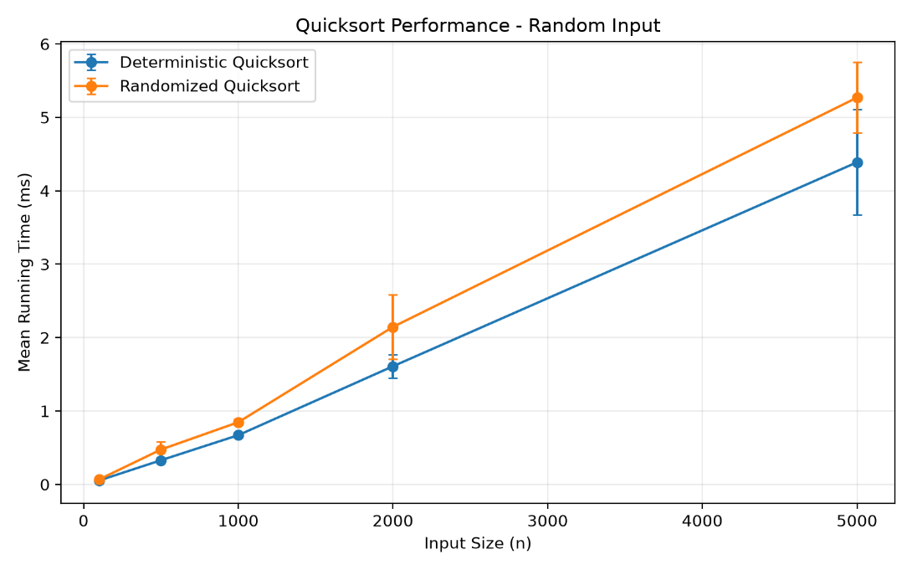
Figure 1. Deterministic and Randomized Quicksort Performance on Random Input
Figure 1 shows that both implementations scale relatively smoothly on random input. Their running times remain close throughout the tested range, although the randomized implementation is generally slightly slower. This is consistent with the additional work required for random pivot selection when the original input order is already favorable enough for the deterministic endpoint pivot.
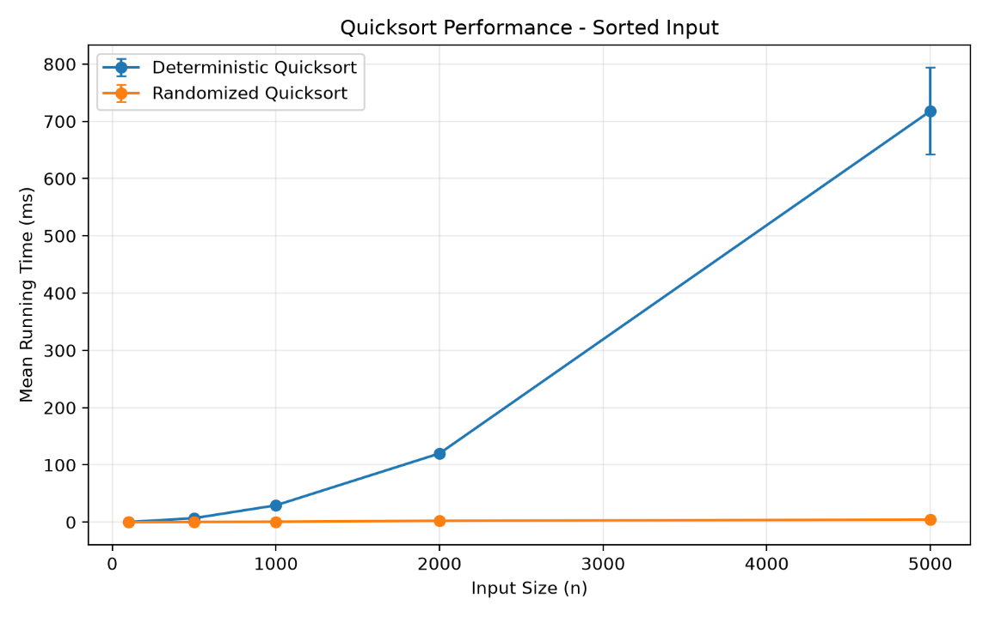
Figure 2. Deterministic and Randomized Quicksort Performance on Sorted Input
Figure 2 shows the strongest divergence between the implementations. As the input size increases, the deterministic running time rises sharply, while randomized Quicksort remains comparatively low. The shape of the deterministic curve is consistent with the expected quadratic behavior caused by repeatedly selecting an extreme pivot from sorted input.
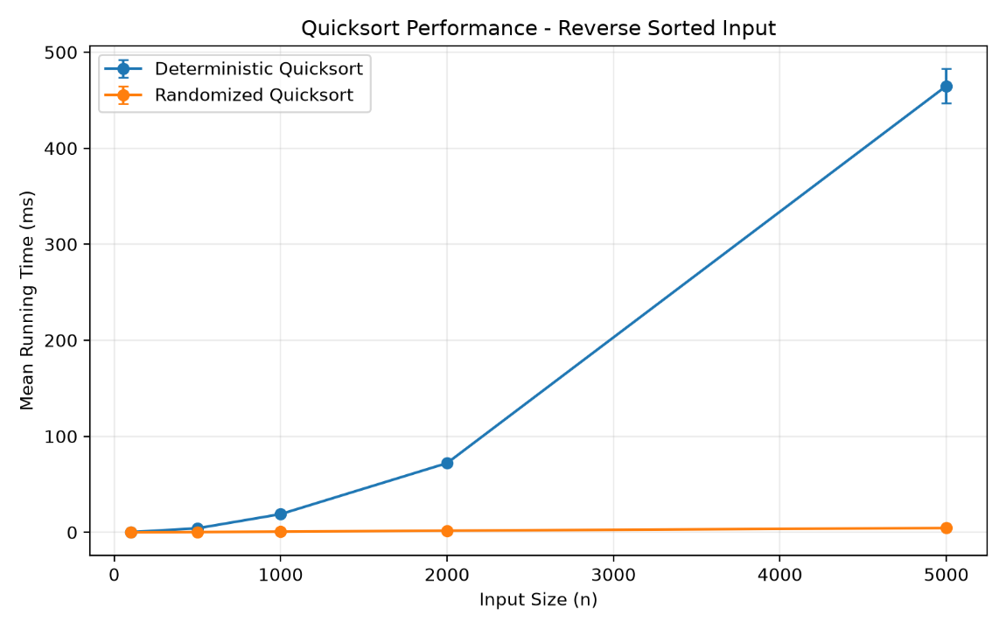
Figure 3. Deterministic and Randomized Quicksort Performance on Reverse-Sorted Input
Figure 3 shows a pattern similar to the sorted-input experiment. The deterministic implementation becomes increasingly expensive as the dataset grows, while randomized Quicksort remains relatively stable. This supports the theoretical expectation that a fixed endpoint pivot is highly sensitive to ordered input, whether the values are arranged in ascending or descending order.
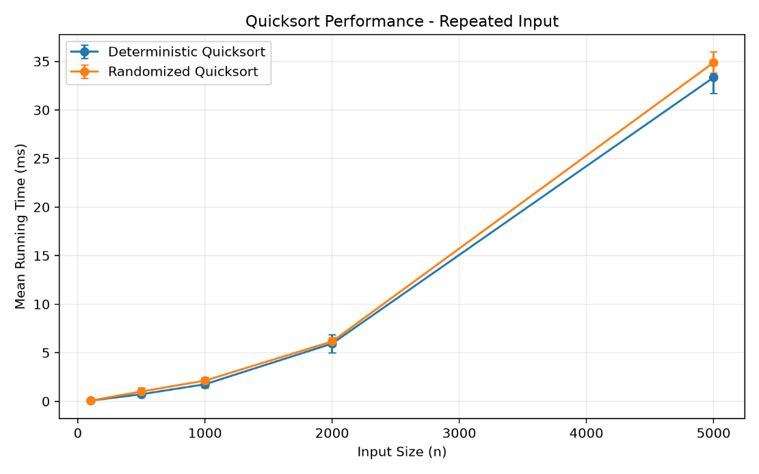
Figure 4. Deterministic and Randomized Quicksort Performance on Repeated-Value Input
Figure 4 differs from the ordered-input results because the two implementations remain close throughout the tested sizes. Random pivot selection provides little advantage when many candidate pivots have equal values. This observation reinforces that randomization reduces sensitivity to the original ordering of the data but does not by itself resolve partition imbalance caused by large numbers of duplicate keys.

Testing and Validation
Before analyzing performance, I verified the correctness of both Quicksort implementations with an automated test suite. The final suite contains 22 tests covering normal cases, edge cases, input-ordering patterns, duplicate values, and implementation-specific behavior. Testing both implementations separately was important because performance measurements are only meaningful if the sorting results are correct.
For the deterministic implementation, the tests include empty and single-element inputs, a two-element case, already sorted and reverse-sorted lists, duplicate values, all-equal values, mixed negative and positive numbers, and a large randomly generated dataset. I also tested a large sorted input to confirm that the implementation completes correctly even when the fixed endpoint pivot produces highly unbalanced partitions. Additional tests verify that the original list object is sorted in place and that the Lomuto partition function places the pivot correctly relative to the values on both sides.
The randomized implementation was tested with the same major input patterns, including sorted, reverse-sorted, duplicate-heavy, all-equal, negative-value, and large random datasets. I also executed the randomized implementation with multiple fixed seeds. This checks that correctness does not depend on one particular sequence of randomly selected pivots.
The final test run completed with all 22 tests passing. In addition, the benchmark performs its own correctness check during every timed run by comparing the algorithm output with the expected sorted result before storing the timing measurement. This provides a second layer of validation across all 200 benchmark executions.
I also performed syntax validation on the Python source files before the final analysis. Together, the automated tests, per-run benchmark checks, and reproducible random seeds gave me confidence that the observed timing differences were caused by the algorithm and input characteristics rather than incorrect sorting behavior.

Practical Implications and Limitations
The results show that pivot selection has a direct practical effect on Quicksort performance. A fixed endpoint pivot can work well when the input order does not consistently produce extreme pivots, but it can perform very poorly when the data is already sorted or reverse sorted. In contrast, randomized pivot selection makes the algorithm much less dependent on the original ordering of the input and therefore provides more stable performance across those cases.
At the same time, the experiment also shows that randomization is not universally better. On random input, the deterministic implementation was slightly faster in this test because it avoided the extra work required to generate and position a random pivot. The repeated-value results also showed that randomization does not automatically solve partition imbalance when many elements are equal to the pivot. This is a limitation of the two-way Lomuto partitioning approach used in both implementations.
One possible improvement for duplicate-heavy input would be to use a three-way partitioning strategy that separates values less than, equal to, and greater than the pivot. That approach could reduce repeated work when many duplicate keys are present. I did not include three-way partitioning in this assignment because the goal was to compare deterministic and randomized pivot selection using the same partitioning method.
The empirical results are also limited by the tested environment and input sizes. The timing values were measured on one system and may differ on other hardware, Python versions, or system loads. For that reason, the exact millisecond values should be treated as measurements from this experiment rather than universal performance guarantees. The more important observation is the consistent pattern across the tested distributions and how that pattern aligns with the theoretical analysis.
Another limitation is that five trials provide only a modest sample for timing variability. Increasing the number of trials or testing much larger inputs could provide a more detailed performance profile. Even so, the current experiment was sufficient to expose the major differences between the pivot-selection strategies, especially on sorted and reverse-sorted data.

Conclusion
This assignment demonstrated how strongly Quicksort performance can depend on pivot selection and input characteristics. I implemented both deterministic and randomized versions using the same Lomuto partition procedure so that the main difference between the algorithms was the method used to select the pivot. The deterministic version consistently used the last element of the active subarray, while the randomized version selected a pivot from within the current range before applying the same partition logic.
The theoretical analysis and experimental results were closely aligned. Both implementations performed efficiently on random input, although the randomized version showed a small amount of additional overhead. In contrast, sorted and reverse-sorted inputs exposed the weakness of the deterministic endpoint pivot. At n = 5,000, deterministic Quicksort averaged 717.9259 ms on sorted input and 464.8349 ms on reverse-sorted input, compared with 4.4940 ms and 4.4472 ms, respectively, for randomized Quicksort. These results illustrate how repeated extreme pivots can produce behavior consistent with the Θ(n²) worst case and how randomization reduces sensitivity to a fixed input ordering.
The repeated-value experiment provided an additional observation that was not visible from the ordered-input tests. Both versions performed similarly when many duplicate values were present, showing that random pivot selection does not eliminate every cause of unbalanced partitioning. Overall, the project reinforced the difference between theoretical worst-case guarantees and expected practical behavior. Randomization improves the robustness of Quicksort against unfavorable input ordering, while the partitioning strategy and characteristics of the data still remain important.

GitHub Repository
The complete Python implementations, automated tests, benchmark results, performance figures, README documentation, and final report are available in Assignment 5 GitHub repository:
https://github.com/naganaveenachennupati/MSCS532_Assignment5

References
Cormen, T. H., Leiserson, C. E., Rivest, R. L., & Stein, C. (2022). Introduction to algorithms (4th ed.). The MIT Press.
Python Software Foundation. (n.d.). time — Time access and conversions. Python 3.14 documentation. https://docs.python.org/3/library/time.html

