Assignment 6: Medians and Order Statistics & Elementary Data Structures

Naga Naveena Chennupati

Student ID: 005063666

MSCS 532 – Algorithms and Data Structures

University of the Cumberlands

November 1, 2026
Introduction
This assignment focuses on two related areas of algorithm design: order-statistic selection and elementary data structures. The first part examines how the k-th smallest element can be found without fully sorting an array. I implemented both a deterministic Median of Medians algorithm, which provides worst-case linear-time selection, and a Randomized Quickselect algorithm, which provides expected linear-time performance. The two approaches were then compared theoretically and empirically using different input sizes and distributions, including random, sorted, reverse-sorted, and repeated-value data.
The second part focuses on elementary data structures that are commonly used as building blocks for more advanced algorithms. I implemented a dynamic array and matrix operations, an array-based stack, a circular array-based queue, and a singly linked list. Each implementation includes basic operations and error handling for invalid or empty cases. Their operation costs are analyzed to show how data-structure choice affects performance depending on the type of access, insertion, deletion, or traversal required.
The goal of the assignment is not only to implement these algorithms and data structures correctly, but also to connect their theoretical behavior with practical results. The empirical selection study includes 200 timed runs, while the complete implementation was validated with 55 automated tests. Together, the analysis demonstrates the trade-off between strong theoretical guarantees, practical execution speed, memory requirements, and implementation complexity.

Deterministic Selection Using Median of Medians
The deterministic selection algorithm is implemented in deterministic_select.py and returns the k-th smallest value using 1-based indexing. The implementation follows the Median of Medians strategy so that pivot selection remains controlled even when the input is already sorted, reverse-sorted, or otherwise arranged in an unfavorable order.
The algorithm first divides the input into groups of at most five elements. Each group is sorted using a small insertion-sort helper, and the median of each group is collected. If more than one group median exists, the algorithm recursively selects the median of those medians and uses that value as the pivot. This provides a more reliable pivot than simply choosing the first, last, or middle element of the current input.
After the pivot is selected, the input is separated into three lists: values smaller than the pivot, values equal to the pivot, and values greater than the pivot. This three-way partitioning is important because it handles duplicate values directly. If the requested position falls inside the group equal to the pivot, the pivot can be returned immediately without further recursion.
The implementation also includes validation for edge cases. An empty input raises a ValueError, while a value of (k) outside the valid range raises an IndexError. A single-element input returns immediately. These checks make the implementation easier to test and prevent invalid order-statistic requests from producing misleading results.
One design choice in this implementation is that partitioning creates new Python lists rather than rearranging the original input in place. This simplifies the logic and makes duplicate handling clear, although it introduces additional memory overhead. The implementation therefore emphasizes correctness, clarity, and the required worst-case linear-time selection strategy.

Deterministic Selection: Time and Space Complexity
The main advantage of Median of Medians is that it provides a worst-case linear-time guarantee (Cormen et al., 2022). The algorithm does additional work to choose a pivot, but that pivot is selected in a way that prevents the recursive subproblem from remaining almost as large as the original input.
For an input of size (n), the elements are divided into groups of five. Finding the median of each group requires linear work overall because each element belongs to only one small group. The algorithm then recursively selects the median of approximately (n/5) group medians. Because the resulting pivot is reasonably balanced, at least a fixed fraction of the elements can be excluded from further consideration.
Ignoring lower-order terms, the worst-case recurrence can be represented as:
$$T(n) ≤ T(n/5) + T(7n/10) + O(n))$$
The (T(n/5)) term represents recursively selecting the median of the group medians. The (T(7n/10)) term represents the largest remaining partition that may need to be searched after partitioning around the selected pivot. The (O(n)) term accounts for grouping, processing the small groups, and partitioning the input.
The important point is that the two recursive subproblems together represent only a fixed fraction of the original input. Therefore, the recurrence resolves to:
$$T(n) = O(n)$$
in the worst case. This distinguishes Median of Medians from selection methods that can repeatedly choose poor pivots and degrade to quadratic time.
The implementation also has additional space costs. Because the input is partitioned into separate lower, equal, and higher lists instead of being rearranged in place, the algorithm uses (O(n)) auxiliary space. The recursive problem size decreases by a constant fraction, so the recursion depth is logarithmic in the worst case. The list allocations contribute more memory overhead than an in-place implementation, but they make the partitioning logic and duplicate handling easier to follow.
Overall, the deterministic algorithm accepts some additional constant-factor computation and memory usage in exchange for a strong (O(n)) worst-case time guarantee.

Randomized Quickselect Implementation and Complexity
The randomized selection algorithm is implemented in randomized_select.py using Randomized Quickselect. Like the deterministic implementation, it returns the k-th smallest value using 1-based indexing and uses three-way partitioning to handle duplicate values cleanly.
The main difference is pivot selection. Instead of computing a Median of Medians pivot, the randomized version selects one element uniformly at random from the current input and uses it as the pivot. The values are then divided into elements smaller than the pivot, equal to the pivot, and greater than the pivot. Only the partition containing the requested order statistic is processed recursively.
The implementation accepts an optional random.Random object. This does not change the algorithm’s behavior, but it allows the random choices to be reproduced during testing and benchmarking. That was useful in this assignment because it made the empirical comparison repeatable while still preserving randomized pivot selection.
Randomized Quickselect has expected linear running time (Cormen et al., 2022):
$$ET(n) = O(n)$$
The expected behavior comes from the fact that a randomly selected pivot is unlikely to produce highly unbalanced partitions repeatedly. On average, enough elements are discarded at each stage that the total expected amount of work remains proportional to the input size.
However, the algorithm does not provide a deterministic linear-time guarantee. In the worst case, a sequence of poor pivots can repeatedly reduce the problem by only one element. This leads to the recurrence:
$$T(n) = T(n-1) + O(n)$$
which resolves to:
$$T(n) = O(n^2)$$
Therefore, the randomized algorithm offers expected (O(n)) performance but retains a quadratic theoretical worst case.
Its space behavior is also affected by implementation choices. Like the deterministic version, this implementation creates new lower, equal, and higher lists during partitioning, so it uses additional auxiliary memory. In typical balanced behavior, recursion depth remains relatively small, while highly unbalanced pivot choices can increase the depth of recursion.
For this list-based implementation, the expected auxiliary space is (O(n)) when recursive partition sizes decrease normally. In a pathological sequence of extremely unbalanced partitions, recursion depth can grow to (O(n)), and the temporary partition lists retained across recursive calls can increase worst-case auxiliary storage beyond the typical linear behavior.
In practice, Randomized Quickselect often performs very well because random pivot selection has little overhead compared with constructing a deterministic Median of Medians pivot. This trade-off between stronger guarantees and lower practical overhead is one of the main differences explored in the empirical portion of this assignment.

Empirical Methodology
To compare the deterministic and randomized selection algorithms in practice, I created a benchmark in benchmark_selection.py. The experiment measured execution time across multiple input sizes and input distributions so that the observed behavior could be compared with the theoretical analysis.
Four input distributions were tested: random, sorted, reverse-sorted, and repeated-value data. The professor specifically required different distributions such as random, sorted, and reverse-sorted input, and repeated values were added because duplicate handling is also an important requirement of the assignment.
The tested input sizes were:
n ∈ {100, 500, 1000, 2000, 5000}
For each size and distribution, both algorithms were executed five times. The selected order statistic was the median position:
k = (n + 1) / 2
using integer division in the implementation. This resulted in:
4 × 5 × 2 × 5 = 200
timed selection runs.
Execution time was measured using Python’s time.perf_counter_ns(), a high-resolution performance counter appropriate for measuring short durations (Python Software Foundation, n.d.). Dataset generation, creation of the expected sorted result, and correctness validation were performed outside the timed section so that the measurements focused on the selection operation itself.
Each selected result was validated against the corresponding value from Python’s sorted version of the same input. If an algorithm returned an incorrect result, the benchmark was designed to stop rather than record the timing. This ensured that only correct executions were included in the empirical dataset.
The randomized algorithm used fixed seeds during benchmarking so that the experiment could be reproduced. The benchmark saved every individual timing measurement to selection_trials.csv and calculated the mean runtime and sample standard deviation for each algorithm, size, and distribution combination in selection_summary.csv.
This methodology provides a practical comparison of the two selection strategies while keeping the experiment consistent across different input conditions.

Empirical Results and Analysis
The empirical results showed that both selection algorithms scaled efficiently across the tested input sizes, but Randomized Quickselect was consistently faster than the deterministic Median of Medians implementation in this experiment. This difference is reasonable because the deterministic method performs additional work to construct a pivot with a guaranteed quality, while the randomized method selects a pivot with much lower overhead.
Table 1 summarizes the mean runtime and sample standard deviation for the largest tested input size, (n = 5000).

Table 1
Selection Performance at (n = 5000)
Input Distribution | Deterministic Median of Medians | Randomized Quickselect
Random | 5.8384 ± 1.3286 ms | 2.2337 ± 0.3732 ms
Sorted | 4.3026 ± 0.2970 ms | 1.7109 ± 0.7739 ms
Reverse Sorted | 6.9600 ± 0.8952 ms | 1.5107 ± 0.5040 ms
Repeated Values | 2.2452 ± 0.0715 ms | 1.0677 ± 0.2836 ms

For random input, both algorithms showed increasing runtime as the input size increased. At (n = 5000), deterministic selection averaged 5.8384 ms compared with 2.2337 ms for randomized selection. The randomized implementation was approximately 2.6 times faster at this size. The difference reflects the extra work required by Median of Medians to divide the input into groups, sort the small groups, collect their medians, and recursively select a pivot.
Sorted input did not cause either implementation to degrade sharply. At (n = 5000), the deterministic algorithm averaged 4.3026 ms, while Randomized Quickselect averaged 1.7109 ms. This result is important because the randomized implementation does not depend on a fixed endpoint pivot. Therefore, an already sorted input does not systematically force the algorithm into the type of poor partitioning that can occur with a poorly designed deterministic Quickselect implementation.
Reverse-sorted input produced the highest deterministic mean runtime at the largest tested size. Median of Medians averaged 6.9600 ms, compared with 1.5107 ms for Randomized Quickselect. In this case, the randomized implementation was approximately 4.6 times faster. Even though the deterministic algorithm had a larger measured runtime, its theoretical advantage remains its worst-case (O(n)) guarantee rather than the smallest constant factor.
Repeated-value data produced the lowest runtimes for the deterministic implementation among the (n = 5000) tests. The deterministic algorithm averaged 2.2452 ms, while the randomized version averaged 1.0677 ms. The three-way partitioning used in both implementations helps explain this result. When many values are equal to the pivot, a large portion of the input can fall into the equal partition, and the algorithm may avoid further recursion for those elements.
Across all four distributions at (n = 5000), Randomized Quickselect was faster than Median of Medians. However, this does not mean that the randomized algorithm has a stronger theoretical guarantee. Median of Medians guarantees worst-case linear time, while Randomized Quickselect provides linear time only in expectation and still has a theoretical (O(n^2)) worst case.
The measured results therefore illustrate a practical trade-off. Median of Medians pays additional constant-factor cost to obtain predictable worst-case behavior, whereas Randomized Quickselect uses a simpler pivot-selection strategy and achieved lower execution times in these experiments. The benchmark results are consistent with the theoretical analysis, but timing measurements alone do not prove asymptotic complexity because they depend on the implementation, input sizes, runtime environment, and hardware used for the experiment.
Performance Visualizations
The following figures present the mean runtime of the deterministic Median of Medians algorithm and Randomized Quickselect across the tested input sizes. Each figure includes standard-deviation error bars calculated from five trials. These visualizations make it easier to compare how the two algorithms behaved as input size increased under different data distributions.
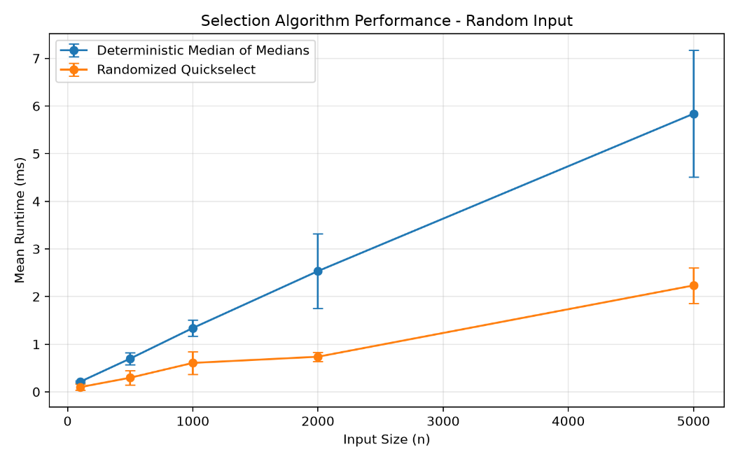
Figure 1. Mean runtime comparison for random input with standard-deviation error bars.

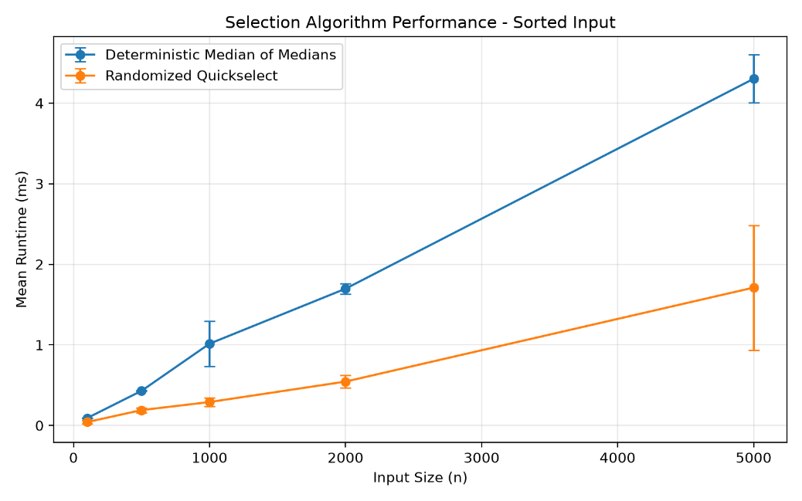
Figure 2. Mean runtime comparison for sorted input with standard-deviation error bars.
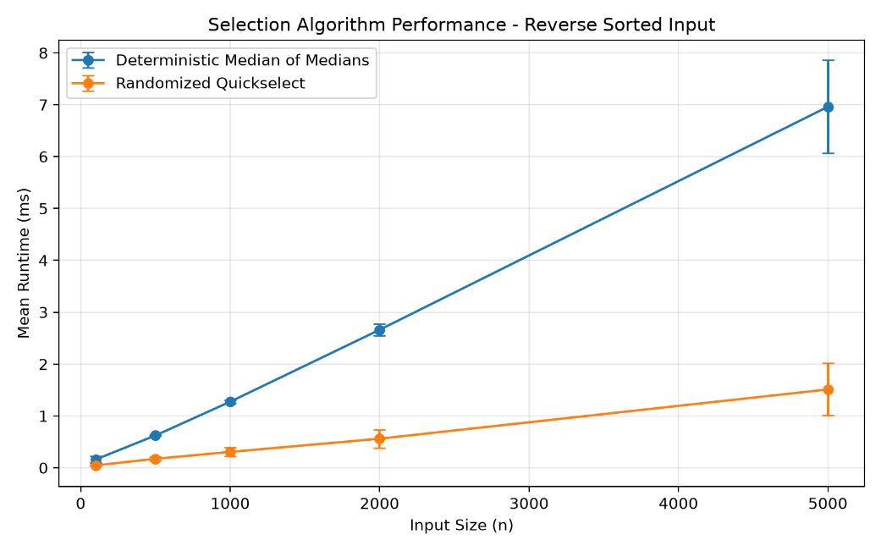
Figure 3. Mean runtime comparison for reverse-sorted input with standard-deviation error bars.

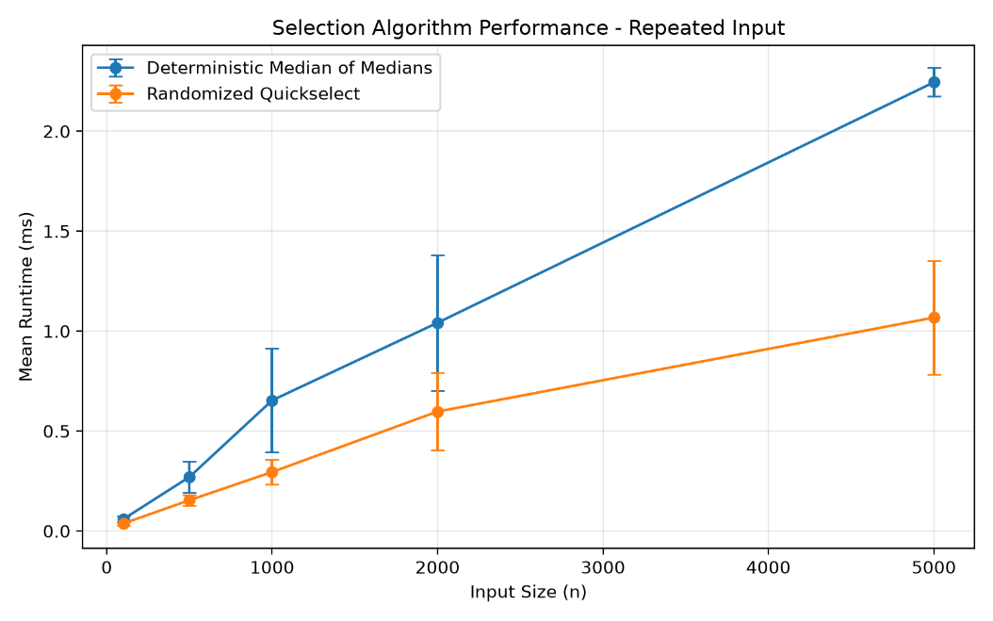
Figure 4. Mean runtime comparison for repeated-value input with standard-deviation error bars.

Elementary Data Structures: Implementation and Complexity Analysis
The second part of the assignment focuses on elementary data structures and the performance of their basic operations. I implemented a dynamic array, a matrix, an array-based stack, an array-based circular queue, and a singly linked list. Each implementation includes validation for invalid operations so that edge cases can be handled predictably.
Dynamic Array
The DynamicArray class in array_matrix.py manages its own size and capacity. It begins with a fixed internal capacity and automatically doubles the backing storage when additional space is required. When an element is inserted at an arbitrary position, existing elements are shifted to the right. Deletion shifts the remaining elements to the left so that the logical contents remain contiguous.
Indexed access is (O(1)) because the desired position can be accessed directly. Appending is amortized (O(1)) because most append operations place the new element directly into available capacity, although an occasional resize requires (O(n)) work. Insertion and deletion at an arbitrary position are (O(n)) because elements may need to be shifted.
Matrix
The Matrix class represents two-dimensional data using nested arrays. The implementation supports storing a value at a row-and-column position, retrieving a value, and deleting a value by resetting the selected position to the matrix default. Row and column bounds are checked before an operation is performed.
Because a matrix position is located directly using its row and column indexes, access, update, and reset operations are (O(1)). The matrix requires O(r × c) storage for (r) rows and (c) columns.
Array-Based Stack
The ArrayStack class uses a dynamic array to implement Last In, First Out (LIFO) behavior. The supported operations include push, pop, peek, size, and is_empty.
A push operation appends an item to the end of the backing array and therefore takes amortized (O(1)) time. Pop and peek operate on the final element and take (O(1)) time. Checking the size or whether the stack is empty is also (O(1)).
Array-Based Circular Queue
The ArrayQueue class uses a circular dynamic array rather than repeatedly removing the first element of a standard list. The queue maintains a front index and logical size. When the rear of the underlying array is reached, indexing wraps around to the beginning of the available storage. If the array becomes full, its capacity is doubled and the queued elements are copied into the new storage in front-to-rear order.
This design allows dequeue and peek to run in (O(1)) time because existing elements do not need to be shifted. enqueue is amortized (O(1)); an individual resize requires (O(n)), but resizing does not occur on every insertion. Size and empty-state checks are (O(1)).
Singly Linked List
The SinglyLinkedList implementation stores data in individual Node objects. Each node contains a value and a reference to the next node. The list supports insertion at the beginning, insertion at the end, insertion at a specified index, deletion of the first matching value, indexed access, and traversal.
Insertion at the beginning is (O(1)) because only the head reference needs to be updated. In this implementation, insertion at the end is (O(n)) because the list does not maintain a tail reference and must traverse from the head to locate the final node. Insertion at an arbitrary index, deletion by value, and indexed access are also (O(n)) in the worst case. Traversing the complete list requires (O(n)) time.
The operation complexities of the implemented structures are summarized in Table 2.
Table 2
Time Complexity of Elementary Data-Structure Operations
Data Structure | Operation | Time Complexity
Dynamic Array | Indexed access | (O(1))
Dynamic Array | Append | Amortized (O(1))
Dynamic Array | Insert at arbitrary index | (O(n))
Dynamic Array | Delete at arbitrary index | (O(n))
Matrix | Access | (O(1))
Matrix | Insert/update | (O(1))
Matrix | Delete/reset | (O(1))
Stack | Push | Amortized (O(1))
Stack | Pop | (O(1))
Stack | Peek | (O(1))
Circular Queue | Enqueue | Amortized (O(1))
Circular Queue | Dequeue | (O(1))
Circular Queue | Peek | (O(1))
Singly Linked List | Insert at beginning | (O(1))
Singly Linked List | Insert at end | (O(n))
Singly Linked List | Insert at arbitrary index | (O(n))
Singly Linked List | Delete by value | (O(n))
Singly Linked List | Indexed access | (O(n))
Singly Linked List | Traversal | (O(n))

Arrays vs. Linked Lists and Data-Structure Trade-offs
Arrays and linked lists provide different advantages, so the better choice depends on the operations that are most important for the application. Arrays store elements in indexed positions, which makes direct access very efficient. Accessing an element by index is (O(1)), making arrays a strong choice when a program frequently reads or updates known positions. Their main disadvantage is that insertion or deletion in the middle may require shifting many elements, producing (O(n)) work.
Linked lists organize data as separate nodes connected by references. This avoids the need to shift elements when the structure changes. For example, inserting a new node at the beginning of a singly linked list takes (O(1)) time. However, linked lists do not provide direct indexed access. To reach a position, the list must be traversed node by node, which takes (O(n)) time in the worst case. Linked lists also require extra memory for the reference stored in each node.
These differences also affect the implementation of stacks and queues. An array works well for a stack because both push and pop can occur at the end of the array in constant or amortized constant time. A linked-list stack can also support (O(1)) push and pop operations when the head is treated as the top of the stack. The array implementation is simpler in this project and benefits from compact storage.
Queues require more careful design. Removing the first element from a basic array can be inefficient because all remaining elements may need to shift. The circular array queue implemented in this assignment avoids that problem by keeping a front index and reusing available positions in the backing array. As a result, dequeue runs in (O(1)) time and enqueue runs in amortized (O(1)) time. A linked-list queue could also provide (O(1)) enqueue and dequeue operations if both head and tail references were maintained.
The preferred structure therefore depends on the application. Arrays are useful when fast indexed access and memory locality are important. Linked lists are more appropriate when the structure changes frequently and sequential access is acceptable. For stacks and queues, either representation can be efficient if it is designed around the operations that occur most often. The trade-off is not simply which structure is faster overall, but which structure provides the best performance, memory behavior, and implementation simplicity for the specific workload.

Practical Applications of Elementary Data Structures
Elementary data structures are useful because each one supports a different pattern of storing and processing information. The most appropriate choice depends on how frequently data must be accessed, inserted, removed, or processed in sequence.
Arrays are effective when fast indexed access is important. Examples include storing measurements collected over time, maintaining lookup tables, processing fixed collections of records, and supporting numerical computations. Because an array can retrieve an element directly by index in (O(1)) time, it is useful when the location of the desired item is already known. The trade-off is that inserting or deleting values in the middle of the array may require shifting other elements.
Matrices extend the idea of indexed storage to two dimensions. They are useful for representing structured data such as tables, images, grids, and adjacency matrices in graph-related applications. A specific row-and-column position can be accessed or updated directly, making matrices appropriate when relationships are naturally represented in a two-dimensional form. Their main consideration is memory usage because storage grows with the number of rows multiplied by the number of columns.
Stacks are appropriate when the most recently added item should be processed first. Common examples include function-call management, expression evaluation, undo operations, backtracking, and depth-first traversal. The array-based stack implemented in this assignment supports these patterns efficiently because push, pop, and peek operations occur at the end of the underlying array.
Queues are useful when items should be processed in the same order in which they arrive. Practical examples include task scheduling, print-job management, request processing, buffering, and breadth-first traversal. The circular queue implementation is particularly useful because removing the front element does not require shifting the remaining elements. This provides efficient FIFO processing while still using array-based storage.
Singly linked lists are useful when data changes dynamically and sequential traversal is acceptable. They can be used to maintain ordered chains of records, build certain stack or queue implementations, and serve as building blocks for more advanced linked structures. Inserting an element at the beginning is efficient because only the head reference needs to change. However, accessing an arbitrary position requires traversal from the head, so linked lists are less suitable when frequent indexed access is required.
These examples show that data-structure selection should be based on the operations that dominate the workload. An array may be preferable when direct access is the priority, a stack when processing follows LIFO order, a queue when FIFO order is required, and a linked list when flexible node-based organization is more useful than constant-time indexed access. Memory usage, execution speed, and implementation complexity all influence which structure is most appropriate for a particular application.

Testing and Validation
The implementations were validated using an automated test suite in test_assignment6.py. The final suite contains 55 tests covering both selection algorithms and all required elementary data structures.
For deterministic selection, the tests include single-element input, smallest and largest order statistics, middle elements, duplicate values, all-equal values, negative values, sorted input, reverse-sorted input, large random input, empty input, and invalid values of (k). The randomized selection algorithm was tested against similar cases, along with multiple random seeds to confirm that different pivot choices still produced the correct order statistic.
The dynamic array tests verify append, insertion, deletion, indexed access, invalid indexes, resizing, and insertion after a resize. Matrix tests validate insertion, deletion/reset behavior, access, invalid dimensions, and out-of-range positions.
The stack tests confirm Last In, First Out behavior, peek, size tracking, and correct error handling when operations are attempted on an empty stack. The queue tests confirm First In, First Out behavior, peek, automatic resizing, circular wraparound, wraparound followed by resizing, invalid capacity, and correct handling of empty-queue operations.
The singly linked-list tests cover insertion at the beginning, end, and arbitrary indexes; deletion of the head and middle nodes; deletion of a value that is not present; indexed access; invalid indexes; traversal; size tracking; and empty-state behavior.
The final automated test run produced:
Ran 55 tests in 0.013s
OK
In addition to unit testing, the benchmark code validates every measured selection result against the corresponding element from Python’s sorted version of the same input before recording the timing. This provides a second layer of correctness checking during the empirical analysis.
A final syntax check was also performed using Python’s py_compile module across all implementation, testing, benchmarking, and graph-generation files. The command completed without errors. Together, these checks provide evidence that the implementations are functioning correctly across normal cases, edge cases, and larger test inputs.
Limitations and Design Considerations
Although the implementations satisfy the requirements of the assignment, several design choices affect their practical behavior. The selection algorithms use three separate lists for values smaller than, equal to, and greater than the pivot. This makes the implementation clear and handles duplicate values effectively, but it requires additional memory compared with an in-place partitioning approach.
The deterministic Median of Medians algorithm also performs more work during pivot selection than Randomized Quickselect. Dividing the input into groups, sorting each group, collecting the group medians, and recursively selecting their median adds constant-factor overhead. The empirical results reflect this cost because the randomized implementation was faster across all tested distributions, even though Median of Medians provides the stronger worst-case (O(n)) guarantee.
The benchmark results should also be interpreted within the scope of the experiment. Five trials were performed for each algorithm, size, and distribution combination, and the largest tested input contained 5,000 elements. Execution times can vary depending on processor load, Python runtime behavior, operating-system scheduling, and hardware. Therefore, the measured timings illustrate practical behavior for this implementation but should not be treated as proof of asymptotic complexity.
The elementary data structures also involve implementation-specific trade-offs. The dynamic array doubles its capacity when full, which provides amortized (O(1)) append performance but temporarily requires additional storage during resizing. The circular queue has similar resizing overhead when its backing array reaches capacity. The singly linked list does not maintain a tail reference, so insertion at the end requires (O(n)) traversal. Maintaining a tail pointer could reduce that operation to (O(1)), but it would add another reference that must be updated correctly.
The matrix implementation focuses on fixed-size element access, updates, and resets rather than dynamically inserting or removing complete rows or columns. This keeps individual cell operations simple and constant time while matching the basic matrix operations implemented for this assignment.
These limitations do not prevent the structures from meeting their intended purpose. Instead, they demonstrate that algorithm and data-structure performance depends not only on theoretical complexity but also on implementation choices, memory usage, workload characteristics, and the operations that an application performs most frequently.

Conclusion
This assignment provided a practical comparison between deterministic and randomized selection algorithms while also reinforcing the performance characteristics of elementary data structures. The deterministic Median of Medians implementation demonstrated how careful pivot selection can guarantee worst-case (O(n)) performance. Randomized Quickselect, in contrast, achieved expected (O(n)) performance with lower pivot-selection overhead, although its theoretical worst case remains (O(n^2)).
The empirical results supported this trade-off. Across random, sorted, reverse-sorted, and repeated-value inputs, Randomized Quickselect was faster than the deterministic implementation in the measured trials. At the same time, the deterministic algorithm retained the stronger theoretical guarantee. This showed that algorithm selection depends on more than asymptotic notation alone; practical overhead, predictability, and workload characteristics also matter.
The second part of the assignment demonstrated similar trade-offs among arrays, matrices, stacks, queues, and linked lists. Arrays provide efficient indexed access, stacks and queues support specialized processing orders, and linked lists offer flexible node-based organization at the cost of direct access speed. The circular queue and dynamic-array implementations also illustrated how design decisions such as resizing and index management can improve practical efficiency.
The completed implementation was validated with 55 automated tests, and the selection algorithms were further evaluated through 200 benchmark runs. Overall, the assignment connected theoretical analysis with implementation behavior and showed why choosing an algorithm or data structure requires consideration of time complexity, memory use, operational needs, and implementation design.

GitHub Repository
The complete Python implementations, automated tests, benchmark results, performance visualizations, README documentation, and final report are available in the Assignment 6 GitHub repository:

GitHub Repository:
Repository link will be added after the Assignment 6 repository is created and pushed.

References
Cormen, T. H., Leiserson, C. E., Rivest, R. L., & Stein, C. (2022). Introduction to algorithms (4th ed.). MIT Press.
Python Software Foundation. (n.d.). time — Time access and conversions. Python 3 documentation. https://docs.python.org/3/library/time.html

