LAB ASSIGNMENT 2

CSEE5590/CS5590 APS
Programing for Web/Cloud/Mobile Applications Lab

NAGA NIDESH BABU DOPPALAPUDI
Class ID: 7

Introduction
Task 1: To create a Tic Tac Toe application in Angular js
Tic Tac Toe is a 3*3 squared or greater board game played between two players. The players start with either X or O. The game is designed such that when a complete row, column or diagonal is completed then the corresponding player wins and if not completed then it results in a draw.
Task 2: To create a YouTube API Application:
This application searches relative videos based on the keyword entered in the search box. The videos are readily available in YouTube API.

Work Flow
Task 1: In this application the input which we wrote takes the size of the board. In our case the size of the board is taken 3*3. Initially in the java script file the row, column and diagonal counts are set to zero using necessary flags. The games starts with O as he enters inside the box. After entering O, the event object and corresponding row, column and diagonal count increases. And if a letter is objected in a ow, column or diagonal then count decreases and when count reaches 3 then a player wins. By pressing the new game button a fresh game is started and the function returns to initial stage.
The technologies used here are :
- HTML
- Angular JS
- Bootstrap
Task 2: In the video search application, I have used the help of YouTube API, firstly I went on to get an API key from the Google developers console, and registered for a YouTube API v3, and fetched an API key.
YouTube API showed a clear description of how to import the API data in its developer website. The same have been imported into my angular js script.
I have used an ng-model for the search box using Bootstrap, and this search box is a key to the API result end tag. On successful hitting the API, the resultant json data can be used appropriately into the html body.

Technologies Used:
- HTML
- Google Developer Console for YouTube API key
- Bootstrap
- Angular JS
Final output screenshots :

- Tic Tac Toe
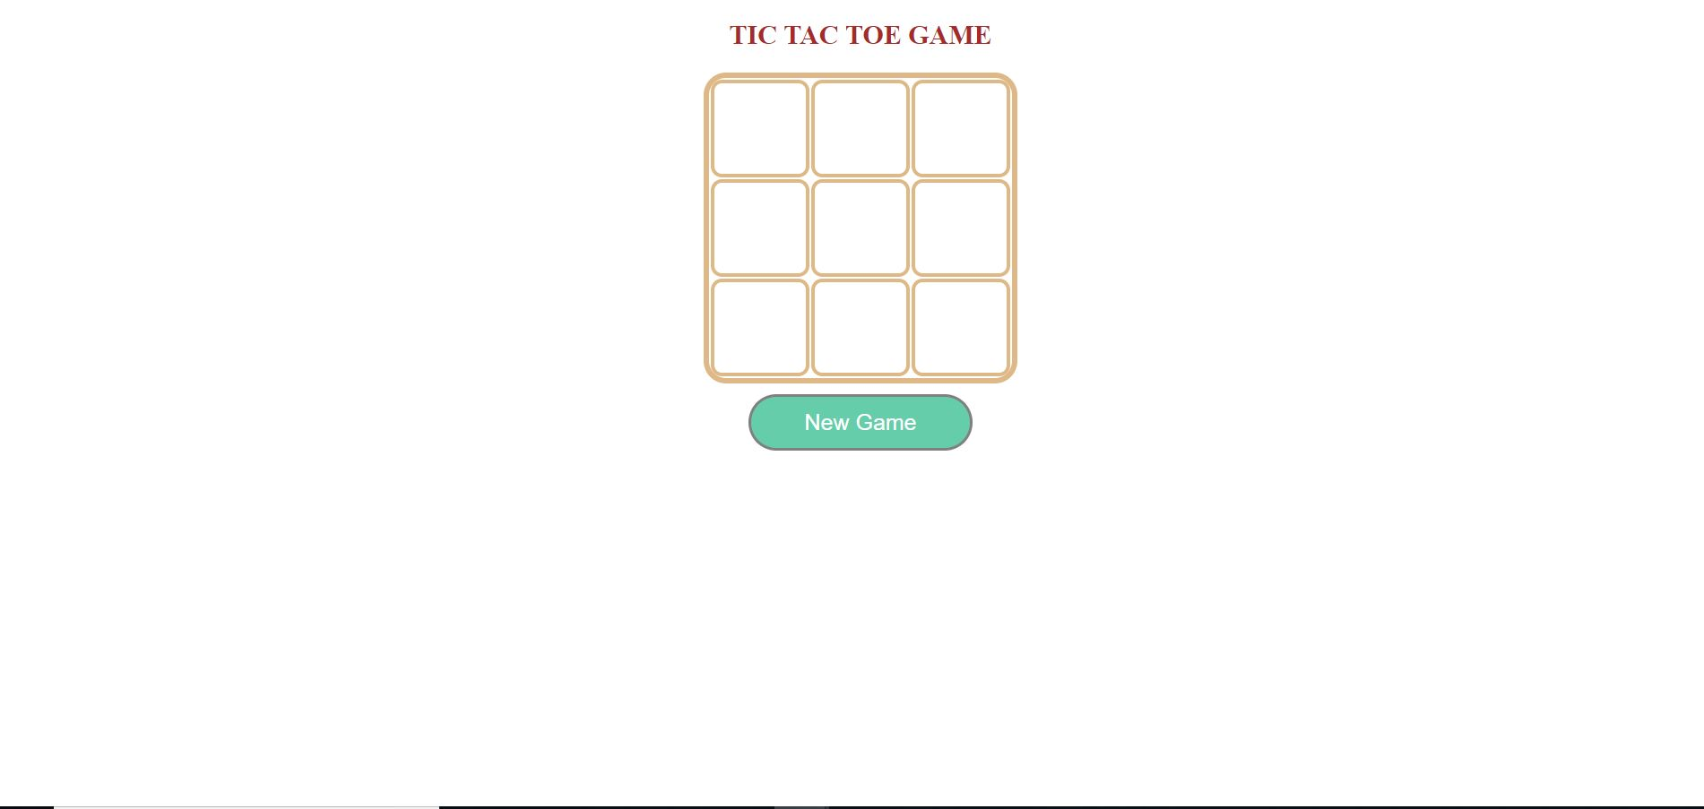
- YouTube API

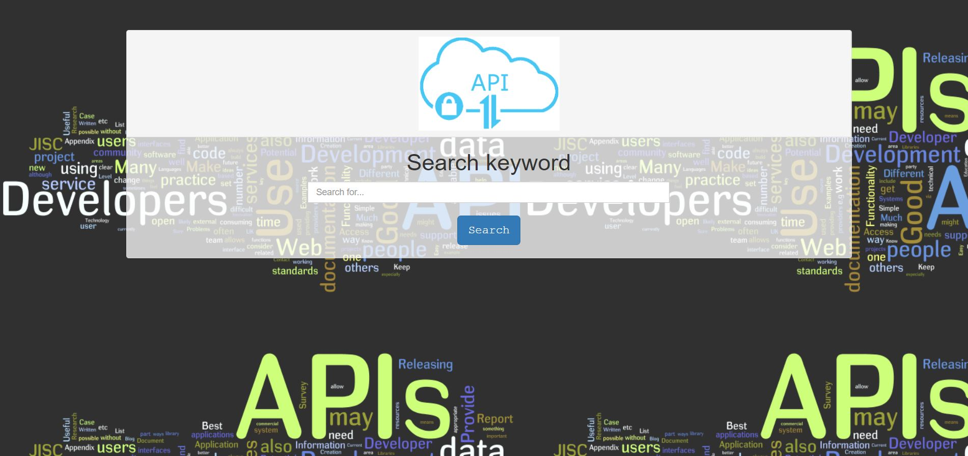

Conclusion:
The game can be made more eventful using CSS styling and also adding different functionalities. We can increase the size of the board and also increases player size to maximum of 4.
The YouTube application can be made more eventful by adding video details, number of likes and followers. By using video queries the video can be played inside my application.

