1. Configure password less authentication in the repo’s.

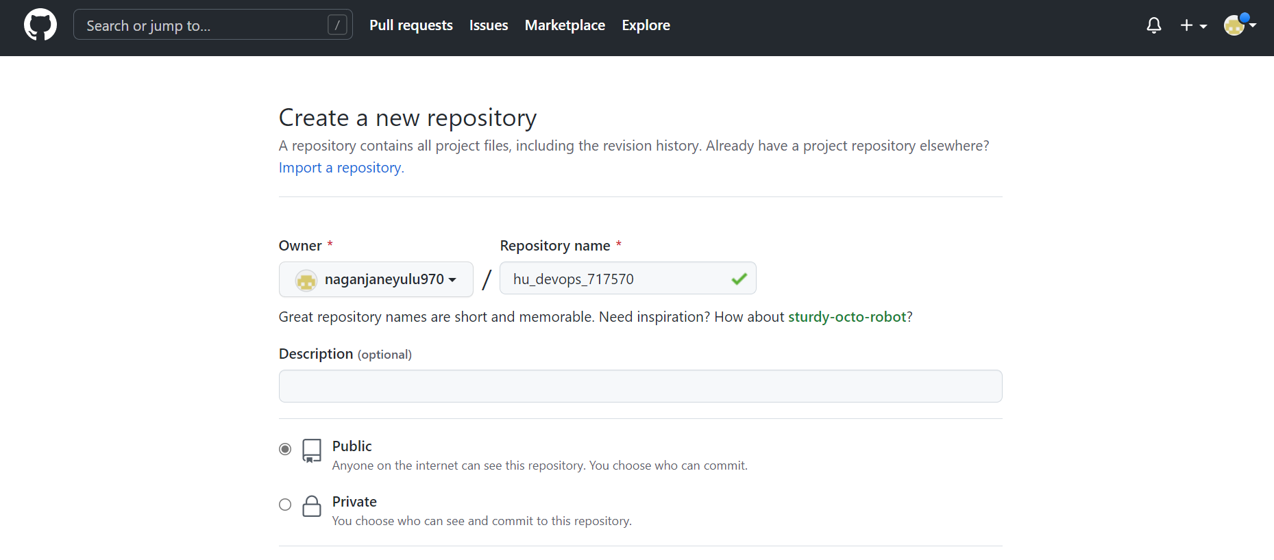

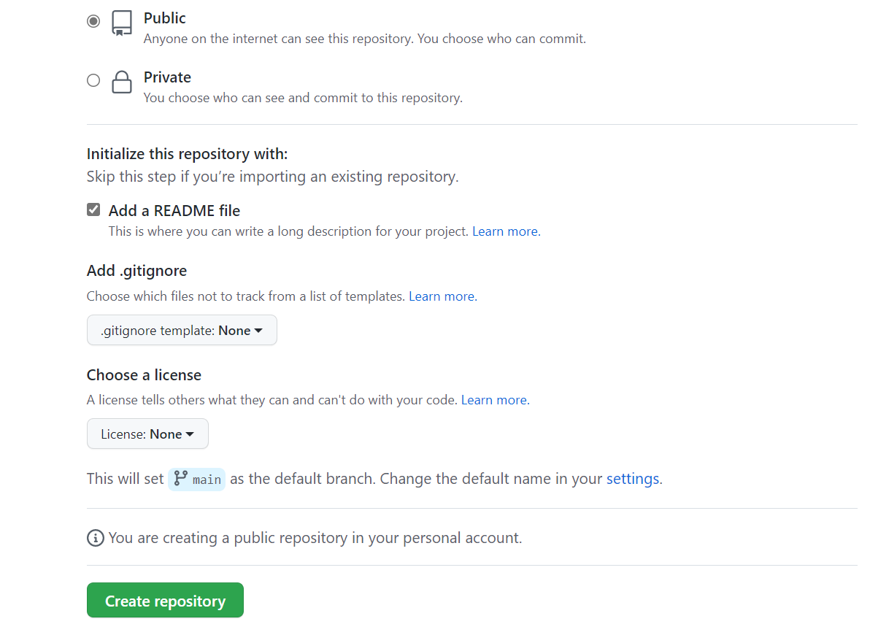

1. Disable the forking in your repository hu_devops_19_<employee_id>.

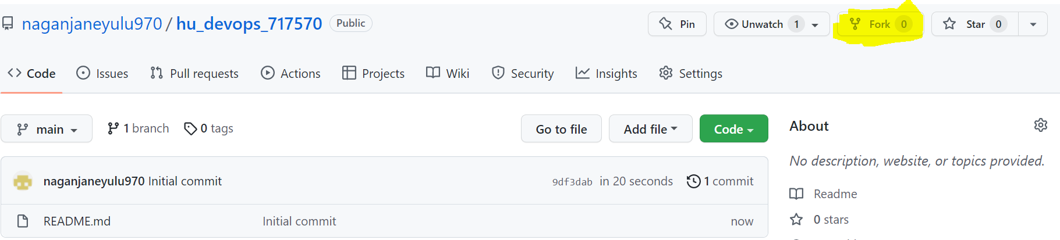

1. Clone the repo hu_devops_19_<employee_id> to your localhost.

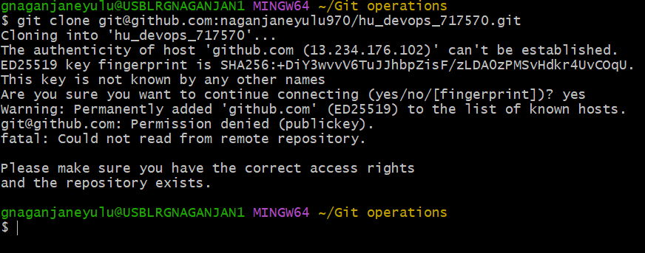

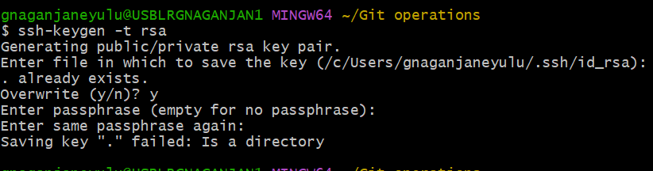

1. Create a branch name git-assignment and start working on it, for all documents and code should be put on this branch

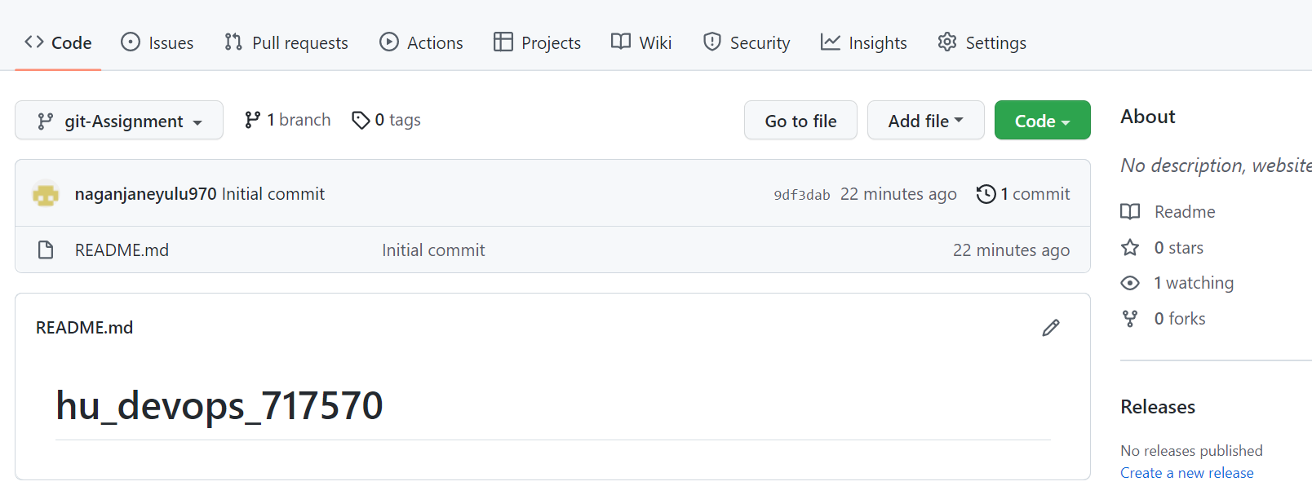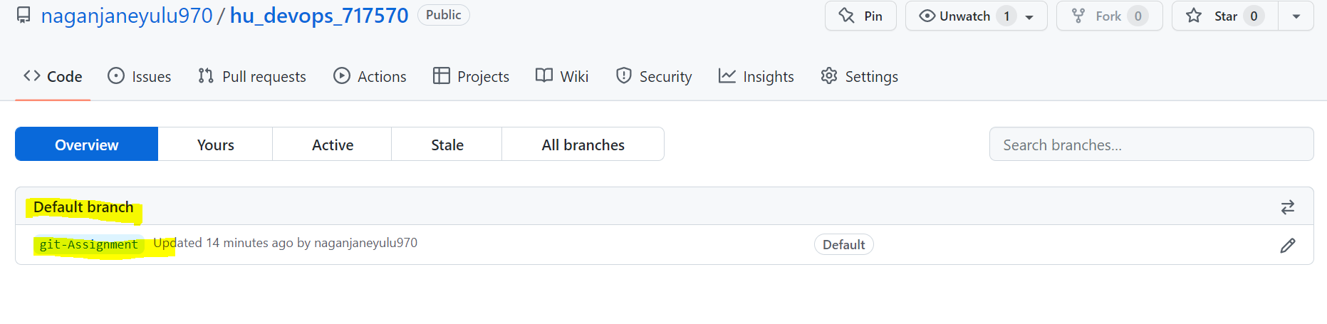

1. Create a file named secrets that should have your gitlab username and password, this file should not reflect in git console while you push to git repository.

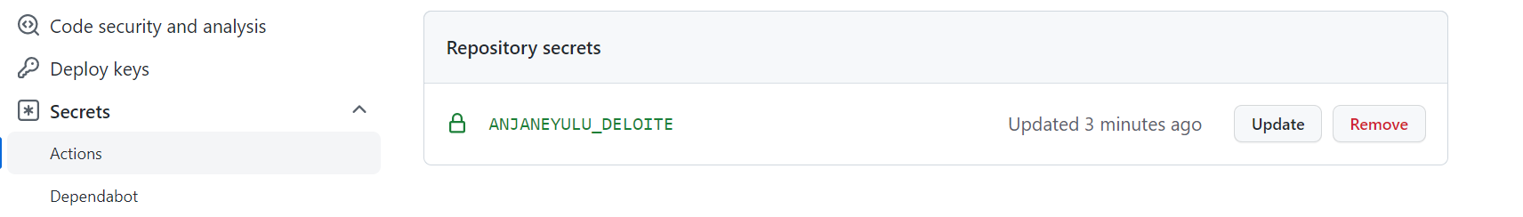

6……..

