An AI-Based Medical Chatbot Model for Infectious Disease Prediction

In this paper author utilized LSTM algorithm to train a model which will accept question as input from the user and then predict closed matched answer and then display to user as Chatbot reply.

To train LSTM algorithm author has given some medical question dataset which can be download from below URL

<https://github.com/Kodierer-desafiador/Covid-19-dataset-json-file/blob/main/covid-19.json>

Above dataset contains some questions showing in below screen

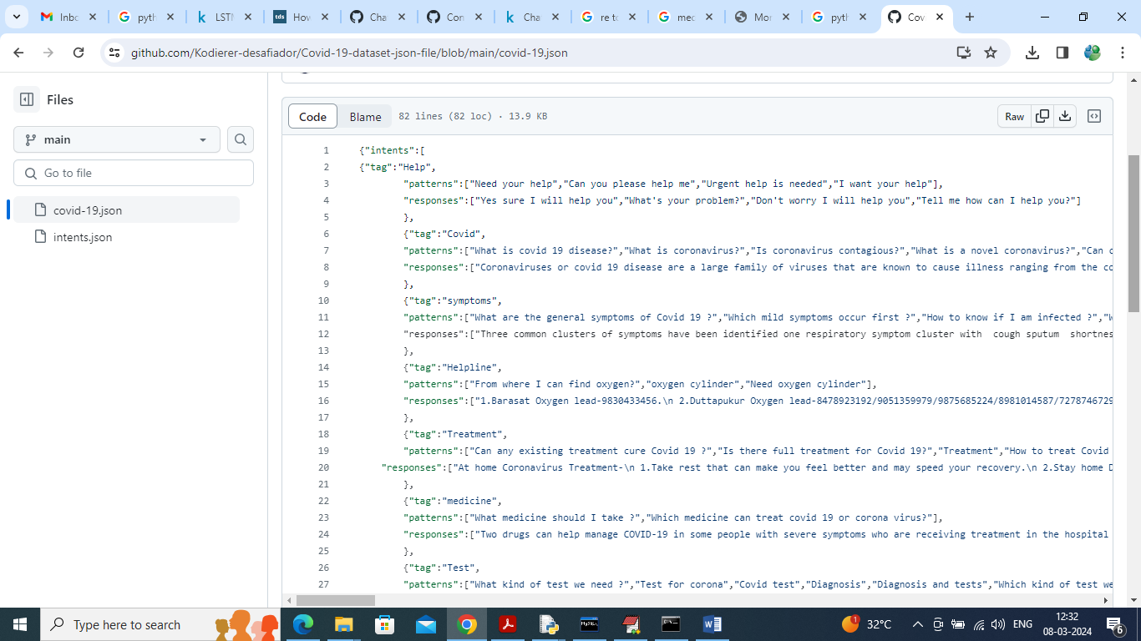

So trained LSTM Chatbot can reply for any question available in above dataset screen and I saved this dataset inside ‘Dataset’ folder.

As per your request we have made this application work for both Text and Voice based Chatbot. Chatbot reply to use in both English and Telugu and for translation we have used Google translation which will work for few questions as this free based API. If application stuck then you can consider translator not working so you can start after some time. You can run for five queries at a time and may work for more queries also but some time it may not work.

To implement this project we have designed following modules

1. Sign up: user can sign up with the application
2. User Login: after sign up can login to application
3. Train LSTM Algorithm: after login you can run this module to train and load LSTM algorithm and then calculate training accuracy and graph
4. Interact with Voice Based Chatbot: using this module u can interact with Chatbot in voice based mode
5. Text Based Chatbot: can interact with Chatbot in text mode
6. View History: can view all chats of history

SCREEN SHOTS

To run project install python 3.7 and then install all packages given in requirement.txt file and then install MYSQL and then copy content from DB.txt file and paste in MYSQL console to create database. Now double click on run.bat file to start python web server and get below page

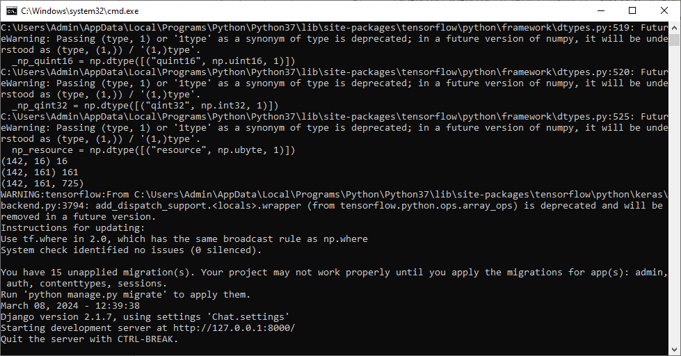

In above screen python server started and now open browser and enter URL as <http://127.0.0.1:8000/index.html> and press enter key to get below page

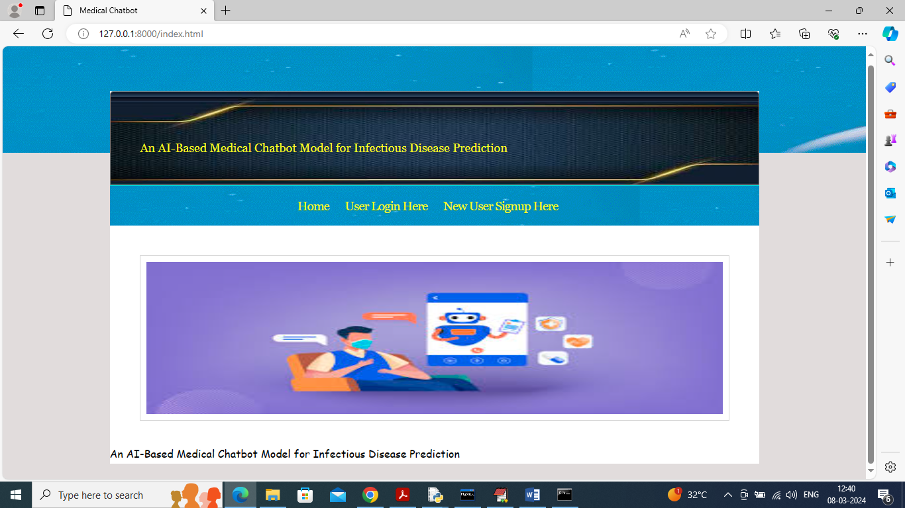

In above screen click on ‘User Sign up’ link to get below page

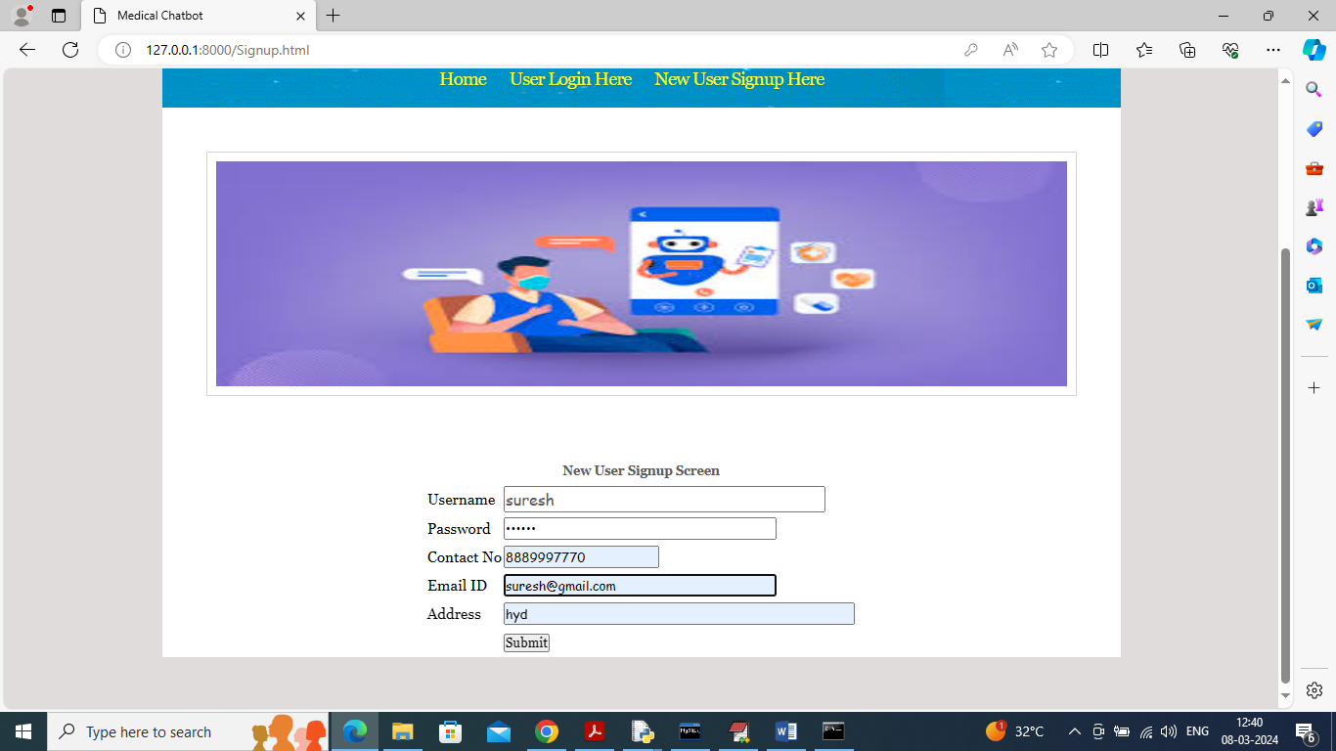

In above screen user is entering sign up details and then press button to get below page

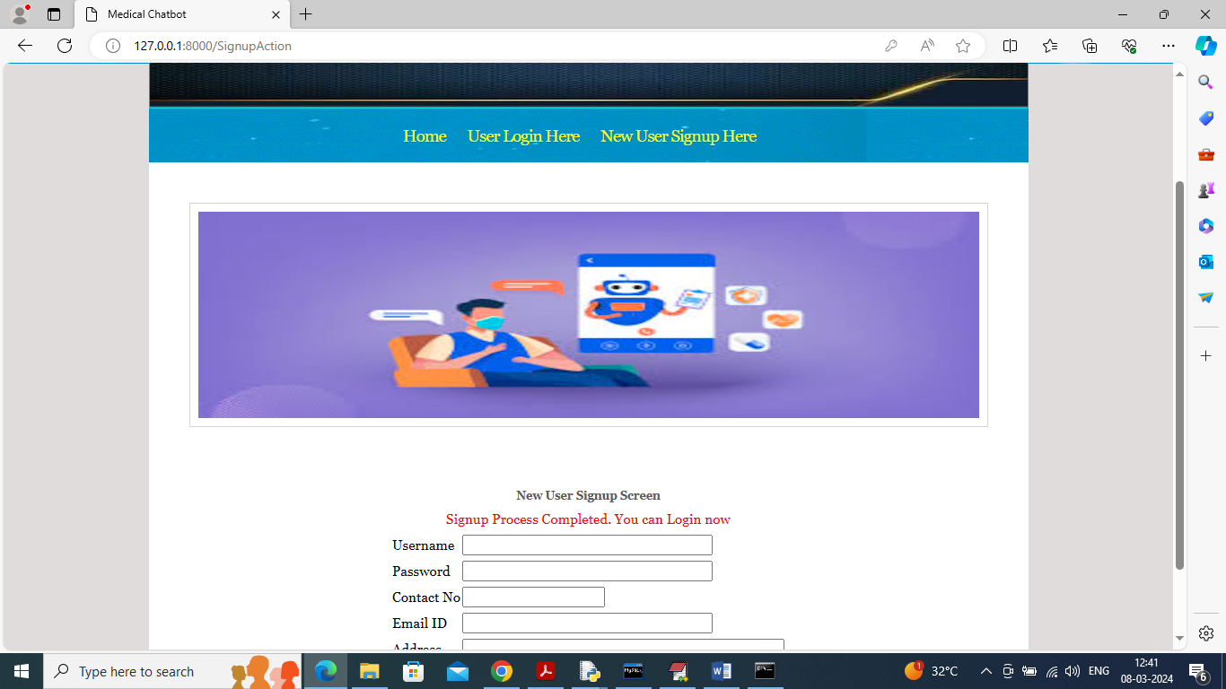

In above screen user sign up completed and now click on ‘User Login’ link to get below page

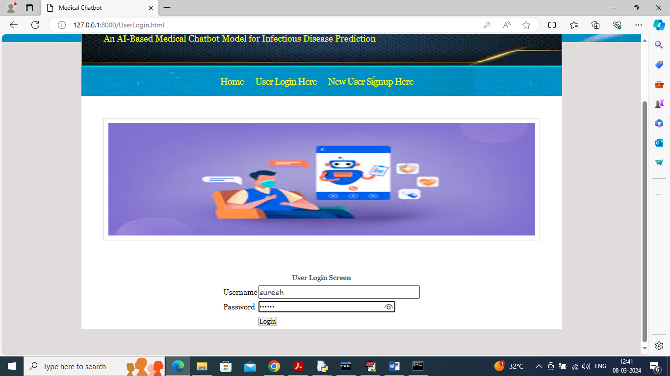

In above screen user is login and after login will get below page

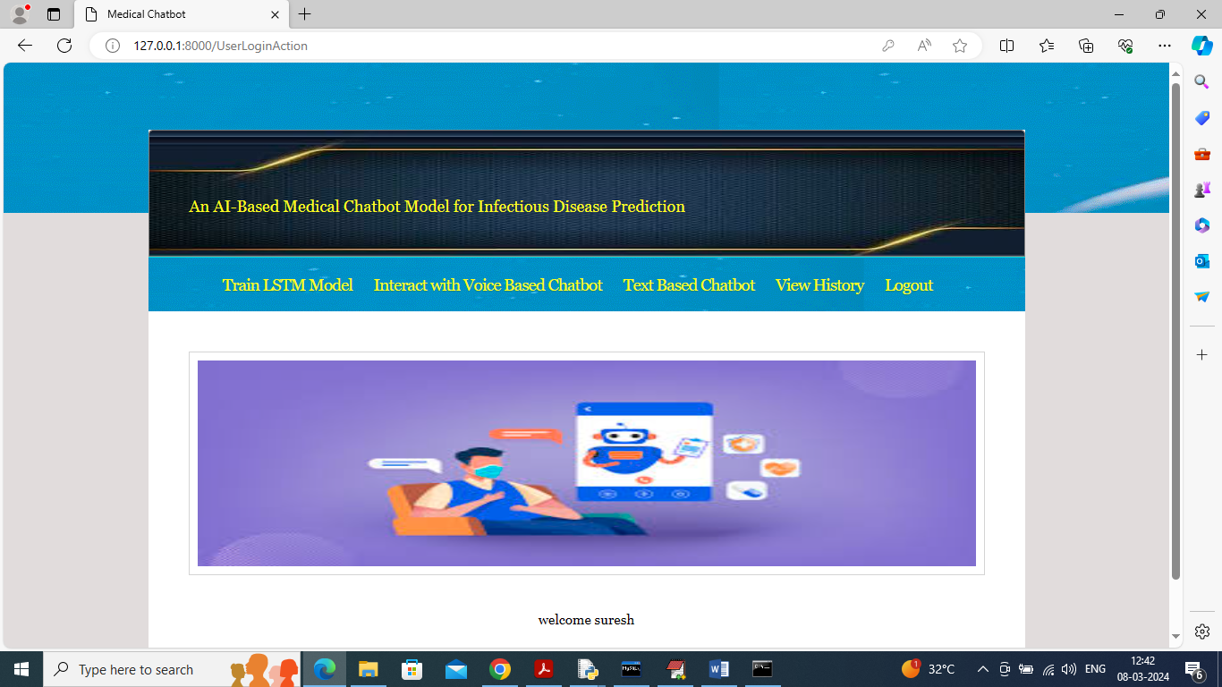

In above screen user can click on ‘Train LSTM Model’ link to get below page

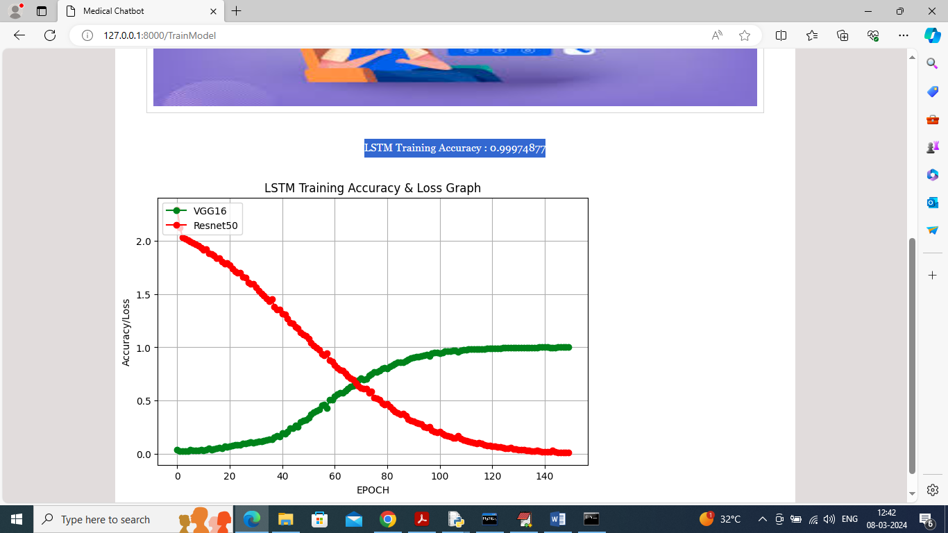

In above screen LSTM training completed and in blue colour text can see LSTM accuracy is 99% and in graph x-axis represents training EPOCHS and y-axis represents Accuracy/LOSS values and then green line represents Accuracy and red line represents LOSS and can see with each increasing epoch accuracy got increase and reached closer to 1 and loss got decrease. Now click on ‘Interact with Voice Chatbot’ link to get below voice recorder

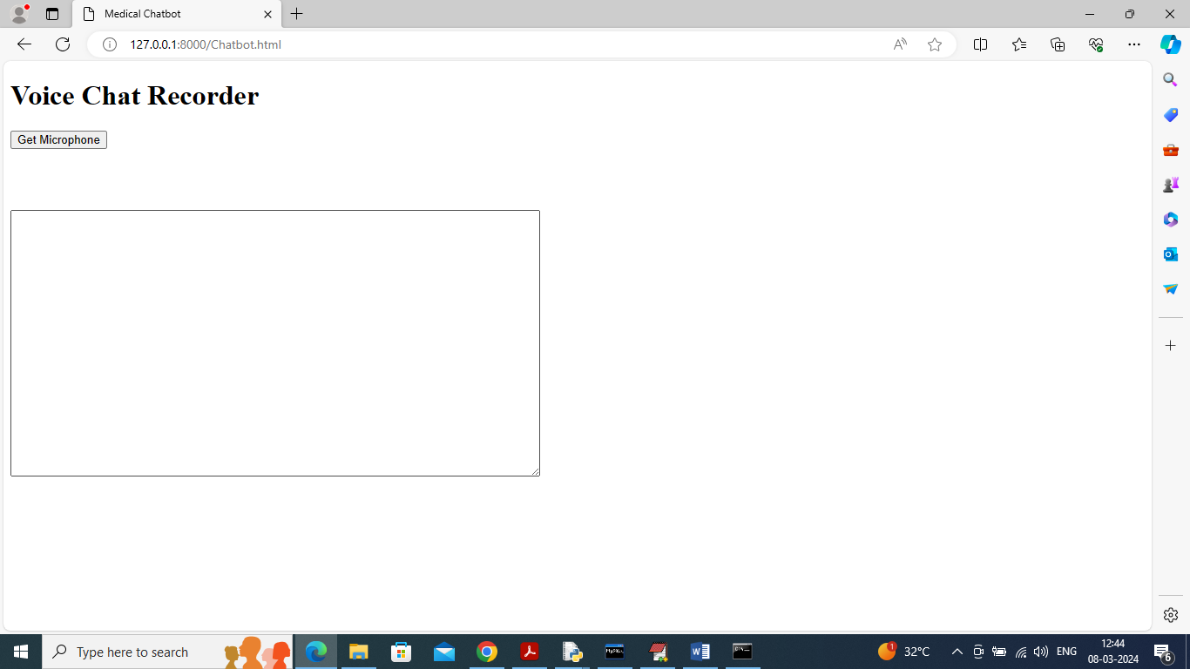

In above screen click on ‘Get Microphone’ link to connect to micro phone and get below page

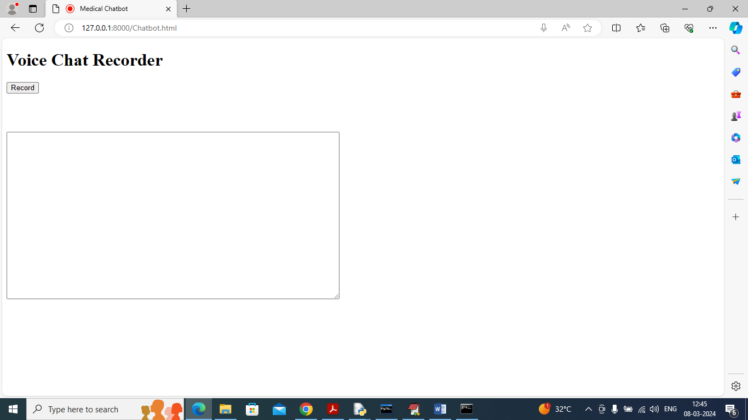

In above screen click on ‘Record’ button and start speaking and once done click ‘Stop’ button to get reply from Chatbot

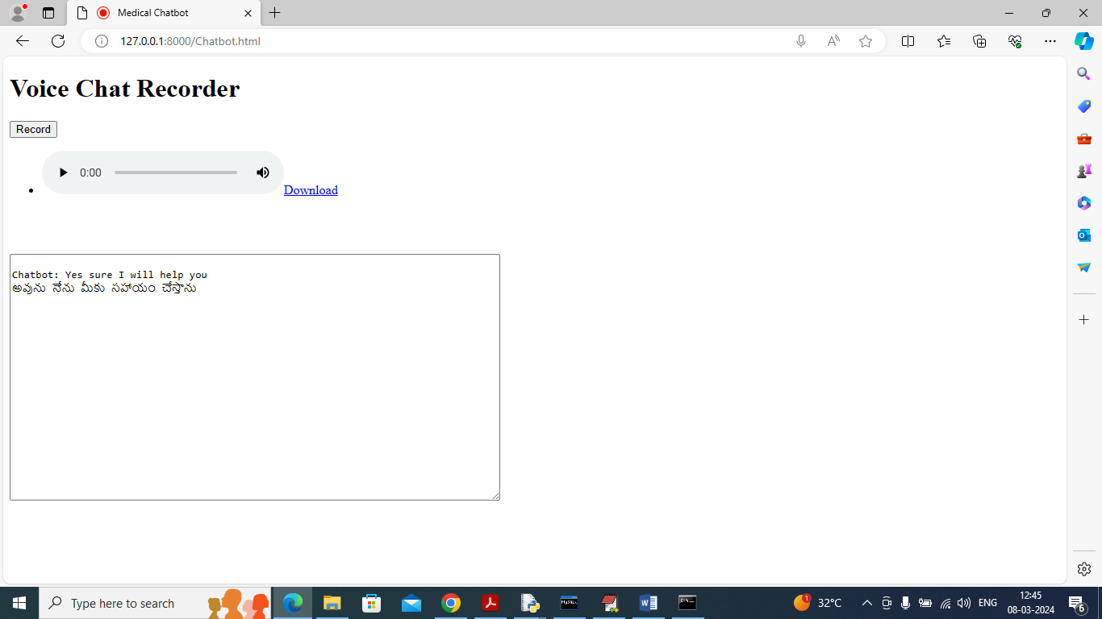

In above screen I spoke word as ‘Need Your Help’ and then got reply from Chatbot in both English and Telugu and similarly you can record and get output from Chatbot and now click on ‘Text Based Chatbot’ to get below page

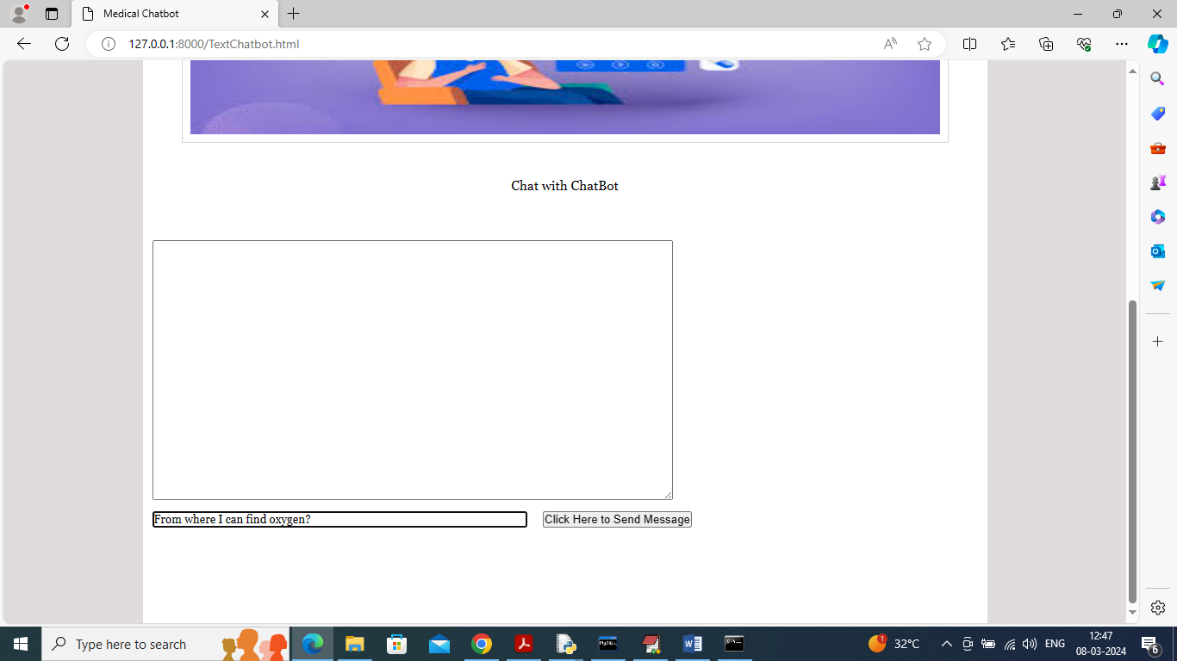

In above screen I asked question about ‘Oxygen Cylinder’ and press button to get below page

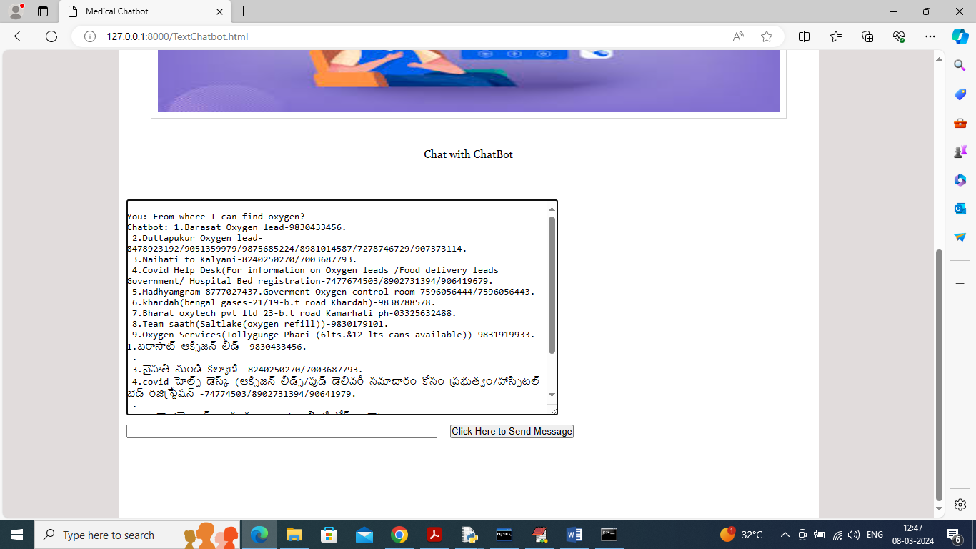

In above screen got reply from Chatbot in both English and Telugu and below is another question

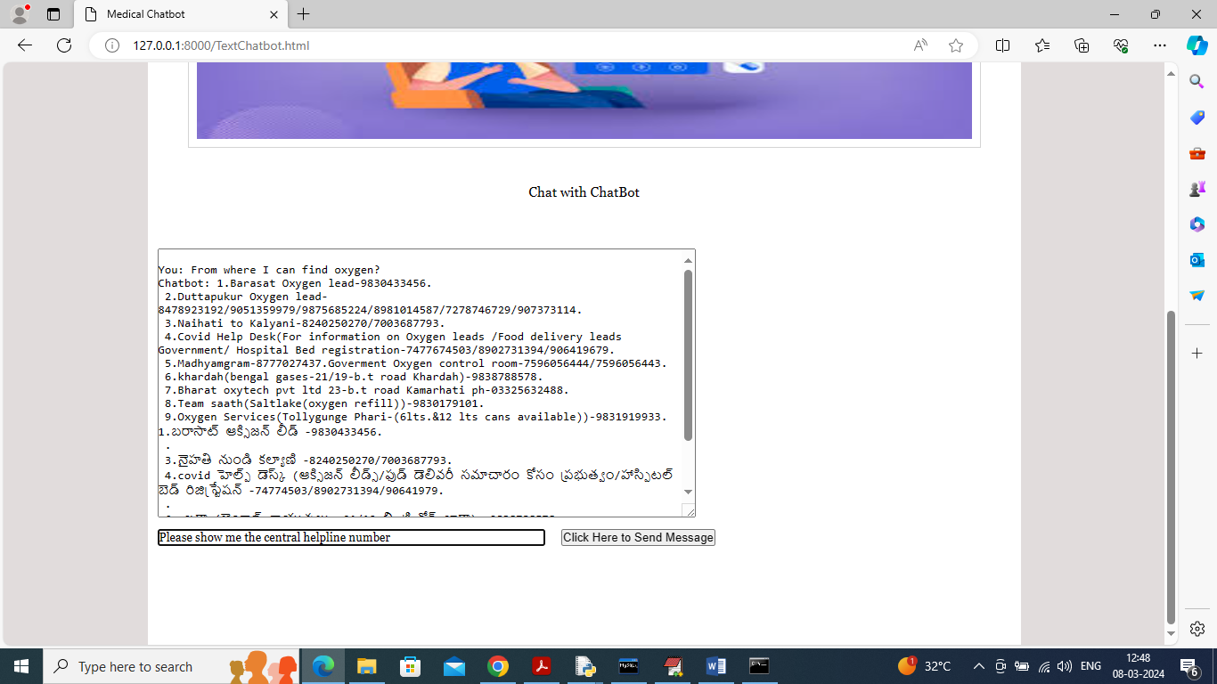

In above screen asking for ‘covid help line number’ and below is the response

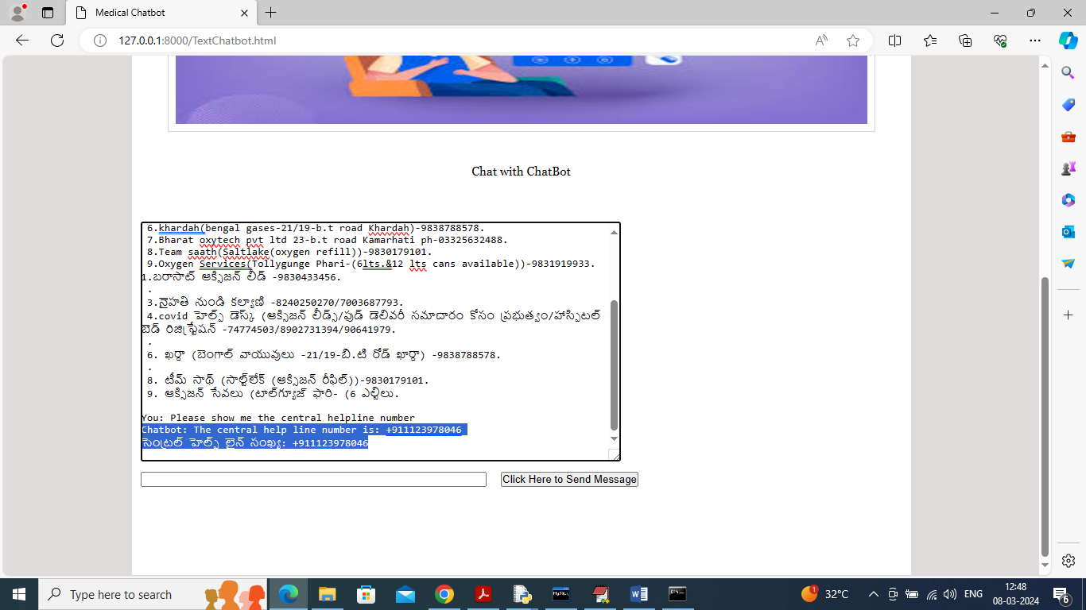

In above screen can see response for help line in both Telugu and English and now click on ‘View History’ link to get below page

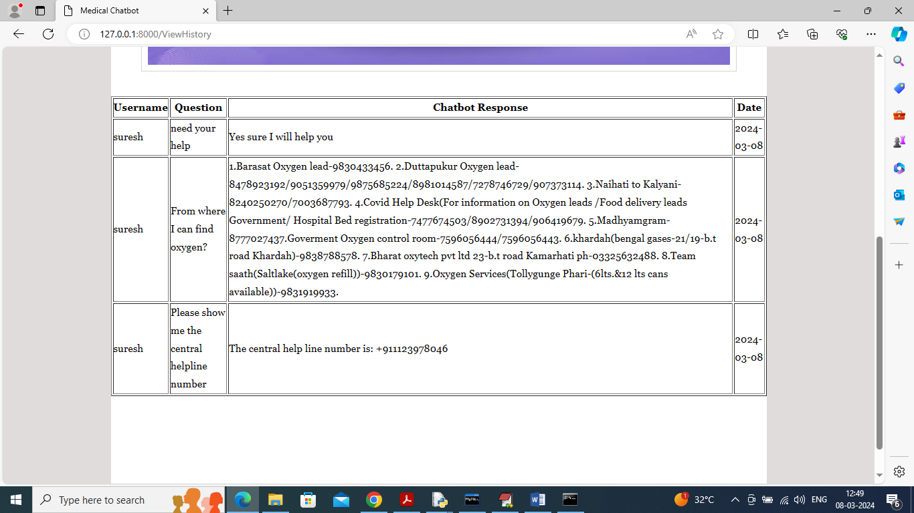

In above screen user can view all question he asked and the response from the Chatbot.

Similarly by following above screens you can run Medical Chatbot in both voice and text format