Prototype: LockME.com (Digital Locker)

# Product Capabilities:

1.1 Allow users to save credentials all at one place.

1.2 Allow user to fetch all credentials at one time.

1.3 Allow user to fetch single credential at a time.

1.4 Fetch all the credentials in Lexi graphically sorted order for easy readability.

1.5 Allow user to update any credential.

1.6 Allow user to delete any credential.

1.7 Allow user update the account password.

1.8 Allow user to delete user account.

# Appearance:

Prototype appearance would be console based.

# User Interaction:

Prototype user interaction would be command based i.e. from console.

# Number of Sprints required: 3

## 4.1 Sprint 1: Design and implement functionality for home page, login page, signup page and exit app.

## 4.2 Sprint 2: Develop store credential, fetch all credential, fetch single credential, update credential, delete credential feature

## 4.3 Sprint 3: Develop user account password update and user account delete feature.

# Sprint 1: Stories

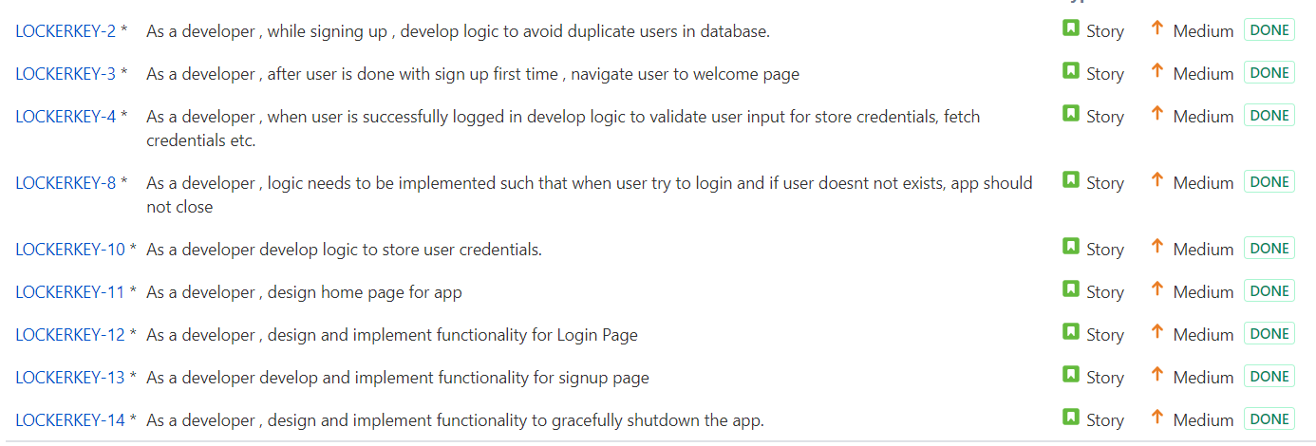

# Sprint 2: Stories

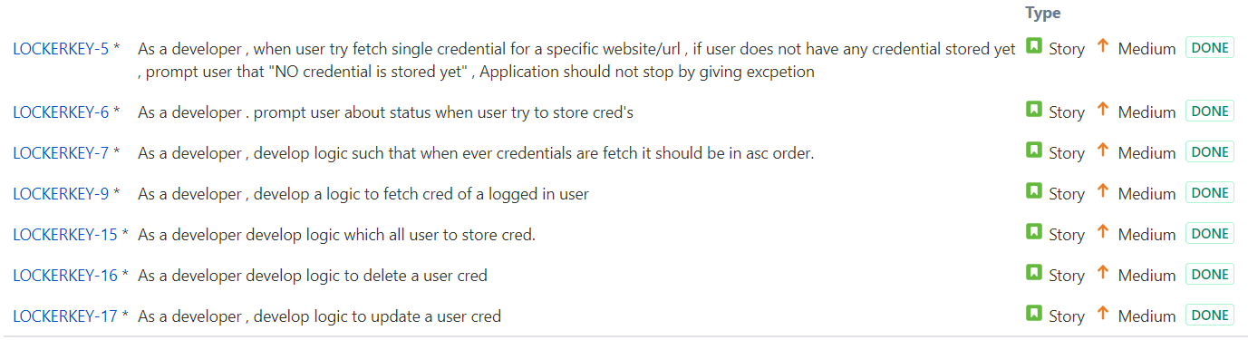

# Sprint 3: Stories

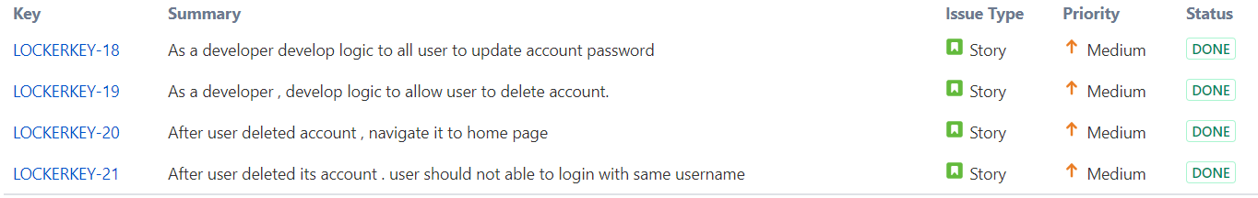

# Software required to run application

## Min Java 8

## GIT (min 2.1+ version)

## Maven (min 3.6 version)

# How to run project:

## Step 1: git clone <https://github.com/nagapparohit/lockme.com.git>

## Step 2: cd lockme.com

## Step 3: mvn package

## Step 4: java -jar target/lockme-0.0.1-jar-with-dependencies.jar

## **OR**

## you can directly download jar from below url and jump to step 4 above directly

## https://github.com/nagapparohit/lockme.com/blob/master/lockme-0.0.1-jar-with-dependencies.jar

# 10. Tools used to build a project

## Eclipse (IDE)

## Java 8 (compile)

## Maven (Build)

# 11. Algorithm and Data Structure used

## Quicksort used to sort the credentials.

## ArrayList used to store credential object.

## Map used to store json object.

# 12. Location to track project for further enhancement

## <https://github.com/nagapparohit/lockme.com.git>

# 13. Below find the attached source code.



# 14. Below find snippets of application

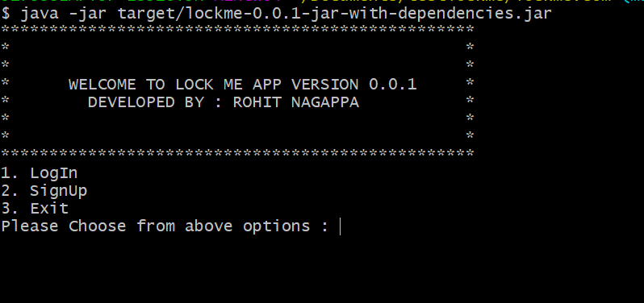

**Welcome Page**

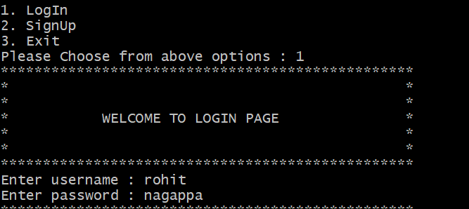

**Login Page**

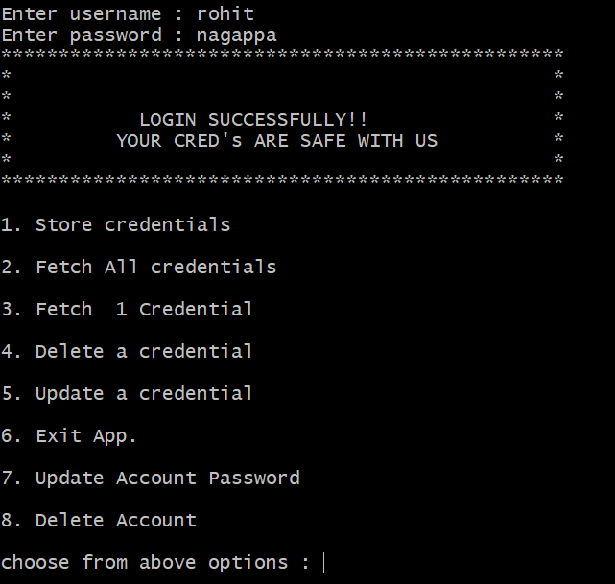

**Login Successful Page**

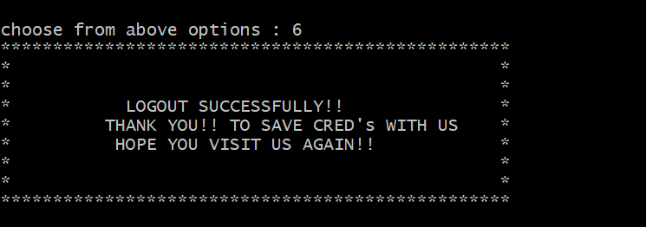

**Logout Page**

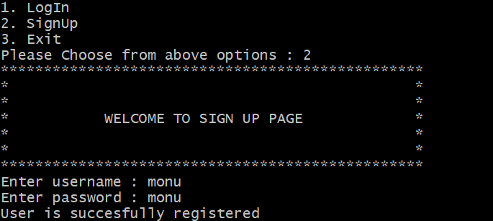

**Sign Up Page**

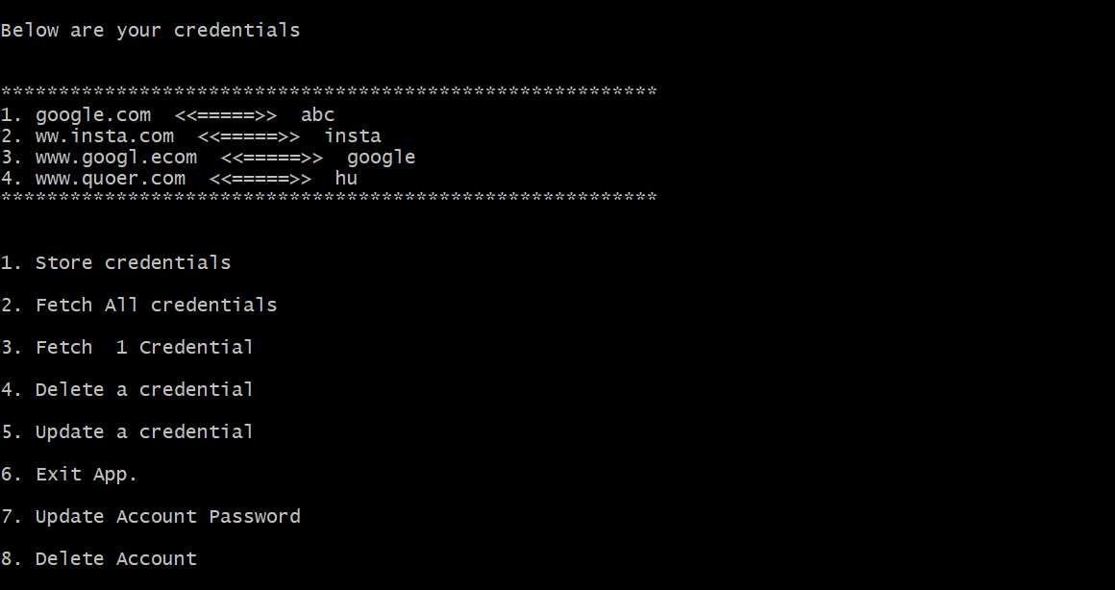

**Fetch credentials page**

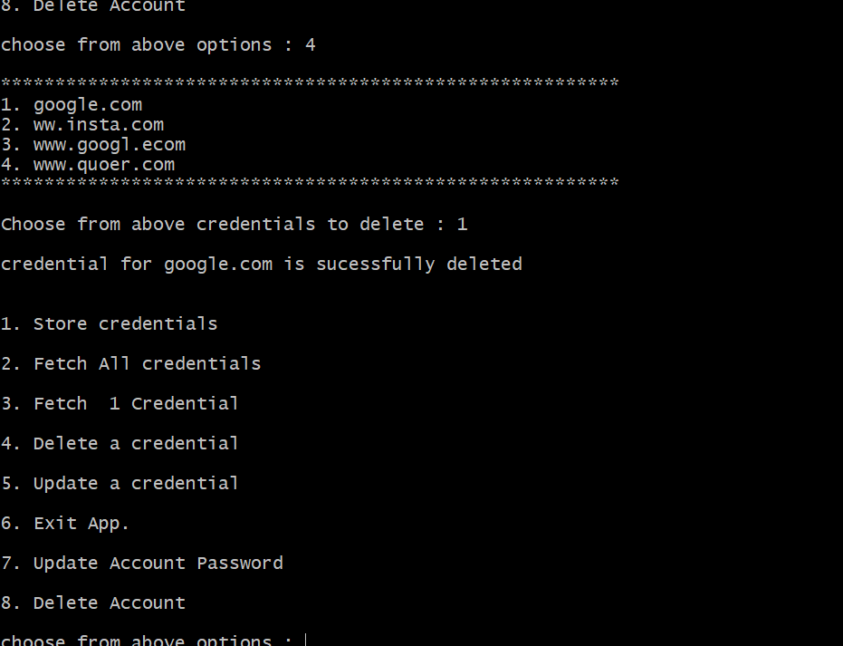

**Delete Credential Page**

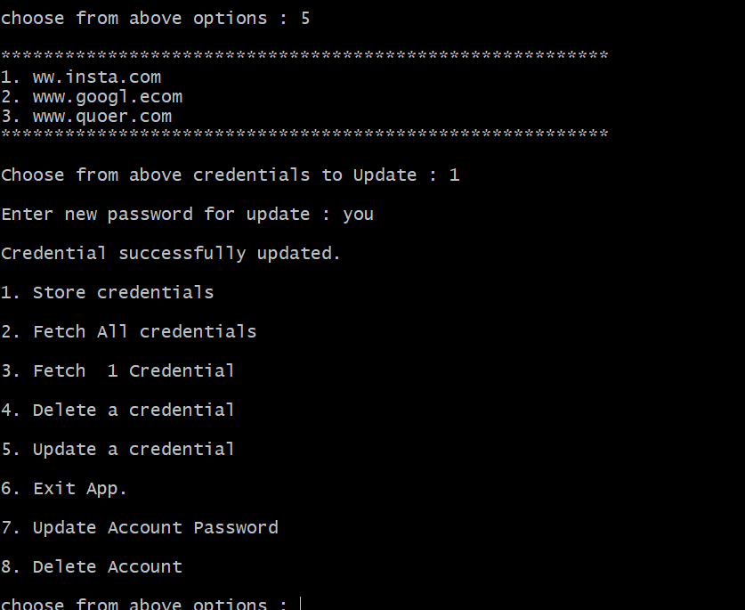

**Update new credential page**

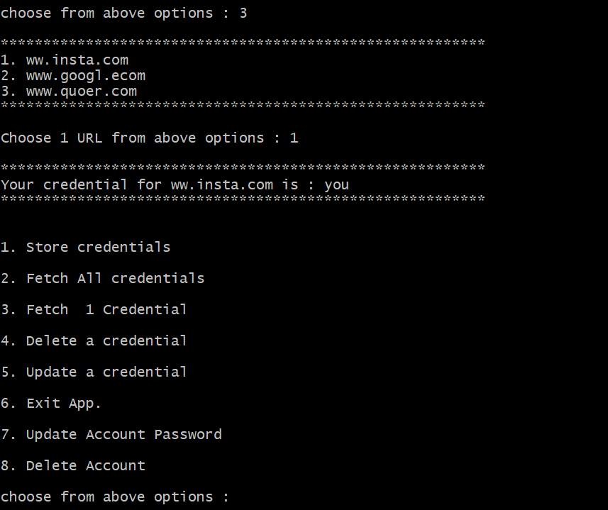

**Fetch single credential page**

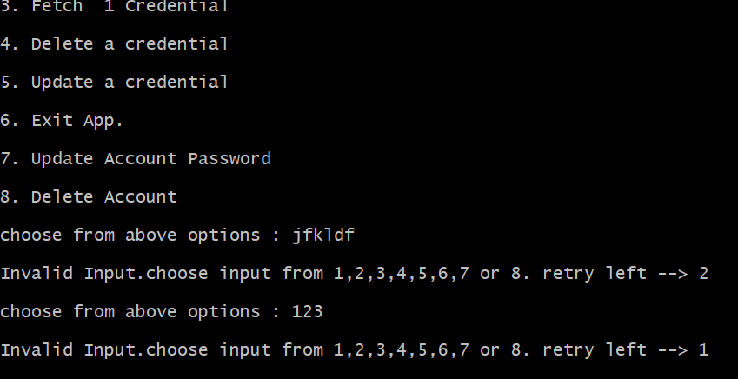

**Invalid input handled screenshot**

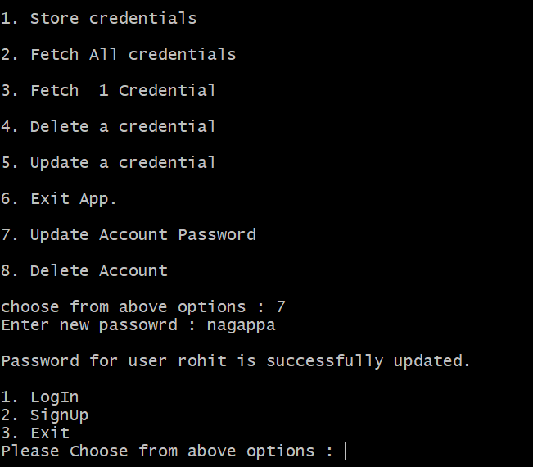

**Update account password page**

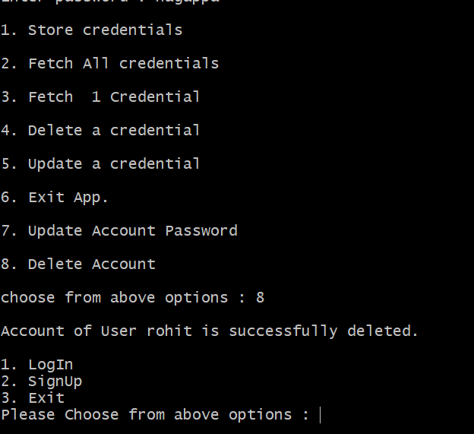

**Delete user account page**