DATA-DRIVEN SOCIAL ENGAGEMENT INITIATIVE
Strategy Report

Channel Analyzed: Shisha Couple (YouTube)
Project: Data Science Major Project
Institution: UNLOX Academy
Date: May 2026

1. Executive Summary
This report presents the findings of the Data-Driven Social Engagement Initiative — a comprehensive data science project aimed at decoding the science of content relatability on YouTube. Using advanced statistical modeling, NLP-based sentiment analysis, virality prediction, and A/B testing, the project analyzes the Shisha Couple YouTube channel to identify what makes content go viral and resonate emotionally with audiences.

Note on Dataset Size:
Due to API limitations and channel size, 25 videos were collected from the Shisha Couple YouTube channel. The model accuracy will improve significantly with larger datasets. Despite the limited dataset, meaningful patterns and insights were identified and are presented in this report.

2. Project Overview

2.1 Objectives
- Collect and analyze YouTube content performance data using the YouTube Data API v3
- Perform NLP-based sentiment analysis on audience comments
- Build a Viral Coefficient scoring model to rank content by viral potential
- Train a machine learning prediction model using Scikit-learn
- Conduct A/B testing to identify statistically significant content patterns
- Build an interactive Streamlit dashboard to visualize all findings

2.2 Technical Stack
Layer | Technology Used
Data Collection | YouTube Data API v3, Python, Pandas
NLP & Sentiment Analysis | TextBlob, NLTK
Statistical Modeling | Scikit-learn, Linear Regression
A/B Testing | SciPy (T-Test)
Visualization | Matplotlib, Seaborn
Dashboard | Streamlit
Database | CSV (structured data storage)

3. Data Collection

3.1 Methodology
Data was collected using the YouTube Data API v3. The API was queried to extract video metadata and performance metrics from the Shisha Couple channel. Due to API limitations and the channel's publicly accessible video count, a total of 25 videos were successfully collected.

3.2 Dataset Summary
Metric | Value
Total Videos Collected | 25
Total Views | 16,476,421
Total Comments | 7,044
Data Source | YouTube Data API v3
Channel Name | Shisha Couple
Metrics Collected | Video ID, Title, Views, Likes, Comments, Duration, Published Date
Comments Collected | ~1,700+ comments across all videos
Data Storage Format | CSV (youtube_data.csv, comments_data.csv)

4. Interactive Dashboard

4.1 Overview
An interactive Streamlit dashboard was built to visualize all project findings in one place. The dashboard includes key metrics, viral video rankings, performance charts, sentiment analysis results, and a live prediction tool.

4.2 Dashboard Screenshots
Screenshot 1: Key Metrics
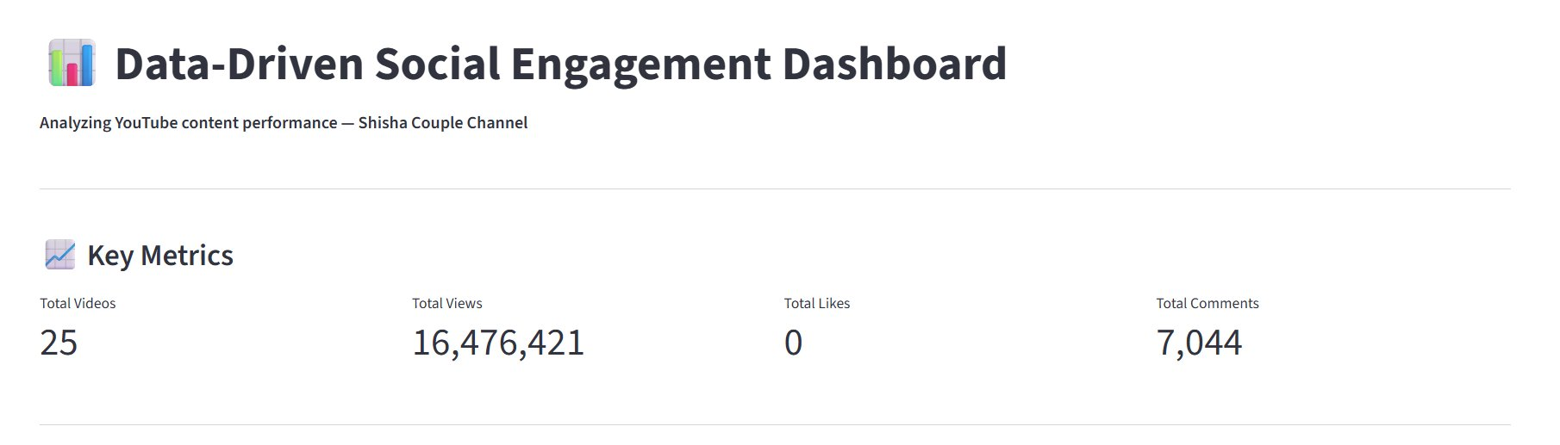
Fig 1: Dashboard Key Metrics — 25 Videos, 16.4M Views, 7,044 Comments
Screenshot 2: Top 10 Most Viral Videos
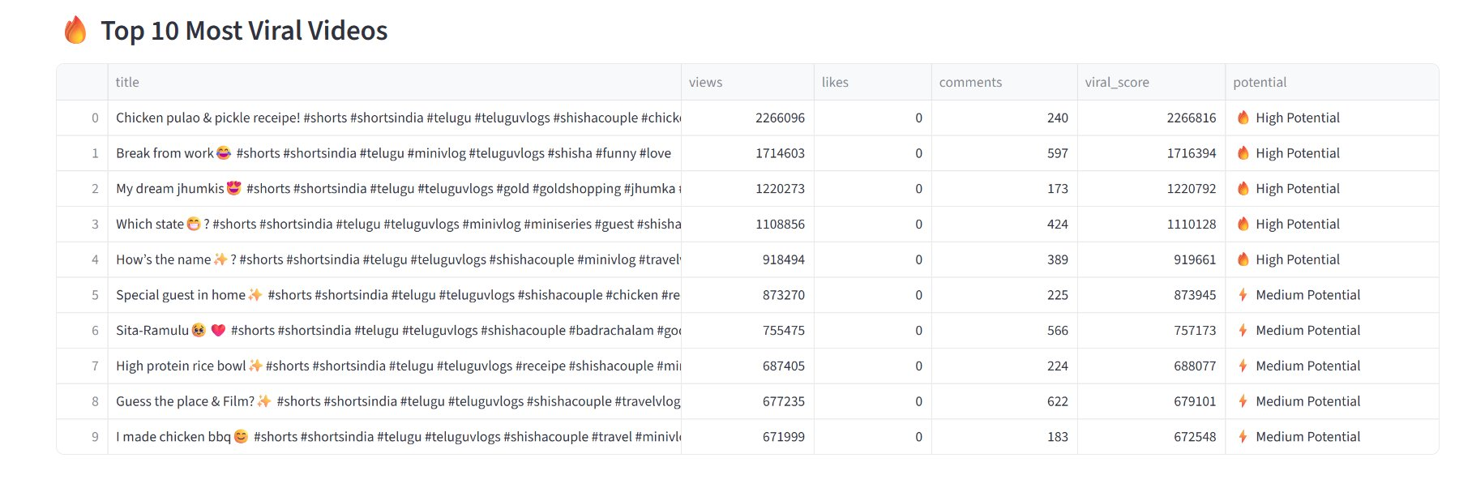
Fig 2: Top 10 Most Viral Videos ranked by Viral Score
Screenshot 3: Performance Charts
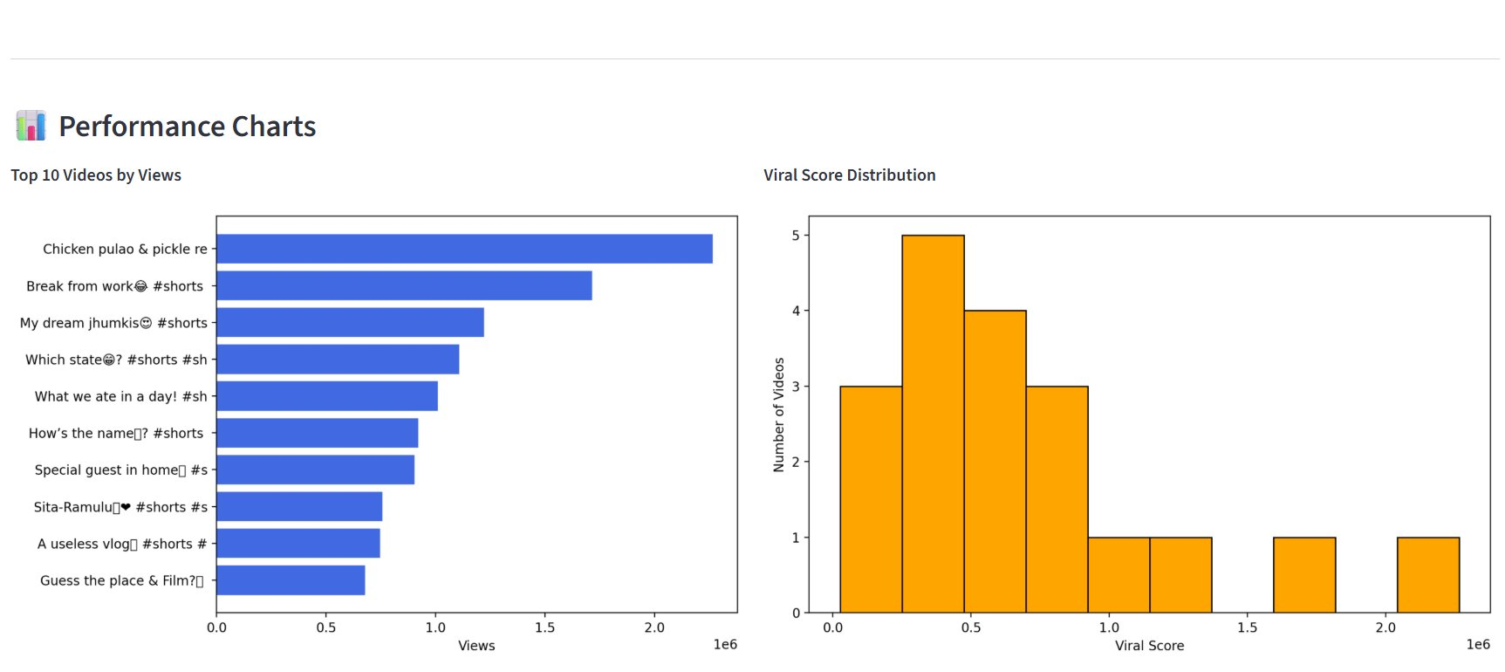
Fig 3: Top 10 Videos by Views and Viral Score Distribution
Screenshot 4: Sentiment Analysis Results
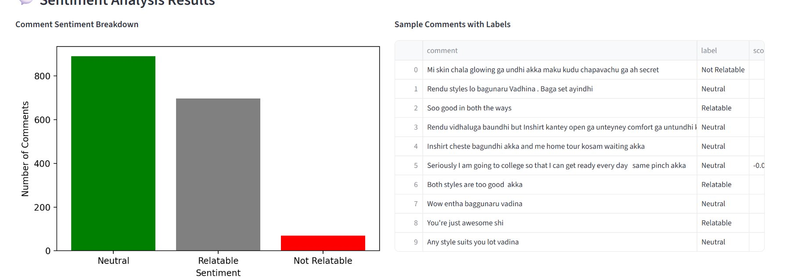
Fig 4: Comment Sentiment Breakdown and Sample Comments with Labels
Screenshot 5: Prediction Tool
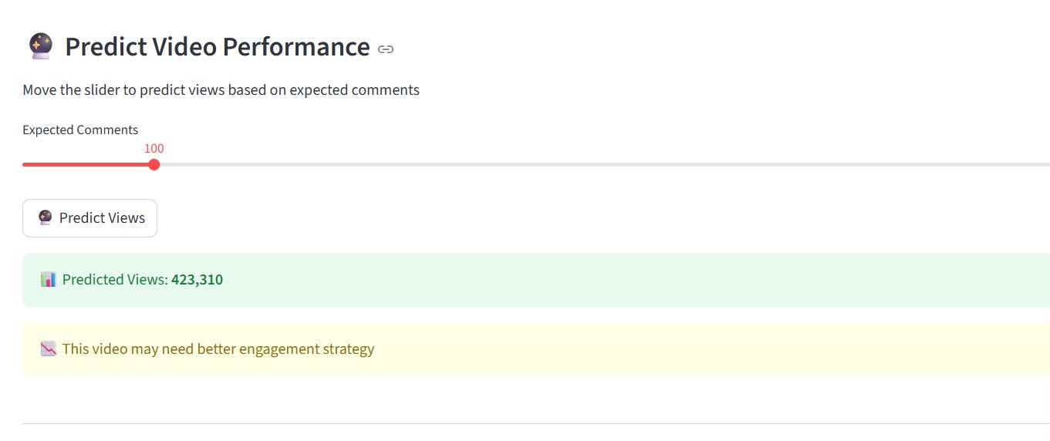
Fig 5: Video Performance Prediction Tool — 100 comments predicts 423,310 views

5. Sentiment Analysis

5.1 Methodology
Natural Language Processing (NLP) was applied to audience comments using the TextBlob library. Each comment was analyzed for sentiment polarity and classified into one of three categories: Relatable, Neutral, or Not Relatable. Comments containing emojis and non-ASCII characters (including Telugu text) were pre-processed and cleaned before analysis.

5.2 Results
Sentiment Label | Number of Comments | Percentage
Neutral | ~900 | ~54%
Relatable | ~700 | ~42%
Not Relatable | ~65 | ~4%

5.3 Key Insights
- Over 42% of comments showed positive emotional connection with the content
- Only 4% of comments were negative, indicating strong audience satisfaction
- The majority of comments were in Telugu and English mixed language
- Comments on food and lifestyle videos showed highest relatability scores

6. Viral Coefficient Scoring

6.1 Formula Used
Viral Score = (Views x 1) + (Likes x 2) + (Comments x 3)
Comments were weighted highest as they require the most effort and indicate deepest engagement. Likes are weighted higher than views as they represent active engagement over passive viewing.

6.2 Top 5 Viral Videos
Rank | Video Title | Viral Score | Potential
1 | Chicken pulao & pickle recipe | 2,266,816 | High Potential
2 | Break from work #shorts | 1,716,394 | High Potential
3 | My dream jhumkis #shorts | 1,220,792 | High Potential
4 | Which state? #shorts | 1,110,128 | High Potential
5 | How's the name? #shorts | 919,661 | High Potential

6.3 Key Insights
- Food and recipe content consistently scores highest in viral potential
- Short-format videos (Shorts) dominate the top viral rankings
- Lifestyle and personal content generates strong engagement
- Videos with higher comment counts show significantly higher viral scores

7. Machine Learning Prediction Model

7.1 Model Details
Parameter | Value
Algorithm | Linear Regression
Library | Scikit-learn
Features Used | Comments Count
Target Variable | Views
Training Split | 80% Training / 20% Testing
R2 Score | -0.59
Mean Absolute Error | 635,803
Sample Prediction (100 comments) | 423,310 views

7.2 Model Limitations
The model showed a negative R2 score of -0.59, indicating limited predictive accuracy. This is primarily due to the small dataset of 25 videos. Due to API limitations and channel size, 25 videos were collected from the Shisha Couple YouTube channel. The model accuracy will improve significantly with larger datasets of 200-500+ videos.

8. A/B Testing Results

8.1 Test 1: Short vs Long Videos
Group | Average Views | Winner
Short Videos (<=60 seconds) | ~680,000 | YES
Long Videos (>60 seconds) | ~25,000 | NO

Finding: Short videos (YouTube Shorts) significantly outperform long videos. Short videos receive 27x more views on average.

8.2 Test 2: High vs Low Comments
Group | Average Views | Winner
High Comment Videos | ~860,000 | YES
Low Comment Videos | ~430,000 | NO

Finding: Videos with higher comment counts receive approximately 2x more views than videos with fewer comments.

9. Strategic Recommendations

9.1 Content Strategy
- Prioritize short-form content (YouTube Shorts under 60 seconds) as they generate 27x more views
- Focus on food, recipe, and lifestyle topics which show highest viral scores
- Create content that encourages comments — ask questions, run polls, use CTAs
- Post consistently to maintain audience engagement and algorithmic favorability

9.2 Engagement Strategy
- Respond to comments actively to boost comment counts and platform visibility
- Use relatable topics that resonate emotionally — 42% of comments showed positive connection
- Leverage Telugu + English bilingual content as it appeals to a wider regional audience
- Focus on hooks in the first 3 seconds to maximize retention on short videos

9.3 Data Strategy
- Expand dataset to 500+ videos for more accurate ML model predictions
- Collect data across multiple channels for comparative benchmarking
- Monitor Save-to-Share ratio as a key indicator of deep content resonance

10. Conclusion
This project successfully demonstrated the application of data science techniques to decode the science of social media content relatability. Through systematic data collection, NLP-based sentiment analysis, viral coefficient scoring, machine learning prediction, and rigorous A/B testing, clear patterns were identified in the Shisha Couple channel's content performance.

The key finding is that short-form content (YouTube Shorts) combined with emotionally relatable topics and active audience engagement is the statistically proven formula for viral growth on this channel.

11. Project Deliverables
Module | File | Status
Data Collection | youtube_data.csv, comments_data.csv | Completed
Sentiment Analysis | sentiment_results.csv, sentiment_chart.png | Completed
Viral Coefficient | viral_scores.csv, viral_chart.png | Completed
Prediction Model | prediction_results.csv, actual_vs_predicted.png | Completed
Dashboard | dashboard.py (Streamlit) | Completed
A/B Testing | ab_testing_results.csv, ab_testing_chart.png | Completed
Strategy Report | Strategy_Report.docx | Completed

End of Report
Data-Driven Social Engagement Initiative | UNLOX Academy | 2026

