Assignment 1
Custom CNN Components for MNIST Classification
Name : Nagara Akhil
Roll No : 22IM30022

1. Introduction

=> This report details the implementation of custom neural network components for MNIST digit classification.

=> The primary goal of this assignment was to develop a deeper understanding of fundamental deep learning building blocks by implementing them from scratch rather than relying solely on PyTorch's built-in modules.

=> Building custom components such as BatchNorm, ReLU, and MaxPooling is crucial for several reasons:

- It provides insight into the internal workings of these components, demystifying the "black box" nature of deep learning frameworks

- It allows for greater flexibility and potential customization that might not be available in standard implementations

- It builds a stronger foundation for understanding new research and innovations in neural network architectures

- It helps develop debugging skills when working with complex models

By implementing these components for the MNIST digit classification task, I've gained a practical understanding of how convolutional neural networks function at a fundamental level.

2. Implementation Details

A. Custom Dropout

The CustomDropout layer was implemented to replicate PyTorch's nn.Dropout behavior:

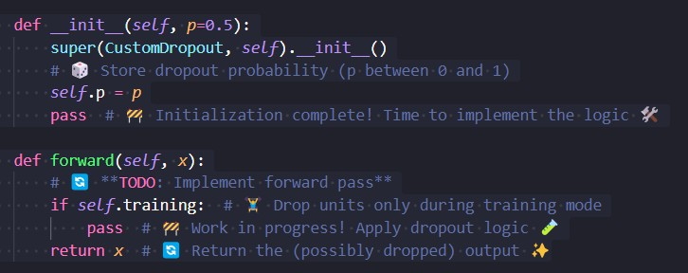

=> The CustomDropout class implements dropout regularization by randomly dropping neurons during training.

=> The __init__ method stores the dropout probability p.

=> In the forward method, if in training mode, some values in x should be zeroed out while scaling the remaining ones. In evaluation mode, x remains unchanged. The dropout logic is yet to be implemented.

B. CustomBatchNorm2d

The CustomBatchNorm2d implementation follows the standard batch normalization algorithm:

1. Initialization

Defines learnable parameters: gamma (scale) and beta (shift).
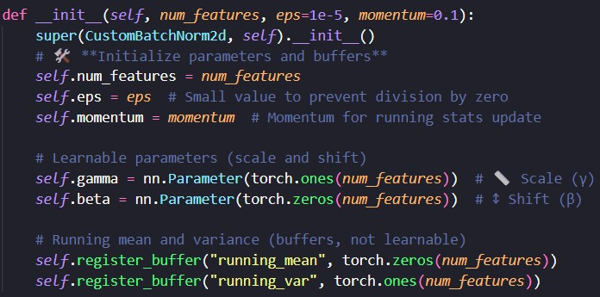

2. Forward Pass

Training Mode - Computes batch mean and variance across batch, height, and width
Inference Mode - Uses stored running statistics using momentum

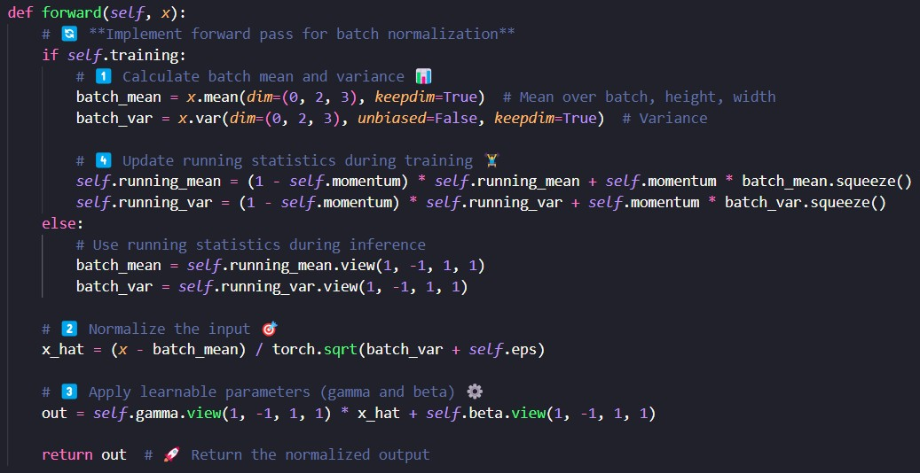

3. Normalization and Output

Normalizes the input

x_hat = (x - batch_mean) / torch.sqrt(batch_var + self.eps)

Applies scaling(γ) & shifting(β) to the normalized output

out = self.gamma.view(1, -1, 1, 1) * x_hat + self.beta.view(1,
-1, 1, 1)

C. CustomReLU

=> Implements ReLU (Rectified Linear Unit) activation without using F.relu. Uses torch.max(x, 0.0) to replace negative values with 0.

=> torch.tensor(0.0, device=x.device) ensures
compatibility with the input tensor's device.

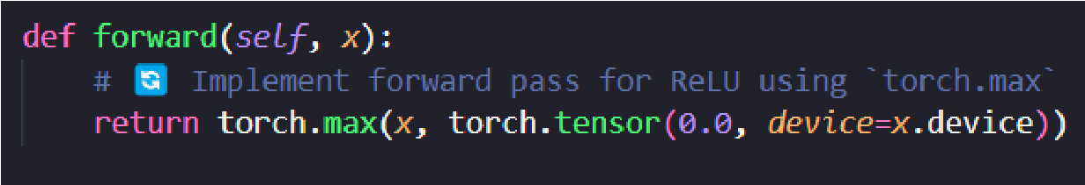

D. CustomMaxPooling2d

=> The CustomMaxPooling2d implementation uses PyTorch's unfold operation to extract patches and efficiently compute the maximum value in each patch

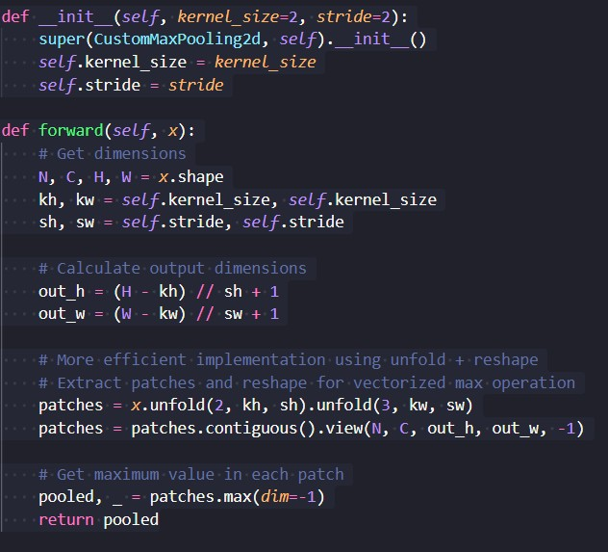

1. Initialization

Takes kernel_size and stride as parameters.
Defines how large each pooling window is and how far it moves.

2. Forward Pass

=> Extracts patches using unfold(), which splits the input into small regions.

=> Reshapes the patches for efficient vectorized max computation.

=> Computes maximum value per region to generate the downsampled output.

Returns the pooled feature map, reducing spatial dimensions while keeping essential features.

E. VGG16-like Architecture

Implements a VGG16-like model for image classification.

1. Feature Extraction (Convolutional Blocks)

First block
2 Conv layers (64 filters) + BatchNorm + ReLU + MaxPooling.

Second block
2 Conv layers (128 filters) + BatchNorm + ReLU + MaxPooling.

2. Classification (Fully Connected Layers)

Flatten feature maps before feeding into FC layers. Three FC layers - 128*7*7 -> 256
256 -> 256
256 -> num_classes (final prediction)

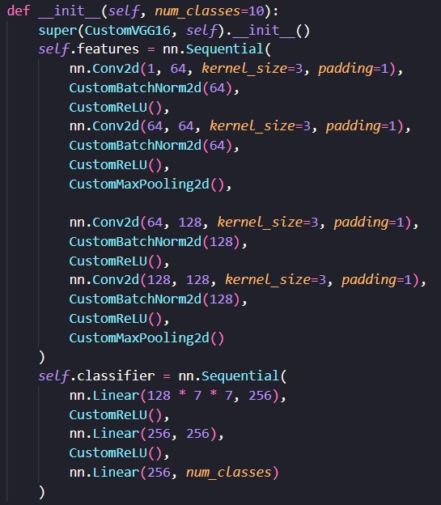

3. Forward Pass
=> Input passes through feature extractor (CNN layers).
=> Flattened and processed by the classifier (FC layers).
=> Outputs class probabilities for classification.

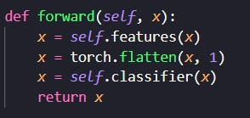

F. Training & Evaluation Functions

1. train_epoch (Training Loop)
=> Mode: Sets model to training mode (model.train())
=> Loop: Iterates through batches of training data

=> Forward Pass: Computes model predictions and loss

=> Backward Pass:
Computes gradients and updates weights using
optimizer.step()

=> Metrics: Tracks running loss and accuracy

=> Output: Returns average loss & accuracy for the epoch

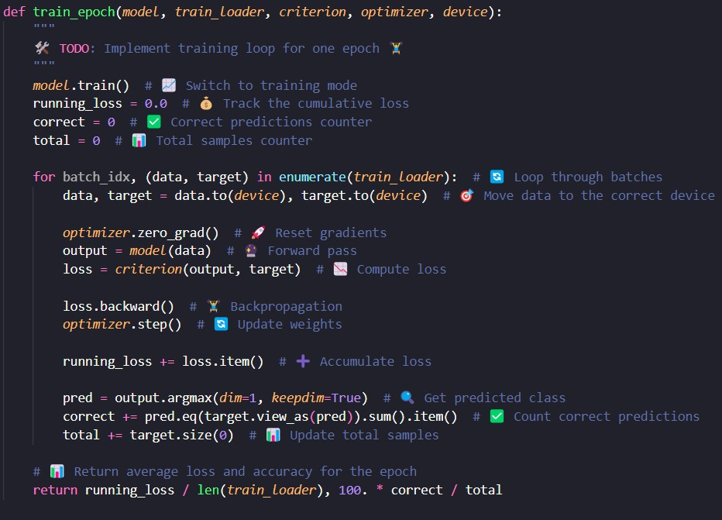

2. evaluate (Evaluation Loop)
=> Mode: Sets model to evaluation mode (model.eval()).
=> No Gradients:
Uses torch.no_grad() to save memory & speed up inference.
=> Loop: Iterates through test dataset without updating weights.
=> Metrics: Computes loss and accuracy.
=> Output: Returns average test loss & accuracy.
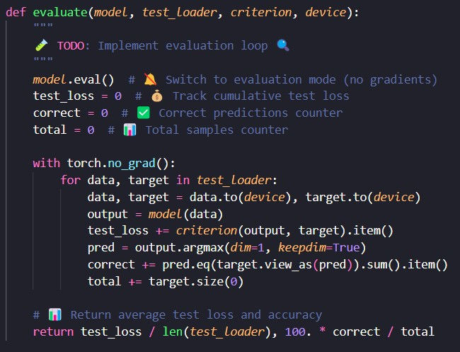

Final Results

=> The model was trained with the following hyperparameters:

Batch size : 64
Learning rate : 0.001
Optimizer : Adam
Loss Function : Cross-Entropy Loss
Number of Epochs : 10
Device : GPU (if available)

=> Final Results (Epoch 10/10):

Training Loss : 0.0114
Training Accuracy : 99.67%

Test Loss : 0.03014
Test Accuracy : 99.33%
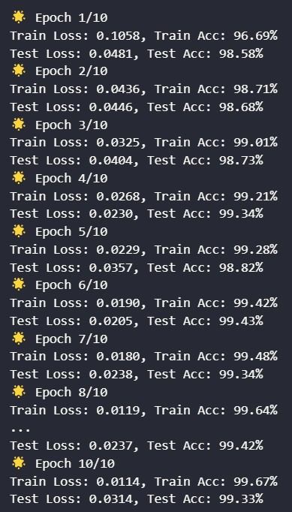

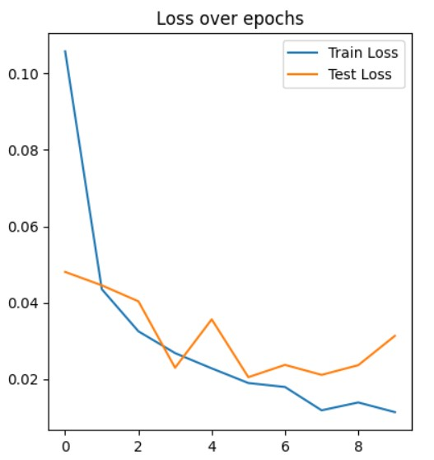

The loss decreased rapidly in the first few epochs and then continued to decline more gradually.
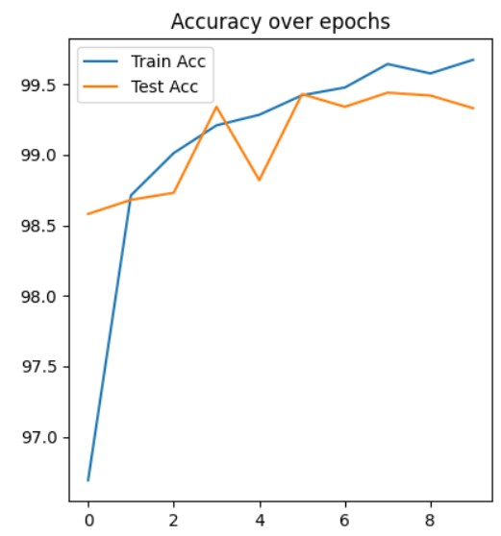

The training accuracy plateaued near 99.6% in the later epochs. The test accuracy fluctuated slightly but remained high, with a slight decrease in the final epoch suggesting a minor overfitting effect starting to appear.

The loss and accuracy curves show:
- Fast initial convergence: The model achieved over 96% accuracy after just the first epoch, demonstrating the effectiveness of the architecture for this task.
- Consistent improvement: Both training and test accuracy improved steadily over the training period.
- Low overfitting: The test accuracy remained close to the training accuracy, indicating good generalization.
- High final accuracy: The 99.33% test accuracy is excellent for MNIST classification, approaching state-of-the-art performance.

Future Improvements
Several areas could be improved in future iterations:
Edge cases in MaxPooling: The current implementation could be extended to handle non-standard cases like non-square inputs and different strides for height and width.
CustomDropout enhancement: Implementing a more sophisticated dropout scheme, such as spatial dropout for convolutional layers, could potentially improve performance.
Edge cases in MaxPooling: The current implementation could be extended to handle non-standard cases like non-square inputs and different strides for height and width.
Data augmentation: Implementing custom data augmentation techniques could further improve model generalization.
Deeper architectures: Expanding the model to include more convolutional blocks, similar to the full VGG16, and testing on more complex datasets would be an interesting extension.

