[Gopal Nagarajan]
[B00675008]
APEX PIPELINE SIMULATION
Design Document

APEX pipeline stages:

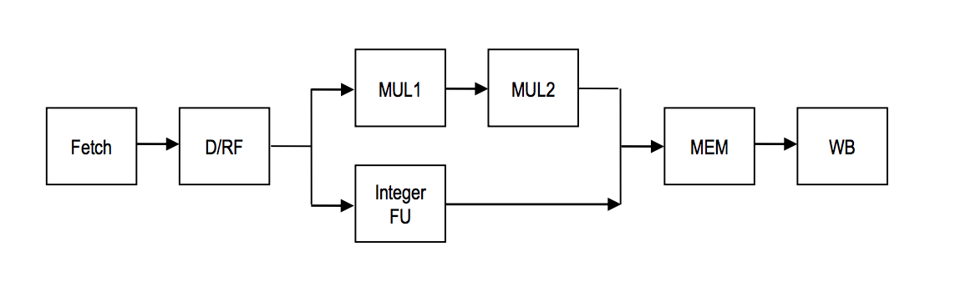
Implementation details:

Java Programming language is used to develop the simulator.
16 Registers are used- R0 to R15. ArrayList data structure used to implement register logic.
one additional PSW register to maintain the zero-flag status.
ArrayList data structure is used as a memory component. It ranges from 0 to 3999.
HashMap is used to maintain pipeline stages.
And the instructions available in the input file read line by line and store it in a List as an instruction set. Every index of this list is considered as four bytes instruction.
The Program counter value is initialized with 4000. Each instruction is accessed by increasing the program counter by 4bytes.
On looking in to each instruction, it’s going to be segregated with opcode (to represent what kind of operation) and operands. Operands number can vary depends on the opcode. So, based on the opcode split the number of the operands including register, literal.

Code level explanation:
A RegisterHandler POJO is used to manage the 16 Register values and the operations like setting up the value, retrieving the value.
An apex-simulator-helper used to initialize values to register, memory, print results of every clock cycle along with stages, registers and memory level.
A hashmap is used to hold the status of every stage details. This one helps in manage available dependencies.

Approach:
For a single clock cycle the instructions available in every stage should be processed. I am calling the executing methods in the order like writeback, memory, MUL2, MUL1, Integer FU, Decode, Fetch stages. It is the reverse order to original pipeline stage wise execution. This is very handy in detect the dependency and stalling the registers.

My approach is like starting from last stage writeback to check any unexecuted instructions available. Suppose if it’s available it should be executed in a clock cycle. Once there are no instructions available in the writeback stage it check the memory stage for any pending instructions and moved to writeback. Then it goes to MUL1, MUL2, Integer FU, decode, fetch. At every stage pipeline status, corresponding stage is set up with the instructions and the previous stage is setup with null to represent the instructions available in previous stage moved to next stage and it currently free to hold next instructions.
For Example:
In Decode stage, the instructions from fetch stage is moved to decode and set fetch as null. This will help to set up new instructions in fetch stage in the next clock cycle.

This will happen in every stage like moving the output of one stage to the input of next stage for further processing.

In the case of multiply operation, the execution stage is of two cycles MUL1 and MUL2 as per design diagram. Once MUL opcode is figured it moved to MUL1 stage from decode and doing no operation. It is like a hold back stage for a cycle. And in the next cycle instruction moved to MUL2 where the actual computation happens. Then moved to Memory stage.

Interlocking logic:

The dependencies can be identified in the decode stage. Each register is having status flag and this will set true once the instructions loaded in decode stage. This status remains true until the writeback stage write the result to the corresponding register. So, whenever a new instruction arrives to decode stage it check for the source register status is whether it is occupied by any other ongoing computation. Suppose if it is then stalled the current instructions in decode stage and wait for all their source register operation get completed in writeback stage. The fetch instruction is also stopped because of this stalling.

Apart from Multiply instructions all other instructions pass through the Integer FU stage as Execution stage in one clock cycle. Then move to memory and so on.

Whenever some instructions like add or sub followed by MUL operation should be moved to the Memory stage after that mul operation. Because MUL needs two clock cycles from decode to memory. At the same time the other operation available in fetch stage need two clock cycle to reach memory stage via Integer FU. Since the both operations trying to hold the memory at the same clock cycle and MUL operation gets the memory stage because of inorder execution. And the other operation holds in the Integer FU stage for one more cycle and took the memory stage in the next cycle.

In writeback stage the PSW zero-flag register value set to 1 if its arithmetic operation. Otherwise set zero in PSW zero-flag.
BNZ and BZ depends on the PSW zero-flag value.
Once BNZ or BZ instruction encountered in instruction parsing phase it check for any previous instruction in execution. If it is the case then set those instructions register set as one of the source for this branch instruction. This will help to be in stall state at decode stage when there are any ongoing arithmetic operation takes place.

Jump instructions adds the register value and literal value resulted in address of the next instructions to be executed. This takes place by resetting the PC value. And flush the current fetch and decode stages.

Once Halt instruction is encountered fetch and decode stages are stopped and cleared. No more instructions are going to execute after this.

Instruction Set:
- Register-to-register instructions: ADD, SUB, MOVC, MUL, AND, OR, EX-OR
ADD → ADD <dest> <src1> <src2>
SUB → SUB <dest> <src1> <src2>
MUL → MUL <dest> <src1> <src2>
AND → AND <dest> <src1> <src2>
MOVC → MOVC <dest> <literal>
OR → OR <dest> <src1> <src2>
EXOR → EXOR <dest> <src1> <src2>

- LOAD, STORE
LOAD → LOAD <dest> <src1> <literal>
STORE → STORE <src1> <src2> <literal>

- BZ, BNZ, JUMP, HALT
BZ → BZ #literal
BNZ → BNZ #literal
JUMP → JUMP <src> #literal
HALT → Stops execution

