TASK 2:
Enrolling the Finger Print:
The files EnrollClient and FingerprintUtils helps android enrol the given fingerprint for the user. On successful enrolling, it would send a vibration pattern for 30 milliseconds without any delay, if it's a failure, the device vibrates for 30 milliseconds with 100 milliseconds pause and again vibrates for 30 milliseconds.
Authenticating User Fingerprints:
The Authentication Client file authenticates the user using the finger Id provided. Here it maintains three state based on number of times the authentication failed. If failed more than 5 times it times out the process up to 300000ms and failed more than 20 times enter the permanent lock state. Suppose If it’s successful on 2nd or 3rd time it resets the state to zero attempts.
Removing Fingerprints:
Fingerprints User State file is used to store the finger print details such as fingerprint id, user id etc, in an XML file. This file is used to check if a finger print is present and also has functions to read and write the XML file. The device verifies if the user is authorized to remove the fingerprint and checks for the fingerprint based on the fingerId and removes it.

Task 3:

UML Class diagram describing Superclass along with Inheritance and interface implemented in our chosen set of files for code review

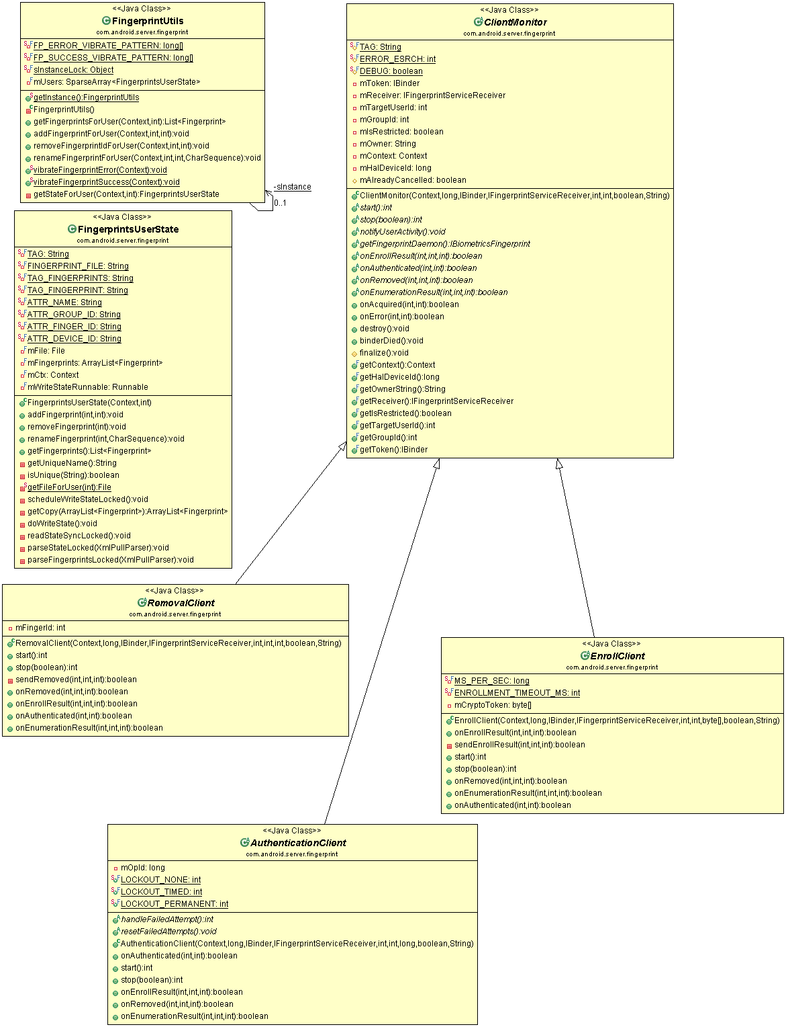

Task 4:
UML class diagram describe all non-inheritance associations existing between different classes are shown along with actual inheritance and interface implementation. The diagram provided below.

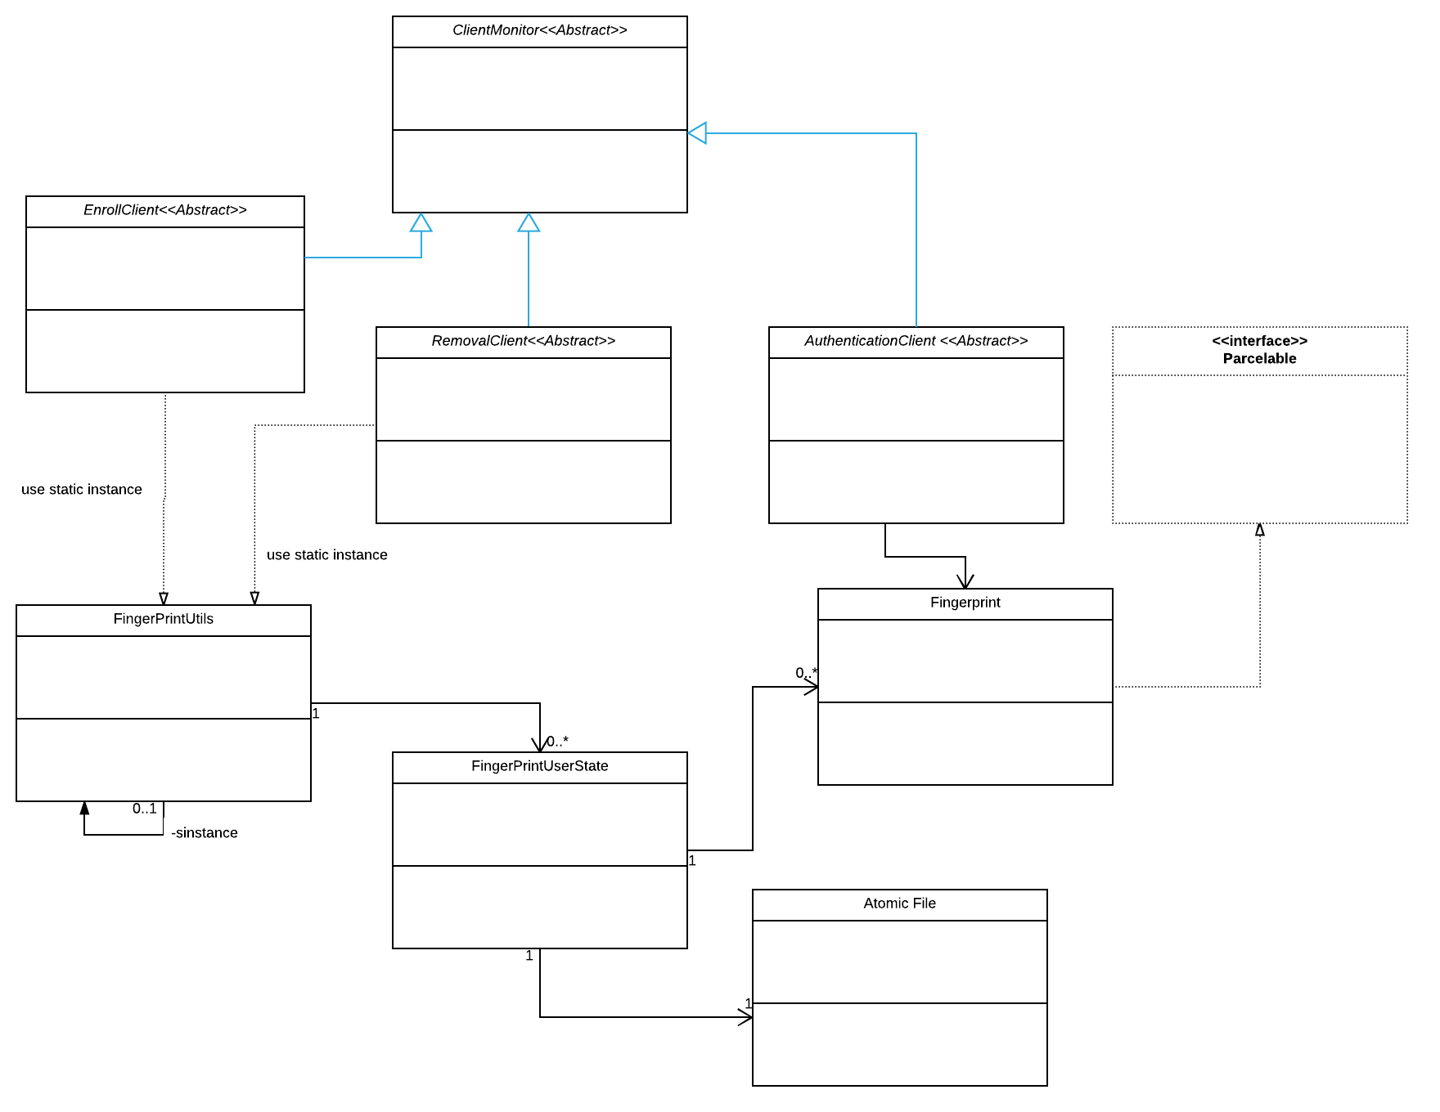

Task 5:

The one thing we learned to review the code is how multi-threading is done and is simple in Java. By extending the Runnable Interface and overriding the run method. Then by using the start() we start the thread. We also learnt how to synchronously access the list (fingerprint list) by using locks on the (this) object.

