**COVID -19 ANALAYSIS**

**DEVELOPMENT PART II**

|  |  |
| --- | --- |
| **Date** | **31-10-2023** |
| **Team ID** | **720** |
| **Project Name** | **Covid-19 Cases Analysis** |

**Table of Contents**

|  |  |
| --- | --- |
| 1 | Introduction |
| 2 | Problem Statement |
| 3 | Visualisation using IBM Cognos and insights. |
| 3.1 | Home |
| 3.2 | Descriptive statistical analysis |
| 3.3 | Cases Analysis -1 |
| 3.4 | Cases analysis - 2 |
| 3.5 | Death Analysis - 1 |
| 3.6 | Death Analysis - 2 |
| 5 | Conclusion |

**1. Introduction**

COVID-19, also known as Coronavirus Disease 2019, is a highly contagious respiratory illness caused by the novel coronavirus SARS-CoV-2. It emerged in late 2019 in Wuhan, China, and swiftly evolved into a global pandemic. The virus spreads primarily through respiratory droplets, leading to a wide range of symptoms, from mild respiratory issues to severe pneumonia and, in some cases, fatalities. The pandemic has had a profound impact on public health, economies, and daily life worldwide, prompting governments and healthcare systems to implement extensive measures such as lockdowns, mask mandates, and vaccination campaigns to control its spread. The ongoing battle against COVID-19 has underscored the importance of scientific research, international cooperation, and public health measures to combat emerging infectious diseases.

**2. Problem Statement**

The project involves analysing COVID-19 cases and deaths data using IBM Cognos. The objective is to compare and contrast the mean values and standard deviations of cases and associated deaths per day and by country in the EU/EEA. This project encompasses defining analysis objectives, collecting COVID-19 data, designing relevant visualizations in IBM Cognos, and deriving insights from the data.

**3. Visualisation using IBM Cognos and insights**.

**3.1. Home**



**3.2. Statistical Analysis**

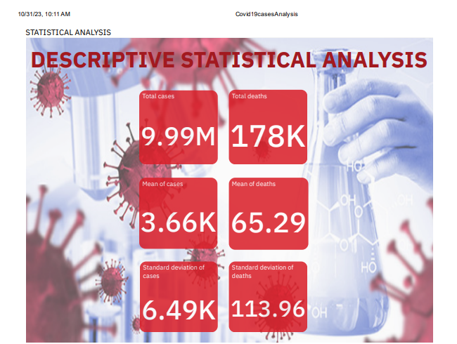

The analysis of COVID-19 cases and deaths data using IBM Cognos for the months of March, April, and May in the year 2021, within the EU/EEA, reveals several key insights:

* **Total Cases and Deaths**: During this three-month period, the total number of COVID-19 cases in the EU/EEA was approximately 9.99 million, with a total of 178,000 associated deaths.
* **Daily Averages:** The mean or average number of daily cases was approximately 3.66 thousand, while the mean number of daily deaths was around 65.29.
* **Variability:** The data shows that there was significant variation in daily case numbers, with a standard deviation of 6.49 thousand. Similarly, the standard deviation for daily deaths was 113.96, indicating a substantial variation in the number of deaths reported each day.

**3.3. Cases Analysis -1**

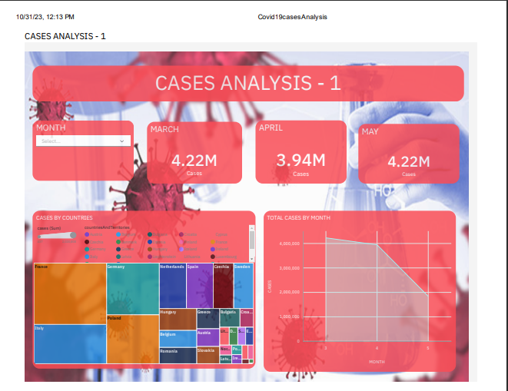

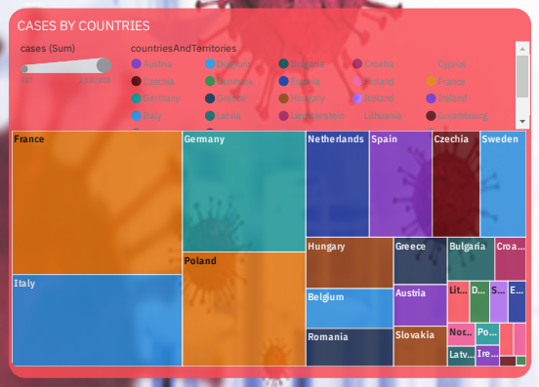

The chart reveals significant variations in COVID-19 cases among EU/EEA countries over three months.

* France recorded the highest case count, totalled 2,020,808 in March, April, and May.
* In contrast, Malta reported the lowest cases, with only 7,586 cases during the same period, highlighting marked differences in pandemic impact.

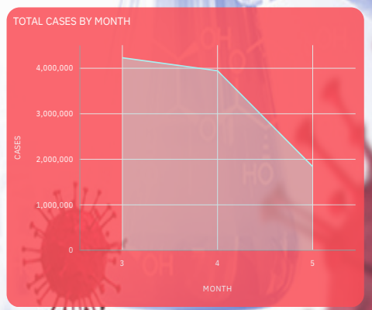

During March, April, and May, there was a decreasing trend in the number of COVID-19 cases.

**3.3. Cases Analysis – 2**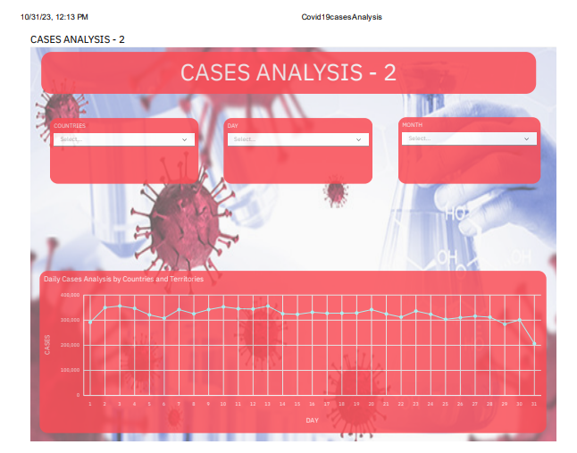

By specifying the month, year, and day, we can conduct a tailored analysis of the cases, allowing us to delve into the data with precision.

**3.4 Death analysis – 1**

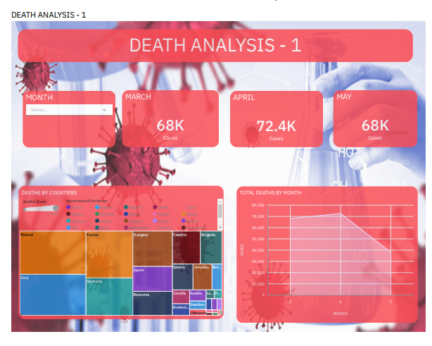

The chart illustrates notable disparities in COVID-19 deaths among EU/EEA countries over the three-month period.

* Poland recorded the highest number of deaths, totaling 29,989 in March, April, and May, signifying a substantial total during that timeframe.
* Conversely, Malta reported the lowest number of deaths, with just 106 cases during the same period.

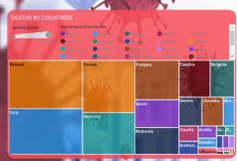

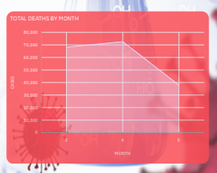

The death has slightly increased in the month of April and totally decreased in the month of may.

**4. Conclusion**

In conclusion, the data presented in the chart highlights the stark contrasts in COVID-19 mortality rates among EU/EEA countries, with Poland bearing a heavy burden of 29,989 deaths and Malta experiencing remarkably low mortality with just 106 deaths during the three-month period of March, April, and May. These disparities underscore the complex interplay of factors, including healthcare infrastructure, public health measures, and population demographics, in shaping the pandemic's impact.

Moreover, the capacity for detailed analysis by specific dates, with provided month, year, and day, offers a valuable tool to unearth nuances in the pandemic's trajectory. This precision allows for a deeper understanding of localized trends, facilitating more targeted responses and decision-making.

The significance of these findings extends beyond mere statistics, emphasizing the need for international cooperation and shared insights to better combat the challenges posed by the pandemic. By learning from the experiences of diverse nations, we can adapt strategies, allocate resources, and improve preparedness to mitigate the effects of future health crises and safeguard global well-being.

**3.5. Death Analysis - 2**

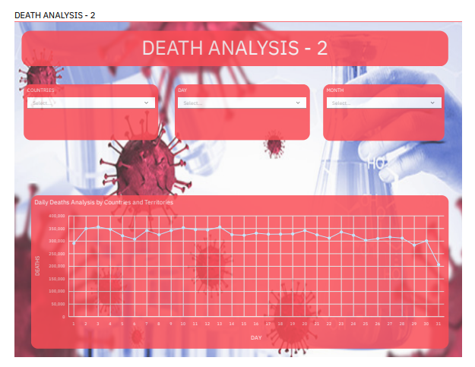

By specifying the month, year, and day, we can conduct a tailored analysis of the deaths, allowing us to delve into the data with precision.

**4. Conclusion**

In conclusion, the analysis reveals a clear trend in the progression of COVID-19 cases. By closely monitoring daily variations, it becomes evident whether cases are on the rise or decline. These insights can be instrumental in making informed decisions and implementing appropriate measures to manage the pandemic effectively. The combination of preprocessing techniques and data visualization through Cognos contributes to a more comprehensive understanding of the COVID-19 situation, aiding in the development of strategies to combat the virus.