**MACY’s Use Cases**

**Prepared by**

***Anand Kulkarni***

[***anand.kulkarni1@zensar.com***](mailto:anand.kulkarni1@zensar.com)

**Introduction:**

We are developing an Order application where orders are produced & consumed through asynchronous communication.

**Architecture:**

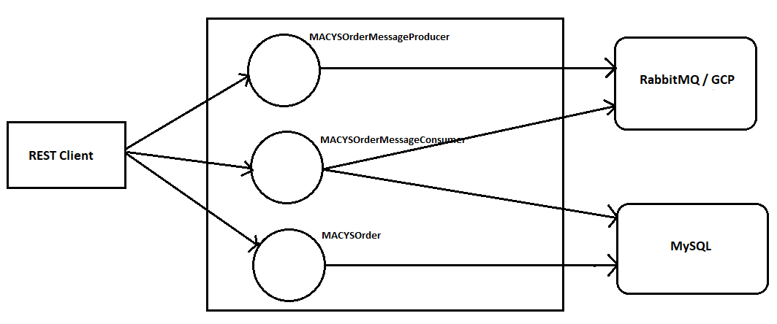

**Technology Stack:**

SpringBoot, Microservices, MySQL, RabbitMQ, Jenkins, Google Cloud Platform (GCP)

**Tasks:**

1. Create 3 Microservices MACYSOrderMessageProducer, MACYSOrderMessageConsumer & MACYSOrder using SpringBoot.
2. Design 2 REST endpoints in MACYSOrderMessageProducer, one that pumps XML message & another that pumps JSON message into a separate RabbitMQ Queues.
3. Design 2 REST endpoints in MACYSOrderMessageConsumer, one that retrieves XML messages from a queue, parses it using XML parser & persists them into MySQL database. Another REST endpoint should retrieve JSON messages from a queue, parses it using JSON parser & persists them into MySQL database.
4. Design a REST endpoint in MACYSOrder that updates the order status.
5. Design an actuator in MACYOrder that gives statistics of how many XML orders & JSON orders consumed into database.
6. Write Junit test cases for testing all REST endpoints using Mockito.
7. Design 3 Jenkins pipelines that pulls respective Microservice from GITHUB, builds & runs all Junit test cases.
8. Finally try giving additional facility of communicating with Google Cloud Platform(GCP) queue service instead of RabbitMQ. For this, you need to open free account in GCP & configure queues.

**Note:**

1. Every order has 3 possible status Created(Initial state) , Confirmed & Shipped.
2. Use SpringBoot with AMQP for RabbitMQ communication.
3. Use Spring Data Repository API for database communication. You can decide tables names & their columns. Tables for JSON & XML messages should be different.
4. Add swagger API documentation support for all REST endpoints & make sure you use swagger UI instead of Postman.
5. The JSON order message has following structure:

*{*

*"messageName": "ITEMMASTER",*

*"command": "ADD",*

*"itemName": "WALLET",*

*"itemDescription": "FLAT WALLET",*

*"itemLength": 2.3,*

*"itemWidth": 0.5,*

*"itemHeight": 1.3,*

*"itemWeight": 1.5,*

*"imagePathname": null,*

*"rfidTagged": "Y",*

*"storageAttribute": 1,*

*"pickType": "E",*

*"upcList": null*

*}*

1. The XML order message has following structure:

*<?xml version="1.0" encoding="UTF-8"?>  
<ns0:fulfillmentOrder xmlns:ns0="*[*http://www.mst.macys.com/main/eos/fulfillmentOrder/orderDetails.v1.1">*](http://www.mst.macys.com/main/eos/fulfillmentOrder/orderDetails.v1.1%22%3E) *<ns0:orderHeader>  
<ns0:orderID>490048499</ns0:orderID>  
<ns0:orderTypeCode>Digital</ns0:orderTypeCode>  
<ns0:partnerOrderID>SAN10000137</ns0:partnerOrderID>  
<ns0:orderStatus>Created</ns0:orderStatus>  
<ns0:messageCreateTimeStamp>2017-08-16T15:20:29.657-04:00</ns0:messageCreateTimeStamp>  
<ns0:fulfillmentChannelCode>POOL</ns0:fulfillmentChannelCode>  
<ns0:orderStatusCode>110</ns0:orderStatusCode>  
<ns0:orderStatusDescription>IN_PROCESS</ns0:orderStatusDescription>  
<ns0:sellZLDivisionNbr>71</ns0:sellZLDivisionNbr>  
<ns0:sellZLLocationNbr>139</ns0:sellZLLocationNbr>  
<ns0:source>  
<ns0:clientID>MCOM</ns0:clientID>  
<ns0:subClientID>SITE</ns0:subClientID>  
<ns0:sellingChannelCode>MCOM</ns0:sellingChannelCode>  
<ns0:seperatorSource0>0</ns0:seperatorSource0>  
<ns0:separatorSource1>1</ns0:separatorSource1>  
</ns0:source>  
<ns0:orderTotals>  
<ns0:totalPurchaseAmount>41.95</ns0:totalPurchaseAmount>  
<ns0:seperatorOrderTotals0>0</ns0:seperatorOrderTotals0>  
</ns0:orderTotals>  
<ns0:billingAddress>  
<ns0:contact>  
<ns0:custID>51238851</ns0:custID>  
<ns0:name>  
<ns0:firstName>SUPRAJA</ns0:firstName>  
<ns0:lastName>CHIDURAL</ns0:lastName>  
<ns0:seperatorName0>0</ns0:seperatorName0>  
<ns0:seperatorName1>1</ns0:seperatorName1>  
</ns0:name>  
<ns0:address>  
<ns0:line1>2200 Galvin Dr</ns0:line1>  
<ns0:line2>2200 Galvin Dr</ns0:line2>  
<ns0:line3>2200 Galvin Dr</ns0:line3>  
<ns0:city>BUFORD</ns0:city>  
<ns0:state>GA</ns0:state>  
<ns0:zipCode>30087</ns0:zipCode>  
<ns0:countryCode>USA</ns0:countryCode>  
<ns0:seperatorAddress0>0</ns0:seperatorAddress0>  
</ns0:address>  
<ns0:daytimePhoneNbr>968-789-87642345</ns0:daytimePhoneNbr>  
<ns0:homePhoneNbr>968-789-8764</ns0:homePhoneNbr>  
<ns0:alternatePhoneNbr>741-119-3501</ns0:alternatePhoneNbr>  
<ns0:sendSMSMessage>false</ns0:sendSMSMessage>  
<ns0:emailAddress>SUPRAJA.CHIDURAL@MACYS.COM</ns0:emailAddress>  
<ns0:seperatorContact0>0</ns0:seperatorContact0>  
</ns0:contact>  
</ns0:billingAddress>  
</ns0:fulfillmentOrder>*