Expected output:

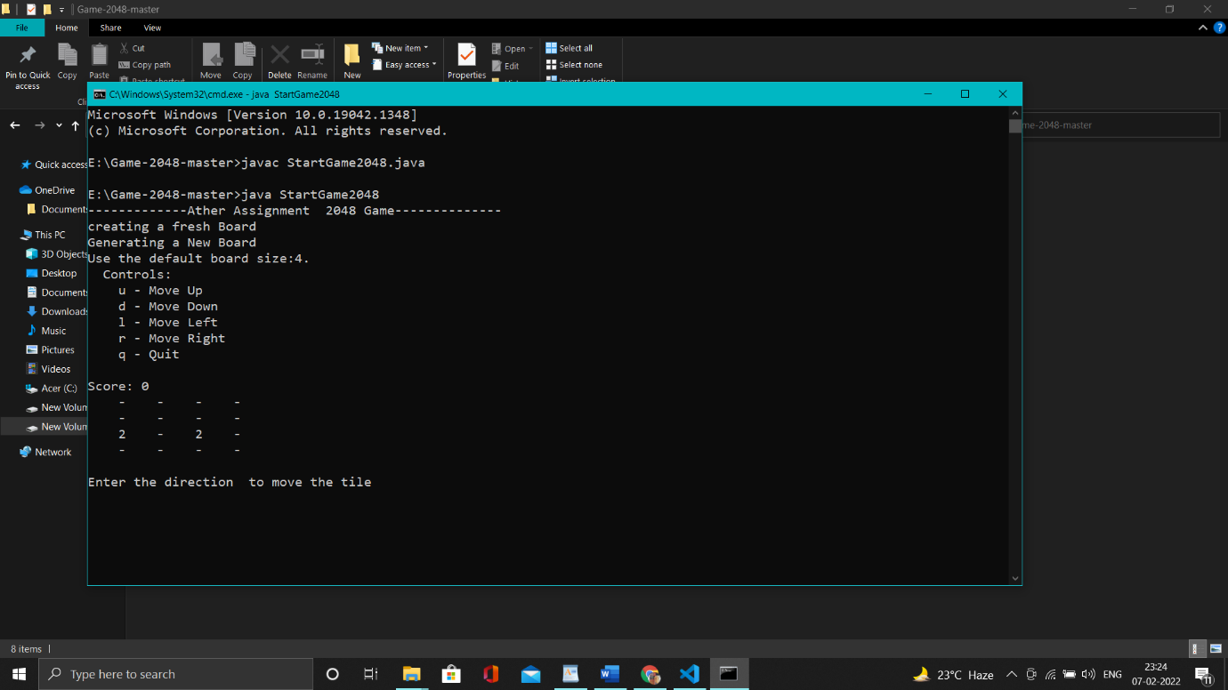

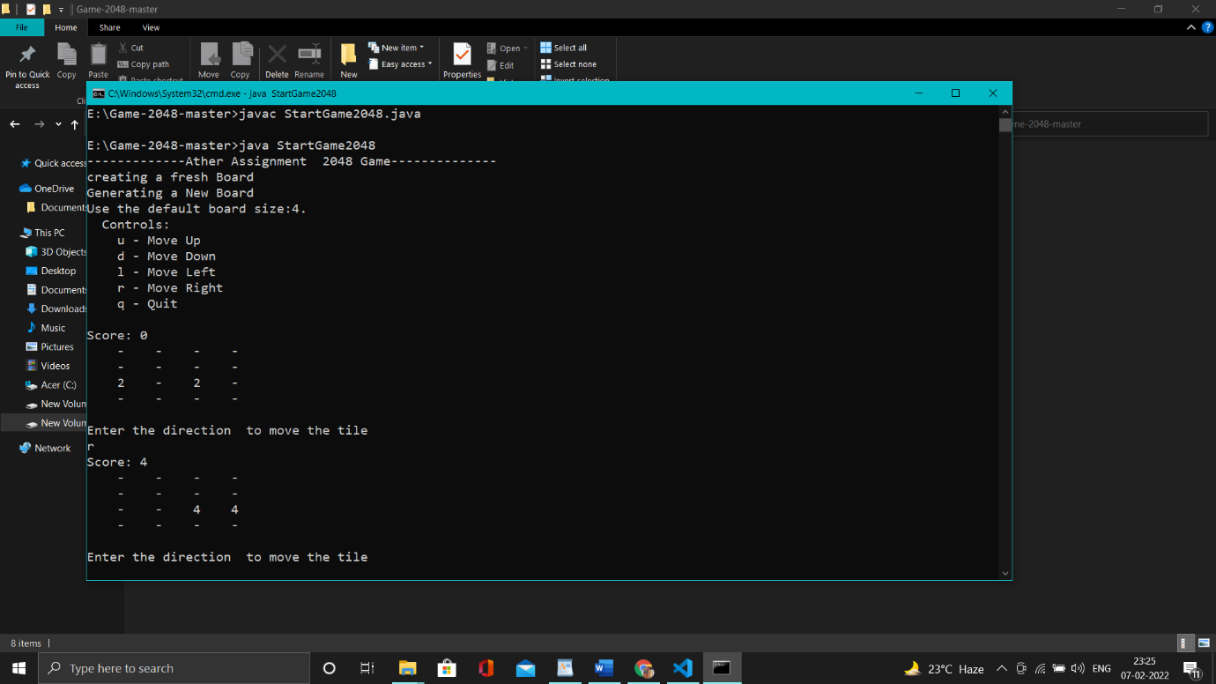

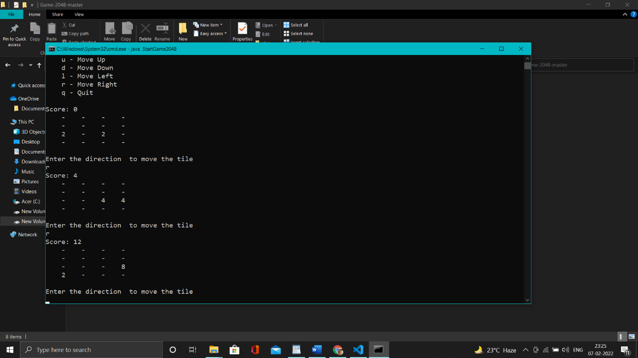

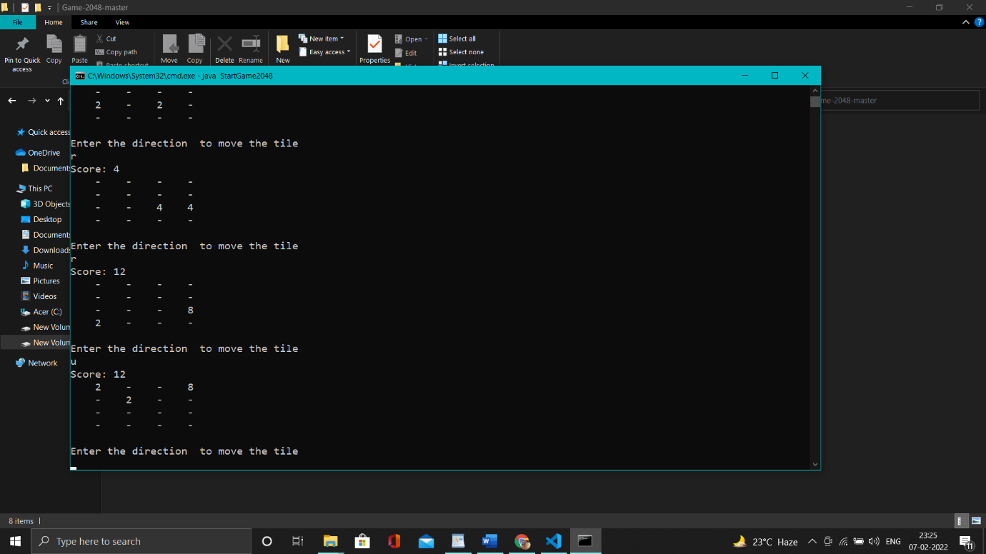

Implementation details:

* It will initially have 2 or 4
* User will input commands like left ,right ,down up.
* Next we merge the tales
* And repeat to have a 2048

Language used:

Used \*\*\*\*java\*\*\*\*

Discussion objectives:

🡪Used object oriented programming , java syntax to solve the problem.

--🡪 thought of using various graphics but messed up with various functions

-🡪 g0t infinite loops while providing the inputs.

🡪 while generating various unoccupied spaces 2 or 4 generation is difficult taken a lot of time

Walk through:

On walk through I faced many problem i.e getting errors and satisfying to the particular input ,I sorted It out easily.

Scope of making 8x8 from 4x4:

We can use same operations in 8x8 as in 4x4 there is a change in matrix and the win stage Is 4096