**Task-12 CODE**

**EVENT LISTENER FOR CREATING PAGE WORKFLOW STARTED**

**package com.adobe.aem.guides.demo.core.listeners;**

**import java.util.HashMap;**

**import java.util.Map;**

**import javax.jcr.Session;**

**import javax.jcr.observation.Event;**

**import javax.jcr.observation.EventIterator;**

**import javax.jcr.observation.EventListener;**

**import org.apache.sling.api.resource.LoginException;**

**import org.apache.sling.api.resource.Resource;**

**import org.apache.sling.api.resource.ResourceResolver;**

**import org.apache.sling.api.resource.ResourceResolverFactory;**

**import org.apache.sling.jcr.api.SlingRepository;**

**import org.osgi.service.component.annotations.Activate;**

**import org.osgi.service.component.annotations.Component;**

**import org.osgi.service.component.annotations.Deactivate;**

**import org.osgi.service.component.annotations.Reference;**

**import org.slf4j.Logger;**

**import org.slf4j.LoggerFactory;**

**import com.day.cq.workflow.WorkflowException;**

**import com.day.cq.workflow.WorkflowService;**

**import com.day.cq.workflow.WorkflowSession;**

**import com.day.cq.workflow.exec.WorkflowData;**

**import com.day.cq.workflow.model.WorkflowModel;**

**@Component(immediate = true)**

**public class PageTask implements EventListener {**

**private static final Logger log = LoggerFactory.getLogger(PageTask.class);**

**@Reference**

**private WorkflowService workflowService;**

**@Reference**

**private ResourceResolverFactory resolverFactory**

**@Reference**

**private SlingRepository repository;**

**private Session observationSession;**

**@Activate**

**protected void activate() {**

**try {**

**observationSession = repository.loginService("naga", null);**

**observationSession.getWorkspace().getObservationManager().addEventListener(**

**this,**

**Event.NODE_ADDED,**

**"/content", // or any specific path you want to observe**

**true,**

**null,**

**null,**

**false**

**);**

**log.info("PageCreationEventListener activated");**

**} catch (Exception e) {**

**log.error("Error activating PageCreationEventListener", e);**

**}**

**}**

**@Deactivate**

**protected void deactivate() {**

**if (observationSession != null) {**

**try {**

**observationSession.getWorkspace().getObservationManager().removeEventListener(this);**

**observationSession.logout();**

**} catch (Exception e) {**

**log.error("Error deactivating PageCreationEventListener", e);**

**}**

**}**

**}**

**@Override**

**public void onEvent(EventIterator events) {**

**while (events.hasNext()) {**

**Event event = events.nextEvent();**

**try {**

**String path = event.getPath();**

**handleResourceAddedEvent(path);**

**} catch (Exception e) {**

**log.error("Error handling event", e);**

**}**

**}**

**}**

**private void handleResourceAddedEvent(String path) {**

**ResourceResolver resourceResolver = null;**

**try {**

**Map<String, Object> param = new HashMap<>();**

**param.put(ResourceResolverFactory.SUBSERVICE, "naga");**

**resourceResolver = resolverFactory.getServiceResourceResolver(param);**

**Resource resource = resourceResolver.getResource(path);**

**if (resource != null && resource.isResourceType("cq:Page")) {**

**log.info("Page created at path: {}", path);**

**startWorkflow(path);**

**}**

**} catch (LoginException e) {**

**log.error("Error obtaining resource resolver", e);**

**} finally {**

**if (resourceResolver != null) {**

**resourceResolver.close();**

**}**

**}**

**}**

**private void startWorkflow(String payloadPath) {**

**Map<String, Object> param = new HashMap<>();**

**param.put(ResourceResolverFactory.SUBSERVICE, "naga");**

**try (ResourceResolver resolver = resolverFactory.getServiceResourceResolver(param)) {**

**Session session = resolver.adaptTo(Session.class);**

**WorkflowSession workflowSession = workflowService.getWorkflowSession(session);**

**String workflowModelPath = "/var/workflow/models/taskflow";**

**WorkflowModel workflowModel = workflowSession.getModel(workflowModelPath);**

**WorkflowData workflowData = workflowSession.newWorkflowData("JCR_PATH", payloadPath);**

**workflowSession.startWorkflow(workflowModel, workflowData);**

**log.info("Workflow started for payload: {}", payloadPath);**

**} catch (LoginException e) {**

**log.error("LoginException while starting workflow", e);**

**} catch (WorkflowException e) {**

**log.error("WorkflowException while starting workflow", e);**

**} catch (Exception e) {**

**log.error("Exception while starting workflow", e);**

**}**

**}**

**}**

**ADD PROPERTY THROUGH WORKFLOW**

**package workflow;**

**import java.util.Calendar;**

**import java.util.HashMap;**

**import java.util.Map;**

**import javax.jcr.Node;**

**import javax.jcr.Session;**

**import org.apache.sling.api.resource.LoginException;**

**import org.apache.sling.api.resource.PersistenceException;**

**import org.apache.sling.api.resource.ResourceResolver;**

**import org.apache.sling.api.resource.ResourceResolverFactory;**

**import org.osgi.service.component.annotations.Component;**

**import org.osgi.service.component.annotations.Reference;**

**import org.slf4j.Logger;**

**import org.slf4j.LoggerFactory;**

**import com.adobe.granite.workflow.WorkflowSession;**

**import com.adobe.granite.workflow.exec.WorkItem;**

**import com.adobe.granite.workflow.exec.WorkflowProcess;**

**import com.adobe.granite.workflow.metadata.MetaDataMap;**

**@Component(service = WorkflowProcess.class, property = {"process.label=Page Created"})**

**public class PagecreatedWorkflow implements WorkflowProcess {**

**private static final Logger log = LoggerFactory.getLogger(PagecreatedWorkflow.class);**

**@Reference**

**private ResourceResolverFactory resolverFactory;**

**@Override**

**public void execute(WorkItem workItem, WorkflowSession workflowSession, MetaDataMap metaDataMap) {**

**String payloadPath = workItem.getWorkflowData().getPayload().toString();**

**ResourceResolver resourceResolver = null;**

**try {**

**// Using service user to obtain resource resolver**

**Map<String, Object> param = new HashMap<>();**

**param.put(ResourceResolverFactory.SUBSERVICE, "hemanth");**

**resourceResolver = resolverFactory.getServiceResourceResolver(param);**

**Session session = resourceResolver.adaptTo(Session.class);**

**Node pageNode = session.getNode(payloadPath);**

**if (pageNode != null && pageNode.hasNode("jcr:content")) {**

**Node contentNode = pageNode.getNode("jcr:content");**

**Calendar currentDate = Calendar.getInstance();**

**contentNode.setProperty("expired", currentDate);**

**session.save();**

**log.info("Property 'expired' added to jcr:content of page at {}", payloadPath);**

**} else {**

**log.warn("jcr:content node not found for page at {}", payloadPath);**

**}**

**} catch (Exception e) {**

**log.error("Error adding property to jcr:content of page at {}", payloadPath, e);**

**throw new RuntimeException(e);**

**} finally {**

**if (resourceResolver != null) {**

**resourceResolver.close();**

**}**

**}}}**

**WORKFLOW PROCESS STEP**

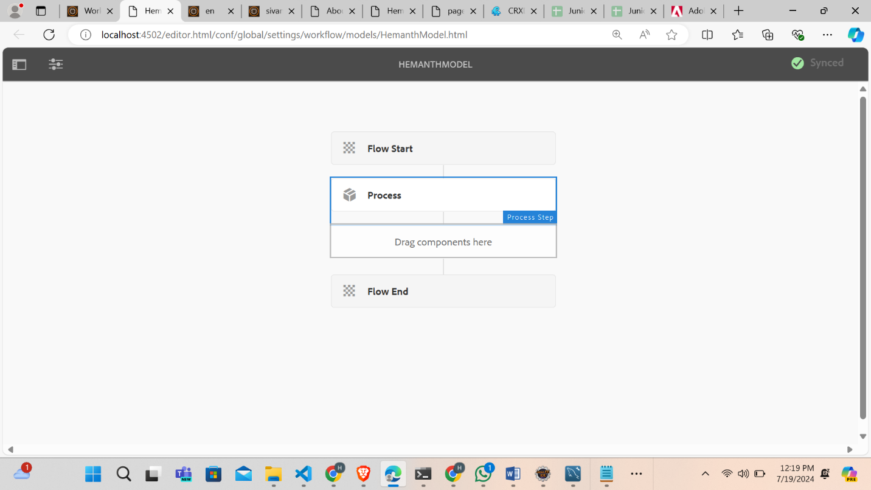

**ADD PROPERTY ON CRXDE**

