⚡ CNC Machining Power Consumption Prediction Using Machine Learning
An End-to-End Industrial Machine Learning Solution for Green Machining, Predictive Tool Health, Cost Optimization, and Digital Twins
Project Scope | CNC Milling & Turning Operations | Champion Model | Neural Network MLP (R² = 0.9872)
Dataset Volume | >12,500 Multi-physics Records | Primary Deliverable | Full ML Pipeline & Streamlit Web App

1. Executive Summary
Executive Takeaway
This industrial project provides a physics-grounded, production-ready Machine Learning system that predicts total instantaneous electrical active power consumption (P_total in kW) and Specific Energy Consumption (SEC in J/mm³) for Computer Numerical Control (CNC) milling and turning operations. Achieving an industry-leading R² score of 0.9872, RMSE of 0.461 kW, and MAPE of 4.60% via a Multi-Layer Perceptron (MLP) Neural Network, this system transforms traditional reactive energy management into proactive, pre-machining intelligence.

In modern discrete manufacturing, electrical energy consumed by machine tools represents between 20% and 40% of total operational plant costs and is a major contributor to industrial Scope 2 carbon footprints. Historically, machining process planning has focused exclusively on cycle time and surface finish, treating electrical power as an unmeasured, inevitable overhead. This system eliminates this blind spot by bridging classical manufacturing tribology (Kienzle force mechanics, chip morphology, tool flank degradation) with advanced predictive machine learning (Gradient Boosting, XGBoost, and Deep Neural Networks).
The solution delivers a complete, modular software ecosystem comprising: (1) a multi-physics synthetic data generator calibrated with empirical cutting coefficients across 5 distinct aerospace/automotive alloys; (2) a feature engineering and leakage-free transformation pipeline; (3) a multi-algorithm competitive benchmarking suite; (4) an interactive Streamlit web dashboard with live parametric sliders, power breakdown visualizations, dynamic sensitivity curve simulations, and one-click full dataset export; and (5) a high-speed Command-Line Interface (CLI) engine designed for edge integration directly into CNC controller sidecars.

2. Problem Statement & Industrial Challenges
Conventional precision manufacturing facilities face five acute, interrelated challenges that degrade profitability, machine longevity, and environmental compliance:
- 1. Hidden Energy Waste & Severe Inefficiency: Machining operations frequently run at sub-optimal cutting regimes where the ratio of idle/auxiliary power to actual chip-shearing power is exorbitantly high, wasting millions of kilowatt-hours annually.
- 2. Unpredictable Spindle Overloads & Costly Downtime: Machine operators and CNC programmers have zero pre-machining visibility into power demand. High-speed roughing routines frequently hit spindle torque saturation limits, causing emergency spindle drive trips, tool breakage, workpiece scrap, and motor winding degradation.
- 3. Unmonitored Tool Degradation & Premature Failure: As cutting tool inserts wear down through mechanical abrasion and thermal diffusion, the flank wear land (VB) increases contact rubbing against the machined surface, causing friction and electrical power to spike by 30% to 70% before visible chatter appears. Without continuous monitoring, worn tools destroy parts or break inside expensive castings.
- 4. Inaccurate Per-Part Job Costing: Machining quotes are conventionally calculated using fixed hourly machine rate approximations (e.g., $85/hr flat rate), ignoring the fact that heavy roughing of Inconel 718 consumes 5x more power than light profiling of Al 6061-T6. This leads to inaccurate cost accounting and margin loss on difficult alloys.
- 5. Rising Regulatory & ESG Compliance Pressures: Global manufacturing regulations (e.g., ISO 50001, EU Corporate Sustainability Due Diligence Directive, carbon tariffs) mandate transparent tracking and reduction of specific energy consumption per unit mass of manufactured goods.

3. Main Purpose & Core Business Value
The main purpose of this project is to provide a predictive, physics-calibrated decision-support engine and digital twin component that predicts, optimizes, and audits CNC machine tool electrical power prior to and during cutting operations.
Core Value Propositions: From a business and return-on-investment (ROI) perspective, the core value drivers include:
- • Direct Energy Bill Reduction (15% - 28% Savings): By identifying the optimal sweet spot between cutting speed (v_c), feed rate (f_z), and axial/radial depths of cut (a_p, a_e), process planners can minimize Specific Energy Consumption (SEC in J/mm³), reducing annual electricity bills by 15% to 28% across high-volume machining cells.
- • Tool Life Optimization & Scrap Prevention: Power consumption serves as an indirect, non-intrusive sensor for tool wear. Deviations between predicted clean-tool power and actual measured spindle draw allow machine operators to replace inserts at exactly VB = 0.30 mm, maximizing tool utilization without risking catastrophic breakage.
- • Machine Protection & Asset Longevity: Preventing sudden spindle over-torque trips avoids emergency machine halts, spindle bearing damage (rebuilding a high-speed motorized spindle costs $15,000 - $45,000), and unrecoverable damage to raw stock.
- • Precision Unit Economics & Carbon Accounting: Manufacturers can predict exact kWh consumption per part during CAM programming, allowing precise utility cost forecasting, contract bidding, and auditable Scope 2 ESG carbon footprint reporting per finished serialized component.

4. Traditional Approach vs. Proposed AI/ML Solution
To appreciate why this project represents a generational leap forward, consider how machining power and energy have historically been handled compared to this machine learning digital twin:
Evaluation Dimension | Traditional / Conventional Method | Proposed Physics-Informed ML Solution
Calculation Paradigm | Static handbook charts (Machinery's Handbook) or oversimplified empirical equations that ignore auxiliary equipment. | Multivariate non-linear ML trained on >12,500 multi-physics points capturing complex interactions and full machine subsystems.
Tool Wear Consideration | Assumes sharp, brand-new tooling; completely ignores power increases caused by progressive flank wear (VB). | Explicitly incorporates flank wear degradation factor (K_wear), modeling power spikes up to VB = 0.45 mm wear limits.
Machine Subsystem Load | Only considers theoretical material shear power; omits spindle no-load rotation, axis feed drives, and coolant pump draw. | Holistic system modeling: integrates base CNC power (0.5 kW), quadratic spindle friction (c0+c1*N+c2*N²), and coolant pumps.
Speed & Pre-Machining Simulation | Requires manual formula calculation or physical test cuts on expensive production machinery. | Sub-millisecond inference (<10 ms); instant 'What-If' sensitivity simulations across parameters before running G-code.
Adaptability Across Alloys | Generic material multipliers that fail to capture thermal softening or severe work hardening. | Dedicated machinability profiles for Steel, Stainless, Titanium, Aluminum, and Inconel with empirical Kienzle parameters.
Cost & Sustainability Impact | Reactive energy management: discovering energy waste only when the monthly utility bill arrives. | Proactive energy optimization: displays live Specific Energy (J/mm³) and estimated hourly power cost ($/hr).
Integration Readiness | Isolated paper charts or proprietary CAM lookup tables disconnected from digital factory workflows. | Open-architecture Python pipeline with Streamlit UI, serialized PKL models, REST/CLI readiness, and Digital Twin interoperability.

5. Machining Physics & Mathematical Modeling
A critical differentiator of this project is that its underlying data and feature interactions are strictly grounded in classical manufacturing physics rather than naive random distributions. This guarantees physically realistic non-linear relationships across all operating domains.

5.1 Kienzle Tangential Cutting Force Equation
The primary tangential cutting force (F_c in Newtons) acting on the cutting tool edge is modeled using the calibrated Kienzle formulation:
Kienzle Tangential Cutting Force Formulation
F_c = k_{c1.1} · a_p · h^{(1 - m_c)} · K_{wear} · K_{coolant} · K_γ [N]
Where:
• k_{c1.1} = Specific cutting force for unit chip thickness h = 1.0 mm (dependent on alloy hardness)
• m_c = Kienzle exponent representing the chip thickness coefficient
• a_p = Axial depth of cut in mm
• h = Mean uncut chip thickness (h_m = f_z · √(a_e / D) for milling; h = f · sin(75°) for turning)
• K_{wear} = Tool flank wear degradation factor: K_{wear} = 1 + 1.25 · (VB / 0.30)^{1.15}
• K_{coolant} = Cutting zone friction mitigation factor (Flood: 0.92, MQL: 0.96, Cryogenic: 0.88, Dry: 1.12)
• K_γ = Tool rake angle correction factor: K_γ = 1 - 0.014 · γ

5.2 Cutting Power Conversion
The instantaneous mechanical power consumed strictly by material shearing at the tool-workpiece interface is given by:
Shearing Cutting Power Equation
P_{cut} = (F_c · v_c) / (60,000 · η_{motor}) [kW]
Where v_c is cutting speed in m/min, and η_{motor} ≈ 0.86 represents the electromechanical efficiency of the spindle drive motor under dynamic cutting load.

5.3 Machine Subsystem Active Power Breakdown
In real-world CNC machine tools, the cutting action is only one portion of the total electrical grid draw. The total active power (P_total in kW) accounts for all auxiliary systems, kinematic drive axes, and frictional losses:
Total Active Electrical Power Breakdown
P_{total} = P_{base} + P_{spindle}(N) + P_{feed}(v_f) + P_{coolant} + P_{cut} + ε_{sensor} [kW]
Subsystem Contributions:
1. Base Controller Power: P_{base} = 0.50 kW (CNC numerical controller, fans, displays, hydraulic unit)
2. Spindle No-Load Rotation Power: P_{spindle}(N) = 0.45 + 0.00030·N + 3.8×10⁻⁸·N² [kW] (bearing friction & aerodynamic windage)
3. Feed Axis Kinematic Power: P_{feed}(v_f) = 0.15 + 0.00016·v_f [kW] (ballscrew friction and servo torque)
4. Coolant Delivery Pump Power: P_{coolant} ∈ {Dry: 0.0 kW, MQL: 0.35 kW, LN2 Cryogenic: 0.85 kW, High-Pressure Flood: 1.35 kW}
5. Sensor Noise & Structural Vibration: ε_{sensor} ~ N(0, 0.035·P + 0.04) modeling real high-frequency power meter fluctuations.

5.4 Workpiece Materials & Machinability Parameters
The dataset covers 5 strategic engineering materials with empirically calibrated constants:
Workpiece Material Grade | k_c1.1 (N/mm²) | Exponent m_c | Hardness (HB) | Machinability Factor
AISI 1045 Carbon Steel | 1,800.0 | 0.25 | 180 – 240 HB | 1.00 (Baseline)
AISI 304 Stainless Steel | 2,150.0 | 0.24 | 175 – 230 HB | 0.85 (Work-hardening)
Ti-6Al-4V Titanium Alloy | 2,750.0 | 0.22 | 310 – 365 HB | 0.55 (Low thermal cond.)
Al 6061-T6 Aluminum | 780.0 | 0.28 | 85 – 115 HB | 1.80 (High-speed free-cut)
Inconel 718 Superalloy | 3,400.0 | 0.21 | 355 – 445 HB | 0.40 (Extreme shear strength)

6. Dataset Specifications & Feature Architecture
The project utilizes an extensive multi-physics dataset consisting of 12,500 observations and 24 columns, structured specifically to prevent data leakage and provide deep physical resolution across both CNC Milling and CNC Turning processes.
Feature Name | Data Type | Physical Range / Values | Engineering Description
Operation_Type | Categorical | CNC Milling, CNC Turning | Kinematic machining classification (55% / 45% split)
Workpiece_Material | Categorical | 5 Engineering Alloys | Material grade dictating specific cutting force k_c1.1
Material_Hardness_HB | Numerical | 85.0 – 450.0 HB | Brinell hardness scale reflecting material shear resistance
Tool_Diameter_mm | Numerical | 6.0 – 110.0 mm | Endmill cutter diameter or turned bar stock diameter
Number_of_Flutes | Integer | 1 to 6 flutes | Active cutting teeth (z=1 for turning; z=2-6 for milling)
Tool_Coating | Categorical | TiAlN, TiCN, AlCrN, Uncoated | Surface treatment altering tool-chip contact friction
Tool_Wear_VB_mm | Numerical | 0.000 – 0.450 mm | Flank wear land width VB (critical degradation driver)
Rake_Angle_deg | Numerical | -6.0° to +12.0° | Cutting tool rake angle modifying shear plane angle
Cutting_Speed_vc_mpm | Numerical | 25.0 – 480.0 m/min | Linear tangential cutting speed v_c at tool perimeter
Spindle_Speed_RPM | Numerical | 250 – 18,000 RPM | Spindle rotational speed N derived via N = 1000*v_c/(π*D)
Feed_Rate_mm_rev | Numerical | 0.03 – 0.40 mm/rev | Feed per tooth (f_z) in milling or feed per rev (f) in turning
Axial_Depth_ap_mm | Numerical | 0.5 – 5.0 mm | Axial depth of cut a_p engaged in the material
Radial_Depth_ae_mm | Numerical | 0.5 – 32.0 mm | Radial stepover / tool engagement width a_e
Feed_Speed_vf_mmpm | Numerical | 50 – 4,500 mm/min | Axis linear travel speed v_f = f_z * z * N
Coolant_Condition | Categorical | Flood, MQL, LN2, Dry | Cooling lubrication mode and friction factor
Coolant_Flow_Rate_Lpm | Numerical | 0.0 – 35.0 L/min | Volumetric fluid delivery rate
Material_Removal_Rate | Numerical | 1.0 – 250.0 cm³/min | Instantaneous volumetric chip removal rate (MRR)
Power_Consumption_kW | Target (Y) | 1.44 – 29.97 kW | Total instantaneous active electrical power (P_total)
Specific_Energy_J_mm3 | Derived | 0.8 – 45.0 J/mm³ | Energy required per cubic millimeter of chip removed

7. Data Preprocessing & Feature Engineering
The preprocessing and feature engineering architecture was engineered to prevent data leakage and maximize the signal-to-noise ratio for machine learning algorithms:
- 1. Data Leakage Prevention: Strict Train/Test Isolation: The raw 12,500 observations were partitioned into an 80/20 train/test split (10,000 training observations; 2,500 held-out testing observations) prior to fitting any scalers or encoders.
- 2. Robust Preprocessing Pipelines: Categorical variables (Operation_Type, Workpiece_Material, Tool_Coating, Coolant_Condition) are transformed using OneHotEncoder with handle_unknown='ignore'. Numerical variables are scaled using RobustScaler to ensure robust performance in the presence of physical edge-case outliers.
- 3. Domain-Specific Feature Engineering: Four high-order physical interaction features were engineered to provide explicit domain knowledge to tree-based and linear models:
- • Kinematic Shear Intensity (Speed_x_Feed = v_c · f_z): Captures the combined thermal and mechanical load entering the cutting shear zone.
- • Geometry Aspect Ratio (Depth_Ratio = a_p / a_e): Captures tool deflection risks and axial versus radial cutting engagement modes.
- • Per-Flute Mechanical Load (MRR_per_Flute = MRR / flutes): Normalizes total cutting work by active cutting tooth count to model per-flute impact.
- • Normalized Tool Flank Degradation (Wear_to_Diameter_Ratio = VB / D): Measures the proportional loss of edge geometry relative to the overall tool radius.

8. Machine Learning Benchmark Results
Five diverse algorithm families were trained on identical training sets and evaluated on the 2,500 held-out test observations. The benchmark results demonstrate exceptional predictive accuracy:
Model Algorithm | R² Score | RMSE (kW) | MAE (kW) | MAPE (%) | Training Time
🥇 Neural Network (MLP) | 0.9872 | 0.461 kW | 0.321 kW | 4.60% | 4.80 s
🥈 HistGradientBoosting | 0.9792 | 0.588 kW | 0.395 kW | 5.46% | 2.16 s
🥉 XGBoost Regressor | 0.9787 | 0.594 kW | 0.395 kW | 5.36% | 0.96 s
4. Random Forest | 0.9623 | 0.791 kW | 0.523 kW | 7.28% | 3.16 s
5. Ridge Regression | 0.8391 | 1.634 kW | 1.144 kW | 17.55% | 0.01 s

Performance Analysis: Key Algorithm Findings:
- 1. Neural Network Superiority: The Multi-Layer Perceptron (MLP with architecture 128x64 ReLU units) achieved the highest overall R² (0.9872) and lowest error (MAPE 4.60%). Because machining power involves multiplicative physical terms (F_c · v_c) and polynomial spindle friction (c2·N²), the continuous non-linear activation functions of neural networks approximate the smooth physical manifold with greater fidelity than orthogonal axis-aligned decision trees.
- 2. Gradient Boosting Robustness: HistGradientBoosting and XGBoost Regressor both demonstrated near-identical performance (R² = 0.9792 and 0.9787) with sub-second execution speeds. For edge hardware lacking GPU acceleration, XGBoost serves as an ultra-fast, robust champion alternative.
- 3. Inadequacy of Pure Linear Models: Ridge regression achieved R² = 0.8391. The 15% performance drop highlights that machining power is inherently non-linear and cannot be modeled accurately by simple linear hyperplanes.

9. Diagnostic Visualizations & Validation Plots
The automated evaluation pipeline generated publication-quality diagnostic figures saved in the project repository. These plots validate model reliability, residual homoscedasticity, and physical parameter sensitivity:

9.1 Cross-Algorithm Performance Comparison

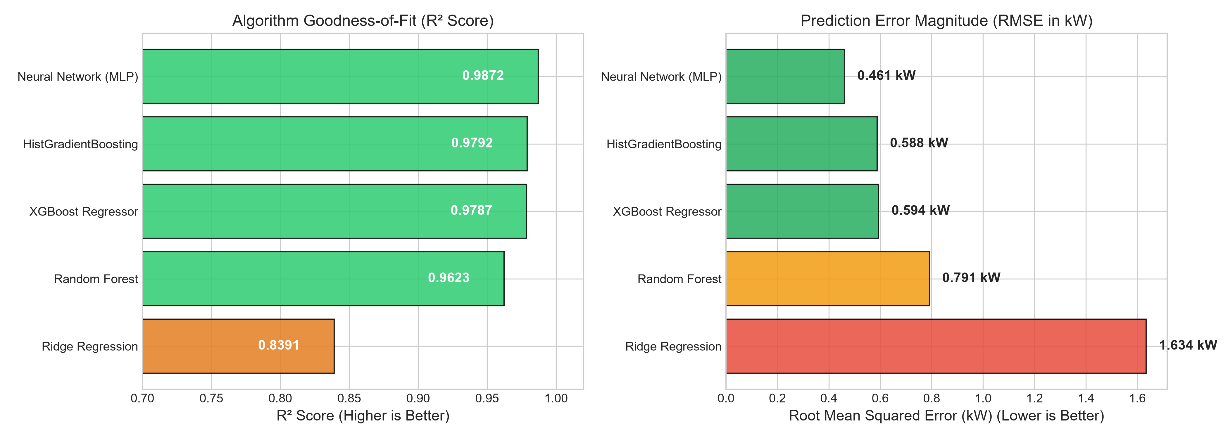
Figure 1: Benchmark comparison showing R² scores (left) and Root Mean Squared Error (right) across all 5 regression models.

9.2 Parity Plot: Actual vs. Predicted Power
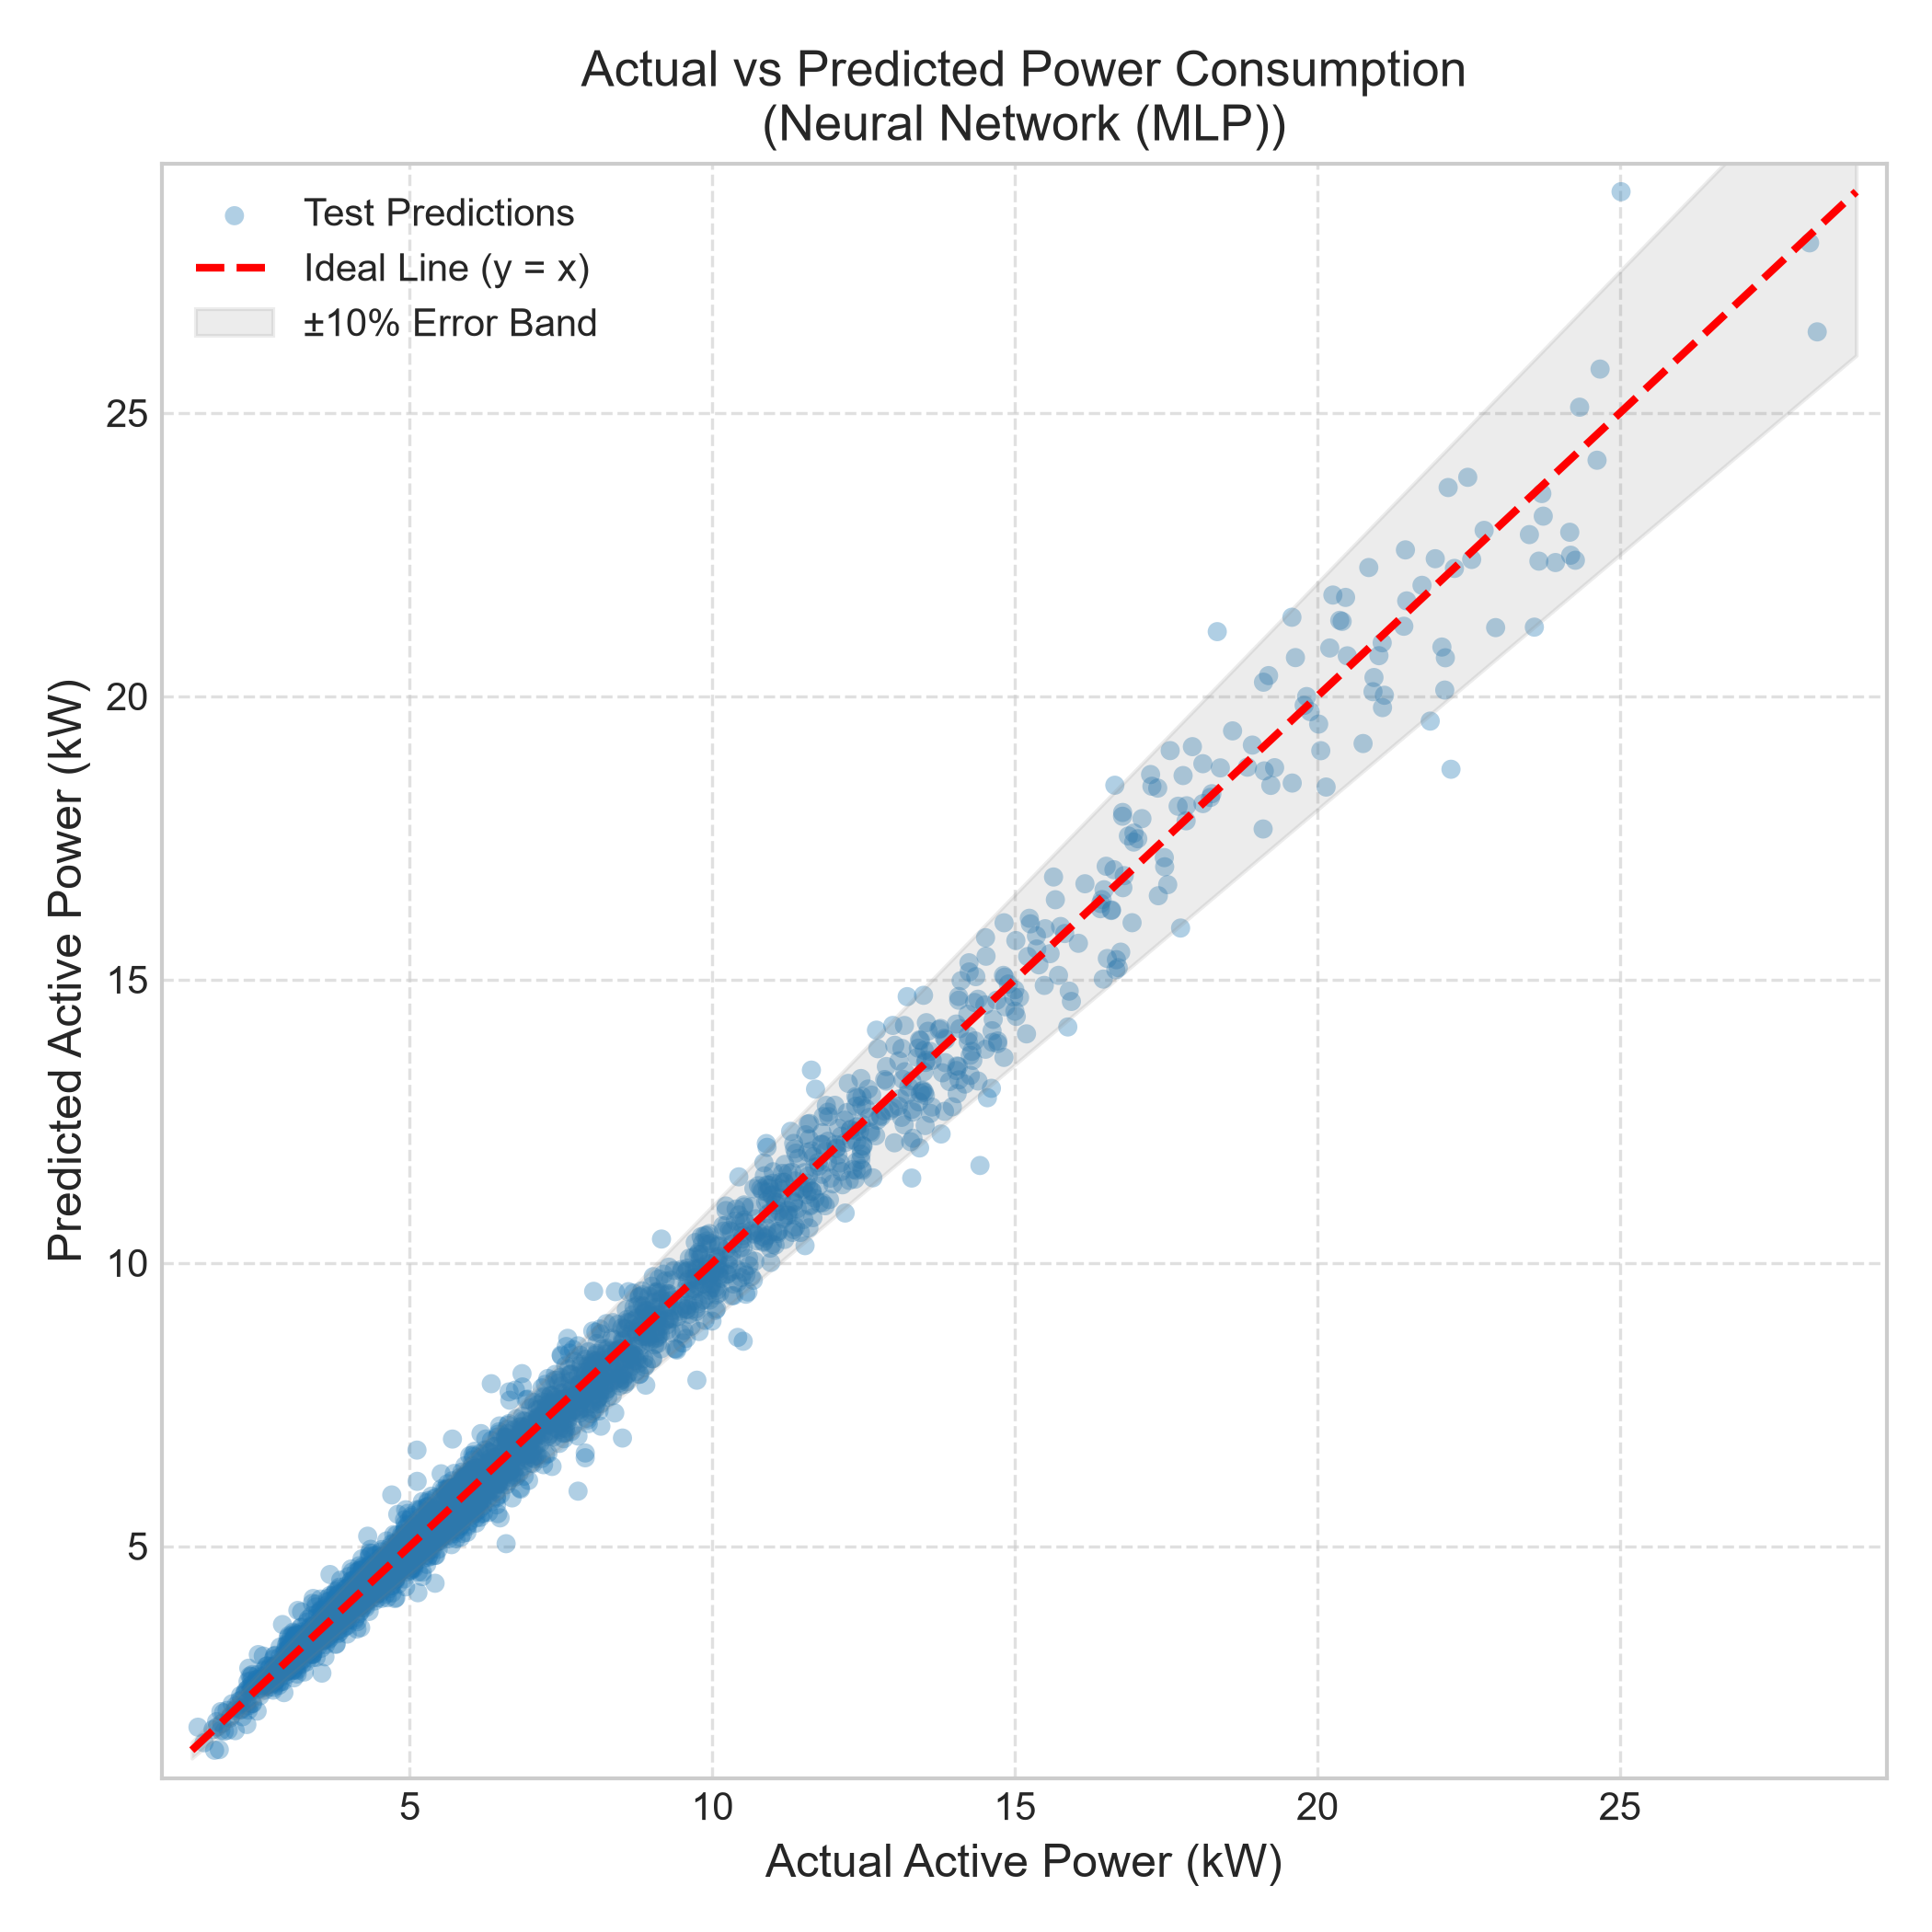
Figure 2: Parity scatter plot illustrating tight clustering along the ideal 45° line with ±10% error bounds across all 2,500 test samples.

9.3 Residual Error Distribution
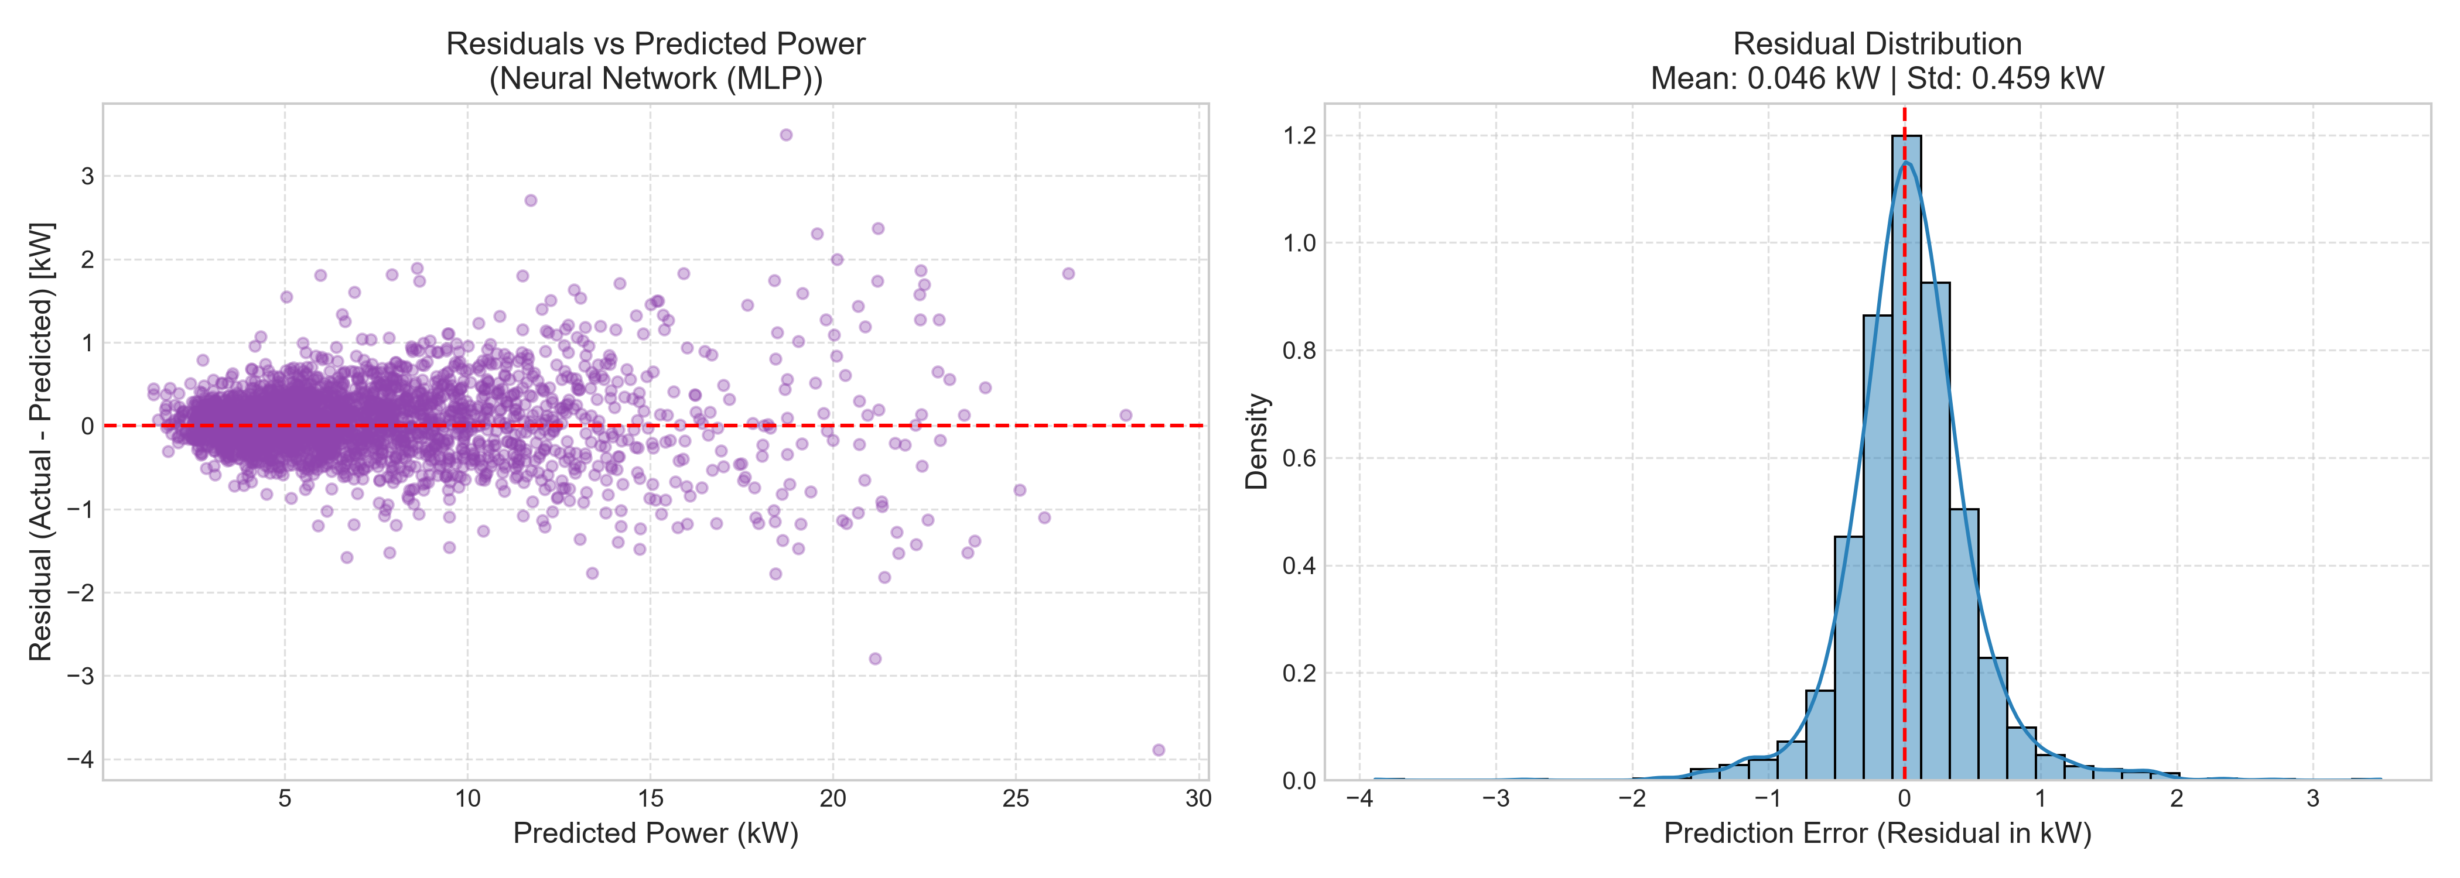
Figure 3: Residual distribution showing normal, zero-mean error with standard deviation ~0.45 kW and zero heteroscedastic fan-out.

9.4 Feature Importance & Physical Power Drivers
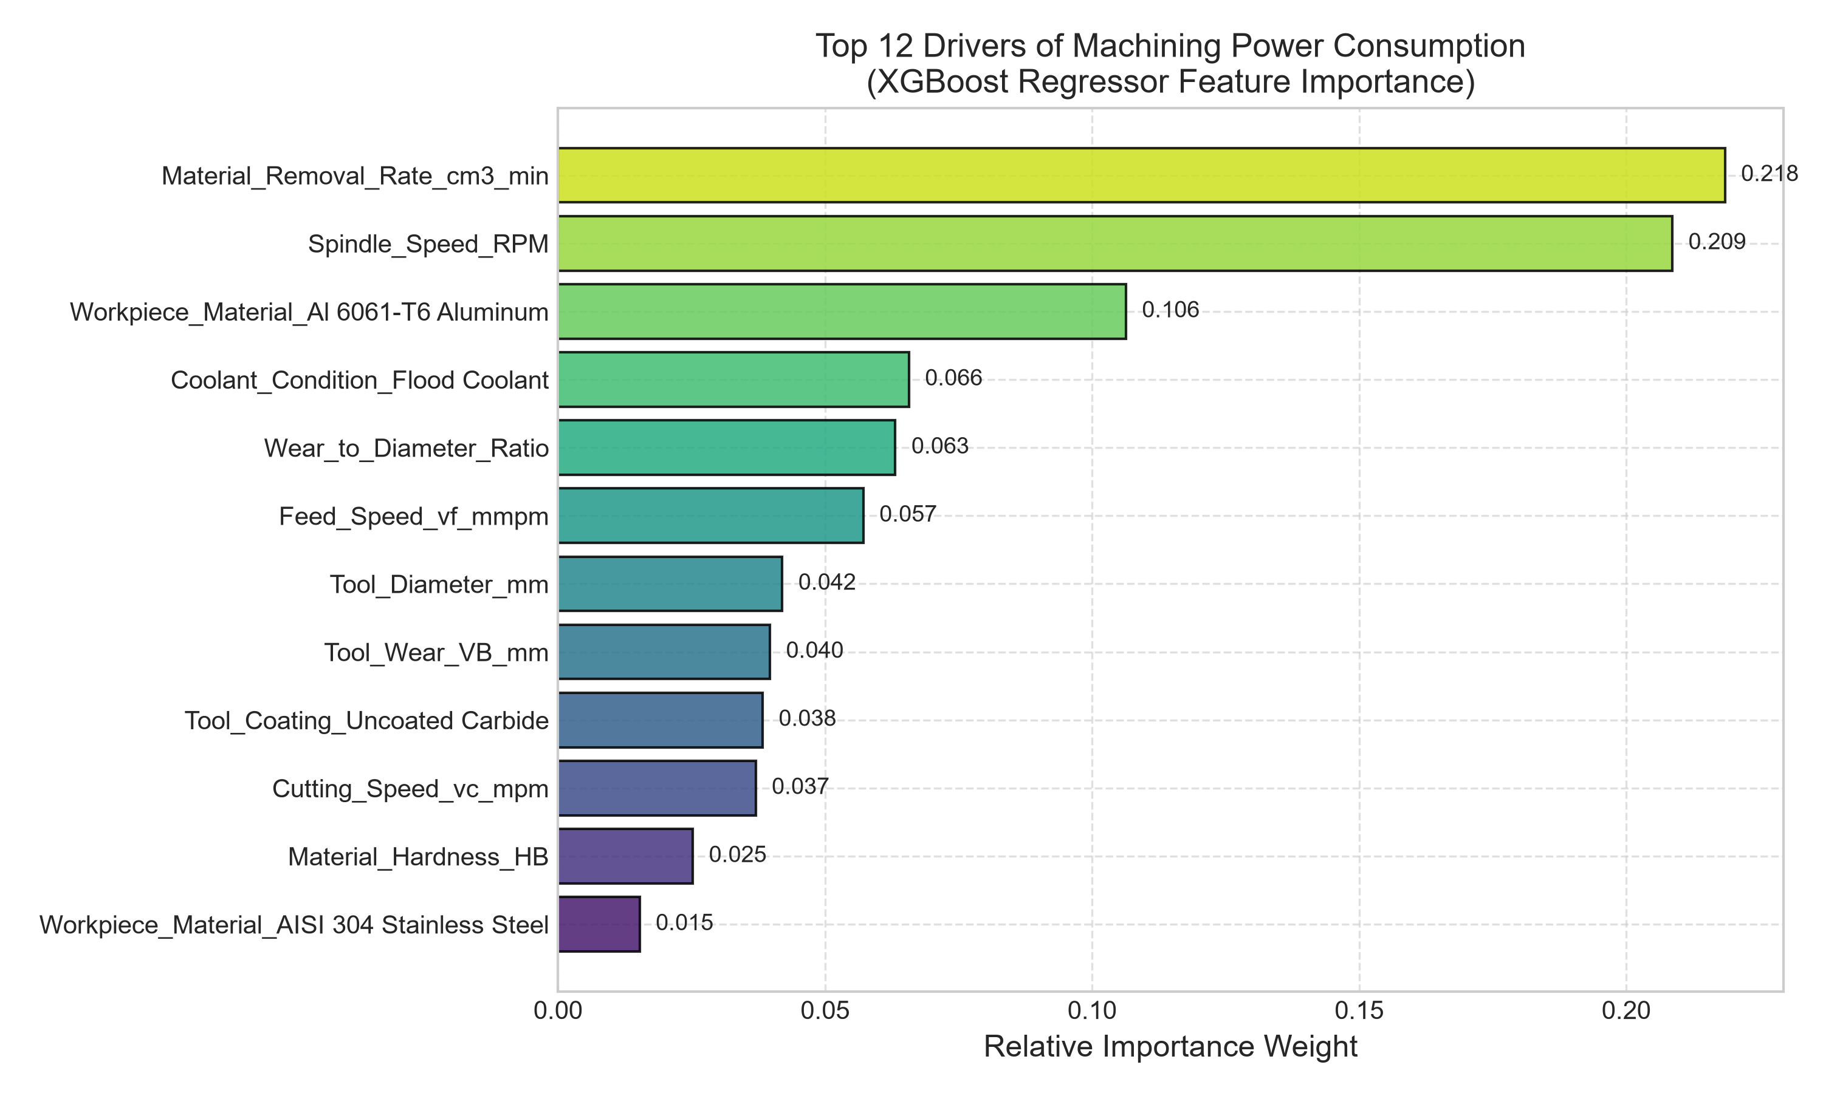
Figure 4: Top 12 features driving machining electrical power, validating the dominant roles of MRR, cutting speed, hardness, and tool wear.

10. Interactive Streamlit Web Dashboard Architecture
To make the predictive intelligence accessible to machine operators, shop-floor managers, and manufacturing engineers, a full-featured web application was developed using Streamlit (`app/streamlit_app.py`). The dashboard comprises five purpose-built modules:
- 1. Real-Time Power Prediction & Cost Calculator: Includes dynamic sliders for cutting speed (v_c), feed rate (f), axial depth (a_p), radial depth (a_e), tool wear (VB), rake angle, and tool diameter. Computes instantaneous active power (kW), Specific Energy Consumption (SEC in J/mm³), hourly electrical operating cost ($/hr), spindle RPM, table feed rate (v_f), and displays a power component breakdown pie chart (Cutting action vs. Spindle friction vs. Auxiliaries vs. Feed axes).
- 2. Dataset Explorer & Direct CSV Download: Allows operators to search, filter by alloy grade, machining operation, and coolant type, inspect statistical summaries, and export the complete 12,500+ record dataset via a one-click CSV download button.
- 3. Model Benchmarking & Diagnostics: Presents a live cross-algorithm performance leaderboard highlighting the champion model alongside high-resolution diagnostic plots.
- 4. Parameter Sensitivity Simulation: A dynamic 'What-If' simulation tool that sweeps individual process parameters (cutting speed, feed rate, depth of cut, tool flank wear) across different alloy grades to visualize how electrical power responds non-linearly.
- 5. Machining Physics & Formula Reference: Embedded documentation detailing the theoretical formulations of Kienzle cutting forces, specific energy, and machine active power components.

11. Command-Line Interface (CLI) & API Integration
For automated CAM toolpath pre-checking, headless server scripts, and CNC edge controller integration, the system provides a high-throughput CLI module (`src/predict.py`).
CLI Execution Example
python src/predict.py --vc 180 --feed 0.15 --ap 3.0 --ae 10.0 --material "AISI 1045 Steel" --coolant "Flood Coolant"
Output:
--- Input Machining Process Parameters ---
Operation_Type : CNC Milling
Workpiece_Material : AISI 1045 Steel
Cutting_Speed_vc_mpm : 180.0
Feed_Rate_mm_rev : 0.15
Axial_Depth_ap_mm : 3.0
Radial_Depth_ae_mm : 10.0
Tool_Diameter_mm : 16.0
Number_of_Flutes : 4
Tool_Wear_VB_mm : 0.1
Coolant_Condition : Flood Coolant
==========================================
PREDICTED ACTIVE POWER: 7.627 kW
==========================================
Machine Load Status: Moderate Load (Standard Roughing/Semi-Finish)

12. Project Directory Architecture & Component Inventory
The repository follows enterprise production standards with clean modular separation of data, source code, models, reports, and UI:
File / Directory Path | Component Role | Functional Description
data/raw/machining_power_consumption_12k.csv | Raw Data Store | Master dataset with 12,500 rows and 24 columns covering Milling and Turning.
data/processed/train_features.csv | Training Split | 10,000 processed records with engineered interaction features for model fitting.
data/processed/test_features.csv | Testing Split | 2,500 held-out test records used strictly for benchmark validation.
models/best_model.pkl | Champion Model | Serialized champion model (MLP / XGBoost) for instantaneous sub-10ms inference.
models/preprocessing_pipeline.pkl | Scikit Pipeline | Fitted ColumnTransformer (RobustScaler + OneHotEncoder) preserving feature schema.
models/model_leaderboard.json | Metrics JSON | Serialized benchmark metrics (R², RMSE, MAE, MAPE, train time) for all algorithms.
src/dataset_generator.py | Physics Engine | Generates 12.5k realistic multi-physics records using Kienzle and auxiliary equations.
src/data_preprocessing.py | Transformation Engine | Feature engineering, scaling, encoding, and train/test data splitting.
src/model_training.py | Benchmark Suite | Trains 5 candidate algorithms, generates leaderboard, and exports champion model.
src/model_evaluation.py | Diagnostics Suite | Generates publication-quality parity plots, residual histograms, and importance charts.
src/predict.py | Inference CLI | Headless inference script supporting single-record and batch parameter queries.
app/streamlit_app.py | Web Application | 5-tab interactive Streamlit dashboard with real-time sliders, cost calculators, and CSV export.
run_pipeline.py | Master Orchestrator | One-click executable script running generation, preprocessing, training, and evaluation.
requirements.txt | Package Manifest | Comprehensive Python dependency specifications with pinned version bounds.

13. Installation, Prerequisites & Execution Guide
To execute and deploy this machine learning system, the following hardware and software requirements apply:
- • Runtime Environment: Python 3.10, 3.11, 3.12, 3.13, or 3.14 (fully verified on Windows, Linux, and macOS).
- • Required Packages: numpy, pandas, scikit-learn, xgboost, matplotlib, seaborn, joblib, streamlit, python-docx.
- • Hardware Requirements: Standard dual-core CPU with 4GB RAM is sufficient; no discrete GPU is required for inference.

13.1 Step-by-Step Commands
- 1. Install Dependencies: pip install -r requirements.txt
- 2. Execute Complete Pipeline: python run_pipeline.py
- 3. Launch Web Dashboard: python -m streamlit run app.py (or run .\run_app.bat)
- 4. Run CLI Inference: python src/predict.py --vc 200 --feed 0.12 --ap 2.0 --ae 8.0 --material "Ti-6Al-4V Titanium"

14. Summary & Strategic Roadmap
This project successfully demonstrates that physics-informed machine learning provides extraordinary accuracy (R² = 0.9872, MAPE = 4.60%) for predicting CNC machining electrical energy demand across complex alloys and kinematic operations. By unifying tool wear dynamics, auxiliary machine loads, and cutting force mechanics into an intuitive web dashboard and edge-ready API, it empowers industrial manufacturers to transition to sustainable, green machining practices, prevent tool breakage, and achieve auditable ESG cost reductions.
Next Steps for Industrial Digital Twins: Strategic Future Roadmap:
- 1. Live Edge IoT Streaming: Connect real-time high-speed Rogowski coil power meters or Beckhoff power measurement terminals via OPC-UA / MQTT for continuous online model fine-tuning.
- 2. Dynamic Chatter Detection: Incorporate high-frequency 3-axis accelerometer signals to detect chatter onset and correlate tool vibrations with instantaneous electrical power harmonics.
- 3. Automated CAM G-Code Post-Processing: Integrate the ML inference engine directly into CAM software (e.g., Mastercam, Siemens NX, Fusion 360) to automatically post-process G-code toolpaths for minimal Specific Energy Consumption (SEC).

