**Practical Part Goal**

Creating a Database name spatial_db and creating extension postgis

Creating a table name spatial_table

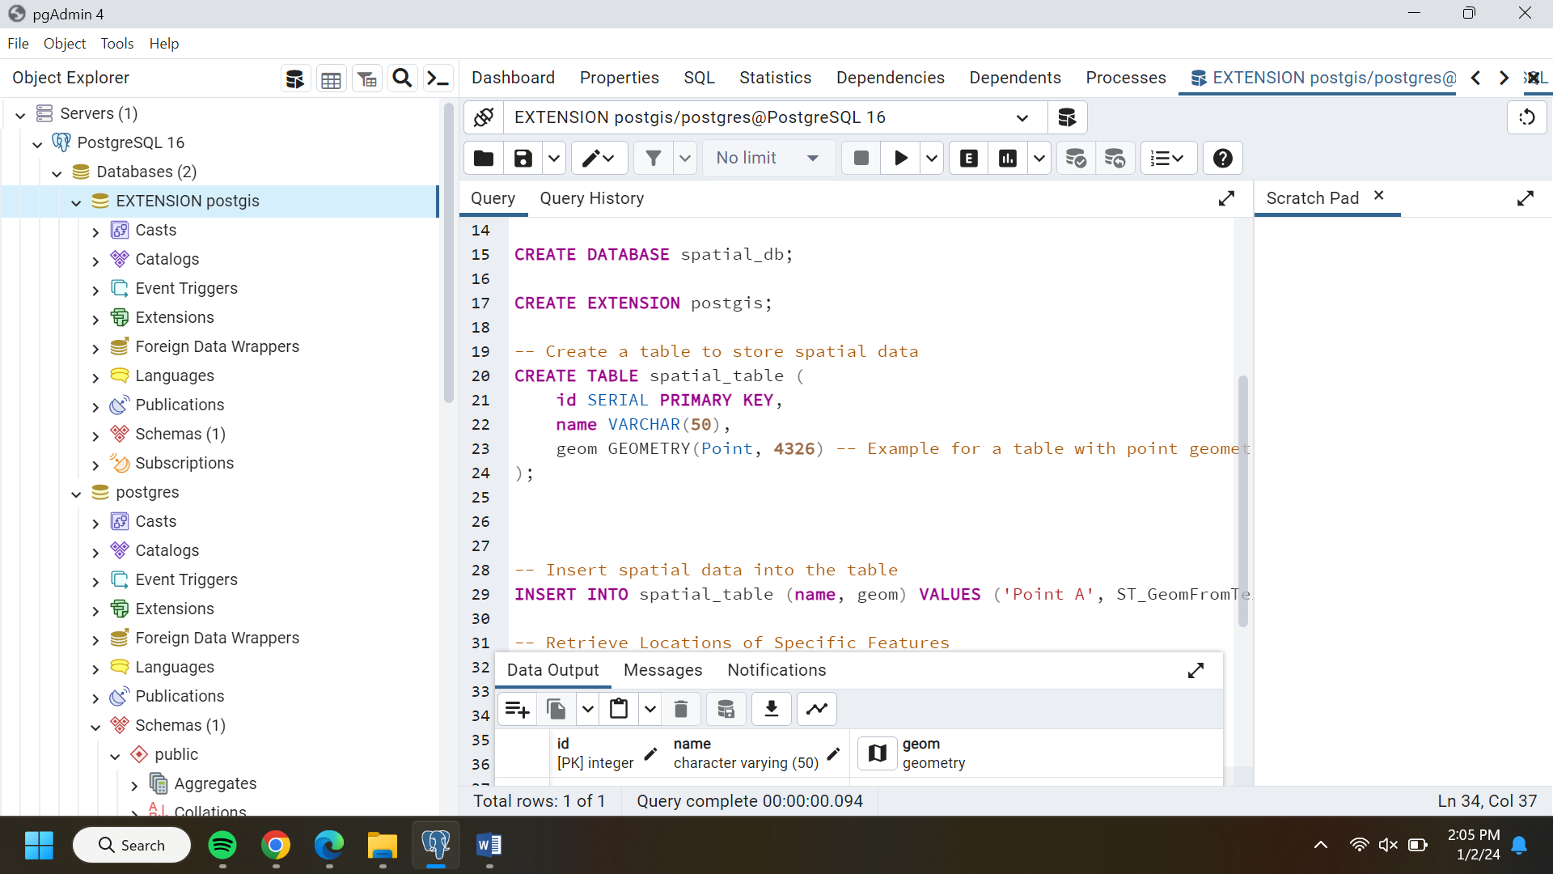

Inserting special data into table

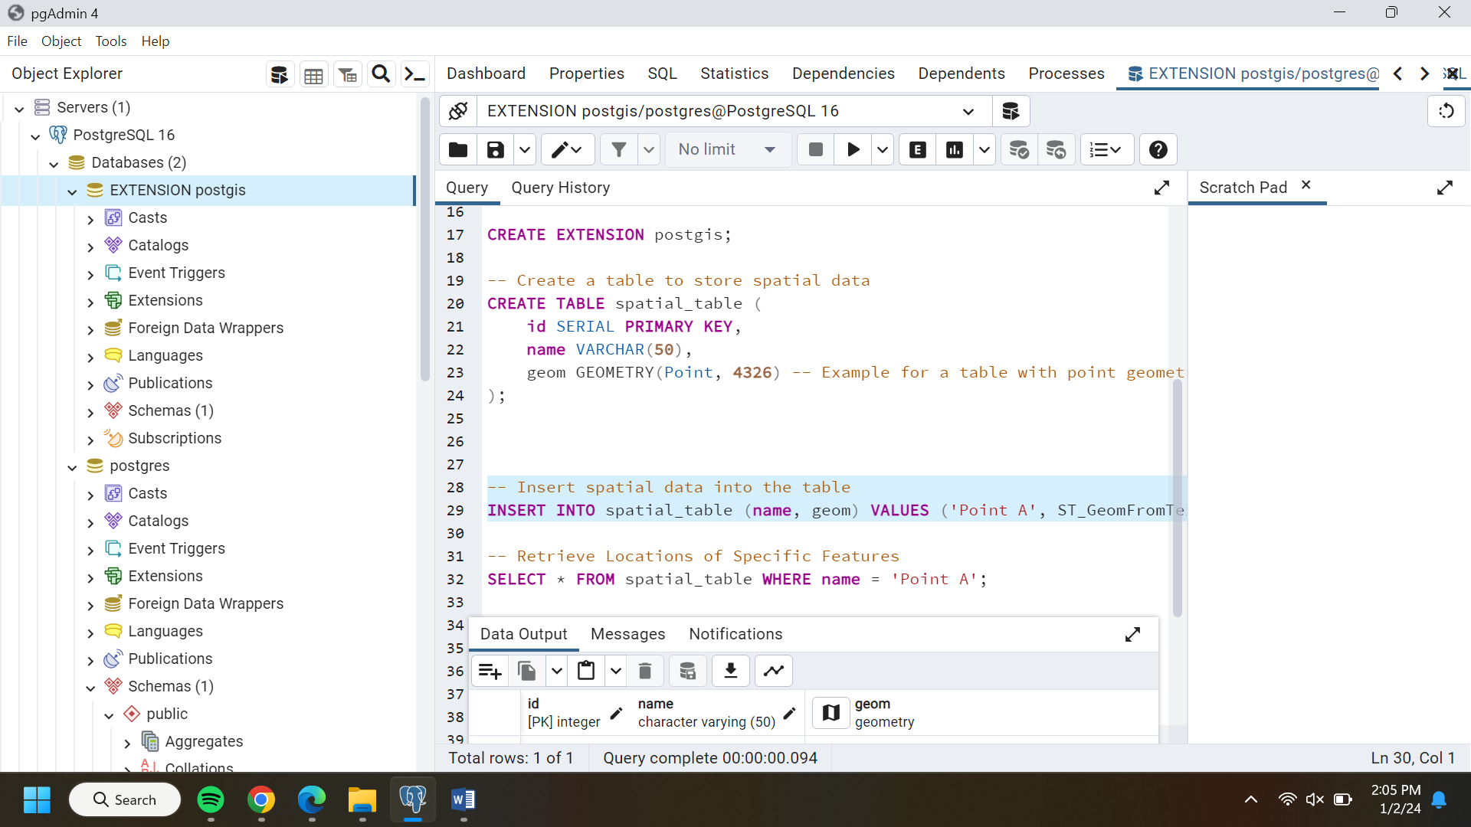

Retrieve Locations of Specific Features

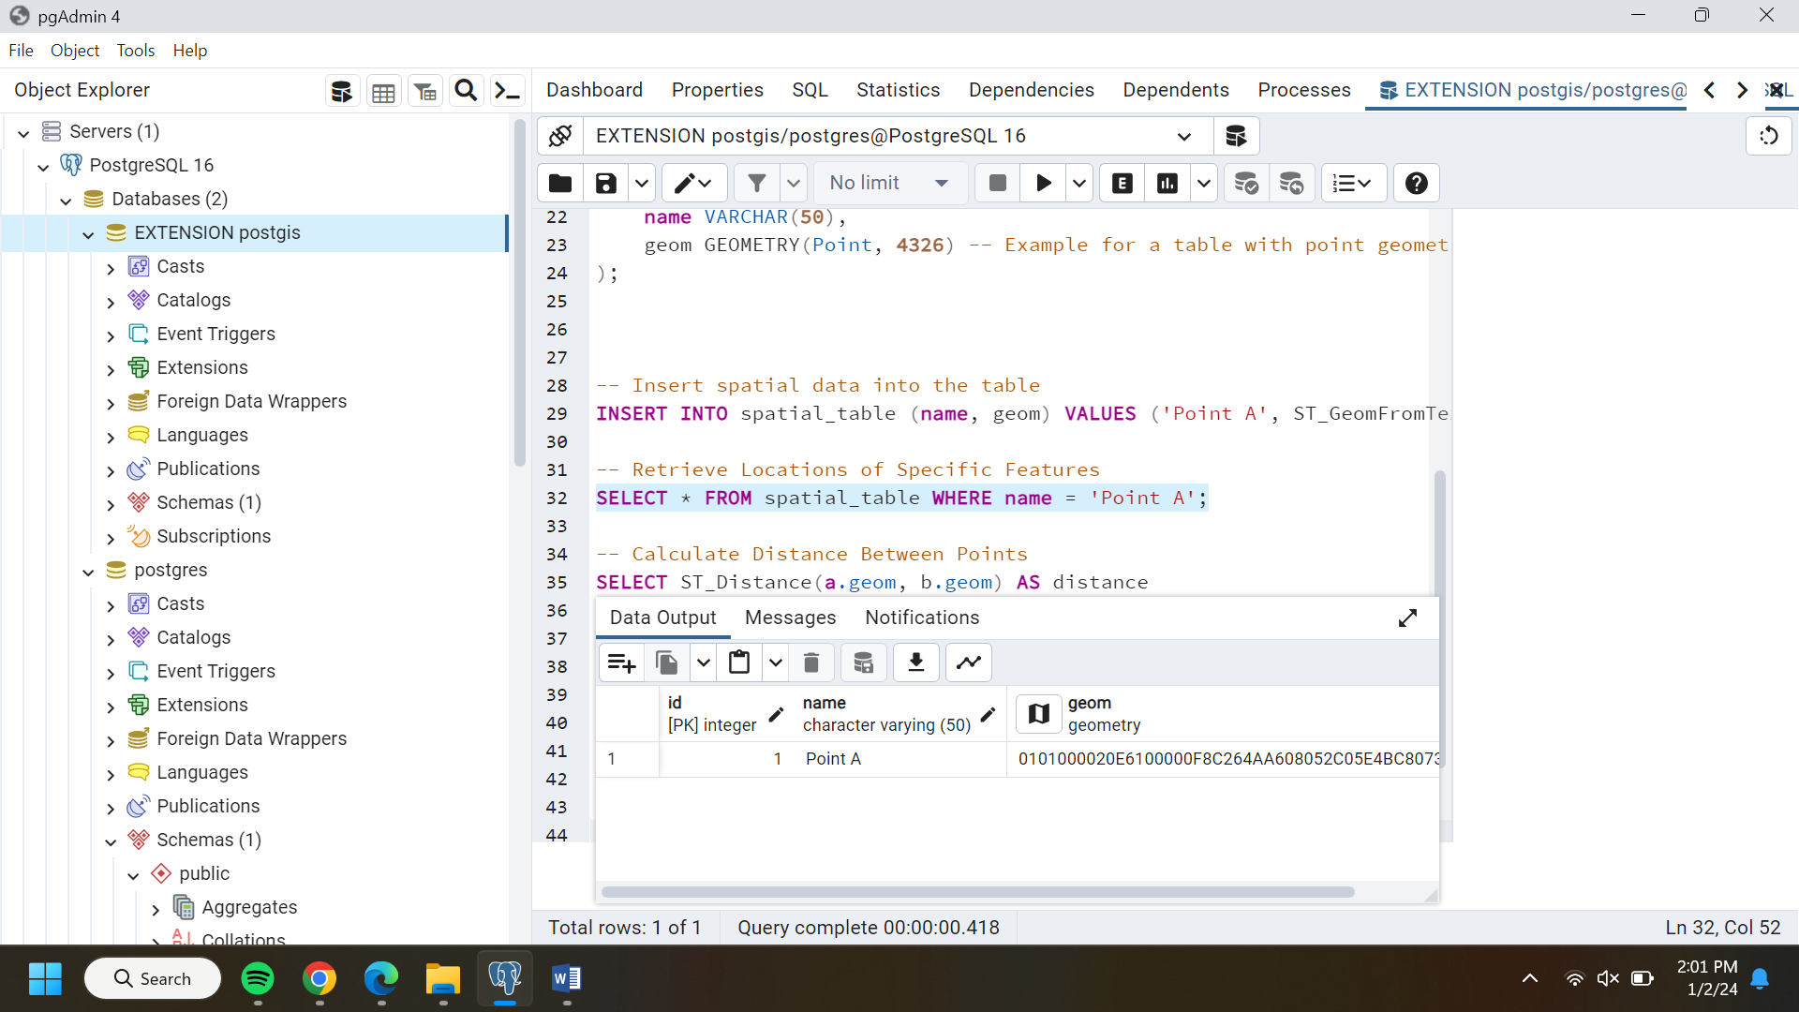

Calculate Distance Between Points

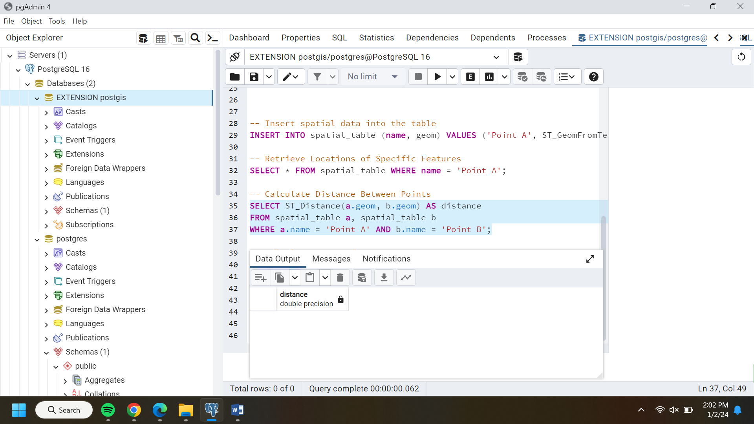

Calculate Areas of Interest

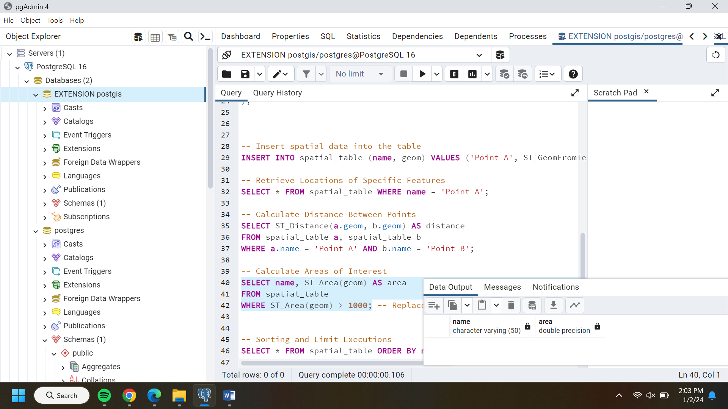

Sorting and Limit Executions

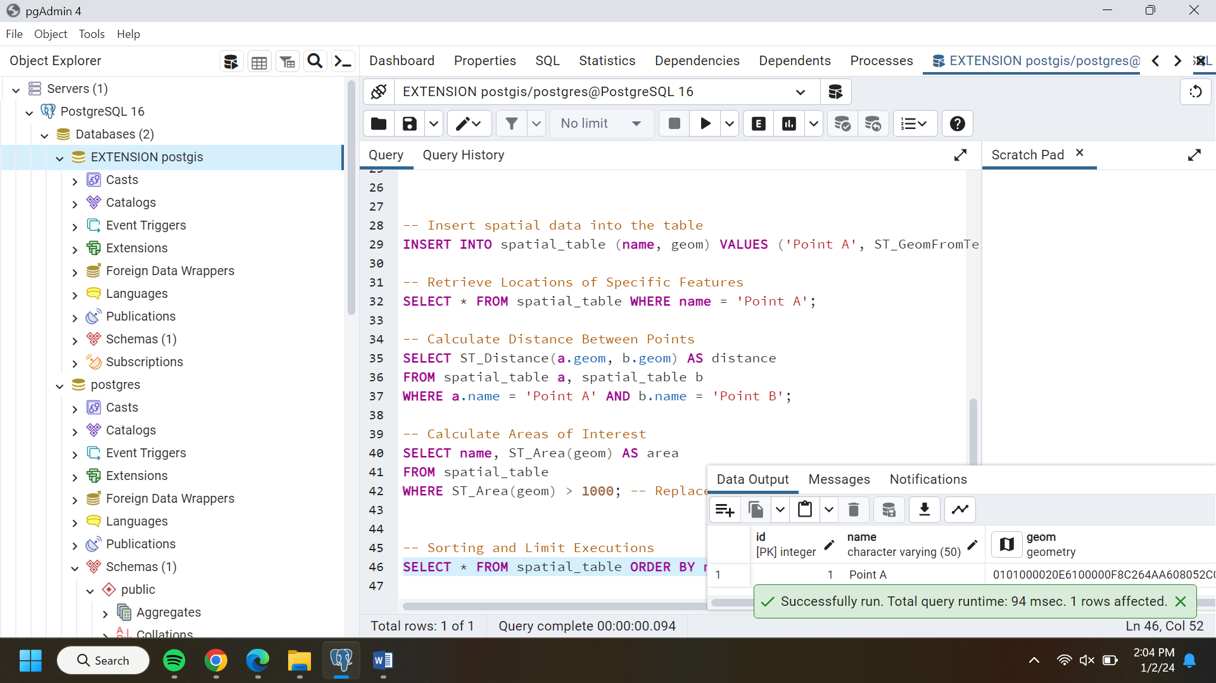

**THEORY PART**

1. External Merge Sort Passes:

Using the formula for the number of passes in external merge sort: \( \lceil \log_{B1} N \rceil \), where \( N = 1,000,000 \) and \( B = 6 \) (number of buffers).

Substitute the values and solve for the number of passes needed.

2. B+ Tree Pointers Chased:

Analyze the given B+ tree and determine the number of pointers (parenttochild and siblingtosibling) to find all keys between \( 9^* \) and \( 19^* \).

Start from the root node and follow the pointers based on the conditions specified in the question.

3. Hash Table Insertion and Split:

Based on the hash functions provided and the bucket split condition, determine the largest key less than 25 whose insertion will cause a split in the hash table.

4. Sparse B+ Tree Nodes Count:

Calculate the number of nodes in a sparse B+ tree of order \( d = 2 \) containing keys 1 through 20.

5. SQL Query Optimization in Relational Algebra:

Analyze the given relational algebraic expressions and determine which one of the two logical plans is likely to be more efficient for the provided SQL query.

6. Vectorized Processing Model:

Determine if each operator in the vectorized processing model requires multithreaded execution when receiving input from multiple children. Provide a True/False answer with a brief explanation.

7. Optimizing Hash Join Algorithm:

List some strategies or techniques to optimize a hash join algorithm for better performance.

8. Cost of Query Plan in SQL Query:

Calculate the cost (number of page I/Os) for the provided query plan, considering the assumptions given.

9. Join Algorithms and I/O Costs:

Answer the subparts related to optimizing hash functions and calculating I/O costs for a block nested loop join based on the given table sizes and buffer information.

10. Full Binary Tree Leaf Nodes:

Calculate the number of leaf nodes in a full binary tree with \( 2n \) internal nodes.

11. Cuckoo Hashing Sequence:

Analyze the provided Cuckoo hashing schema and predict the sequence produced based on the given hashing functions and insertion order.

These questions cover a wide range of topics in database systems and algorithms. The solutions often require intricate calculations, understanding of data structures, query optimization principles, and hashing techniques. For detailed and accurate answers, referring to textbooks, lecture notes, or relevant course materials would be ideal. If you have specific parts you're unsure about or need deeper explanations for, feel free to ask!