* 1. **Essential points of test Strategy**

**Test Scope:**

In this section clearly calling out the Scope

Sample example:

|  |  |
| --- | --- |
| # | Features |
| 1 | Validate Price,media from retrieved from External service |
| 2 | Verify integration of Rest API with partners website |

**Test Methodology**

**Key Phases:**

|  |  |
| --- | --- |
| **Backlog** | * Epics will be broken into smaller user stories and added to the backlog. * Every story is estimated and pulled to the Sprint backlog |
| **Dev** | * User stories is developed in DEV. * Unit test is performed by dev team. * Build and deploy changes to QA env. |
| **QA** | * **Sanity test is performed on the new build ,if any showstopper issues build is rejected.** * **Functional testing of stories is performed and all issues identified will be logged as bugs and triage with DEV and PO.** * **Integration test is perfomed.** * **Regression test and final signoff is provided.** * **Automated API /UI tests** * **Create UAT scenarios .** * **Work with Performance ,security team to develop scripts to execute perftests and finding the vulnerabilities in the application and get the signoff.** |
| **UAT** | * **Testing is performed by PO and end users** * **QA team will coordinate and support during UAT** * **Signoff off provided** |

**Test Process in a Sprint:**

This section defines the approach to Test the Solution.

* Every sprint shall be executed for a period of 2 weeks.
* During the first day of the Sprint, the list of user stories which can be delivered as part of the sprint, shall be defined and agreed upon for scope.
  + - Every User story shall be captured in Jira with complete details including any documents required for marking the Use Story complete.
    - The User Story shall be deemed fit for Test and delivery only when the Acceptance Criteria is clearly defined and agreed upon by the Test team along with relevant effort estimations.
    - The Test cycles of User Stories shall be based on the delivery plan of the development team for the respective User stories.
    - All the Accepted US should be planned with the efforts which includes both Dev and QA effort hours.
* During the Sprint Cycle, every single User Story shall go through the following activities for Testing
  + - * User Story Analysis and clarifications.
      * Analysis to test the story by in-sprint automation or do manual test
      * Test Scenario development & review
      * Test Case Development.
      * Test Case Review .
      * Test Execution
      * Build Verification  test cases will be identified which will focus on high level end to end functionality belonging to the solution and which are critical to the business.
      * The test team will prioritize the test cases based on different scenarios and functionalities. This prioritization is based on the impact of the functionality to the application.
      * Test cases will be prioritized as Critical/High/Medium/Low based on the Scenarios that respective test case covers.
      * Bug Reporting and tracking
      * Regression testing will be done before 1 week of UAT (depending on the bandwidth available)
* The Test cases will be reviewed to identify the UAT test cases.
* One complete Regression Cycle will be carried out in Stabilization Phase to ensure system stability.
* Every discrepancy noted during Test execution, shall be captured as bug in Jira  and appropriately triaged. Quick regression would be done around the fixes deployed for the reported Bugs.
* All the Test cases shall be executed from Test Suites created in Test rail/Qmetry and observations shall be reported back in the same.
* Test Case execution and Bug status maintained appropriately.
* Test execution status tracking will be done in Test rail  and no separate test reports will be shared.

|  |  |  |  |  |  |
| --- | --- | --- | --- | --- | --- |
| Time Sprint N-1 Sprint day1 Sprint Last day | | | | | |
| customer | Prioritize Backlog  Complete accept. Crit  BackLog Estimation and Requirement Gathering |  | Clarify Requirements |  | Customer demo.  Sprint Retro and Team retro |
| BA/ Arch | Collect user Req | Check planned task |  |  |  |
| Team Lead |  |  | Daily | Triage Defects,  Update docs and Release notes |  |
| UX |  |  | Design |  |  |
| dev |  | Task Break down and Assign Task | Build | Fix defects,Complete Tasks |  |
| test |  |  | Create Testcase  Write Automation scripts  Triage | Identify issues |  |

Review Story and Moved to ready to Eng

InProgress

Review Definition of Done mask as Done

**Testing Work Flow in a Sprint**

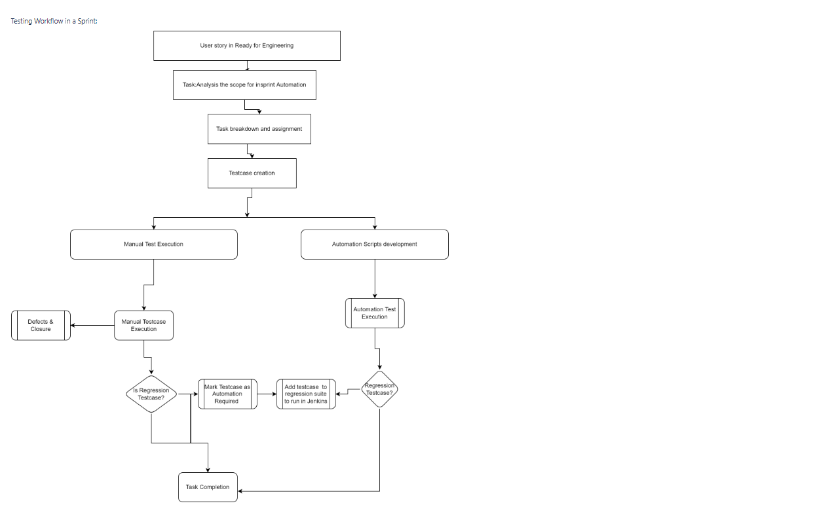

**Types Of Testing:**

**Following types of testing will be carried out:**

**Testing Cycle:**

|  |  |
| --- | --- |
| Type of testing | Approach |
| Smoke or Sanity Test | 1.      100% automate coverage and integrated in Pipeline |
| 2.      The test would include the basic happy path test cases. |
| 3.      Failure of a Sanity suite results in a build reject |
| Functional Test | 1. Functional test will be categorized into 3 buckets |
| a. API testing - All the functional and scenario based tested to be triggered in this category. |
| b. Backend testing - All the database validation and transformations falls in this category. |
| c. UI testing,usability tests,Compatibility test - Limited to UI web elements validation. |
| 2. All the functional test cases will be maintained in the master suite and given a priority(Critical/High/Medium/Low ) |
| Regression Test | 1. Will be categorized like functional test into 3 buckets |
| 2. Regression suite is updated end of every sprint and prioritize will be revisited |
| 3. An automation backlog will be created and Jira tickets with be added to sprint backlog based on capacity |
| Non-functional - Performance and Load Test | 1. Performance tests has to be executed before releasing |
| Non-Functional - Security Test | 1.Security scan will be executed during the regression phase with a stable build on the end product .Zap tool can be used |

**Automation Test Process:**

* Unit Test will be developed by DEV Team
* Build Verifications will be implemented and Executed as part of Pipeline.
* Integration / System Automation cases will be Planned based on Capacity.
* Target to Automate more API testcases and key features.

**Test Coverage**

Ex:

|  |  |  |
| --- | --- | --- |
| # | TestCoverage | Priority |
| 1 | End to testing of prices media with integrations | High |
| 2 | Db level valaidations | High |

**Entry and Exit Criteria:**

**Entry:**

* Availability of Userstories with agreed Acceptance criteria
* Availability of Planned Test Team
* Good Unit test coverage and code coverage
* Testcases in Testrail
* stable Environment .

**Exit:**

Testcases reviewed and executed

100% test execution

Minimum 95% pass percentage

No P1 ,p2 issues.

**Test Deliverables:**

Test Plan

Updated Test cases

Consolidated list of Known Issues, Bug report

Test Execution report.

**Test Team:**

We will create 3(dev):1(QA) ration for each scrum team

**TestData:**

Testdata for testing should be agreed

Test Environment Ownership

**Test Matrix:**

Testexecution,number of defcets based on priority,defect removal efficiency

**Bug Reporting and Methods**

* + Priority Taxonomy

High,Medium Low

**Define Bug lifecycle**

**Triage Process**

**Environment and Tools**

**Communication Plan**

**Risk and Mitigation Plan**

* 1. **Challenges for testing in this Project**

Right Now there is no clear requirements available .

We don´t have the Estimation from Dev team to deliver the application.

Some things like Authentication,logging need to be discussed.

Tight Deadlines.

No clue about testmanagement tools ,QA resources,Skills and other tools

Missing Documenation

No Clue about Devops ,as it’s a new team we will have challenge setting up with Test Environment and testdata.

Dependency with Other teams In the organization/third party services regarding the integration.

* 1. **Automation Strategy:**

**I have explained the simple work flow of user story in this section “Testing Work Flow in a Sprint”**

* + - Goal is to Automate 80 to 90 % of API testcases,End to end tests in front end and InSprint Automation will be implemented in both the Scrum Teams.
    - Mark testacases as Automation required,Not Auomated ,Automated etc to define the Automation Backlog.
    - Define Defination of Done for a user story .ex:80-100% Api testing should be completed,UI Testcases 0-50% Completed,Pass rate of the Automated Testcase in Pipeline or nightly build.
    - UI and other Testcases will be given low priority during the initial stages.
    - During requirement gathering phase Create POC for API Automation ,UI Automation,Agree on Automation tools and definition of done and scope.
    - Automating tests which gives more ROI and helps with Regression.
    - Define Testdata for the Automation tests and environment
    - Demo Automation progress on Sprint demo and status of the Automation.
    - Integrate Automation results with Testmanagement tool and monitor the daily runs ,email notifications and report Bugs if anything found,if it’s a script issues create a jira ticket.
    - Train New QA if they are not used to the framework.
    - Check with other teams in the company if they have good framework ,take advantage of it.
    - Create Automation onborading
  1. **Approach to integrate automated tests into CICD Pipeline**
     + 1. **In order to merge a PR with master or Release branch we have to include sanity tests as part of the pipline script so that if anything broken it will be detected early and build will be failed for that particular PR.**
       2. **While Deploying the latest changes to the QA Env ,as part of the Postdeployment steps trigger full automaion tests.**
       3. Jenkins can be used and as its opensource and wide community

1. **Methodology**

**2.1**

**Methodologies**

**Agile:**

**it has good feedback system and sprint demo helps getting stakeholders feedback.**

**Decreased risk**

**visibility**

**adaptability**

**agile in nature**

**Collaboration**

**Frequent delivery**

1. **Test Team**
   1. **I will do it in this ratio 3(dev):1(QA)**
   2. **Skills required**

**Prior QA experience with API and UI Automation using java rest assured,Java selenium.**

**Understanding of microservice based architecture**

**Worked in agile teams**

**Any test managemt tool**

**Able to write sql queries**

**Understanding of cicd**

* 1. **Attitude**

**Works under tight deadlines and pressure**

**Works on multiple projects,cross functional teams**

**QA mindset**

**Passion towards quality**

**Quick learner**

**Work independently.**

**Teamwork**

1. **QA Process**

**4.1**

* **Assuming we have Stories with Acceptance criteria ,so writing testcases based on Acceptance criteria.**
* **If No Acceptance available ,based on the discussion with Partners convert them to the user stories and create testcases**
* **Apply testacase design techniques ex boundary value ,equivalance portioning etc**
* **Understand the requirements,functional ,non functional.**

**4.2**

**All user stories under a epic in jira will have testcases created and each testcase in Testrail is linked with Jira issue.**

**For each story we are going to have Test runs and capturing the results.**

**Continuous testing and continuous integration call for Automation tracability checks.everytime there is a change ,the concerned stakeholder will be notified and appropriate action will be taken.**

**Shift left testing helps in early traceability.**

**4.3 Responsibility between dev and QA**

**As part of**

|  |  |
| --- | --- |
| **DEV** | **QA** |
| **Unit testing and they will work on DEV env** | **Functional and Automation** |
| **QA and Perf env setup ,configuring,deployments** | **QA and Perf env maintenance** |
| **Dev collaborates in Review process** | **Testcase review** |
|  | **• Sanity test is performed on the new build ,if any showstopper issues build is rejected.**  **• Functional testing of stories is performed and all issues identified will be logged as bugs and triage with DEV and PO.**  **• Integration test is perfomed.**  **• Regression test and final signoff is provided.**  **• Automated API /UI tests**  **• Create UAT scenarios .**  **• Work with Performance ,security team to develop scripts to execute perftests and finding the vulnerabilities in the application and get the signoff.** |

1. **Tools**

|  |  |
| --- | --- |
| **Testmanagement** | **Testrail,** |
| **Performance** | **Locust,neoload** |
| **API testing** | **Postman,restassured** |
| **UI testing** | **Selenium,selenium grid** |
| **other** | **Jira,maven,sql developer,Zap,Jenkins,different browsers.** |