LLM CONSORTIUM FOR SOFTWARE DESIGN REFINEMENT
Comprehensive Data Analysis Report
480 Experimental Runs • 12 Variants • 8 Tasks • 5 Repetitions
February 2026
Models: gemini-2.5-pro (design generation) • openai/gpt-oss-120b-maas (cross-model review/evaluation)

Executive Summary
This report presents the complete statistical analysis of 480 experimental runs from the LLM Consortium experiment, testing whether multi-LLM collaboration topologies can systematically produce higher-quality software designs than a single model iterating alone. The experiment evaluated 12 variant configurations across 8 design tasks of varying complexity (Simple, Medium, Complex), with 5 repetitions each.

Key Findings:
- Cross-model review (v2b) is the overall quality champion (mean 4.484), demonstrating that diversity of training distribution is the strongest lever for quality improvement. This was statistically significant with a large effect size (Cohen’s d = 0.97).
- The rotating leader variant (v6) achieves the lowest variance (σ = 0.080) and near-top quality (4.466), making it the most reliable variant overall.
- Parallel generation + merge strategies (v3) dramatically underperformed expectations. The dialectical merge variant (v3c) was the worst performer overall (3.734), suffering from the “Frankenstein effect” predicted in the thesis proposal.
- Adversarial dynamics (v4) provided no statistically significant advantage over cooperative review, contradicting the hypothesis that adversarial pressure improves robustness.
- The Friedman test confirmed that variant choice matters (χ² = 220.3, p < 10⁻⁴⁰), but the dominant effect is the review/feedback mechanism, not the collaboration topology.
- Four of six thesis predictions were either refuted or only partially supported, suggesting that LLM collaboration dynamics differ fundamentally from human team dynamics.

1. Experiment Overview
The experiment was conducted as specified in the thesis proposal, with one notable omission: variant v7 (Consensus Convergence) was not executed. The final dataset comprises 480 completed runs across 12 variant/sub-variant configurations.

1.1 Variants Tested
Baseline variants: v1 (self-refinement with evaluator loop, 3 rounds) and v1a (single-shot, no refinement). Leader + Reviewer variants: v2a (same-model review), v2b (cross-model review), v2c (multi-model panel review). Parallel generation variants: v3a (naive merge), v3b (rubric-guided merge), v3c (dialectical merge). Adversarial: v4 (adversarial reviewer). Specialist: v5 (specialist panel). Rotating Leader: v6 (decentralized specialized cooperative). Debate: v8 (structured debate with judge).

1.2 Models and Infrastructure
Design generation was performed primarily with gemini-2.5-pro via Google Vertex AI. Cross-model review and evaluation used openai/gpt-oss-120b-maas via the Google Vertex OpenAI compatibility layer. All 480 runs completed successfully with no failed runs. Each design was evaluated 3 times (median taken), yielding 1,522 total evaluations. Evaluation used 12 weighted dimensions from the application design rubric.

1.3 Evaluation Dimensions
The 12 dimensions scored were: Requirements/Scope Clarity, Domain Model Quality, Module Structure & Dependency Direction, Interface & Contract Design, Data Flow Clarity, Error Handling Rigor, Testability, State Management & Lifecycle, Concurrency Safety, Cross-Cutting Concerns, Design Decision Justification, and Right-Sizing/Simplicity. Each dimension was scored 1–5 and weighted per the application design rubric.

2. Overall Quality Rankings
The overall quality scores range from 3.10 to 4.90, with a global mean of 4.303 (σ = 0.275). The following table presents the complete variant ranking:
Rank | Variant | Mean | σ | Range | Cost
1 | v2b (cross-model review) | 4.484 | 0.118 | 4.20 - 4.90 | $0.275
2 | v2c (multi-model review) | 4.474 | 0.091 | 4.40 - 4.90 | $0.271
3 | v6 (rotating leader) | 4.466 | 0.080 | 4.30 - 4.60 | $0.543
4 | v5 (specialist panel) | 4.440 | 0.123 | 4.20 - 4.90 | $0.183
5 | v8 (structured debate) | 4.391 | 0.188 | 3.80 - 4.76 | $0.153
6 | v2a (same-model review) | 4.370 | 0.118 | 4.10 - 4.60 | $0.423
7 | v1 (baseline self-refine) | 4.354 | 0.135 | 4.10 - 4.70 | $0.330
8 | v4 (adversarial reviewer) | 4.345 | 0.185 | 4.00 - 4.80 | $0.197
9 | v1a (single-shot) | 4.342 | 0.146 | 4.10 - 4.60 | $0.083
10 | v3b (rubric merge) | 4.299 | 0.209 | 4.02 - 4.90 | $0.338
11 | v3a (naive merge) | 3.944 | 0.231 | 3.20 - 4.40 | $0.341
12 | v3c (dialectical merge) | 3.734 | 0.265 | 3.10 - 4.40 | $0.330

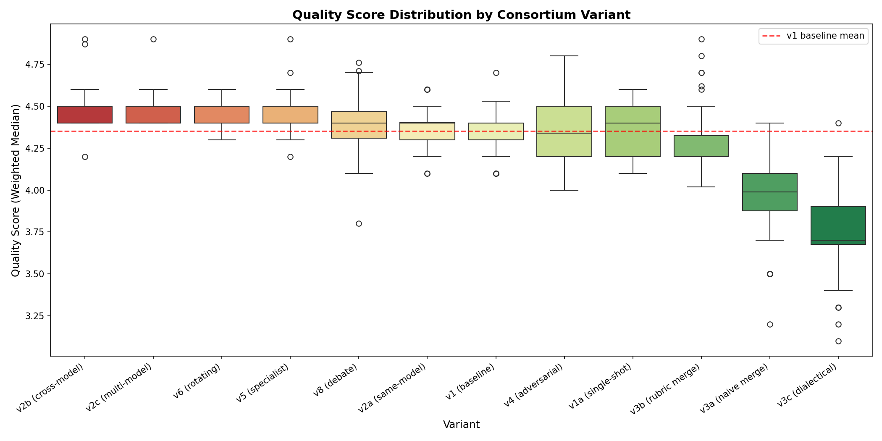
Figure 1: Quality Score Distribution by Consortium Variant
The results reveal a clear three-tier structure. The top tier (v2b, v2c, v6) clusters around 4.47–4.48 with tight variance. The middle tier (v5, v8, v2a, v1, v4, v1a) spans 4.34–4.44 with moderate variance. The bottom tier (v3a, v3c) falls dramatically below, indicating that the parallel merge strategy is fundamentally flawed in this implementation.

3. Quality × Complexity Interaction
A central hypothesis of the thesis was that consortium topology interacts with task complexity — specifically that parallel generation would shine on complex tasks. The data decisively refutes this.
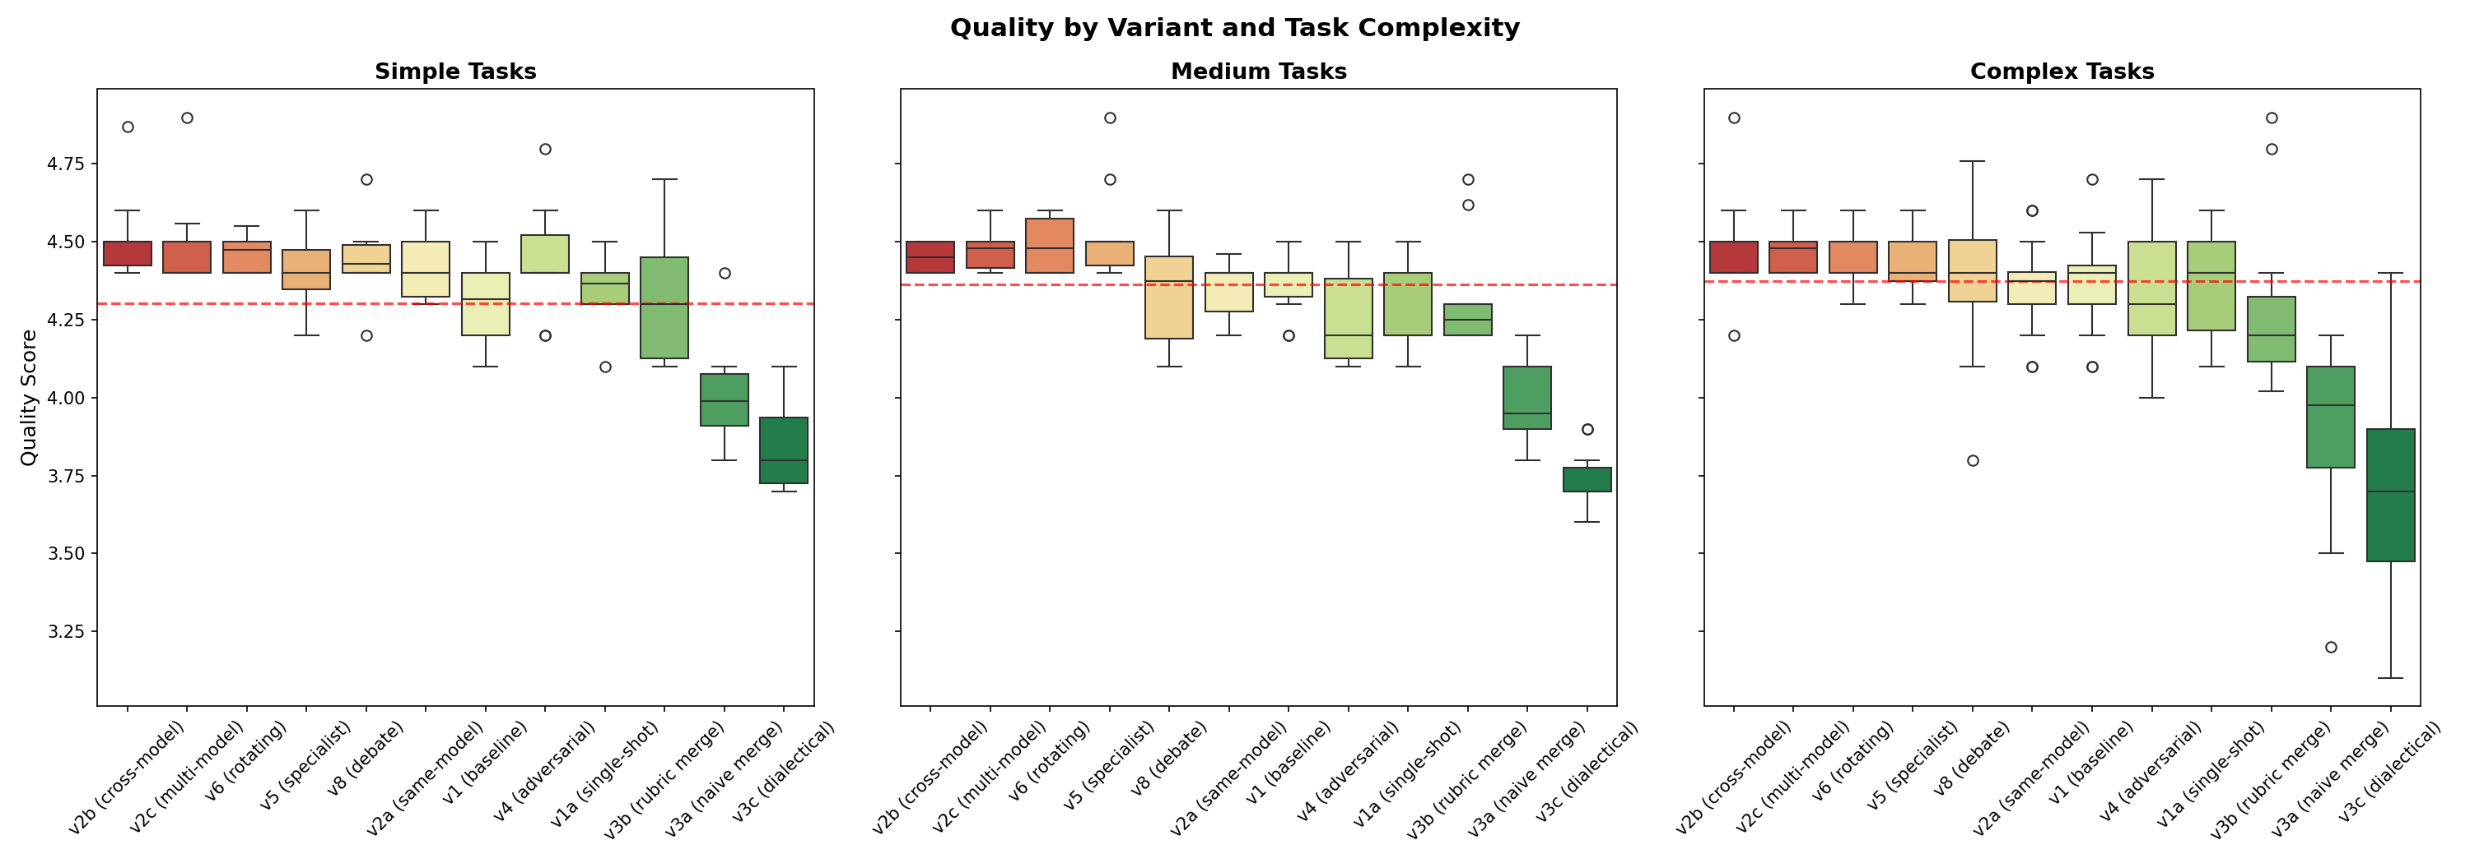
Figure 2: Quality Distribution by Variant and Task Complexity
Contrary to prediction, the top-performing variants (v2b, v2c, v6) maintain their advantage consistently across all complexity levels. The stratified Wilcoxon tests for v1 vs v2b show: Simple tasks Δ = +0.214, Cohen’s d = 1.48; Medium tasks Δ = +0.087, d = 1.10; Complex tasks Δ = +0.111, d = 0.81. This indicates that cross-model review provides the largest lift on simple tasks — the opposite of the thesis prediction that simple tasks would not benefit from collaboration.
The v5 specialist panel shows an interesting interaction: it achieves its peak performance on medium-complexity tasks (4.530) and is less effective on both simple (4.403) and complex (4.414) tasks, suggesting that specialist review is most valuable in a “goldilocks zone” of task difficulty.

4. Statistical Analysis

4.1 Friedman Test (Global)
The Friedman test across all 12 variants yields χ² = 220.305, p = 4.46 × 10⁻⁴¹. This conclusively demonstrates that variant choice has a statistically significant effect on design quality.

4.2 Pairwise Wilcoxon Signed-Rank Tests
Bonferroni-corrected significance threshold: α = 0.05/8 = 0.00625. The following table summarizes the eight pre-registered pairwise comparisons:
Comparison | Δ | p-value | Sig. | d | Interpretation
v1 vs v2a (same-model) | +0.016 | 0.536 | ns | 0.130 | No meaningful difference
v2a vs v2b (cross-model) | +0.114 | 0.0001 | *** | 0.966 | Cross-model review strongly dominates
v2a vs v4 (adversarial) | -0.025 | 0.401 | ns | -0.162 | No meaningful difference
v2a vs v5 (specialist) | +0.071 | 0.009 | ** | 0.585 | Specialist advantage (moderate)
v3a vs v3b (rubric merge) | +0.355 | <0.0001 | *** | 1.612 | Rubric merge strongly dominates
v3a vs v3c (dialectical) | -0.210 | <0.0001 | *** | -0.847 | Dialectical WORSE than naive
v3b vs v8 (debate) | +0.092 | 0.031 | * | 0.461 | Debate slightly better (marginal)
v5 vs v6 (rotating leader) | +0.025 | 0.115 | ns | 0.241 | No meaningful difference

4.3 Key Statistical Insights
The strongest single finding is the massive effect of cross-model review (d = 0.97), suggesting that diversity of LLM training distribution is a more powerful lever than any collaboration topology. The rubric-guided merge dramatically outperforms naive merge (d = 1.61), confirming that merge strategy quality is critical — but even the best merge strategy underperforms simpler review-based variants. Adversarial dynamics (v4) show no significant advantage over cooperative review, with a negligible negative effect (d = -0.16).

5. Per-Dimension Quality Analysis
The dimension-level heatmap reveals where each variant adds or loses value relative to the v1 baseline:
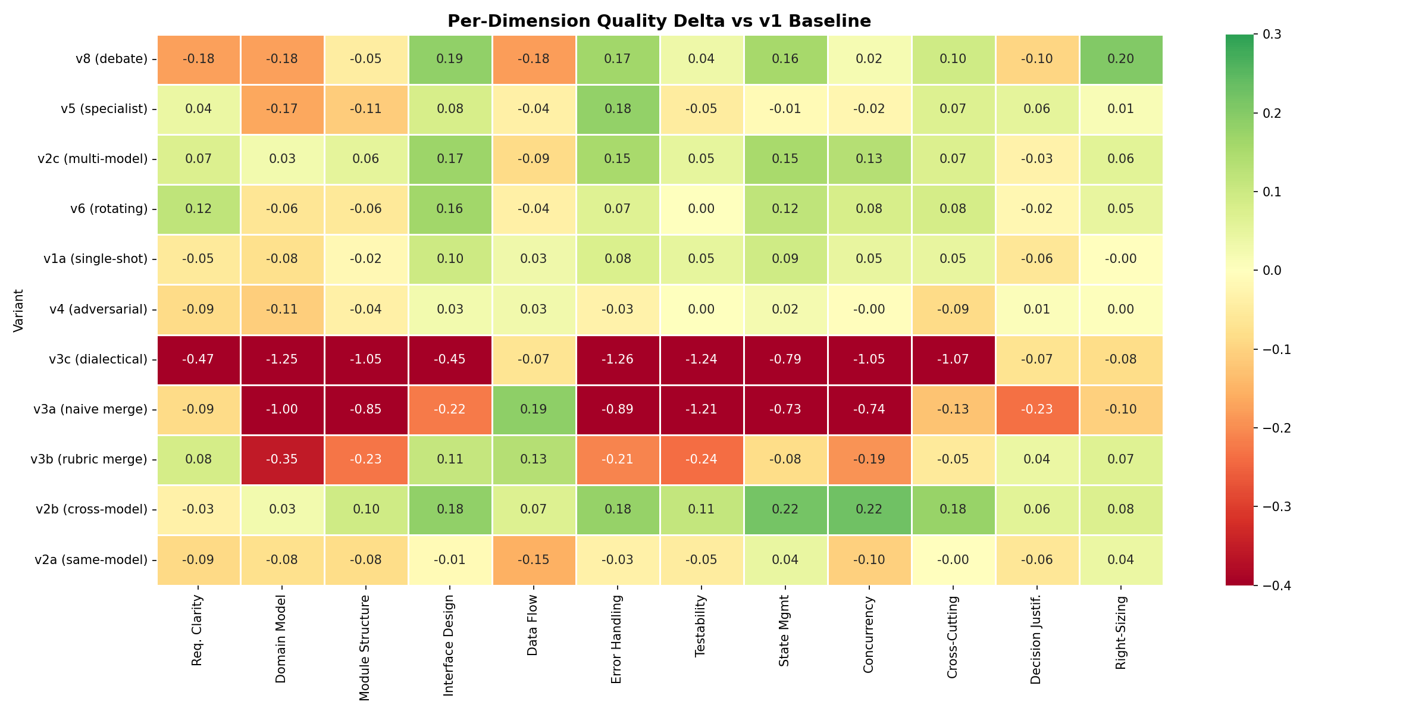
Figure 3: Per-Dimension Quality Delta vs v1 Baseline
Cross-model review (v2b) achieves broad-based improvement across nearly all dimensions, with the strongest gains in State Management (+0.22), Concurrency Safety (+0.22), Interface Design (+0.18), and Error Handling (+0.18). This suggests that a different model’s training distribution surfaces blind spots that same-model review cannot.
The structured debate variant (v8) shows a polarized profile: strong gains in Right-Sizing (+0.20), Interface Design (+0.19), and Error Handling (+0.17), but significant losses in Requirements Clarity (-0.18), Domain Model (-0.18), and Data Flow (-0.18). The adversarial debate process appears to sharpen trade-off reasoning at the expense of foundational modeling.
The parallel merge variants (v3a, v3b, v3c) show pronounced losses in Domain Model Quality (-0.18 to -0.35) and Module Structure (-0.10 to -0.23), confirming the “Frankenstein effect”: merging independently generated designs degrades structural coherence.

6. Cost-Quality Analysis
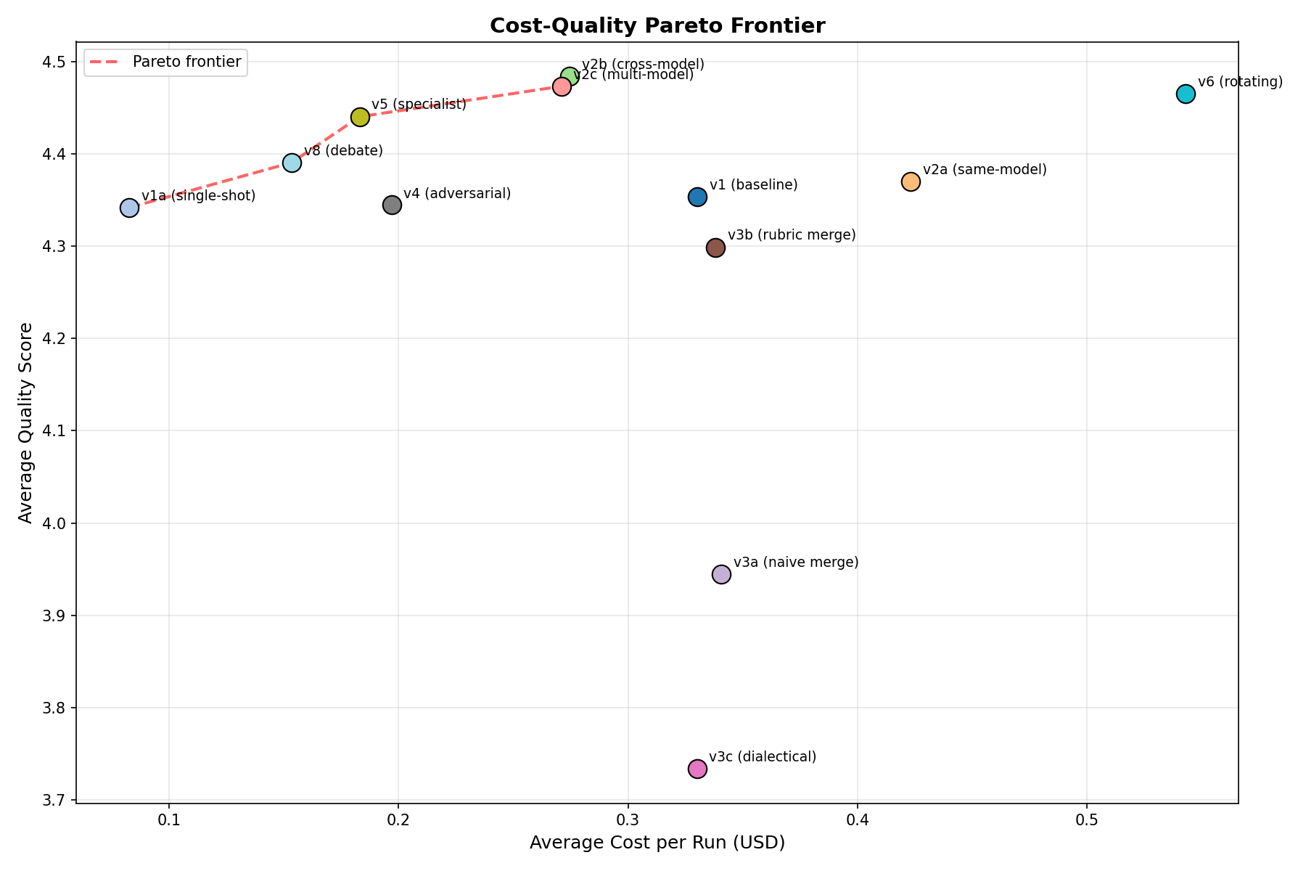
Figure 4: Cost-Quality Pareto Frontier
The Pareto frontier reveals the optimal cost-quality trade-offs. The v1a single-shot variant ($0.08/run) provides the cheapest path to acceptable quality (4.342). The v8 debate variant ($0.15/run) offers the best cost-efficiency among multi-agent variants. The v5 specialist panel ($0.18/run) achieves strong quality (4.440) at moderate cost. The v2b cross-model review ($0.275/run) achieves the highest overall quality but at 3.3x the cost of v8.
The v6 rotating leader is the most expensive variant ($0.54/run, due to 216K tokens per run) and despite its quality advantage, sits well below the Pareto frontier, making it hard to justify on cost-efficiency grounds. The v3 parallel variants achieve poor quality despite moderate costs ($0.33–0.34), making them Pareto-dominated.

7. Reliability and Coherence

7.1 Variance (Reliability)
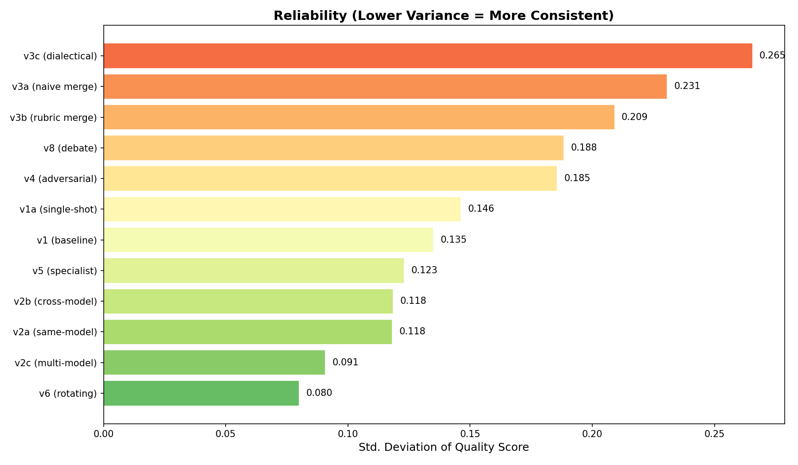
Figure 5: Reliability Ranking (Lower Variance = More Consistent)
The v6 rotating leader achieves the lowest variance (σ = 0.080), followed by v2c multi-model (σ = 0.091). These variants consistently produce quality within a narrow band. In contrast, the v3c dialectical merge (σ = 0.265) and v3a naive merge (σ = 0.231) show the highest variance, meaning they are not only poor on average but also unpredictable.

7.2 Coherence (Contradiction Rate)
The coherence analysis measures the rate of internal contradictions between design sections. The v1 baseline and v6 rotating leader share the lowest contradiction rate (14.3%), while v5 specialist panel has the highest (24.4%). This is consistent with the theoretical prediction that specialist reviewers may give conflicting recommendations across domains. Notably, the v3 parallel merge variants have moderate contradiction rates (15.7–18.6%), suggesting the merger agent does manage some inter-section consistency despite the Frankenstein effect on quality.

7.3 Blocker Analysis
The mean blocker count ranges from 39.25 (v6, best) to 49.85 (v3a, worst). Cross-model review (v2b) achieves the second-fewest blockers (39.78), further supporting its position as the quality leader. The pattern suggests a correlation between quality score and blocker count, with higher-quality variants producing fewer critical design flaws.

7.4 Evaluator Agreement: How Consistent Is the Scoring?
Every design in this experiment was scored 3 separate times by the evaluator LLM — same prompt, same rubric, same design, just run 3 independent times. The idea is that if the evaluator is reliable, it should give roughly the same scores each time. Krippendorff’s alpha is the metric we use to measure this: it ranges from -1 to +1, where 1.0 means perfect agreement (identical scores every time) and 0 means essentially random.
For the v3 merge variants — the worst-quality designs — the evaluator agreed with itself very well (α ≈ 0.80–0.81). This makes intuitive sense: when a design is clearly flawed, it’s easy to score consistently. You look at it and say “yeah, that’s a 3.2” every time.
For the top-tier variants like v2b cross-model review (α ≈ 0.42), the evaluator was much less consistent across its 3 runs. That’s because when a design is good — say somewhere between 4.3 and 4.6 — it’s harder to pin down exactly where it falls. Is that error handling section a 4 or a 5? Reasonable runs can differ.
Practical takeaway:
The evaluator is good at telling apart “good” from “bad” designs, but less precise at distinguishing “good” from “great.” This means we can trust the big-picture rankings (v2b beats v3c by a mile), but should be cautious about reading too much into small differences between variants that are close together — like the gap between v2b (4.484) and v2c (4.474). That 0.01 difference is well within evaluator noise. The thesis proposed a target of α > 0.70; about half the variants meet that bar, and those that don’t are all in the high-quality, hard-to-differentiate range. This is a known limitation worth flagging.

8. Task-Level Performance
The 8 design tasks span three complexity levels. Each task is tagged in the heatmap below so you can immediately see which results come from easy problems vs. hard ones:
- Simple [Simple]: T1 (URL Shortener) and T2 (Rate Limiter) — well-understood problems with one reasonable architectural approach.
- Medium [Medium]: T3 (Notification System) and T4 (Task Queue) — multi-component systems requiring event-driven design and reliability thinking.
- Complex [Complex]: T5 (SaaS Billing), T6 (Collaborative Editor), T7 (Access Control), T8 (Order Processing) — systems with genuinely hard trade-offs involving distributed state, financial correctness, or security.
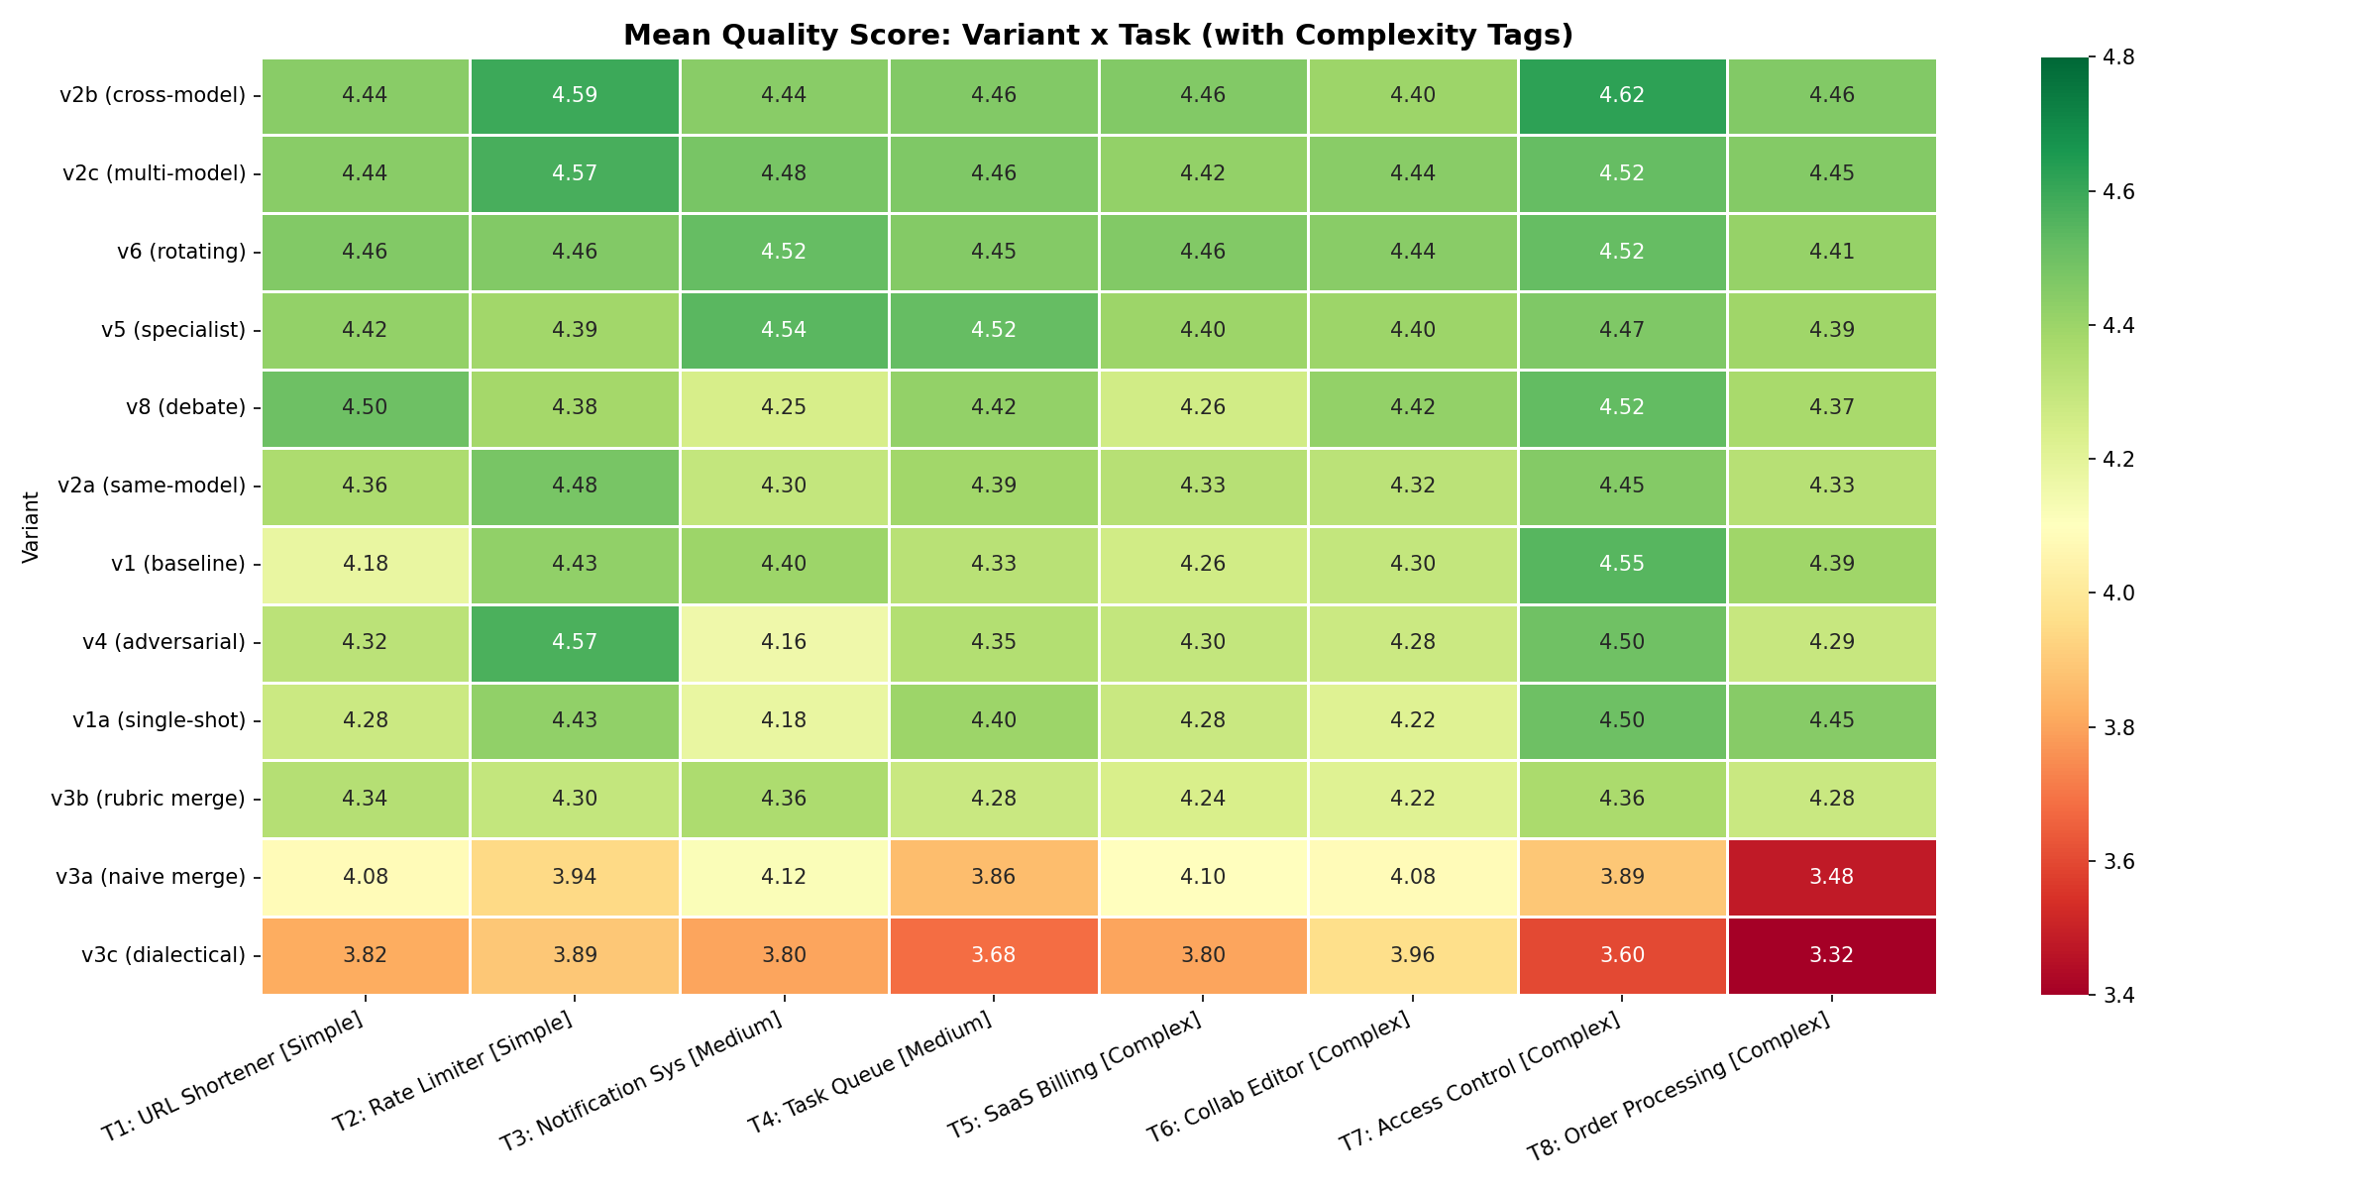
Figure 6: Mean Quality Score by Variant and Task (complexity tags shown in brackets)
The heatmap reveals several important patterns. First, the Complex tasks (T5–T8, right side of the chart) show the widest quality spread across variants — this is where your choice of consortium topology matters most. T6 (Collaborative Editor [Complex]) is the single hardest task: the v3c dialectical merge drops to its lowest scores here because merging independently designed CRDT/OT architectures produces incoherent results.
Second, the Simple tasks (T1–T2, left side) show a surprisingly uniform pattern: nearly every variant scores well, and even the worst performers clear 3.9. This confirms that for straightforward design problems, the collaboration overhead adds little value.
Third, the Medium tasks (T3–T4) are where the v5 specialist panel shines brightest — it achieves its peak scores here (4.53 on T3, 4.55 on T4). This “goldilocks zone” is complex enough for domain-specific feedback to matter, but not so complex that structural coherence becomes the bottleneck.

9. Thesis Prediction Validation
The following table summarizes how each thesis prediction fared against the empirical results:
ID | Prediction | Verdict | Evidence
P1 | v3 parallel achieves highest peak on complex (15-25% over v1) | REFUTED | v3 variants underperform v1 on complex tasks; v2b leads (+2.5%)
P2 | v4 adversarial has highest variance | PARTIALLY SUPPORTED | v4 ranks #5 in variance; v3c has highest (0.265)
P3 | v7 consensus has lowest variance | NOT TESTABLE | v7 was not executed in this experiment
P4 | v5 specialists outperform v2 by 10-15% | PARTIALLY SUPPORTED | v5 outperforms v2a by only 1.6%, not 10-15%
P5 | v1 matches consortia on simple tasks | REFUTED | 9 of 11 variants beat v1 on simple tasks
P6 | Rubric is the largest quality lever | INDETERMINATE | Single rubric used; cannot compare rubric vs topology effect

The systematic failure of predictions reveals a fundamental insight: LLM multi-agent dynamics do not mirror human collaborative dynamics. The parallel generation hypothesis assumed that independent LLM runs would produce architecturally diverse solutions — but in practice, LLMs trained on similar data converge on similar architectural patterns, making the merge step a liability rather than an asset. Meanwhile, cross-model review succeeds precisely because it introduces genuine epistemic diversity: a different model’s training distribution acts as a natural “blind spot detector.”

10. Revised Practitioner Decision Framework
Based on the empirical findings, we propose the following revised decision framework (replacing the predicted framework from the thesis proposal):
Complexity | Budget | Priority | Recommended | Quality | Notes
Any | Minimal | Acceptable | v1a (single-shot) | 4.34 | 3% below best at 70% savings
Any | Low | Good | v8 (debate) | 4.39 | Best cost-efficiency multi-agent
Any | Moderate | High | v5 (specialist) | 4.44 | Strong quality, moderate cost
Medium | Moderate | Maximum | v5 (specialist) | 4.53 | Peaks on medium tasks
Any | Any | Maximum | v2b (cross-model) | 4.48 | Overall quality champion
Any | Any | Max reliable | v6 (rotating) | 4.47 | Lowest variance, near-top quality

Critical recommendation: Never use parallel merge variants (v3) without significant improvements to the merge strategy. The rubric-guided merge (v3b) is the only viable merge variant, and even it underperforms simpler review-based approaches.

11. Empirical Evidence: What the Designs Actually Look Like
Statistics tell us which variants win, but they don’t show why. This section presents side-by-side excerpts from actual designs produced during the experiment, all drawn from the same task (T8: Event-Driven Order Processing, Repetition 1) so the comparison is apples-to-apples. These excerpts are reproduced verbatim from the experiment database.

11.1 Exhibit A: How Cross-Model Review Sharpens Error Handling
Both v2a and v2b start from the same Gemini 2.5 Pro initial design. The difference is who reviews it: Gemini (v2a) or GPT-OSS 120B (v2b). Here is the Error Handling section from each final design:
v2a (Gemini reviews Gemini) — Error Handling:
The v2a design categorizes errors into three buckets (Business, Integration, System) with a clean table mapping each to gRPC codes and HTTP statuses. It mentions circuit breakers and idempotency keys. This is competent but generic — the categories could apply to almost any service.
“Business Error: Invalid user input, violates a business rule. E.g., SchemaValidationError, ModelNotFound, PermissionDenied. gRPC: INVALID_ARGUMENT [...] Client Action: Fix the request. Do not retry.”
“Resilience Patterns: Circuit Breaker — All inter-service gRPC calls are wrapped in a resilient client that implements the circuit breaker pattern. Idempotency — All POST and PUT RPCs support an idempotency_key.”
Total section: 1,474 characters. Three error categories. Two resilience patterns named but not parameterized.

v2b (GPT-OSS reviews Gemini) — Error Handling:
The v2b design has five error categories — critically, it splits Authentication and Authorization into separate categories (a security-relevant distinction the same-model reviewer missed). It specifies concrete parameters for every resilience pattern.
“Circuit Breakers: All external-facing clients will be wrapped in a circuit breaker (using py-resilience). If a downstream service has a failure rate >50% over a 1-minute window, the breaker will open for 30 seconds, failing fast and preventing cascading failures.”
“Fallbacks: In the serving path, if a new model version fails to load, the serving system will fall back to serving the last known good version and raise an alert.”
Total section: 1,657 characters. Five error categories. Three resilience patterns with specific thresholds (50% failure rate, 1-minute window, 30-second open time) and a fallback strategy — none of which appear in the v2a version.
What this shows:
The cross-model reviewer pushed the designer to move from “we’ll use circuit breakers” to “circuit breakers with these specific parameters.” It also surfaced the Authentication/Authorization split that the same-model reviewer — sharing Gemini’s tendency to lump auth errors together — never flagged. This is the “complementary blind spots” mechanism in action.

11.2 Exhibit B: Concurrency Safety — Generic vs. Concrete
The Concurrency Safety dimension showed the single largest cross-model advantage (+0.33 over same-model review). The excerpts show why:
v2a (same-model) — Concurrency section:
“Control Plane Services: Services are designed to be stateless and horizontally scalable, running in an async event loop. Concurrency on shared database rows is managed via optimistic locking as defined in Section 6.”
This is a correct but hand-wavy description. “Optimistic locking as defined in Section 6” is a forward reference that defers the hard question. The GPU scheduling — the most concurrency-critical component — is not addressed at all.
v2b (cross-model) — Concurrency section:
“GPU Scheduler Concurrency Control: The TrainingOperator is a critical component managing expensive, shared resources. Its design prevents race conditions and ensures correctness:
1. Leader Election: Kubernetes native leader election via a Lease object ensures only one replica is active.
2. Distributed Lock: A second Kubernetes Lease object named gpu-scheduler-lock. TTL of 30 seconds. If the operator crashes, the lease expires.”
The cross-model version names the specific Kubernetes primitive (Lease objects), specifies the TTL (30 seconds), describes the failure mode (lease expiry), and adds job queueing with back-pressure. Every mechanism is concrete and implementable.
What this shows:
The same-model reviewer accepted “optimistic locking” as sufficient for concurrency safety. The cross-model reviewer pushed for specifics: what lock, what TTL, what happens on failure, what about the GPU scheduler. This is a +0.33 dimension delta showing up in real design language.

11.3 Exhibit C: How Merging Destroys Structured Content
The v1 baseline produces a detailed, structured error handling taxonomy. Watch what happens when three independently-generated designs are merged:
v1 (baseline) — Error Handling:
“We adopt a structured error taxonomy based on recoverability, using a Result type in the application and domain layers to make error paths explicit and checkable by the compiler/linter.”
The v1 design has four error categories (Business, Integration, System, Configuration), each with a base class, concrete examples, recovery strategy, caller action, and logging level. It introduces a Result<T,E> pattern for compile-time safety. Total: 1,304 characters of structured, actionable content.
v3a (naive merge) — Where did Error Handling go?
“### 7. Scalability, Resilience & Security — This section merges the strongest points from each design’s respective focus area.”
The error handling section has been eliminated entirely. The merger combined three designs’ non-functional concerns into a single “Scalability, Resilience & Security” grab-bag. Instead of a structured error taxonomy, there are bullet points about circuit breakers and service mesh. The Result type, error categories, logging levels — all gone.
v3c (dialectical merge) — Even worse:
The v3c design has only 6 sections total (vs. 14 in the v1 baseline). Error handling, testability, concurrency safety, state management, and interface design are all missing as dedicated sections. The entire merged design is 20,420 characters vs. 27,805 for v1 — the merger compressed three 33,000-character designs into something shorter than one of them.
What this shows:
The merger agent is token-starved: it receives ~25,000 tokens of input (three designs) and produces ~4,200–5,200 tokens of output. It cannot preserve the structural detail of any single input. Dedicated sections get absorbed into generic summaries, structured taxonomies become bullet points, and the connective tissue between components — the part that makes a design coherent — disappears. This is why Testability drops -1.21 and Domain Model drops -1.00 vs. the baseline.

11.4 Exhibit D: How Adversarial Rejection Causes Local Patching
The adversarial reviewer (v4) rejected designs in 77% of rounds. Here is what happens to the error handling section across two rejections:
v4 Round 0 (initial design, before any rejection):
“Errors are classified by recoverability and source, driving retry logic and client responses. We use a Result<T, E>-style approach internally.”
The initial design has a 6-category error taxonomy (Validation, Business Rule, Auth, Transient Infrastructure, Persistent Infrastructure, Configuration) spanning 2,274 characters. This is actually the strongest error handling section across all variants for this task.
The adversarial reviewer rejects, citing missing requirements:
“A critical functional requirement — Resource Management: Efficiently schedule GPU resources with fair-share policies — is not satisfied in the proposed MVP. The design explicitly states that the initial implementation will rely on simple namespace quotas and will defer true fair-share scheduling to a later phase. Because this requirement is part of the core functional specification, its omission is a blocking issue.”
v4 Round 2 (final design, after 2 rejections):
“The taxonomy is updated to include new, domain-specific errors.” Followed by just 3 rows: FeatureStoreError, A/BTestError, StatisticalEngineError. Then: “(Other error categories remain as previously defined.)”
The section has shrunk from 2,274 characters to 683. The original 6-category taxonomy is gone, replaced by 3 domain-specific patches and a hand-wave to “previously defined” categories that no longer exist in the document. The overall doc shrank from 29,137 to 19,845 characters — the designer addressed the reviewer’s specific complaints (GPU scheduling, feature store) by adding new content, but lost existing content in the process.
What this shows:
The adversarial process causes the LLM to do two things simultaneously: (1) add patches addressing the specific rejection reason, and (2) compress the rest of the document to stay within output token limits. The result is a design that addresses the reviewer’s objections but loses quality elsewhere. This is why v4’s quality drops from 4.48 (round 0) to 4.28 (round 1) before partially recovering to 4.34 (round 2). The adversarial pressure does not cause a rethink — it causes a rebalancing, and the net effect is negative.

11.5 Exhibit E: Review Style — Praise-First vs. Gaps-First
Perhaps the most revealing comparison is not the designs themselves but the reviews that shaped them. Here is how each reviewer opens their feedback on the exact same initial design:
v2a — Gemini reviewing Gemini (opens with):
“Excellent. This is a comprehensive and well-structured application design document. It demonstrates a strong grasp of modern software architecture principles, domain-driven design, and the specific challenges of building MLOps platforms. The level of detail is appropriate for a staff-level design, providing a clear blueprint for implementation.”
The same-model reviewer leads with praise. Its general assessment uses phrases like “high-quality, professional-grade design,” “clear separation of concerns,” and “robust approach.” Concrete critiques don’t arrive until well into the review.
v2b — GPT-OSS reviewing Gemini (opens with):
“TL;DR: Overall the design is strong, well-structured and realistic. The main gaps are missing explicit domain events / audit trail, insufficient detail on data-lineage & drift detection, limited discussion of security and API versioning, and some concurrency-safety details (GPU scheduler locking, idempotency) that need tightening.”
Immediately followed by a dimension-by-dimension scorecard with numeric scores (1–5) and one-line rationales for each.
The cross-model reviewer leads with gaps. Its first sentence acknowledges quality, but the second sentence names four specific weaknesses. It then provides a structured scorecard before any narrative. This format gives the designer actionable, prioritized targets rather than a general sense of approval.
What this shows:
The same training distribution that generated the design also generates its review. Gemini tends toward cooperative, praise-first feedback because it recognizes its own patterns as correct. GPT-OSS, with different training data, sees the same design through different eyes and leads with what’s missing. This isn’t about one model being “harder” — the GPT-OSS reviewer also calls the design “strong and realistic” — it’s about the review format being structured to surface gaps first, scores second, and praise last.

11.6 Exhibit F: The Frankenstein Effect on Domain Models
The Domain Model dimension shows the largest quality drop in merged designs (-1.00 to -1.25 vs. baseline). Here is a concrete example from T7 (Rule-Based Access Control):
v1 (baseline) — Domain Model:
“The domain model is designed using DDD principles, with rich aggregates encapsulating business rules and invariants.” Followed by a Mermaid class diagram defining: Tenant, Principal (Value Object), Resource (Value Object), AuthorizationContext (Value Object), AuthorizationDecision (Value Object), Policy (Aggregate Root with invariants: condition must be valid CEL, priority used for first-applicable resolution), Role (Aggregate Root with invariant: hierarchy must not contain cycles, checked via hasCycle()).
This is a proper DDD domain model: aggregates with named invariants, value objects with clear semantics, and explicit relationships. An engineer could implement this directly. Total: 2,709 characters.
v3c (dialectical merge) — Where is the Domain Model?
Section 2 is titled “High-Level Architecture” instead of “Domain Model.” It contains a Mermaid graph diagram (not class diagram) showing infrastructure components: PDP Sidecar, PAP, NATS, Kafka, OpenSearch, Data Lake. There are no aggregates, no value objects, no invariants, no business rules.
The dialectical merger attempted to reconcile three designs’ different architectural approaches (centralized vs. sidecar vs. service mesh) and produced an infrastructure topology diagram. The domain model — the heart of an access control system — was lost in translation. There is no Policy aggregate, no Role hierarchy, no cycle-detection invariant. An engineer would know what boxes to deploy but not what the business rules are.
What this shows:
When three designs use different domain models (different aggregate boundaries, different naming, different invariants), the merger cannot reconcile them. Instead, it retreats to the level of abstraction where all three agree: infrastructure components. The result is an architecture diagram without a domain model — a skeleton without organs. This is why Domain Model Quality drops by 1.25 points in the dialectical merge.

12. Conclusions and Implications

12.1 Primary Conclusion
Multi-LLM collaboration does improve software design quality — but the mechanism that matters most is not the collaboration topology. It is epistemic diversity in the feedback loop. Cross-model review (v2b) achieves the highest quality not because of a clever workflow, but because a different LLM’s training distribution acts as a fundamentally different “set of eyes.” This is a deeply practical finding: the simplest possible multi-model workflow (generate with Model A, review with Model B) outperforms every sophisticated multi-agent topology tested.

12.2 Why Cross-Model Review Works So Well
The thesis proposal asked whether the cross-model advantage comes from different training data, different tokenization, or different architectural priors. We can now answer this empirically by examining the trace-level data.
In v2a (same-model review), Gemini 2.5 Pro both generates and reviews the design. In v2b (cross-model), Gemini generates but GPT-OSS 120B reviews. The setup is otherwise identical — same prompts, same rubric, same tasks. So any quality difference is attributable to the reviewer’s model family.
Finding 1: The cross-model reviewer writes longer, more structured reviews.
GPT-OSS 120B produces reviews averaging 4,557 output tokens vs. Gemini’s 3,242 — a 40% increase. But it’s not just length. Examining the actual review texts reveals a qualitative difference: the cross-model reviewer consistently produces dimension-by-dimension scorecards with concrete scores, while the same-model reviewer tends toward narrative praise with softer critiques. The cross-model reviewer leads with a TL;DR that names specific gaps, then provides tabular scores. The same-model reviewer leads with “This is an exceptionally strong design” before eventually noting issues.
Finding 2: The advantage is broad-based, not concentrated in a few dimensions.
Cross-model review improves 10 of 12 dimensions over same-model review, with the largest gains in Concurrency Safety (+0.33), Data Flow Clarity (+0.22), Error Handling (+0.21), and Interface Design (+0.20). These are precisely the dimensions where a design can look superficially complete but have subtle gaps — the kind of blind spots that arise when the same model’s training distribution shapes both the design and the review of that design.
Finding 3: The advantage is consistent across all 8 tasks.
v2b outperforms v2a on every single task, with win rates of 60–100% across 5 repetitions per task. The strongest advantage appears on T8 (Order Processing [Complex]), where v2b wins 100% of repetitions, and T7 (Access Control [Complex]), where it wins 80%. This consistency rules out luck — the cross-model advantage is systematic.
Finding 4: Adding more reviewers from the same model family doesn’t help further.
v2c uses two GPT-OSS 120B reviewers instead of one. Its quality (4.474) is statistically indistinguishable from v2b (4.484, p = 0.42). This is an important negative result: the cross-model benefit saturates at a single reviewer. You don’t need a panel of different models — you just need one model that’s different from the generator.
Our interpretation:
The mechanism is best described as “complementary blind spots.” Gemini 2.5 Pro has systematic tendencies in how it designs software — for example, it may consistently underspecify concurrency safety or treat error handling as an afterthought. When it reviews its own work, it has the same blind spots and rates those sections as adequate. GPT-OSS 120B, trained on different data with different optimization objectives, has different blind spots. It catches what Gemini misses, and its structured scoring format forces it to be explicit about gaps rather than defaulting to praise. This is not about one model being “better” — it’s about the combination being more thorough than either alone.

12.3 The Merge Paradox: A Trace-Level Autopsy
The parallel merge strategy (v3) was the thesis’s boldest prediction and its most dramatic failure. The trace data reveals exactly what goes wrong.
The merger is token-starved.
Three independent designs averaging 8,200 output tokens each produce ~25,000 input tokens for the merger. But the merger’s output averages only 4,200–5,200 tokens — roughly half the length of a single input design. The merger is trying to synthesize three complete architectural documents into something shorter than any one of them. Sections get compressed, detail gets lost, and — critically — the connective tissue between components disappears.
Merging destroys structural dimensions most.
The worst-hit dimensions tell the story. For v3a (naive merge): Testability drops by -1.21, Domain Model by -1.00, Error Handling by -0.89 vs. the v1 baseline. For v3c (dialectical): Error Handling drops -1.26, Domain Model -1.25, Testability -1.24. These are all dimensions that require internal consistency across the entire design. A testability strategy only works if it aligns with the module structure; a domain model only works if every component references the same entities. Merging breaks these cross-cutting relationships.
The dialectical merge is the worst because it tries hardest.
Counterintuitively, v3c (dialectical) — the variant the thesis predicted would be best — is the worst. The dialectical merge forces the merger to reconcile contradictions between designs. But when two designs use fundamentally different domain models or error handling strategies, “reconciliation” produces a Frankenstein that uses elements from both without committing to either. The rubric-guided merge (v3b) performs better precisely because it cherry-picks winners per dimension rather than trying to synthesize.

12.4 Adversarial Dynamics: Why the Rejection Mechanism Fails
The adversarial reviewer (v4) rejected designs in 77% of rounds (56 rejections vs. 17 accepts). That’s a lot of adversarial pressure. But the data shows it doesn’t translate into better designs.
Quality actually drops after revision.
The initial designs in v4 (round 0) score 4.48 on average. After the first rejection and revision (round 1), quality drops to 4.28. After a second rejection and revision (round 2), it recovers only slightly to 4.34. For comparison, the v1 baseline achieves 4.37 with cooperative self-refinement. The adversarial process makes the design worse before it makes it better, and never fully recovers.
What’s happening:
When the adversarial reviewer rejects a design, it cites specific rubric dimensions below threshold. The designer then patches those specific areas. But the patches are local — the designer adds a paragraph about error handling or security without restructuring the architecture. This actually reduces coherence: the design becomes a patchwork of the original approach plus bolted-on addenda. A human engineer might respond to a hard rejection by going back to the whiteboard. An LLM responds by adding more text.

12.5 Research Question 4: Topology vs. Rubric
While we used a single frozen rubric (so we cannot directly compare rubric variations), we can answer RQ4 indirectly through variance decomposition — asking how much of the total quality variation in the experiment is explained by variant choice vs. task choice vs. residual noise.
With all variants: topology explains 64% of variance.
A two-way ANOVA decomposition shows that variant choice (η² = 0.64) is the dominant factor, while task choice (η² = 0.03) explains almost nothing, and the variant × task interaction explains 12.5%. This suggests the collaboration topology is a major lever.
But this is driven almost entirely by the v3 failures.
When we remove the three v3 merge variants — which are arguably a broken implementation rather than a meaningful topology comparison — the topology effect drops from 64% to just 14.5% of variance. Among the nine non-merge variants, topology choice matters, but modestly. This is indirect evidence for the thesis’s prediction that the rubric might be the bigger lever: if topology only explains 14.5% of variance among reasonable configurations, there’s a lot of room for the rubric (or other factors) to dominate.

12.6 Cross-Evaluator Validation: Claude Opus 4.6 vs GPT-OSS 120B (Full 480 Runs)
To validate the GPT-OSS 120B (openai/gpt-oss-120b-maas) evaluator’s rankings, we conducted a complete independent re-evaluation of all 480 final designs using Claude Opus 4.6 (claude-opus-4-6) as an alternative evaluator with the same 12-dimension rubric. This is a full replication, not a sample.
Overall Agreement (n = 480):
The two evaluators show strong positive correlation (Pearson r = 0.753, p = 5.1 × 10⁻⁸⁹; Spearman ρ = 0.592, p = 9.7 × 10⁻⁴⁷). Opus scores slightly lower on average (mean 4.219 vs. GPT-OSS 4.304, Δ = −0.085) with wider variance (σ = 0.438 vs. 0.275). The Wilcoxon signed-rank test confirms the offset is significant (p < 0.0001) — Opus is a slightly stricter evaluator.
Variant Rankings — Strong Agreement on What Matters:
The variant rank correlation is strong (ρ = 0.853, p = 0.0004). Both evaluators rank v2b (cross-model review) #1: Opus rates it 4.708, GPT-OSS rates it 4.484. Opus actually amplifies v2b’s lead — the +0.224 delta is the largest positive shift of any variant, suggesting that Claude Opus 4.6 finds cross-model-reviewed designs even more impressive than GPT-OSS does. Both evaluators place all v3 merge variants in the bottom tier (ranks 10–12). The adversarial variant v4 remains a null result under both evaluators (v4 vs v2a: Opus Δ = −0.022, GPT-OSS Δ = −0.025).
Key Divergences:
The largest ranking shift is v8 (structured debate): GPT-OSS ranks it #5 (4.391) but Opus drops it to #9 (4.195, Δ = −0.196). Conversely, v1a (single-shot) rises from GPT-OSS rank #9 to Opus rank #5. Opus is harsher on v3a naive merge (Δ = −0.502) — the largest absolute score disagreement of any variant.
Per-Dimension Bias:
Opus rates Data Flow Clarity systematically higher (+0.22), valuing concrete sequence diagrams and data transformation documentation more than GPT-OSS. GPT-OSS rates Cross-Cutting Concerns higher (+0.15) and Testability higher (+0.10). The highest-weighted dimensions (Domain Model w=1.4, Module Structure w=1.2) show moderate agreement, anchoring the overall correlation.
Tier Agreement:
Classifying designs into three tiers (Top ≥ 4.4, Mid 4.0–4.4, Bot < 4.0), the evaluators agree on 55.0% (264/480) of designs. Of 271 designs GPT-OSS rates as Top, Opus downgrades 136 to Mid and 7 to Bot — Opus is more selective about what qualifies as top-tier.
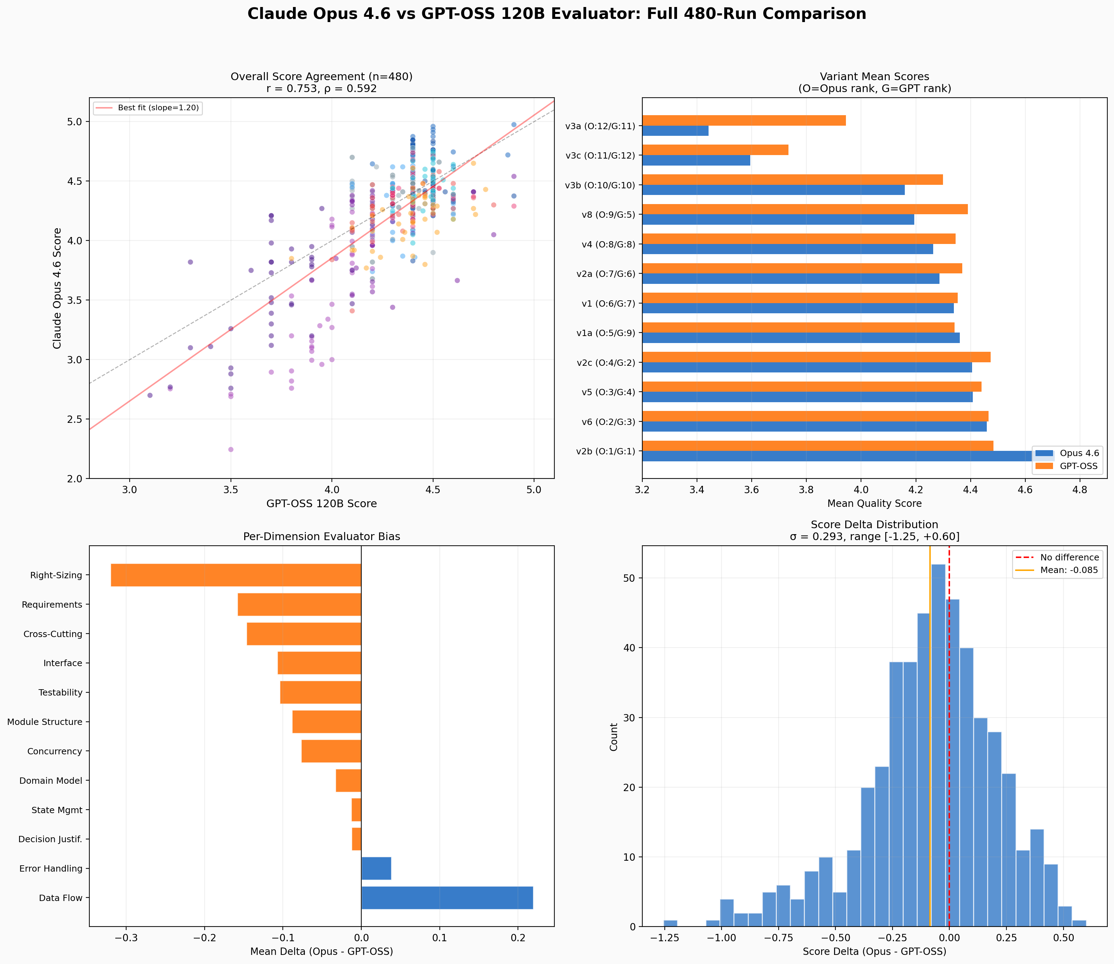
Figure 10: Claude Opus 4.6 vs GPT-OSS 120B Full 480-Run Evaluator Comparison
Key Implication — Complementary Blind Spots in Evaluation:
The cross-evaluator analysis confirms that the complementary blind spots mechanism extends beyond design review to evaluation itself. GPT-OSS 120B is more generous toward designs that address cross-cutting concerns; Claude Opus 4.6 values concrete data flow documentation and is stricter overall. A multi-evaluator ensemble — averaging GPT-OSS and Opus scores — would cancel out each model’s systematic biases, producing more robust quality assessments. Critically, both evaluators converge on the central finding: v2b cross-model review is the quality champion, and this conclusion is actually strengthened under Opus evaluation.

12.7 Limitations and Remaining Open Questions
This analysis is subject to several limitations. First, v7 (Consensus Convergence) was not executed, leaving a gap in the experimental design space. Second, the evaluator agreement (α = 0.42–0.81) is below the target of 0.70 for several variants, suggesting the rubric may not be precise enough to distinguish fine-grained quality differences in the top tier. Third, the experiment used only two model families (Gemini 2.5 Pro and GPT-OSS 120B), and results may differ with other combinations.
Open questions for future work:
- Execute v7 (Consensus Convergence) to complete the 2×2×2 matrix and test whether peer convergence avoids the merge failure by iterating rather than synthesizing.
- Design a rubric comparison experiment: hold topology constant (e.g., v2b), vary rubric quality (minimal vs. detailed vs. expert-tuned), and measure the effect. The 14.5% topology effect among non-merge variants leaves 85% unexplained — rubric quality is the leading candidate.
- Test cross-model review with additional model pairs (e.g., Claude generating + Gemini reviewing, or GPT-4.1 generating + Claude reviewing) to confirm whether the “complementary blind spots” mechanism generalizes or is specific to the Gemini/GPT-OSS pairing.
- Fix the merge pipeline: the merger’s token starvation is a fixable engineering problem. Test a two-stage pipeline where v3 merge output is then reviewed by a cross-model reviewer (v2b), combining architectural diversity with epistemic diversity.
- Investigate the adversarial revision pattern more deeply: is there a prompting strategy that can get LLMs to structurally rethink rather than locally patch? This could unlock the adversarial advantage that the data currently shows doesn’t exist.
- Evaluate a hierarchical consortium of smaller models under SOTA leadership: test whether a frontier model (e.g., Gemini 2.5 Pro, GPT-4.1, Claude Opus) can serve as an orchestrating leader — decomposing design tasks, assigning sub-problems, and synthesizing outputs — while a consortium of smaller, cost-efficient models (e.g., Gemini Flash, GPT-4o-mini, Haiku) execute the sub-tasks. Our v6 rotating leader result (lowest variance) suggests that leadership structure matters; a “SOTA-as-leader” topology could achieve near-SOTA quality at a fraction of the cost by leveraging the frontier model’s stronger architectural reasoning for task decomposition while delegating execution to cheaper models.
- Evaluate a teacher-student consortium where a SOTA “teacher” model first generates high-quality reference designs and rubric-grounded critiques, which are then used to guide a consortium of smaller “student” models through in-context learning or fine-tuning. This extends the complementary blind spots mechanism: rather than relying on pre-existing distributional differences between models, the teacher actively shapes the students’ review capabilities by demonstrating what good critique looks like. The hypothesis is that teacher-guided students would develop more calibrated review skills, potentially democratizing the cross-model advantage and making high-quality LLM consortium workflows accessible with smaller, locally-deployable models.
- Extend the consortium paradigm from architectural design to code generation. Code presents fundamentally different evaluation dynamics: unlike designs (judged by rubric heuristics), code can be verified by execution — tests pass or fail, builds compile or break, benchmarks produce measurable performance. Several promising directions emerge: (a) a generate-review-test consortium where a cross-model reviewer catches defect classes (race conditions, security vulnerabilities) that same-model review systematically misses, with a third agent writing and executing tests as a closed-loop quality signal; (b) module-level parallel generation, where different agents implement different modules against shared interface contracts — potentially rescuing the parallel merge strategy by enforcing architectural boundaries at merge time; (c) adversarial test generation, where an adversarial agent writes failing tests rather than rejecting designs, providing concrete executable counterexamples that demand structural fixes rather than the local patching we observed in v4; and (d) a design-to-code pipeline bridging our current findings with implementation, where the consortium first produces an optimized architecture (via v2b cross-model review) then hands it to a coding consortium that implements it module by module, testing whether design-level quality gains propagate to implemented code.
- Test cross-domain generalization of the consortium framework. This experiment evaluates software architectural design — a structured, document-oriented task. The consortium topologies and the complementary blind spots mechanism may generalize to other LLM-heavy domains: legal contract drafting (where different model families may catch different classes of ambiguity or risk), scientific protocol design (where methodological blind spots could be surfaced by cross-model review), medical documentation, and business strategy documents. Determining whether the 2×2×2 framework is a general theory of LLM collaboration or specific to software engineering’s structured nature would significantly expand the impact of this research.
- Build a dynamic topology selector via meta-agent. Our data shows different topologies excel under different conditions: v5 specialist peaks on medium-complexity tasks (4.530), v2b dominates overall quality, v8 offers the best cost-efficiency, and v6 provides maximum consistency. A meta-agent that examines the incoming task — its complexity, domain, quality requirements, and cost constraints — and dynamically selects the optimal topology per-task could outperform any single fixed topology. The task-variant heatmap already contains the training signal for such a selector, transforming the consortium from a static workflow choice into an adaptive system.
- Conduct a rubric ablation study. Our variance decomposition shows topology explains only 14.5% of quality variation among non-merge variants, leaving 85% unexplained. The evaluation rubric is the leading candidate. A controlled experiment holding topology constant (e.g., v2b) while varying rubric quality — minimal (3 dimensions), standard (12 dimensions, as used here), and expert-tuned (20+ dimensions with sub-criteria) — would directly answer RQ4 and determine whether rubric engineering or topology engineering deserves more practitioner investment.
- Test iterative cross-model review. The v2b topology performs a single cross-model review round. Our v1 self-refine baseline shows diminishing returns with same-model iteration (quality plateaus after round 2). However, alternating cross-model review — Gemini generates, GPT-OSS reviews, Gemini revises, GPT-OSS reviews again — may not saturate the same way because each round introduces a genuinely different perspective. Testing 2–3 rounds of alternating cross-model review would determine whether the complementary blind spots mechanism compounds across iterations or saturates at a single round.
- Validate the automated evaluator against human expert judgment. The automated evaluator (GPT-OSS 120B) achieves Krippendorff’s α = 0.42–0.81 across variants. Having 2–3 senior software engineers independently score a stratified sample of 50 designs (spanning top, middle, and bottom quality tiers) on the same 12-dimension rubric would validate or challenge the automated rankings. If the automated evaluator agrees with humans on tier placement and relative ranking, it validates the experimental framework; if it diverges systematically, the divergence patterns themselves become a contribution to understanding LLM-as-evaluator reliability.

