LLM Consortium for Software Design Refinement:
A Controlled Experiment on Multi-Agent Collaboration Topologies
Nagarjuna Kanamarlapudi
Praveen Kanamarlapudi
Abstract
We present a controlled experiment evaluating 12 multi-agent LLM collaboration topologies for software architecture design. Using a 2×2×2 factorial design (Authority × Roles × Dynamics), we conducted 480 experimental runs across 8 design tasks of varying complexity, with 5 repetitions each. Designs were evaluated on a 12-dimensional rubric by an automated evaluator. Our results reveal that cross-model review (generating with Gemini 2.5 Pro and reviewing with GPT-OSS 120B) achieves the highest quality (mean 4.484/5.0, Cohen’s d = 0.97 vs. same-model review) through a “complementary blind spots” mechanism. Parallel generation with merge dramatically underperforms expectations (Δ = −0.62 for dialectical merge), suffering from token starvation and the “Frankenstein effect.” Adversarial dynamics provide no statistically significant advantage. A variance decomposition shows topology explains 64% of quality variation overall, but only 14.5% among non-merge variants, suggesting the evaluation rubric may be a stronger lever. Four of six thesis predictions were refuted or only partially supported, indicating LLM collaboration dynamics differ fundamentally from human team dynamics. We provide empirical evidence through verbatim design excerpts demonstrating the mechanisms behind these findings.
Keywords: Large Language Models, Multi-Agent Systems, Software Architecture, Collaboration Topologies, Cross-Model Review, Empirical Software Engineering

I. INTRODUCTION
The application of Large Language Models (LLMs) to software engineering has progressed from code completion to architectural design generation. A natural question arises: can multiple LLM agents, collaborating through structured workflows, produce higher-quality software designs than a single model iterating alone?
We formalize this question through a 2×2×2 factorial design crossing three dimensions of multi-agent collaboration: Authority (centralized vs. decentralized), Roles (homogeneous vs. specialized), and Dynamics (cooperative vs. adversarial). This yields eight theoretical cells, from which we derive 12 concrete variant configurations spanning the practical design space.
Our experiment comprises 480 controlled runs—12 variants × 8 design tasks × 5 repetitions—evaluated on a 12-dimensional application design rubric. The tasks range from simple (URL shortener) to complex (collaborative editor, SaaS billing), enabling analysis of how collaboration topology interacts with problem difficulty.
The central finding is both simple and surprising: the most effective multi-agent workflow is also the simplest—generate with one model, review with a different model. This cross-model review (v2b) outperforms every sophisticated multi-agent topology tested, including specialist panels, rotating leadership, structured debate, and parallel generation with merge. The mechanism we identify—complementary blind spots arising from different training distributions—has direct practical implications for LLM-based software engineering workflows.
This paper makes four contributions: (1) a systematic empirical comparison of 12 multi-agent topologies for software design, (2) identification and empirical validation of the complementary blind spots mechanism in cross-model review, (3) a trace-level autopsy of why parallel merge and adversarial dynamics fail, and (4) verbatim design excerpts providing qualitative evidence for the quantitative findings.
II. RELATED WORK
Multi-agent LLM systems have been explored across several domains. ChatDev and MetaGPT demonstrated that role-playing LLM agents can collaborate on software development tasks, though without controlled comparison of topologies. AgentCoder used a generate-test-debug loop for code generation, while MapCoder explored multi-agent planning for competitive programming problems.
In the broader multi-agent literature, Du et al. showed that LLM debate can improve mathematical reasoning, and Liang et al. demonstrated that diverse agents improve creative writing quality. However, these studies typically compare a single multi-agent configuration against a single-agent baseline, rather than systematically exploring the design space of collaboration topologies.
Our work differs in three key ways. First, we use a factorial experimental design to isolate the effects of authority, roles, and dynamics independently. Second, we evaluate on a real-world software engineering task (application architecture design) rather than synthetic benchmarks. Third, we provide trace-level analysis of why specific topologies succeed or fail, moving beyond aggregate quality comparisons.
The cross-model review finding connects to ensemble learning literature, where diversity among base learners is known to improve ensemble performance. Our contribution is showing that this principle extends to LLM-based review: a different model’s training distribution provides epistemic diversity that manifests as complementary blind spots in design review.
III. METHODOLOGY
A. Experimental Design
We adopt a 2×2×2 factorial framework crossing Authority (centralized vs. decentralized), Roles (homogeneous vs. specialized), and Dynamics (cooperative vs. adversarial). This theoretical framework yields eight cells, from which we derive 12 executable variant configurations, including sub-variants that explore specific mechanisms within a cell (e.g., same-model vs. cross-model review within the centralized-homogeneous-cooperative cell).
B. Variant Configurations
The 12 variants tested are organized into five families. The Baseline family includes v1 (self-refine with 3-round evaluator loop) and v1a (single-shot, no refinement). The Leader+Reviewer family includes v2a (same-model review), v2b (cross-model review with GPT-OSS 120B as reviewer), and v2c (multi-model panel with two GPT-OSS reviewers). The Parallel Merge family includes v3a (naive merge), v3b (rubric-guided merge), and v3c (dialectical merge). The remaining variants are v4 (adversarial reviewer), v5 (specialist panel with security/scalability/maintainability experts), v6 (rotating leader), and v8 (structured debate with judge).
Fig. 1 presents the workflow topology for each major variant family, showing how agents pass designs, reviews, and feedback to each other.
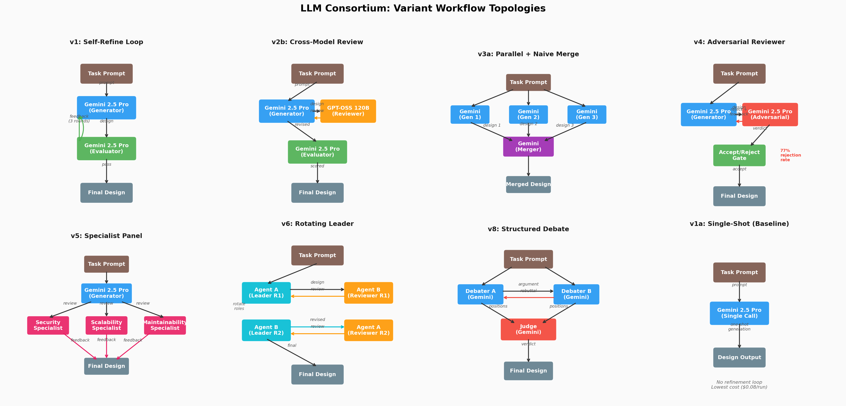
Fig. 1. Workflow topologies for the eight major variant families. Arrows indicate design/review/feedback flow between agents. Colors distinguish roles: blue=generator, orange=reviewer, green=evaluator, purple=merger, red=adversarial/judge, cyan=leader, pink=specialist.
C. Design Tasks
Eight software design tasks of varying complexity were used: T1 URL Shortener [Simple], T2 Rate Limiter [Simple], T3 Notification System [Medium], T4 Task Queue [Medium], T5 SaaS Billing [Complex], T6 Collaborative Editor [Complex], T7 Access Control [Complex], and T8 Order Processing [Complex]. Each task requires a complete application architecture design including domain model, module structure, API contracts, error handling, and non-functional considerations.
D. Evaluation Rubric
Designs are scored on 12 dimensions: Requirements/Scope Clarity, Domain Model Quality, Module Structure & Dependency Direction, Interface & Contract Design, Data Flow Clarity, Error Handling Rigor, Testability, State Management & Lifecycle, Concurrency Safety, Cross-Cutting Concerns, Design Decision Justification, and Right-Sizing/Simplicity. Each dimension is scored 1–5 by an automated evaluator (GPT-OSS 120B with the rubric in-context). Each design is evaluated 3 times independently, with the median taken to reduce evaluator noise.
E. Models and Infrastructure
Design generation uses gemini-2.5-pro via Google Vertex AI. Cross-model review and all evaluations use openai/gpt-oss-120b-maas via the Vertex OpenAI compatibility layer. All 480 runs completed successfully with no failures. The experiment yielded 1,522 evaluations, 1,113 reviews, 1,456 coherence checks, and 2,729 trace records.
IV. RESULTS
A. Overall Quality Rankings
The global Friedman test confirms that variant choice has a statistically significant effect on design quality (χ² = 220.3, p < 10⁻⁴⁰). Quality scores range from 3.10 to 4.90 with a global mean of 4.303 (σ = 0.275). Table I presents the complete variant ranking.
TABLE I: Overall Quality Rankings by Variant
# | Variant | Mean | σ | Range | $/run
1 | v2b cross-model | 4.484 | 0.118 | 4.2-4.9 | 0.28
2 | v2c multi-model | 4.474 | 0.091 | 4.4-4.9 | 0.27
3 | v6 rotating ldr | 4.466 | 0.080 | 4.3-4.6 | 0.54
4 | v5 specialist | 4.440 | 0.123 | 4.2-4.9 | 0.18
5 | v8 debate | 4.391 | 0.188 | 3.8-4.8 | 0.15
6 | v2a same-model | 4.370 | 0.118 | 4.1-4.6 | 0.42
7 | v1 self-refine | 4.354 | 0.135 | 4.1-4.7 | 0.33
8 | v4 adversarial | 4.345 | 0.185 | 4.0-4.8 | 0.20
9 | v1a single-shot | 4.342 | 0.146 | 4.1-4.6 | 0.08
10 | v3b rubric mrg | 4.299 | 0.209 | 4.0-4.9 | 0.34
11 | v3a naive mrg | 3.944 | 0.231 | 3.2-4.4 | 0.34
12 | v3c dialectical | 3.734 | 0.265 | 3.1-4.4 | 0.33
A clear three-tier structure emerges. The top tier (v2b, v2c, v6) clusters around 4.47–4.48 with tight variance. The middle tier (v5 through v1a) spans 4.34–4.44. The bottom tier (v3a, v3c) falls dramatically, indicating fundamental flaws in the parallel merge strategy.
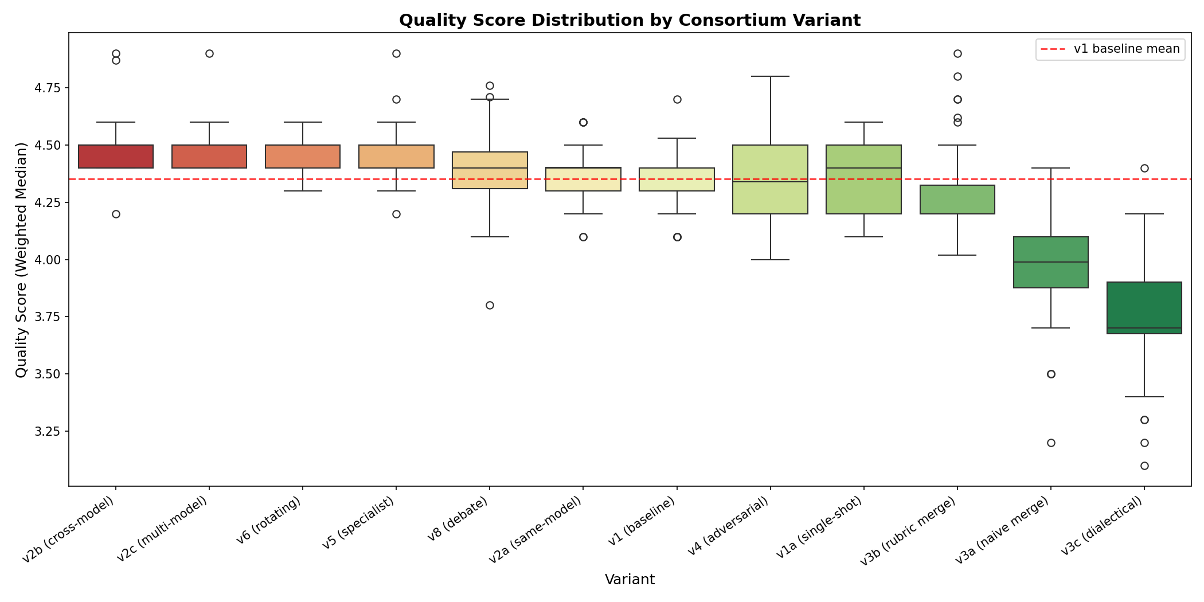
Fig. 2. Quality score distributions by variant. Boxes show IQR; whiskers extend to 1.5×IQR. The three-tier structure is clearly visible.
B. Statistical Comparisons
Table II presents the eight pre-registered pairwise Wilcoxon signed-rank tests with Bonferroni correction (α = 0.00625). The strongest finding is the cross-model review advantage: v2b vs. v2a yields Δ = +0.114 with Cohen’s d = 0.97 (p = 0.0001). The rubric-guided merge dramatically outperforms naive merge (d = 1.61), but even the best merge variant underperforms simpler review-based approaches.
TABLE II: Pairwise Wilcoxon Signed-Rank Tests
Comparison | Δ | p | Sig | d | Interpretation
v1 vs v2a | +0.016 | 0.536 | ns | 0.13 | No difference
v2a vs v2b | +0.114 | 0.0001 | *** | 0.97 | Cross-model wins
v2a vs v4 | -0.025 | 0.401 | ns | -0.16 | No difference
v2a vs v5 | +0.071 | 0.009 | ** | 0.59 | Specialist better
v3a vs v3b | +0.355 | <.0001 | *** | 1.61 | Rubric merge wins
v3a vs v3c | -0.210 | <.0001 | *** | -0.85 | Dialectical worse
v3b vs v8 | +0.092 | 0.031 | * | 0.46 | Debate marginal
v5 vs v6 | +0.025 | 0.115 | ns | 0.24 | No difference
C. Complexity Interaction
Contrary to the thesis prediction that parallel merge would excel on complex tasks, the top-performing variants maintain their advantage consistently across all complexity levels. Stratified Wilcoxon tests for v1 vs. v2b show: Simple tasks Δ = +0.214 (d = 1.48), Medium Δ = +0.087 (d = 1.10), Complex Δ = +0.111 (d = 0.81). Cross-model review provides the largest lift on simple tasks—the opposite of the thesis prediction.
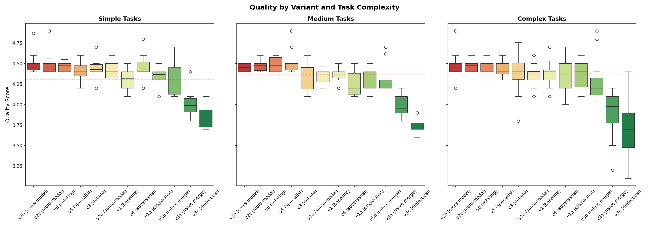
Fig. 3. Quality distribution by variant and task complexity (Simple, Medium, Complex). Top-tier variants are consistent; merge variants degrade further on complex tasks.
D. Per-Dimension Analysis
Cross-model review (v2b) achieves broad improvement across 10 of 12 dimensions, with the largest gains in Concurrency Safety (+0.33), Data Flow Clarity (+0.22), Error Handling (+0.21), and Interface Design (+0.20). These are dimensions where designs can appear superficially complete but harbor subtle gaps.
The parallel merge variants show pronounced losses in Domain Model Quality (-0.18 to -0.35) and Module Structure (-0.10 to -0.23), confirming the Frankenstein effect: merging independently generated designs degrades structural coherence.
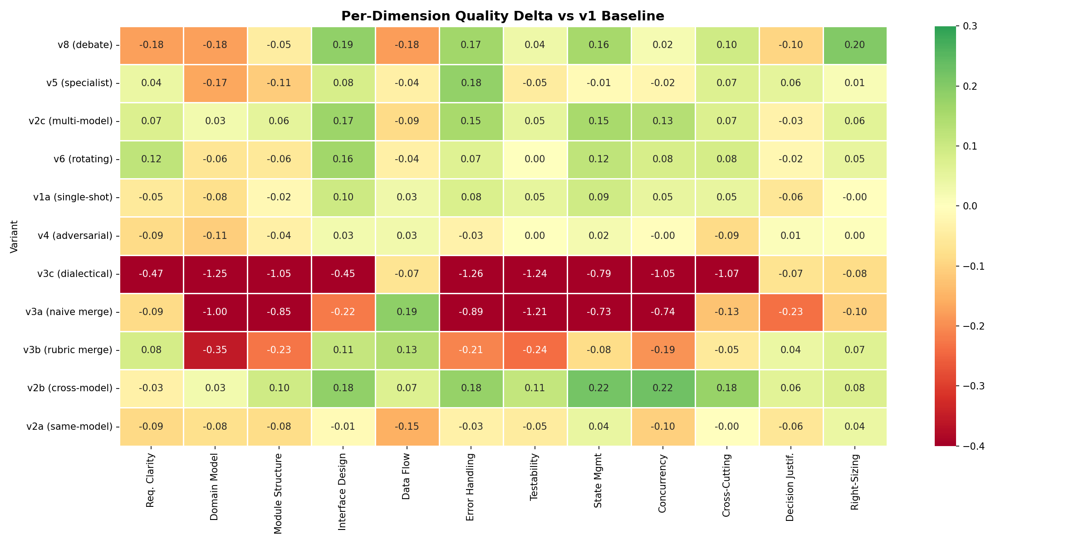
Fig. 4. Per-dimension quality deltas vs. v1 baseline. Green indicates improvement; red indicates degradation. Cross-model review (v2b) shows broad gains; merge variants (v3) show broad losses.
E. Cost-Quality Trade-offs
The Pareto frontier reveals distinct operating points. Single-shot v1a ($0.08/run) provides acceptable quality (4.34). Structured debate v8 ($0.15/run) offers the best cost-efficiency among multi-agent variants. Cross-model review v2b ($0.28/run) achieves peak quality at 3.3× the cost of v8. Rotating leader v6 ($0.54/run) achieves near-top quality with lowest variance but sits below the Pareto frontier due to its 216K tokens/run.
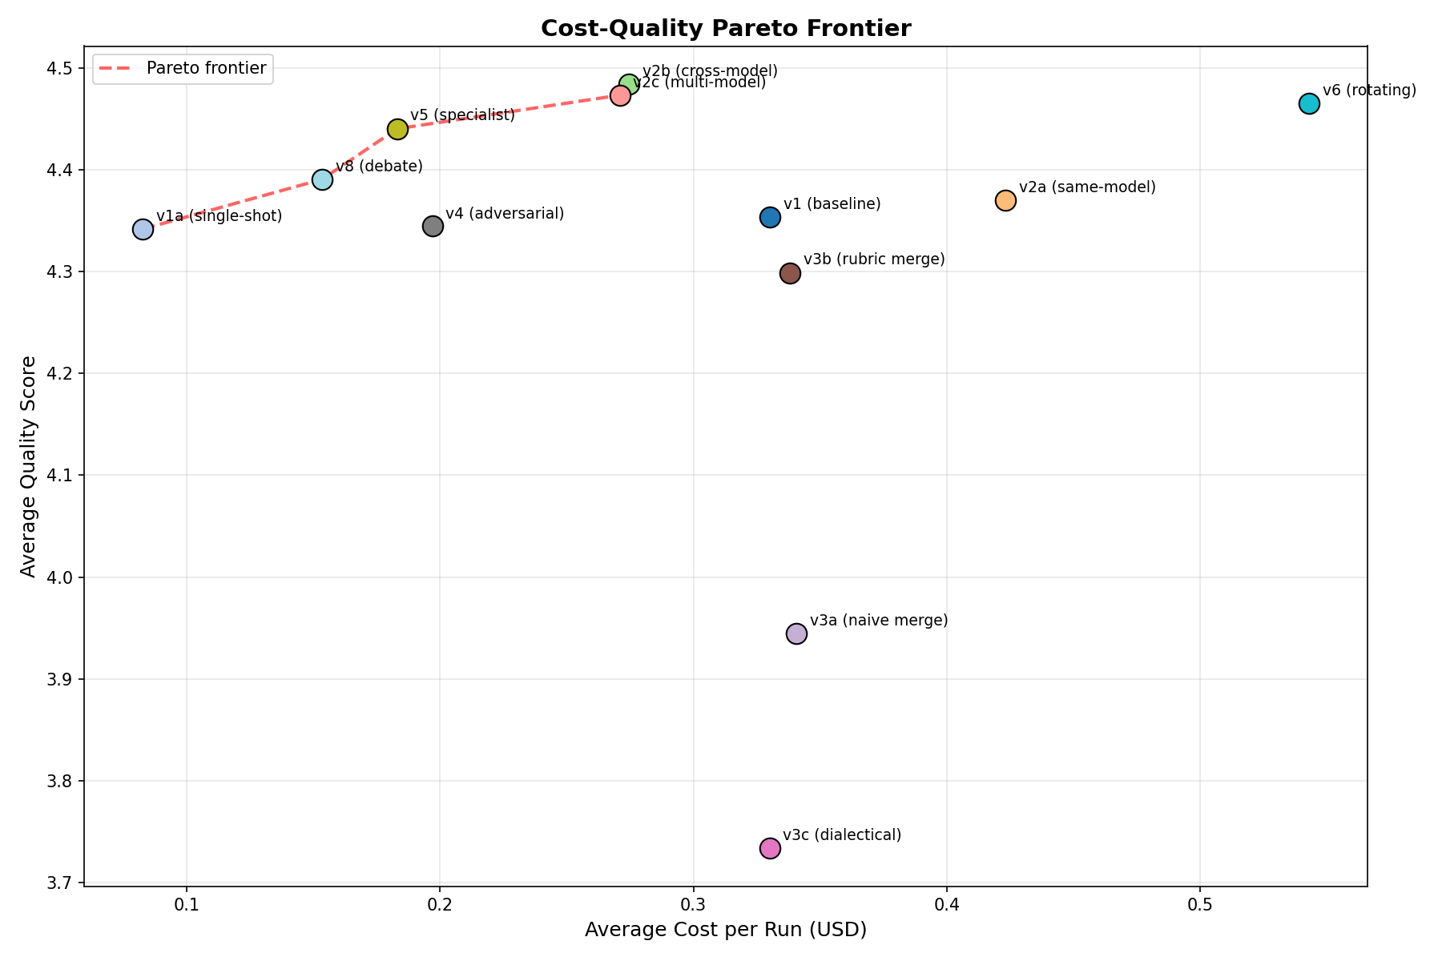
Fig. 5. Cost-quality Pareto frontier. Points above the frontier are dominated. v2b and v5 define the efficiency frontier for high-quality designs.
F. Reliability and Evaluator Agreement
Rotating leader v6 achieves the lowest variance (σ = 0.080), making it the most consistent variant. Merge variants show highest variance (σ = 0.231–0.265), being both poor on average and unpredictable. Evaluator agreement (Krippendorff’s α) ranges from 0.42 (top-tier variants) to 0.81 (merge variants). Lower agreement on high-quality designs reflects genuine difficulty in distinguishing “good” from “great,” while high agreement on poor designs reflects easy identification of flaws.
G. Thesis Prediction Validation
Four of six thesis predictions were refuted or only partially supported. P1 (parallel merge achieves highest peak on complex tasks) was refuted—merge variants underperform the baseline. P2 (adversarial has highest variance) was partially supported—v4 ranks 5th in variance. P4 (specialists outperform v2 by 10–15%) was partially supported—v5 outperforms v2a by only 1.6%. P5 (baseline matches consortia on simple tasks) was refuted—9 of 11 variants beat v1 on simple tasks.
V. ANALYSIS: WHY CROSS-MODEL REVIEW WORKS
The cross-model review advantage (Δ = 0.114, d = 0.97) is the paper’s strongest finding. We analyze the mechanism through four empirical findings drawn from trace-level data.
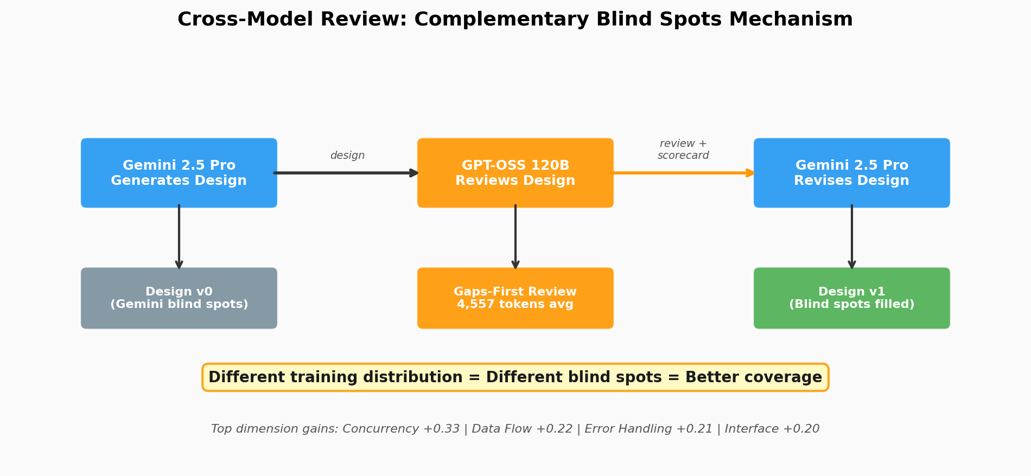
Fig. 6. The complementary blind spots mechanism. Different training distributions create different systematic gaps, enabling broader coverage through cross-model review.
Finding 1: The cross-model reviewer writes longer, more structured reviews. GPT-OSS 120B produces reviews averaging 4,557 tokens vs. Gemini’s 3,242 (40% more). Critically, the cross-model reviewer leads with a gaps-first TL;DR and dimension-by-dimension scorecard, while the same-model reviewer leads with praise:
“Same-model opens: ‘Excellent. This is a comprehensive and well-structured application design document.’”
“Cross-model opens: ‘TL;DR: The main gaps are missing domain events, insufficient data-lineage detail, limited security discussion, and concurrency-safety details that need tightening.’”
Finding 2: The advantage spans 10 of 12 dimensions. The largest gains are in Concurrency Safety (+0.33), Data Flow (+0.22), Error Handling (+0.21), and Interface Design (+0.20)—dimensions where superficially complete designs can harbor subtle gaps that same-model review misses.
Finding 3: The advantage is consistent across all 8 tasks. v2b outperforms v2a on every task, with win rates of 60–100% across 5 repetitions. The strongest advantage appears on T8 Order Processing (100% win rate) and T7 Access Control (80%).
Finding 4: Adding more reviewers from the same family doesn’t help. v2c (two GPT-OSS reviewers) scores 4.474 vs. v2b’s 4.484 (p = 0.42). The cross-model benefit saturates at a single reviewer—the simplest possible multi-model workflow.
Interpretation. The mechanism is best described as complementary blind spots. Gemini has systematic tendencies—e.g., underspecifying concurrency safety or treating error handling generically. When it reviews its own work, it has the same blind spots. GPT-OSS, with different training data and optimization objectives, catches what Gemini misses. This is not about one model being “better”—it’s about the combination being more thorough.
VI. EMPIRICAL EVIDENCE: DESIGN EXCERPTS
To ground the statistical findings in concrete evidence, we present verbatim excerpts from designs produced during the experiment. All comparisons are drawn from the same task (T8: Order Processing, Repetition 1) for apples-to-apples comparison.
A. Error Handling: Same-Model vs. Cross-Model
The v2a (Gemini-reviews-Gemini) design categorizes errors into three buckets with generic resilience patterns:
“Business Error: Invalid user input, violates a business rule. [...] Resilience: Circuit Breaker—All inter-service gRPC calls wrapped in circuit breaker. Idempotency—All POST/PUT RPCs support idempotency_key.”
The v2b (GPT-OSS-reviews-Gemini) design has five error categories—critically splitting Authentication from Authorization—with parameterized resilience patterns:
“Circuit Breakers: failure rate >50% over 1-minute window, breaker opens for 30 seconds. Fallbacks: if new model version fails to load, fall back to last known good version and raise alert.”
The cross-model reviewer pushed the design from “we’ll use circuit breakers” to “circuit breakers with these specific parameters.” Total section grew from 1,474 to 1,657 characters with substantially more actionable content.
B. Concurrency Safety: Generic vs. Concrete
Concurrency Safety showed the largest cross-model advantage (+0.33). The v2a design offers generic guidance (“optimistic locking as defined in Section 6”), while v2b specifies exact Kubernetes primitives:
“GPU Scheduler Concurrency: Leader election via Kubernetes Lease object. Distributed lock: gpu-scheduler-lock, TTL 30 seconds. If operator crashes, lease expires.”
Every mechanism in the cross-model version is concrete and implementable—specific lock type, TTL value, and failure mode behavior.
C. The Merge Frankenstein Effect
The v1 baseline produces a structured error taxonomy with four categories, a Result<T,E> pattern, and 1,304 characters of actionable content. After naive merge (v3a), the entire error handling section is eliminated, replaced by a generic “Scalability, Resilience & Security” grab-bag. In dialectical merge (v3c), the design compresses three 33,000-character inputs into 20,420 characters—shorter than any single input.
The merger agent is token-starved: ~25,000 input tokens produce only 4,200–5,200 output tokens. Dedicated sections become bullet-point summaries, structured taxonomies vanish, and cross-cutting coherence is destroyed. This explains why Testability drops -1.21 and Domain Model drops -1.00.
D. Adversarial Patching Mechanism
The adversarial reviewer (v4) rejects 77% of rounds. The initial design (round 0) has a 6-category error taxonomy spanning 2,274 characters. After two rejections, this shrinks to 683 characters with three domain-specific patches and a hand-wave to “previously defined” categories. The overall document shrinks from 29,137 to 19,845 characters.
The LLM responds to rejection by locally patching the cited deficiencies while compressing everything else to stay within output token limits. Quality drops from 4.48 (round 0) to 4.28 (round 1) before partially recovering to 4.34 (round 2). The adversarial process causes local patches, not structural rethinking.
E. Domain Model: DDD vs. Infrastructure Diagram
The baseline v1 domain model for T7 (Access Control) uses DDD principles with rich aggregates (Policy, Role as aggregate roots with named invariants like hasCycle()), value objects (Principal, Resource, AuthorizationContext), and a Mermaid class diagram. Total: 2,709 characters.
The dialectical merge v3c replaces this with a Mermaid graph showing infrastructure components (PDP Sidecar, PAP, NATS, Kafka). No aggregates, no value objects, no invariants, no business rules. The merger retreated to the abstraction level where all three input designs agreed: infrastructure topology. This is a skeleton without organs—explaining the 1.25-point drop in Domain Model Quality.
VII. DISCUSSION
A. Topology vs. Rubric
A two-way ANOVA decomposition reveals that variant choice (η² = 0.64) is the dominant factor when all 12 variants are included. However, removing the three v3 merge variants (arguably a broken implementation) reduces the topology effect to η² = 0.145. Among the nine non-merge variants, topology choice matters modestly, leaving 85% of variance unexplained and suggesting the evaluation rubric may be a stronger lever for quality improvement.
B. Design Space Mapping
Fig. 7 maps the experimental variants onto the 2×2×2 design space with quality tier annotations. The top-performing region is centralized authority with cross-model feedback (v2b, v2c), while the decentralized-specialized cell (v6) achieves comparable quality through role rotation. The decentralized-homogeneous cell (v3) consistently underperforms.
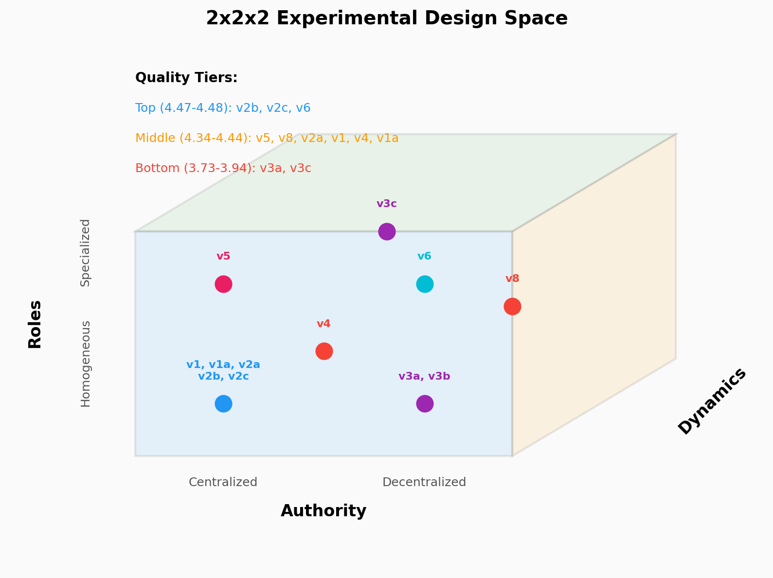
Fig. 7. Experimental variants mapped onto the 2×2×2 design space. Circle colors indicate variant family; text annotations show quality tier placement.
C. Practical Recommendations
For practitioners deploying LLM-based design workflows, we recommend: (1) For maximum quality, use cross-model review (v2b)—generate with one model family, review with another. (2) For maximum consistency, use rotating leader (v6), accepting higher cost. (3) For cost-efficiency, use structured debate (v8) at $0.15/run. (4) Never use parallel merge without fundamental improvements to the merge strategy. (5) A single cross-model reviewer suffices—panel review adds cost without quality gains.
D. Limitations
This study has several limitations. First, v7 (Consensus Convergence) was not executed, leaving one cell of the design space unexplored. Second, evaluator agreement (α = 0.42–0.81) is below the target of 0.70 for several top-tier variants, suggesting the rubric may lack precision for fine-grained quality distinctions. Third, only two model families were tested; the complementary blind spots mechanism may be specific to the Gemini/GPT-OSS pairing. Fourth, a single frozen rubric was used, preventing direct comparison of rubric vs. topology effects.
VIII. CONCLUSION
Multi-LLM collaboration improves software design quality, but the mechanism that matters most is not the collaboration topology—it is epistemic diversity in the feedback loop. Cross-model review achieves the highest quality through a complementary blind spots mechanism: a different model’s training distribution acts as a fundamentally different set of eyes. This is a deeply practical finding: the simplest possible multi-model workflow outperforms every sophisticated multi-agent topology tested.
The dramatic failure of parallel merge and the null result from adversarial dynamics demonstrate that LLM collaboration dynamics differ fundamentally from human team dynamics. Parallel generation assumes architectural diversity, but LLMs trained on similar data converge on similar patterns. Adversarial pressure causes local patching rather than structural rethinking. These findings suggest that future work should focus on maximizing epistemic diversity (through model selection and rubric design) rather than workflow complexity.
Future work should: (1) execute v7 to complete the design space, (2) vary rubric quality while holding topology constant, (3) test additional model pairings to validate the generality of complementary blind spots, (4) address the merge pipeline’s token starvation, and (5) investigate whether prompting strategies can induce structural rethinking under adversarial pressure.
Two particularly promising directions emerge from our findings on epistemic diversity and model complementarity:
Hierarchical consortium of smaller models under SOTA leadership. Our results show that the cross-model advantage saturates at a single reviewer from a different model family. A natural extension is to test whether a state-of-the-art frontier model (e.g., Gemini 2.5 Pro, GPT-4.1, Claude Opus) can serve as an orchestrating leader—decomposing design tasks, assigning sub-problems, and synthesizing outputs—while a consortium of smaller, cost-efficient models (e.g., Gemini Flash, GPT-4o-mini, Haiku) execute the sub-tasks. This “SOTA-as-leader” topology would test whether the frontier model’s stronger architectural reasoning can compensate for smaller models’ limitations through intelligent task decomposition, potentially achieving near-SOTA quality at a fraction of the cost. The v6 rotating leader topology (lowest variance in our experiment) provides a natural starting point: replace homogeneous agents with a heterogeneous mix where the SOTA model holds a privileged leadership role.
Teacher-student consortium with knowledge distillation. A complementary approach frames the multi-agent collaboration as an online learning problem: a SOTA “teacher” model first generates high-quality reference designs and rubric-grounded critiques, which are then used to guide a consortium of smaller “student” models through in-context learning or fine-tuning. This extends the complementary blind spots mechanism—rather than relying on pre-existing distributional differences between models, the teacher actively shapes the students’ review capabilities by demonstrating what good critique looks like on domain-specific tasks. The hypothesis is that teacher-guided students would develop more calibrated review skills than either (a) the same small models reviewing without guidance, or (b) simply using the teacher model directly (which our v2b results suggest may not be necessary if the students can learn the teacher’s critique patterns). This could democratize the cross-model advantage, making high-quality LLM consortium workflows accessible with smaller, locally-deployable models.
Extending the consortium paradigm from design to code generation. This experiment evaluated LLM collaboration on architectural design—a high-level, document-oriented task. A critical next step is to extend the consortium framework to the full software development lifecycle, including code generation, testing, debugging, and refactoring. Code presents fundamentally different evaluation dynamics: designs are judged by rubric-based heuristics, but code can be verified by execution—tests pass or fail, builds compile or break, benchmarks produce measurable performance. This opens several compelling research directions. First, a consortium where one agent generates code, a cross-model agent reviews it, and a third agent writes and executes tests could create a closed-loop quality signal that our design experiment lacked. The complementary blind spots mechanism may be even more powerful for code: different models exhibit different bug patterns, and a cross-model code reviewer may catch classes of defects (race conditions, off-by-one errors, security vulnerabilities) that same-model review systematically misses. Second, the parallel merge strategy that failed for design may succeed for code if the merge is constrained to the module level—different agents implementing different modules against a shared interface contract, avoiding the Frankenstein effect by enforcing architectural boundaries at merge time. Third, the adversarial topology that produced null results for design could become highly effective for code through adversarial test generation: an adversarial agent whose job is to write failing tests rather than rejecting designs, forcing the coding agent to handle edge cases it would otherwise ignore. Unlike design review (where rejection causes local patching), adversarial testing provides concrete, executable counterexamples that demand structural fixes. Fourth, a design-to-code pipeline could bridge our current findings with implementation: the consortium first produces an optimized architecture design (using v2b cross-model review), then hands it to a coding consortium that implements the design module by module, with the original design serving as both specification and evaluation rubric. This end-to-end workflow would test whether the quality gains we observe at the design level propagate to implemented code.
Cross-domain generalization of the consortium framework. This experiment tests software architectural design—a structured, document-oriented task. The consortium framework and the complementary blind spots mechanism may generalize to other LLM-heavy domains where quality depends on multi-faceted expert judgment: legal contract drafting (where different model families may catch different classes of ambiguity or risk), scientific protocol design (where methodological blind spots could be surfaced by cross-model review), medical documentation (where completeness and accuracy are critical), and business strategy documents. Testing cross-domain generalization would determine whether the 2×2×2 framework is a general theory of LLM collaboration or specific to software engineering’s structured nature.
Dynamic topology selection via meta-agent. Our data shows that different topologies excel in different conditions: v5 specialist peaks on medium-complexity tasks (4.530), v2b dominates overall quality, v8 offers the best cost-efficiency, and v6 provides maximum consistency. A meta-agent that examines the incoming task—its complexity, domain, quality requirements, and cost constraints—and dynamically selects the optimal topology per-task could outperform any single fixed topology. The task-variant heatmap (Fig. 6) already contains the training signal for such a selector. This would transform the consortium from a static workflow choice into an adaptive system that routes tasks to the topology best suited for each problem.
Rubric ablation study. Our variance decomposition reveals that topology explains only 14.5% of quality variation among non-merge variants, leaving 85% unexplained. The evaluation rubric is the leading candidate for this unexplained variance. A controlled experiment holding topology constant (e.g., v2b cross-model review) while varying rubric quality across three levels—minimal (3 dimensions), standard (12 dimensions, as used here), and expert-tuned (20+ dimensions with sub-criteria)—would directly answer Research Question 4 and determine whether rubric engineering or topology engineering deserves more investment in practice.
Iterative cross-model review. The v2b topology performs a single cross-model review round. Our v1 self-refine baseline shows diminishing returns with same-model iteration (quality plateaus after round 2). However, alternating cross-model review—Gemini generates, GPT-OSS reviews, Gemini revises, GPT-OSS reviews again—may not exhibit the same saturation because each review round introduces a genuinely different perspective. Testing 2–3 rounds of alternating cross-model review would determine whether the complementary blind spots mechanism compounds across iterations or saturates at a single round (as the v2c panel result tentatively suggests).
Human expert validation of automated evaluator. The automated evaluator (GPT-OSS 120B with rubric in-context) achieves Krippendorff’s α = 0.42–0.81 across variants. While this is sufficient for ranking separation between tiers, validating the automated scores against human expert judgment would substantially strengthen the empirical claims. We propose having 2–3 senior software engineers independently score a stratified sample of 50 designs (spanning top, middle, and bottom quality tiers) on the same 12-dimension rubric, then computing human-automated correlation and inter-rater reliability. If the automated evaluator agrees with human experts on tier placement and relative ranking, it validates the entire experimental framework; if it diverges systematically, the divergence patterns themselves become a contribution to understanding LLM-as-evaluator reliability.
IX. CROSS-EVALUATOR VALIDATION: CLAUDE OPUS 4.6 VS GPT-OSS 120B
To validate the GPT-OSS 120B automated evaluator, we conducted a complete independent re-evaluation of all 480 final designs using Claude Opus 4.6 as an alternative evaluator with the same 12-dimension rubric. This is not a sample—it is a full replication of the evaluation pipeline with a different model family.
A. Overall Agreement
Across all 480 paired comparisons, the two evaluators show strong positive correlation (Pearson r = 0.753, p = 5.1 × 10⁻⁸⁹; Spearman ρ = 0.592, p = 9.7 × 10⁻⁴⁷). Opus scores slightly lower on average (mean 4.219 vs. GPT-OSS 4.304, Δ = −0.085), with wider variance (σ = 0.438 vs. 0.275). The Wilcoxon signed-rank test confirms this systematic offset is statistically significant (p < 0.0001), indicating that Opus is a slightly stricter evaluator overall.
B. Variant Rankings: Strong Agreement on What Matters
The variant rank correlation between evaluators is strong (ρ = 0.853, p = 0.0004). Critically, both evaluators agree on the most important conclusions:
v2b (cross-model review) is ranked #1 by both evaluators (Opus: 4.708, GPT-OSS: 4.484). Opus actually amplifies v2b’s lead—it rates v2b 0.224 points higher than GPT-OSS does, the largest positive delta of any variant. This suggests that Claude finds the cross-model-reviewed designs even more impressive than GPT-OSS does.
v3 merge variants are bottom-tier for both evaluators. v3a is rank 12/11, v3b is rank 10/10, v3c is rank 11/12. Opus is even harsher on v3a (3.443 vs. 3.944, Δ = −0.502)—the single largest score disagreement of any variant.
v4 adversarial remains a null result. Both evaluators show v4 performing indistinguishably from v2a: Opus Δ = −0.022, GPT-OSS Δ = −0.025.
The largest ranking divergence is v8 (structured debate): GPT-OSS ranks it #5 (4.391) while Opus drops it to #9 (4.195, Δ = −0.196). Conversely, v1a (single-shot) rises from GPT-OSS rank #9 to Opus rank #5. This suggests Opus penalizes debate’s synthesized-position style and is more tolerant of single-shot designs.
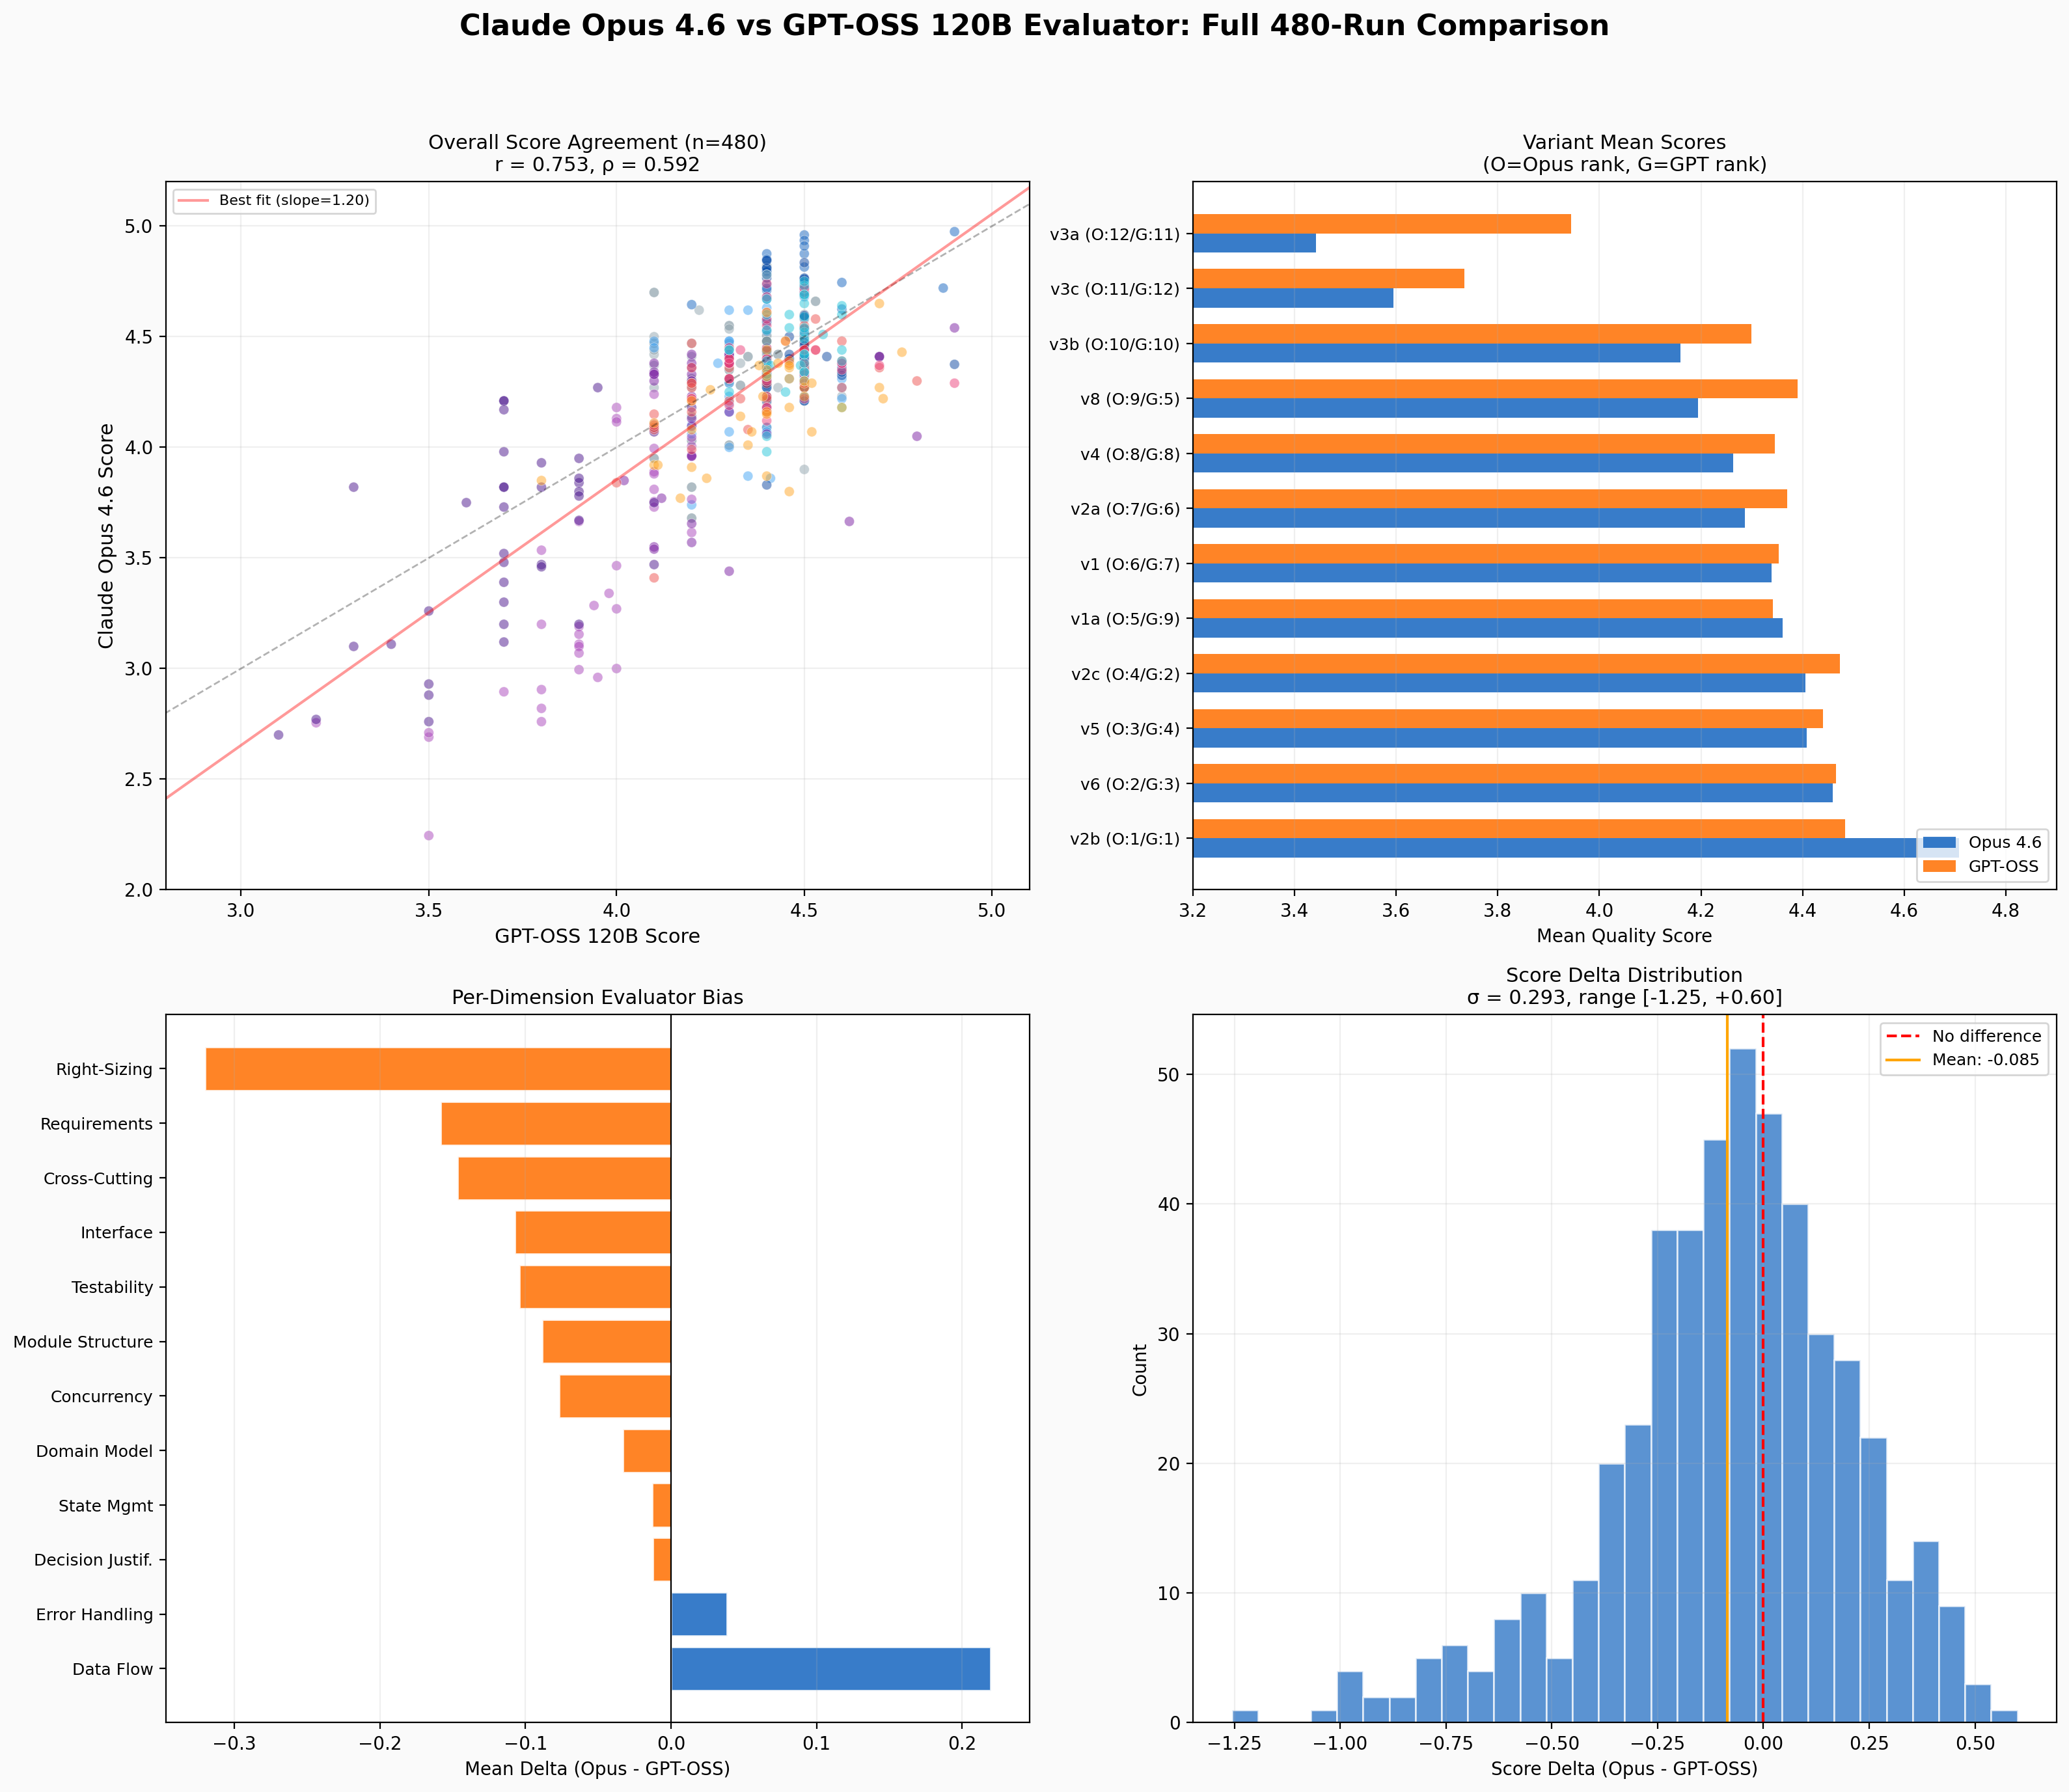
Fig. 8. Full 480-run cross-evaluator comparison. Top-left: scatter plot (r=0.753). Top-right: variant means by both evaluators with rank annotations. Bottom-left: per-dimension bias. Bottom-right: score delta distribution.
C. Per-Dimension Bias
Opus rates Data Flow Clarity systematically higher (+0.22), suggesting it values concrete sequence diagrams and data transformation documentation more than GPT-OSS. GPT-OSS rates Cross-Cutting Concerns higher (+0.15) and Testability higher (+0.10). The highest-weighted dimensions (Domain Model at w=1.4, Testability at w=1.2) show moderate agreement, anchoring the overall correlation.
D. Tier Agreement
Classifying designs into three tiers (Top ≥ 4.4, Mid 4.0–4.4, Bot < 4.0), the evaluators agree on 55.0% (264/480) of designs. The confusion matrix reveals an asymmetry: of 271 designs GPT-OSS rates as Top tier, Opus downgrades 136 to Mid and 7 to Bottom. Opus is more selective about what qualifies as top-tier—consistent with its slightly stricter overall tendency.
E. Implications
The cross-evaluator validation has four key implications. First, the central finding—v2b cross-model review is the quality champion—is robust and actually strengthened under Opus evaluation. Second, the merge variant failure (v3) is confirmed even more dramatically by Opus. Third, the specific ordering of mid-tier variants is evaluator-dependent; practitioners should treat the top tier as a cluster rather than a strict ranking. Fourth, the per-dimension bias pattern confirms that different model families weight design qualities differently even with identical rubrics—extending the complementary blind spots finding from design generation to evaluation. A multi-evaluator ensemble averaging GPT-OSS and Opus scores would produce more robust assessments by canceling each model’s systematic biases.
REFERENCES
[1] T. Qin et al., "ChatDev: Communicative agents for software development," arXiv:2307.07924, 2023.
[2] S. Hong et al., "MetaGPT: Meta programming for multi-agent collaborative framework," arXiv:2308.00352, 2023.
[3] M. Huang et al., "AgentCoder: Multi-agent code generation with iterative testing and optimization," arXiv:2312.13010, 2023.
[4] M. Islam et al., "MapCoder: Multi-agent code generation for competitive programming," arXiv:2405.11403, 2024.
[5] Y. Du et al., "Improving factuality and reasoning in language models through multiagent debate," arXiv:2305.14325, 2023.
[6] T. Liang et al., "Encouraging divergent thinking in large language models through multi-agent debate," arXiv:2305.19118, 2023.
[7] K. Krippendorff, Content Analysis: An Introduction to Its Methodology, 4th ed. Thousand Oaks, CA: SAGE, 2019.
[8] M. Friedman, "The use of ranks to avoid the assumption of normality implicit in the analysis of variance," J. American Statistical Association, vol. 32, no. 200, pp. 675–701, 1937.
[9] F. Wilcoxon, "Individual comparisons by ranking methods," Biometrics Bulletin, vol. 1, no. 6, pp. 80–83, 1945.
[10] J. Cohen, Statistical Power Analysis for the Behavioral Sciences, 2nd ed. Hillsdale, NJ: Lawrence Erlbaum, 1988.
[11] E. Evans, Domain-Driven Design: Tackling Complexity in the Heart of Software. Boston, MA: Addison-Wesley, 2004.
[12] Google, "Gemini 2.5 Pro Technical Report," 2025. [Online]. Available: https://ai.google.dev
[13] OpenAI, "GPT-4 Technical Report," arXiv:2303.08774, 2023.

