HIVE Queries

1. **What are the top 10 stations where bikes are picked from (starting station for a trip)?**

**Query:**

select trip.start_station,

count(trip.start_station) as number_of_times

from babs.trip group by trip.start_station

order by number_of_times desc limit 10;

**Output:**

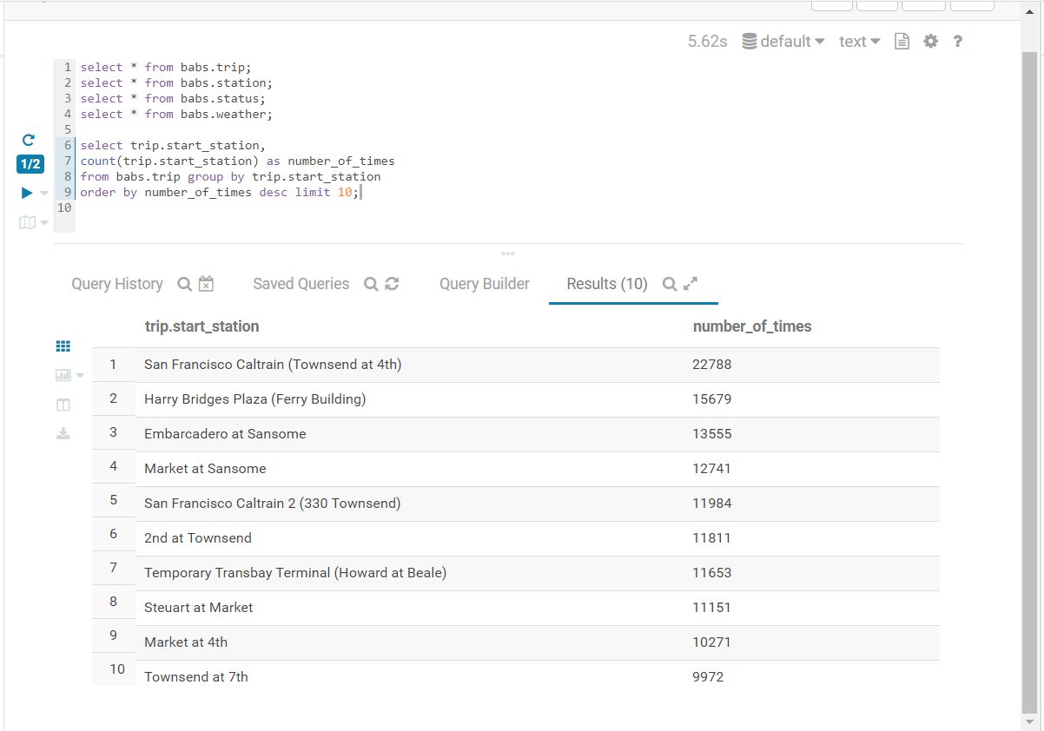

1. **What are the 10 most popular trips (pairs of starting and end locations)?**

**Query:**

select trip.start_station, trip.end_station,

count(trip.start_station) as no_of_times

from babs.trip

group by trip.start_station , trip.end_station

order by no_of_times desc limit 10;

**Output:**

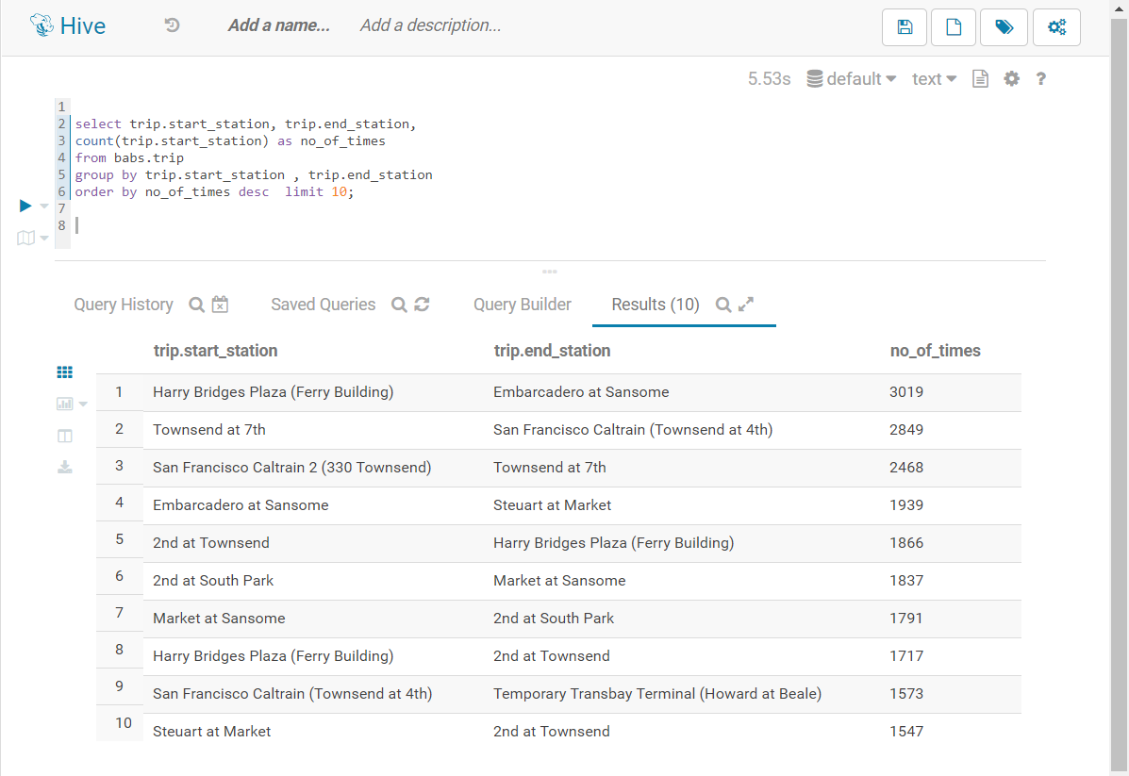

1. **What is the average duration of a trip in minutes?**

**Query:**

select avg(trip.duration)/60 as average_duration

from babs.trip;

**Output:**

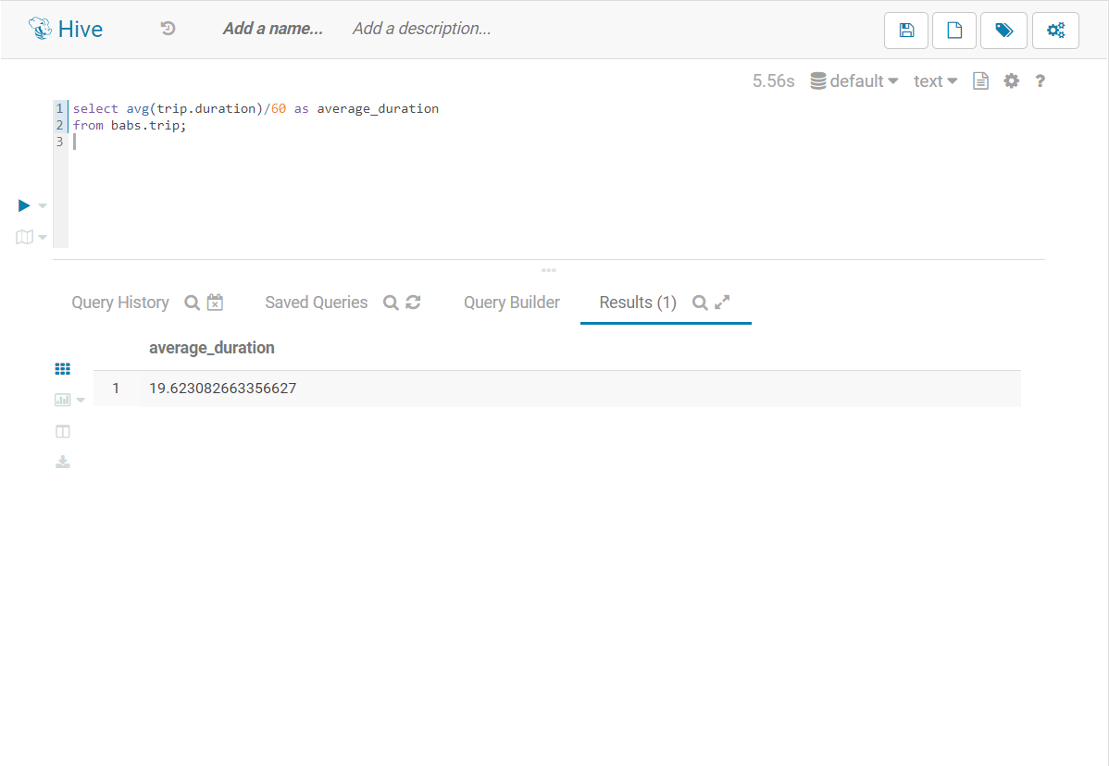

1. **Which are the 10 bikes which have been used the most?**

**Query:**

select trip.bike_id,

count(trip.bike_id) as no_of_times

from babs.trip

group by trip.bike_id

order by no_of_times desc limit 10;

**Output:**

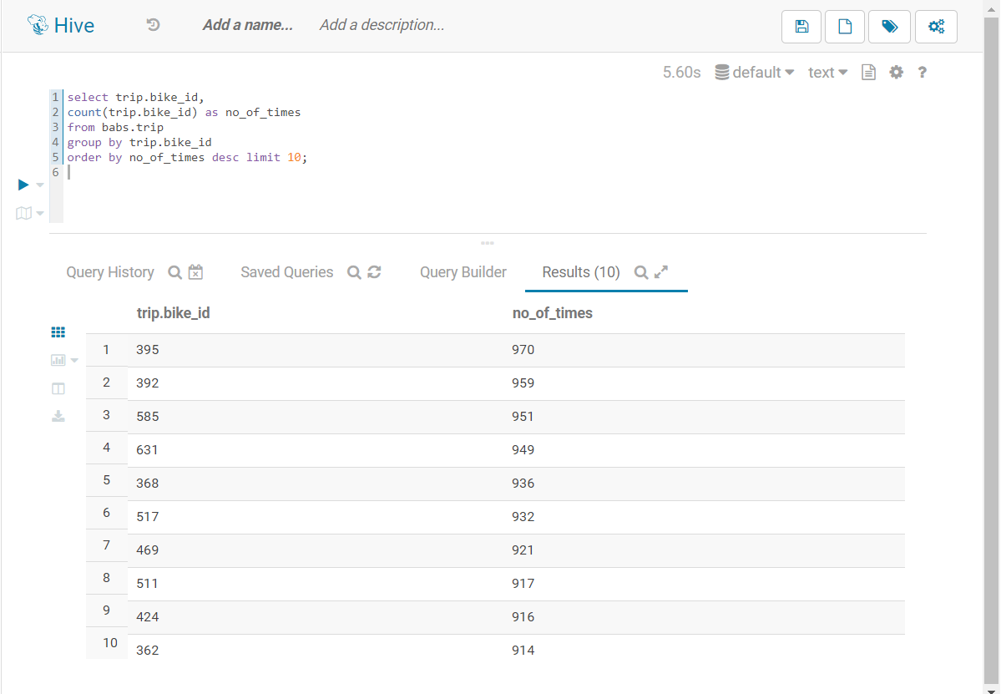

1. **What are 10 most popular destinations from the station San Francisco Caltrain (Townsend at 4th)?**

**Query:**

select trip.end_station,

count(trip.end_station) as no_of_times from babs.trip

where trip.start_station = 'San Francisco Caltrain (Townsend at 4th)'

group by trip.end_station order by no_of_times desc limit 10;

**Output:**

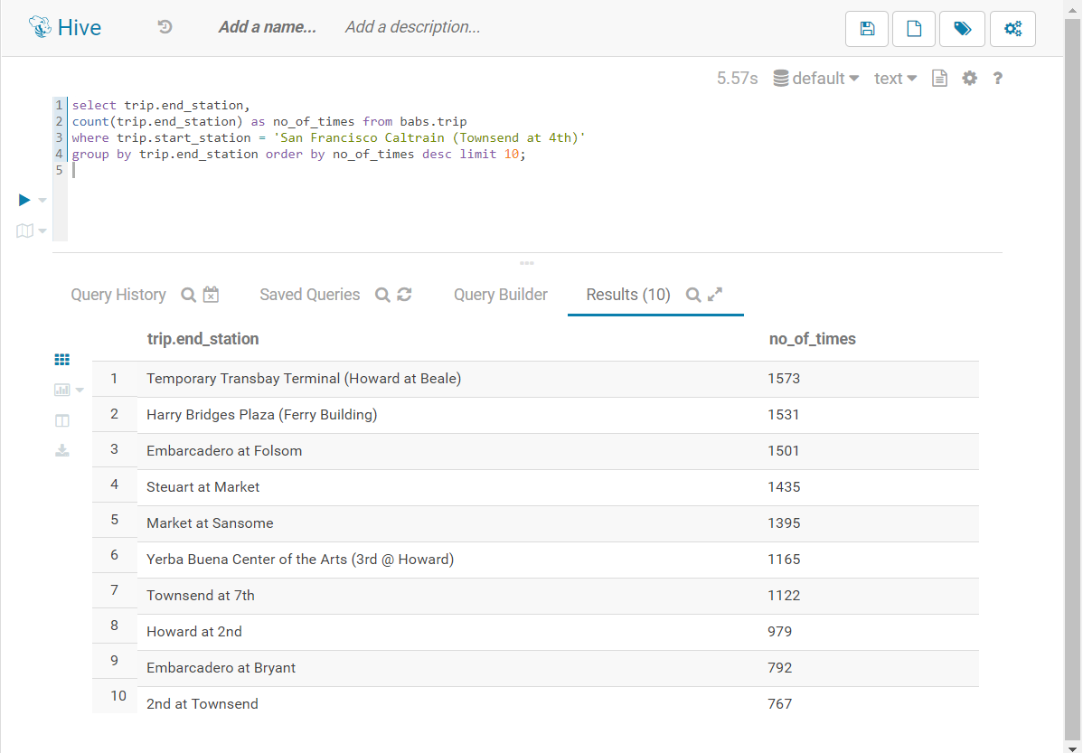

1. **Visualize the result of 5th question using Hue’s geospatial visualizations.**

**Query:**

select station.name, station.long, station.lat

from babs.station where station.name in (select t.end_station from (select trip.end_station, trip.start_station, count(*) as no_of_times from babs.trip

where trip.start_station = 'San Francisco Caltrain (Townsend at 4th)'

group by trip.start_station, trip.end_station order by no_of_times desc limit 10) as t) group by station.name, station.long, station.lat

**Output:**

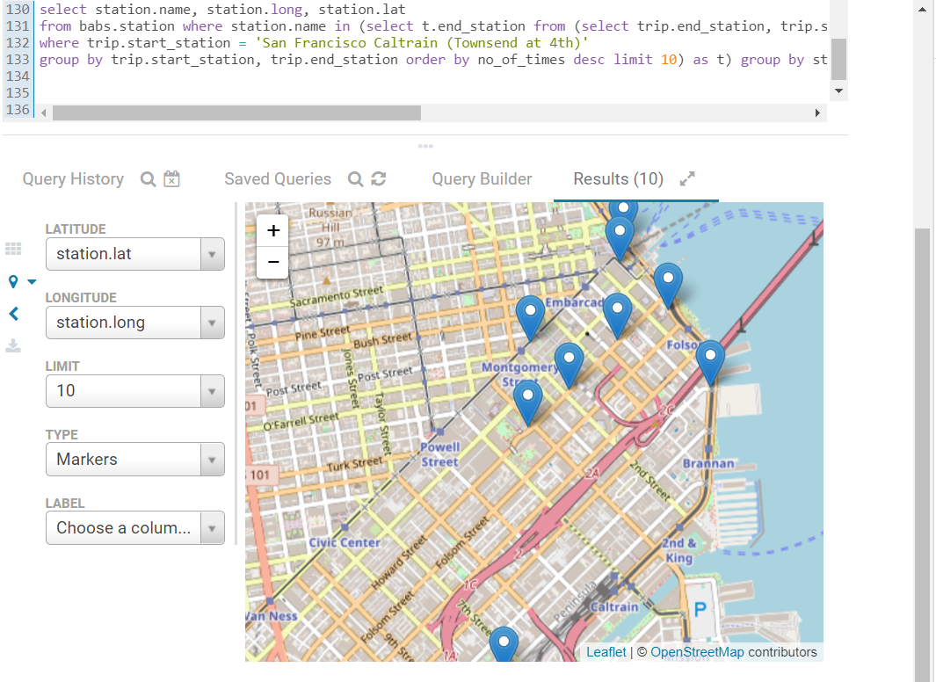

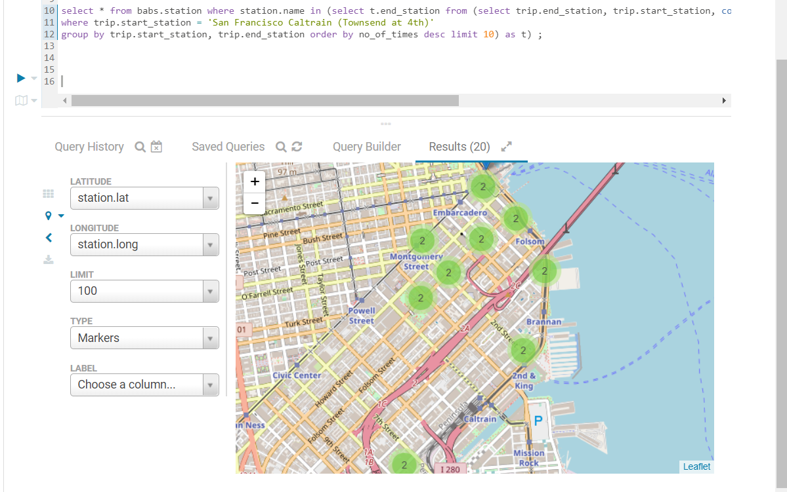

1. **Visualize the total number of trips and average duration in minutes, grouped by hour for San Francisco Caltrain (Townsend at 4th) station using a scatterplot.**

**Query:**

select t.start_hours as start_hours ,

count(t.start_hours) as total_trips,

avg(t.trip_duration)/60 as average_duration,

round(avg(t.trip_duration)/60) as average_duration_in_round from

(select trip.duration as trip_duration ,

(from_unixtime(unix_timestamp(trip.start_time , 'MM/dd/yyyy'), 'yyyy-dd-MM')) as start_date,

hour((from_unixtime(unix_timestamp(trip.start_time , 'MM/dd/yyyy HH:MM'), 'yyyy-dd-MM HH:MM:SS'))) as start_hours from babs.trip

where trip.start_station='San Francisco Caltrain (Townsend at 4th)') as t

group by t.start_hours order by average_duration_in_round desc;

**Output:**

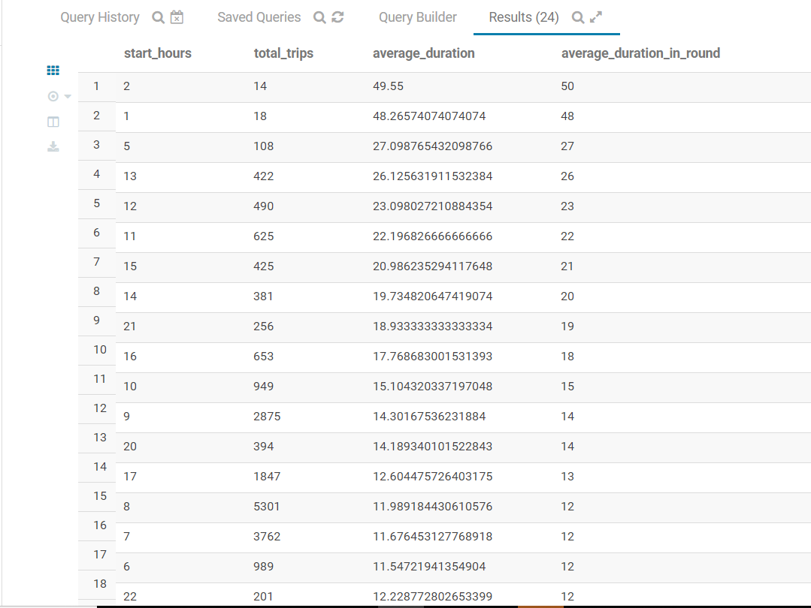

**Visualization:**

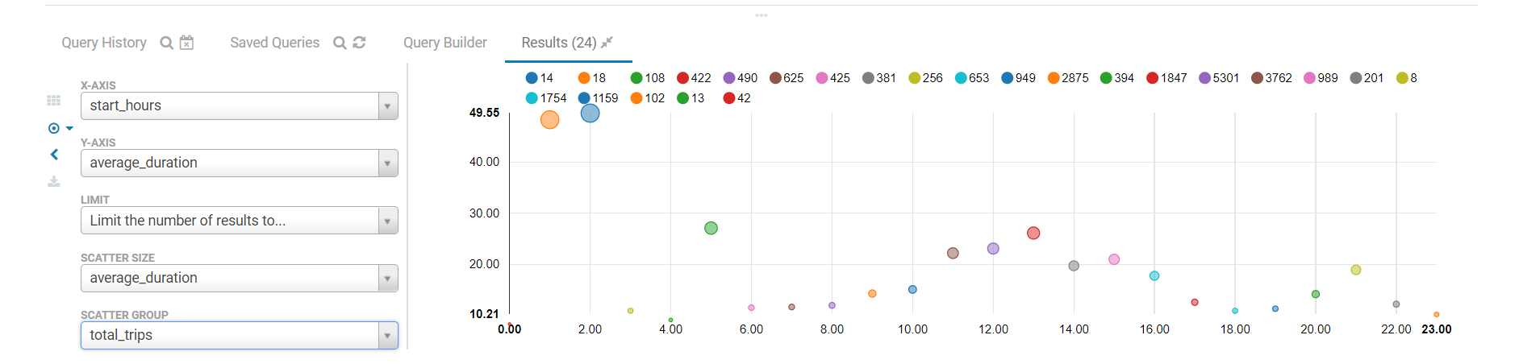

**The below visualization is with respect to start date**

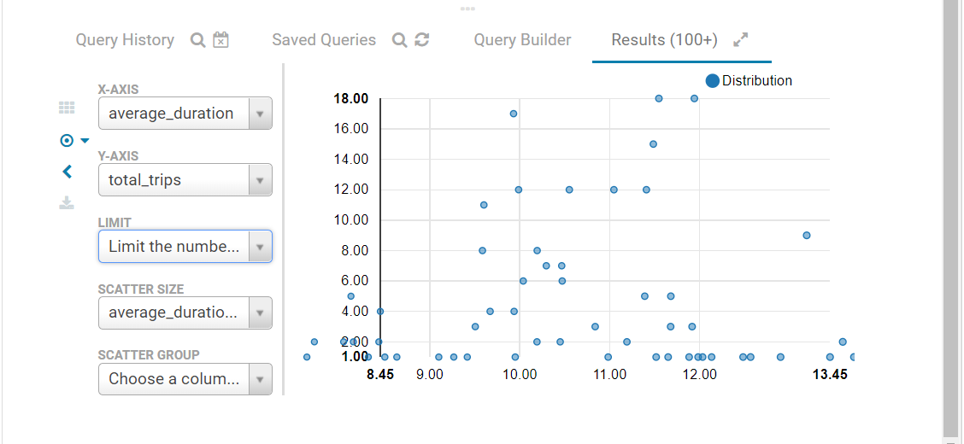

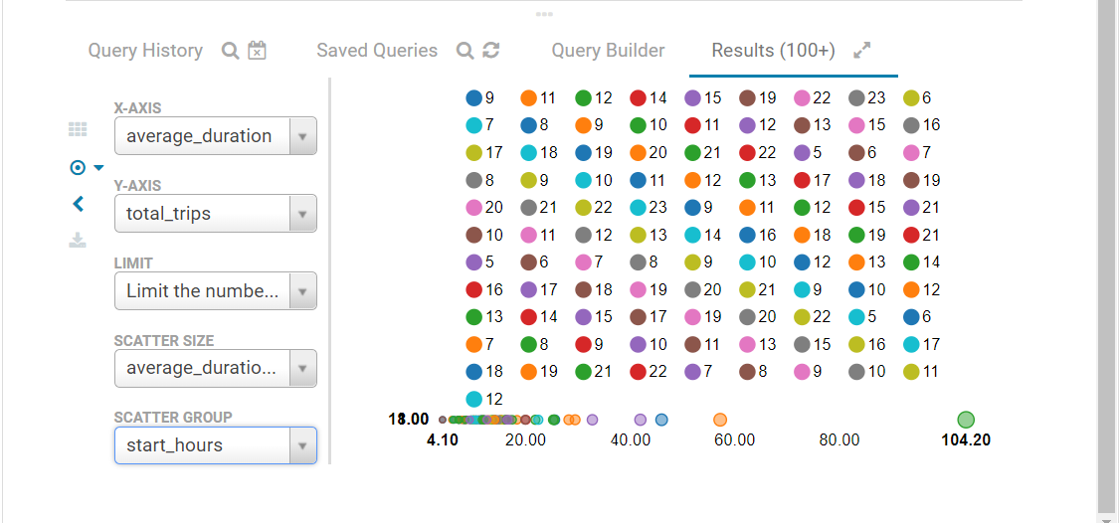

1. **How many trips were charged with overtime fees? (Trips having duration over 30 minutes)**

**Query:**

select count(*) as no_of_trips

from babs.trip

where (trip.duration/60) > 30;

**Output:**

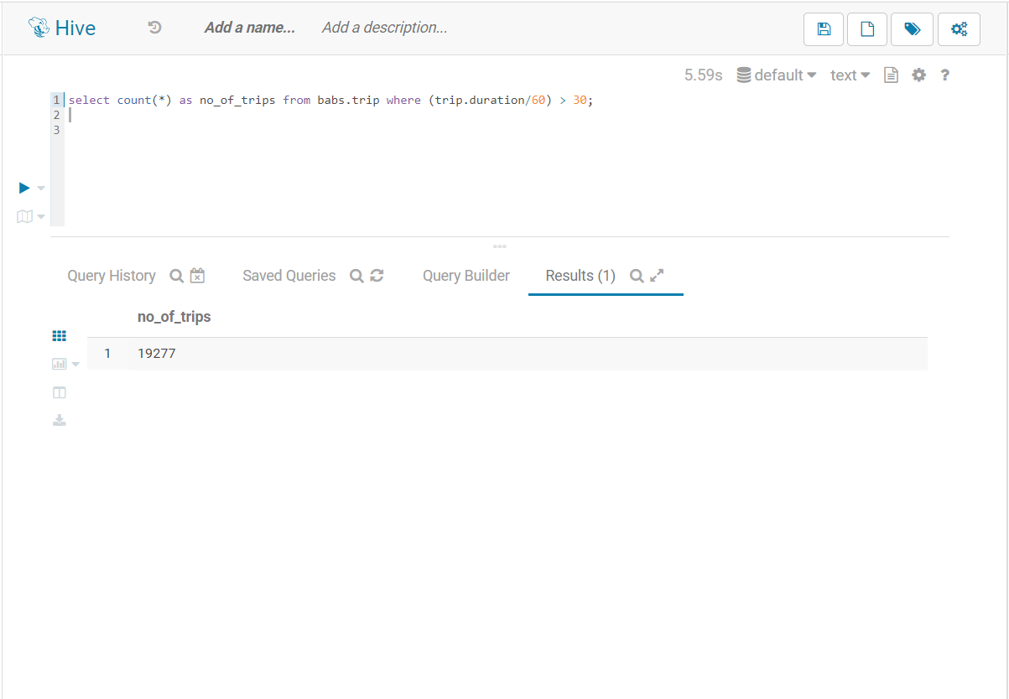

1. **Which trips cause highest number of overtime charges, how many seconds in total overtime was charged?**

**Query:**

select trip.start_station as start_station, trip.end_station as end_station,

count(*) as number_of_trips, round(avg(trip.duration)) as average_duration,

round(avg(trip.duration)-1800) as avg_overtime_seconds,

(sum(trip.duration) - (1800 * count(*))) as total_overtime_sec,

(round(avg(trip.duration)-1800) * count(*)) as toal_OT_Sec_usingAvg

from babs.trip

where trip.duration > 1800

group by trip.start_station, trip.end_station

order by number_of_trips desc;

**Output:**

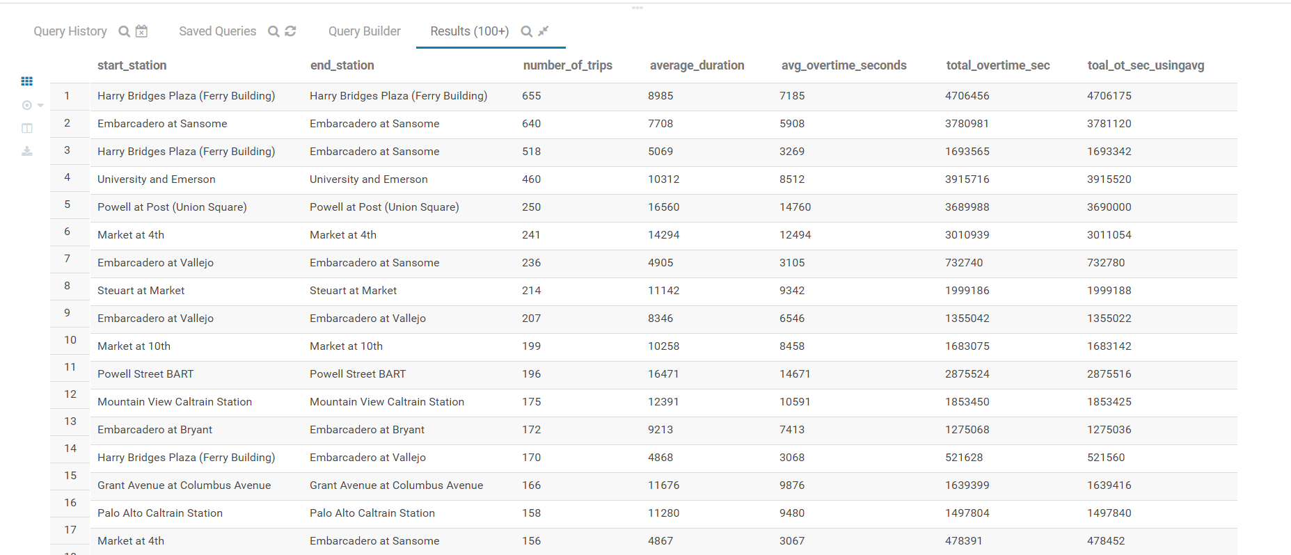

1. **Visualize the breakdown of trips by subscription type.**

**Method 1:**

**Query:**

select t.subscription_type, start_day, count(*) as TripCount from

(select trip.subscription_type,

from_unixtime(unix_timestamp(trip.start_time , 'MM/dd/yyyy'), 'EEEE') as start_day

from babs.trip) as t

group by start_day, subscription_type

order by subscription_type desc

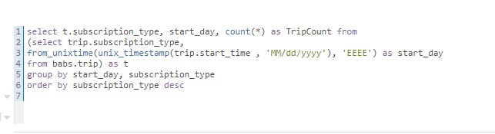

**Output:**

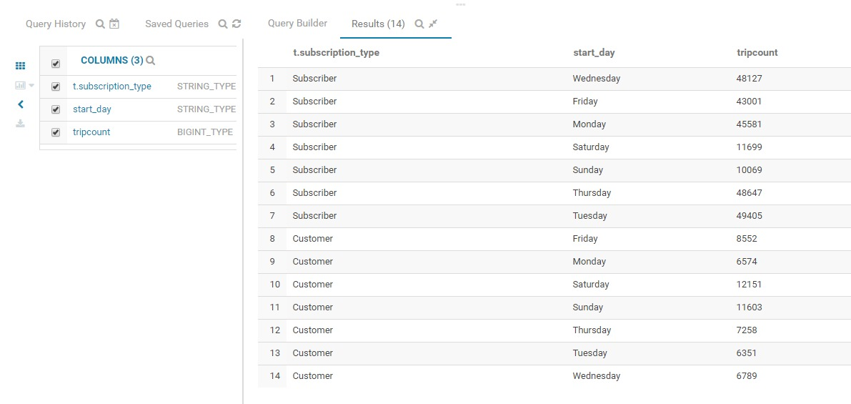

**Visualizations:**

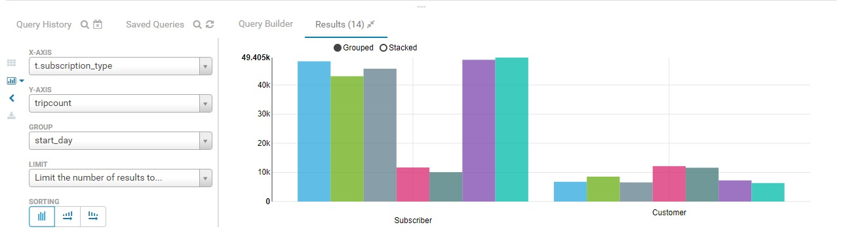

**Method 2:**

**Query:**

select t.subscription_type, round((t.no_of_times /t.total)*100) as percentage, t.no_of_times, t.total

from (select trip.subscription_type, count(*) as no_of_times, sum(count(*)) over()

as total from babs.trip group by trip.subscription_type) as t;

**Output:**

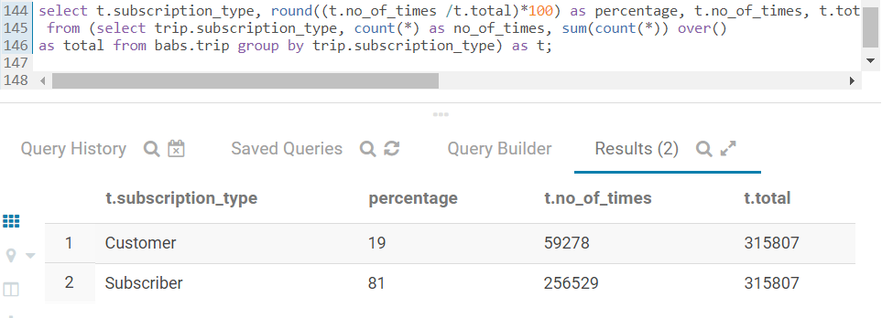

**Visualizations:**

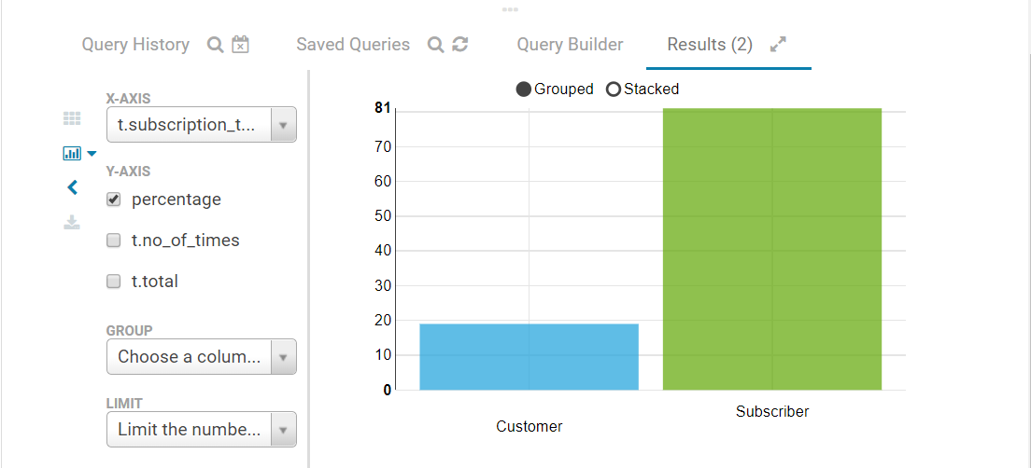

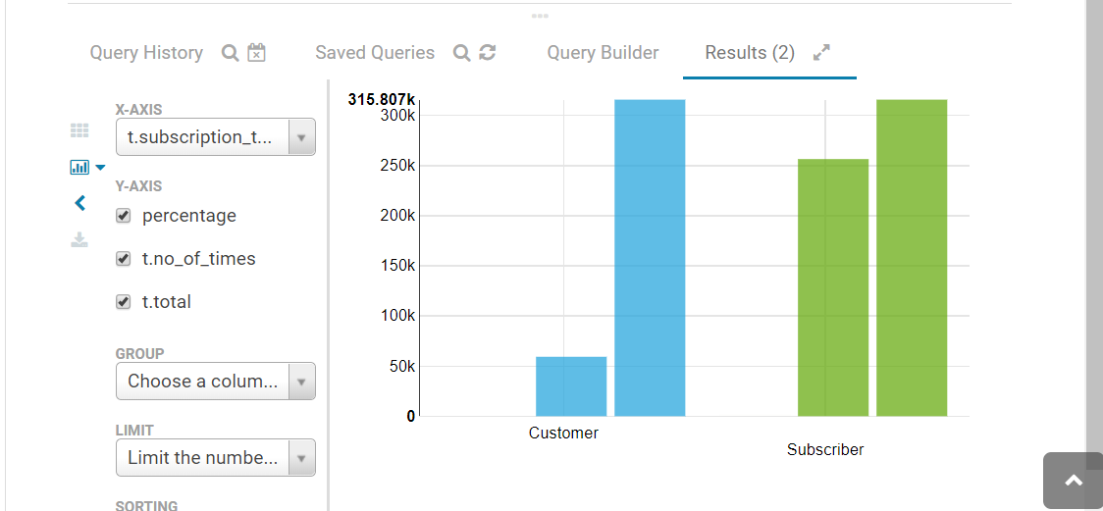

1. **The Bike Share system is intended to be used for short rides: trips under a half hour do not incur any additional charges. Do riders use the system in the intended way? (Do subscribers make many shorter trips compared to customers who do not pay monthly subscription?)**

**Query:**

create table tempTable(

subscription_type varchar(30),

condition_type varchar(30)) ;

insert into tempTable

(

select trip.subscription_type,

case

when (trip.duration/60) > 30 then 'greaterthan30'

when (trip.duration/60) < 30 then 'lessthan30'

when (trip.duration/60) = 30 then 'equals30'

end as condition_type

from babs.trip

);

select subscription_type, condition_type, count(*) as number_of_trips from temptable group by subscription_type, condition_type;

drop table temptable;

**Output:**

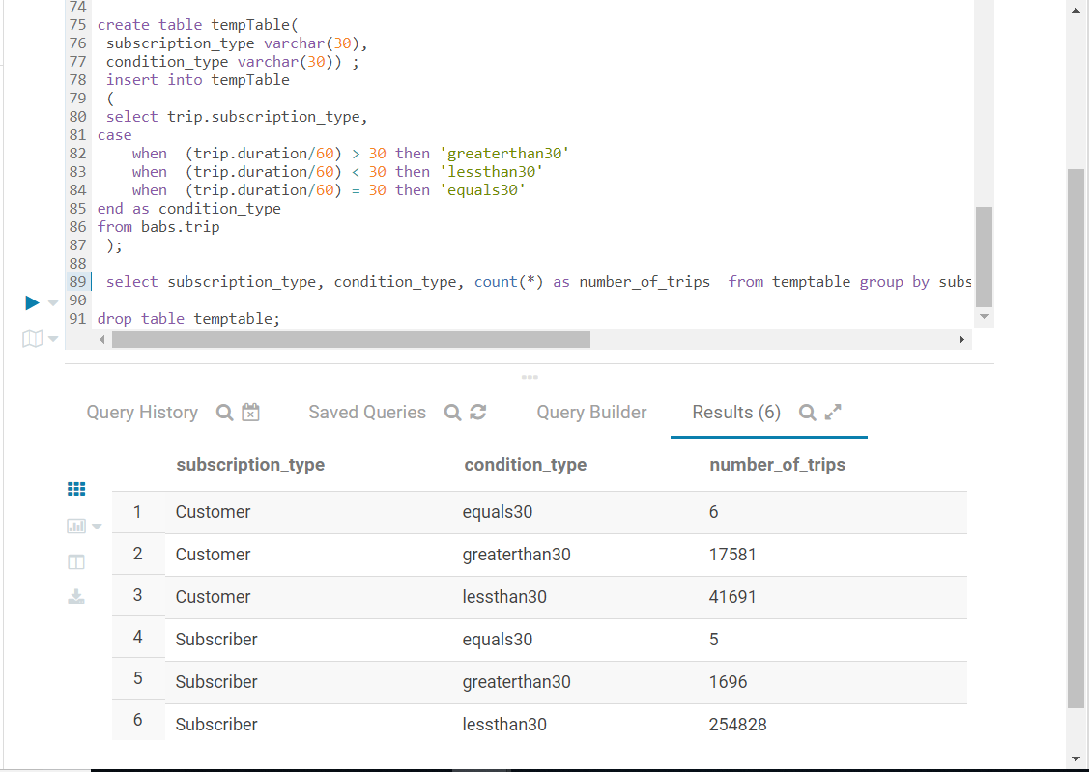

**Visualization:**

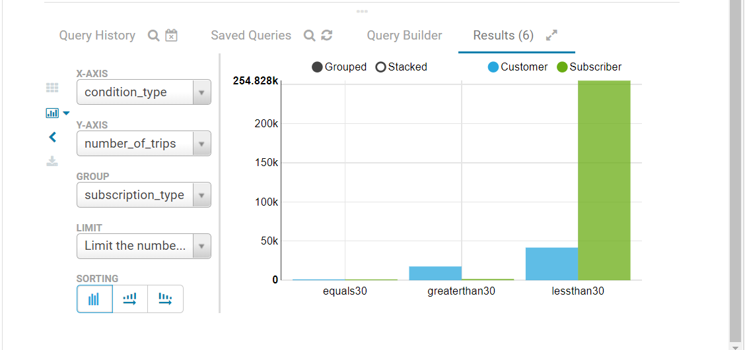

**Explanation:**

Customers have made around 17581 trips which are greater than 30 minutes but subscribers have made only 1696 trips which are greater than 30 minutes. From this we conclude that subscribers are using intend way.

Subscribers have made 254828 trips which are less than 30 minutes but customers have made only 41691 trips which are less than 30 minutes.

So, we conclude that subscribers make many shorter trips compared to customers who do not pay monthly subscription

**12. Find the total count of trips grouped into Weekday and Weekend.**

**Query:**

create table tempTable(

trip_id varchar(30),

start_date varchar(30),

converted varchar(30),

daytype varchar(30)) ;

insert into tempTable (

select datepart.trip_id, (from_unixtime(unix_timestamp(datepart.d , 'MM/dd/yyyy'), 'yyyy-MM-dd')) as start_date,

(from_unixtime(unix_timestamp(datepart.d , 'MM/dd/yyyy'), 'EEEE')) as converted,

case

when (from_unixtime(unix_timestamp(datepart.d , 'MM/dd/yyyy'), 'EEEE')) = 'Monday' then 'Weekday'

when (from_unixtime(unix_timestamp(datepart.d , 'MM/dd/yyyy'), 'EEEE')) = 'Tuesday' then 'Weekday'

when (from_unixtime(unix_timestamp(datepart.d , 'MM/dd/yyyy'), 'EEEE')) = 'Wednesday' then 'Weekday'

when (from_unixtime(unix_timestamp(datepart.d , 'MM/dd/yyyy'), 'EEEE')) = 'Thursday' then 'Weekday'

when (from_unixtime(unix_timestamp(datepart.d , 'MM/dd/yyyy'), 'EEEE')) =

'Friday' then 'Weekday'

when (from_unixtime(unix_timestamp(datepart.d , 'MM/dd/yyyy'), 'EEEE')) = 'Saturday' then 'Weekend'

when (from_unixtime(unix_timestamp(datepart.d , 'MM/dd/yyyy'), 'EEEE')) =

'Sunday' then 'Weekend'

end as daytype

from (select trip.trip_id, substring(trip.start_time,0,9) as d from babs.trip) as datepart

);

select daytype, count(daytype) as no_of_trips_byWeekDay_WeekEnd, sum(count(daytype)) over() as total_trips from tempTable group by daytype ;

**Output:**

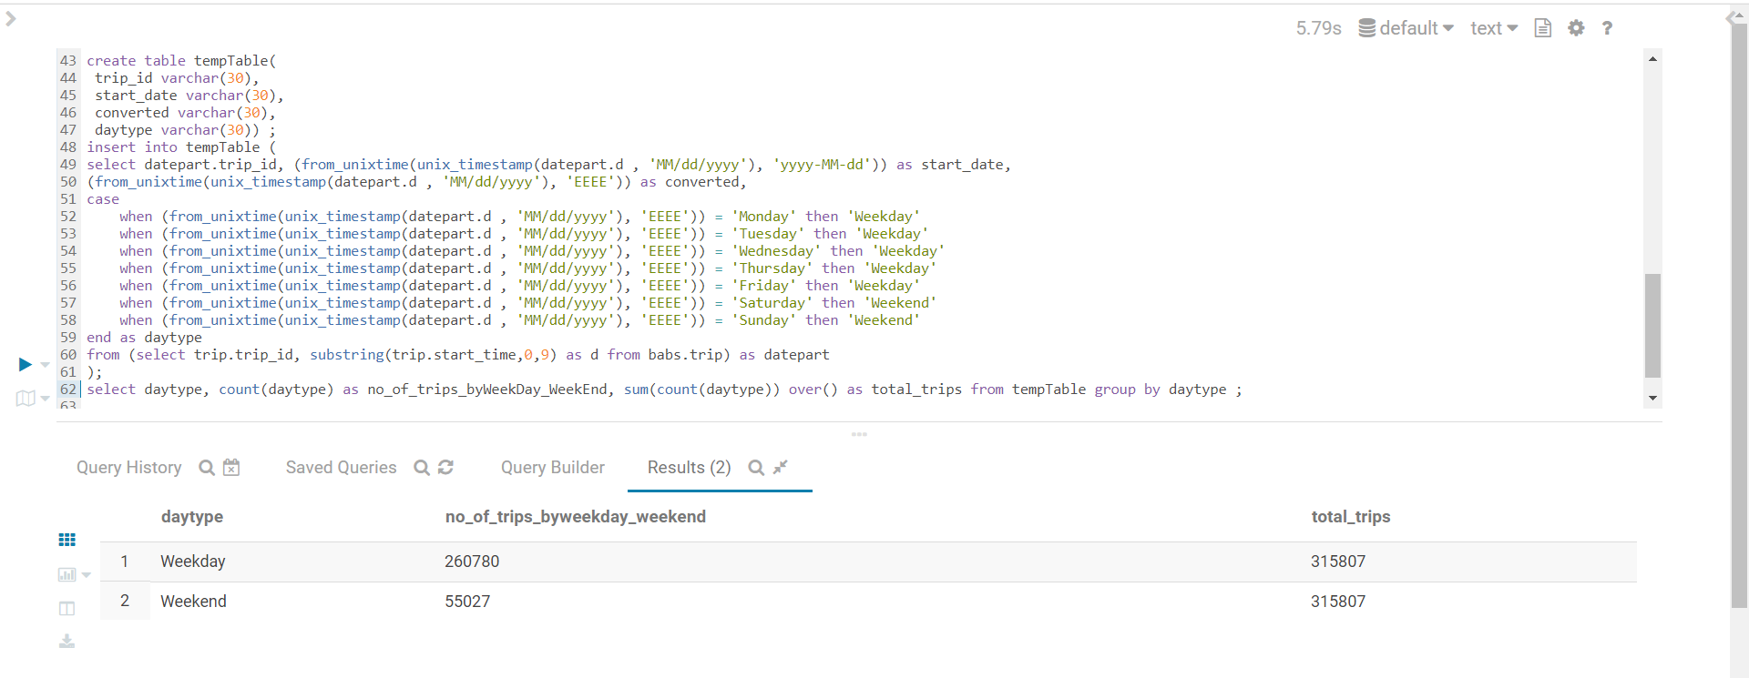

**Visualization:**

