



NTEG

Technical Design Document V0.1

Nagarro Inc., 220 Airport Parkway, San Jose, CA 95110

Nagarro Europe, Baslerstrasse 115 D, 79115 Freiburg, Germany

Nagarro Software Pvt. Ltd., Plot 14, Electronic City, Sector - 18, Gurgaon – 122015, Haryana, India

**Document Change History**

|  |  |  |
| --- | --- | --- |
|  |  |  |

|  |  |  |  |  |
| --- | --- | --- | --- | --- |
| Version # | Author | Date (dd-mon-yy) | Reviewer | Description |
| 0.1 | Rakesh Garg | 14 May 2014 |  | Initial Section |

Table of Contents

Document Change History 2

1 Introduction 4

1.1 Purpose of the document 4

1.2 Scope of the document 4

1.3 Project Overview 4

2 System Overview 5

2.1 Data flow within components 5

3 Permission Management 7

4 App Part/Client Web part 7

5 Workflow 7

6 SharePoint List and Library 10

6.1 Custom List: Forms 11

6.2 Custom List: Expense 11

6.3 Custom List: Expense Details 11

6.4 Custom List: Business Rules Type 12

6.5 Custom List: Business Rules Mapping 12

7 Deployment 12

# Introduction

## Purpose of the document

The purpose of the document is to describe low level design of Expense online application.The document will help in understanding the architecture, description of module/component and the workflow of the Expense online in detail. This document provides a low level design of all the functions, specifications and content management system which would be driven by SharePoint 2013. This document gives the idea about the schema, all the relationship and master data management entities.

## Scope of the document

The proposed design in this document is based on requirement specification documents mentioned under reference documents. The design is subject to change in case we get some additional requirements that are not covered in documents mentioned under reference document section below.

## Project Overview

The application includes the implementation of expense tracking online for Nagarro.

# System Overview

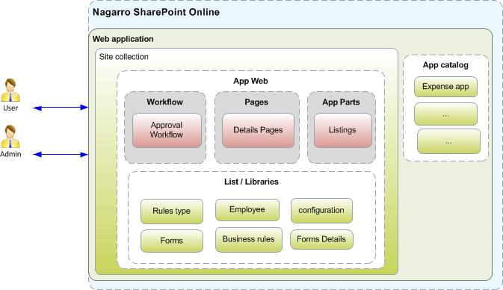



## Data flow within components

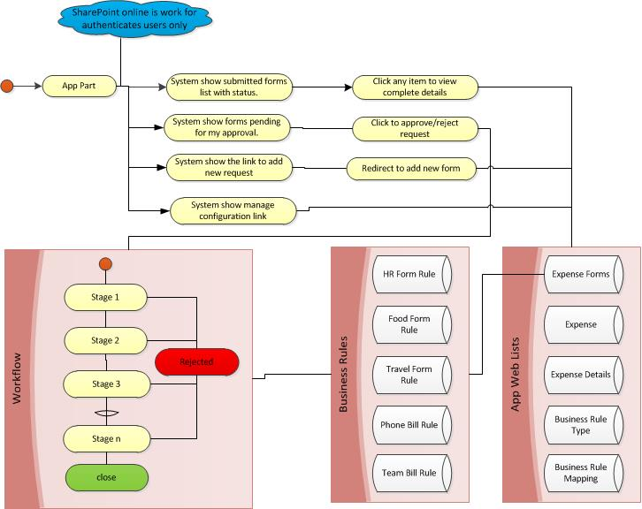



# Permission Management



Vaibhav and Rakesh is working on this Activity. We need to identify Super Admin functionality to create and modify the rules.

# App Part/Client Web part

We have one landing page for all

1. Landing page
   1. Link to create new Expense
      1. This link is available to all.
      2. This link will redirect user into the add expense details page.
   2. Show logged in users Expenses Grouped by status (In Progress, Rejected, and Closed).
      1. This Grid will show the Expense name along with Expense amount and time stamp.
      2. User can select any record to view the complete details.
   3. Show List of all Task assigned to me

# Workflow

We are planning to use the Default SharePoint 2013 approval Workflow.

1. We need to create List workflow for our project on the list “Expense”.
2. We need to select new instance of a workflow History list as well as its own new task list to use.
3. We need to select the workflow start automatically when an item is created.
4. Now it’s time to design a few workflow activity items.
   1. We need to work start the instance of workflow on the new item created for expense list.
   2. Check the “Expense Type” from the item and find out the Business rule mapping from the list “Business Rule mapping”.
   3. Create a sequence of approval required again the business rule defined again the Expense type.
   4. Create new task for all approves. (approver can be multiple so we need to check for at least one approval against each stage of workflow)
   5. When all the stages get completed we need to approve the expense.
5. Email notification: when the workflow get completed we need to notify the employee.

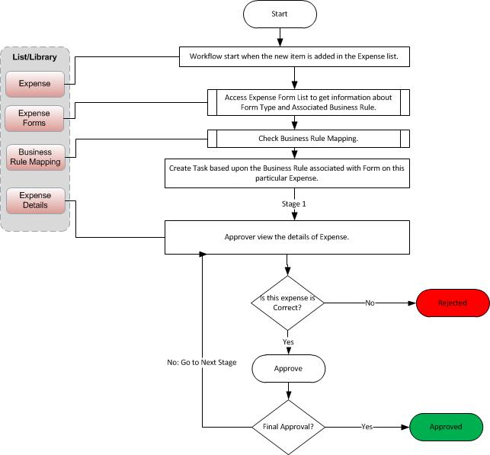

# SharePoint List and Library

This section discusses about the custom list information with their attributes.

## Custom List: Forms

|  |  |  |  |
| --- | --- | --- | --- |
| **List Description** | This list store the information form configured by the admin. | | |
| **Column Name** | **Column Type** | **Required** | **Comments** |
| Form Name | Single line of text | Yes | Default Title field |
| Form Description | Multi line of text |  |  |
| Form Type | Choice | Yes | Values “Food”, “Travel”, “Device”, “Telephone”, “Team Party”…etc. |
| Business Rule | Lookup | Yes | Business Rule List |

## Custom List: Expense

|  |  |  |  |
| --- | --- | --- | --- |
| **List Description** | This list store the information about the employees submitted the employee. | | |
| **Column Name** | **Column Type** | **Required** | **Comments** |
| Employee Name | Single line of text | Yes | Default Title field |
| Employee ID | Number | Yes |  |
| Employee login name | Single line of text | Yes |  |
| Description | Multi line of text | No |  |
| Total Expense | Number | Yes |  |
| Approved Amount | Number | No |  |
| Date |  |  |  |
| Approved By | People | No |  |
| Expense Type | Lookup | No | Refer to forms List |
| Is Active | Boolean | No | Active/Inactive  Default Value: No |
| Approver Comments | Multi line of text | No |  |

## Custom List: Expense Details

|  |  |  |  |
| --- | --- | --- | --- |
| **Reference Details** |  | | |
| **List Description** | This list store the information about the employees who submit the expense form. | | |
| **Column Name** | **Column Type** | **Required** | **Comments** |
| Title | Single line of text | Yes | Default Title field |
| Description | Multi line of text | Yes |  |
| Date |  |  |  |
| Expense ID | Number | Yes | Refer to Expense List ID |
| Amount | Number | Yes |  |
| Client Name | Single line of text |  |  |

## Custom List: Business Rules Type

|  |  |  |  |
| --- | --- | --- | --- |
| **Reference Details** |  | | |
| **List Description** |  | | |
| **Column Name** | **Column Type** | **Required** | **Comments** |
| Rule Name | Single line of text | Yes | Default Title field |
| Number of stages | Number | Yes |  |

## Custom List: Business Rules Mapping

|  |  |  |  |
| --- | --- | --- | --- |
| **Reference Details** |  | | |
| **List Description** |  | | |
| **Column Name** | **Column Type** | **Required** | **Comments** |
| Stage Name | Single line of text | Yes | Default Title field |
| Stage Description | Multi line of text | No |  |
| Rule ID | Number | Yes | ID column of Business Rule Type |
| Approver Name | People or Group | Yes |  |
|  |  |  |  |

# Deployment