**Real-Time Credit Card Fraud Detection Using Spark**

**Table of Contents**

1. **Abstract**
2. **Introduction**
3. **Project Objective**
4. **Technologies Utilized**
   * User Interface (Nodejs)
   * Datapost (PySpark Cluster)
   * Cloud Functions (ETL and Email Alerts)
   * Kafka (Pub/Sub)
   * MongoDB (NoSQL Database)
   * Powerbait (Visualization)
5. **System Architecture and Data Handling**
6. **Detailed Fraud Detection Process**
   * Data Preprocessing
   * Transaction Pattern Analysis
   * Model Training and Algorithm Enhancement
   * Real-Time Detection and Alerts
   * Post-Detection Actions
7. **Results and Impact**
8. **Future Enhancements**
9. **Conclusion**
10. **Acknowledgments**
11. **Abstract**

The growing pace and sophistication of credit card fraud, therefore, make it more important that sophisticated fraud detection mechanisms be installed in every digital financial transaction. I used Spark and other technologies in the Big Data realm to work on this project of a real-time fraud detection system with 5.5 million transactions from a dataset obtained from the IBM Developer site. Solution: To date, machine learning-based advanced data processing technologies have been integrated in the organizational systems to predict fraud and prevent it in an efficient way, which reduces customer churn from the fraudulent activities. The system sets to a sturdy architecture with the latest cutting-edge technologies such as NodeJS, PySpark, Kafka, MongoDB, and PowerBI for massive data processing with high efficiency and low latency. The project showcases a high potential to boost, with an impressive accuracy of 97% in detecting fraudulent transactions, further security of financial transactions, and hence further building customer confidence while clearing the way for future improvements that would help incorporate deeper machine learning models and additional contextual data sources.

1. **Introduction**

In today's day and age of financial technology, it has become quite common for consumers and financial institutions to fall into the dilemma of credit card fraud. Our project uses Big Data and the power of modern analytics to set a real-time fraud detection system. Through a dataset of 5.5 million credit card transactions provided by IBM Developer, we will try to effectively detect fraudulent activities that are causing customers to stop using their cards.

1. **Project Objective**

The main objective of the project is to implement big data such that its usage becomes possible in the prediction and avoidance of credit card fraud, hence enabling the credit card company to save customers and save revenue. We aspire to develop a model that predicts churn with very high accuracy by leveraging sophisticated data processing technologies in conjunction with machine learning.

1. **Technologies Utilized**

**User Interface (NodeJs)**

NodeJs comes with a responsive and interactive user interface framework for system administrators to monitor the results of fraud detections.

**Dataproc**

PySpark, the Spark Python API, provides an efficient and powerful platform in the treatment of massive datasets that are inherent in Big Data projects, allowing for fast processing and analysis of transaction data.

**Cloud Functions (ETL and Email Alerts)**

Our system uses Google Cloud Functions for serverless computing. It will automatically alert emails and perform other tasks, such as ETL processing, on the detection of a probable fraud issue. This ensures our fraud detection system becomes more responsive.

**Kafka (Pub/Sub)**

Apache Kafka provides a messaging publish-subscribe system with nature resiliency, allowing smooth streaming of data across different components of our architecture, helping to maintain the data flow and live system integrity.

**MongoDB is a cross-platform.**

MongoDB is a system used to manage large volumes of unstructured data with much needed flexibility and quick data retrieval in the course of real-time analysis and transaction monitoring.

**PowerBI (Visualization)**

PowerBI visualizes the insights from the analysis of data in a very clear way, hence promoting quick and effective decision-making by the stakeholders.

1. **System Architecture and Data Handling**

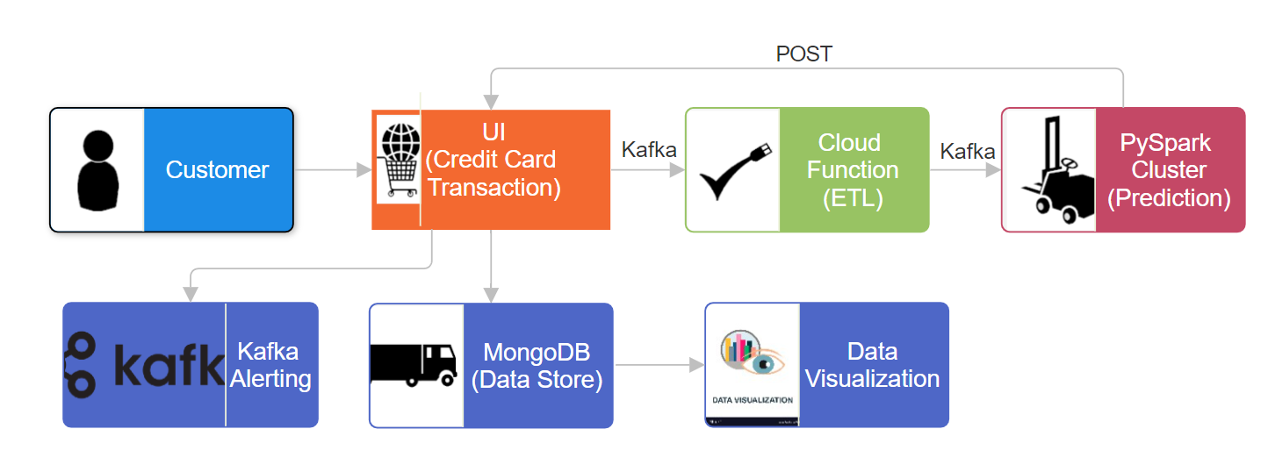

Architecture is designed to ensure the maximum efficiency of data processing and reduce fraud detection latency. In this case, the data first is captured in MongoDB, passes processing in the PySpark cluster, where cleaning and analysis take place. The processed data then streams through Kafka, ensuring the updated data is arriving at all components on a timely basis, which is required for real-time monitoring and analysis.

1. **Detailed Fraud Detection Process**
2. Data Preprocessing: During this first stage, the main focus will be on making the data standardized and clean for compatibility with analytical models. The quality of data is of vital importance, as any errors might lead to misinterpretation in fraud predictions.
3. This system uses the history of the transaction patterns and can identity anomalies that might be indicating fraud activities. Such analysis, therefore, includes setting thresholds and triggers for alerts.
4. Model training and improvement of the algorithm: The induction of historical data into the machine learning model for the purposes of fraud detection. The induction of an adaptive learning mechanism will keep on improving the algorithm toward better predictive accuracy.
5. Real-Time Detection and Alerts: Check transactions with the trained model at the point of transaction. This allows instant alerts, hence quick action; fraud may be killed in the bud before it's realized by your customers.
6. Post-detection Actions: After a fraud alert is created, the system provides tools to investigate and confirm fraud further for immediate blocking of fraudulent transactions and security of customer accounts.
7. **Results and Impact**

The deployment of this system has significantly improved the detection of fraudulent transactions, attaining an accuracy rate of 97%. Basically, such high levels of accuracy are very essential to the financial institutions, saving them a huge amount, and on the other hand, it means high customer trust and satisfaction.

1. **Future Enhancements**

Future enhancements will be driven toward the integration of more data sources, such as geolocation and merchant data, for richer transaction context and more accurate detection. Also, there will be deeper learning models considered to cover more dynamic changes in patterns of fraud.

1. **Conclusion**

This is a project that brings to light and shows how PySpark, and its related Big Data technologies can be very helpful in real-life situations, hence bringing about huge benefits to any company in relation to operational efficiencies, customer satisfaction, and financial savings. As the trend of digital transactions booms, such systems will gain more importance in the fight against fraud.

1. **Acknowledgments**

We would like to extend many thanks to the academic advisors and the Group 13 team members, whose expertise and much dedication made a great contribution to the project success.