JAVA PROJECT



**Done by:**

A. Priyamvada - 23WH1A05E4

K. Harshitha - 23WH1A05G6

B. Naga Sharmada - 23WH1A05H1

**1. Introduction**

Voting System is a desktop application developed to facilitate electronic voting with a secure, efficient, and user-friendly interface. It is built using **Java Swing** for the graphical user interface (GUI) and **JDBC** with **MySQL** for the backend database, which stores voter information and votes securely. This system aims to replace traditional paper-based voting methods, reducing the risk of fraud and errors, and ensuring faster vote counting.

**Key Objectives**:

* Streamline the voting process using a digital platform.
* Ensure voter authentication through a unique Voter ID.
* Provide an admin interface for managing election results.
* Store data securely using MySQL.

**2. Features**

The Voting System offers a range of features to both voters and administrators:

**Voter Side:**

* **Voter Authentication**:
  + Voters must enter a valid Voter ID to log in.
  + Only authenticated users can proceed to vote, ensuring secure access.
* **Vote Casting**:
  + A simple, intuitive interface allows voters to select their preferred candidate.
  + Once a vote is cast, it is stored in the database, and the user is logged out to prevent multiple votes.
* **Confirmation Message**:
  + After a vote is successfully cast, a confirmation message is displayed.

**Admin Side:**

* **Admin Authentication**:
  + Admins log in with a secure username and password to access administrative functionalities.
* **View Results**:
  + Admins can view the real-time vote counts for each candidate.
  + Results are displayed in a tabular format with a breakdown of total votes.
* **Data Security**:
  + Sensitive information, such as voter details and vote counts, is securely stored in a MySQL database.

**3. System Requirements**

To ensure smooth installation and operation of the Voting System application, the following software and hardware configurations are recommended:

**Software Requirements:**

* **Operating System**: Windows 10, macOS, or Linux (Ubuntu preferred)
* **Java Development Kit (JDK)**: JDK 8 or higher (JDK 11 recommended)
* **Database**: MySQL Server 8.0 or higher
* **JDBC Driver**: MySQL Connector/J (compatible with MySQL version)
* **IDE (Optional)**: Eclipse, IntelliJ IDEA, or NetBeans for code development

**4. Technologies Used**

This Voting System uses a combination of frontend and backend technologies to ensure a seamless user experience:

* **Java Swing**:
  + Used for creating a rich desktop GUI.
  + Provides components like buttons, text fields, tables, and dialog boxes.
* **JDBC (Java Database Connectivity)**:
  + Facilitates interaction between the Java application and the MySQL database.
  + Handles database connections, executing queries, and retrieving results.
* **MySQL**:
  + A relational database management system (RDBMS) used for storing voter details and votes.
  + Provides data security, indexing, and efficient querying capabilities.
* **Java SE (Standard Edition)**:
  + Core Java libraries used for building the application logic, exception handling, and input/output operations.

**5. Application Flow**

1. **Voter Login**:
   * The system prompts the voter to enter their Voter ID.
   * The application verifies the ID against the database.
   * If valid, the voter proceeds to the voting screen; otherwise, an error message is displayed.
2. **Vote Casting**:
   * The voter selects a candidate and confirms their vote.
   * The vote is recorded in the database, and the voter's status is updated.
3. **Admin Login**:
   * Admins use a secure login to access the results dashboard.
   * The system displays a table with who voted to which candidate.

**6.Screenshots**

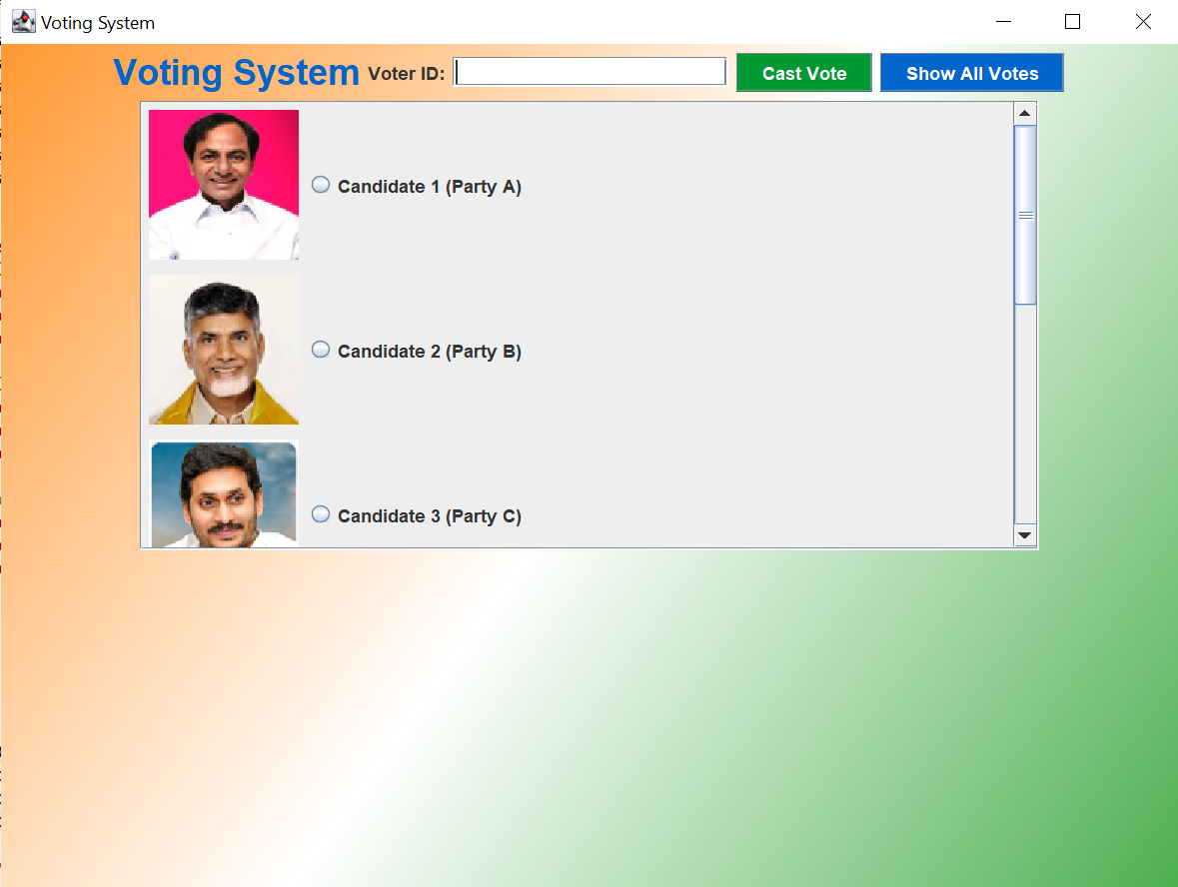

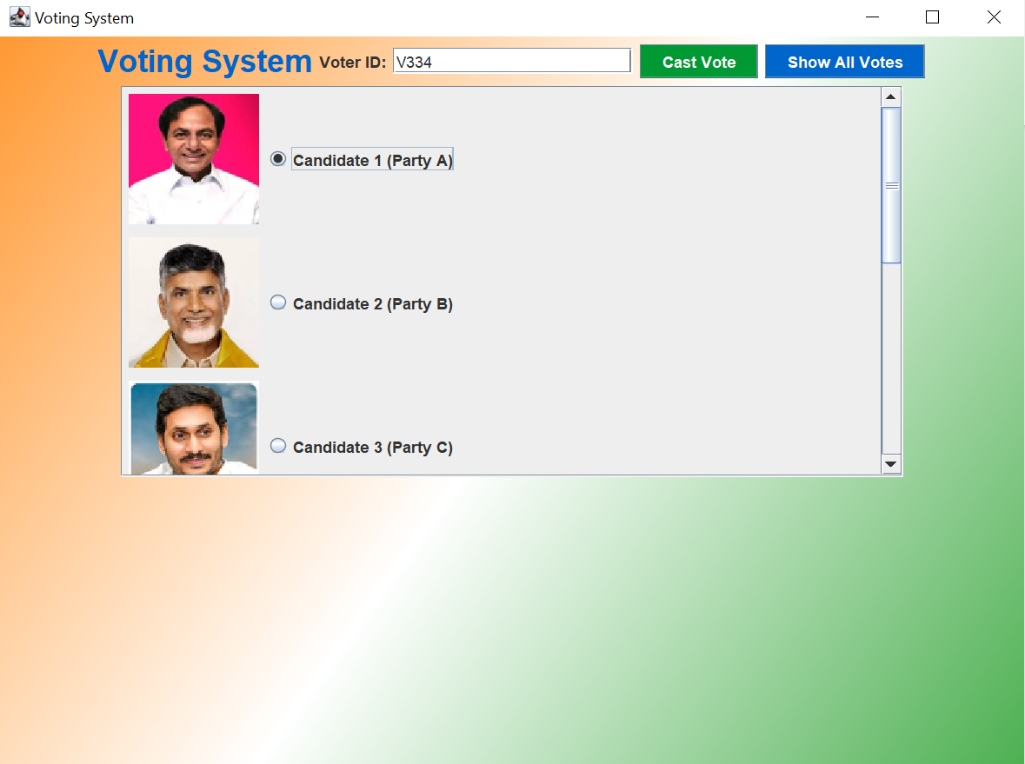

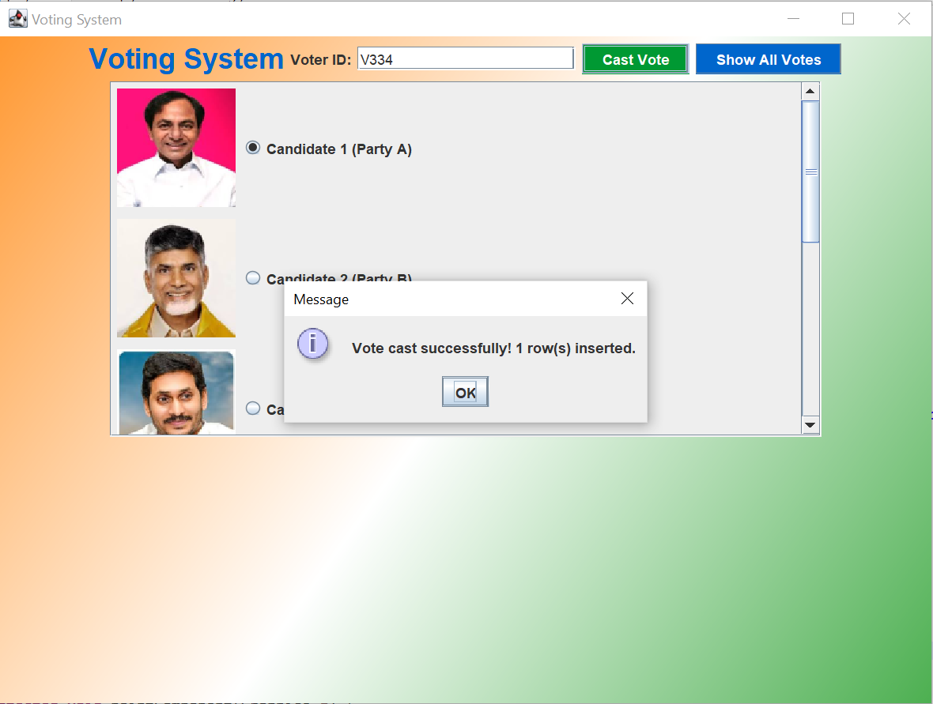

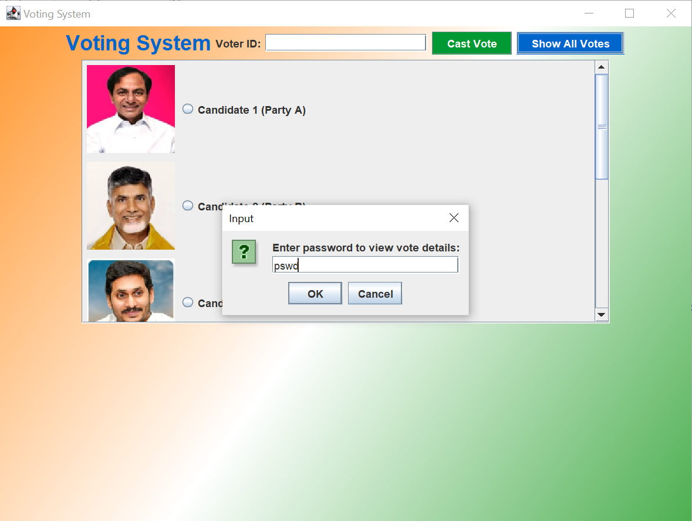

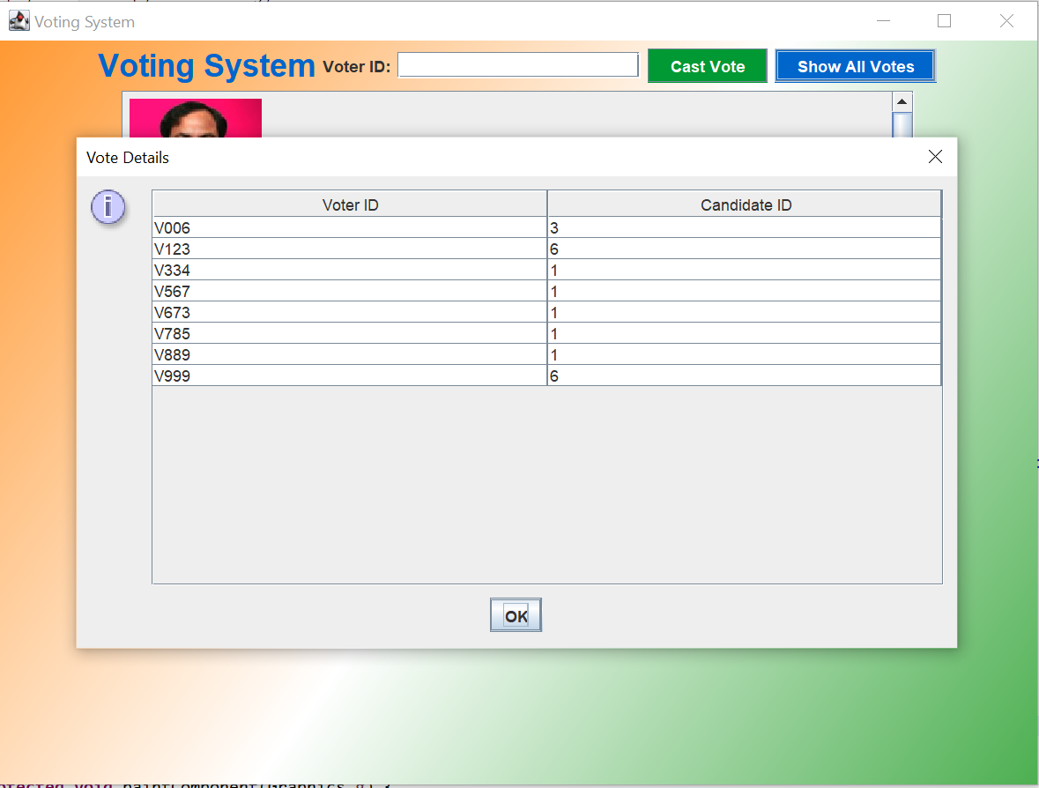

**7. Applications**

The Voting System you have developed has a wide range of applications across different sectors and scenarios. Below are some potential use cases:

1. Corporate Elections

* Suitable for annual general meetings (AGMs) where shareholders vote on company matters like board elections, mergers, and policy changes.
* Provides a secure and transparent voting mechanism for employees, board members, and stakeholders.

2. Educational Institutions

* Can be used in universities and colleges for student council elections, club elections, and other administrative decisions.
* Reduces administrative overhead by automating the voting and result counting process.

3. Non-profit Organizations and Societies

* Useful for electing board members, passing resolutions, or making organizational decisions in non-profit organizations, housing societies, and clubs.
* Ensures fair and transparent voting among members.

4. Surveys and Polls

* Can be adapted for conducting opinion polls, surveys, and feedback collection in various sectors like market research, product launches, and employee engagement initiatives.
* Ensures that responses are securely stored, providing reliable data for analysis.
* Ensures confidentiality and integrity of the voting process within the organization.

**8.Conclusion**

In conclusion, this Voting System serves as a robust solution for organizations looking to digitize their voting processes. It not only enhances the security and accuracy of elections but also streamlines the voting experience for all participants. With potential extensions and enhancements, this system can be adapted to suit various election scenarios, making it a valuable tool in the digital transformation of electoral processes.