STUDENT MANAGEMENT SYSTEM

Computer Science and Engineering Department
National Institute of Technology Silchar, Assam
Project by:
Naga Shasanka Yerram
Table of contents:
1. Problem statement
2. Introduction
3. Code structure: -
Object oriented programming used
Class functions
Other functions
4. Flowchart
5. Algorithm
6. Output
7. Conclusion

1. Problem Statement

Background:
Manual student record keeping is inefficient and error-prone. Traditional methods often rely on registers or spreadsheets, which make searching, updating, and sorting data difficult and time-consuming.

Problem Description:
You are tasked to design a Student Management System using the C++ programming language. The system should provide functionalities to add, remove, update, and search student records. It should also allow displaying all students and sorting them by marks. The system must offer a simple command-line interface for user interaction.

2. Introduction

Overview:
The Student Management System is a command-line application designed to handle student records efficiently. It allows administrators to manage student details such as ID, name, age, course, and marks.

Key Features:
- Add, remove, update, and search student records.
- Search by ID, Name, or Course.
- Sort students by marks in descending order.
- Simple CLI with numbered options for interaction.

Technologies Used:
- C++ programming language
- Standard Template Library (STL): map, vector, algorithm
- Object-Oriented Programming principles

3. Code Structure

Object-Oriented Programming Concepts Used:
- Classes and Objects: Student and StudentManager classes.
- Encapsulation: Private data members with public getters and setters.
- Abstraction: High-level functions hide internal implementation.
- Polymorphism: Overloaded methods for search and update operations.

Class Descriptions:
Student Class:
- Attributes: id, name, age, course, marks
- Methods: Getters, Setters, displayDetails()
StudentManager Class:
- Attributes: map<int, Student> students
- Methods: addStudent, removeStudentById, removeStudentByName, searchStudentById, searchStudentByName, searchStudentByCourse, updateStudent, updateStudentByName, displayAllStudents, sortStudentsByMarks

Other Functions:
The main function provides a command-line interface with a menu. It uses a loop and switch-case structure to handle user input and perform corresponding operations until the user chooses to exit.
4.Flowchart

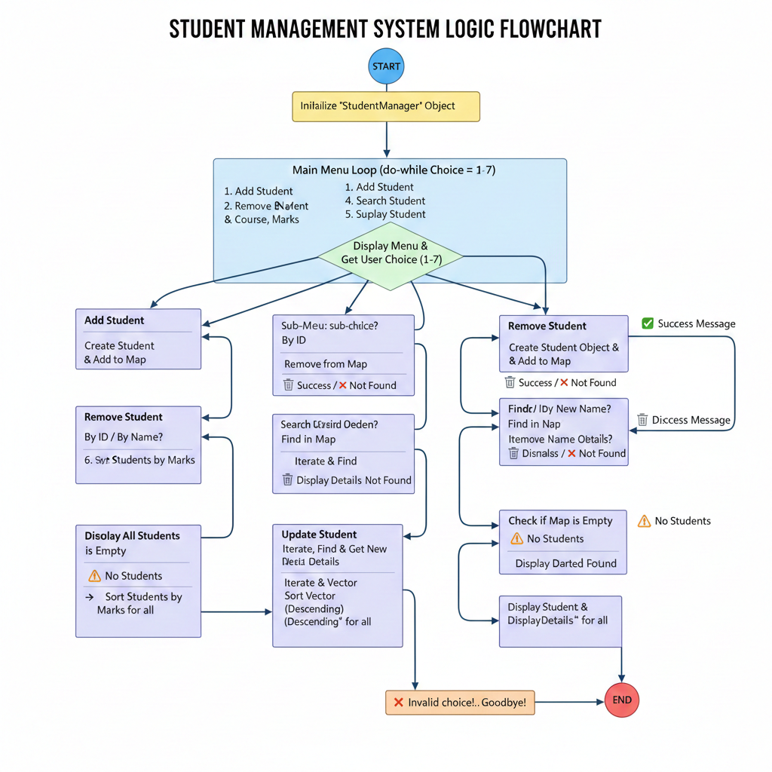

5. Algorithm
1. Start program and initialize StudentManager.
2. Display menu and get user input.
3. Perform action based on user choice:
- Add Student: Input details and store in map.
- Remove Student: By ID or Name.
- Search Student: By ID, Name, or Course.
- Update Student: Modify existing record.
- Display All Students: Show all records.
- Sort Students by Marks: Sort and display.
4. Loop until Exit is selected.

6. Output
Sample CLI Output:
Add Student:
Enter ID: 101
Enter Name: Alice
Enter Age: 20
Enter Course: CSE
Enter Marks: 85
✅ Student added successfully!
Search Student by ID:
Enter ID: 101
🔍 Student found:
ID: 101 | Name: Alice | Age: 20 | Course: CSE | Marks: 85

7. Conclusion
The Student Management System project demonstrates the application of object-oriented programming concepts in solving real-world problems. By leveraging C++ features such as STL containers and encapsulation, the system provides efficient record management.
This project enhanced our understanding of:
- File-free record handling using STL
- Designing modular and reusable code
- Implementing search and sort functionalities
Overall, the project has been a valuable learning experience, strengthening our skills in C++ and OOP design.

